❄ SNOWFLAKE TRAINING PROGRAM
DAY 4
Data Loading & Unloading in Snowflake
Complete Beginner-Friendly Training Session
Duration: 4 Hours | Format: Instructor-Led + Hands-On Labs

TODAYS SESSION IS NOT MUCH THEORY IT IS PRACTICAL SO ALL EXPLANATIONS ARE THERE INSIDE THE SNOWFLAKE.
WHATEVER THEORY AND EXPLANATION NEEDED WILL BE GUIDED INTO THE SNOWFLAKE AND IN AMAZON S3 ITSELF LIVE.

SESSION OVERVIEW & LEARNING OBJECTIVES

What You Will Learn Today
By the end of this 4-hour session, you will be able to:
- Explain how Snowflake loads data and why it matters in real enterprise projects
- Differentiate between internal and external stages
- Set up AWS S3 as an external stage with proper IAM and Storage Integration
- Load CSV, JSON, and Parquet files into Snowflake using COPY INTO
- Handle load errors, validate files, and reprocess them
- Use metadata columns (METADATA$FILENAME, METADATA$FILE_ROW_NUMBER)
- Unload/export data from Snowflake back to AWS S3
- Understand Snowpipe for near-real-time automated ingestion
- Monitor loads using COPY_HISTORY and QUERY_HISTORY
- Apply performance best practices and security guidelines

Pre-requisites (Quick Recap)
Already Covered (Days 1-3) | Needed for Today
Snowflake Architecture & Virtual Warehouses  RBAC, Roles, Users, Grants  SQL Basics (SELECT, WHERE, JOIN)  Database, Schema, Table creation | AWS Account with S3 access  Snowflake trial/enterprise account  ACCOUNTADMIN or SYSADMIN role  Basic understanding of cloud storage

MODULE 1 — INTRODUCTION TO DATA LOADING IN SNOWFLAKE

1.1 Why Data Loading Matters
Think of Snowflake as a sophisticated data warehouse — but a warehouse without inventory is useless. Data loading is the process of bringing your raw data from various sources into Snowflake so analysts, engineers, and applications can query and use it.

In the real world, companies constantly receive data from:
- E-commerce platforms generating millions of order records daily
- Banking systems processing thousands of transactions per second
- IoT devices sending sensor readings every few milliseconds
- Healthcare systems receiving patient records from hospitals
- Log files from applications and web servers

🎯 Beginner Tip
Think of data loading like loading groceries into a refrigerator.
The S3 bucket = the grocery bag (temporary holding area)
The Snowflake table = the refrigerator (permanent organized storage)
COPY INTO = the action of moving groceries from bag to fridge

1.2 Batch vs Streaming Ingestion
Aspect | Batch Ingestion | Streaming Ingestion
Definition | Load large files at scheduled intervals | Load data continuously in real-time or near-real-time
Tool Used | COPY INTO (this session's focus) | Snowpipe, Kafka Connector
Trigger | Manual or scheduled (cron job, Airflow) | Event-driven (S3 event, SQS message)
Latency | Minutes to hours | Seconds to minutes
Use Case | Daily sales report, monthly invoice data | Real-time fraud detection, IoT alerts
Cost | Lower (fewer compute cycles) | Higher (continuous compute)
Example | Load yesterday's 5M orders from S3 at 2AM | Load every new payment immediately as it happens

1.3 Snowflake Staging Concepts — The Foundation
Before data can be loaded into Snowflake, it must first be placed in a STAGE. A stage is a temporary holding location — like a loading dock at a warehouse.

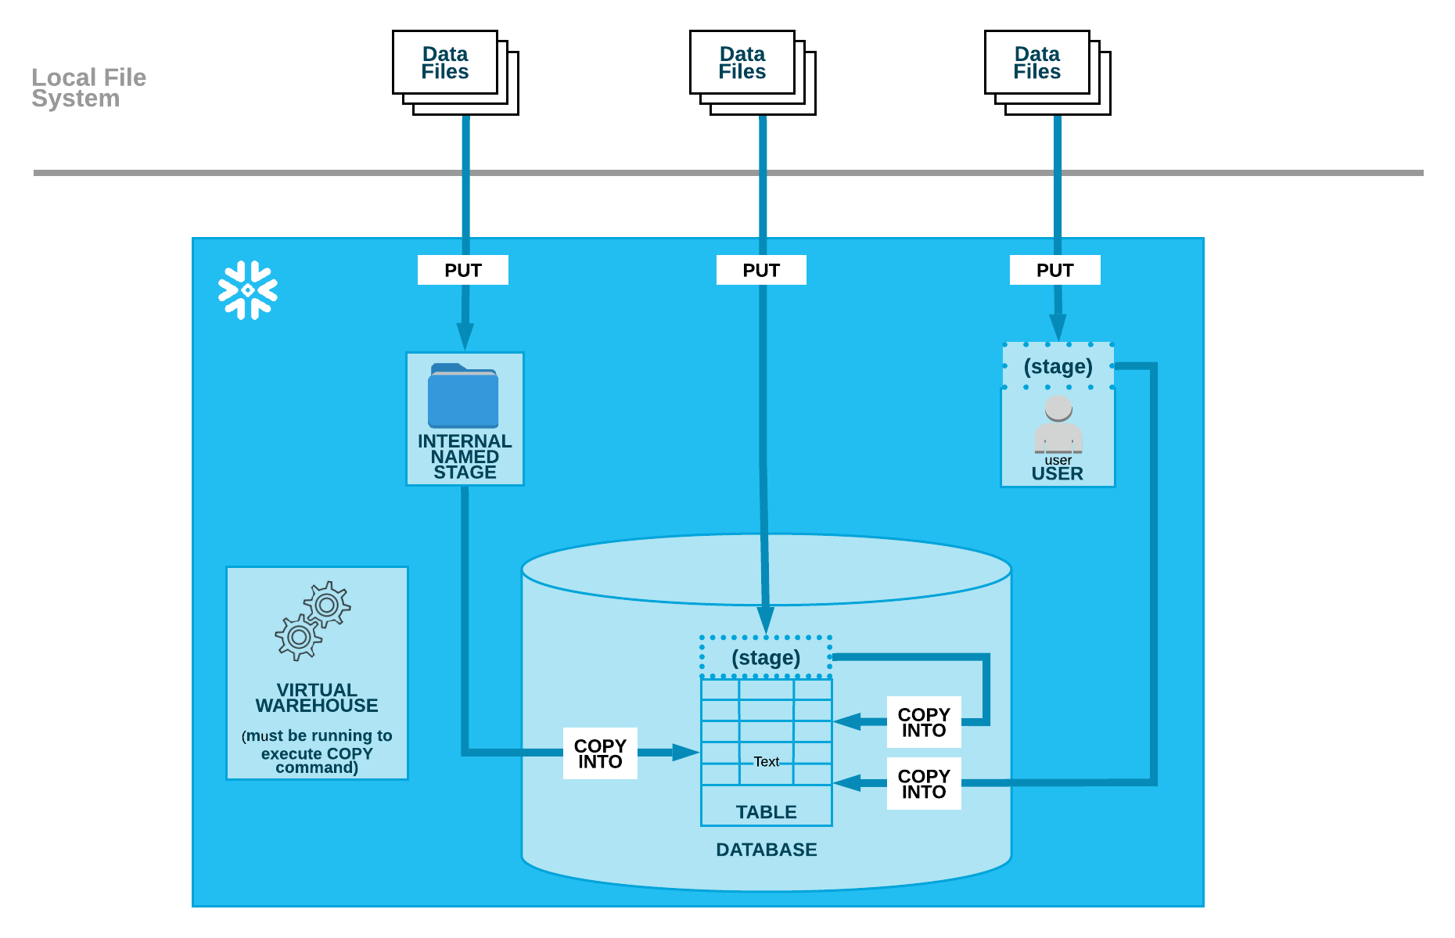

Organizing data by path
Both internal (i.e. Snowflake) and external (Amazon S3, Google Cloud Storage, or Microsoft Azure) stage references can include a path (or prefix in AWS terminology). When staging regular data sets, we recommend partitioning the data into logical paths that include identifying details such as geographical location or other source identifiers, along with the date when the data was written.
Organizing your data files by path lets you copy any fraction of the partitioned data into Snowflake with a single command. This allows you to execute concurrent COPY statements that match a subset of files, taking advantage of parallel operations.
For example, if you were storing data for a North American company by geographical location, you might include identifiers such as continent, country, and city in paths along with data write dates:
- Canada/Ontario/Toronto/2016/07/10/05/
- United_States/California/Los_Angeles/2016/06/01/11/
- United_States/New York/New_York/2016/12/21/03/
- United_States/California/San_Francisco/2016/08/03/17/

When you create a named stage, you can specify any part of a path. For example, create an external stage using one of the above example paths:

CREATE STAGE my_stage URL='s3://mybucket/United_States/California/Los_Angeles/' CREDENTIALS=(AWS_KEY_ID='1a2b3c' AWS_SECRET_KEY='4x5y6z');

You can also add a path when you stage files in an internal user or table stage. For example, stage mydata.csv in a specific path in the t1 table stage:

PUT file:///data/mydata.csv @%t1/United_States/California/Los_Angeles/2016/06/01/11/

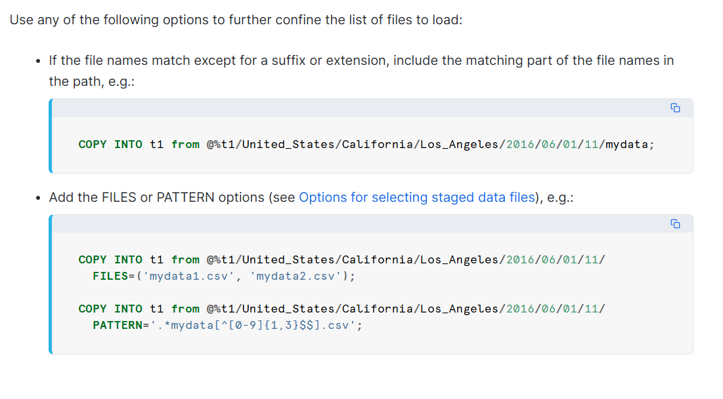

1.3.1 Internal Stages
Internal stages are managed and stored by Snowflake itself. Files are uploaded using the PUT command.

Three subtypes:
- User Stage (@~): Every Snowflake user automatically gets a private stage. Accessible only by that user.
- Table Stage (@%table_name): Every table automatically gets a stage. Files here can only load into that specific table.
- Named Internal Stage: You create this explicitly. Reusable across multiple tables and sessions.

ℹ️ When to use Internal Stages
Use internal stages when: your source files are on a local machine or server
and you do not have a cloud bucket, or when doing quick one-time loads.
Not recommended for production enterprise pipelines.

By default, each user and table in Snowflake is automatically allocated an internal stage for staging data files to be loaded. In addition, you can create named internal stages.
File staging information is required during both steps in the data loading process:
- You must specify an internal stage in the PUT command when uploading files to Snowflake.
- You must specify the same stage in the COPY INTO <table> command when loading data into a table from the staged files.

A user stage in Snowflake is a personal storage space for each user to upload and manage files.
Key points:
- Access it using @~ (example: LIST @~).
- Good for storing files that only one user needs.
- Useful when the same files need to be loaded into multiple tables.
- You cannot modify or delete a user stage.
- File format settings must be added directly in the COPY INTO command.
Not suitable when:
- Multiple users need access to the files.
- The user doesn’t have permission to insert data into the target tables.

A table stage in Snowflake is a storage area automatically linked to a specific table.
Key points:
- Every table gets its own stage by default.
- Refer to it using @%tablename (example: @%mytable).
- Best when files are only needed for one table but should be accessible to multiple users.
- Only the table owner can upload, view, query, or delete files in the stage.
- You cannot modify or delete a table stage.
- Table stages cannot be used to load transformed data during COPY INTO.
Not suitable when:
- You need to load the same files into multiple tables.
- You want flexible permissions or advanced stage settings.

A named stage in Snowflake is a reusable storage location created as a database object for loading data.
Key points:
- Multiple users can access it if they have the required permissions.
- Files from a named stage can be loaded into any table.
- Permissions can be granted, revoked, or transferred to different roles.
- Best choice for regular data loads involving multiple users or tables.
- More flexible and secure compared to user stages or table stages.
Use named stages when:
- Multiple users need access to the files.
- Files need to be loaded into multiple tables.
- You want better control over permissions and management.

1.3.2 External Stages (The Enterprise Standard)
External stages point to files stored in cloud storage (AWS S3, Azure Blob, GCP GCS). Snowflake does NOT copy the files — it reads directly from the cloud provider.

EXTERNAL STAGE ARCHITECTURE
===========================
AWS Account Snowflake Account
+------------------+ +-------------------+
| S3 Bucket | | External Stage |
| (raw-data/) |<---Points to| @my_s3_stage |
| |- orders.csv | | |
| |- returns.csv | | Storage |
| |- products.csv| | Integration |
+------------------+ | (IAM Role Trust) |
| +-------------------+
| |
+------- COPY INTO reads ----------+
files from S3
|
v
+-------------------+
| Snowflake Table |
| (permanent data) |
+-------------------+

💡
An external stage is like a GPS address pointing to your cloud folder.
You tell Snowflake: 'My files live at s3://my-company-bucket/sales/'
Snowflake then uses that address every time you run COPY INTO.
The files stay in S3 — Snowflake just reads from there.

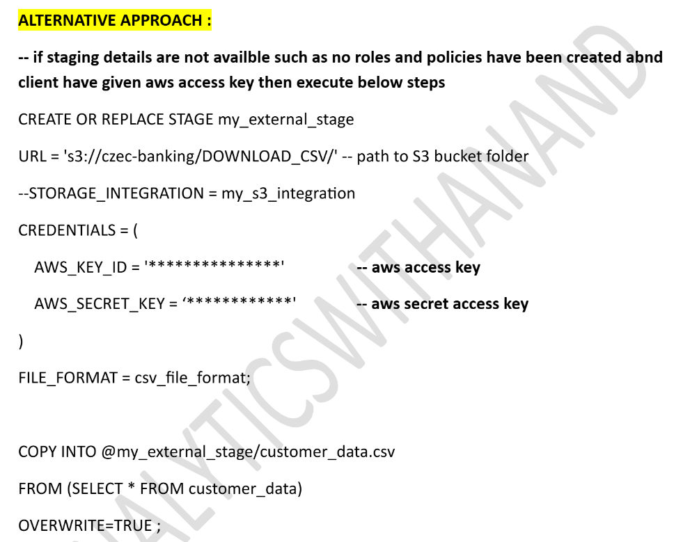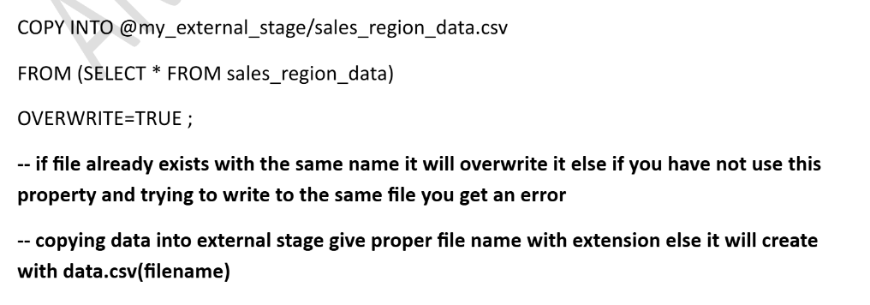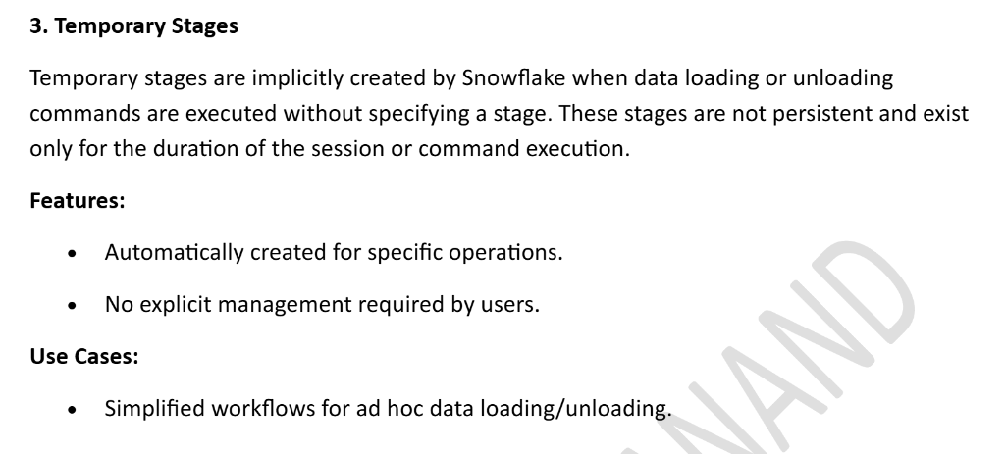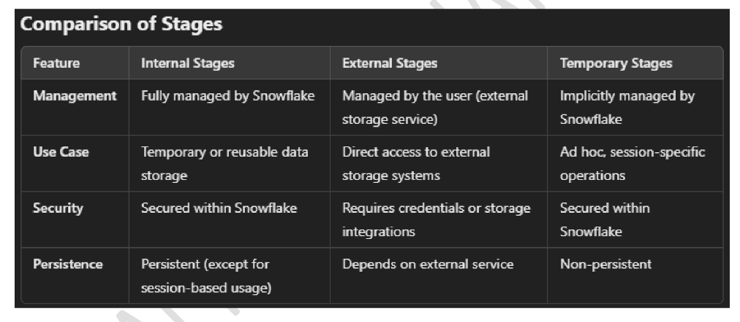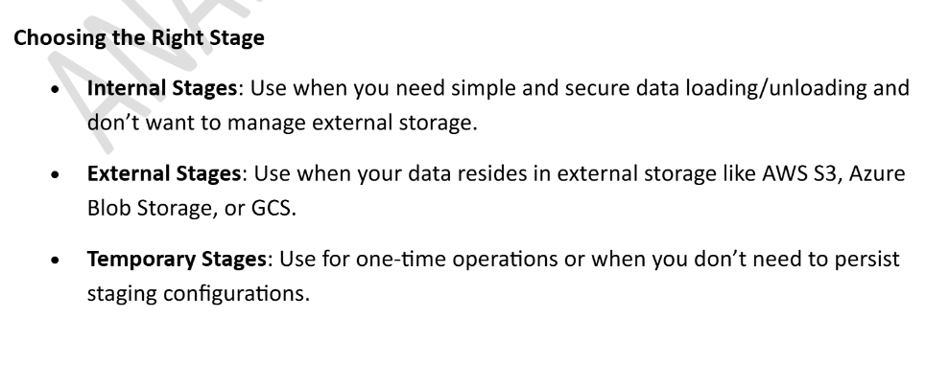
MODULE 2 — AWS S3 INTEGRATION (STEP-BY-STEP)

2.1 The Complete AWS S3 → Snowflake Architecture
Before writing a single SQL command, let's understand the full architecture of how Snowflake securely connects to your AWS S3 bucket.

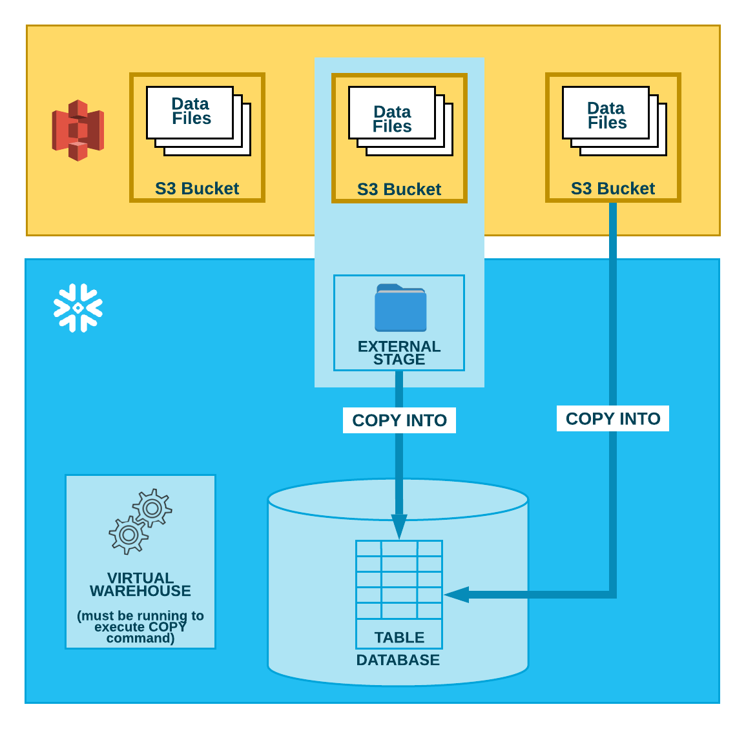

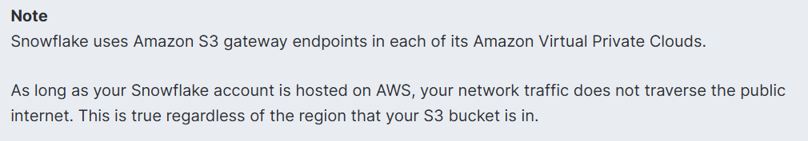

COMPLETE AWS S3 <-> SNOWFLAKE SECURE INTEGRATION FLOW
======================================================
STEP 1: Create S3 Bucket
+-----------------------+
| AWS S3 |
| s3://myco-snowflake/ |
| /raw/ |
| /processed/ |
+-----------------------+
|
v
STEP 2: Create IAM Policy (permissions to S3)
+--------------------------------------------+
| IAM Policy: snowflake-s3-policy |
| Allows: s3:GetObject, s3:ListBucket, |
| s3:PutObject, s3:DeleteObject |
+--------------------------------------------+
|
v
STEP 3: Create IAM Role + Trust Relationship
+--------------------------------------------+
| IAM Role: snowflake-integration-role |
| Trust: Snowflake's AWS Account |
| can assume this role |
+--------------------------------------------+
|
v
STEP 4: Create Storage Integration in Snowflake
+--------------------------------------------+
| CREATE STORAGE INTEGRATION my_s3_int |
| TYPE = EXTERNAL_STAGE |
| STORAGE_PROVIDER = S3 |
| STORAGE_AWS_ROLE_ARN = <role ARN> |
+--------------------------------------------+
|
v
STEP 5: Update Trust Relationship with Snowflake IDs
+--------------------------------------------+
| DESC INTEGRATION → get Snowflake IAM ID |
| Update IAM Role Trust with these IDs |
+--------------------------------------------+
|
v
STEP 6: Create External Stage in Snowflake
+--------------------------------------------+
| CREATE STAGE my_s3_stage |
| STORAGE_INTEGRATION = my_s3_int |
| URL = 's3://myco-snowflake/raw/' |
+--------------------------------------------+
|
v
STEP 7: COPY INTO table FROM Stage
+--------------------------------------------+
| COPY INTO orders FROM @my_s3_stage |
| FILE_FORMAT = (TYPE = CSV) |
+--------------------------------------------+

2.2 Step-by-Step AWS Console Setup

[Do the below process in Snowflake]

SNOWFLAKE CONTINUOUS DATA LOADING

1]. Create an AWS account in aws.amazon.com

2]. After successful account creation and activation, you can use the AWS service.

3]. Go to the Console home and search for S3 (Simple Storage Service) and click on it.

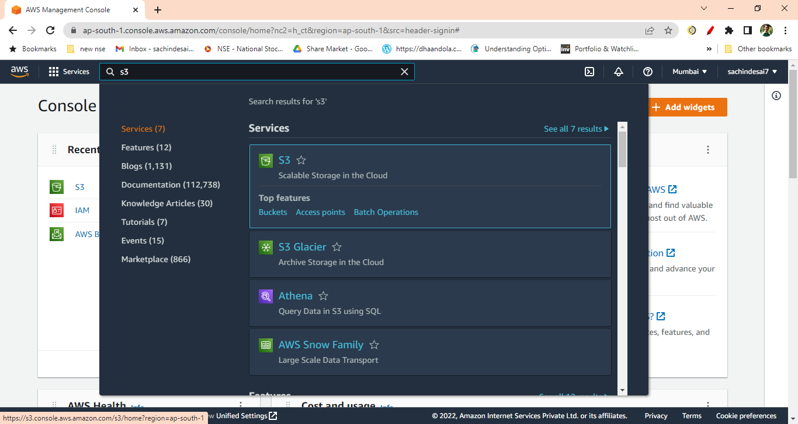

4]. Create S3 bucket

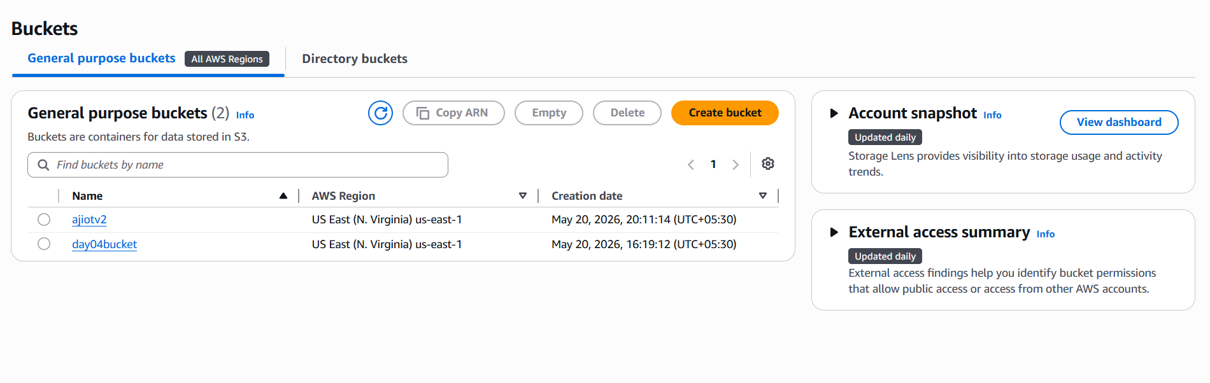

5]. Create a folder inside the bucket

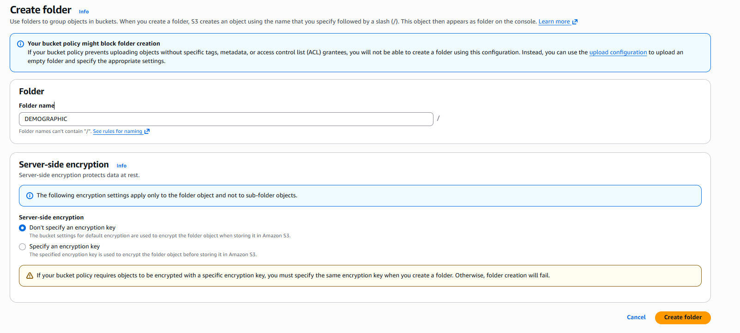

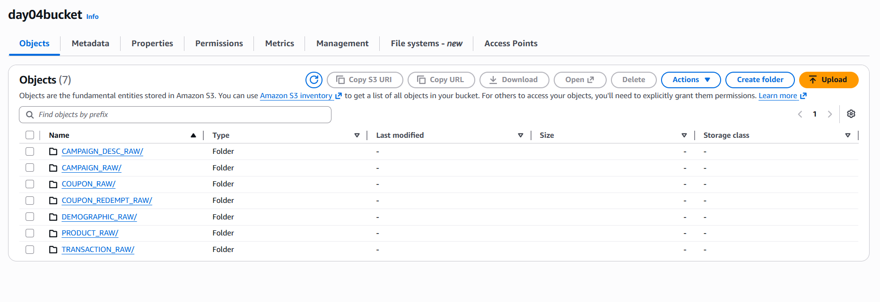

6]. Once the S3 bucket and folder are created, search and select the IAM (Identity and Access Management) service from the AWS console.

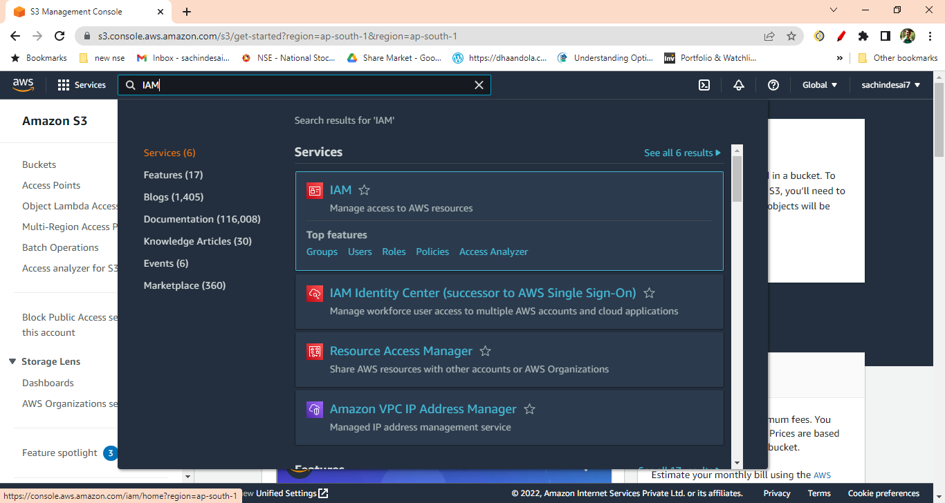

7]. Click on the Policies from IAM Dashboard

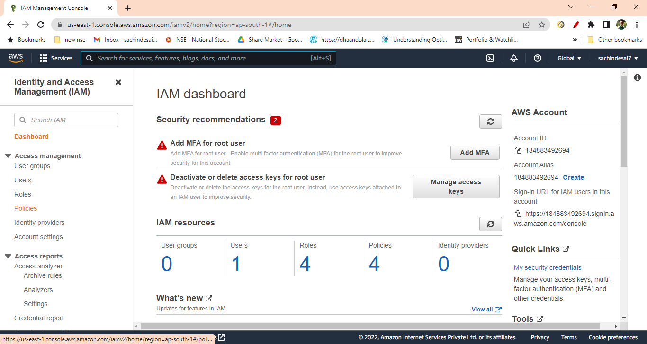

8]. Create IAM policy for the bucket by clicking on the “Create Policy” button

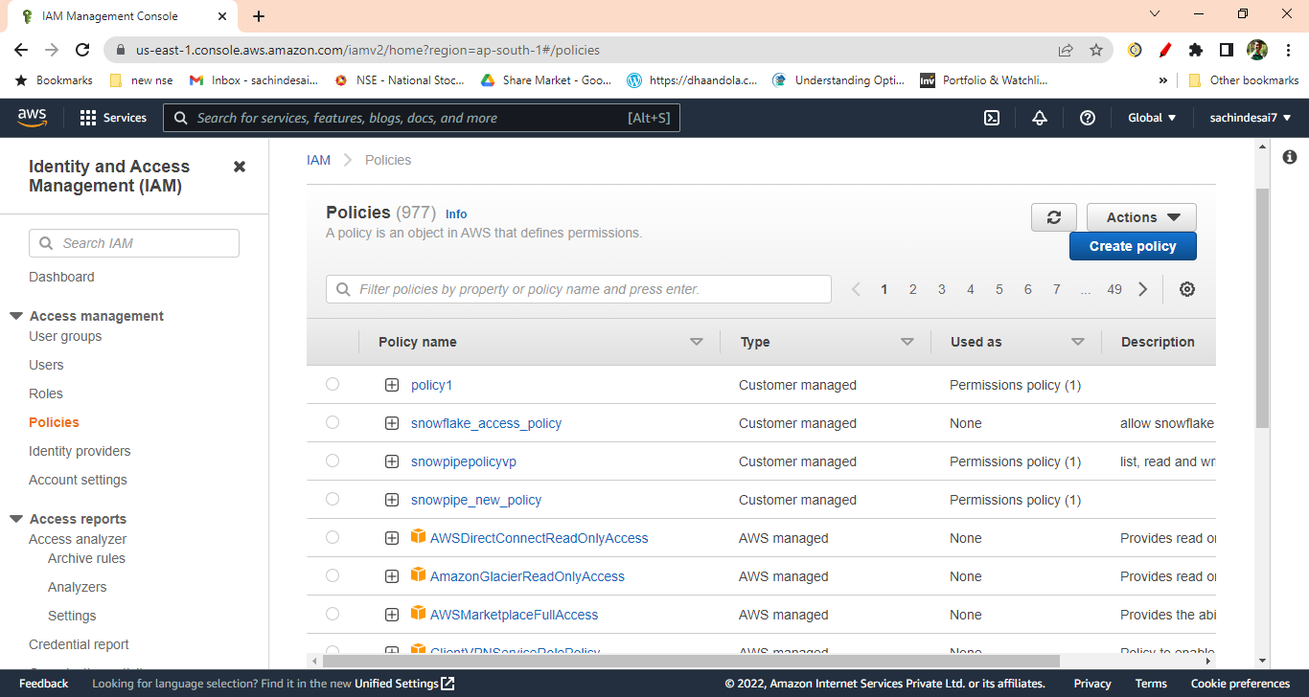

9]. Click on the JSON tab and replace the existing text with the text given in the reference
Document (https://docs.snowflake.com/en/user-guide/data-load-snowpipe-auto-s3.html).

After clicking on the above link you will get following doc then just copy the code.
( It is under the step no. 8 from the document)

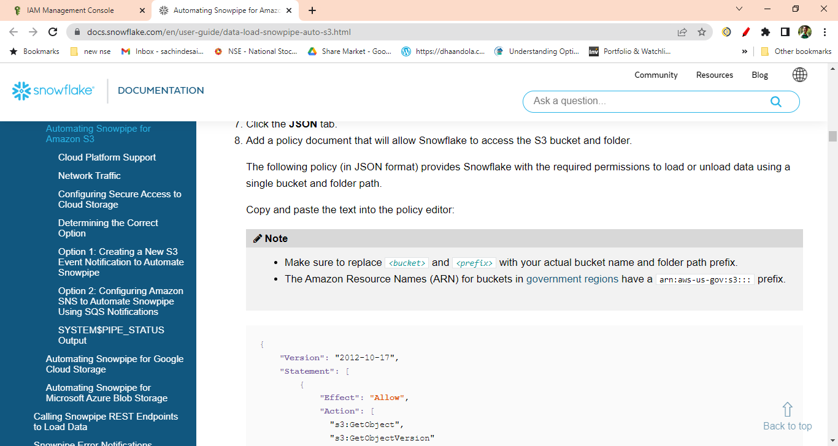

10]. Replace the <bucket> and <prefix> with your actual bucket name and folder path.

Also set the S3:prefix to “ *”
"s3:prefix":[
“*"

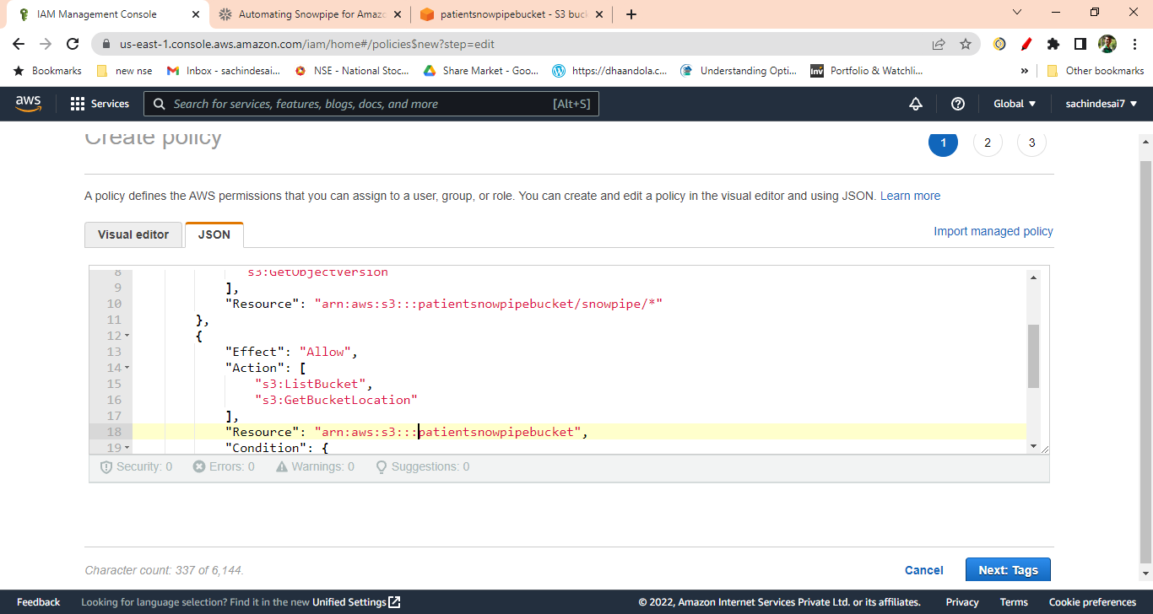

11]. Click Next then skip the Add Tags. Enter the policy name 🡪 Click Create Policy.
Your policy will get created.

12]. Create IAM Role. Click on Create Role
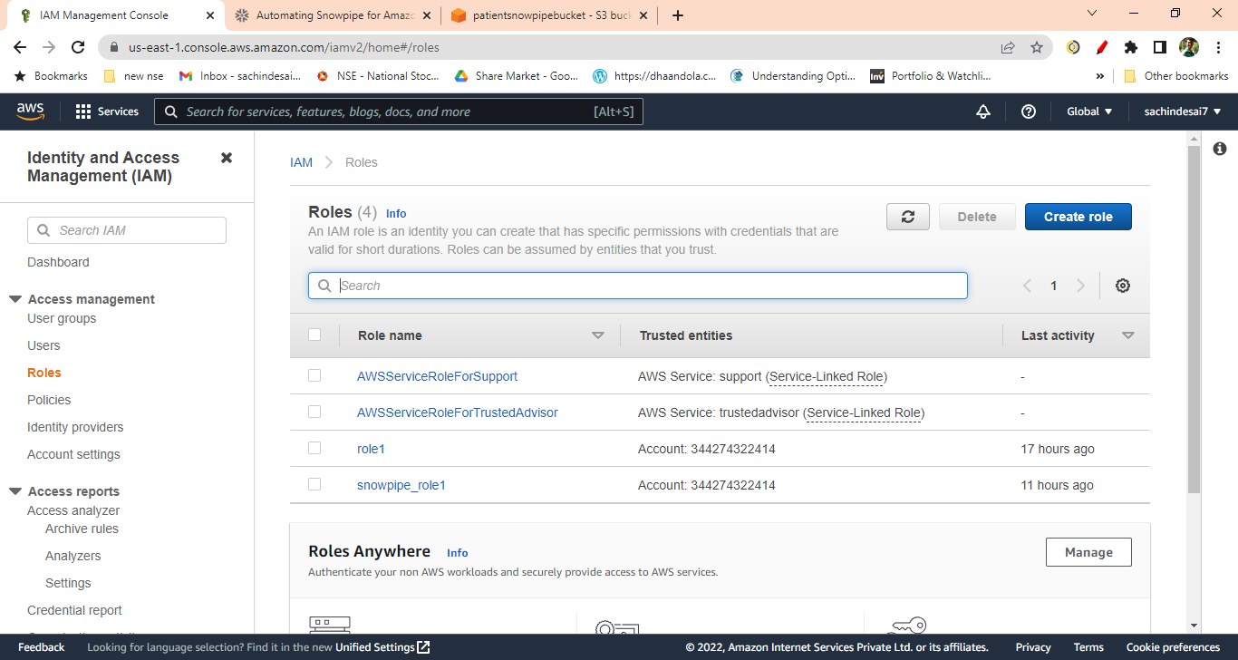

13]. Select AWS Account from Trusted Entity Type.
You will get your account number selected by default when you select AWS account.

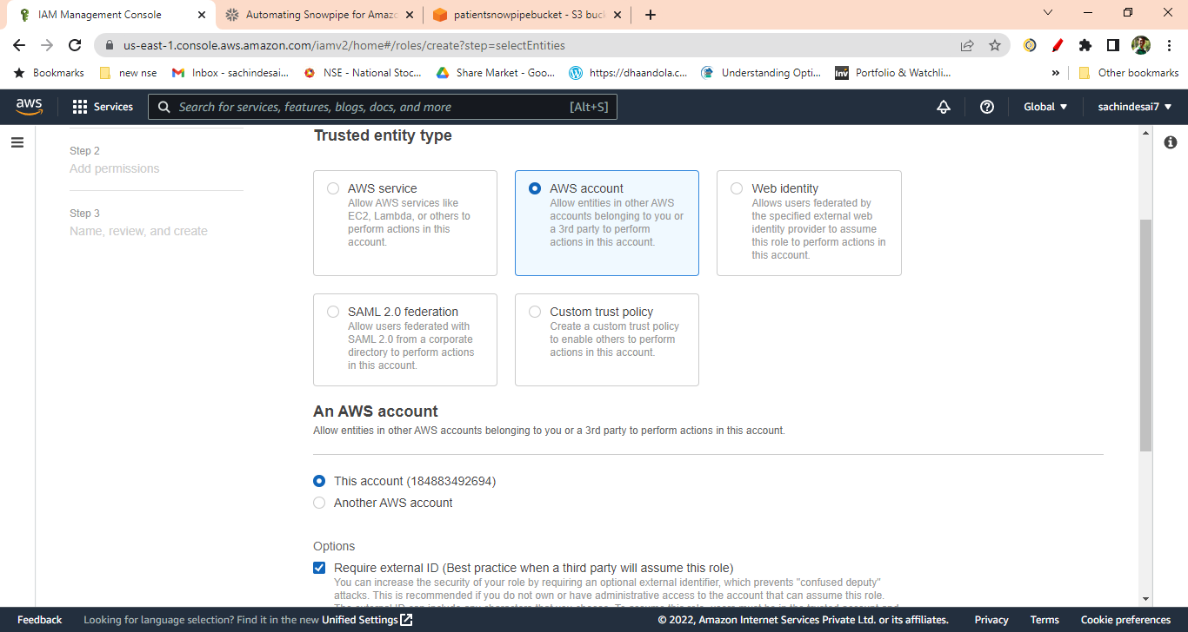

14] Check Require external ID and enter 000 (as currently we are not having it) and click next

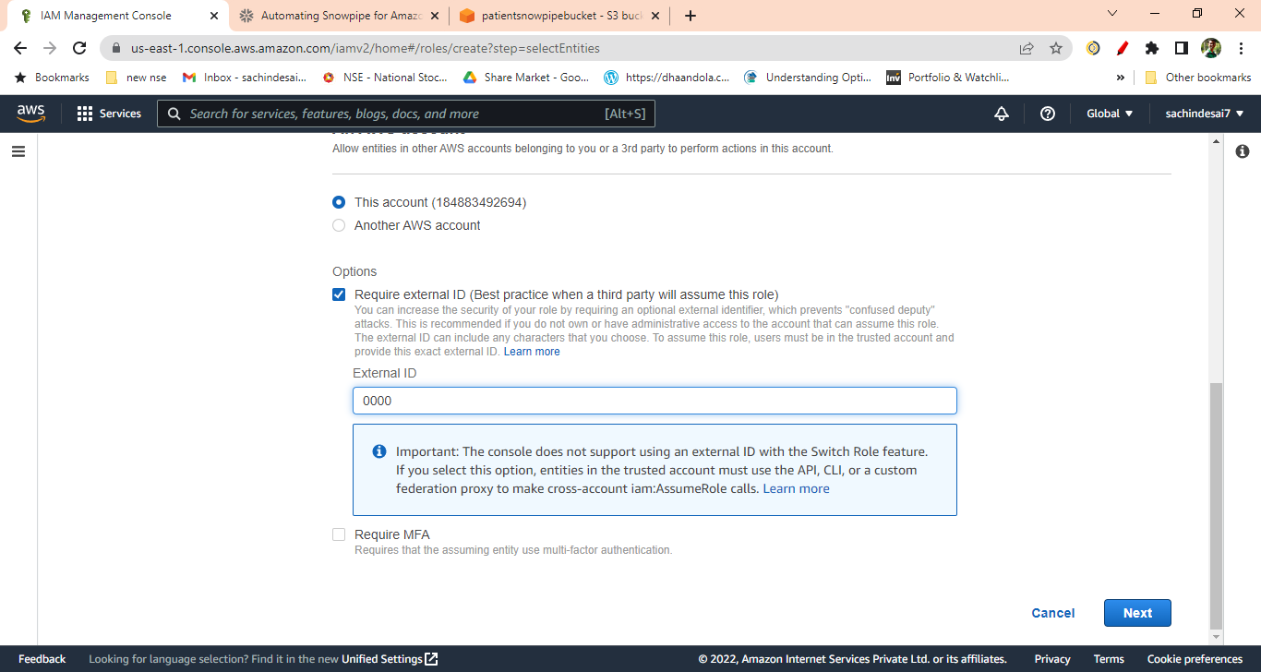

15]. On the next page, Select the IAM policy that you have created

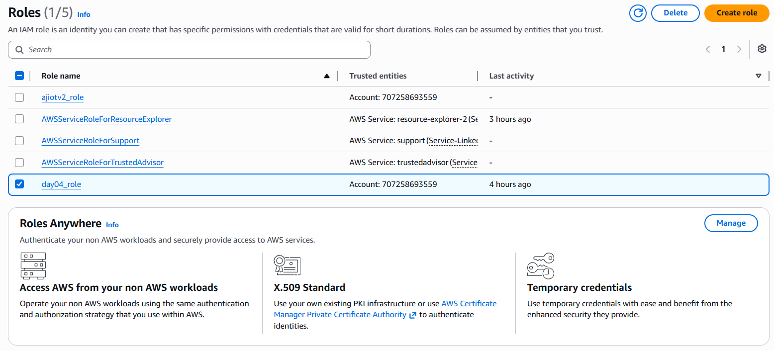

16]. On the next page Enter any unique name to the role you are creating. The description is optional.
Click on the Create Role (Skip the Add Tags).

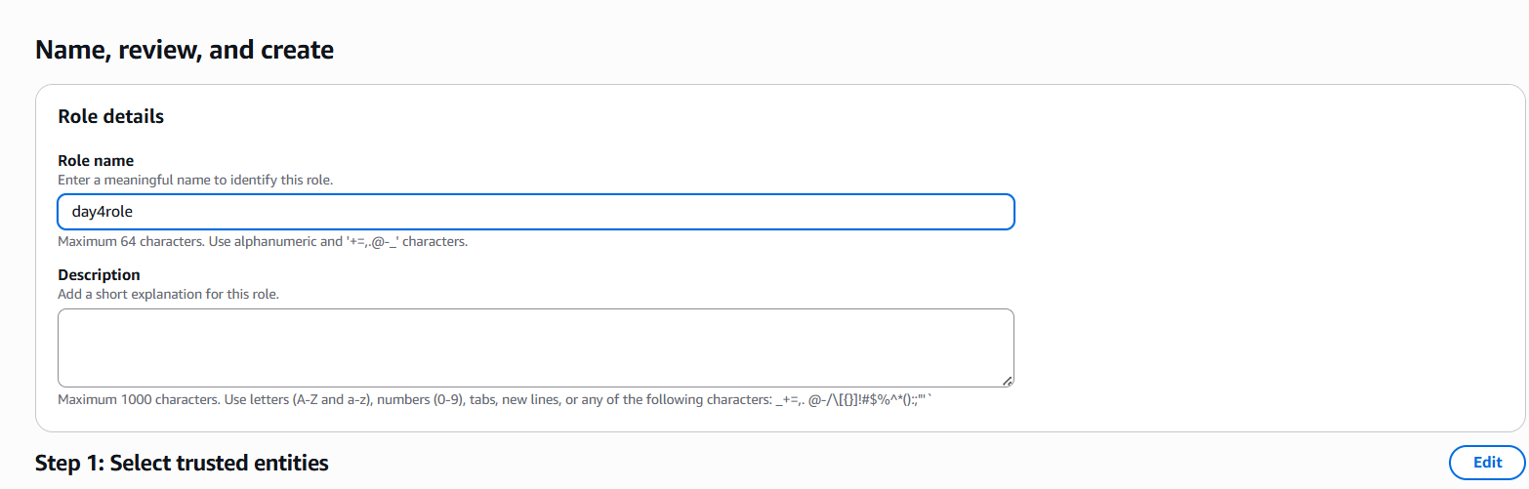

17]. Click on the role that you have created. It will show you the summary page.

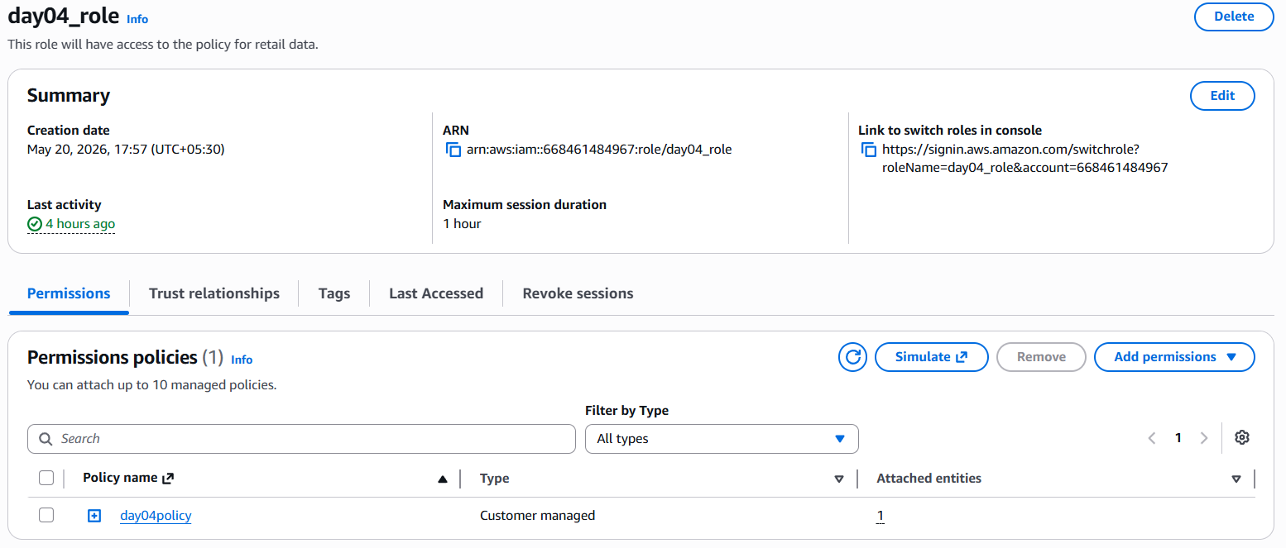

You will get the following window

Note down the Role ARN, which we will need when we create the ‘Storage Integration’.



18]. Login to the Snowflake Account.
Create Cloud Storage Integration in Snowflake and map S3 user/role with it(STORAGE_AWS_ROLE_ARN).

CREATE OR REPLACE STORAGE INTEGRATION snowpipe_integration
TYPE = external_stage
STORAGE_PROVIDER = s3
STORAGE_AWS_ROLE_ARN = 'arn:aws:iam::184883492694:role/snowpipe_newuser_vp'
ENABLED = true
STORAGE_ALLOWED_LOCATIONS = ('*');

19]. In Snowflake worksheet run command

Desc integration integration_name;
e.g. desc integration snowpipe_integration;
And Note down the STORAGE_AWS_IAM_USER_ARN and STORAGE_AWS_EXTERNAL_ID from the result set

20]. Now go to the AWS Console
IAM Role
Select the role you created
Click Trust Relationships -> Edit trust relationship
Replace the value of "AWS": with the AWS_IAM_USER_ARN String you got using DESC INTEGRATION
command
Click Update Policy

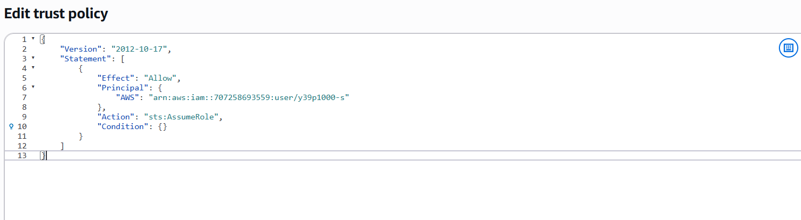

21]. Create Snowflake file format. This file format will be used at the time of Stage creation.

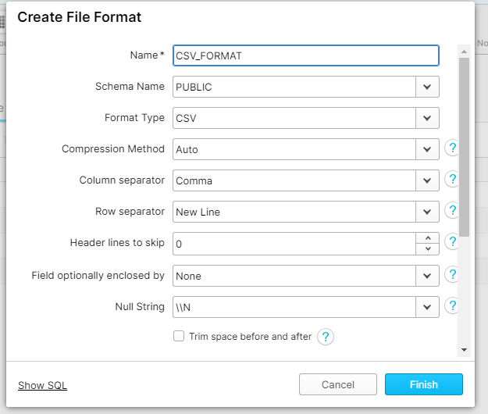

22]. Create a stage in snowflake pointing to your S3 bucket:

23]. Now Create auto-ingest pipe.

CREATE OR REPLACE PIPE RETAIL_SNOWPIPE_DEMOGRAPHIC_RAW AUTO_INGEST = TRUE AS
COPY INTO "RETAILS"."PUBLIC"."DEMOGRAPHIC_RAW"
FROM '@RETAIL_STAGE/DEMOGRAPHIC_RAW/' --s3 bucket subfolde4r name
FILE_FORMAT = RETAIL_CSV; --YOUR CSV FILE FORMAT NAME

24]. After creating snowpipe, get ‘Notification Channel’ value
Run command
Show pipes;
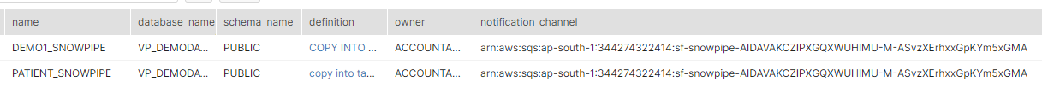

Or Go to Database Pipes
Here also you will get the notification channel value.
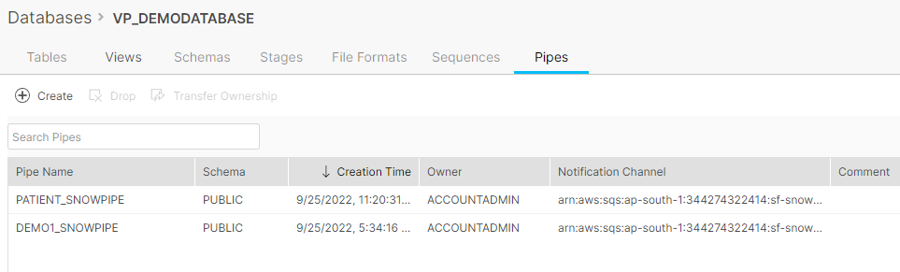

25]. This is the final step. Create an event on S3 bucket. Go to your S3 bucket that you have created. Click on Properties tab and scroll down to

Event Notification -> Click Create Event Notification
Enter any name for the Notification.

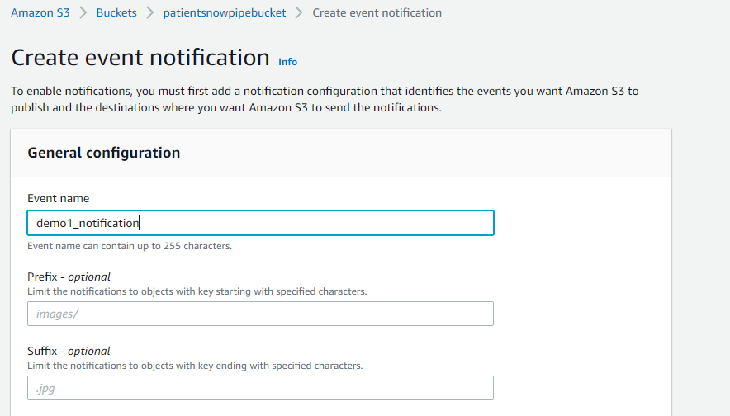

Check All Object create Events

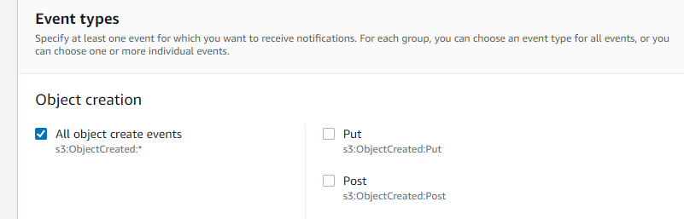

Scroll down to Destination

Select SQS Queue
Select Enter SQS Queue ARN
And paste that ‘Notification Channel’ under SQS Queue

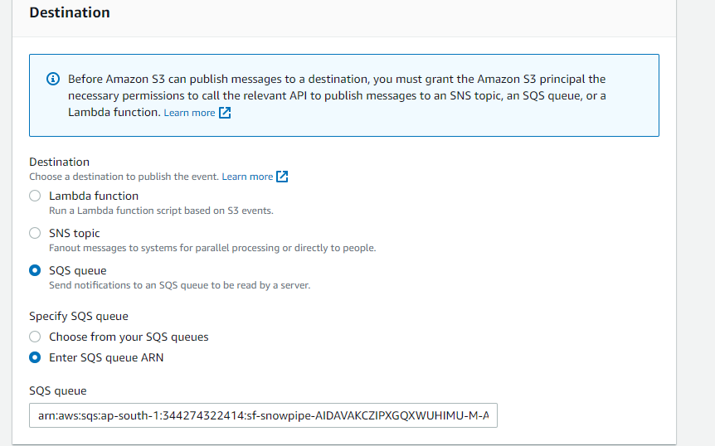

Now you are ready to load the file to s3 bucket.

❌ Common Errors & Fixes
Error: 'Access Denied' on LIST @stage
→ Fix: IAM Role trust relationship not updated, or policy missing ListBucket permission

Error: 'Integration not found'
→ Fix: You forgot to GRANT USAGE ON INTEGRATION to your role

Error: 'The bucket does not exist'
→ Fix: Check your S3 URL — bucket name must match exactly (case-sensitive!)

Error: 'External ID mismatch'
→ Fix: You copied the wrong EXTERNAL_ID. Re-run DESC INTEGRATION and copy again.

LOAD JSON FILE

{
"Version": "2012-10-17",
"Statement": [
{
"Effect": "Allow",
"Action": [
"s3:PutObject",
"s3:GetObject",
"s3:GetObjectVersion",
"s3:DeleteObject",
"s3:DeleteObjectVersion"
],
"Resource": "arn:aws:s3:::awshealthcarebucket/*"
},
{
"Effect": "Allow",
"Action": "s3:ListBucket",
"Resource": "arn:aws:s3:::awshealthcarebucket"
}
]
}

MODULE 3 — FILE FORMATS IN SNOWFLAKE

3.1 Why File Formats Matter
Before loading data, Snowflake needs to know HOW to read the file. Is it comma-separated? Tab-separated? Compressed? Does it have a header row? File Formats answer all these questions.

3.2 Supported File Formats
Format | Best For | Compression | Notes for Beginners
CSV | Flat tabular data, most common | gzip, bzip2, zstd | Use for most beginner exercises
JSON | Nested/hierarchical data, APIs | gzip, bzip2, zstd | Load into VARIANT columns
Parquet | Analytics, columnar storage | Snappy, gzip | Great for big data, faster queries
AVRO | Schema-embedded binary format | deflate, snappy | Common in Kafka pipelines
ORC | Hadoop ecosystems | zlib, snappy | Columnar, used in Hive
XML | Legacy systems, basic support | None native | Limited Snowflake support

3.3 Creating File Formats
-- ============================================
-- CSV FILE FORMAT (Most Common)
-- ============================================
CREATE OR REPLACE FILE FORMAT csv_format
TYPE = 'CSV'
FIELD_DELIMITER = ',' -- Column separator
RECORD_DELIMITER = '\n' -- Row separator
SKIP_HEADER = 1 -- Skip the header row
NULL_IF = ('NULL', 'null', '') -- Treat these as NULL
EMPTY_FIELD_AS_NULL = TRUE
FIELD_OPTIONALLY_ENCLOSED_BY = '"' -- Handle quoted fields
COMPRESSION = 'AUTO' -- Auto-detect gzip, bzip2 etc.
DATE_FORMAT = 'YYYY-MM-DD'
TIMESTAMP_FORMAT = 'YYYY-MM-DD HH24:MI:SS'
COMMENT = 'Standard CSV format for raw data loading';
-- ============================================
-- JSON FILE FORMAT
-- ============================================
CREATE OR REPLACE FILE FORMAT json_format
TYPE = 'JSON'
COMPRESSION = 'AUTO'
STRIP_OUTER_ARRAY = TRUE -- If file has [ {...}, {...} ] array wrapper
STRIP_NULL_VALUES = FALSE -- Keep NULLs
IGNORE_UTF8_ERRORS = FALSE
COMMENT = 'JSON format for API and event data';
-- ============================================
-- PARQUET FILE FORMAT
-- ============================================
CREATE OR REPLACE FILE FORMAT parquet_format
TYPE = 'PARQUET'
COMPRESSION = 'AUTO'
SNAPPY_COMPRESSION = TRUE -- Parquet uses Snappy by default
COMMENT = 'Parquet format for columnar data loading';
-- Verify file formats created:
SHOW FILE FORMATS;

MODULE 4 — COPY INTO COMMAND

4.1 COPY INTO Command Syntax — Complete Reference
The COPY INTO command is the engine of Snowflake data loading. Let's learn its full syntax:

-- COMPLETE COPY INTO SYNTAX (Loading INTO a table):
COPY INTO <table_name>
FROM { @<stage_name>[/<path>] | 's3://<bucket>/<path>' }
[ FILES = ( '<file_name>' [, '<file_name>' ...] ) ]
[ PATTERN = '<regex_pattern>' ]
[ FILE_FORMAT = ( { FORMAT_NAME = '<format_name>' | TYPE = <format_type> [options] } ) ]
[ ON_ERROR = { CONTINUE | SKIP_FILE | SKIP_FILE_<num> | ABORT_STATEMENT } ]
[ SIZE_LIMIT = <num> ]
[ PURGE = TRUE | FALSE ]
[ FORCE = TRUE | FALSE ]
[ VALIDATION_MODE = RETURN_<num>_ROWS | RETURN_ERRORS | RETURN_ALL_ERRORS ]

-- COMPLETE COPY INTO SYNTAX (Unloading FROM a table to stage):
COPY INTO { @<stage_name>[/<path>] | 's3://<bucket>/<path>' }
FROM { <table_name> | ( <query> ) }
[ PARTITION BY <expr> ]
[ FILE_FORMAT = ( ... ) ]
[ MAX_FILE_SIZE = <num> ]
[ SINGLE = TRUE | FALSE ]
[ HEADER = TRUE | FALSE ]
[ OVERWRITE = TRUE | FALSE ]

4.2 Key COPY INTO Parameters Explained
Parameter | What It Does | Example
ON_ERROR = CONTINUE | Skip bad rows, continue loading good rows | Use for messy data where some errors are acceptable
ON_ERROR = ABORT_STATEMENT | Stop entire load if any error found (default) | Use for critical financial data — no partial loads
ON_ERROR = SKIP_FILE | Skip entire file if it has errors | Use when file-level integrity matters
VALIDATION_MODE | Preview errors without actually loading | VALIDATION_MODE = RETURN_ERRORS
FORCE = TRUE | Reload files even if already loaded | Testing & reprocessing scenarios
PURGE = TRUE | Delete files from stage after successful load | Clean up after loading — use with caution!
PATTERN = '.*\.csv' | Filter files by regex pattern | Load only CSV files from stage
FILES = ('f1.csv') | Load specific named files only | Target specific files in a large stage
SIZE_LIMIT = 100 | Max MB to load per COPY command | Control resource usage on large datasets

What is Snowpipe?
Snowpipe is Snowflake's automated, serverless data ingestion service. While COPY INTO requires you to manually run a command, Snowpipe automatically triggers a load whenever a new file arrives in your S3 bucket.

SNOWPIPE AUTO-INGESTION ARCHITECTURE (AWS S3)
============================================
Application/ETL AWS Services Snowflake
+-------------+ +----------+ +-----------+
| Write new | | S3 Bucket| | Snowpipe |
| file to S3 +----->| Event +------->| (pipe) |
+-------------+ PUT | Notif. | SQS | |
| (PUT) | msg | Triggers |
+----+-----+ | COPY INTO |
| +-----+-----+
v |
+----------+ |
| SQS Queue| v
| (buffer) | +-----------+
+----+-----+ | Snowflake |
| | Table |
+-------------->| (data |
Snowpipe polls SQS | loaded!) |
+-----------+
KEY: Files trigger loads automatically — no manual COPY INTO needed!
Latency: typically within 1-2 minutes of file arrival.

Snowpipe is a Snowflake feature that automatically loads new files into tables as soon as the files arrive in a stage.
Instead of running COPY INTO manually every few hours, Snowpipe continuously watches for new files and loads them automatically within minutes.
How it works
- You create a pipe that contains a COPY INTO command.
- The pipe tells Snowflake:
  - where the files are stored (stage)
  - which table to load data into
- When new files arrive, Snowpipe automatically loads them.

Ways Snowpipe detects new files

1. Cloud Notifications (Recommended)
- AWS S3, Azure, or GCS sends a notification when a new file is uploaded.
- Snowpipe receives the alert and loads the file automatically.
- Fully automated and serverless.

2. REST API
- Your application calls a Snowpipe API and provides file names.
- Snowpipe then loads those files into the table.

Benefits
- Near real-time data loading
- No manual scheduling needed
- Works with structured and semi-structured data (JSON, Avro, etc.)
- Serverless and scalable

In short, Snowpipe automates continuous data loading into Snowflake.

Feature | COPY INTO (Manual/Scheduled) | Snowpipe (Automated)
Trigger | Manual or scheduled (Airflow, cron) | Automatic on file arrival
Compute | Uses your Virtual Warehouse | Serverless (Snowflake manages)
Latency | Minutes to hours | ~1-2 minutes typically
Cost model | Warehouse compute seconds | Per-file ingestion credit
Best for | Daily batch loads, large files | Event-driven, streaming-like
Setup complexity | Simple (just COPY INTO) | Requires SQS/SNS configuration

About semi-structured data
Semi-structured data is data that does not conform to the standards of traditional structured data, but contains tags (labels) or other types of mark-up that identify individual, distinct entities within the data.

Two of the key attributes that distinguish semi-structured data from structured data are nested data structures and the lack of a fixed schema:
- Structured data requires a fixed schema that is defined before the data can be loaded and queried in a relational database system. Semi-structured data does not require a prior definition of a schema and can constantly evolve (i.e. new attributes can be added at any time).

In addition, entities within the same class may have different attributes even though they are grouped together, and the order of the attributes is not important.
- Unlike structured data, which represents data as a flat table, semi-structured data can contain N-level hierarchies of nested information.

IoT begins with sensors and devices that collect data from their environment. This data may include temperature readings, geographic location information, audio or video feeds and more.

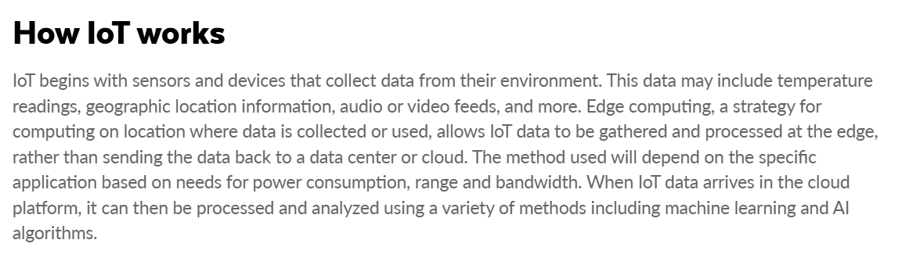

Semi Structured Data [HANDS ON LAB]
IOT_V2_TABLE CREATION -> IOT DATA

Parson Json Problem Statement
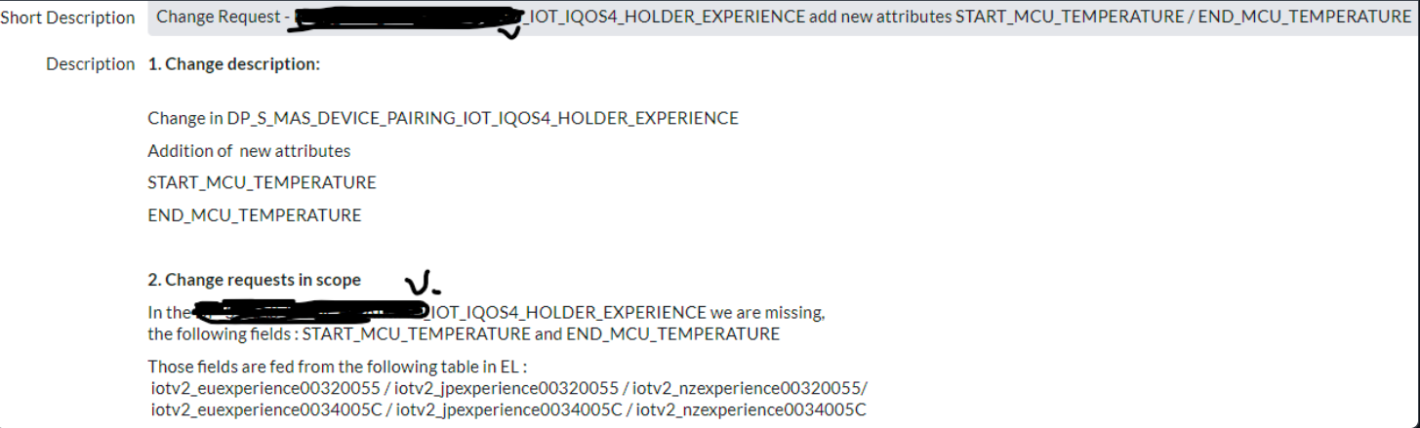

--IOT_V2_TABLE CREATION

CREATE OR REPLACE DATABASE IOT_DB;
CREATE OR REPLACE SCHEMA IOT_SCHEMA;

create or replace file format iot_csv
type='csv'
compression='none'
field_delimiter=','
field_optionally_enclosed_by='\042' -- double quotes ASCII value
skip_header=1;

create or replace TABLE IOT_DB.IOT_SCHEMA.LOAD_IOTV2_EUEXPERIENCE00320055
(
ATOMICCONSENTS VARCHAR(16777216),
DATA VARIANT,
ORIGINREGION VARCHAR(16777216),
REQUESTID VARCHAR(16777216),
SERIALNUMBER VARCHAR(16777216),
SOURCE_FILE_NAME VARCHAR(16777216),
EVENT_LOCAL_TIMESTAMP VARCHAR(16777216)
);

create or replace TABLE LOAD_IOTV2_EUEXPERIENCE00320055_COPY as select * from LOAD_IOTV2_EUEXPERIENCE00320055;

create or replace TABLE IOT_DB.IOT_SCHEMA.LOAD_IOTV2_JPEXPERIENCE00320055 (
ATOMICCONSENTS VARCHAR(16777216),
DATA VARIANT,
ORIGINREGION VARCHAR(16777216),
REQUESTID VARCHAR(16777216),
SERIALNUMBER VARCHAR(16777216),
SOURCE_FILE_NAME VARCHAR(16777216),
EVENT_LOCAL_TIMESTAMP VARCHAR(16777216)
);

create or replace TABLE LOAD_IOTV2_JPEXPERIENCE00320055_COPY as select * from LOAD_IOTV2_JPEXPERIENCE00320055;
select * from IOT_DB.IOT_SCHEMA.LOAD_IOTV2_EUEXPERIENCE00320055_COPY;

--endMCUtemperature
--startMCUtemperature

create or replace TABLE IOT_DB.IOT_SCHEMA.LOAD_IOTV2_NZEXPERIENCE002F0052 (
ATOMICCONSENTS VARCHAR(16777216),
DATA VARIANT,
ORIGINREGION VARCHAR(16777216),
REQUESTID VARCHAR(16777216),
SERIALNUMBER VARCHAR(16777216),
SOURCE_FILE_NAME VARCHAR(16777216),
EVENT_LOCAL_TIMESTAMP VARCHAR(16777216)
);

create or replace TABLE LOAD_IOTV2_NZEXPERIENCE002F0052_COPY as select * from LOAD_IOTV2_NZEXPERIENCE002F0052;

----------------------------------------------------AWS (S3) INTEGRATION------------------------------------------------------------------------
create or replace file format iot_csv
type='csv'
compression='none'
field_delimiter=','
field_optionally_enclosed_by='\042' -- double quotes ASCII value
skip_header=1;

CREATE OR REPLACE STORAGE integration iot_si
TYPE = EXTERNAL_STAGE
STORAGE_PROVIDER = S3
ENABLED = TRUE
STORAGE_AWS_ROLE_ARN ='arn:aws:iam::668461484967:role/ajiotv2_role'
STORAGE_ALLOWED_LOCATIONS =('s3://ajiotv2/');

DESC integration iot_si;

CREATE OR REPLACE STAGE iot_stage
URL ='s3://ajiotv2'
file_format = iot_csv
storage_integration = iot_si;

SHOW STAGES;

LIST @iot_stage;

-------------------------------------------------iotv2_snowpipe--------------------------------------------------------------------

CREATE OR REPLACE PIPE iotv2_snowpipe_EUEXPERIENCE00320055 AUTO_INGEST = TRUE AS
COPY INTO IOT_DB.IOT_SCHEMA.LOAD_IOTV2_EUEXPERIENCE00320055 --yourdatabase -- your schema ---your table
FROM '@iot_stage/iotv2_prd_euexperience00320055/' --s3 bucket subfolde4r name
FILE_FORMAT = iot_csv; --YOUR CSV FILE FORMAT NAME

CREATE OR REPLACE PIPE iotv2_snowpipe_JPEXPERIENCE00320055 AUTO_INGEST = TRUE AS
COPY INTO IOT_DB.IOT_SCHEMA.LOAD_IOTV2_JPEXPERIENCE00320055
FROM '@iot_stage/iotv2_prd_jpexperience00320055/'
FILE_FORMAT = iot_csv;

CREATE OR REPLACE PIPE iotv2_snowpipe_NZEXPERIENCE002F0052 AUTO_INGEST = TRUE AS
COPY INTO IOT_DB.IOT_SCHEMA.LOAD_IOTV2_NZEXPERIENCE002F0052
FROM '@iot_stage/iotv2_prd_nzexperience002f0052/'
FILE_FORMAT = iot_csv;

----------------------------------------------------------PIPEREFRESH-----------------------------------------------------------------

ALTER PIPE iotv2_snowpipe_EUEXPERIENCE00320055 refresh;
ALTER PIPE iotv2_snowpipe_JPEXPERIENCE00320055 refresh;
ALTER PIPE iotv2_snowpipe_NZEXPERIENCE002F0052 refresh;

SELECT COUNT(*) FROM LOAD_IOTV2_EUEXPERIENCE00320055;
SELECT COUNT(*) FROM LOAD_IOTV2_JPEXPERIENCE00320055;
SELECT COUNT(*) FROM LOAD_IOTV2_NZEXPERIENCE002F0052;

SELECT * FROM LOAD_IOTV2_EUEXPERIENCE00320055;
SELECT * FROM LOAD_IOTV2_JPEXPERIENCE00320055;
SELECT * FROM LOAD_IOTV2_NZEXPERIENCE002F0052;

---------------------------------------------------------------------------------------------

create or replace view IOT_DB.IOT_SCHEMA.V_LOAD_IOTV2_JSON_IQOS4_HOLDER_EXP
(
ATOMICCONSENTS,
RECORDINDEX,
RECORDFORMATVERSION,
RECORDSIZE,
STARTTIME,
EXPCREDIT,
STARTBATTERYGAUGELEVEL,
ENDBATTERYGAUGELEVEL,
CONTROLSTARTBATTERYVOLTAGE,
CONTROLSTARTTEMPERATURE2,
CONTROLINTERNALRESISTORINDICATOR,
CONTROLENDBATTERYVOLTAGE,
CONTROLENDTEMPERATURE2,
CONTROLSTOPREASON,
STARTREASON,
SKU,
STARTTEMP1,
STARTTEMP2,
START_MCU_TEMPERATURE,
END_MCU_TEMPERATURE,
STARTDCDCVOLTAGE,
ENDTEMP1,
ENDTEMP2,
ENDDCDCVOLTAGE,
DCDCVOLTAGEVARIATION,
INTERNALRESISTORINDICATOR,
STARTCONDUCTANCE,
FIRSTVALLEYCONDUCTANCE,
FIRSTDELTASCURVECONDUCTANCE,
LASTDELTASCURVECONDUCTANCE,
PREHEATSLOPETIME,
OUTOFRANGEREGULATION,
DRIFTCOMPENSATIONERROR,
HEATINGDURATION,
PAUSEDURATION,
PAUSETIMESTAMP,
PAUSEENERGY,
HEATINGENERGY,
ENGINESTOPREASON,
HEATINGPROFILE,
STARTBATTERYVOLTAGE,
ENDBATTERYVOLTAGE,
BATTERYVOLTAGEVARIATION,
LASTVALLEYCONDUCTANCE,
FIRSTHILLCONDUCTANCE,
CALIBRATIONDURATION,
HOTALARMTREATED,
MAXIMUMDELTASVARIATION,
VALIDSCURVEDETECTED,
COOLINGSEQUENCEFAILURE,
CALIBRATIONPULSEFAILURE,
APPLICATIONVERSION,
PUFFCOUNT,
PUFFS,
INDEX,
PUFFCOUNTBEFOREPAUSE,
PUFFCOUNTAFTERPAUSE,
PUFFVOLUMEAFTER14PUFFS,
TOTALPUFFVOLUME,
PUFFDURATION,
PAUSEPROFILE,
ENERGYTOFIRSTVALLEY,
STICKEXTRACTIONDURATION,
ENGINEFLAGS,
CONTROLFLAGS,
ORIGINREGION,
REQUESTID,
SERIALNUMBER,
SOURCE_FILE_NAME,
EVENT_LOCAL_TIMESTAMP
) as
SELECT
EXP3.ATOMICCONSENTS,
parse_json(DATA):recordIndex,
parse_json(DATA):recordFormatVersion,
parse_json(DATA):recordSize,
parse_json(DATA):startTime,
parse_json(DATA):expCredit,
parse_json(DATA):startBatteryGaugeLevel,
parse_json(DATA):endBatteryGaugeLevel,
parse_json(DATA):controlStartBatteryVoltage,
parse_json(DATA):controlStartTemperature2,
parse_json(DATA):controlInternalResistorIndicator,
parse_json(DATA):controlEndBatteryVoltage,
parse_json(DATA):controlEndTemperature2,
parse_json(DATA):controlStopReason,
parse_json(DATA):startReason,
parse_json(DATA):SKU,
parse_json(DATA):startTemp1,
parse_json(DATA):startTemp2,
parse_json(DATA):startMCUtemperature,
parse_json(DATA):endMCUtemperature,
parse_json(DATA):startDCDCVoltage,
parse_json(DATA):endTemp1,
parse_json(DATA):endTemp2,
parse_json(DATA):endDCDCVoltage,
parse_json(DATA):DCDCVoltageVariation,
parse_json(DATA):internalResistorIndicator,
parse_json(DATA):startConductance,
parse_json(DATA):firstValleyConductance,
parse_json(DATA):firstDeltaScurveConductance,
parse_json(DATA):lastDeltaScurveConductance,
parse_json(DATA):preheatSlopeTime,
parse_json(DATA):outOfRangeRegulation,
parse_json(DATA):driftCompensationError,
parse_json(DATA):heatingDuration,
parse_json(DATA):pauseDuration,
parse_json(DATA):pauseTimeStamp,
parse_json(DATA):pauseEnergy,
parse_json(DATA):heatingEnergy,
parse_json(DATA):engineStopReason,
parse_json(DATA):heatingProfile,
parse_json(DATA):startBatteryVoltage,
parse_json(DATA):endBatteryVoltage,
parse_json(DATA):batteryVoltageVariation,
parse_json(DATA):lastValleyConductance,
parse_json(DATA):firstHillConductance,
parse_json(DATA):calibrationDuration,
parse_json(DATA):hotAlarmTreated,
parse_json(DATA):maximumDeltaSvariation,
parse_json(DATA):validScurveDetected,
parse_json(DATA):coolingSequenceFailure,
parse_json(DATA):calibrationPulseFailure,
parse_json(DATA):application version,
parse_json(DATA):puffCount,
parse_json(DATA):puffs,
parse_json(DATA):index,
NULL,
NULL,
NULL,
NULL,
parse_json(DATA):puffDuration,
NULL,
NULL,
NULL,
NULL,
NULL,
EXP3.ORIGINREGION,
REPLACE(EXP3.REQUESTID,'__USAGE_DATA',''),
EXP3.SERIALNUMBER,
EXP3.SOURCE_FILE_NAME,
EXP3.EVENT_LOCAL_TIMESTAMP
FROM (SELECT ATOMICCONSENTS,DATA,ORIGINREGION,REQUESTID,SERIALNUMBER,SOURCE_FILE_NAME,EVENT_LOCAL_TIMESTAMP
FROM IOT_DB.IOT_SCHEMA.LOAD_IOTV2_EUEXPERIENCE00320055
UNION
SELECT ATOMICCONSENTS,DATA,ORIGINREGION,REQUESTID,SERIALNUMBER,SOURCE_FILE_NAME,EVENT_LOCAL_TIMESTAMP
FROM IOT_DB.IOT_SCHEMA.LOAD_IOTV2_JPEXPERIENCE00320055
UNION
SELECT ATOMICCONSENTS,DATA,ORIGINREGION,REQUESTID,SERIALNUMBER,SOURCE_FILE_NAME,EVENT_LOCAL_TIMESTAMP
FROM IOT_DB.IOT_SCHEMA.LOAD_IOTV2_NZEXPERIENCE002F0052
) EXP3;

SELECT * FROM IOT_DB.IOT_SCHEMA.V_LOAD_IOTV2_JSON_IQOS4_HOLDER_EXP;

SELECT * FROM IOT_DB.IOT_SCHEMA.V_LOAD_IOTV2_JSON_IQOS4_HOLDER_EXP
WHERE START_MCU_TEMPERATURE IS NOT NULL AND END_MCU_TEMPERATURE IS NOT NULL;

SELECT * FROM IOT_DB.IOT_SCHEMA.V_LOAD_IOTV2_JSON_IQOS4_HOLDER_EXP
WHERE START_MCU_TEMPERATURE <> 'null'
AND END_MCU_TEMPERATURE <> 'null';
--PUFFDURATION <> 'null'

SELECT data:startMCUtemperature::VARCHAR as "Starting MCU Temperature Value",
data:endMCUtemperature::VARCHAR as "Ending MCU Temperature Value"
FROM LOAD_IOTV2_EUEXPERIENCE00320055
WHERE data:startMCUtemperature <> 'null'
AND data:startMCUtemperature <> 'null';

-- SELECT
-- data:puffs::VARCHAR as "Puffs"
--data:endMCUtemperature::VARCHAR as "Ending MCU Temperature Value"
-- FROM LOAD_IOTV2_EUEXPERIENCE00320055

-- NULL Values
-- Snowflake supports two types of NULL values in semi-structured data:

-- SQL NULL: SQL NULL means the same thing for semi-structured data types as it means for structured data types: the value is missing or unknown.

-- JSON null (sometimes called “VARIANT NULL”):
-- In a VARIANT column, JSON null values are stored as a string containing the word “null” to distinguish them from SQL NULL values.

-- The following example contrasts SQL NULL and JSON null:;

-- select
-- parse_json(NULL) AS "SQL NULL",
-- parse_json('null') AS "JSON NULL",
-- parse_json('[ null ]') AS "JSON NULL",
-- parse_json('{ "a": null }'):a AS "JSON NULL",
-- parse_json('{ "a": null }'):b AS "ABSENT VALUE";

-- To convert a VARIANT "null" value to SQL NULL, cast it as a string. For example:;

-- select
-- parse_json('{ "a": null }'):a,
-- to_char(parse_json('{ "a": null }'):a);

------------------------------------------- READING SEMI-STRUCTURED-DATA ------------------------------------------------

CREATE OR REPLACE table parsing_json_data
(
src variant
)
AS
SELECT PARSE_JSON(column1) AS src
FROM VALUES
('{
"date" : "2017-04-28",
"dealership" : "Valley View Auto Sales",
"salesperson" : {
"id": "55",
"name": "Frank Beasley"
},
"customer" : [
{"name": "Joyce Ridgely", "phone": "16504378889", "address": "San Francisco, CA"}
],
"vehicle" : [
{"make": "Honda", "model": "Civic", "year": "2017", "price": "20275", "extras":["ext warranty", "paint protection"]}
]
}'),
('{
"date" : "2017-04-28",
"dealership" : "Tindel Toyota",
"salesperson" : {
"id": "274",
"name": "Greg Northrup"
},
"customer" : [
{"name": "Bradley Greenbloom", "phone": "12127593751", "address": "New York, NY"}
],
"vehicle" : [
{"make": "Toyota", "model": "Camry", "year": "2017", "price": "23500", "extras":["ext warranty", "rust proofing", "fabric protection"]}
]
}') v;

SELECT * FROM parsing_json_data;

---- Traversing Semi-structured Data
--- Insert a colon : between the VARIANT column name and any first-level element: <column>:<level1_element>.

/* Note
In the following examples, the query output is enclosed in double quotes because the query output is VARIANT, not VARCHAR. (The VARIANT values are not strings; the VARIANT values contain strings.) Operators : and subsequent . and [] always return VARIANT values containing strings. */

SELECT src:dealership
FROM parsing_json_data
ORDER BY 1;

-- There are two ways to access elements in a JSON object:
-- Dot Notation (in this topic).
-- Bracket Notation (in this topic).

-- Important

-- Regardless of which notation you use, the column name is case-insensitive but element names are case-sensitive.
-- For example, in the following list, the first two paths are equivalent, but the third is not:

-- src:salesperson.name
-- SRC:salesperson.name
-- SRC:Salesperson.Name

-- Dot Notation
-- Use dot notation to traverse a path in a JSON object: <column>:<level1_element>.<level2_element>.<level3_element>.
-- Optionally enclose element names in double quotes: <column>:"<level1_element>"."<level2_element>"."<level3_element>".;

--Get the names of all salespeople who sold cars:;

SELECT src:salesperson.name
FROM parsing_json_data
ORDER BY 1;

-- Bracket Notation
-- Alternatively, use bracket notation to traverse the path in an object: <column>['<level1_element>']['<level2_element>']. Enclose element names in single quotes. Values are retrieved as strings.

-- Get the names of all salespeople who sold cars:;

SELECT src['salesperson']['name']
FROM parsing_json_data
ORDER BY 1;

-- Retrieving a Single Instance of a Repeating Element
-- Retrieve a specific numbered instance of a child element in a repeating array by adding a numbered predicate (starting from 0) to the array reference.

-- Note that to retrieve all instances of a child element in a repeating array, it is necessary to flatten the array.

-- Get the vehicle details for each sale:;

SELECT src:customer[0].name, src:vehicle[0]
FROM parsing_json_data
ORDER BY 1;

-- Get the price of each car sold:;
SELECT src:customer[0].name, src:vehicle[0].price
FROM parsing_json_data
ORDER BY 1;

-- Explicitly Casting Values
-- When you extract values from a VARIANT, you can explicitly cast the values to the desired data type.
-- For example, you can extract the prices as numeric values and perform calculations on them:;

SELECT src:vehicle[0].price::NUMBER * 0.10 AS tax
FROM parsing_json_data
ORDER BY tax;

-- By default, when VARCHARs, DATEs, TIMEs, and TIMESTAMPs are retrieved from a VARIANT column, the values are surrounded by double quotes.
-- You can eliminate the double quotes by explicitly casting the values. For example:;

SELECT src:dealership, src:dealership::VARCHAR
FROM parsing_json_data
ORDER BY 2;

-- Using the FLATTEN Function to Parse Arrays
-- Parse an array using the FLATTEN function. FLATTEN is a table function that produces a lateral view of a VARIANT, OBJECT, or ARRAY column. The function returns a row for each object, and the LATERAL modifier joins the data with any information outside of the object.

-- Get the names and addresses of all customers. Cast the VARIANT output to string values:;

SELECT
value:name::string as "Customer Name",
value:address::string as "Address"
FROM parsing_json_data, LATERAL FLATTEN(INPUT => SRC:customer);

-- Using the FLATTEN Function to Parse Nested Arrays¶
-- The extras array is nested within the vehicle array in the sample data:

-- "vehicle" : [
-- {"make": "Honda", "model": "Civic", "year": "2017", "price": "20275", "extras":["ext warranty", "paint protection"]}
-- ]
-- Add a second FLATTEN clause to flatten the extras array within the flattened vehicle array and retrieve the “extras” purchased for each car sold:;

SELECT
vm.value:make::string as make,
vm.value:model::string as model,
ve.value::string as "Extras Purchased"
FROM
parsing_json_data
, LATERAL FLATTEN(INPUT => SRC:vehicle) vm
, LATERAL FLATTEN(INPUT => vm.value:extras) ve
ORDER BY make, model, "Extras Purchased";

What is a VARIANT Column?
VARIANT is a Snowflake data type that can hold ANY semi-structured data — JSON, XML, AVRO. Think of it as a flexible container.

Loading Parquet Files
Objective | Load Parquet columnar format files from S3 into Snowflake
Why Parquet? | Column-level compression, schema embedded, 5-10x smaller than CSV

-- Parquet files have embedded schema, so Snowflake can detect columns automatically.
-- You still need to map to your target table.
-- Create target table
CREATE OR REPLACE TABLE nyc_taxi_trips (
vendor_id INTEGER,
tpep_pickup_datetime TIMESTAMP_NTZ,
tpep_dropoff_datetime TIMESTAMP_NTZ,
passenger_count INTEGER,
trip_distance FLOAT,
ratecode_id INTEGER,
store_and_fwd_flag VARCHAR(1),
pu_location_id INTEGER,
do_location_id INTEGER,
payment_type INTEGER,
fare_amount FLOAT,
extra FLOAT,
mta_tax FLOAT,
tip_amount FLOAT,
tolls_amount FLOAT,
improvement_surcharge FLOAT,
total_amount FLOAT
);
-- Create Parquet file format
CREATE OR REPLACE FILE FORMAT parquet_format
TYPE = 'PARQUET'
COMPRESSION = 'AUTO'
SNAPPY_COMPRESSION = TRUE;
-- Load Parquet — use $1 to reference the Parquet columns by position
COPY INTO nyc_taxi_trips
FROM (
SELECT
$1:VendorID::INTEGER,
$1:tpep_pickup_datetime::TIMESTAMP_NTZ,
$1:tpep_dropoff_datetime::TIMESTAMP_NTZ,
$1:passenger_count::INTEGER,
$1:trip_distance::FLOAT,
$1:RatecodeID::INTEGER,
$1:store_and_fwd_flag::VARCHAR(1),
$1:PULocationID::INTEGER,
$1:DOLocationID::INTEGER,
$1:payment_type::INTEGER,
$1:fare_amount::FLOAT,
$1:extra::FLOAT,
$1:mta_tax::FLOAT,
$1:tip_amount::FLOAT,
$1:tolls_amount::FLOAT,
$1:improvement_surcharge::FLOAT,
$1:total_amount::FLOAT
FROM @s3_raw_stage/taxi_parquet/
)
FILE_FORMAT = (FORMAT_NAME = 'parquet_format')
ON_ERROR = 'CONTINUE';
-- Validate
SELECT COUNT(*) FROM nyc_taxi_trips;
SELECT AVG(total_amount), MAX(trip_distance), MIN(fare_amount)
FROM nyc_taxi_trips;

PATTERN MATCHING DURING DATA LOADING

Using PATTERN to Load Specific Files
In production, your S3 stage may contain hundreds of files from different dates and sources. PATTERN lets you load only the files matching a specific naming convention using regex.

-- Scenario: Your S3 stage contains:
-- raw/sales_2024_01.csv.gz
-- raw/sales_2024_02.csv.gz
-- raw/returns_2024_01.csv.gz
-- raw/products.csv
-- raw/inventory_check.txt

-- LIST to see all files
LIST @s3_raw_stage;

-- Load ONLY sales files (not returns, not products)
COPY INTO sales_monthly
FROM @s3_raw_stage
PATTERN = '.*sales_.*\.csv\.gz' -- regex: any file with 'sales_' in name ending .csv.gz
FILE_FORMAT = (FORMAT_NAME = 'csv_orders_format')
ON_ERROR = 'CONTINUE';

-- Load files for a specific month only
COPY INTO sales_monthly
FROM @s3_raw_stage
PATTERN = '.*sales_2024_01.*' -- only January 2024 files
FILE_FORMAT = (FORMAT_NAME = 'csv_orders_format');

-- Load files from a specific subfolder
COPY INTO orders
FROM @s3_raw_stage/2024/january/
PATTERN = '.*\.csv'
FILE_FORMAT = (FORMAT_NAME = 'csv_orders_format');

💡 PATTERN Regex Quick Reference
.* → Match any characters (0 or more)
\.csv → Match literal .csv (escape the dot)
\.csv$ → Match .csv at end of filename
sales_.* → Any filename starting with 'sales_'
2024_0[1-6] → January through June 2024

5.1 What is Data Unloading?
Data unloading is the reverse of loading — you export data FROM Snowflake TO an external location (S3, Azure, GCP). Common use cases:
- Generate reports and export them to S3 for business users to download
- Share processed/cleansed data with downstream systems
- Archive historical data out of Snowflake to reduce storage costs
- Feed ML training pipelines that read from S3
- Export data for regulatory reporting

DATA UNLOADING ARCHITECTURE
==========================
Snowflake Table S3 Destination
+---------------+ +------------------+
| orders | | s3://myco-bucket/|
| 99,441 rows | | unload/ |
| 8 columns |-------->| orders_part_0.gz |
+---------------+ | orders_part_1.gz |
| COPY | orders_part_2.gz |
| INTO @stage +------------------+
| (unload syntax)
|
SELECT query filters
what data to export

Monitoring Load History
-- ============================================
-- COPY_HISTORY: See all recent loads
-- ============================================
SELECT *
FROM TABLE(INFORMATION_SCHEMA.COPY_HISTORY(
TABLE_NAME => 'ORDERS',
START_TIME => DATEADD('day', -7, CURRENT_TIMESTAMP())
))
ORDER BY LAST_LOAD_TIME DESC;
-- Key columns in output:
-- FILE_NAME : which S3 file
-- LAST_LOAD_TIME : when it was loaded
-- STATUS : LOADED, LOAD_FAILED, PARTIALLY_LOADED
-- ROW_COUNT : rows successfully loaded
-- ERROR_COUNT : number of errors
-- FIRST_ERROR : description of first error
-- ============================================
-- LOAD_HISTORY: Alternative view via table
-- ============================================
SELECT *
FROM INFORMATION_SCHEMA.LOAD_HISTORY
WHERE TABLE_NAME = 'ORDERS'
AND LAST_LOAD_TIME > DATEADD('day', -7, CURRENT_TIMESTAMP())
ORDER BY LAST_LOAD_TIME DESC;
-- ============================================
-- QUERY_HISTORY: See past COPY commands
-- ============================================
SELECT
QUERY_ID,
QUERY_TEXT,
EXECUTION_STATUS,
ROWS_PRODUCED,
TOTAL_ELAPSED_TIME / 1000 AS duration_seconds,
START_TIME
FROM TABLE(INFORMATION_SCHEMA.QUERY_HISTORY())
WHERE QUERY_TYPE = 'COPY'
ORDER BY START_TIME DESC
LIMIT 20;

Common Errors and Fixes
Error Message | Cause | Fix
Number of columns mismatch | File has more/fewer columns than table | Check file structure vs. table DDL; use column mapping in COPY INTO
Numeric value 'ABC' is not recognized | Text in a numeric column | Clean data or use ON_ERROR=CONTINUE
Date out of range | Wrong date format | Set DATE_FORMAT in file format or use AUTO
File not found | S3 path wrong or stage URL wrong | Run LIST @stage to verify exact path
JWT token is invalid | Snowpipe auth issue | Rotate the Snowpipe keys or refresh integration
Quota exceeded for COPY_HISTORY | COPY_HISTORY only stores 14 days | Use ACCOUNT_USAGE.COPY_HISTORY for longer history
LOAD_SKIPPED — file already loaded | File was loaded before | Use FORCE=TRUE if you need to reload
Cannot insert NULL into NOT NULL col | Source has NULLs but table disallows it | Add NULL_IF to file format or change table constraint

Performance Optimization

Optimal File Sizing
FILE SIZE RECOMMENDATIONS FOR SNOWFLAKE
========================================
Too Small (<1MB each): Optimal Range: Too Large (>5GB):
+------------------+ +------------------+ +------------------+
| 10,000 files | | 100-250MB each | | 1-2 files |
| 1MB each | | Gzip compressed | | 10GB each |
| = Overhead! | | = BEST performance| | = Slow, serial |
| Many small loads | | Parallel loading | | loading |
+------------------+ +------------------+ +------------------+
BAD IDEAL BAD

- Recommended file size: 100MB–250MB per file (compressed)
- For CSV: compress with GZIP (typically 3-5x compression ratio)
- Split large files: Use tools like AWS S3 multipart upload or split command
- Parallel loading: Multiple files load in parallel — use many medium files, not one giant file
- Warehouse sizing: X-Small for small loads, MEDIUM+ for millions of rows

7.4 Security Best Practices
- NEVER hardcode AWS access keys in Snowflake — always use Storage Integration (IAM Role)
- Apply IAM least privilege — only grant the minimum S3 permissions needed
- Use STORAGE_ALLOWED_LOCATIONS to restrict which S3 paths the integration can access
- Enable S3 server-side encryption (SSE-S3 or SSE-KMS) for data at rest
- Enable CloudTrail logging on your S3 bucket to audit all access
- Use Snowflake's data masking policies on sensitive columns loaded from S3
- Rotate IAM roles and Snowflake keys regularly (every 90 days)

INTERVIEW QUESTIONS — DATA LOADING IN SNOWFLAKE

Beginner Level Questions
- What is a Snowflake Stage, and what are the different types?
Answer: A stage is a temporary location that holds data files before loading into Snowflake tables. Types: User Stage (@~), Table Stage (@%table), Named Internal Stage (you create it), and External Stage (points to S3/Azure/GCP).

- What is the difference between an internal and external stage?
Answer: Internal stages are hosted and managed by Snowflake itself. External stages are pointers to cloud storage (AWS S3, Azure Blob, GCP GCS) that is managed by you or your company.

- What does SKIP_HEADER = 1 do in a file format?
Answer: It tells Snowflake to skip the first row of the file, which typically contains column header names (like 'order_id', 'customer_id', etc.).

- What is COPY INTO used for?
Answer: COPY INTO loads data from a stage into a Snowflake table. It can also be used in reverse (COPY INTO <stage>) to export/unload data from Snowflake to cloud storage.

- What is ON_ERROR = CONTINUE in COPY INTO?
Answer: It tells Snowflake to skip rows that have errors and continue loading the good rows. The errors are logged and can be reviewed after the load.

Intermediate Level Questions
- What is a Storage Integration in Snowflake and why is it needed?
Answer: A Storage Integration is a Snowflake object that establishes a trusted, secure connection between Snowflake and a cloud storage provider (like AWS S3) using IAM role-based authentication. It avoids the need to hardcode AWS credentials in your SQL code.

- What is VALIDATION_MODE and when would you use it?
Answer: VALIDATION_MODE allows you to test a COPY INTO command without actually loading data. RETURN_ERRORS shows you rows that would fail; RETURN_n_ROWS previews what would be loaded. Use it before first production loads to catch data quality issues.

- What is FORCE = TRUE in COPY INTO and what risk does it carry?
Answer: FORCE = TRUE reloads files that Snowflake has already processed, bypassing its duplicate file detection. The risk is creating duplicate rows in your table if you run it on already-loaded data.

- What are METADATA$FILENAME and METADATA$FILE_ROW_NUMBER?
Answer: These are special pseudo-columns available during COPY INTO from a stage. METADATA$FILENAME gives the path of the source file; METADATA$FILE_ROW_NUMBER gives the row's position in the original file. They're used for data lineage and debugging.

- How do you load a compressed file (like .csv.gz) into Snowflake?
Answer: Simply set COMPRESSION = 'AUTO' in your file format. Snowflake automatically detects and decompresses gzip, bzip2, zstd, and other formats. You do not need to decompress files before loading.

Advanced Level Questions
- Explain the complete AWS S3 → Snowflake integration setup process.
Answer: (1) Create S3 bucket, (2) Create IAM Policy with S3 permissions, (3) Create IAM Role with that policy, (4) Create Storage Integration in Snowflake with the Role ARN, (5) Run DESC INTEGRATION to get the Snowflake IAM User ARN and External ID, (6) Update the IAM Role's trust relationship with these values, (7) Create External Stage using the Storage Integration, (8) Run COPY INTO to load data.

- What is Snowpipe and how does it differ from COPY INTO for production pipelines?
Answer: Snowpipe is Snowflake's serverless, event-driven continuous ingestion service. Unlike COPY INTO (which requires manual or scheduled execution using a virtual warehouse), Snowpipe automatically triggers when new files arrive in S3 via SQS event notifications. It uses Snowflake-managed compute, so you don't pay for a warehouse being idle between loads. Snowpipe is ideal for near-real-time ingestion with minutes of latency.

- Scenario: Your COPY INTO command loaded 0 rows and showed LOAD_SKIPPED. How do you debug this?
Answer: LOAD_SKIPPED means Snowflake already loaded those files. Steps: (1) Check COPY_HISTORY to confirm files were previously loaded, (2) Verify the data actually exists in the target table, (3) If table was dropped and recreated, use FORCE = TRUE to reload, (4) Check if the files are genuinely new or if they're the same files from a previous run.

- How would you optimize a COPY INTO job that is loading 500 small 1MB files from S3?
Answer: (1) Consolidate files into larger 100-250MB files before loading (use AWS S3 Batch or Lambda), (2) Increase warehouse size to add parallel processing capacity, (3) Use PATTERN matching to load in batches by date partition, (4) Enable Snowpipe with SQS for event-driven micro-batches, (5) Consider using S3 intelligent tiering to organize files by partition prefix.

MCQ Questions:
Q1. Which command is used to upload files from a local machine to a Snowflake Internal Stage?
a) COPY INTO
b) PUT
c) LOAD DATA
d) INSERT INTO
Your Answer: [ ]
Q2. What does the COMPRESSION = 'AUTO' setting do in a Snowflake File Format?
a) Compresses data before loading into the table
b) Automatically detects and decompresses the file’s compression format (gzip, bzip2, zstd, etc.)
c) Forces all files to be stored as gzip in the stage
d) Disables compression for faster loading
Your Answer: [ ]
Q3. Which of the following is NOT a valid ON_ERROR option in the COPY INTO command?
a) CONTINUE
b) SKIP_FILE
c) RETRY_ROW
d) ABORT_STATEMENT
Your Answer: [ ]
Q4. In Snowflake, what is the primary purpose of LATERAL FLATTEN()?
a) To join two tables laterally
b) To convert a VARIANT array or object into multiple rows
c) To flatten a multi-level table hierarchy
d) To normalize a denormalized table
Your Answer: [ ]
Q5. Which stage type is automatically assigned to every Snowflake table and cannot be dropped?
a) User Stage
b) Named Internal Stage
c) Table Stage
d) External Stage
Your Answer: [ ]
Q6. What does the SKIP_HEADER = 1 parameter do in a CSV File Format?
a) Skips the last row of the file
b) Removes the first column from each row
c) Skips the first row of the file (typically column headers)
d) Ignores rows that contain the word 'header'
Your Answer: [ ]
Q7. When creating a Storage Integration, which parameter specifies the AWS IAM Role that Snowflake will assume?
a) STORAGE_ALLOWED_LOCATIONS
b) STORAGE_AWS_ROLE_ARN
c) STORAGE_PROVIDER
d) AWS_ACCESS_KEY_ID
Your Answer: [ ]
Q8. What is the correct notation to access a nested JSON element 'name' inside 'salesperson' from a VARIANT column called 'src'?
a) src->salesperson->name
b) src.salesperson.name
c) src:salesperson.name
d) JSON_EXTRACT(src, 'salesperson.name')
Your Answer: [ ]

Q9. Which Snowflake function converts a JSON string into a VARIANT data type?
a) TO_JSON()
b) CAST_JSON()
c) PARSE_JSON()
d) JSON_DECODE()
Your Answer: [ ]
Q10. What is the typical data ingestion latency for Snowpipe?
a) Instant (real-time, sub-second)
b) 1–2 minutes after file arrival
c) 30–60 minutes
d) Same as COPY INTO (depends on warehouse size)
Your Answer: [ ]
Q11. Which file format in Snowflake uses columnar storage with embedded schema and is typically compressed with Snappy?
a) CSV
b) JSON
c) AVRO
d) Parquet
Your Answer: [ ]
Q12. After creating a Storage Integration in Snowflake, which command do you run to obtain the STORAGE_AWS_IAM_USER_ARN and STORAGE_AWS_EXTERNAL_ID?
a) SHOW INTEGRATIONS
b) DESC INTEGRATION <integration_name>
c) SELECT * FROM INFORMATION_SCHEMA.INTEGRATIONS
d) GET INTEGRATION DETAILS <integration_name>
Your Answer: [ ]
Q13. What does SINGLE = TRUE do in a COPY INTO (unload) command?
a) Loads data from a single file only
b) Exports the entire result set into one single output file
c) Limits the export to a single row
d) Creates a single-column output
Your Answer: [ ]
Q14. Which INFORMATION_SCHEMA function can you use to view the history of data loads into a specific table over the last 14 days?
a) QUERY_HISTORY()
b) COPY_HISTORY()
c) LOAD_STATUS()
d) PIPE_HISTORY()
Your Answer: [ ]
Q15. In the Snowpipe auto-ingest architecture for AWS, which AWS service acts as the message queue between S3 event notifications and Snowpipe?
a) AWS Lambda
b) AWS SNS
c) AWS SQS
d) AWS Kinesis
Your Answer: [ ]

Additional Resources
- Official Snowflake Docs: docs.snowflake.com/en/user-guide/data-load-s3
- Snowpipe Auto-Ingest Docs: docs.snowflake.com/en/user-guide/data-load-snowpipe-auto

❄ Congratulations! You've Completed Day 4 of the Snowflake Training Program ❄

