SNOWFLAKE
DATA PLATFORM

Introduction to Snowflake & Snowflake Architecture
Enterprise-Grade Corporate Training | 4-Hour Session

Audience  Freshers, SQL Beginners, Data Analysts,  Data Engineers, BI Developers, DBAs,  Migration Professionals | Session Details  Duration: 4 Hours  Format: Lecture + Hands-On + Quiz  Level: Beginner to Intermediate

Prepared by: Senior Snowflake Architect & Enterprise Data Platform Consultant
References: Snowflake Official Documentation | docs.snowflake.com

TABLE OF CONTENTS
TABLE OF CONTENTS 1
SECTION 1: SESSION AGENDA — 4-Hour Breakdown 1
SECTION 2: Icebreaker & Introduction (15 Minutes) 1
2.1 Trainer Introduction 1
2.2 Poll Questions — Open Discussion 1
2.3 Why Snowflake? — Setting the Stage 1
The Data Explosion 1
Traditional Data Warehouse Limitations 1
Modern Data Platform Challenges 1
SECTION 3: What is Snowflake? (20 Minutes) 1
3.1 Definition 1
3.2 History & Evolution 1
3.3 Understanding Key Terminology 1
Data Warehouse 1
Data Lake 1
Data Lakehouse 1
Data Cloud 1
3.4 Snowflake vs Traditional Platforms 1
3.5 Real-World Industry Use Cases 1
SECTION 4: Snowflake Architecture Deep Dive (45 Minutes) 1
4.1 The Multi-Cluster Shared Data Architecture 1
4.2 Architecture Diagram Description 1
4.3 Layer 1: Database Storage Layer 1
How Snowflake Stores Data 1
Columnar Storage 1
Micro-Partitions — The Core of Snowflake Storage 1
Automatic Clustering 1
Compression 1
4.4 Layer 2: Compute Layer (Query Processing) 1
Virtual Warehouses — The Engines of Snowflake 1
MPP (Massively Parallel Processing) 1
Local Disk Cache (Warehouse Cache) 1
4.5 Layer 3: Cloud Services Layer 1
Components of the Cloud Services Layer 1
The Three Caching Mechanisms 1
4.6 Query Lifecycle — End-to-End Execution Flow 1
4.7 Concurrency Handling 1
4.8 Architecture Interview Questions & Answers 1
SECTION 5: Snowflake Key Features (20 Minutes) 1
5.1 Time Travel 1
5.2 Fail-Safe 1
5.3 Zero-Copy Cloning 1
5.4 Secure Data Sharing 1
5.5 Semi-Structured Data Support 1
5.6 Other Key Features Summary 1
SECTION 6: Snowflake Editions & Deployment Models (15 Minutes) 1
6.1 Snowflake Editions 1
6.2 Cloud Deployment Models 1
6.3 Deployment Regions 1
SECTION 7: Snowflake Object Hierarchy (25 Minutes) 1
7.1 The Hierarchy Explained 1
7.2 Each Object Explained 1
7.3 Table Types 1
7.4 SQL Examples — Creating Objects 1
SECTION 8: Virtual Warehouses Deep Dive (25 Minutes) 1
8.1 What is a Virtual Warehouse? 1
8.2 Warehouse Sizes & Credit Consumption 1
8.3 Auto Suspend & Auto Resume 1
8.4 Multi-Cluster Warehouses (Enterprise+) 1
8.5 Workload Isolation Best Practice 1
SECTION 9: Snowflake Security Fundamentals (20 Minutes) 1
9.1 Security Architecture Overview 1
9.2 Role-Based Access Control (RBAC) 1
9.3 Security SQL Examples 1
9.4 Authentication Methods 1
9.5 Encryption 1
9.6 Security Best Practices 1
SECTION 10: Hands-On Lab — Step-by-Step Demo (30 Minutes) 1
10.1 Lab Objectives 1
10.2 Complete Lab SQL Script 1
SECTION 11: Snowflake vs Traditional Data Warehouses (15 Minutes) 1
11.1 Comprehensive Comparison 1
11.2 Migration Considerations 1
Migrating from On-Prem Oracle/SQL Server/Teradata 1
SECTION 12: Costing & Pricing Basics (10 Minutes) 1
12.1 The Credit System 1
12.2 Cost Components 1
12.3 Cost Optimization Best Practices 1
SECTION 13: Best Practices & Design Recommendations (15 Minutes) 1
13.1 Warehouse Best Practices 1
13.2 Schema Design Best Practices 1
13.3 Data Loading Best Practices 1
13.4 Security Best Practices 1
13.5 Production Readiness Checklist 1
SECTION 14: Interactive Quiz — 15 MCQs + Scenarios + Interview Questions 1
14.1 Multiple Choice Questions 1
14.2 Interview Questions & Model Answers 1
SECTION 15: FAQs & Troubleshooting (10 Minutes) 1
15.1 Frequently Asked Questions 1
15.2 Common Troubleshooting Scenarios 1
SECTION 16: Summary Cheat Sheet 1
Architecture Quick Reference 1
Warehouse Sizing Quick Reference 1
Essential SQL Commands Reference 1
Key Terminology Glossary 1

SECTION 1: SESSION AGENDA
This structured agenda ensures every concept is delivered systematically, with practical exercises, quizzes, and breaks to maximize learning retention.

Time | Module | Topic | Activity Type | Duration
0:00–0:15 | 1 | Icebreaker & Introduction | Discussion / Poll | 15 min
0:15–0:35 | 2 | What is Snowflake? | Lecture + Discussion | 20 min
0:35–1:20 | 3 | Snowflake Architecture Deep Dive | Lecture + Diagram | 45 min
1:20–1:30 | — | BREAK | — | 10 min
1:30–1:50 | 4 | Key Features Overview | Lecture + Examples | 20 min
1:50–2:05 | 5 | Editions & Deployment Models | Lecture | 15 min
2:05–2:30 | 6 | Object Hierarchy | Lecture + SQL Demo | 25 min
2:30–2:55 | 7 | Virtual Warehouses Deep Dive | Lecture + Demo | 25 min
2:55–3:05 | — | BREAK | — | 10 min
3:05–3:25 | 8 | Security Fundamentals | Lecture + SQL | 20 min
3:25–3:55 | 9 | Hands-On Lab | Hands-On Exercise | 30 min
3:55–4:00 | 10 | Snowflake vs Traditional DW | Comparison Table | 5 min
— | 11 | Costing & Pricing | Lecture | Supplemental
— | 12 | Best Practices | Discussion | Supplemental
— | 13 | Quiz & Interview Prep | Quiz / Q&A | Supplemental
— | 14 | FAQs & Troubleshooting | Q&A | Supplemental

Instructor Note
Print this agenda and display it on the projector at session start. Adjust timing based on audience questions — the quiz and FAQ sections can be assigned as take-home if time runs short.

SECTION 2: Icebreaker & Introduction (15 Minutes)

2.1 Introduction
Welcome to this enterprise training session on Snowflake — one of the fastest-growing cloud data platforms in the industry. Today we will take you from zero to understanding one of the most powerful and innovative data technologies available today.

2.2 Poll Questions — Open Discussion
- Poll 1: What is your current role? (Data Analyst / Data Engineer / DBA / Developer / Fresher)
- Poll 2: How many years of experience do you have with SQL?
- Poll 3: Have you heard of Snowflake before today?
- Poll 4: Have you worked with any cloud platform? (AWS / Azure / GCP / None)
- Poll 5: What data warehouse tools have you used? (Oracle / SQL Server / Redshift / BigQuery / None)

2.3 Why Snowflake?

The Data Explosion
We are living in the age of data. Every second, the world generates 2.5 quintillion bytes of data. Enterprises collect data from social media, IoT sensors, transactional systems, web logs, mobile apps, and third-party sources. Managing and analyzing this data at scale has become the single most critical business challenge of our era.

Traditional Data Warehouse Limitations
- Fixed capacity — you provision hardware upfront, pay whether you use it or not
- Scaling is painful — requires downtime, migration, or purchasing new servers
- Separate teams manage infrastructure, databases, and queries
- Concurrency issues — too many users slow down the entire system
- No native support for semi-structured data like JSON, XML, Parquet
- Maintenance-heavy — patching, upgrades, tuning consume DBA bandwidth
- Poor cloud integration — legacy systems weren't designed for the cloud era

Modern Data Platform Challenges
Challenge | Traditional DW | Modern Need
Scalability | Fixed hardware | Elastic, on-demand scaling
Data Types | Structured only | JSON, XML, Parquet, Avro
Users | Few power users | Hundreds of concurrent users
Cost Model | CapEx (hardware) | OpEx (pay-per-use)
Maintenance | High DBA overhead | Near-zero maintenance
Cloud | Partial/bolted-on | Cloud-native by design
Data Sharing | Complex ETL pipelines | Instant secure sharing

KEY TAKEAWAYS
- Data volumes are growing exponentially and traditional systems cannot keep up
- Modern platforms must be elastic, cloud-native, and low-maintenance
- Snowflake was designed from the ground up to solve these exact problems

SECTION 3: What is Snowflake? (20 Minutes)

3.1 Definition
Snowflake is a fully managed, cloud-native Software-as-a-Service (SaaS) data platform built to power the modern data-driven enterprise. It is not simply a database or a data warehouse — it is an integrated platform that provides data warehousing, data lake capabilities, data engineering, data science, data application development, and secure data sharing — all within a single platform.
Key Insight
Snowflake runs ENTIRELY in the cloud. There is no hardware to buy, no software to install, and no infrastructure to manage. You simply sign up, connect, and query your data.

3.2 History & Evolution
Year | Milestone
2012 | Snowflake founded by Benoit Dageville, Thierry Cruanes, and Marcin Zukowski — all former Oracle engineers
2014 | Product launched on AWS
2018 | Expanded to Microsoft Azure
2019 | Expanded to Google Cloud Platform (GCP)
2020 | Largest software IPO in history at that time — raised $3.4B
2021 | Introduced Snowpark (code in Python/Java/Scala on Snowflake)
2022 | Snowflake Data Cloud — ecosystem of data sharing and marketplace
2023 | AI/ML integrations, Snowflake Arctic LLM, Cortex AI features
2024-25 | Snowflake Intelligence, Document AI, Native App Framework, Polaris Catalog

3.3 Understanding Key Terminology

Data Warehouse
A Data Warehouse is a centralized repository optimized for analytical queries (OLAP). It stores historical data from multiple source systems, organized in a structured format, and is used for business intelligence, reporting, and decision making. Traditional DWs include Oracle DW, Teradata, SQL Server DW, and IBM Netezza.

Data Lake
A Data Lake stores raw data in its native format (structured, semi-structured, unstructured) at massive scale and low cost. Data Lakes use object storage (S3, ADLS, GCS) and are typically associated with Hadoop/HDFS ecosystems. The challenge: data lakes often become 'data swamps' without proper governance.

Data Lakehouse
A Data Lakehouse combines the best of both worlds — the flexibility and scale of a data lake with the structure, governance, and performance of a data warehouse. Snowflake is often described as a Lakehouse platform because it supports both structured and semi-structured data in a governed, performant manner.

Data Cloud
Snowflake's vision for the 'Data Cloud' goes beyond a single platform. It is an ecosystem where thousands of organizations can share, collaborate on, and monetize data securely across clouds, regions, and industries — without moving data or copying it.

3.4 Snowflake vs Traditional Platforms
Dimension | Traditional Database | Hadoop/HDFS | Snowflake
Storage | On-premise servers | Commodity servers | Cloud object storage (S3/ADLS/GCS)
Compute | Fixed CPUs tied to storage | Fixed nodes | Elastic virtual warehouses
Scaling | Manual, requires downtime | Add nodes (complex) | Instant, automatic, zero downtime
Data Types | Structured SQL | Unstructured/semi-structured | All types including JSON/XML/Parquet
Maintenance | High (patching/tuning) | Very high (cluster mgmt) | Near-zero (fully managed SaaS)
Concurrency | Limited, degrades under load | Limited | High — multi-cluster warehouses
Cost Model | CapEx + licensing | CapEx + ops team | Pay-per-use (compute + storage)
SQL Support | Full ANSI SQL | HiveQL (limited) | Full ANSI SQL + extensions
Setup Time | Weeks/months | Months | Minutes

3.5 Real-World Industry Use Cases
Industry | Use Case | Business Value
Retail | Unified sales, inventory, customer analytics | 360-degree customer view, demand forecasting
Banking | Risk analytics, fraud detection, regulatory reporting | Real-time risk management, compliance
Healthcare | Patient data analytics, clinical trials, population health | Improved outcomes, research acceleration
Manufacturing | IoT sensor analytics, supply chain optimization | Predictive maintenance, cost reduction
Media/Streaming | Content recommendation, subscriber analytics | Personalization, churn reduction
E-Commerce | Real-time pricing, recommendation engines | Revenue optimization
Insurance | Actuarial analysis, claims processing | Faster settlements, accurate pricing

KEY TAKEAWAYS
- Snowflake is a SaaS cloud data platform — not just a database
- It unifies data warehousing, data lake, and data sharing in one platform
- Zero infrastructure management, elastic scaling, pay-per-use pricing
- Used across all major industries for enterprise analytics

SECTION 4: Snowflake Architecture Deep Dive (45 Minutes)
Instructor Note
This is the most critical section. Take your time. Use the whiteboard or slides to draw the 3-layer diagram. Ask the class to imagine the architecture as a restaurant (see analogy below).

4.1 The Multi-Cluster Shared Data Architecture
Snowflake's architecture is its greatest differentiator. It was designed from scratch (not adapted from an existing database) with a unique multi-cluster shared data architecture. This architecture cleanly separates three key concerns that traditional databases tightly coupled together:
- Storage — WHERE your data lives (centralized, cloud object storage)
- Compute — HOW your data is processed (elastic virtual warehouses)
- Services — WHO coordinates everything (cloud services layer)

Real-World Analogy: The Restaurant
Think of Snowflake as a high-end restaurant: STORAGE = The pantry/refrigerator where all food (data) is stored centrally. COMPUTE = Multiple independent kitchen teams (virtual warehouses) that can cook simultaneously from the same pantry. SERVICES = The restaurant manager who coordinates orders, checks bookings, manages the menu, and ensures everything runs smoothly. Multiple kitchens can serve different customers simultaneously without interfering — this is concurrency in Snowflake.

4.2 Architecture Diagram
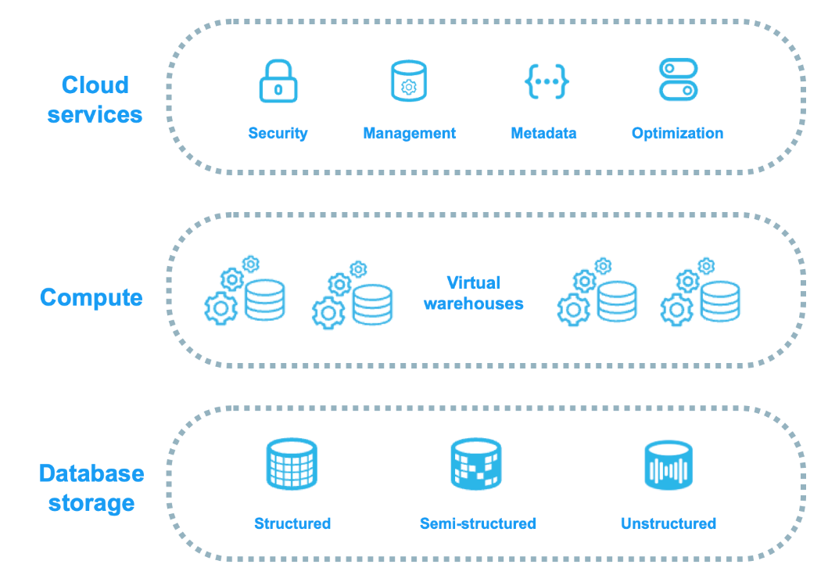

4.3 Layer 1: Database Storage Layer

How Snowflake Stores Data
When you load data into Snowflake, it automatically reorganizes and optimizes the data into its internal format. The data is stored in cloud object storage (Amazon S3 for AWS, Azure Blob Storage for Azure, Google Cloud Storage for GCP) and is NOT directly accessible by end users — you only interact with it through Snowflake's query engine.

Columnar Storage
Unlike traditional row-based databases (Oracle, SQL Server) that store entire rows together, Snowflake stores data column-by-column. This is dramatically more efficient for analytical queries that typically read only a few columns from millions of rows.
Storage Type | Row Layout | Best For | Example
Row-Based (OLTP) | [ID, Name, Age, Salary] together | Transactional (INSERT/UPDATE/DELETE) | Oracle OLTP, MySQL
Columnar (OLAP) | [All IDs] [All Names] [All Ages] | Analytics (SELECT, aggregations) | Snowflake, BigQuery, Redshift

Micro-Partitions — The Core of Snowflake Storage
All data in Snowflake tables is automatically divided into micro-partitions. These are the fundamental units of Snowflake storage.
- Each micro-partition contains 50–500 MB of uncompressed data
- Stored in a columnar format (PAX — Partition Attributes Across)
- Each micro-partition has metadata: min/max values per column, number of distinct values, null counts
- Micro-partitions are immutable — they are never overwritten, only new ones are created
- Snowflake tracks which micro-partitions contain which data ranges

Why Micro-Partitions Matter
When you run: SELECT * FROM sales WHERE region = 'APAC' Snowflake checks the metadata: 'Which micro-partitions contain APAC in the region column?' It reads ONLY those partitions — skipping potentially 90%+ of your data. This is called PARTITION PRUNING and it makes Snowflake queries dramatically faster.

Automatic Clustering
Snowflake automatically maintains clustering of your data based on how it was loaded. For tables with billions of rows, you can optionally define a Clustering Key — a column (or set of columns) by which Snowflake actively reorganizes micro-partitions in the background using Automatic Clustering. This continuously optimizes query performance without user intervention.

Compression
Snowflake automatically applies best-in-class compression algorithms (Zstandard, LZO, Snappy) to each column independently, based on the column's data type and cardinality. Average compression ratios of 3x–7x are typical, significantly reducing storage costs.

4.4 Layer 2: Compute Layer (Query Processing)

Virtual Warehouses — The Engines of Snowflake
A Virtual Warehouse (VW) is a cluster of compute resources (CPU, memory, temporary disk) that executes your SQL queries. Virtual warehouses are completely independent from each other and from the storage layer — this is what makes Snowflake's architecture revolutionary.
- Each virtual warehouse is a Massively Parallel Processing (MPP) cluster
- Multiple virtual warehouses can read from the SAME data simultaneously
- Running one VW does NOT impact the performance of another VW
- VWs can be started, stopped, or resized in seconds
- You are only charged when a VW is actively running queries

Critical Concept: Compute-Storage Separation
This is Snowflake's most important innovation. In Oracle/SQL Server, compute and storage are on the same server — adding a user slows everyone down. In Snowflake, your Finance team can run on a Large warehouse, your Data Science team on an X-Large warehouse, and your BI dashboard on a Medium warehouse — ALL querying the same data simultaneously with ZERO performance impact on each other.

MPP (Massively Parallel Processing)
When you submit a query to a virtual warehouse, Snowflake's compute layer splits the query across all compute nodes in that warehouse simultaneously. Each node processes its portion of the data in parallel, and results are aggregated. This is why Snowflake can process billions of rows in seconds.

Local Disk Cache (Warehouse Cache)
Each virtual warehouse maintains a local SSD cache of data that it has recently read from remote storage. If the same data is queried again while the warehouse is running, it reads from the local cache instead of remote storage — dramatically improving performance. This cache is cleared when the warehouse is suspended.

4.5 Layer 3: Cloud Services Layer
The Cloud Services layer is the 'brain' of Snowflake. It coordinates all activities across the platform and runs on Snowflake-managed infrastructure — you never manage it. It includes:

Components of the Cloud Services Layer
Component | Function
Authentication | Validates user identity — password, MFA, SSO, OAuth, key-pair auth
Infrastructure Management | Manages the lifecycle of virtual warehouses — provisioning, scaling, suspending
Metadata Management | Stores all metadata — table schemas, column stats, micro-partition info, query history
Query Optimizer | Parses, plans, and optimizes SQL queries before execution
Access Control | Enforces RBAC — checks privileges before allowing any operation
Transaction Management | ACID transactions — ensures consistency even with concurrent writes
Result Cache | Stores query results for 24 hours — identical queries return instantly without compute

The Three Caching Mechanisms
Performance Multiplier: Caching
Snowflake has THREE layers of caching, each serving a different purpose:

Cache Type | Location | Duration | What it Stores | Benefit
Result Cache | Cloud Services Layer | 24 hours | Complete query results | Identical queries return in milliseconds — zero compute cost
Metadata Cache | Cloud Services Layer | Persistent | Table statistics, schema, partition info | Enables query planning without reading data
Warehouse (Local) Cache | Virtual Warehouse SSD | While VW runs | Raw data from remote storage | Re-reads avoided — data served from local SSD

4.6 Query Lifecycle — End-to-End Execution Flow
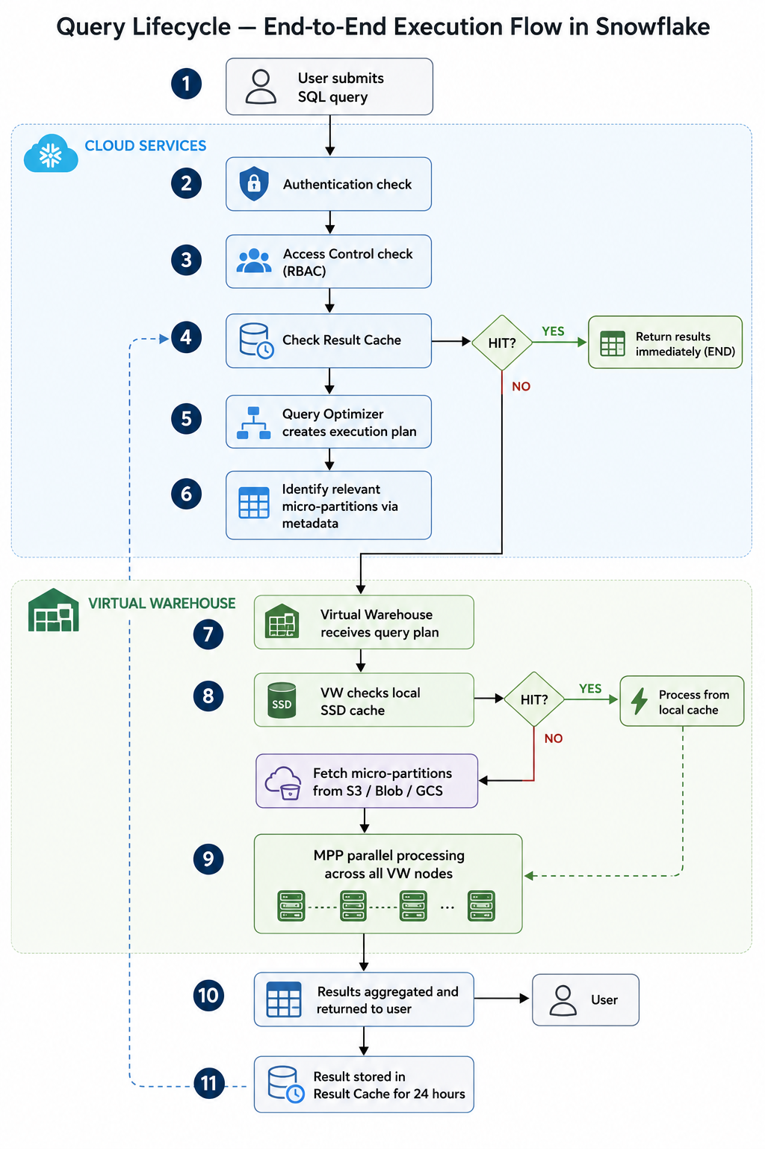

4.7 Concurrency Handling
One of the biggest challenges in traditional data warehouses is concurrency — when too many users submit queries simultaneously, performance degrades for everyone. Snowflake solves this with multiple independent mechanisms:
- Multiple Virtual Warehouses: Different teams use different VWs — completely isolated workloads
- Multi-Cluster Warehouses: A single warehouse can automatically spin up additional clusters when query queuing is detected
- Concurrency Scaling: Snowflake can automatically add concurrency clusters to handle burst loads
- Result Cache: Repeated queries consume zero compute resources

KEY TAKEAWAYS
- 3-layer architecture: Storage (cloud object storage) + Compute (virtual warehouses) + Services (cloud brain)
- Micro-partitions with metadata enable partition pruning — read only relevant data
- Multiple virtual warehouses = multiple independent compute clusters reading same storage
- 3 cache types: Result Cache (24hr), Metadata Cache, Local Warehouse Cache
- Cloud Services layer handles auth, optimization, access control, and metadata — always on, zero cost

4.8 Architecture Interview Questions & Answers
Interview Question | Model Answer
What is Snowflake's architecture called? | Multi-Cluster Shared Data Architecture — 3 layers: Storage, Compute, Cloud Services
How does compute and storage separation benefit users? | Multiple teams can query the same data simultaneously with independent warehouses, preventing resource contention
What are micro-partitions? | Immutable columnar storage units of 50-500MB containing data + metadata (min/max, nulls, distinct values) enabling partition pruning
What is the Result Cache? | Cloud Services stores query results for 24 hours — identical queries return instantly with zero compute cost
How does Snowflake handle concurrency? | Multiple VWs, Multi-Cluster Warehouses, Concurrency Scaling, and Result Cache work together
Is Snowflake an MPP database? | Yes — virtual warehouses use MPP to parallelize query execution across compute nodes

SECTION 5: Snowflake Key Features (20 Minutes)

5.1 Time Travel
Time Travel allows you to access historical versions of your data — tables, schemas, or entire databases — for a configurable period of time (up to 90 days on Enterprise edition). This is like a built-in 'undo' button for your entire data platform.
- Default retention: 1 day (Standard), up to 90 days (Enterprise+)
- Use AT or BEFORE clause in queries to access past versions
- Recover accidentally dropped or modified tables with zero downtime
- Audit historical data for compliance or debugging

-- Assigning the role for the account
USE ROLE ACCOUNTADMIN;

-- Assigning the warehouse to the account
USE WAREHOUSE COMPUTE_WH;

CREATE OR REPLACE DATABASE TRAINING_DB;
USE DATABASE TRAINING_DB;
CREATE OR REPLACE SCHEMA TIME_TRAVEL_DEMO;
USE SCHEMA TIME_TRAVEL_DEMO;

-- Create sample data
CREATE OR REPLACE TABLE sales (
sale_id INT,
product STRING,
amount NUMBER(10,2),
sale_date TIMESTAMP
);
INSERT INTO sales VALUES
(1, 'Laptop', 50000, CURRENT_TIMESTAMP()),
(2, 'Mobile', 25000, CURRENT_TIMESTAMP()),
(3, 'Keyboard', 2000, CURRENT_TIMESTAMP());

SELECT * FROM sales;
-- Capture Current Timestamp
SELECT CURRENT_TIMESTAMP(); -- Copy the timestamp value shown because Now this timestamp represents the old version of the table.

-- Modify Data
UPDATE sales
SET amount = amount + 10000;

-- Insert More Data
INSERT INTO sales VALUES
(4, 'Mouse', 1500, CURRENT_TIMESTAMP());

SELECT * FROM sales; -- modified data

-- TIME TRAVEL — Query Old Data Using TIMESTAMP

-- Use the timestamp copied earlier.
SELECT *
FROM sales
AT (TIMESTAMP => '2026-05-14 00:07:51.221'::TIMESTAMP

-- This shows table data BEFORE update and insert.
-- Snowflake stores historical versions automatically.

-- if error then => it will be because the timestamp you used is either:
-- Before the table was created
-- OR
-- Outside the Time Travel retention period

-- Alternative — Query Using OFFSET
-- Instead of exact timestamp.
-- Example: Last 5 minutes
SELECT *
FROM sales
AT (OFFSET => -60*5);

-- OFFSET is in seconds
-- Negative means “go to past”

-- | Offset | Meaning |
-- | ------ | ------------ |
-- | -60 | 1 minute ago |
-- | -3600 | 1 hour ago |
-- | -7200 | 2 hours ago |

-- Delete records accidentally.
DELETE FROM sales
WHERE sale_id = 2;

-- Check current data:
SELECT * FROM sales;

-- Now recover old state:
SELECT *
FROM sales
AT (OFFSET => -60);
-- This shows deleted row.

-- DROP + UNDROP
-- Drop table accidentally.

DROP TABLE sales;

SELECT * FROM sales; -- It fails.

-- Now recover:
UNDROP TABLE sales;

-- Verify:
SELECT * FROM sales;

-- Table metadata + data restored
-- Works within Time Travel retention period

5.2 Fail-Safe
After Time Travel expires, data enters a 7-day Fail-Safe period (Enterprise). This is a disaster recovery mechanism maintained by Snowflake — you cannot self-serve access Fail-Safe data; Snowflake Support must recover it. Think of it as your last line of defense.

5.3 Zero-Copy Cloning
One of Snowflake's most unique features — you can instantly clone a database, schema, or table without physically copying data. The clone shares the same underlying micro-partitions as the original. Only when data is modified in the clone does new storage get created (copy-on-write mechanism).
- Instant clone creation regardless of table size
- Zero additional storage cost at clone creation time
- Perfect for: Dev/Test environments, Sandboxing, Data experiments

-- CLONE from Past
-- This is a very important enterprise feature.
-- First modify table again:

UPDATE sales
SET amount = 999;

-- Check data:
SELECT * FROM sales;

-- Now create clone from older version:
CREATE OR REPLACE TABLE sales_recovery
CLONE sales
AT (OFFSET => -60);

-- Check cloned table:
SELECT * FROM sales_recovery;

-- Clone contains old data
-- Zero-copy clone
-- Instant operation
-- No physical duplication initially

-- Show Retention Period
SHOW PARAMETERS LIKE 'DATA_RETENTION_TIME_IN_DAYS' FOR TABLE sales;

SELECT * FROM sales; -- Current table:

SELECT *
FROM sales
AT (OFFSET => -60); -- Past table

-- Snowflake automatically maintains historical versions of data for a retention period. We can query, restore, or clone old versions without backups.

5.4 Secure Data Sharing
Snowflake enables real-time secure data sharing between Snowflake accounts without physically copying data. A data provider shares a database object (table, view, schema); the consumer sees live data. This eliminates ETL pipelines between partner organizations.
- No data movement or duplication
- Consumers see live, real-time data
- Fine-grained access control on what is shared
- Works across regions and clouds with Replication
- Snowflake Marketplace: monetize your datasets

5.5 Semi-Structured Data Support
Snowflake natively handles semi-structured data formats using the VARIANT data type — a flexible column that can store any JSON, XML, Avro, ORC, or Parquet data. You can query nested JSON with dot-notation and colon-notation directly in SQL.
-- For Semi Structured Data
-- Create Table with VARIANT Column
CREATE OR REPLACE TABLE events (
event_id INT,
event_data VARIANT
);
-- Insert JSON Data
INSERT INTO events
SELECT
1,
PARSE_JSON('
{
"user_id": "U101",
"product": {
"name": "Laptop",
"brand": "Dell"
},
"items": [
{
"item_name": "Mouse",
"price": 499.99
},
{
"item_name": "Keyboard",
"price": 899.50
}
],
"orders": [
{
"order_id": "ORD1001"
},
{
"order_id": "ORD1002"
}
]
}');

-- PARSE_JSON() converts JSON string into Snowflake VARIANT object.
-- VARIANT can store semi-structured data.

SELECT * FROM events; -- will see complete JSON stored in one column.
-- Unlike relational databases, Snowflake can directly store nested JSON.

-- Query JSON Fields
SELECT
event_id,
event_data:user_id::STRING AS user_id,
event_data:product.name::STRING AS product_name,
event_data:product.brand::STRING AS brand,
event_data:items[0].price::FLOAT AS first_item_price
FROM events;

-- Colon Notation -> event_data:user_id is to Access JSON key.
-- Dot Notation -> event_data:product.name is to Access nested object.
-- Array Access -> event_data:items[0] is to Access first array element.
-- Type Casting
-- ::STRING
-- ::FLOAT
-- Convert VARIANT into SQL datatype.

-- Show Entire Array
SELECT
event_data:items
FROM events;

-- Access Second Array Element
SELECT
event_data:items[1].item_name::STRING AS second_item
FROM events;

-- FLATTEN Nested Arrays (Most Important Feature)
SELECT
f.value:order_id::STRING AS order_id
FROM events,
LATERAL FLATTEN(input => event_data:orders) f;

-- FLATTEN Converts Array Into Rows
-- Input JSON
-- "orders": [
-- {"order_id":"ORD1001"},
-- {"order_id":"ORD1002"}
-- ]
-- Output:
-- ORDER_ID
-- ORD1001
-- ORD1002

-- Complete FLATTEN Output
SELECT *
FROM events,
LATERAL FLATTEN(input => event_data:orders);

-- | Column | Meaning |
-- | ------ | ------------------ |
-- | VALUE | Actual JSON object |
-- | INDEX | Array position |
-- | PATH | JSON path |

-- Flatten Items Array
SELECT
f.value:item_name::STRING AS item_name,
f.value:price::FLOAT AS price
FROM events,
LATERAL FLATTEN(input => event_data:items) f;

-- Real-World Use Cases
-- Snowflake Semi-Structured Data is Commonly Used For:

-- | Use Case | Example |
-- | ---------------- | ------------------ |
-- | API responses | JSON payloads |
-- | Clickstream data | Website tracking |
-- | IoT devices | Sensor JSON |
-- | Logs | Application logs |
-- | Kafka ingestion | Streaming JSON |
-- | Data lakes | Parquet/Avro files |

5.6 Other Key Features Summary
Feature | Description | Business Value
Elastic Scalability | Resize warehouses in seconds, scale up/down based on demand | Match compute to workload — no over-provisioning
Near-Zero Maintenance | No patches, no upgrades, no tuning — Snowflake manages it all | DBA team focuses on analytics, not operations
Multi-Cloud Support | Deploy on AWS, Azure, or GCP — your choice | Avoid vendor lock-in, match your cloud strategy
Cross-Region Replication | Replicate databases across regions for DR and global access | Business continuity, low-latency global access
Snowpark | Write code in Python, Java, or Scala that runs inside Snowflake | Data engineers use their preferred languages
Dynamic Data Masking | Mask sensitive data dynamically based on role | PII protection without duplicating data
Row Access Policies | Control which rows each role can see | Fine-grained data governance

KEY TAKEAWAYS
- Time Travel: query/restore historical data up to 90 days (Enterprise)
- Zero-Copy Cloning: instant table/DB clones with no storage cost
- Secure Data Sharing: share live data without ETL or data movement
- VARIANT type: native JSON/XML support with SQL dot-notation queries
- Fail-Safe: 7-day Snowflake-managed disaster recovery backstop

SECTION 6: Snowflake Editions & Deployment Models (15 Minutes)

6.1 Snowflake Editions
Feature | Standard | Enterprise | Business Critical | VPS
Time Travel | 1 Day | 90 Days | 90 Days | 90 Days
Multi-Cluster Warehouses | No | Yes | Yes | Yes
Materialized Views | No | Yes | Yes | Yes
Dynamic Data Masking | No | Yes | Yes | Yes
Search Optimization | No | Yes | Yes | Yes
HIPAA/PCI Compliance | No | No | Yes | Yes
Private Connectivity | No | No | Yes | Yes
Customer-Managed Keys | No | No | Yes | Yes
Dedicated VPC | No | No | No | Yes
Best For | Dev/Test, Small teams | Most enterprises | Regulated industries | Government, Finance

6.2 Cloud Deployment Models
- Amazon Web Services (AWS): Most regions globally, most feature-mature, default choice for most organizations
- Microsoft Azure: Preferred for Microsoft-centric organizations (Azure Data Factory, Power BI integration)
- Google Cloud Platform (GCP): Best for BigQuery migrators, AI/ML workloads on Google ecosystem

Best Practice
Choose your cloud provider based on where your existing data already lives (S3, ADLS, GCS) to minimize data transfer costs and latency. For most new deployments, AWS us-east-1 is the default starting point.

6.3 Deployment Regions
Snowflake is available in 30+ regions across AWS, Azure, and GCP globally including regions in the US, EU, APAC (including AWS ap-south-1 Mumbai for Indian enterprises), and more. Cross-region replication allows data to be available in multiple regions simultaneously for disaster recovery and global access.

KEY TAKEAWAYS
- 4 editions: Standard → Enterprise → Business Critical → VPS — match to compliance and feature needs
- Enterprise is the most commonly deployed edition in large organizations
- Business Critical for regulated industries (HIPAA, PCI, SOC 2 Type II)
- Cloud choice: match where your data lives to minimize transfer costs

SECTION 7: Snowflake Object Hierarchy (25 Minutes)

7.1 The Hierarchy Explained
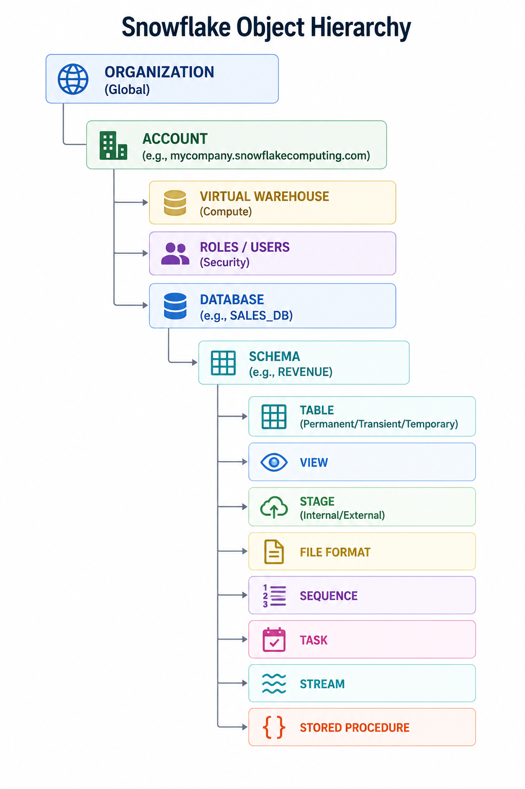

7.2 Each Object Explained
Object | Description | Real-World Analogy
Organization | Top-level container grouping multiple Snowflake accounts (enterprise feature) | A corporation with multiple subsidiaries
Account | Your Snowflake instance — unique URL and isolated environment | One company's entire Snowflake deployment
Database | Logical grouping of schemas and objects — top-level namespace | A folder/library for a business domain
Schema | Sub-grouping within a database — contains tables, views, stages | A section within the library
Table | Stores structured data in rows and columns | A spreadsheet or physical filing cabinet
View | Saved SQL query — virtual table; no data stored | A saved search/filter criteria
Stage | Location for loading/unloading data (internal or external S3/Blob/GCS) | A loading dock for incoming/outgoing shipments
File Format | Defines how to parse staged files (CSV, JSON, Parquet, Avro, ORC) | A translator/decoder for file types
Sequence | Auto-incrementing number generator | An auto-number stamp machine
Task | Scheduled SQL job — like a cron job for SQL | A calendar reminder to run a report
Stream | Change Data Capture (CDC) — tracks DML changes on a table | A security camera recording all table changes

7.3 Table Types
Table Type | Time Travel | Fail-Safe | Storage Cost | Use Case
Permanent | Yes (up to 90 days) | 7 days | Full cost | Production data, master tables
Transient | Yes (0 or 1 day) | No | Lower cost | ETL staging, intermediate tables
Temporary | Within session only | No | Lowest cost | Session-specific temp calculations
External | No | No | No Snowflake cost | Query data in S3/ADLS/GCS directly

7.4 SQL Examples — Creating Objects
-- Assigning the role for the account
USE ROLE ACCOUNTADMIN;
-- Assigning the warehouse to the account
USE WAREHOUSE COMPUTE_WH;

-- Step 1: Create a Database
CREATE DATABASE SALES_DB
DATA_RETENTION_TIME_IN_DAYS = 7
COMMENT = 'Sales domain database';

-- Show databases
SHOW DATABASES LIKE 'SALES_DB';

-- Step 2: Create Schemas
CREATE SCHEMA SALES_DB.RAW COMMENT = 'Raw ingested data';
CREATE SCHEMA SALES_DB.STAGING COMMENT = 'Cleaned/transformed data';
CREATE SCHEMA SALES_DB.REPORTING COMMENT = 'Business-ready analytics';

-- Show schemas
SHOW SCHEMAS IN DATABASE SALES_DB;

-- Step 3: Create a Permanent Table
CREATE OR REPLACE TABLE SALES_DB.REPORTING.SALES_FACT (
sale_id NUMBER AUTOINCREMENT PRIMARY KEY,
sale_date DATE NOT NULL,
customer_id NUMBER NOT NULL,
product_id NUMBER NOT NULL,
region VARCHAR(50),
quantity NUMBER(10,0),
unit_price NUMBER(10,2),
total_amount NUMBER(12,2),
created_at TIMESTAMP_NTZ DEFAULT CURRENT_TIMESTAMP()
);

-- Describe table structure
DESC TABLE SALES_DB.REPORTING.SALES_FACT;

-- Show tables
SHOW TABLES IN SCHEMA SALES_DB.REPORTING;

-- Step 4: Create a Transient Table (for staging)
CREATE OR REPLACE TRANSIENT TABLE SALES_DB.STAGING.SALES_STAGE (
raw_data VARIANT
);

-- Describe transient table
DESC TABLE SALES_DB.STAGING.SALES_STAGE;

-- Show tables in staging schema
SHOW TABLES IN SCHEMA SALES_DB.STAGING;

-- Step 5: Create an Internal Stage
CREATE OR REPLACE STAGE SALES_DB.RAW.my_stage
FILE_FORMAT = (
TYPE = 'CSV'
FIELD_DELIMITER = ','
SKIP_HEADER = 1
);

-- Show stages
SHOW STAGES IN SCHEMA SALES_DB.RAW;

-- Step 6: Create a File Format
CREATE OR REPLACE FILE FORMAT SALES_DB.RAW.csv_format
TYPE = 'CSV'
FIELD_DELIMITER = ','
SKIP_HEADER = 1
NULL_IF = ('NULL', 'null', '')
EMPTY_FIELD_AS_NULL = TRUE;

-- Show file formats
SHOW FILE FORMATS IN SCHEMA SALES_DB.RAW;

-- Step 7: Create a View
CREATE OR REPLACE VIEW SALES_DB.REPORTING.MONTHLY_REVENUE AS
SELECT
DATE_TRUNC('MONTH', sale_date) AS month,
region,
SUM(total_amount) AS revenue
FROM SALES_DB.REPORTING.SALES_FACT
GROUP BY 1, 2;

-- Show views
SHOW VIEWS IN SCHEMA SALES_DB.REPORTING;
-- Describe view
DESC VIEW SALES_DB.REPORTING.MONTHLY_REVENUE;

-- Step 8: Create a Sequence
CREATE OR REPLACE SEQUENCE SALES_DB.RAW.customer_seq
START = 1 INCREMENT = 1;

-- Show sequences
SHOW SEQUENCES IN SCHEMA SALES_DB.RAW;

-- Generate sample sequence values
SELECT SALES_DB.RAW.customer_seq.NEXTVAL AS next_sequence_value;

-- Insert Sample Data to View Results
---------------------------------------------------
INSERT INTO SALES_DB.REPORTING.SALES_FACT
(
sale_date,
customer_id,
product_id,
region,
quantity,
unit_price,
total_amount
)
VALUES
('2026-05-01', 1, 101, 'North', 2, 500, 1000),
('2026-05-02', 2, 102, 'South', 1, 700, 700),
('2026-05-10', 3, 103, 'East', 5, 200, 1000);

-- Query table data
SELECT *
FROM SALES_DB.REPORTING.SALES_FACT;

-- Query view output
SELECT *
FROM SALES_DB.REPORTING.MONTHLY_REVENUE;

KEY TAKEAWAYS
- Hierarchy: Organization > Account > Database > Schema > Table/View/Stage/etc.
- Use separate schemas for RAW, STAGING, and REPORTING layers (medallion architecture)
- Transient tables for ETL staging — save on Time Travel storage costs
- Streams for CDC, Tasks for scheduling — Snowflake has built-in orchestration

SECTION 8: Virtual Warehouses Deep Dive (25 Minutes)

8.1 What is a Virtual Warehouse?
A Virtual Warehouse is a named cluster of compute resources in Snowflake. It is the engine that executes your SQL queries, data loading operations, and DML statements. You can think of it as renting a powerful compute cluster on-demand — it starts in seconds and you only pay for active usage.

8.2 Warehouse Sizes & Credit Consumption
Size | Credits/Hour | Approx. Cost/Hr (AWS) | Nodes | Best For
X-Small (XS) | 1 | ~$3 | 1 node | Development, small queries, BI tools
Small (S) | 2 | ~$6 | 2 nodes | Small analytics, dashboards
Medium (M) | 4 | ~$12 | 4 nodes | Moderate analytics workloads
Large (L) | 8 | ~$24 | 8 nodes | Complex analytics, data engineering
X-Large (XL) | 16 | ~$48 | 16 nodes | Heavy data engineering, large datasets
2X-Large (2XL) | 32 | ~$96 | 32 nodes | Very large transformations
3X-Large (3XL) | 64 | ~$192 | 64 nodes | Data science, ML training
4X-Large (4XL) | 128 | ~$384 | 128 nodes | Massive parallel workloads
5X-Large (5XL) | 256 | ~$768 | 256 nodes | Extreme scale (select regions)
6X-Large (6XL) | 512 | ~$1,536 | 512 nodes | Extreme scale (select regions)

Cost Note
Costs are approximate and vary by cloud provider, region, and Snowflake edition. Credits are the billing unit — 1 credit = fraction of a dollar. Actual pricing visible in your Snowflake account under Admin > Cost Management.

8.3 Auto Suspend & Auto Resume
- Auto Suspend: Warehouse automatically suspends after a configurable idle period (default: 10 minutes). No credits consumed while suspended.
- Auto Resume: Warehouse automatically starts when a query is submitted. Typically takes 1-5 seconds.

-- Create a warehouse with auto-suspend and auto-resume
CREATE OR REPLACE WAREHOUSE ANALYTICS_WH
WAREHOUSE_SIZE = 'MEDIUM'
AUTO_SUSPEND = 300 -- Suspend after 5 minutes of inactivity
AUTO_RESUME = TRUE -- Resume automatically on query submission
MIN_CLUSTER_COUNT = 1 -- For multi-cluster: min clusters
MAX_CLUSTER_COUNT = 3 -- For multi-cluster: max clusters
SCALING_POLICY = 'STANDARD' -- STANDARD or ECONOMY
COMMENT = 'Analytics team warehouse';

-- Manually start/stop a warehouse
ALTER WAREHOUSE ANALYTICS_WH RESUME;
ALTER WAREHOUSE ANALYTICS_WH SUSPEND;

-- Resize a warehouse (takes effect immediately)
ALTER WAREHOUSE ANALYTICS_WH SET WAREHOUSE_SIZE = 'LARGE';

8.4 Multi-Cluster Warehouses (Enterprise+)
A Multi-Cluster Warehouse is a single logical warehouse that can automatically scale from 1 to N compute clusters based on query queue depth. This solves the concurrency problem — when too many queries queue up, Snowflake automatically adds another cluster to handle the load.
- Maximized Mode: All clusters always running — lowest latency, highest cost
- Auto-Scale Mode: Clusters added/removed based on demand — balanced cost and performance

8.5 Workload Isolation Best Practice
Warehouse | Team/Purpose | Size | Auto-Suspend
ETL_WH | Data Engineering / ELT jobs | Large or X-Large | 15 min
ANALYTICS_WH | Data Analysts / Ad-hoc queries | Medium | 5 min
REPORTING_WH | BI Tools (Tableau, Power BI) | Small | 5 min
DS_WH | Data Science / ML | X-Large or 2X-Large | 30 min
ADMIN_WH | DBA / Administration tasks | X-Small | 2 min

KEY TAKEAWAYS
- Virtual Warehouses = on-demand compute clusters; only pay when running
- Sizes from X-Small (1 credit/hr) to 6X-Large (512 credits/hr) — double credits per size
- Auto-Suspend and Auto-Resume are essential cost controls — ALWAYS enable them
- Create separate warehouses per team/workload for isolation and cost attribution
- Multi-Cluster Warehouses (Enterprise) automatically handle concurrency spikes

SECTION 9: Snowflake Security Fundamentals (20 Minutes)

9.1 Security Architecture Overview
Snowflake employs a comprehensive, layered security model with enterprise-grade controls at every layer — network, encryption, access control, and auditing. All data is encrypted at rest and in transit by default — this is not optional.

9.2 Role-Based Access Control (RBAC)
Snowflake uses RBAC as its primary access control model. Permissions are granted to ROLES, and roles are assigned to USERS. Users never receive direct privileges — they get roles, and roles get privileges.
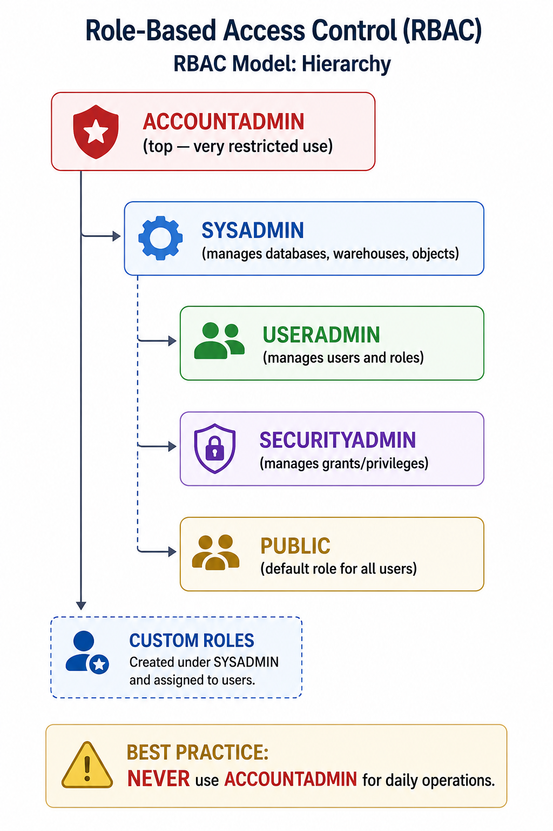

9.3 Authentication Methods
Method | Description | Best For
Username / Password | Standard login with password | Development and testing
Multi-Factor Authentication (MFA) | Duo Mobile push notification for every login | All production users — MANDATORY best practice
SSO (SAML 2.0) | Integrate with Okta, Azure AD, Ping Identity | Enterprise workforce SSO
OAuth | Token-based — for BI tools, applications | Tableau, Power BI, dbt integrations
Key-Pair Authentication | RSA key-pair — no password in connection string | Service accounts, automated ETL pipelines
External OAuth | Identity provider tokens (Google, Azure AD) | Modern app authentication

9.5 Encryption
- All data encrypted at rest using AES-256 encryption
- All data encrypted in transit using TLS 1.2+
- Snowflake manages encryption keys by default (Tri-Secret Secure available on Business Critical)
- Customer-Managed Keys (CMK) available on Business Critical edition
- Periodic key rotation — automatic, transparent to users

9.6 Security Best Practices
- Never use ACCOUNTADMIN for day-to-day operations — create a custom admin role
- Enable MFA for ALL users — especially those with ACCOUNTADMIN or SYSADMIN
- Use key-pair authentication for all service accounts and ETL pipelines
- Implement Network Policies to restrict access to corporate IP ranges
- Apply the Principle of Least Privilege — grant minimum required permissions
- Regularly audit role assignments: SHOW GRANTS TO ROLE <rolename>
- Enable Snowflake's Audit Logging to track all activities
- Use Dynamic Data Masking for PII columns (Enterprise+)

KEY TAKEAWAYS
- RBAC: Privileges → Roles → Users; never grant directly to users
- System roles: ACCOUNTADMIN > SYSADMIN > USERADMIN > SECURITYADMIN > PUBLIC
- All data encrypted at rest (AES-256) and in transit (TLS) by default
- MFA is mandatory best practice for all production users
- Network Policies restrict access to trusted IP ranges

SECTION 10: Hands-On Lab — Step-by-Step
Lab Prerequisites
Participants need: (1) Snowflake Trial Account — sign up at trial.snowflake.com (2) Web browser — Chrome recommended (3) Snowsight UI — the modern Snowflake web interface

10.1 Lab Objectives
- Log into Snowflake
- Create a Virtual Warehouse
- Create Database, Schema, and Tables
- Load sample sales data
- Run analytical queries
- Explore Query History and Warehouse Monitoring
- Demonstrate Time Travel

10.2 Complete Lab SQL Script
-- =============================================
-- SNOWFLAKE HANDS-ON LAB: SALES ANALYTICS
-- Run each step sequentially in Snowsight
-- =============================================

-- STEP 1: Set Context
USE ROLE SYSADMIN;

-- STEP 2: Create Virtual Warehouse
CREATE OR REPLACE WAREHOUSE LAB_WH
WAREHOUSE_SIZE = 'X-SMALL'
AUTO_SUSPEND = 120
AUTO_RESUME = TRUE
COMMENT = 'Lab warehouse for training';

USE WAREHOUSE LAB_WH;

-- STEP 3: Create Database and Schemas
CREATE OR REPLACE DATABASE TRAINING_DB
DATA_RETENTION_TIME_IN_DAYS = 1
COMMENT = 'Training database for lab exercises';

CREATE OR REPLACE SCHEMA TRAINING_DB.SALES
COMMENT = 'Sales analytics schema';

USE SCHEMA TRAINING_DB.SALES;

-- STEP 4: Create Tables
CREATE OR REPLACE TABLE CUSTOMERS (
customer_id NUMBER(10,0) PRIMARY KEY,
first_name VARCHAR(50) NOT NULL,
last_name VARCHAR(50) NOT NULL,
email VARCHAR(100),
city VARCHAR(50),
country VARCHAR(50),
segment VARCHAR(30)
);

CREATE OR REPLACE TABLE PRODUCTS (
product_id NUMBER(10,0) PRIMARY KEY,
product_name VARCHAR(100) NOT NULL,
category VARCHAR(50),
sub_category VARCHAR(50),
unit_price NUMBER(10,2)
);

CREATE OR REPLACE TABLE SALES_ORDERS (
order_id NUMBER(10,0) PRIMARY KEY,
order_date DATE NOT NULL,
customer_id NUMBER(10,0) REFERENCES CUSTOMERS(customer_id),
product_id NUMBER(10,0) REFERENCES PRODUCTS(product_id),
quantity NUMBER(5,0),
discount_pct NUMBER(5,2),
total_amount NUMBER(12,2),
region VARCHAR(30)
);

-- STEP 5: Insert Sample Data (Customers)
INSERT INTO CUSTOMERS VALUES
(1,'Rahul','Sharma','rahul@example.com','Mumbai','India','Corporate'),
(2,'Priya','Patel','priya@example.com','Delhi','India','Consumer'),
(3,'John','Smith','john@example.com','New York','USA','Corporate'),
(4,'Emma','Wilson','emma@example.com','London','UK','Consumer'),
(5,'Zhang','Wei','zhang@example.com','Shanghai','China','Corporate'),
(6,'Fatima','Ahmed','fatima@example.com','Dubai','UAE','Consumer'),
(7,'Carlos','Garcia','carlos@example.com','Mexico City','Mexico','Consumer'),
(8,'Yuki','Tanaka','yuki@example.com','Tokyo','Japan','Corporate');

-- STEP 6: Insert Sample Data (Products)
INSERT INTO PRODUCTS VALUES
(101,'MacBook Pro 14','Technology','Laptops',199999),
(102,'iPhone 15 Pro','Technology','Phones',99999),
(103,'Wireless Mouse','Technology','Accessories',2999),
(104,'Office Chair','Furniture','Chairs',15000),
(105,'Standing Desk','Furniture','Desks',45000),
(106,'Notebook Pack','Office Supplies','Paper',500),
(107,'USB-C Hub','Technology','Accessories',3500),
(108,'Monitor 27 inch','Technology','Monitors',35000);

-- STEP 7: Insert Sample Data (Orders)
INSERT INTO SALES_ORDERS VALUES
(1001,'2025-01-05',1,101,2,5.0,379998.00,'APAC'),
(1002,'2025-01-08',2,102,1,0.0,99999.00,'APAC'),
(1003,'2025-01-10',3,104,5,10.0,67500.00,'Americas'),
(1004,'2025-01-12',4,108,3,0.0,105000.00,'EMEA'),
(1005,'2025-01-15',5,105,10,15.0,382500.00,'APAC'),
(1006,'2025-02-01',6,103,20,5.0,57000.00,'EMEA'),
(1007,'2025-02-05',7,106,100,0.0,50000.00,'Americas'),
(1008,'2025-02-10',8,107,15,10.0,47250.00,'APAC'),
(1009,'2025-02-14',1,102,3,5.0,284997.00,'APAC'),
(1010,'2025-03-01',2,104,2,0.0,30000.00,'APAC'),
(1011,'2025-03-05',3,101,1,0.0,199999.00,'Americas'),
(1012,'2025-03-10',4,108,5,10.0,157500.00,'EMEA');

-- STEP 8: Basic Verification Queries
SELECT COUNT(*) AS customer_count FROM CUSTOMERS;
SELECT COUNT(*) AS product_count FROM PRODUCTS;
SELECT COUNT(*) AS order_count FROM SALES_ORDERS;

-- STEP 9: Analytical Queries
-- Q1: Total Revenue by Region
SELECT
region,
COUNT(order_id) AS total_orders,
SUM(total_amount) AS total_revenue,
AVG(total_amount) AS avg_order_value,
ROUND(SUM(total_amount) / SUM(SUM(total_amount)) OVER () * 100, 2) AS revenue_pct
FROM SALES_ORDERS
GROUP BY region
ORDER BY total_revenue DESC;

-- Q2: Top Products by Revenue
SELECT
p.product_name,
p.category,
SUM(s.quantity) AS units_sold,
SUM(s.total_amount) AS total_revenue
FROM SALES_ORDERS s
JOIN PRODUCTS p ON s.product_id = p.product_id
GROUP BY p.product_name, p.category
ORDER BY total_revenue DESC
LIMIT 5;

-- Q3: Monthly Revenue Trend
SELECT
DATE_TRUNC('MONTH', order_date) AS month,
SUM(total_amount) AS monthly_revenue,
LAG(SUM(total_amount)) OVER (ORDER BY DATE_TRUNC('MONTH', order_date)) AS prev_month,
ROUND((SUM(total_amount) - LAG(SUM(total_amount))
OVER (ORDER BY DATE_TRUNC('MONTH', order_date)))
/ LAG(SUM(total_amount)) OVER (ORDER BY DATE_TRUNC('MONTH', order_date)) * 100, 2) AS mom_growth_pct
FROM SALES_ORDERS
GROUP BY DATE_TRUNC('MONTH', order_date)
ORDER BY month;

-- Q4: Customer Segment Analysis
SELECT
c.segment,
c.country,
COUNT(DISTINCT s.order_id) AS orders,
SUM(s.total_amount) AS revenue
FROM SALES_ORDERS s
JOIN CUSTOMERS c ON s.customer_id = c.customer_id
GROUP BY c.segment, c.country
ORDER BY revenue DESC;

-- STEP 10: Demonstrate Time Travel
-- Check current row count
SELECT COUNT(*) AS before_delete FROM SALES_ORDERS;

-- Accidentally delete some records
DELETE FROM SALES_ORDERS WHERE region = 'EMEA';

-- See the damage
SELECT COUNT(*) AS after_delete FROM SALES_ORDERS;

-- Recover using Time Travel (go back 60 seconds)
SELECT COUNT(*) FROM SALES_ORDERS AT (OFFSET => -60);

-- Restore the deleted records
INSERT INTO SALES_ORDERS
SELECT * FROM SALES_ORDERS AT (OFFSET => -60)
WHERE region = 'EMEA';

-- Verify restoration
SELECT COUNT(*) AS restored_count FROM SALES_ORDERS;

-- STEP 11: Zero-Copy Clone
CREATE TABLE SALES_ORDERS_BACKUP CLONE SALES_ORDERS;
SELECT COUNT(*) FROM SALES_ORDERS_BACKUP; -- Instant! Same data.

-- STEP 12: Check Query History
SELECT
query_text,
execution_status,
total_elapsed_time / 1000 AS elapsed_seconds,
bytes_scanned,
percentage_scanned_from_cache
FROM TABLE(INFORMATION_SCHEMA.QUERY_HISTORY())
ORDER BY start_time DESC
LIMIT 10;

Expected Outputs & Troubleshooting
If queries fail with 'Object does not exist' — ensure you ran USE SCHEMA TRAINING_DB.SALES If warehouse fails to start — check role permissions (USE ROLE SYSADMIN) If INSERT fails — verify column count matches VALUES clause Time Travel OFFSET must be negative (seconds) — e.g., -60 = 60 seconds ago Cache hit percentage > 0% in Query History means warehouse cache was used

SECTION 11: Snowflake vs Traditional Data Warehouses (15 Minutes)

11.1 Comprehensive Comparison
Dimension | Oracle/SQL Server | Teradata | Amazon Redshift | Google BigQuery | Snowflake
Architecture | Row-based RDBMS | Shared-nothing MPP | Shared-nothing cloud MPP | Serverless columnar | Multi-cluster shared data
Compute-Storage | Tightly coupled | Tightly coupled | Partially separated | Fully separated | Fully separated
Scaling | Manual, requires downtime | Manual node addition | Manual resize (minutes) | Automatic (serverless) | Instant, zero downtime
Concurrency | Limited | Limited | Limited (queuing) | High (serverless) | Excellent (multi-cluster)
Semi-structured | Minimal (JSON in 12c+) | Limited | SUPER type | Native JSON/STRUCT | VARIANT type (native)
Maintenance | Very High (DBA-intensive) | Very High | Medium (managed) | Low (serverless) | Near-Zero (SaaS)
Data Sharing | Complex ETL | Complex ETL | Limited | Analytics Hub | Native secure sharing
Time Travel | Manual backups | Manual backups | Manual snapshots | Snapshots (BigQuery) | Native (up to 90 days)
Cloning | No native feature | No native feature | No native feature | No native feature | Native zero-copy clone
Pricing | Upfront licensing | Upfront licensing | Reserved/on-demand | Per-query/storage | Pay-per-use credits
Cloud Native | No (cloud lifted) | No (cloud lifted) | Yes (AWS native) | Yes (GCP native) | Yes (multi-cloud)

11.2 Migration Considerations

Migrating from On-Prem Oracle/SQL Server/Teradata
- Assessment: Document all tables, views, stored procedures, ETL jobs, users/roles
- Schema Migration: Use SnowConvert (Snowflake's migration tool) for automatic SQL conversion
- Data Migration: Export to S3/ADLS/GCS → Load with COPY INTO command
- ETL Modernization: Replace SSIS/Informatica jobs with dbt, Snowpark, or cloud ETL tools
- Security Migration: Recreate roles/users in Snowflake RBAC model
- Validation: Row counts, aggregation checks, business logic validation
- Performance Tuning: Right-size virtual warehouses, set auto-suspend
- Training & Adoption: Train teams on Snowflake-specific features

Migration Reality Check
Most SQL dialects migrate 70-80% automatically with tools like SnowConvert. The remaining 20-30% requires manual conversion of stored procedures, proprietary functions, and complex ETL logic. Budget 3-6 months for a mid-size data warehouse migration (50-200 TB).

SECTION 12: Costing & Pricing Basics (10 Minutes)

12.1 The Credit System
Snowflake charges for compute using Credits. One credit = a specific amount of compute per hour, varying by warehouse size. Credits are consumed only when a warehouse is actively running — suspended warehouses cost nothing.

12.2 Cost Components
Cost Type | What is Charged | How to Control
Compute (Virtual Warehouses) | Credits per hour while warehouse is active | Auto-suspend, right-size warehouses, use result cache
Storage | Per TB per month for data + Time Travel + Fail-Safe | Use transient tables for staging, compress data, set short Time Travel for staging
Data Transfer | Egress charges for data leaving Snowflake to other cloud services | Keep data in same cloud region, minimize external egress
Serverless Features | Snowpipe, Tasks, Search Optimization, Automatic Clustering | Monitor usage, disable unused features
Cloud Services | Typically <10% of daily compute — free up to that threshold | Usually not a concern; monitor in cost management

12.3 Cost Optimization Best Practices
- Set AUTO_SUSPEND = 60 to 300 seconds — critical for cost control
- Use X-Small for development, Medium for analytics, Large+ for heavy ETL only
- Schedule large ETL jobs together to fully utilize a large warehouse then suspend
- Monitor the Result Cache hit rate — high cache hits = low compute cost
- Use RESOURCE MONITORS to set spending alerts and limits per warehouse
- Convert long-lived staging tables from Permanent to Transient (saves Time Travel storage)
- Disable Automatic Clustering on tables that are not frequently range-scanned

-- Create a Resource Monitor to control spending
CREATE OR REPLACE RESOURCE MONITOR monthly_limit
WITH CREDIT_QUOTA = 500 -- Alert at 500 credits/month
FREQUENCY = MONTHLY
START_TIMESTAMP = IMMEDIATELY
TRIGGERS
ON 75 PERCENT DO NOTIFY -- Email alert at 75%
ON 90 PERCENT DO NOTIFY -- Email alert at 90%
ON 100 PERCENT DO SUSPEND; -- Suspend warehouse at 100%

ALTER WAREHOUSE ANALYTICS_WH SET RESOURCE_MONITOR = monthly_limit;

SECTION 13: Best Practices & Design Recommendations (15 Minutes)

13.1 Warehouse Best Practices
- One warehouse per team/workload for isolation and cost attribution
- Start with X-Small or Small — scale up only if queries are slow
- Set AUTO_SUSPEND between 60-300 seconds based on workload patterns
- Always enable AUTO_RESUME = TRUE for user-facing warehouses
- Use Multi-Cluster warehouses for high-concurrency BI/reporting workloads
- Use Resource Monitors on ALL production warehouses

13.2 Schema Design Best Practices
- Use a layered schema approach: RAW → STAGING → REPORTING (Medallion Architecture)
- Prefer star schema or snowflake schema for analytical tables
- Use VARIANT sparingly — extract frequently queried JSON fields into typed columns
- Avoid IDENTITY / AUTOINCREMENT in high-volume tables — use sequences selectively
- Define Clustering Keys on very large tables (multi-TB) queried by specific columns

13.3 Data Loading Best Practices
- Use COPY INTO for bulk loading — it is highly optimized for throughput
- Load data in files between 100 MB - 1 GB (uncompressed) for optimal parallelism
- Always validate with COPY INTO ... VALIDATION_MODE = 'RETURN_ERRORS' before loading
- Use Snowpipe for continuous/streaming data ingestion with low latency
- Remove staged files after successful load with PURGE = TRUE

13.4 Security Best Practices
- Implement RBAC with custom roles — never grant to PUBLIC or use ACCOUNTADMIN for daily work
- Enable MFA for all human users
- Use key-pair authentication for all service accounts
- Implement Network Policies for production accounts
- Use Dynamic Data Masking for PII and sensitive data
- Audit role grants quarterly — remove stale access

SECTION 14: Interactive Quiz — 15 MCQs + Interview Questions

14.1 Multiple Choice Questions

Q1: Which architecture does Snowflake use?
A) Shared-Nothing Architecture
B) Multi-Cluster Shared Data Architecture
C) Traditional Client-Server Architecture
D) Peer-to-Peer Architecture

Q2: What is the primary unit of storage in Snowflake?
A) Blocks
B) Pages
C) Micro-partitions
D) Extents

Q3: How long does the Result Cache retain query results by default?
A) 1 hour
B) 12 hours
C) 24 hours
D) 7 days

Q4: Which Snowflake edition supports Multi-Cluster Warehouses?
A) Standard
B) Enterprise and above
C) All editions
D) Business Critical only

Q5: What data type does Snowflake use for semi-structured data like JSON?
A) BLOB
B) TEXT
C) OBJECT
D) VARIANT

Q6: What is the maximum Time Travel retention period in Snowflake Enterprise?
A) 1 day
B) 7 days
C) 30 days
D) 90 days

Q7: What happens to the local SSD cache when a Virtual Warehouse is suspended?
A) Cache is persisted for 24 hours
B) Cache is cleared immediately
C) Cache is moved to cloud storage
D) Cache remains until manually cleared

Q8: In Snowflake RBAC, privileges should be granted to:
A) Users directly
B) Roles, then roles to users
C) Groups, then groups to users
D) Schemas directly

Q9: Zero-Copy Cloning in Snowflake works by:
A) Physically copying all data to new storage
B) Creating a complete backup in S3
C) Sharing micro-partitions via metadata with copy-on-write
D) Compressing data and storing a duplicate

Q10: Which billing unit does Snowflake use for compute?
A) CPU Hours
B) Query Units
C) Snowflake Credits
D) Compute Units

Q11: What is Snowpipe used for?
A) Querying data in S3 directly
B) Continuous/streaming data ingestion
C) Creating data pipelines between warehouses
D) Managing virtual warehouse scaling

Q12: A Transient table in Snowflake differs from a Permanent table by:
A) It cannot be queried with SQL
B) It has no Time Travel or Fail-Safe, reducing storage cost
C) It is automatically deleted after 24 hours
D) It is stored in compute layer, not storage layer

Q13: What is a Stream in Snowflake?
A) A real-time data ingestion pipeline
B) A CDC object that tracks DML changes on a table
C) A type of view for streaming data
D) A network policy for data transfer

Q14: What is the purpose of the COPY INTO command?
A) Clone a table to another schema
B) Copy role privileges to another role
C) Bulk load data from a stage into a table
D) Replicate a database to another region

Q15: Which of the following is NOT a layer in Snowflake's architecture?
A) Database Storage Layer
B) Compute Layer
C) Transaction Processing Layer
D) Cloud Services Layer

14.3 Interview Questions & Model Answers
Interview Question | Strong Answer Points
Explain Snowflake's architecture | 3 layers: Storage (cloud object, micro-partitions) + Compute (virtual warehouses, MPP) + Cloud Services (metadata, auth, optimizer). Compute and storage are fully decoupled. Multiple VWs share the same storage simultaneously.
How does Snowflake handle high concurrency? | Multi-Cluster Warehouses scale out automatically. Multiple independent VWs for different teams. Result Cache eliminates repeated compute. Concurrency Scaling adds clusters for burst loads.
What is a micro-partition and why is it important? | 50-500 MB columnar storage unit with min/max/null metadata per column. Enables partition pruning — queries only read relevant micro-partitions, dramatically reducing scan volume.
How does Snowflake pricing work? | Compute = Credits (per VW size per hour, billed per second, only when running). Storage = per TB/month. Credits only consumed when warehouse is active. Result cache means repeated queries cost nothing.
What is the difference between Time Travel and Fail-Safe? | Time Travel = self-service historical data access (up to 90 days, configurable per object). Fail-Safe = 7-day emergency recovery managed by Snowflake Support only — last resort, not self-serve.
How is Snowflake different from Redshift? | Snowflake: multi-cloud, fully managed SaaS, native data sharing, zero-copy clone, VARIANT type, Time Travel. Redshift: AWS-only, requires more DBA management, no native sharing, separate Spectrum for external data.

SECTION 15: FAQs & Troubleshooting (10 Minutes)

15.1 Frequently Asked Questions
Question | Answer
Why separate compute and storage? | Allows multiple teams to run independent queries on the same data simultaneously without resource contention. Storage scales independently of compute and vice versa — paying for only what you use in each dimension.
Why is Snowflake fast for analytics? | Columnar storage, partition pruning via micro-partition metadata, MPP parallel processing, 3-layer caching system, and automatic query optimization all contribute to sub-second to minute query performance on large datasets.
What happens when a warehouse is suspended? | Compute nodes are released, billing stops immediately. All data remains safely in cloud storage. Local SSD cache is cleared. When a new query is submitted, the warehouse resumes in 1-5 seconds.
Can I query data in S3/ADLS/GCS directly? | Yes — using External Tables (querying in place) or External Stages (as landing zones for COPY INTO). Snowflake can query Parquet, ORC, CSV, and JSON files directly in cloud storage.
What causes high Snowflake costs? | Common culprits: (1) Warehouses not suspended — running 24/7 with no queries. (2) Warehouse too large for the workload. (3) Long Time Travel retention on large staging tables. (4) Unnecessary Automatic Clustering on small tables.
Is Snowflake ACID compliant? | Yes — Snowflake supports full ACID transactions (Atomicity, Consistency, Isolation, Durability) even for multi-statement transactions across multiple tables.
How is data sharing different from ETL? | Data sharing shares metadata pointers to the same underlying micro-partitions — no data movement, no ETL pipeline, no data duplication. The consumer sees live data instantly. Traditional ETL copies data on a schedule (batch lag).
Can Snowflake replace my data lake? | Snowflake can function as a Lakehouse — storing and querying both structured (tables) and semi-structured (VARIANT/JSON) data. For raw/unstructured data, it complements rather than replaces S3/ADLS/GCS.

15.2 Common Troubleshooting Scenarios
Problem | Likely Cause | Resolution
Query queuing or slow performance | Warehouse too small; too many concurrent users | Scale up warehouse size or enable Multi-Cluster; check QUEUED_LOAD in warehouse metrics
Unexpectedly high storage cost | Long Time Travel on large permanent/transient tables; Fail-Safe overhead | Reduce DATA_RETENTION_TIME on staging tables; convert permanent staging tables to transient
Warehouse not suspending | AUTO_SUSPEND not set; long-running query holding warehouse active | Set AUTO_SUSPEND explicitly; identify long queries in Query History
SQL compilation errors after migration | Snowflake SQL dialect differences from Oracle/SQL Server | Use SnowConvert; check Snowflake SQL reference for function equivalents
Access denied errors | Missing USAGE on database/schema or missing GRANT on table | Check SHOW GRANTS TO ROLE <role>; grant USAGE on database AND schema, then SELECT on tables
COPY INTO loading errors | File format mismatch; encoding issues; malformed data | Run COPY INTO ... VALIDATION_MODE='RETURN_ERRORS' first; check file encoding and delimiters

SECTION 16: Summary Cheat Sheet

Architecture Quick Reference
Layer | Components | Key Facts
Cloud Services | Auth, Optimizer, Metadata, Access Control, Result Cache | Always on; <10% of compute is free; stores query results 24hr
Compute | Virtual Warehouses (XS to 6XL) | MPP; only pay when running; multiple VWs share same storage
Storage | Micro-partitions in S3/ADLS/GCS | Columnar, compressed, immutable, auto-partitioned, AES-256 encrypted

Warehouse Sizing Quick Reference
Size | Credits/Hr | Use For
X-Small | 1 | Development, small ad-hoc, admin tasks
Small | 2 | BI reports, small analytics, dashboards
Medium | 4 | Data analysis, moderate SQL workloads
Large | 8 | Heavy analytics, moderate ETL
X-Large | 16 | Large ETL, data engineering, dbt transformations
2X-Large+ | 32+ | Very large transformations, data science

Essential SQL Commands Reference
-- Context Setting
USE ROLE SYSADMIN;
USE WAREHOUSE MY_WH;
USE DATABASE MY_DB;
USE SCHEMA MY_SCHEMA;

-- Warehouse Management
CREATE WAREHOUSE wh SIZE='MEDIUM' AUTO_SUSPEND=300 AUTO_RESUME=TRUE;
ALTER WAREHOUSE wh SUSPEND;
ALTER WAREHOUSE wh RESUME;
ALTER WAREHOUSE wh SET WAREHOUSE_SIZE='LARGE';

-- Object Creation
CREATE DATABASE my_db DATA_RETENTION_TIME_IN_DAYS=7;
CREATE SCHEMA my_db.my_schema;
CREATE TABLE my_table (id NUMBER, name VARCHAR(100));
CREATE TRANSIENT TABLE my_stage_tbl (data VARIANT);
CREATE VIEW my_view AS SELECT ...;
CREATE STAGE my_stage FILE_FORMAT=(TYPE='CSV' SKIP_HEADER=1);

-- Data Loading
PUT file:///local/path/data.csv @my_stage;
COPY INTO my_table FROM @my_stage VALIDATION_MODE='RETURN_ERRORS';
COPY INTO my_table FROM @my_stage PURGE=TRUE;

-- Time Travel
SELECT * FROM my_table AT (OFFSET => -3600);
SELECT * FROM my_table AT (TIMESTAMP => '2025-01-15 10:00:00'::TIMESTAMP);
UNDROP TABLE my_table;
CREATE TABLE recovery CLONE my_table AT (OFFSET => -7200);

-- Security
CREATE ROLE my_role;
GRANT USAGE ON DATABASE my_db TO ROLE my_role;
GRANT USAGE ON SCHEMA my_db.my_schema TO ROLE my_role;
GRANT SELECT ON ALL TABLES IN SCHEMA my_db.my_schema TO ROLE my_role;
GRANT USAGE ON WAREHOUSE my_wh TO ROLE my_role;
CREATE USER myuser PASSWORD='...' DEFAULT_ROLE=my_role;
GRANT ROLE my_role TO USER myuser;

-- Monitoring
SELECT * FROM TABLE(INFORMATION_SCHEMA.QUERY_HISTORY()) ORDER BY start_time DESC LIMIT 20;
SELECT * FROM TABLE(INFORMATION_SCHEMA.WAREHOUSE_METERING_HISTORY(DATEADD('days', -7, CURRENT_DATE)));
SHOW WAREHOUSES;
SHOW DATABASES;
SHOW TABLES;
SHOW GRANTS TO ROLE my_role;

Key Terminology Glossary
Term | Definition
Virtual Warehouse | Named compute cluster; executes SQL queries; independent of storage
Micro-partition | 50-500 MB columnar, immutable storage unit with column-level metadata
Result Cache | Cloud Services cache of query results retained for 24 hours
Time Travel | Access/restore historical data versions for 0-90 days depending on edition
Fail-Safe | 7-day Snowflake-managed disaster recovery after Time Travel expires
Zero-Copy Clone | Instant copy of a table/schema/DB sharing micro-partitions; no storage cost at creation
Secure Data Sharing | Real-time data sharing between Snowflake accounts; no data movement
VARIANT | Flexible column type storing JSON, XML, Avro, ORC, Parquet
Stream | CDC object tracking INSERT/UPDATE/DELETE changes on a table
Task | Scheduled SQL job; Snowflake's built-in cron for SQL statements
Snowpipe | Continuous, event-driven data ingestion from staged files
RBAC | Role-Based Access Control — privileges granted to roles, roles granted to users
Credit | Snowflake's compute billing unit; XS=1 credit/hr, each size doubles
Resource Monitor | Spending control that alerts and/or suspends warehouses at credit thresholds
Partition Pruning | Query optimization that skips non-relevant micro-partitions using metadata
MPP | Massively Parallel Processing — distributes query across all compute nodes simultaneously

KEY TAKEAWAYS
- Snowflake = Multi-Cluster Shared Data Architecture (3 layers: Storage + Compute + Services)
- Separate compute and storage = elastic scaling + workload isolation + pay-per-use
- Virtual Warehouses = independent compute; auto-suspend + auto-resume = cost efficiency
- Micro-partitions + partition pruning = fast analytical queries on massive datasets
- Time Travel + Fail-Safe + Zero-Copy Clone = enterprise data resilience
- Secure Data Sharing = real-time data collaboration without ETL
- RBAC + MFA + encryption + Network Policies = enterprise security posture
- ALWAYS right-size warehouses and set auto-suspend — it is the #1 cost control

Thank you for attending! Continue your Snowflake journey at docs.snowflake.com | community.snowflake.com
Hands-On Practice: trial.snowflake.com | Learning: learn.snowflake.com | Certification: snowflake.com/certifications

