🔹 What is Streamlit?
Streamlit is a free, open-source Python framework used to build interactive, data-driven web apps quickly and easily — with no front-end experience required.
You don’t need to be a web developer. If you know Python, you can build useful, beautiful data apps that run in a web browser.
✅ Key Features:
- Streamlit = Python + Simplicity + Web App
- Great for prototyping ideas, sharing AI tools, or building business dashboards
- No web dev skills needed
- Free and open source
- Works great with Snowflake, Pandas, and AI tools
- Turn Python scripts into shareable web apps in minutes
- Native support for Pandas, NumPy, Matplotlib, Plotly, and more
- Real-time interactivity using widgets like sliders, dropdowns, buttons, etc.
- Ideal for data scientists and analysts who want to visualize and share insights fast
Streamlit is an open-source Python framework for quickly building interactive data/ML apps. It’s minimal API, script semantics and rapid feedback make it ideal for analytics UIs.
Streamlit in Snowflake (a first-class integration) lets you build, run and share Streamlit apps directly inside Snowflake’s platform (Snowsight/Snowflake) so apps run close to the data (no data movement) and use Snowflake security and RBAC. Snowflake provides an in-browser editor, object types for Streamlit apps and ways to manage apps via SQL/CLI/git.

🧠 Why Use Streamlit?
Traditionally, if someone wanted to build a web app, they needed to learn:
- Frontend tools like HTML, CSS, JavaScript
- Web frameworks like Flask or Django
- Hosting and deployment
Streamlit removes all that complexity. You write a Python script, add a few special st. commands (like st.write, st.button, st.slider), and Streamlit handles everything else — including the UI.
Zero data movement — run app logic near data (queries execute in Snowflake), reducing latency and exposure.
Security & Governance — apps run under Snowflake roles; you can use Snowflake RBAC to control who sees or runs an app.
Simplified deployment — Snowflake provides Snowsight editor, CREATE STREAMLIT and CLI/git integration to deploy/replace apps.
Developer ergonomics — Streamlit’s easy API + Snowpark for Python gives a pleasant dev experience for data engineers and analysts.

🛠️ When to use Streamlit (typical use cases)?
Internal dashboards (KPI, BI) that query sensitive data and must respect role/security.
Ad-hoc data exploration tools for analysts who want safe sharing inside the company.
Rapid ML/PoC interfaces where Snowpark executes heavy transformations and Streamlit builds the UI.
Small internal apps distributed to teams without managing external hosting or infra.

🛠️ What Can You Do With Streamlit?
Here are some things you can build with Streamlit:
Use Case | Description
Data Dashboards | Display charts, tables, KPIs, and metrics for business data
AI/ML Model Demos | Allow users to upload data, get predictions, or view model outputs
Customer Feedback Apps | Analyze and summarize survey or transcript data
Business Tools | Build interactive tools (like pricing calculators or cost estimators)
Chatbots & NLP Tools | Interface with GPT, LLMs, or sentiment analysis tools

🖥️ Who Can Use Streamlit?
- ✅ Data analysts and scientists — to make models useful for others
- ✅ Business users — to get insights without coding
- ✅ Teachers/trainers — to create interactive tutorials or demos
- ✅ Anyone who knows a bit of Python and wants to make something people can use

🎯 Key Features of Streamlit
Feature | What it Does
st.write() | Display text, data, charts, and more
st.button(), st.slider(), st.text_input() | Interactive controls
st.file_uploader() | Allow users to upload Excel, CSV, or image files
st.dataframe() | Show tables and dataframes nicely
st.line_chart(), st.bar_chart() | Plot charts instantly
Live reload | Your app refreshes every time you save the Python file
Simple deployment | Easily deploy to the cloud (Streamlit Cloud or Snowflake)

🎯 Limitations & gotchas
Compute cost: queries executed in Snowflake consume warehouse resources (and cost). Design queries & caching carefully.
Third-party packages: when running inside Snowflake, you must specify required Python packages in the app environment (e.g., environment.yml) — not every arbitrary native library may be available. (Snowflake provides environment config in the project).
External network calls: depending on Snowflake account/network policy, outbound network calls may be restricted — affects calling external APIs from inside the app.
Local dev vs in-platform behavior:st.connection("snowflake") behavior differs slightly: inside Snowflake the connection is automatic; locally you must supply credentials (secrets). Watch for role/context differences.
🧩 How Streamlit Works – A Simple Flow
- You write a Python script (app.py)
- You use Streamlit commands (st.write(), st.button(), etc.)
- Run the script with: streamlit run app.py
- It opens a web page where your app is running live.
- Users can interact with it, just like any normal website!
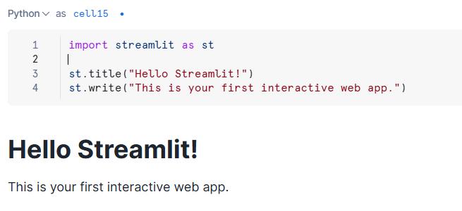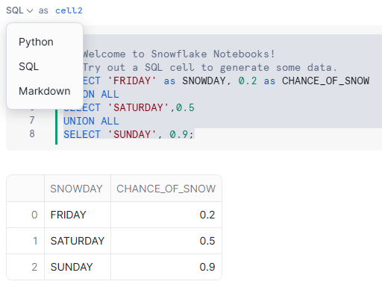
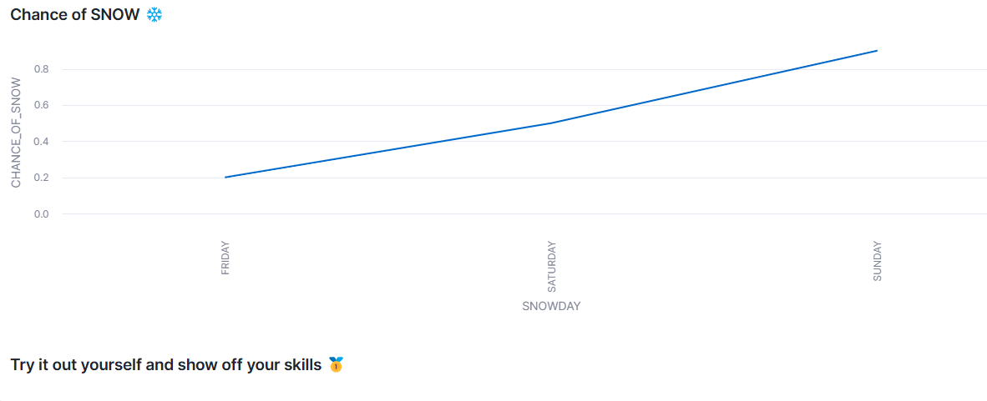

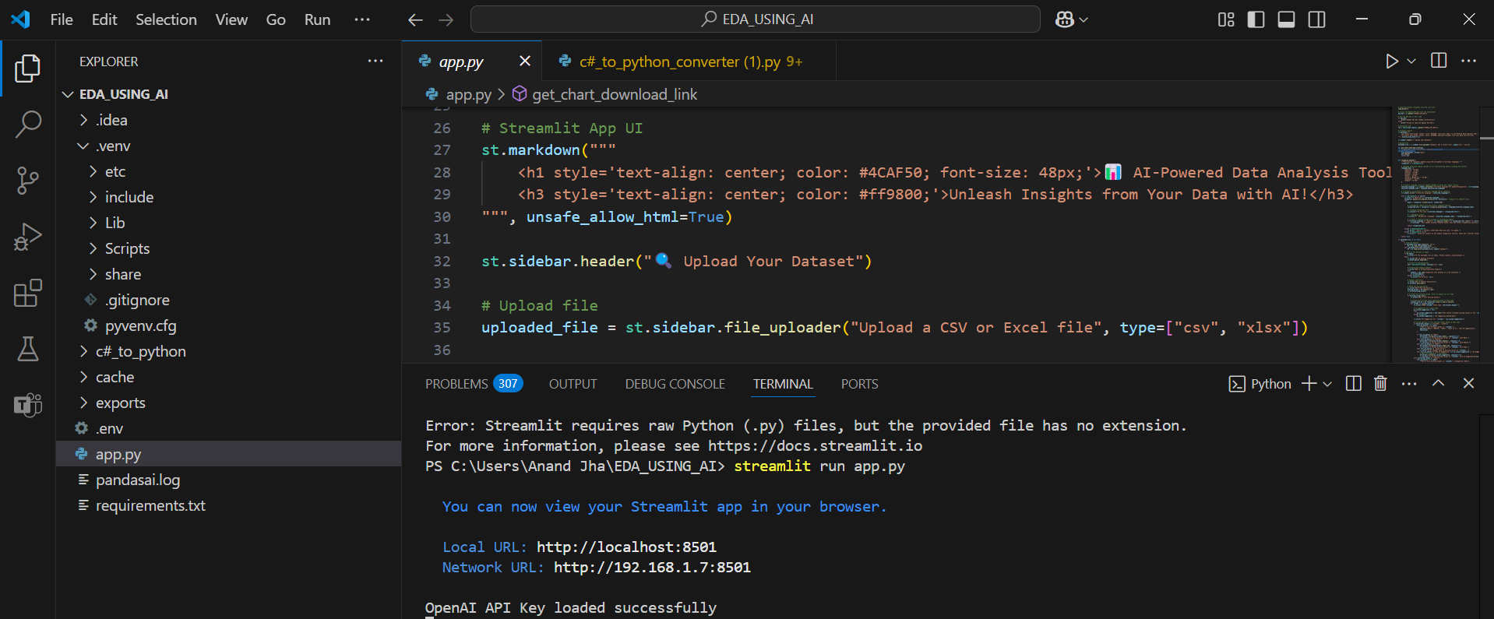
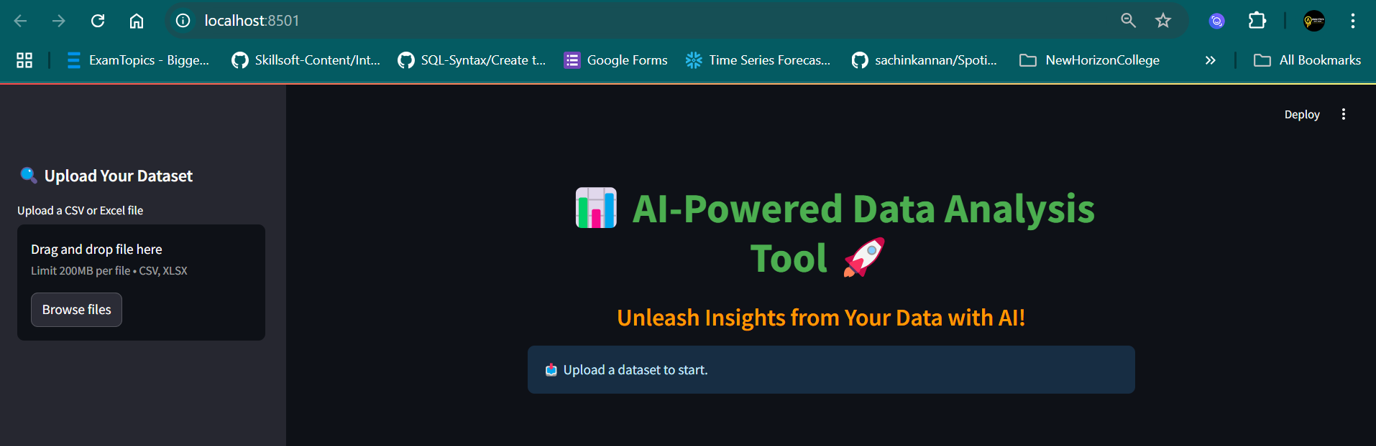

🧩 Best practices & performance tips
Cache results in Streamlit with @st.cache_data for repeat queries — reduces repeated warehouse consumption.
Push computation to Snowflake (use Snowpark) rather than pulling raw data into Python for processing.
Minimize query size (select only needed columns, use LIMIT in development).
Use parameterized SQL or Snowpark to prevent SQL injection.
Specify required packages in environment.yml / Snowflake project config when deploying so the runtime has correct libs.

🧩Quick checklist before you start coding
Do you have a Snowflake account (or trial) and a role with privileges on the DB/schema?
Install: streamlit, snowflake-connector-python, snowflake-snowpark-python.
Create st.secrets for local testing, or use st.connection("snowflake") in Snowflake environment.
let’s dive deeper into a few of the key parts of using Streamlit with Snowflake: how the connection works, how deployment works (with details), and some architecture & role/privilege considerations. Then we’ll walk through a slightly more advanced code example.

🧩Deeper look at the connection & runtime behaviour

Local vs inside Snowflake
If you’re developing locally (on your laptop) you’ll typically use st.connection("snowflake") or the older pattern of using snowflake.connector.connect() / snowflake-snowpark etc. According to the Streamlit docs: “When an app is running in Streamlit in Snowflake, st.connection("snowflake") connects automatically using the app owner’s role without further configuration.”
Locally you must supply credentials (via st.secrets, or other methods) because the automatic role assumption inside Snowflake isn’t available.
On Snowflake (in-cloud) the Streamlit app becomes a native Snowflake object; it uses a specified warehouse for its compute and runs inside Snowflake’s managed infrastructure.

What happens when the app runs
The Streamlit app, when deployed in Snowflake, is tied to a query warehouse. From the docs: “To run a Streamlit app, you must select a single virtual warehouse to run both the app itself and its queries.”
The warehouse remains active while the WebSocket connection (between the user’s browser and the Streamlit app) is open; when it’s idle (approx ~15 minutes) the warehouse may auto-suspend.
The apps are stored (files, code) in an internal stage or “Snowflake object” system. They run near the data (so less data movement) and are secured via Snowflake’s role & access controls (RBAC).

Using st.connection("snowflake") API
Key points from docs:
Syntax: conn = st.connection("snowflake") (or st.connection("<name>", type="snowflake")).
.query(...) method available for executing SQL and returning pandas or SnowparkDataFrame.
For local dev you can pass credentials via secrets.toml (which Streamlit picks up) or via connection kwargs. In production inside Snowflake, the connection uses the app owner’s role so credentials aren’t required.
If you want to use full SnowparkDataFrame APIs, you’ll still create a session using snowflake.snowpark and then use that inside Streamlit.
(Useful for data transformation in code rather than pure SQL).

Compute & cost implications
Because the app uses a Snowflake virtual warehouse, every query you run (especially heavy ones) will consume compute credits. So you must design your queries for performance (e.g., push work into Snowflake, avoid pulling huge tables to Python).
Caching at the Streamlit layer (with @st.cache_data) helps avoid repeated heavy queries.
When user count is large, you may need to size the warehouse (X-Small vs Large) and manage concurrency. You might also consider manual suspend/resume or auto-suspend after idle time to reduce cost.
You should also monitor warehouse usage from Snowflake (WAREHOUSE_LOAD_HISTORY, etc) to identify bottlenecks or cost spikes due to app usage.

Important billing/compute detail: The warehouse remains active while the WebSocket connection (between browser and backend) is open. After ~15 minutes idle the connection expires and the warehouse can auto-suspend.
You can adjust the timeout by providing a config.toml in the stage (under .streamlit/) with [snowflake.sleep] streamlitSleepTimeoutMinutes = X settings.

🎯 Summary Table of Components
Component | Purpose | Key notes
Streamlit app code (Python) | UI + logic | Use Streamlit widgets + data access
Snowflake warehouse (compute) | Runs code & queries | Must be specified; cost/auto-suspend matters
Storage/Stage & Files | Store code/assets/config | Upload stage or via CLI
RBAC & Security | Access control for app/data | Grant roles on app; row-level security
UI/Frontend (Browser) | User interacts via widgets | Client-server model
Deployment tools (Snowsight/CLI) | Manage project lifecycle | snow init, snow deploy, etc
Data Access APIs (Connector/Snowpark) | Connect to Snowflake data | st.connection, Snowpark session

🎯 Streamlit components
— each with a short one-line description for quick reference
Streamlit Function / Component | Purpose / One-line Description
st.markdown("---") | Adds a horizontal line divider in the app using Markdown syntax.
st.caption() | Displays small, gray-colored caption text for notes or explanations.
st.divider() | Inserts a simple horizontal line divider (same as st.markdown("---")).
st.expander() | Creates a collapsible section to hide or show additional content.
st.sidebar | Adds elements (widgets, text, etc.) to the sidebar area of the app.
st.sidebar.header() | Adds a header title section inside the sidebar.
st.toast() | Shows a small temporary popup notification on the app screen.
st.sidebar.selectbox() | Adds a dropdown menu (select box) inside the sidebar.
st.sidebar.success() | Displays a green success message inside the sidebar.
st.sidebar.info() | Displays an informational blue message inside the sidebar.
st.success() | Shows a green success alert box in the main page area.
st.write() | Displays text, data, or any Python object (auto-formatted).
st.button() | Creates a clickable button to trigger an action or function.
st.error() | Displays a red error message box for alerts or validation.

