SNOWFLAKE TRAINING
DAY 08

Iceberg Table implementation in Snowflake

Enterprise Training • Hands-On Labs
Corporate Data & AI Training Programs

Iceberg Table Implementation in Snowflake :

Implementation:

To implement the Iceberg tables, we need to create External Volumes:

External Volumes hold the File data and table metadata, all in customer-supplied storage.

- Create External Volume:
- Before creating External Volume, Create Bucket and new Role on your AWS account
- Grant S3 full access policy to your new Role
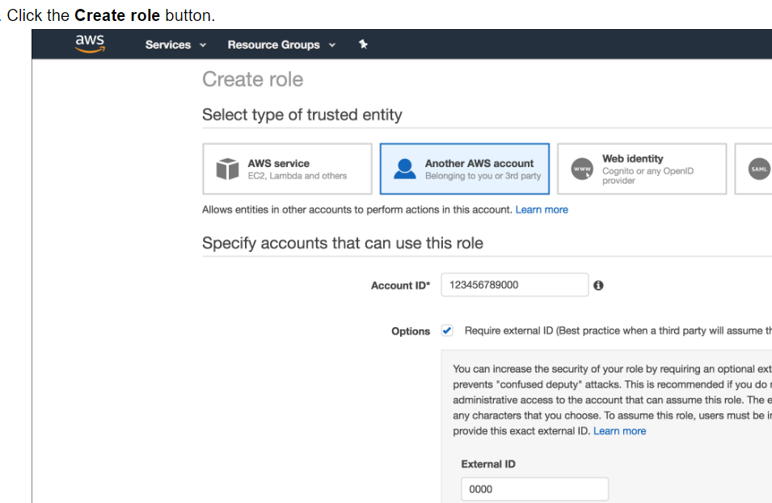

Create External Volume pointing to the S3 bucket
create external volume iceberg_int
storage_locations =
(
(
name = 'my-s3-us-east-2'
storage_provider = 'S3'
storage_base_url = 's3://icebergconfigbucket/'
storage_aws_role_arn = 'arn:aws:iam::913267004595:role/icebergconfigrole'
)
);

- DESC EXTERNAL VOLUME iceberg_int and copy the below highlighted parameters

{"NAME":"my-s3-us-east-2","STORAGE_PROVIDER":"S3",
"STORAGE_BASE_URL":"s3://icebergpracticebucket1/","STORAGE_ALLOWED_LOCATIONS":["s3://icebergpracticebucket1/*"],
"STORAGE_REGION":"us-east-2","STORAGE_AWS_ROLE_ARN":"arn:aws:iam::913267004595:role/icebergrole",
"STORAGE_AWS_IAM_USER_ARN":"arn:aws:iam::315033924470:user/i4v10000-s",
"STORAGE_AWS_EXTERNAL_ID":"QX73654_SFCRole=2_f2MhffRI7tL5Dlrr1HpqmsLmcwc="}

- Granting the IAM User Permissions to Access Bucket Objects

- Click the Edit trust relationship button of your new role.

- Modify the policy document with the DESC EXTERNAL VOLUME

- output values you recorded in previous step

- Click the Update Trust Policy button. The changes are saved

- Create Iceberg table: Two ways to create iceberg table:

Approach1:

create or replace iceberg table customer_detail (
CUST_NUM varchar,
CUST_STAT varchar ,
CUST_BAL number(10,0),
INV_NO varchar ,
INV_AMT number(10,2),
CRID varchar ,
SSN varchar,
phone number(10,0),
Email varchar
)
CATALOG = 'SNOWFLAKE'
external_volume='iceberg_int'
BASE_LOCATION = 'CUSTOMER_INFO';

create or replace storage integration s3_int
type = external_stage
storage_provider = s3
enabled = true
storage_aws_role_arn = 'arn:aws:iam::913267004595:role/testsnowflake'
storage_allowed_locations = ('s3://srcbucketsachin/');

desc integration s3_int

create or replace file format demo_db.public.csv_format
type = csv
skip_header = 1
null_if = ('NULL', 'null')
empty_field_as_null = true;

create or replace stage demo_db.public.ext_csv_stage
URL = 's3://srcbucketsachin/POC'
STORAGE_INTEGRATION = s3_int
file_format = demo_db.public.csv_format;

list @demo_db.public.ext_csv_stage

copy into prod_tbl
from @demo_db.public.ext_csv_stage/Customer_Invc.csv
on_error = CONTINUE;

Approach2:

create or replace iceberg table customer_detail
with EXTERNAL_VOLUME = 'iceberg_int'
as select CUST_NUM, CUST_STAT, CUST_BAL,INV_NO, INV_AMT, CRID,SSN,PHONE,EMAIL from CUSTOMER;

HANDS – ON LAB :

-- =========================================================
-- SNOWFLAKE ICEBERG TABLE
-- =========================================================

-- CREATE DATABASE & SCHEMA

CREATE OR REPLACE DATABASE ORDERS_DB;
CREATE OR REPLACE SCHEMA ORDERS_DB.ORDERS_SCHEMA;

create or replace file format csv_format
type = csv
skip_header = 1
null_if = ('NULL', 'null')
empty_field_as_null = true;

--upload both files
create or replace stage orders_db.orders_schema.iceberg_load
file_format = orders_db.orders_schema.csv_format;

list @orders_db.orders_schema.iceberg_load;

-- tables just for testing
create or replace iceberg table customer_detail (
CUST_NUM varchar,
CUST_STAT varchar,
CUST_BAL number(10,0),
INV_NO varchar,
INV_AMT number(10,2),
CRID varchar,
SSN varchar,
phone number(10,0),
Email varchar
)

create or replace table Accessory_Detail (
CUST_NUM varchar,
Accessory varchar,
status varchar,
amount number(10,0),
renewal varchar
);

create external volume iceberg_int
storage_locations =
(
(
name = 'iceberg_bucket'
storage_provider = 'S3'
storage_base_url = 's3://icebergconfigbucket/'
storage_aws_role_arn = 'arn:aws:iam::913267004595:role/icebergconfigrole'
)
);

describe external volume iceberg_int;

{"NAME":"iceberg_bucket",
"STORAGE_PROVIDER":"S3",
"STORAGE_BASE_URL":"s3://icebergconfigbucket/",
"STORAGE_ALLOWED_LOCATIONS"["s3://icebergconfigbucket/*"],
"STORAGE_AWS_ROLE_ARN":"arn:aws:iam::913267004595:role/icebergconfigrole",
"STORAGE_AWS_IAM_USER_ARN":"arn:aws:iam::940482405254:user/hzdt0000s",
"STORAGE_AWS_EXTERNAL_ID":"RU48962_SFCRole=2_iMI2Dcus3iSF+ArSHAB83WJ8twQ=",
"ENCRYPTION_TYPE":"NONE","ENCRYPTION_KMS_KEY_ID":""
};

create or replace iceberg table customer_detail (
CUST_NUM varchar,
CUST_STAT varchar ,
CUST_BAL number(10,0),
INV_NO varchar ,
INV_AMT number(10,2),
CRID varchar ,
SSN varchar,
phone number(10,0),
Email varchar
)
CATALOG = 'SNOWFLAKE'
external_volume='iceberg_int'
BASE_LOCATION = 'CUSTOMER_INFO';

show tables;

copy into customer_detail
from @orders_db.orders_schema.iceberg_load/Customer_Invoice.csv
on_error = CONTINUE;

select * from customer_detail;

-- Since Iceberg stores Parquet files in S3, you can inspect them using Parquet viewers.
-- https://www.tablab.app/parquet/view

create or replace table Accessory_Detail (
CUST_NUM varchar,
Accessory varchar ,
status varchar ,
amount number(10,0),
renewal varchar

);

copy into Accessory_Detail
from @orders_db.orders_schema.iceberg_load/Accessory.csv
on_error = CONTINUE;

select * from Accessory_Detail;
select * from customer_detail;

select * from customer_detail c,accessory_detail a
where c.cust_num = a.cust_num;

CREATE MASKING POLICY mask_ssn_policy AS (val STRING)
RETURNS STRING ->
CASE
WHEN CURRENT_ROLE() IN ('OPS', 'SECURITY_ADMIN') THEN val
ELSE 'XXX-XX-' || RIGHT(val, 4)
END;

ALTER ICEBERG TABLE customer_detail MODIFY COLUMN SSN SET MASKING POLICY mask_ssn_policy;

CREATE OR REPLACE ROW ACCESS POLICY CRID_ACCESS_POLICY
AS (crid_column STRING) RETURNS BOOLEAN ->
CASE
-- Example: Allow users with role 'CRID_ACCESS_ROLE' to see all rows
WHEN CURRENT_ROLE() = 'CRID_ACCESS_ROLE' THEN TRUE
-- Restrict access for others based on CRID
WHEN crid_column LIKE '2Z3%' THEN TRUE
ELSE FALSE
END;

ALTER iceberg TABLE customer_detail ADD ROW ACCESS POLICY CRID_ACCESS_POLICY ON (CRID);

select * from Filtered_Customer_Accessory;

CREATE OR REPLACE ICEBERG TABLE Customer_Accessory_iceberg (
CUSTOMER_ID varchar,
status varchar ,
customer_bal number(10,0),
Accessory varchar ,
Accessory_Status varchar,
amount number(10,0)
)
CATALOG = 'SNOWFLAKE'
EXTERNAL_VOLUME = 'iceberg_int'
BASE_LOCATION = 'CUST_ACCESSORY';

select * from Customer_Accessory_iceberg;

— End of Document —

