🔹 What is Streamlit?
Streamlit is a free, open-source Python framework used to build interactive, data-driven web apps quickly and easily — with no front-end experience required.
You don’t need to be a web developer. If you know Python, you can build useful, beautiful data apps that run in a web browser.
✅ Key Features:
- Streamlit = Python + Simplicity + Web App
- Great for prototyping ideas, sharing AI tools, or building business dashboards
- No web dev skills needed
- Free and open source
- Free and open source
- Works great with Snowflake, Pandas, and AI tools
- Turn Python scripts into shareable web apps in minutes
- Native support for Pandas, NumPy, Matplotlib, Plotly, and more
- Real-time interactivity using widgets like sliders, dropdowns, buttons, etc.
- Ideal for data scientists and analysts who want to visualize and share insights fast

🧠 Why Use Streamlit?
Traditionally, if someone wanted to build a web app, they needed to learn:
- Frontend tools like HTML, CSS, JavaScript
- Web frameworks like Flask or Django
- Hosting and deployment
Streamlit removes all that complexity. You write a Python script, add a few special st. commands (like st.write, st.button, st.slider), and Streamlit handles everything else — including the UI.

🛠️ What Can You Do With Streamlit?
Here are some things you can build with Streamlit:
Use Case | Description
Data Dashboards | Display charts, tables, KPIs, and metrics for business data
AI/ML Model Demos | Allow users to upload data, get predictions, or view model outputs
Customer Feedback Apps | Analyze and summarize survey or transcript data
Business Tools | Build interactive tools (like pricing calculators or cost estimators)
Chatbots & NLP Tools | Interface with GPT, LLMs, or sentiment analysis tools

🖥️ Who Can Use Streamlit?
- ✅ Data analysts and scientists — to make models useful for others
- ✅ Business users — to get insights without coding
- ✅ Teachers/trainers — to create interactive tutorials or demos
- ✅ Anyone who knows a bit of Python and wants to make something people can use

🎯 Key Features of Streamlit
Feature | What it Does
st.write() | Display text, data, charts, and more
st.button(), st.slider(), st.text_input() | Interactive controls
st.file_uploader() | Allow users to upload Excel, CSV, or image files
st.dataframe() | Show tables and dataframes nicely
st.line_chart(), st.bar_chart() | Plot charts instantly
Live reload | Your app refreshes every time you save the Python file
Simple deployment | Easily deploy to the cloud (Streamlit Cloud or Snowflake)

🧩 How Streamlit Works – A Simple Flow
- You write a Python script (app.py)
- You use Streamlit commands (st.write(), st.button(), etc.)
- Run the script with: streamlit run app.py
- It opens a web page where your app is running live.
- Users can interact with it, just like any normal website!
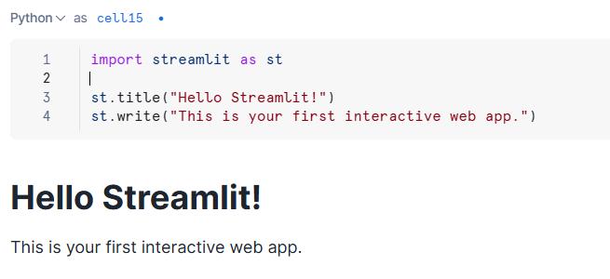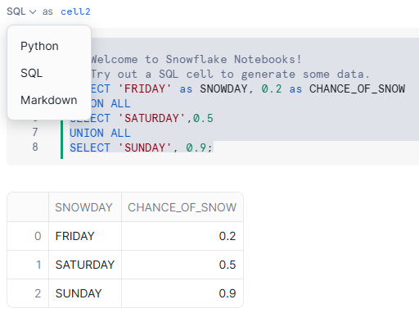
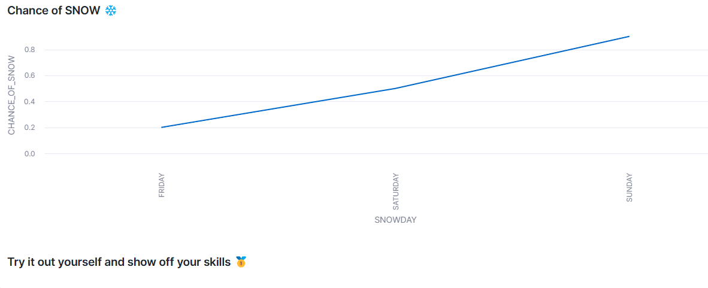

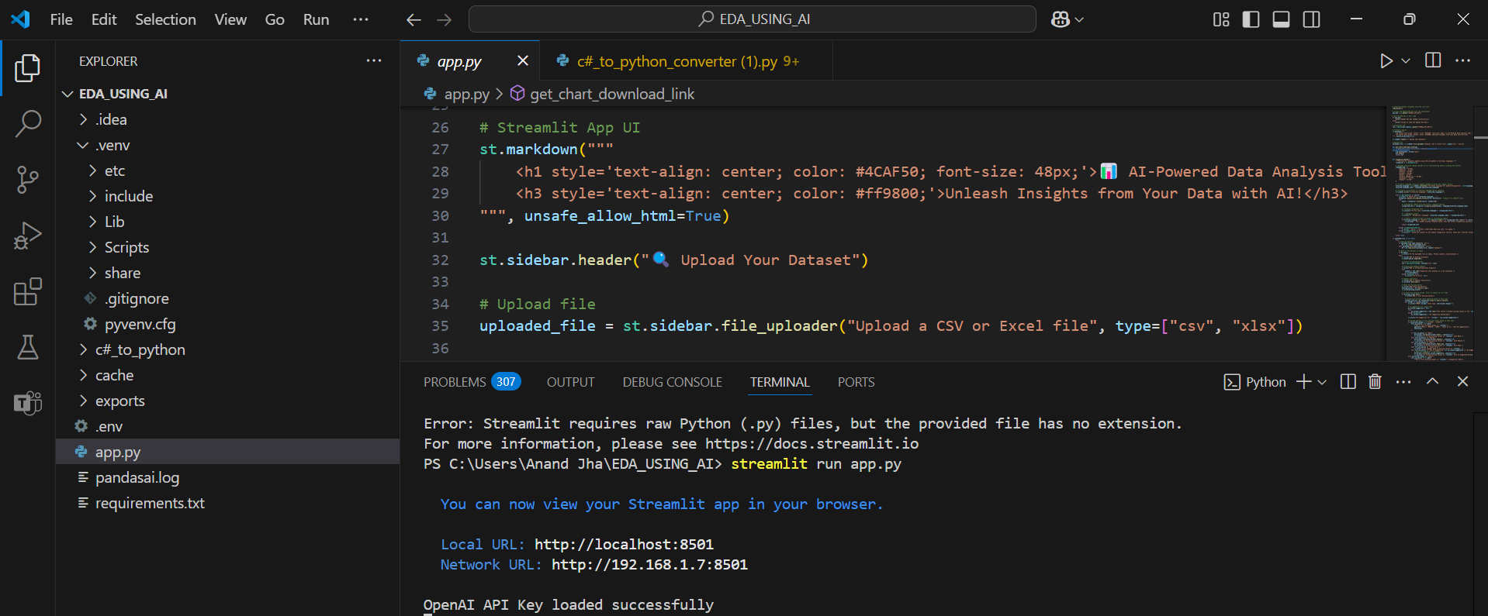
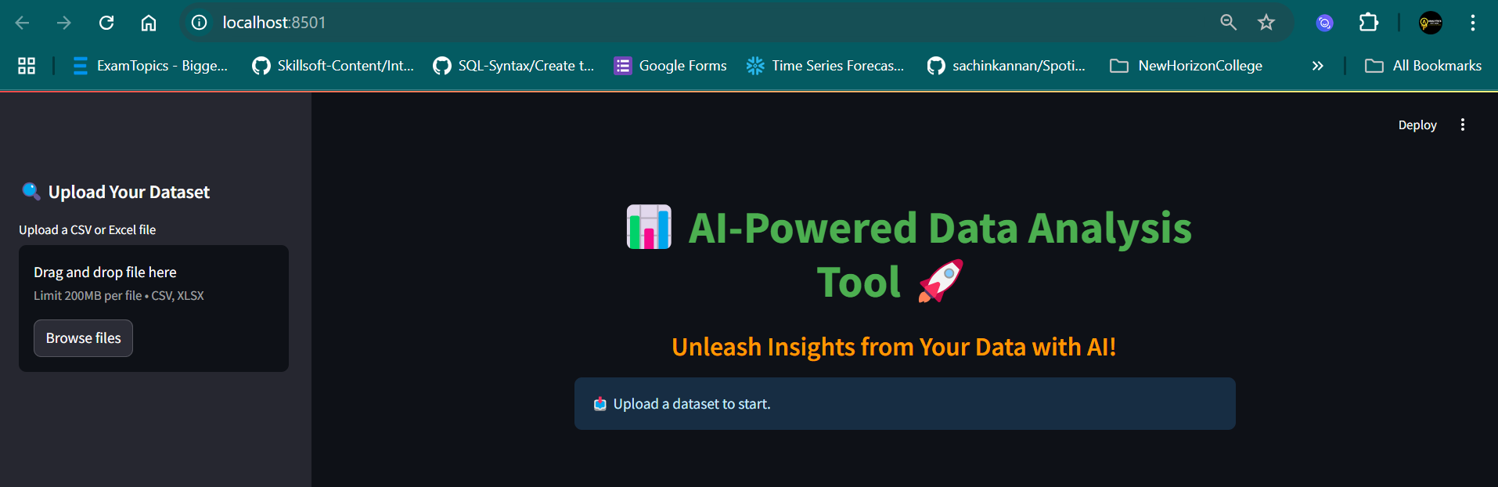

🔹 Business Problem: Call Center Sentiment Analyzer
🎯 Use Case Overview:
A company has thousands of call center transcripts stored in Snowflake. They want to:
- Analyze customer sentiment from these transcripts
- Summarize each call using an LLM
- Display insights in an interactive Streamlit dashboard
🧩 Business Goal:
Help the customer support team understand customer issues better and identify areas for improvement based on conversation analytics

🧾 Project Overview: Call Transcript Sentiment Analysis with Snowflake Cortex & Streamlit
In today’s customer-centric businesses, millions of customer service interactions—including calls, emails, and chats—take place every day. Analyzing this vast amount of unstructured communication manually is not only time-consuming but also nearly impossible to scale. Sentiment analysis helps solve this by automatically detecting the emotional tone behind each message.
🎯 Business Problem
Imagine a large enterprise receiving hundreds of thousands of customer complaints or support calls monthly. It becomes nearly impossible for teams to:
- Review every call transcript manually
- Identify which customers are angry, frustrated, or at risk of churn
- Prioritize critical complaints quickly
- Route issues to the right department with urgency
Ignoring these signals can lead to:
- Poor customer satisfaction
- Brand reputation damage
- Missed revenue recovery opportunities

🤖 How Snowflake Cortex AI Helps
Using Snowflake Cortex’s AI functions like SENTIMENT, we can:
- Automatically analyze the sentiment of each customer call
- Classify transcripts as Positive, Neutral, or Negative
- Summarize long conversations to extract key points
- Classify the topic of discussion (e.g., billing, technical issue, cancellation)
- Translate customer conversations if needed
This all happens natively inside Snowflake, without needing to move data to external ML platforms, which:
- Speeds up processing
- Improves data security
- Reduces engineering overhead

🖥️ Streamlit for Interactive Apps
We use Streamlit inside Snowflake to build an easy-to-use dashboard for analysts or support managers. With a few clicks, they can:
- Select a call from a list
- Instantly see the sentiment and topic
- Read an AI-generated summary
- Take immediate action based on insights

💡 Real-World Impact
This kind of automation is a game-changer for industries like:
- Telecom: Monitoring customer satisfaction at scale
- E-commerce: Detecting unhappy customers before they churn
- Banking/Insurance: Flagging high-risk conversations for compliance
- Tech Support: Prioritizing negative feedback for faster resolution

🔹 Step-by-Step Plan to Build the App
1. Snowflake Setup (assumed pre-known):
- Table: CALL_TRANSCRIPTS
CREATE TABLE CALL_TRANSCRIPTS (
CALL_ID STRING,
AGENT_NAME STRING,
CUSTOMER_NAME STRING,
CALL_DATE DATE,
TRANSCRIPT TEXT
);
- Load the datasets :
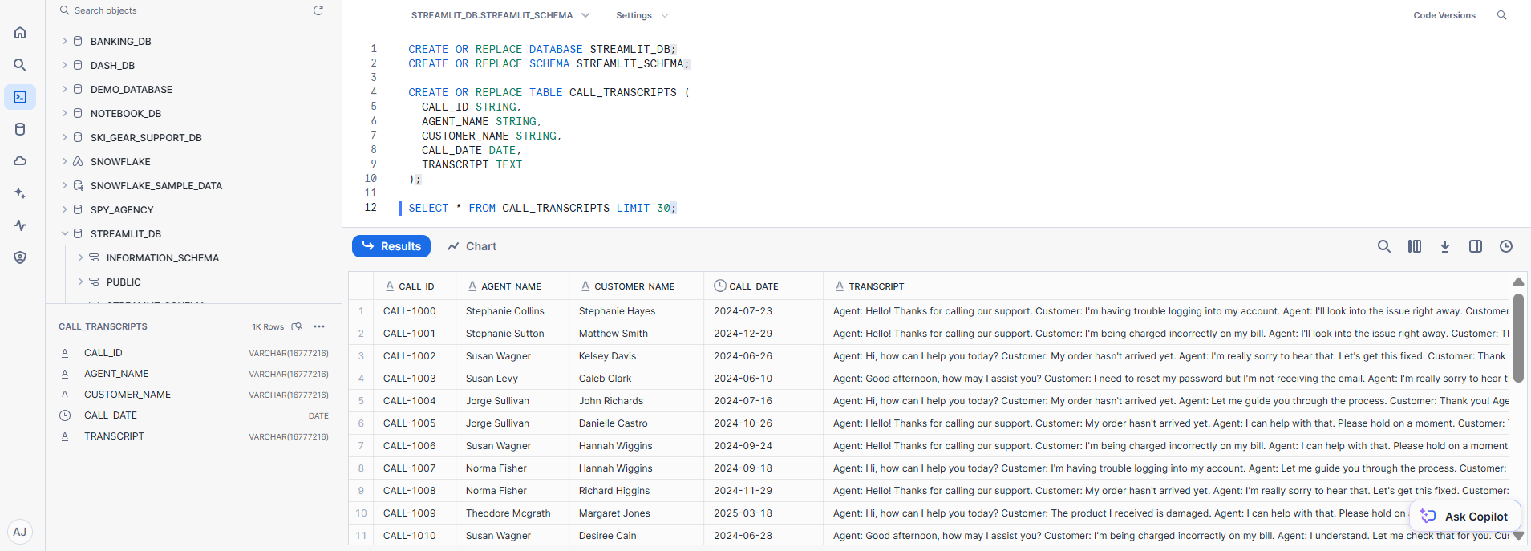
2. Streamlit App Plan:
🧱 Key Features:
- Dropdown to select an agent or date range
- Display filtered transcripts
- Button to analyze sentiment + summarize using Snowflake Cortex or OpenAI
- Show sentiment and summary for each call (AI using Cortex or external API)

📘 Understanding Snowflake Cortex AI – A Beginner-Friendly Guide
🧠 What is Snowflake Cortex?
Snowflake Cortex is an AI and machine learning service built directly into the Snowflake Data Cloud.
It allows you to perform powerful AI tasks — like summarizing text, understanding customer sentiment, or classifying messages — without needing to train a machine learning model yourself.
You just send it your data, and it returns the insights. It's as simple as writing a query or calling a function.
🔍 AI Functions We Used (with Simple Explanations)
In our Streamlit app, we used several AI-powered functions provided by Snowflake Cortex. Let's break down each one:
1️.SNOWFLAKE.CORTEX.SUMMARIZE()
🗂 What it does:
- Summarizes a long block of text into a short, clear summary.
- For example, you can take a customer support call transcript and get a 2-3 sentence summary of what happened.
💡 Why it’s useful:
- Helps managers and support teams quickly understand the key points of a long conversation without reading everything.
📌 Example:
SELECT SNOWFLAKE.CORTEX.SUMMARIZE('Customer called to report login issues...') AS summary;
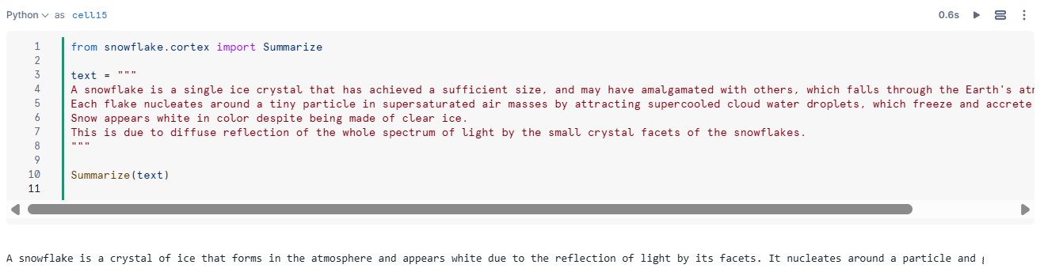

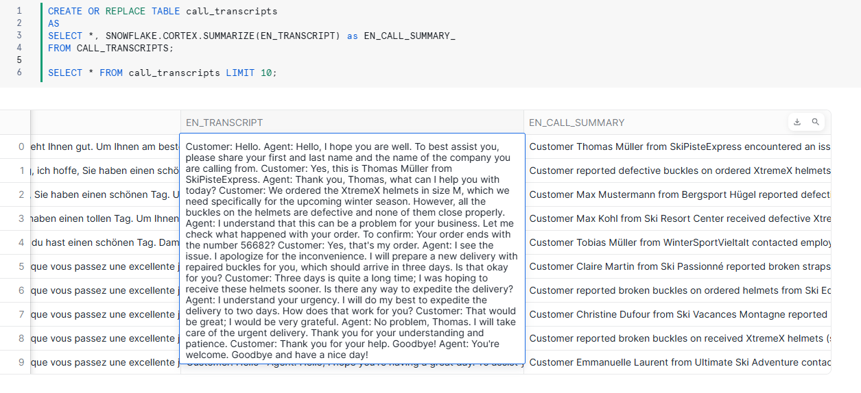
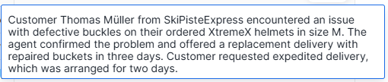
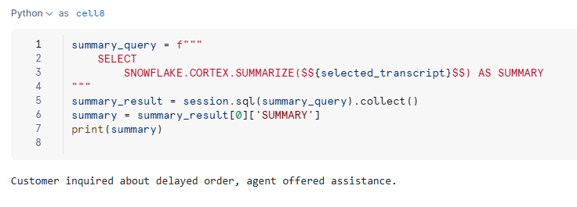
2️. SNOWFLAKE.CORTEX.SENTIMENT()
🧭 What it does:
- Detects the tone or emotion in a block of text — is it positive, negative, or neutral?
💡 Why it’s useful:
- Quickly understand how a customer feels in a support chat or survey feedback.
- Identify angry customers or happy ones automatically.
📌 Example:
SELECT SNOWFLAKE.CORTEX.SENTIMENT('I am very disappointed with your service') AS sentiment;
Output: "NEGATIVE"
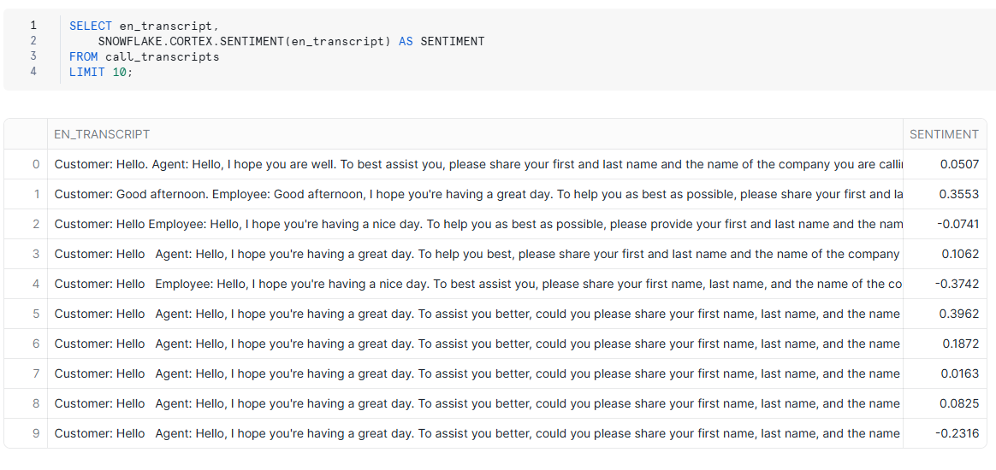

3️. SNOWFLAKE.CORTEX.CLASSIFY_TEXT()
🗃 What it does:
- Categorizes text into predefined groups or labels.
- For example, classify incoming messages as "Billing", "Technical Support", or "Account Access".
💡 Why it’s useful:
- Automates customer routing in support centers
- Helps in tagging content and understanding topics at scale
📌 Example:
SELECT SNOWFLAKE.CORTEX.CLASSIFY_TEXT( 'I forgot my password and can’t log in.',
ARRAY_CONSTRUCT('Billing', 'Technical Support', 'Account Access')) AS category;
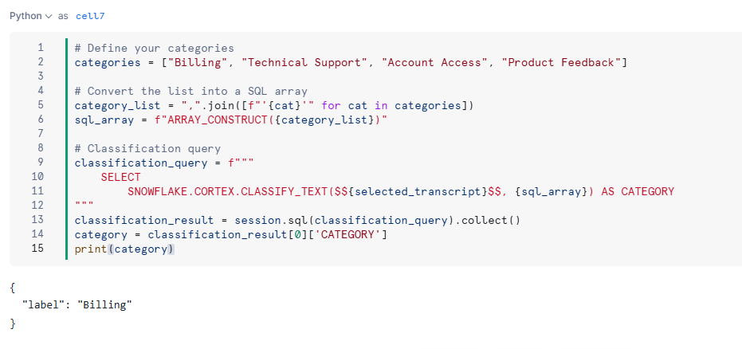
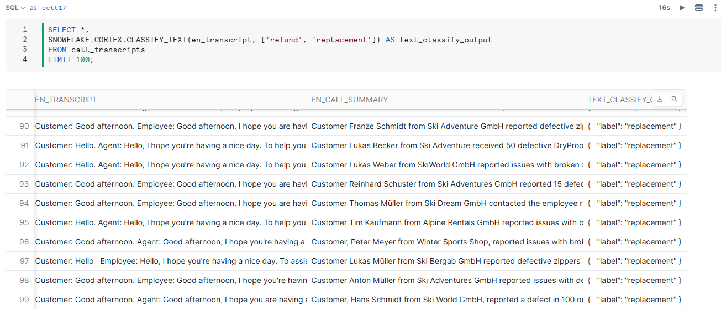
4️.SNOWFLAKE.CORTEX.TRANSLATE()
🌍 What it does:
- Automatically translates text from one language to another using AI.
💡 Why it’s useful:
- Lets companies handle customer messages in different languages and convert them into one standard language (e.g., English) for easier processing.
🌐 Supported Languages
Snowflake Cortex supports many major global languages, including:
English ('en'), French ('fr'), Spanish ('es'), German ('de'), Hindi ('hi'), Chinese ('zh'), Japanese ('ja'), Portuguese ('pt') and more...

📌 Example:
SELECT SNOWFLAKE.CORTEX.TRANSLATE( 'Je ne peux pas accéder à mon compte.','en') AS translated_text;
Output: "I can't access my account."
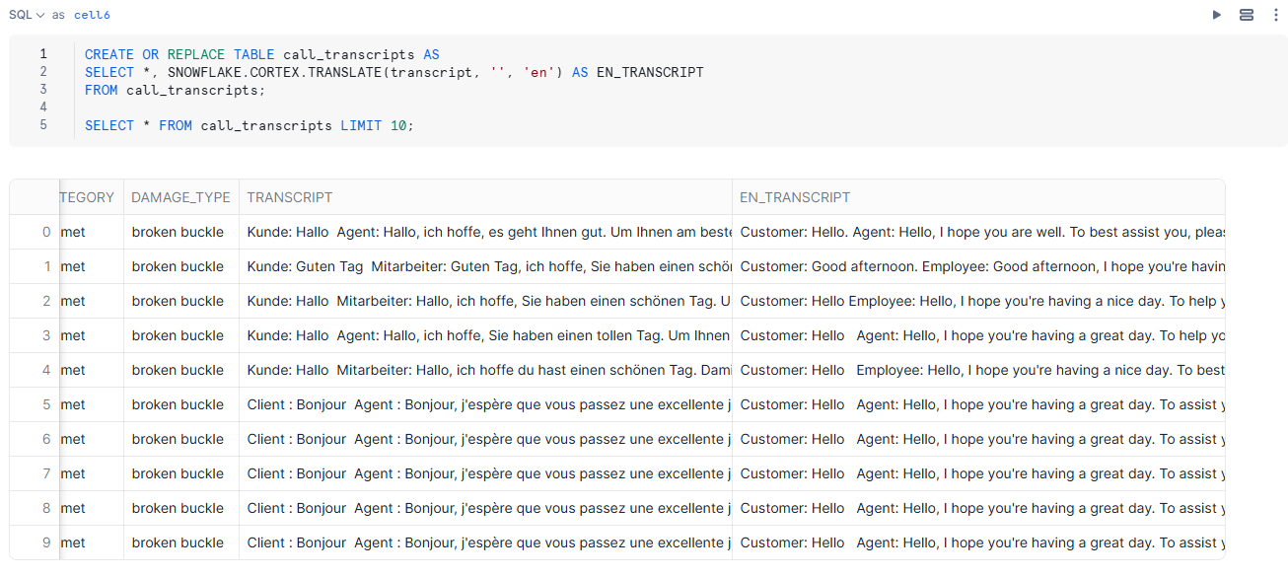
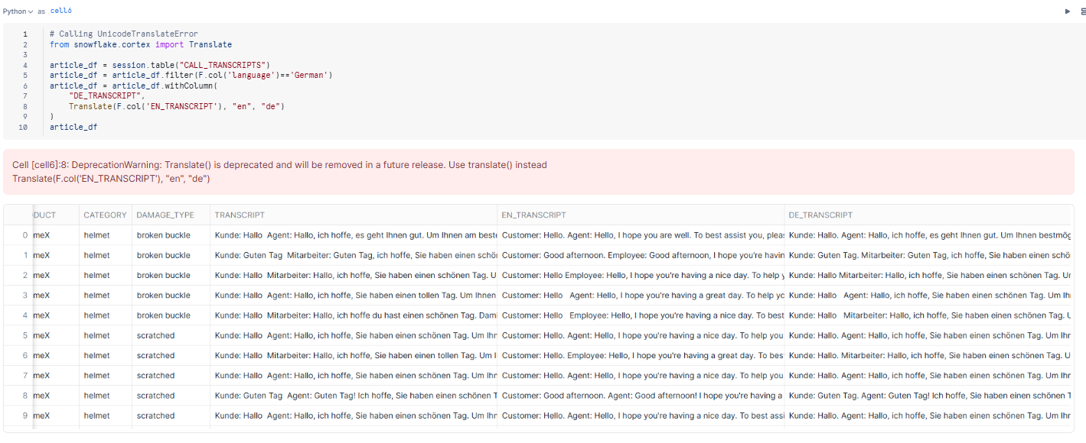
✅ How Did We Use These in Our App?
In our Streamlit app, we:
- Let the user choose a customer call transcript.
- Used SUMMARIZE() to create a short summary of the call.
- Used SENTIMENT() to analyze the mood of the conversation.
- Used CLASSIFY_TEXT() to categorize what the call was about.
- Used TRANSLATE() to convert from one language to another.
- Displayed all results instantly in a friendly web app!

🎯 Benefits for Business Users
Feature | Benefit
No need to train a model | Prebuilt AI functions are ready to use instantly
Scalable | Can analyze thousands of records at once
Accurate | Uses powerful models behind the scenes
Secure | Runs inside your Snowflake account – no data leaves your system
Fast to implement | You can build apps or dashboards in hours, not weeks

✅ Snowflake Cortex: Error Troubleshooting Guide
🔧 1. Unknown Function or Compilation Errors
Example: Unknown user-defined function SNOWFLAKE.CORTEX.SUMMARIZE
Cause:
- Function not yet enabled in your Snowflake region or edition
- Typo in function name or improper syntax
Fixes:
- Check Cortex documentation for supported functions.
- Contact Snowflake support to enable Cortex in your region/account.
- Ensure correct syntax:
SELECT SNOWFLAKE.CORTEX.SUMMARIZE('your input text') AS result;

🔐 2. Permission or Role Errors
Example:
Permission denied: role does not have usage on Cortex
Fixes:
- Switch to a role with USAGE privileges for Cortex.
- Use ACCOUNTADMIN or a custom role with sufficient permissions.
- Ensure your warehouse is active and large enough (L, XL, etc.)

📥 3. Invalid Identifier or Variable Usage
Example:
Invalid identifier 'SELECTED_TRANSCRIPT'
Cause:
- You're using a Python variable inside SQL without proper handling.
Fix: Use parameterized SQL or inline the Python variable using $$:
query = f"""
SELECT SNOWFLAKE.CORTEX.SUMMARIZE($${selected_transcript}$$) AS summary
"""
result = session.sql(query).collect()

🧠 4. Unsupported Models or Functions
Example:Invalid model name: llama2-70b-chat
Fixes:
- Double-check supported models in your account
- Use:
SELECT * FROM SNOWFLAKE.CORTEX.LIST_MODELS();
- Choose model names like:
  - mistral-7b
  - llama2-13b-chat
  - anthropic.claude-v1

🔤 5. Too Long Input Text
Example:
Input exceeds max token limit (e.g., 4,096 tokens)
Fixes:
- Use SUBSTR() in SQL or .str.slice() in pandas to reduce length
- Summarize large text before feeding it to other functions

💸 6. Cost Estimation Function Not Found
Example:
Unknown function SNOWFLAKE.CORTEX.ESTIMATE_TOKENS
Fixes:
- These helper functions are being rolled out gradually
- Not available in every region — check with Snowflake
- For now, use an external estimator like Python + tiktoken

🔗 7. Streamlit Runtime Issues (Snowflake Native App)
Symptoms:
- App crashes on LLM call
- Empty screen or no output
Fixes:
- Add exception handling around model calls:
try:
result = session.sql(query).collect()
except Exception as e:
st.error(f"Error: {str(e)}")
- Log inputs/outputs to debug token or format issues

✅ Best Practices Summary
Step | Action
1 | Always check your role, warehouse, and region
2 | Use parameterized variables in SQL carefully
3 | Use try/except to catch runtime errors in Streamlit
4 | Log or print debug messages (st.write(...))
5 | Estimate cost and token length ahead if possible
6 | Stay within token limits of the selected model

💰 Cost Components of Streamlit in Snowflake
- Virtual Warehouse Usage
  - Each Streamlit app requires a virtual warehouse to execute both the app and any associated SQL queries.
  - The warehouse remains active as long as the app's WebSocket connection is open, which typically stays alive for about 15 minutes after the last user interaction.
  - Charges are based on the size of the warehouse and the duration it remains active.
  - To manage costs, you can configure the warehouse to auto-suspend after a period of inactivity or manually suspend it when not in use. Snowflake
- Cortex Function Usage (if applicable)
  - If your Streamlit app utilizes Snowflake Cortex AI functions (e.g., SUMMARIZE, SENTIMENT, CLASSIFY_TEXT, TRANSLATE), additional charges apply based on the number of tokens processed.
  - Each function has its own pricing model, often calculated per 1,000 tokens processed.
  - It's advisable to consult the Snowflake Cortex pricing guide for detailed information.
- Data Storage
  - While the primary costs are from compute and AI function usage, storing data (e.g., logs, user inputs, outputs) in Snowflake tables also incurs storage charges.
  - Storage costs are generally lower compared to compute costs and are calculated based on the amount of data stored per month. Snowflake

🧠 Tips to Optimize Costs
- Use Appropriate Warehouse Sizes: Select a warehouse size that matches your app's workload. For development or low-traffic apps, smaller warehouses (e.g., X-Small or Small) can be more cost-effective.Snowflake
- Implement Auto-Suspend: Configure your warehouse to auto-suspend after a short period of inactivity (e.g., 5 minutes) to prevent unnecessary charges.
- Monitor Usage: Regularly review your Snowflake usage reports to identify any unexpected compute or storage consumption.
- Optimize AI Function Calls: When using Cortex functions, ensure you're processing only necessary data to minimize token usage.
By understanding these components and implementing cost-saving strategies, you can effectively manage expenses associated with running Streamlit apps in Snowflake.

💰 Snowflake Cortex – Cost Factors for AI Functions (in Our Streamlit App)
Snowflake Cortex charges are primarily based on AI function usage, specifically the number of input/output tokens processed. A token is roughly 4 characters or 1 word (think of tokens like "chunks" of text).
📊 General Pricing Model
Each Cortex function uses an LLM (Large Language Model) under the hood. These models have associated cost per 1,000 tokens, and it varies depending on:
- Which function you're calling (Summarize, Sentiment, etc.)
- Whether it’s a general task (e.g., summarization) or a fine-tuned model
- Which model provider is used (e.g., OpenAI, Anthropic, Mistral, etc.)

🧠 AI Functions We Used and Their Cost Behavior
Function | Description | Tokens Counted | Cost Implication
SUMMARIZE | Summarizes text | Input tokens + Summary tokens | Higher cost if input is long (e.g., full transcripts)
SENTIMENT | Detects tone (positive/negative) | Input tokens only | Very low cost (short output)
CLASSIFY_TEXT | Categorizes text | Input + list of categories | Low to moderate (depends on category count)
TRANSLATE | Translates text between languages | Input + translated output tokens | Depends on language length (e.g., translating to German may use more tokens than to English)
COMPLETE (used in LLM tasks) | Full prompt-based completions | Input + generated text | Can be expensive depending on output length
FINETUNE | Custom model tuning | Varies significantly | High cost for training & storage

🔍 Real-Life Tips to Control Cost in Apps
- 🧹 Pre-clean the input text (remove noise, irrelevant content).
- 🪄 Summarize before classifying to reduce input length.
- 📏 Set character or token limits in your app UI.
- 📦 Cache results of calls in Streamlit to avoid repeated calls.
- 💡 Use smaller models (mistral-7b vs llama2-70b) when possible.

📌 Summary
Action | Cost Impact
Using SUMMARIZE() on large call transcripts | 💰 Moderate to High
Calling SENTIMENT() or CLASSIFY_TEXT() | 💸 Low
Adding TRANSLATE() for multilingual support | 💸 Low to Moderate
Running ESTIMATE_* helpers before real calls | ✅ No cost for AI compute

