❄️SNOWFLAKE
CORTEX AI
4-Hour Comprehensive Corporate Training
From Foundation to Production — All Inside Snowflake
Level: Intermediate to Advanced | Platform: Snowflake (100% Cloud)

Session Agenda — 4 Hours

This training is designed as an intensive, hands-on session where every concept is immediately followed by practical execution — entirely within Snowflake. No external tools, no local Python environments.

Module | Topic | Duration | Type
Module 1 | Snowflake Cortex AI - Introduction & Architecture | 30 min | Theory
Module 2 | Environment Setup & Dataset Loading | 20 min | Practical
Module 3 | Cortex LLM Functions - Complete | 45 min | Theory + Practical
Module 4 | Cortex Analyst & Search Service | 30 min | Theory + Practical
Module 5 | Cortex ML Functions - Forecasting & Anomaly | 45 min | Theory + Practical
Module 6 | Python Notebook - Advanced AI Workflows | 45 min | Practical (Notebook)
Module 7 | Cortex AISQL & Semantic Layer | 25 min | Theory + Practical
Module 8 | Real-world Use Cases & Best Practices | 20 min | Theory
 | Q&A and Wrap-up | 10 min | Discussion

📌 Note: All practicals use the ecommerce_cortex_dataset.csv (20,000 records) provided with this training. Load it into Snowflake before starting Module 3.

Module 1: Snowflake Cortex AI — Architecture & Overview

1.1 What is Snowflake Cortex AI?
Snowflake Cortex AI is the intelligent, fully managed AI and machine learning layer built directly into the Snowflake Data Cloud. It brings state-of-the-art large language models (LLMs), machine learning functions, and AI-powered search directly to your data — without any data movement, external API calls, or infrastructure management.
The core philosophy of Cortex AI is: Bring AI to the data, not data to the AI. Because Cortex runs inside Snowflake, your data never leaves the secure Snowflake environment.

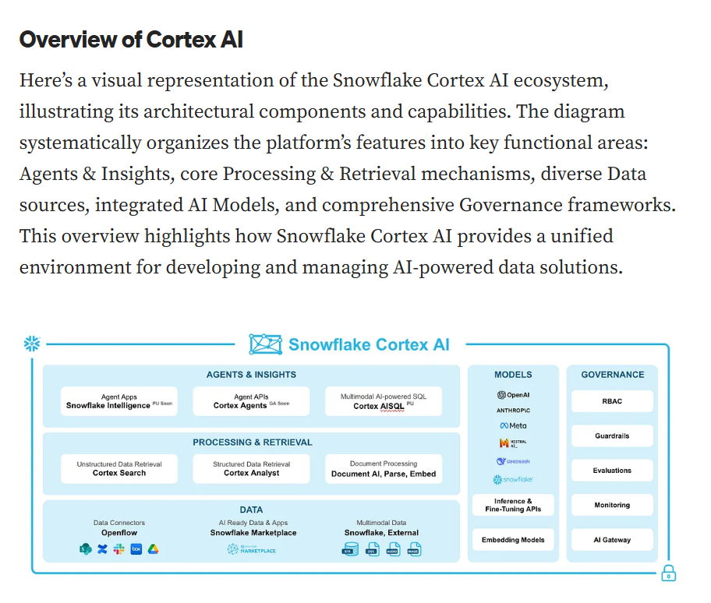

What an AI Agent Brings to Your Business Intelligence
Ready to see how an AI Agent can transform your BI? Here are some core advantages:
- Self-serve data exploration: Imagine generating charts and getting instant answers just by asking natural language questions. No more waiting for custom dashboards or deep technical expertise. This capability is all about cutting down on data request bottlenecks and maximizing how you utilize your data across the organization.
- Democratized intelligence: This agent grants you access to and analysis of thousands of data sources simultaneously. It’s a game-changer for transforming scattered information into clear, actionable business insights for everyone.
- Contextual deep analytical research: This isn’t just surface-level stuff. The agent uses advanced reasoning and analytical methods across both structured and unstructured data. It tackles complex queries head-on, delivering truly comprehensive insights crucial for strategic decision-making.

1.2 Three Pillars of Snowflake Cortex AI
Pillar 1: Cortex LLM Functions
- Pre-built, SQL-callable LLM functions: COMPLETE, SUMMARIZE, SENTIMENT, TRANSLATE, EXTRACT_ANSWER
- Powered by industry-leading open and proprietary LLMs hosted by Snowflake
- Zero latency data movement — functions run where your data lives
- Accessible via SQL, Python (Snowpark), and REST API
Pillar 2: Cortex ML Functions
- Automated ML for structured data: FORECAST, ANOMALY_DETECTION, CLASSIFICATION, REGRESSION
- No MLOps expertise required — fully AutoML
- Feature engineering, model selection, hyperparameter tuning all automated
- Persistent model objects with CALL syntax
Pillar 3: Cortex Intelligence Services
- Cortex Analyst: Natural language to SQL — query data in plain English
- Cortex Search: Semantic (vector) and lexical search over enterprise data
- Cortex Fine-Tuning: Customize LLMs on your own data inside Snowflake
- Cortex Document AI: Extract structured data from PDFs and documents

1.3 Architecture Deep Dive
Snowflake Cortex AI operates on a three-tier architecture that integrates seamlessly with the existing Snowflake platform:
Tier 1 — Compute Layer (Virtual Warehouse)
- Cortex LLM functions route to GPU-equipped Snowflake-managed AI infrastructure
- Standard Snowflake virtual warehouses handle data preparation and result assembly
- Credit consumption is per-function call, billed like query compute
Tier 2 — Model Serving Layer
- Snowflake hosts and serves LLMs (Llama, Mistral, Mixtral, Gemma, Reka, Jamba, Arctic)
- Models are updated and maintained by Snowflake — no version management needed
- Model routing automatically selects optimal inference endpoint
Tier 3 — Data & Security Layer
- Data remains in your Snowflake account — no external API exposure
- Full support for column-level security, row-level security, data masking
- HIPAA, SOC2, PCI-DSS compliant — enterprise grade

1.4 Supported LLM Models

Model | Best For | Speed | Max Tokens
snowflake-arctic | General purpose, cost-effective | Fast | 4,096
llama3.1-8b | Quick tasks, classification | Very Fast | 8,192
llama3.1-70b | Complex reasoning, analysis | Medium | 8,192
llama3.1-405b | Advanced tasks, large context | Slower | 32,768
mistral-7b | Instruction following | Fast | 8,192
mixtral-8x7b | Diverse tasks, multilingual | Medium | 32,768
gemma-7b | Concise responses | Fast | 8,192
jamba-1.5-mini | Long context tasks | Fast | 256,000
jamba-1.5-large | Long context, high quality | Medium | 256,000
reka-flash | Multimodal reasoning | Medium | 100,000

💡 Tip: Start with llama3.1-8b for fast, cost-effective tasks. Use llama3.1-70b or mixtral-8x7b for complex reasoning. Use jamba models for very long documents (256K context).

1.5 Pricing Model
Cortex AI is billed in Snowflake credits. Key pricing principles:
- LLM functions: Charged per 1M tokens processed (input + output tokens)
- ML Functions: Charged in credits based on compute time
- Cortex Search: Charged per document processed and per query
- Cortex Analyst: Charged per natural language query
📌 Note: Use TRY_COMPLETE() instead of COMPLETE() in production to gracefully handle rate limits or errors without failing queries.

Module 2: Environment Setup & Dataset Loading

2.1 Prerequisites
Before starting the practicals, ensure the following are in place:
- Snowflake account with SYSADMIN or ACCOUNTADMIN role (for initial setup)
- Snowsight access (Snowflake's web UI)
- ecommerce_cortex_dataset.csv uploaded to your local machine
- Cortex AI features enabled in your Snowflake account (available in most Enterprise+ regions)

2.2 Complete Environment Setup SQL
▶ Run the following SQL in Snowsight Worksheet:
-- ============================================================
-- STEP 1: ENVIRONMENT SETUP - Run as SYSADMIN or ACCOUNTADMIN
-- ============================================================

-- Create dedicated database and schema
CREATE DATABASE IF NOT EXISTS CORTEX_TRAINING_DB;
USE DATABASE CORTEX_TRAINING_DB;
CREATE SCHEMA IF NOT EXISTS ECOMMERCE;
USE SCHEMA ECOMMERCE;

-- Create Virtual Warehouse
CREATE WAREHOUSE IF NOT EXISTS CORTEX_WH
WAREHOUSE_SIZE = 'MEDIUM'
AUTO_SUSPEND = 120
AUTO_RESUME = TRUE
COMMENT = 'Warehouse for Cortex AI Training';
USE WAREHOUSE CORTEX_WH;

-- ============================================================
-- STEP 2: CREATE TABLE
-- ============================================================
CREATE OR REPLACE TABLE ECOMMERCE_ORDERS (
ORDER_ID VARCHAR(20) NOT NULL,
CUSTOMER_ID VARCHAR(20),
PRODUCT_ID VARCHAR(20),
CUSTOMER_NAME VARCHAR(100),
AGE_GROUP VARCHAR(20),
GENDER VARCHAR(20),
CITY VARCHAR(100),
STATE VARCHAR(100),
REGION VARCHAR(50),
PRODUCT_CATEGORY VARCHAR(100),
PRODUCT_NAME VARCHAR(200),
SALES_CHANNEL VARCHAR(100),
PAYMENT_METHOD VARCHAR(100),
CUSTOMER_SEGMENT VARCHAR(50),
ORDER_DATE DATE,
DELIVERY_DATE DATE,
UNIT_PRICE NUMBER(12,2),
QUANTITY NUMBER(5,0),
DISCOUNT_PCT NUMBER(5,2),
GROSS_AMOUNT NUMBER(12,2),
DISCOUNT_AMOUNT NUMBER(12,2),
NET_AMOUNT NUMBER(12,2),
GST_RATE NUMBER(5,2),
GST_AMOUNT NUMBER(12,2),
TOTAL_AMOUNT NUMBER(12,2),
SHIPPING_STATUS VARCHAR(50),
REVIEW_RATING NUMBER(2,0),
FEEDBACK_SENTIMENT VARCHAR(30),
ORDER_YEAR NUMBER(4,0),
ORDER_MONTH NUMBER(2,0),
MONTH_NAME VARCHAR(20),
IS_WEEKDAY NUMBER(1,0)
);

-- ============================================================
-- STEP 3: CREATE STAGE AND LOAD DATA
-- ============================================================
CREATE OR REPLACE STAGE CORTEX_STAGE
FILE_FORMAT = (TYPE = 'CSV' FIELD_OPTIONALLY_ENCLOSED_BY = '"'
SKIP_HEADER = 1 NULL_IF = ('') EMPTY_FIELD_AS_NULL = TRUE);

-- Upload CSV using Snowsight: Data > Add Data > Load files into table
-- OR use SnowSQL CLI:
-- PUT file://ecommerce_cortex_dataset.csv @CORTEX_STAGE AUTO_COMPRESS=TRUE;

COPY INTO ECOMMERCE_ORDERS
FROM @CORTEX_STAGE/ecommerce_cortex_dataset.csv.gz
FILE_FORMAT = (TYPE='CSV' FIELD_OPTIONALLY_ENCLOSED_BY='"' SKIP_HEADER=1
NULL_IF=('') EMPTY_FIELD_AS_NULL=TRUE)
ON_ERROR = 'CONTINUE';

-- Verify load
SELECT COUNT(*) AS TOTAL_RECORDS FROM ECOMMERCE_ORDERS;
SELECT * FROM ECOMMERCE_ORDERS LIMIT 5;

2.3 Grant Cortex Permissions
-- Grant Cortex usage to your role
GRANT DATABASE ROLE SNOWFLAKE.CORTEX_USER TO ROLE SYSADMIN;
GRANT DATABASE ROLE SNOWFLAKE.CORTEX_USER TO ROLE ACCOUNTADMIN;

-- Verify Cortex is accessible
SELECT SNOWFLAKE.CORTEX.SENTIMENT('This training is excellent!') AS TEST_SENTIMENT;
-- Expected output: a value close to 1.0 (highly positive)

2.4 Verify Dataset
-- Quick data quality check
SELECT
COUNT(*) AS TOTAL_ROWS,
COUNT(DISTINCT CUSTOMER_ID) AS UNIQUE_CUSTOMERS,
COUNT(DISTINCT PRODUCT_CATEGORY) AS CATEGORIES,
COUNT(DISTINCT CITY) AS CITIES,
MIN(ORDER_DATE) AS EARLIEST_ORDER,
MAX(ORDER_DATE) AS LATEST_ORDER,
ROUND(SUM(TOTAL_AMOUNT)/1000000, 2) AS TOTAL_REVENUE_MILLIONS
FROM ECOMMERCE_ORDERS;

-- Distribution check
SELECT PRODUCT_CATEGORY, COUNT(*) AS ORDERS, ROUND(AVG(TOTAL_AMOUNT),2) AS AVG_ORDER
FROM ECOMMERCE_ORDERS
GROUP BY PRODUCT_CATEGORY
ORDER BY ORDERS DESC;

Module 3: Cortex LLM Functions — Complete Reference & Practicals

3.1 Complete LLM Function Reference

Function | Purpose | Input | Output
COMPLETE() | Chat / text generation | Model name + prompt | Generated text
SUMMARIZE() | Text summarization | Long text string | Summary text
SENTIMENT() | Sentiment analysis | Text string | Score -1 to 1
TRANSLATE() | Language translation | Text + target lang | Translated text
EXTRACT_ANSWER() | Q&A from documents | Question + context | Extracted answer
CLASSIFY_TEXT() | Text classification | Text + categories | Category label
EMBED_TEXT_768() | Text embedding (768d) | Text string | Vector array
EMBED_TEXT_1024() | Text embedding (1024d) | Text string | Vector array
TRY_COMPLETE() | Safe completion (no error) | Model + prompt | Text or NULL
PARSE_DOCUMENT() | Extract text from docs | Document object | Parsed text

3.2 SENTIMENT() — Customer Feedback Analysis
The SENTIMENT() function returns a score between -1.0 (most negative) and +1.0 (most positive). It uses a fine-tuned model optimized for accuracy on diverse text types.
▶ Practical: Analyze customer reviews by product category
-- ============================================================
-- MODULE 3A: SENTIMENT ANALYSIS
-- ============================================================

-- Basic sentiment on feedback (using review rating as proxy text)
-- First create a review_text column to simulate customer reviews
CREATE OR REPLACE TABLE ECOMMERCE_WITH_REVIEWS AS
SELECT *,
CASE
WHEN REVIEW_RATING = 5 THEN 'Excellent product! Absolutely loved it. Fast delivery and great quality.'
WHEN REVIEW_RATING = 4 THEN 'Good product, met expectations. Delivery was on time and packaging was fine.'
WHEN REVIEW_RATING = 3 THEN 'Average experience. Product is okay but could be better. Delivery took time.'
WHEN REVIEW_RATING = 2 THEN 'Not satisfied with the product quality. Expected better for the price paid.'
WHEN REVIEW_RATING = 1 THEN 'Terrible experience. Product damaged on arrival. Very poor customer service.'
ELSE 'No review provided.'
END AS REVIEW_TEXT
FROM ECOMMERCE_ORDERS;

-- Run SENTIMENT on review text
SELECT
ORDER_ID,
PRODUCT_NAME,
REVIEW_RATING,
REVIEW_TEXT,
SNOWFLAKE.CORTEX.SENTIMENT(REVIEW_TEXT) AS SENTIMENT_SCORE,
CASE
WHEN SNOWFLAKE.CORTEX.SENTIMENT(REVIEW_TEXT) > 0.3 THEN 'Positive'
WHEN SNOWFLAKE.CORTEX.SENTIMENT(REVIEW_TEXT) < -0.3 THEN 'Negative'
ELSE 'Neutral'
END AS SENTIMENT_LABEL
FROM ECOMMERCE_WITH_REVIEWS
LIMIT 20;

-- Aggregate sentiment by category
SELECT
PRODUCT_CATEGORY,
COUNT(*) AS TOTAL_REVIEWS,
ROUND(AVG(SNOWFLAKE.CORTEX.SENTIMENT(REVIEW_TEXT)), 4) AS AVG_SENTIMENT,
SUM(CASE WHEN SNOWFLAKE.CORTEX.SENTIMENT(REVIEW_TEXT) > 0.3 THEN 1 ELSE 0 END) AS POSITIVE_COUNT,
SUM(CASE WHEN SNOWFLAKE.CORTEX.SENTIMENT(REVIEW_TEXT) < -0.3 THEN 1 ELSE 0 END) AS NEGATIVE_COUNT
FROM ECOMMERCE_WITH_REVIEWS
GROUP BY PRODUCT_CATEGORY
ORDER BY AVG_SENTIMENT DESC;

3.3 SUMMARIZE() — Condensing Customer Feedback
SUMMARIZE() produces a concise, coherent summary of long text inputs. It is ideal for condensing customer reviews, support tickets, and documents into actionable insights.
This codes might not run as the function SNOWFLAKE.CORTEX.SUMMARIZE might not run in trial accounts
▶ Practical: Summarize reviews per category
-- ============================================================
-- MODULE 3B: SUMMARIZE
-- ============================================================

-- Summarize customer feedback for a product category
-- Summarize customer feedback for a product category
SELECT
PRODUCT_CATEGORY,
SNOWFLAKE.CORTEX.SUMMARIZE(
LEFT(
LISTAGG(REVIEW_TEXT, ' | ') WITHIN GROUP (ORDER BY ORDER_DATE DESC),
20000
)
) AS CATEGORY_FEEDBACK_SUMMARY
FROM CORTEX_TRAINING_DB.ECOMMERCE.ECOMMERCE_WITH_REVIEWS
WHERE PRODUCT_CATEGORY = 'Electronics'
GROUP BY PRODUCT_CATEGORY;

-- Summarize per shipping status complaints
SELECT
SHIPPING_STATUS,
SNOWFLAKE.CORTEX.SUMMARIZE(
LEFT(
LISTAGG(REVIEW_TEXT, '. ') WITHIN GROUP (ORDER BY ORDER_DATE DESC),
20000
)
) AS STATUS_SUMMARY
FROM CORTEX_TRAINING_DB.ECOMMERCE.ECOMMERCE_WITH_REVIEWS
WHERE SHIPPING_STATUS IN ('Returned', 'Cancelled')
GROUP BY SHIPPING_STATUS;

3.4 COMPLETE() — LLM Text Generation
COMPLETE() is the most powerful and flexible Cortex function. It calls a specified LLM with a prompt and returns generated text. Use it for classification, generation, recommendation, explanation, and much more.
Not available for trial accounts;
▶ Practical: Product descriptions, complaint classification, upsell recommendations
-- ============================================================
-- MODULE 3C: COMPLETE() - LLM Text Generation
-- ============================================================

-- Generate product descriptions using LLM
SELECT DISTINCT
PRODUCT_NAME,
PRODUCT_CATEGORY,
ROUND(AVG(UNIT_PRICE), 2) AS AVG_PRICE,
SNOWFLAKE.CORTEX.COMPLETE(
'llama3.1-8b',
CONCAT(
'Write a 2-sentence marketing description for this product: ',
PRODUCT_NAME,
' in category ',
PRODUCT_CATEGORY,
' priced at INR ',
ROUND(AVG(UNIT_PRICE), 2),
'. Keep it concise and engaging for Indian e-commerce customers.'
)
) AS PRODUCT_DESCRIPTION
FROM ECOMMERCE_ORDERS
GROUP BY PRODUCT_NAME, PRODUCT_CATEGORY
LIMIT 5;

-- Classify customer complaints automatically
SELECT
ORDER_ID,
SHIPPING_STATUS,
REVIEW_TEXT,
SNOWFLAKE.CORTEX.COMPLETE(
'llama3.1-8b',
CONCAT(
'Classify this customer review into ONE category: ',
'[DELIVERY_ISSUE, PRODUCT_QUALITY, PRICING, PACKAGING, CUSTOMER_SERVICE, POSITIVE_EXPERIENCE] ',
'Review: ', REVIEW_TEXT,
'. Respond with ONLY the category name, nothing else.'
)
) AS COMPLAINT_CATEGORY
FROM ECOMMERCE_WITH_REVIEWS
WHERE REVIEW_RATING <= 2
LIMIT 10;

-- Generate upsell recommendations using COMPLETE
SELECT
CUSTOMER_ID,
CUSTOMER_NAME,
PRODUCT_CATEGORY,
CUSTOMER_SEGMENT,
SNOWFLAKE.CORTEX.COMPLETE(
'llama3.1-70b',
CONCAT(
'A customer who is a ',CUSTOMER_SEGMENT,' buyer just purchased items from ',
PRODUCT_CATEGORY,' category. Suggest 2 complementary product categories ',
'they might buy next. Reply in exactly this JSON format: ',
'{"primary_recommendation": "<category>", "secondary_recommendation": "<category>"}'
)
) AS UPSELL_RECOMMENDATIONS
FROM ECOMMERCE_ORDERS
WHERE CUSTOMER_SEGMENT = 'VIP'
LIMIT 5;

3.5 TRANSLATE() — Regional Language Support
TRANSLATE() translates text between languages. Snowflake supports major Indian regional languages including Hindi, Tamil, Telugu, Kannada, Bengali, Gujarati, and Marathi.

SNOWFLAKE.CORTEX.TRANSLATE() might not available for trial accounts;
▶ Practical: Multi-language product names and notifications
-- ============================================================
-- MODULE 3D: TRANSLATE()
-- ============================================================

-- Translate product names to Hindi for regional campaigns
SELECT
PRODUCT_NAME,
PRODUCT_CATEGORY,
SNOWFLAKE.CORTEX.TRANSLATE(PRODUCT_NAME, 'en', 'hi') AS PRODUCT_NAME_HINDI,
SNOWFLAKE.CORTEX.TRANSLATE(PRODUCT_NAME, 'en', 'ta') AS PRODUCT_NAME_TAMIL,
SNOWFLAKE.CORTEX.TRANSLATE(PRODUCT_NAME, 'en', 'te') AS PRODUCT_NAME_TELUGU
FROM ECOMMERCE_ORDERS
GROUP BY PRODUCT_NAME, PRODUCT_CATEGORY
LIMIT 10;

-- Translate city-level customer communications
SELECT
CITY, STATE,
CONCAT('Your order from ', PRODUCT_NAME, ' has been ', SHIPPING_STATUS) AS NOTIFICATION_EN,
SNOWFLAKE.CORTEX.TRANSLATE(
CONCAT('Your order from ', PRODUCT_NAME, ' has been ', SHIPPING_STATUS),
'en', 'hi'
) AS NOTIFICATION_HINDI
FROM ECOMMERCE_ORDERS
WHERE STATE IN ('Maharashtra', 'Gujarat')
LIMIT 5;

3.6 EXTRACT_ANSWER() — Q&A from Documents
EXTRACT_ANSWER() takes a question and a context string, and extracts the most relevant answer from that context. It returns a JSON object with the answer and a confidence score.
SNOWFLAKE.CORTEX.EXTRACT_ANSWER() is another legacy Cortex function that may not exist in your Snowflake environment.
▶ Practical: Extract delivery and quality insights from reviews
-- ============================================================
-- MODULE 3E: EXTRACT_ANSWER()
-- ============================================================

-- Extract specific answers from review text
SELECT
ORDER_ID,
PRODUCT_NAME,
REVIEW_TEXT,
SNOWFLAKE.CORTEX.EXTRACT_ANSWER(REVIEW_TEXT, 'What is the customer saying about delivery?') AS DELIVERY_INSIGHT,
SNOWFLAKE.CORTEX.EXTRACT_ANSWER(REVIEW_TEXT, 'What is the customer saying about product quality?') AS QUALITY_INSIGHT
FROM ECOMMERCE_WITH_REVIEWS
WHERE REVIEW_RATING IN (1, 2, 5)
LIMIT 10;

3.7 EMBED_TEXT & Vector Similarity Search
The EMBED_TEXT functions convert text into dense numerical vector representations (embeddings). These vectors capture semantic meaning, enabling similarity search, clustering, and retrieval-augmented generation (RAG) patterns entirely within Snowflake using the VECTOR_COSINE_SIMILARITY() function.

- SOME FUNCTIONS LIKE (SNOWFLAKE.CORTEX.EMBED) MAY NOT ACCEPT FOR TRIAL ACCOUNTS
▶ Practical: Create embeddings and run semantic search on reviews
-- ============================================================
-- MODULE 3F: EMBED_TEXT & VECTOR SIMILARITY SEARCH
-- ============================================================

-- Create embeddings table for product reviews
CREATE OR REPLACE TABLE REVIEW_EMBEDDINGS AS
SELECT
ORDER_ID,
PRODUCT_NAME,
PRODUCT_CATEGORY,
REVIEW_TEXT,
REVIEW_RATING,
SNOWFLAKE.CORTEX.EMBED_TEXT_768('snowflake-arctic-embed-m', REVIEW_TEXT) AS REVIEW_EMBEDDING
FROM ECOMMERCE_WITH_REVIEWS
LIMIT 500; -- Limiting for demo; remove limit for full dataset

-- Semantic similarity search: find reviews similar to a query
SELECT
ORDER_ID,
PRODUCT_NAME,
REVIEW_TEXT,
REVIEW_RATING,
VECTOR_COSINE_SIMILARITY(
REVIEW_EMBEDDING,
SNOWFLAKE.CORTEX.EMBED_TEXT_768(
'snowflake-arctic-embed-m',
'product arrived damaged and broken'
)
) AS SIMILARITY_SCORE
FROM REVIEW_EMBEDDINGS
ORDER BY SIMILARITY_SCORE DESC
LIMIT 10;

-- Find semantically similar complaints for clustering
SELECT
A.ORDER_ID AS ORDER_A,
B.ORDER_ID AS ORDER_B,
A.REVIEW_TEXT AS REVIEW_A,
B.REVIEW_TEXT AS REVIEW_B,
VECTOR_COSINE_SIMILARITY(A.REVIEW_EMBEDDING, B.REVIEW_EMBEDDING) AS SIMILARITY
FROM REVIEW_EMBEDDINGS A
JOIN REVIEW_EMBEDDINGS B ON A.ORDER_ID < B.ORDER_ID
WHERE VECTOR_COSINE_SIMILARITY(A.REVIEW_EMBEDDING, B.REVIEW_EMBEDDING) > 0.95
AND A.REVIEW_RATING <= 2
LIMIT 10;

Module 4: Cortex Analyst & Cortex Search Service

4.1 Cortex Analyst — Natural Language to SQL
Cortex Analyst allows business users to query Snowflake data using plain English questions. It uses a semantic layer (defined in YAML) to understand your business context and automatically generates and executes accurate SQL.
How Cortex Analyst Works:
- You define a semantic model in YAML — mapping business terms to table columns
- Upload the YAML to a Snowflake internal stage
- Users ask questions in natural language via Snowsight or REST API
- Cortex Analyst generates SQL, executes it, and returns results plus the SQL for transparency
▶ Practical: Semantic Model Setup and Analyst Queries
-- ============================================================
-- MODULE 4: CORTEX ANALYST - SEMANTIC MODEL SETUP
-- ============================================================

-- Step 1: Create stage for semantic model YAML
CREATE OR REPLACE STAGE SEMANTIC_MODELS_STAGE
DIRECTORY = (ENABLE = TRUE)
COMMENT = 'Stage for Cortex Analyst semantic model files';

-- Step 2: Create the semantic model YAML content
-- Save the following as ecommerce_semantic_model.yaml and upload to stage:
/*
name: ecommerce_sales_model
description: E-commerce sales semantic model for natural language querying
tables:
- name: ECOMMERCE_ORDERS
description: Main orders table with customer and product details
base_table:
database: CORTEX_TRAINING_DB
schema: ECOMMERCE
table: ECOMMERCE_ORDERS
dimensions:
- name: product_category
description: Category of the product
expr: PRODUCT_CATEGORY
data_type: TEXT
- name: city
description: Customer city
expr: CITY
data_type: TEXT
- name: region
description: Geographic region
expr: REGION
data_type: TEXT
- name: customer_segment
description: Customer segment (New/Regular/Premium/VIP)
expr: CUSTOMER_SEGMENT
data_type: TEXT
- name: shipping_status
description: Delivery status of order
expr: SHIPPING_STATUS
data_type: TEXT
- name: sales_channel
description: Channel through which order was placed
expr: SALES_CHANNEL
data_type: TEXT
time_dimensions:
- name: order_date
description: Date when order was placed
expr: ORDER_DATE
data_type: DATE
measures:
- name: total_revenue
description: Total order amount including GST
expr: SUM(TOTAL_AMOUNT)
data_type: NUMBER
- name: order_count
description: Number of orders
expr: COUNT(DISTINCT ORDER_ID)
data_type: NUMBER
- name: avg_order_value
description: Average order value
expr: AVG(TOTAL_AMOUNT)
data_type: NUMBER
- name: avg_rating
description: Average customer review rating
expr: AVG(REVIEW_RATING)
data_type: NUMBER
*/

-- Step 3: After uploading YAML, test Cortex Analyst via Snowsight
-- Navigate to: Snowsight > AI & ML > Cortex Analyst
-- Select your semantic model file and start asking natural language questions

-- Example questions to ask Cortex Analyst:
-- 'What is the total revenue by product category in 2023?'
-- 'Which city has the most orders?'
-- 'Show me monthly revenue trend for Electronics'
-- 'What is the average order value for VIP customers?'
-- 'Which region has the highest return rate?'

4.2 Cortex Search Service
Cortex Search is a fully managed, AI-powered retrieval service within Snowflake. It combines semantic (vector) search with keyword search (hybrid search) for highly accurate enterprise search over documents, reviews, logs, and unstructured data.
Key Features:
- Automatic embedding generation — no need to manage embeddings manually
- Hybrid search — combines semantic similarity with BM25 keyword matching
- Incremental indexing via TARGET_LAG — always up-to-date with your table
- Filtering on structured columns (e.g., filter by PRODUCT_CATEGORY)
- REST API and SQL access via SEARCH_PREVIEW function
▶ Practical: Create and query a Cortex Search Service on customer reviews
-- ============================================================
-- MODULE 4B: CORTEX SEARCH SERVICE
-- ============================================================

-- Create Cortex Search Service on review text
CREATE OR REPLACE CORTEX SEARCH SERVICE PRODUCT_REVIEW_SEARCH
ON REVIEW_TEXT
ATTRIBUTES PRODUCT_CATEGORY, PRODUCT_NAME, REVIEW_RATING, SHIPPING_STATUS
WAREHOUSE = CORTEX_WH
TARGET_LAG = '1 hour'
AS (
SELECT
ORDER_ID,
PRODUCT_CATEGORY,
PRODUCT_NAME,
REVIEW_TEXT,
REVIEW_RATING,
SHIPPING_STATUS,
CUSTOMER_SEGMENT,
ORDER_DATE
FROM ECOMMERCE_WITH_REVIEWS
);

-- Query the Search Service using REST API syntax via SQL
SELECT PARSE_JSON(
SNOWFLAKE.CORTEX.SEARCH_PREVIEW(
'CORTEX_TRAINING_DB.ECOMMERCE.PRODUCT_REVIEW_SEARCH',
'{
"query": "product damaged during delivery",
"columns": ["ORDER_ID", "PRODUCT_NAME", "REVIEW_TEXT", "REVIEW_RATING"],
"filter": {"@eq": {"SHIPPING_STATUS": "Delivered"}},
"limit": 10
}'
)
) AS SEARCH_RESULTS;

-- Search for positive reviews by category
SELECT PARSE_JSON(
SNOWFLAKE.CORTEX.SEARCH_PREVIEW(
'CORTEX_TRAINING_DB.ECOMMERCE.PRODUCT_REVIEW_SEARCH',
'{
"query": "excellent quality fast delivery happy customer",
"columns": ["ORDER_ID", "PRODUCT_CATEGORY", "PRODUCT_NAME", "REVIEW_TEXT"],
"filter": {"@eq": {"PRODUCT_CATEGORY": "Electronics"}},
"limit": 5
}'
)
) AS POSITIVE_SEARCH;

Module 5: Cortex ML Functions — Forecasting, Anomaly Detection & Classification

5.1 Cortex ML Functions Overview

ML Function | Task | Key Parameters | Output
FORECAST() | Time series prediction | Series col, timestamp, horizon | Future predictions
ANOMALY_DETECTION() | Detect outliers in time series | Series, timestamp, labels | Anomaly score + flag
CLASSIFICATION() | Supervised classification | Features + label column | Predicted class
REGRESSION() | Predict numeric values | Feature cols + target col | Predicted value
TOP_INSIGHTS() | Explain metric changes | Metric col + dimensions | Key drivers
CONTRIBUTION_EXPLORER() | Metric attribution | Metric + dimensions | Contribution %

Cortex ML Functions provide automated machine learning for structured data. Models are created as persistent Snowflake objects, can be called via CALL or !METHOD syntax, and support evaluation, explanation, and feature importance — all within Snowflake.

5.2 FORECAST — Time Series Revenue Prediction
The FORECAST function builds a time series model supporting trend, seasonality, and multiple series (per product category, per region, etc.). It automatically handles missing values, outliers, and selects the best forecasting algorithm.
▶ Practical: Forecast 6-month revenue by product category
-- ============================================================
-- MODULE 5A: CORTEX ML - FORECASTING
-- ============================================================

-- Prepare monthly sales aggregation for forecasting
CREATE OR REPLACE VIEW MONTHLY_SALES AS
SELECT
DATE_TRUNC('MONTH', ORDER_DATE) AS SALES_MONTH,
PRODUCT_CATEGORY,
SUM(TOTAL_AMOUNT) AS TOTAL_REVENUE,
COUNT(DISTINCT ORDER_ID) AS ORDER_COUNT,
AVG(TOTAL_AMOUNT) AS AVG_ORDER_VALUE
FROM ECOMMERCE_ORDERS
WHERE SHIPPING_STATUS NOT IN ('Cancelled', 'Returned')
GROUP BY 1, 2
ORDER BY 1, 2;

-- Verify data
SELECT * FROM MONTHLY_SALES ORDER BY SALES_MONTH LIMIT 20;

-- Create forecast model for Electronics category
CREATE OR REPLACE SNOWFLAKE.ML.FORECAST ELECTRONICS_REVENUE_FORECAST (
INPUT_DATA => SYSTEM$REFERENCE('VIEW', 'MONTHLY_SALES'),
SERIES_COLNAME => 'PRODUCT_CATEGORY',
TIMESTAMP_COLNAME => 'SALES_MONTH',
TARGET_COLNAME => 'TOTAL_REVENUE',
CONFIG_OBJECT => { 'ON_ERROR': 'SKIP' }
);

CREATE OR REPLACE VIEW MONTHLY_SALES_SIMPLE AS
SELECT
DATE_TRUNC('MONTH', ORDER_DATE) AS SALES_MONTH,
PRODUCT_CATEGORY,
SUM(TOTAL_AMOUNT) AS TOTAL_REVENUE
FROM ECOMMERCE_ORDERS
WHERE SHIPPING_STATUS NOT IN ('Cancelled', 'Returned')
GROUP BY 1, 2;

CREATE OR REPLACE SNOWFLAKE.ML.FORECAST ELECTRONICS_REVENUE_FORECAST (
INPUT_DATA => SYSTEM$REFERENCE('VIEW', 'MONTHLY_SALES_SIMPLE'),
SERIES_COLNAME => 'PRODUCT_CATEGORY',
TIMESTAMP_COLNAME => 'SALES_MONTH',
TARGET_COLNAME => 'TOTAL_REVENUE',
CONFIG_OBJECT => { 'ON_ERROR': 'SKIP' }
);

-- Generate 6-month forecast
CALL ELECTRONICS_REVENUE_FORECAST!FORECAST(FORECASTING_PERIODS => 6, CONFIG_OBJECT => {'prediction_interval': 0.95});

-- Store forecast results
CREATE OR REPLACE TABLE REVENUE_FORECAST_RESULTS AS
SELECT * FROM TABLE(RESULT_SCAN(LAST_QUERY_ID()));

SELECT * FROM REVENUE_FORECAST_RESULTS ORDER BY TS;

-- Evaluate model performance
CALL ELECTRONICS_REVENUE_FORECAST!SHOW_EVALUATION_METRICS();

Anomaly Detection identifies statistically unexpected values in time series data. It uses unsupervised learning to build a baseline model, then flags data points that deviate significantly from predictions.
▶ Practical: Detect anomalous order volumes by category
-- ============================================================
-- MODULE 5B: ANOMALY DETECTION
-- ============================================================

-- Create daily order count views (split for train/detect)
CREATE OR REPLACE VIEW DAILY_ORDERS_TRAIN AS
SELECT
ORDER_DATE,
PRODUCT_CATEGORY,
COUNT(DISTINCT ORDER_ID) AS DAILY_ORDER_COUNT,
SUM(TOTAL_AMOUNT) AS DAILY_REVENUE
FROM ECOMMERCE_ORDERS
WHERE ORDER_DATE < (SELECT MAX(ORDER_DATE) - INTERVAL '30 DAYS' FROM ECOMMERCE_ORDERS)
GROUP BY ORDER_DATE, PRODUCT_CATEGORY
ORDER BY ORDER_DATE;

CREATE OR REPLACE VIEW DAILY_ORDERS_DETECT AS
SELECT
ORDER_DATE,
PRODUCT_CATEGORY,
COUNT(DISTINCT ORDER_ID) AS DAILY_ORDER_COUNT,
SUM(TOTAL_AMOUNT) AS DAILY_REVENUE
FROM ECOMMERCE_ORDERS
WHERE ORDER_DATE >= (SELECT MAX(ORDER_DATE) - INTERVAL '30 DAYS' FROM ECOMMERCE_ORDERS)
GROUP BY ORDER_DATE, PRODUCT_CATEGORY
ORDER BY ORDER_DATE;

-- Build anomaly detection model
CREATE OR REPLACE SNOWFLAKE.ML.ANOMALY_DETECTION ORDER_ANOMALY_DETECTOR (
INPUT_DATA => SYSTEM$REFERENCE('VIEW', 'DAILY_ORDERS_TRAIN'),
SERIES_COLNAME => 'PRODUCT_CATEGORY',
TIMESTAMP_COLNAME => 'ORDER_DATE',
TARGET_COLNAME => 'DAILY_ORDER_COUNT',
LABEL_COLNAME => NULL,
CONFIG_OBJECT => { 'evaluate': FALSE }
);

-- Detect anomalies
CALL ORDER_ANOMALY_DETECTOR!DETECT_ANOMALIES(
INPUT_DATA => SYSTEM$REFERENCE('VIEW', 'DAILY_ORDERS_DETECT'),
SERIES_COLNAME => 'PRODUCT_CATEGORY',
TIMESTAMP_COLNAME => 'ORDER_DATE',
TARGET_COLNAME => 'DAILY_ORDER_COUNT',
CONFIG_OBJECT => {'prediction_interval': 0.95}
);

-- Store and analyze anomalies
CREATE OR REPLACE TABLE DETECTED_ANOMALIES AS
SELECT * FROM TABLE(RESULT_SCAN(LAST_QUERY_ID()));

SELECT
"SERIES" AS CATEGORY,
TS AS ANOMALY_DATE,
Y AS ACTUAL_ORDERS,
FORECAST AS EXPECTED_ORDERS,
IS_ANOMALY,
PERCENTILE,
DISTANCE
FROM DETECTED_ANOMALIES
WHERE IS_ANOMALY = TRUE
ORDER BY ABS(DISTANCE) DESC
LIMIT 20;

Module 6: Snowflake Notebooks — Python with Cortex AI

6.1 About Snowflake Notebooks
Snowflake Notebooks provide a Jupyter-like interactive Python environment that runs entirely inside Snowflake. They support Snowpark DataFrames, Cortex AI Python APIs, Streamlit for UI, and direct SQL cells — all with no external infrastructure required.
Key Advantages of Snowflake Notebooks:
- Run Python and SQL in the same notebook
- Snowpark DataFrames push computation to Snowflake — no data download
- Cortex Python API: from snowflake.cortex import Complete, Summarize, Sentiment...
- Streamlit apps embedded directly in notebooks for interactive dashboards
- All data stays within your Snowflake account boundary

SAMPLE OUTPUT OF CALL_CENTER_ANALYTICS PROJECT (SNOWFLAKE LIVE):

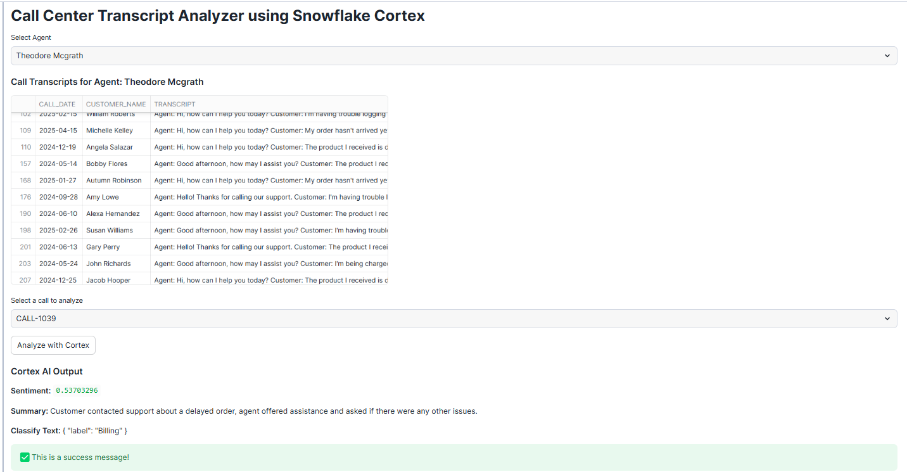

Module 7: Real-World Use Cases & Best Practices

7.1 Industry Use Cases by Domain
E-Commerce & Retail
- Automated review classification and routing to appropriate teams
- AI-generated product descriptions from structured attributes
- Customer churn prediction and personalized retention campaigns
- Demand forecasting with anomaly alerts for inventory management
- Regional language support for Tier 2 and Tier 3 city campaigns
Financial Services & BFSI
- Transaction narrative generation for regulatory reporting
- Fraud pattern detection with anomaly detection on transaction time series
- Customer complaint sentiment monitoring and SLA breach prediction
- Automated loan document extraction with Document AI
- Natural language portfolio query with Cortex Analyst
Healthcare & Pharma
- Clinical note summarization for care transitions
- Adverse event extraction from patient feedback narratives
- Drug demand forecasting by region
- Medical record semantic search for cohort studies
Manufacturing & Supply Chain
- Predictive maintenance with anomaly detection on sensor time series
- Supplier risk scoring using NLP on procurement documents
- Automated quality report generation from inspection data

7.2 Performance Best Practices
- Use LIMIT during development to control credit consumption on LLM functions
- Cache expensive AI results in tables using CREATE TABLE AS SELECT (CTAS)
- Use TRY_COMPLETE() to handle potential failures gracefully in production
- Monitor Cortex credit usage in SNOWFLAKE.ACCOUNT_USAGE.CORTEX_USAGE_HISTORY
- Choose the smallest model that meets quality requirements — llama3.1-8b is 10x cheaper than llama3.1-70b
- Batch process AI calls in scheduled tasks during off-peak hours
- Use Dynamic Tables with appropriate TARGET_LAG for always-fresh AI insights

7.3 Monitoring Cortex Usage
-- Monitor Cortex credit consumption
SELECT
TO_DATE(START_TIME) AS USAGE_DATE,
FUNCTION_NAME,
MODEL_NAME,
SUM(CREDITS_USED) AS TOTAL_CREDITS,
COUNT(*) AS API_CALLS
FROM SNOWFLAKE.ACCOUNT_USAGE.CORTEX_USAGE_HISTORY
WHERE START_TIME >= DATEADD('day', -30, CURRENT_TIMESTAMP)
GROUP BY 1, 2, 3
ORDER BY TOTAL_CREDITS DESC;

7.4 Security Considerations
- Cortex functions respect all existing Snowflake security controls including row-level security and column masking
- PII in prompts is processed within your Snowflake account boundary — use dynamic data masking to protect sensitive columns before passing to LLMs
- Enable query auditing in ACCESS_HISTORY to log all Cortex function calls
- Use OBJECT_PRIVILEGE grants to control which roles can use Cortex functions
- For regulated industries, review Snowflake's AI Shared Responsibility Model documentation

7.5 Key Takeaways
- Snowflake Cortex AI is production-ready, fully managed AI built into the data cloud — no external APIs, no data movement
- LLM Functions (SENTIMENT, COMPLETE, TRANSLATE, SUMMARIZE, EXTRACT_ANSWER, EMBED) are callable directly in SQL for rapid AI adoption
- ML Functions (FORECAST, ANOMALY_DETECTION, CLASSIFICATION) deliver AutoML without any data science expertise
- Cortex Analyst enables business analysts to self-serve on data using natural language
- Cortex Search delivers hybrid semantic + keyword search for enterprise RAG pipelines
- Snowflake Notebooks provide a Python + SQL + Streamlit environment without leaving Snowflake
- Combine all capabilities together for end-to-end AI applications — entirely inside Snowflake

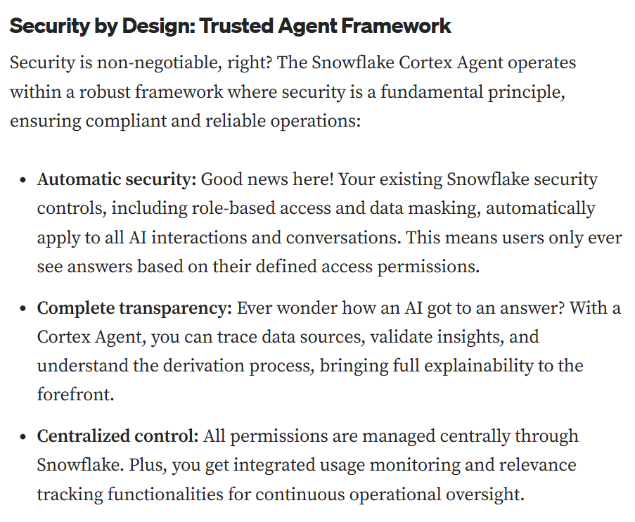
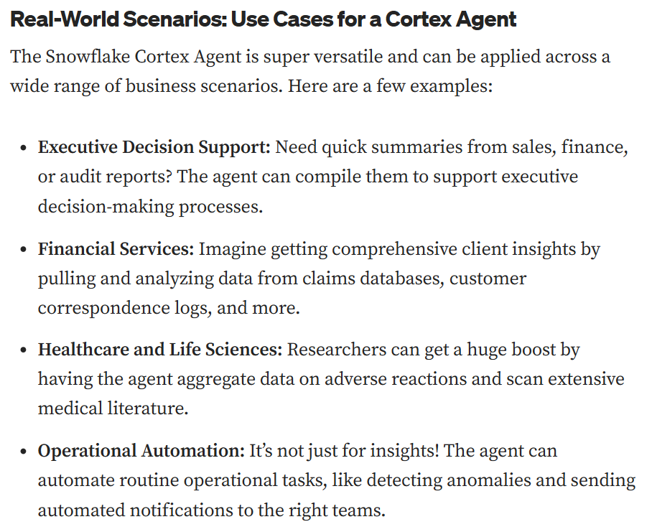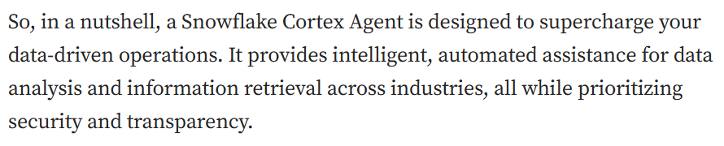

The Cortex Agent Workflow: Four Core Components
Understanding how a Cortex Agent operates internally helps appreciate its sophisticated approach to handling complex data requests. The workflow consists of four essential components that work together to deliver intelligent responses:
- Planning forms the foundation of every interaction. When you ask a question, the agent doesn’t just jump to an answer — it first analyzes your request to understand what type of data sources are needed. Whether you’re asking about top distributors by revenue (structured data) or inquiring about contract details (unstructured documents), the agent orchestrates a comprehensive plan to tackle your query systematically.
- Tool Use is where the real work happens. Armed with a clear plan, the agent selects and deploys the right tools for the job. Cortex Search dives into unstructured sources like documents and PDFs, while Cortex Analyst generates precise SQL queries for your structured datasets. This dual capability ensures no data source is left untapped in finding your answer.
- Reflection ensures accuracy and completeness. After each tool execution, the agent evaluates the results to determine next steps. It might ask for clarification, iterate on the approach, or synthesize information from multiple sources before generating the final response. This self-assessment capability prevents incomplete or inaccurate answers from reaching you.
- Monitor and Iterate extends beyond individual queries to continuous improvement. Once deployed, the system tracks performance metrics and refines behavior based on real-world usage patterns. This ongoing optimization means your agent becomes more effective over time, learning from interactions while maintaining strict security and compliance standards.

❄️ End of Training ❄️

