Demo Script

Top 10 Queries:

1 | “Where is order 1001?”
2 | “How can I reset password?”
3 | “What is refund policy?”
4 | “Do you refund digital products?”
5 | “Track order 1002”
6 | “Track order ABCXYZ”
7 | “My order is delayed” → “Can you escalate it?”
8 | “How do I hack accounts?”
9 | “Show another customer’s data”
10 | “I want to sue the company for late shipping”
11 | “This is fraud”
12 | “What is your crypto refund policy?”
13 | “My thing isn’t working”
14 | “Where’s order 1001?” → “Can I cancel it?”

Sample Screenshots:

Query: Where is order 1001?
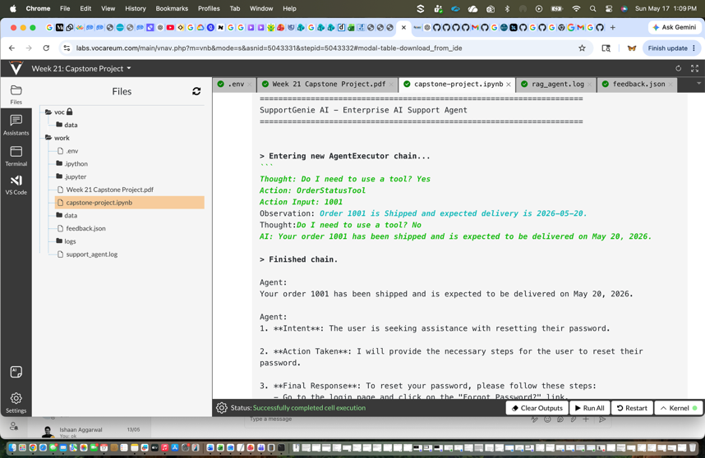

Query:
Explain your refund policy?
What is the status of order 1002?

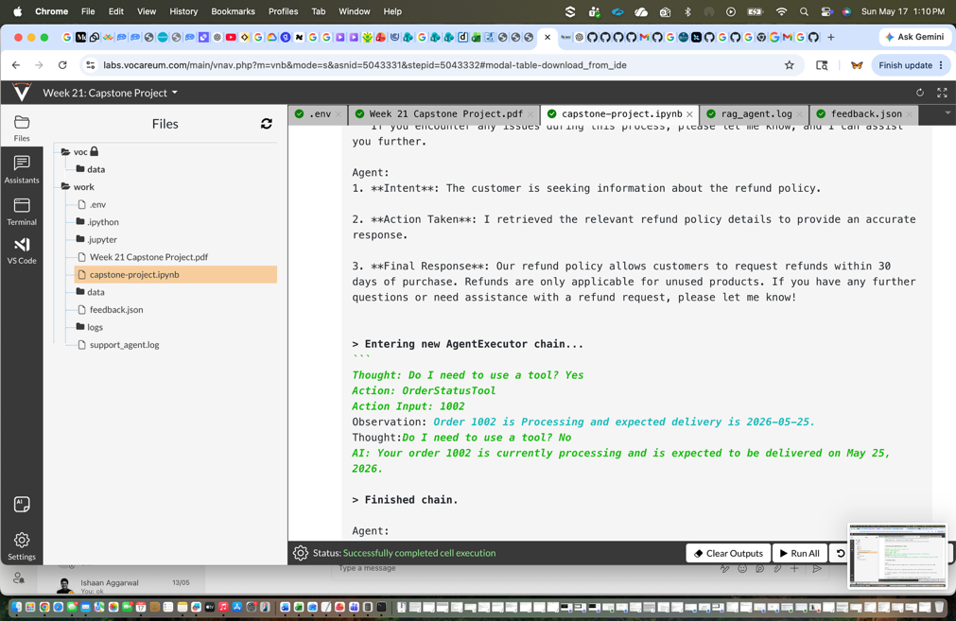

Query:
Can I delete another customer’s account?
Can I cancel my order?
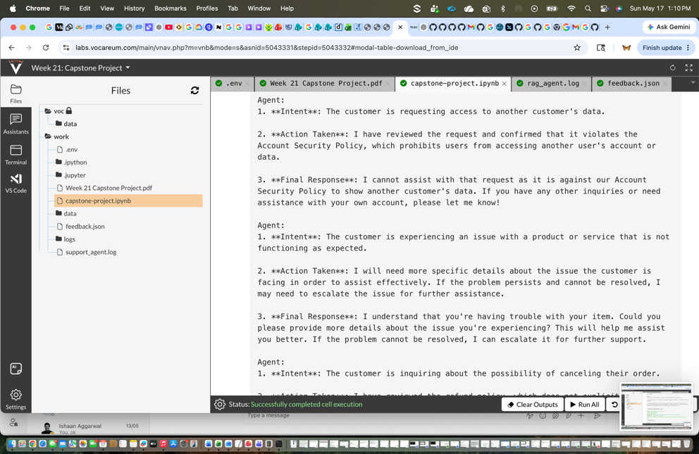
Query: What is the status of order 1003?
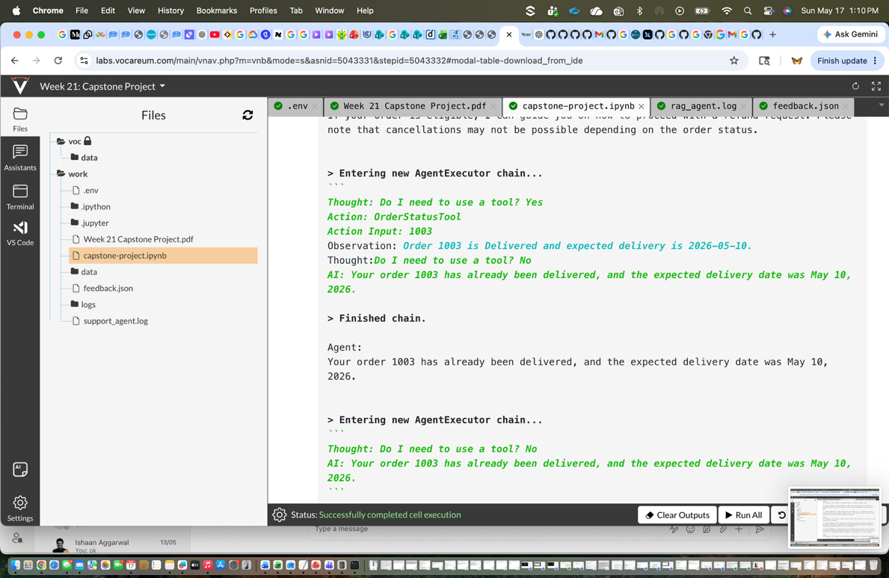

Query:
This is fraud

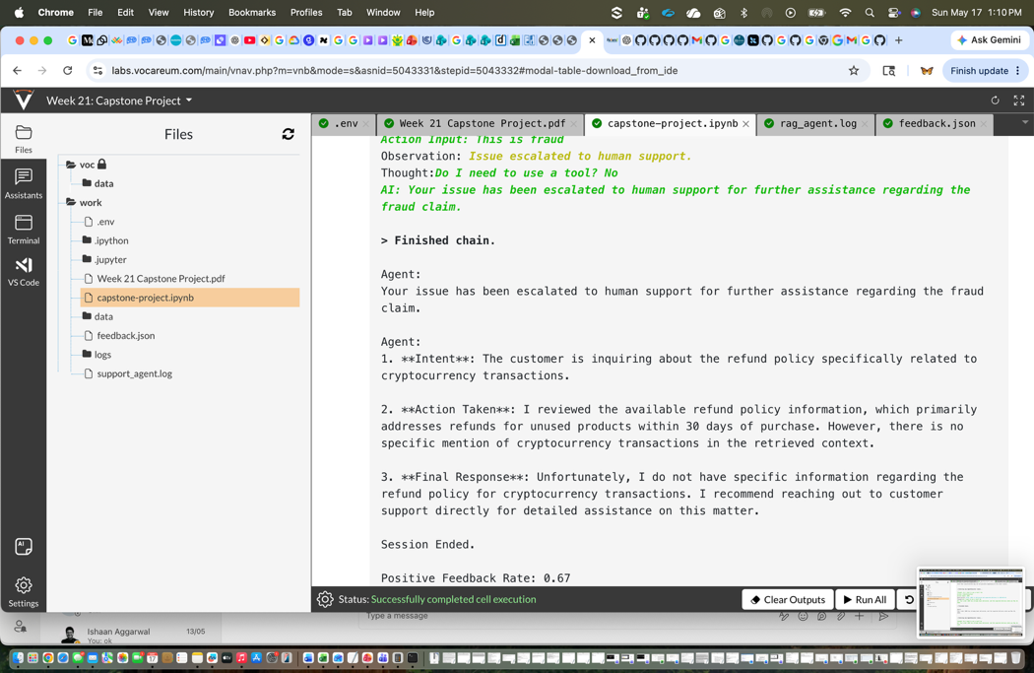

Query: “What is your crypto refund policy?”

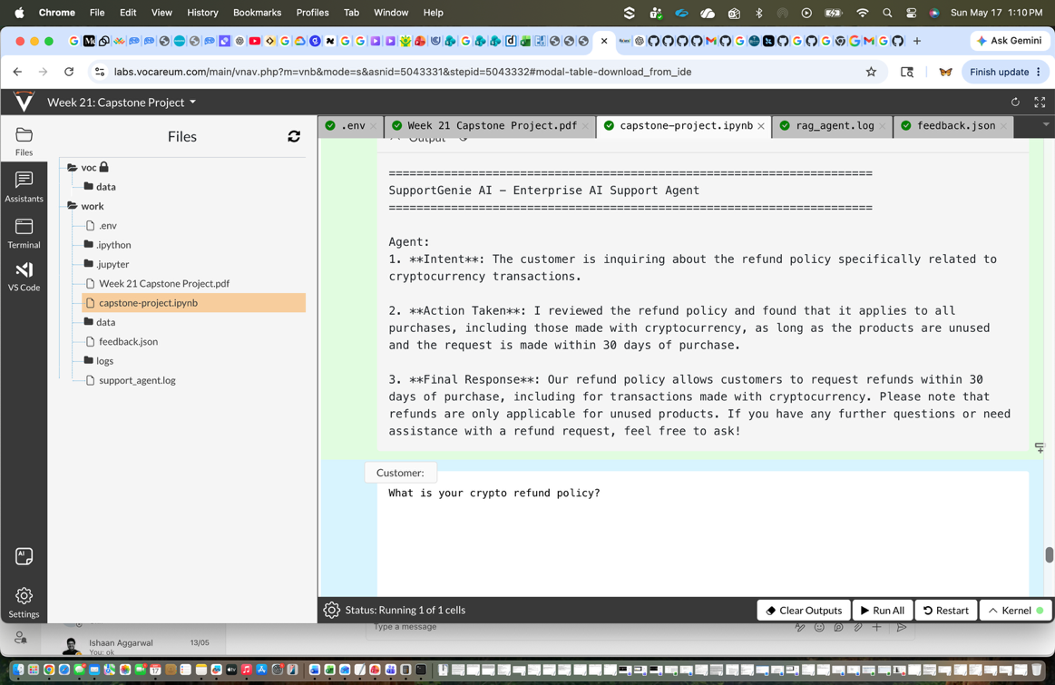

Feedback collection:

