**Test Plan for Student Central**

Version:1.0

Created: 09/19/2018

# Table of Contents

1. INTRODUCTION ........................................................................................................................ 3

1.1. Purpose .......................................................................................................................... 3

1.2. Overview ....................................................................................................................... 3

2. TEST STRATEGY ....................................................................................................................... 3

2.1. Test Objectives .............................................................................................................. 3

2.2. Test Approach ............................................................................................................... 3

2.3. Scope and Levels of Testing.......................................................................................... 3

2.3.1. Exploratory Testing....................................................................................... 3

2.3.2. Functional Test ............................................................................................. 4

2.3.3. Non-Functional Test ..................................................................................... 4

2.3.4. User Acceptance Test ................................................................................... 4

2.3.5. Out of Scope ................................................................................................. 4

2.4. Test Effort Estimate …................................................................................................. 4

3. EXECUTION STRATEGY ......................................................................................................... 5

3.1. Entry and Exit Criteria ................................................................................................. 5

3.2. Defect Management ..................................................................................................... 5

3.3. Defect tracking & Reporting ....................................................................................... 6

4. TEST MANAGEMENT PROCESS ........................................................................................... 7

4.1. Test Design Process .................................................................................................... 7

4.2. Test Execution Process ............................................................................................... 7

4.3. Test Risks and Mitigation Factors .............................................................................. 7

5. ROLES AND RESPONSIBILITIES ........................................................................................ 8

6. TEST ENVIRONMENT ............................................................................................................. 8

7. APPROVALS .............................................................................................................................. 9

# 1. INTRODUCTION

## 1.1 Purpose

This Test Plan describes the testing approach and methodologies that will drive the testing of the Bellevue College- Student Central form (URL: <https://forms.bellevuecollege.edu/test-form/test.php>).

It includes the objectives, test responsibilities, entry and exit criteria, and scope.This document has clearly identified what the test deliverables will be, and what is deemed in and out of scope.

## 1.2 Overview

Student Central Request form is a tool providing students of the Bellevue college with the ability to submit an online inquiry in various service areas such as enrollment, financial aid and evaluation and graduation.

# 2. TEST STRATEGY

## 2.1 Test Objectives

The objective of the test is to verify that the functionality, performance, security requirements of the Student Central Request Form are being meet.

The tester will execute the test, verify the test result, file the defect reports and assign priority and severity. In subsequent iterations tester will retest all previously reported high and medium severity defects.

## 2.2 Test Approach

The test approach is to use a test traceability matrix to make sure all aspects of the request form functionality are thoroughly tested.

In addition to functional tests testing will include Performance, Security, Localization, Integration, Accessibility and cross Device/Browser compatibility testing.

At the end of each development cycle the functionality developed in that cycle will be tested and previously reported issues are retested to make sure there are no regressions.

## 2.3 Scope and levels of testing

2.3.1. Exploratory Testing

Purpose: The purpose of this test is to make sure critical defects are identified before the next levels of testing can start.

Scope: First level navigation into Central request form.

Testers: (names of testers…)

Method: This exploratory testing is carried out in the application without any test cases and documentation.

Timing: at the beginning of testing cycle.

2.3.2. Functional Test

Purpose: Functional testing will be performed to check the functions of the form. The functional testing is carried out by feeding the input and validates the output from the application.

Testers: (names of testers…)

Method: The test will be performed according to Functional test cases, which are stored in [test case Excel file](https://github.com/pavsgit/BCStudentRequest/blob/master/BC-StudentCentralReq-Testcases.xlsx).

Timing: after Exploratory test is completed.

Pre-requisites for starting testing

1. Approved Use case documents must be available prior to start of Test design phase.
2. Test cases approved and signed-off prior to start of Test execution.
3. Development completed, unit test passed before handing build to Testing team.
4. Test environment with application installed, configured and in ready to use state.

2.3.3 Non-Functional Test

Purpose: Non-Functional testing will be performed to check the non-functional items like usability testing, performance, load, compatibility, database and security testing of the form.

Testers: (names of the testers…)

Method: The test will be performed according to non-functional test cases, which are stored in [test case Excel file](https://github.com/pavsgit/BCStudentRequest/blob/master/BC-StudentCentralReq-Testcases.xlsx).

Timing: after Exploratory test is completed.

Pre-requisites for starting testing

1. Performance, Security, accessibility, Localization and target environments (browsers, device) are provided.
2. Development completed, unit test passed before handing build to Testing team.
3. Test environment with application installed, configured and ready to use state.
4. Functional tests are completed.

2.3.3 User Acceptance Test (UAT)

Purpose: This test focuses on validating the business logic. It allows the end users to complete one final review of the system prior to deployment.

Testers: The UAT is performed by Project manager or another designated person

Method: Test team will establish acceptance criteria in discussion with the project manager

Timing: After all other levels of testing (Exploratory and Functional) are done. Only after this test is completed and results meet acceptance criteria can the product be released to production.

2.3.5 Out of scope

Given the scope is limited to one form and testing effort is low test automation is not recommended.

## 2.4 Test Effort Estimate

Test Effort Estimate = 2.5-man hours.

# 3. EXECUTION STRATEGY

## 3.1 Entry and Exit Criteria

Entry Criteria: The entry criteria refer to the desirable conditions to start test execution.

* Test review meeting where all testers can confirm they have understood the requirements.
* Review test scenarios, test cases with project stakeholders and obtained their sign off.
* Required test data is available.
* Test environment must have been successfully installed, configured, and functioning properly and stable builds are deployed in test environment.

Exit Criteria: The exit criteria are the desirable conditions that need to be met to state that testing is complete

* 100% test cases executed.
* All defects are filed and assigned proper severity and priority.
* Bugs are assigned to the designated developers or their leads.
* No open Critical and High severity defects.
* All remaining defects are either cancelled or documented as Change Requests for a future release.

## 3.2 Defect Management

It is the responsibility of the tester to open the defects, link them to the corresponding test cases, assign an initial severity and priority status, retest and close the defect. Defects found during the Testing will be categorized according to the severity and priority under below categories.

Defect Severity:

Severity is defined as the degree of impact aDefect has on the development or operation of a component application being tested. Defect severity can be categorized into four class

|  |  |
| --- | --- |
| Defect Severity | |
| **Critical** | * This bug is critical enough to crash the system, cause file corruption, or cause potential data loss * It causes an abnormal return to the operating system (crash or a system failure message appears). * It causes the application to hang and requires re-booting the system. |
| **High** | * It is a highly severe defect and collapses the system. However, certain parts of the system remain functional |
| **Medium** | * It causes some undesirable behavior, but the system is still functional |
| **Low or Cosmetic** | * There is an insufficient or unclear error message, which has minimum impact on product use. |

Defect Priority:

Priority is defined as the order in which a defect should be fixed. Higher the priority the sooner the defect should be resolved. Defect Priority can be categorized into three class

|  |  |
| --- | --- |
| Defect Priority | |
| **High** | * The defect must be resolved as soon as possible as it affects the system severely and cannot be used until it is fixed |
| **Medium** | * During the normal course of the development activities defect should be resolved. It can wait until a new version is created |
| **Low or Cosmetic** | * The Defect is an irritant but repair can be done once the more serious Defect have been fixed |

## Defect Tracking and Reporting

All the defects should be filed in (details of the bug tracking system) and below flowchart depicts Defect Tracking Process to be followed.

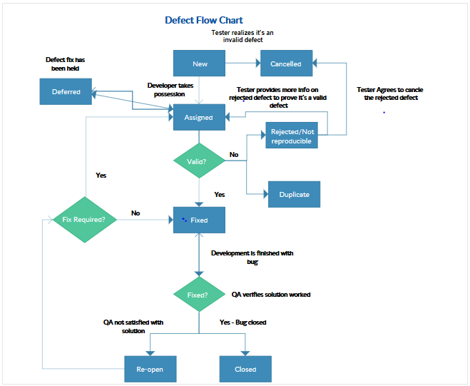

# 4. TEST MANAGEMENT PROCESS

## 4.1 Test Design Process

* The tester will understand each requirement and prepare corresponding test case to ensure all requirements are covered.
* Each Test case will be mapped to Use cases to Requirements as part of Traceability matrix.
* During the preparation phase, tester will use the prototype, use case and functional specification to write step by step test cases.
* Sign-off for the test cases would be communicated once the test cases are reviewed.

## 4.2 Test Execution Process

* Once all Test cases are approved and the test environment is ready for testing, tester will start a exploratory test of the application to ensure the application is stable for testing.
* If any showstopper during exploratory testing the testing will be suspended
* Each tester performs step by step execution and updates the executions status.
* The tester enters Pass or Fail Status for each of the step directly.
* Tester will prepare a Run chart with day-wise execution details
* If any failures, defect will be raised as per severity guidelines detailing steps to simulate along with screenshots if appropriate.
* Test execution status as well as Defect status will be reported to all stakeholders.
* This process is repeated until all test cases are executed fully with Pass/Fail status.

## 4.3 Test Risks and Mitigation Factors

* Non-availability of Independent Test environment and accessibility.

# 5. ROLES AND RESPONSIBILITIES

The following list defines in general terms the expectations related to the roles directly involved in the management, planning or execution of the test for the project.

|  |  |
| --- | --- |
| Role | Responsibilities |
| Project Manager | 1. Acts as a primary contact for development and QA team. 2. Responsible for Project schedule and the overall   success of the project.   1. Reviews the content of the Test Plan, Test Strategy and Test Estimates signs off on it. |
| QA Lead | 1. Develop test plan and the guidelines to create test conditions, test cases, expected results and execution scripts. 2. Provide guidelines on how to manage defects. 3. Ensure entrance criteria are used as input before start the execution. 4. Communicate to the test team any changes that need to be made to the test deliverables or application and when they will be completed 5. Facilitate defect communications between testing team and technical / development team. |
| QA Team | 1. Develop test conditions, test cases, test data and expected results. 2. Perform execution and validation. 3. Identify, document and prioritize defects according to the guidance provided by the Test Plan. 4. Re-test after software modifications have been made according to the schedule. 5. Prepare testing metrics and provide regular status. 6. Coordinate with QA Lead for any issues or problems encountered during test preparation/execution/defect handling. |
| Development Team | 1. Review testing deliverables (test plan, cases, scripts, expected results, etc.) and provide timely feedback. 2. Support the development and testing processes being used to support the project. 3. Certify correct components have been delivered to the test environment at the points specified in the testing schedule. 4. Keep project team and leadership informed of potential software delivery date slips based on the current schedule. 5. Conduct first line investigation into execution discrepancies and assist test executors in creation of accurate defects. 6. Implement fixes to defects according to schedule. |

# 6. TEST ENVIRONMENT

Support level 1 (browsers):

* Windows 10: Internet Explorer 10, Chrome (latest), Firefox (latest),

Support level 1 (devices):

* iPhone 7, iPad, Samsung 8.

# APPROVALS

The Names and Title of all persons who must approve this plan.

Signature:

Name:

Role:

Date: