**Patrick Woodard**

UW Foundations in Python Summer 2021

Assignment 05

8/08/21

# Introduction

The program Assignment05.py reads the file ToDoList.txt, then interacts with the user to display, add to, delete, and finally save the “ToDo” list. All files associated with this assignment are available on GitHub at:

<https://github.com/paw345/IntroToProg-Python>

# The Script

For this assignment I started with the partially built script Assignment05_Starter.py that was given to us. This “starter” script included the basic menu options, a **while** loop, and nested **if** and **elif** statements that provided placeholders for code that I wrote. Within each placeholder, code executes to perform actions consistent with the *Menu of Options* shown in Figure 1.

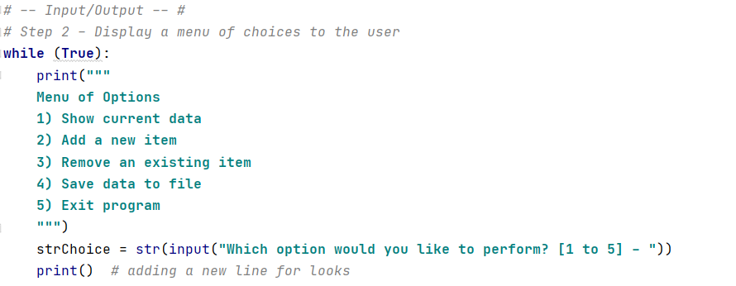

Figure . Menu Options and Beginning of **While** Loop

Before the **while** loop the major variables and constants are declared and anything in the existing ToDoList.txt file is read into a [list]. Each item in the list is a {dictionary} of tasks and priorities. A **for** loop is used to establish this structure. This results in an overall list structure of [{task1:priority},{task2:priority}]. See the related code in Figure 1.

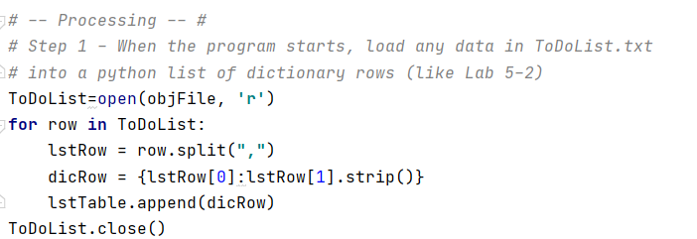

Figure 2. **for** loop that reads in existing items from ToDoList.txt

Within the while loop, the **if** and **elif** statements interact with user to perform the requested actions. A variety of coding elements were used to accomplish this – all details of which can be seen in Figure 3 through Figure 7.

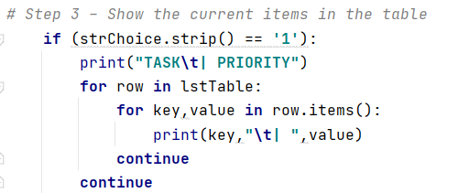

Figure 3. Code for menu option: “Show current cata”

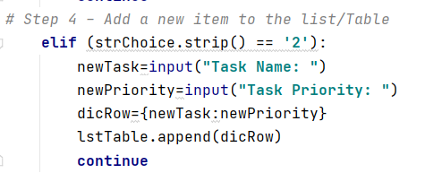

Figure . Code for menu option: “Add a new item”

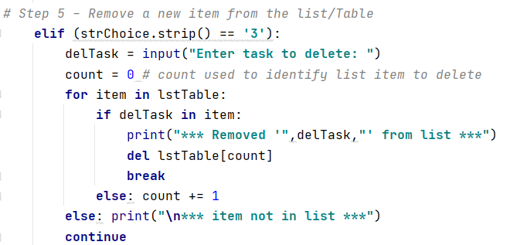

Figure . Code for menu option: “Remove an existing item”

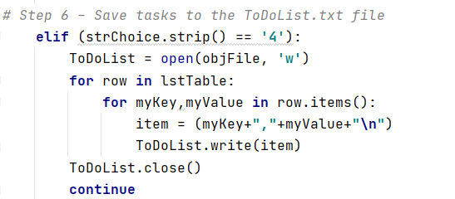

Figure . Code for menu option: “Save data to file”

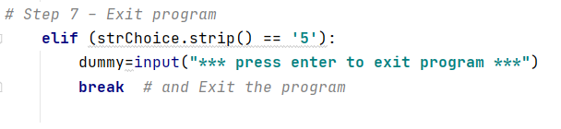

Figure . Code for menu option: “Exit program”

# Running the Code and the Output File

Screenshots of the code running in console mode are presented in Figure 8 through Figure 12. In this you can see the list starts as run,write,sleep and is changed to run,eat,sleep. The updated ToDoList.txt file is presented in Figure 13. .

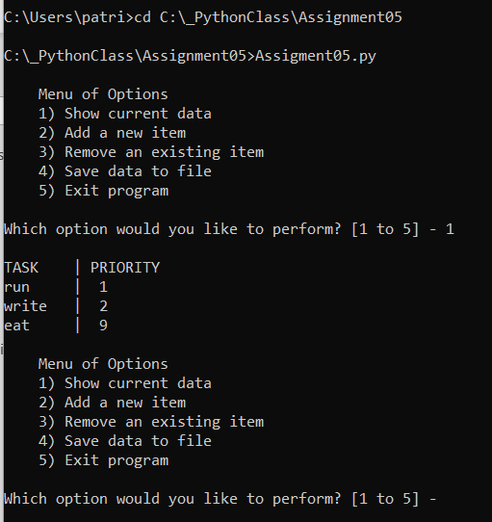

Figure . Screenshot of the Script Running in PyCharm

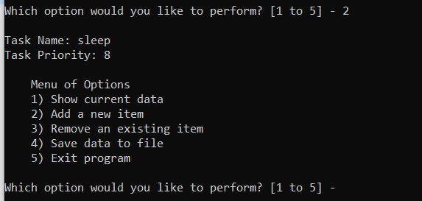

Figure . Screenshot of the Script Running in Console Mode

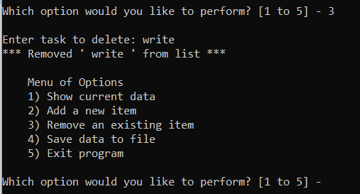

Figure . Screenshot of script output file and data contained therein

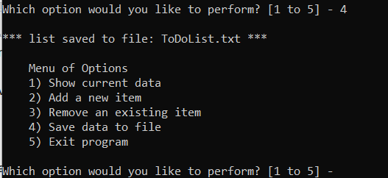

Figure . Screenshot of script output file and data contained therein

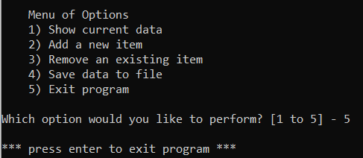

Figure . Screenshot of script output file and data contained therein

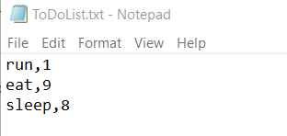

Figure . Screenshot of script output file and data contained therein

# Summary