**A Project Report on**

**E-Shop**

Submitted for

**DAV College Sector 10**

PROJECT ON **EShop** Software

**Submitted To**: **Submitted** **By:**

Harmunish Taneja Talwinder Singh Lalh**(**18049154**)**

**CERTIFICATE**

This is to certify that Talwinder Singh Lalh student of **DAV College Sector 10 Chandigarh** has successfully completed the project work titled ‘**E-Shop’** in the partial fulfillment of requirement for the completion of B.C.A course as prescribed by DAV College.

This project is record of authentic work carried by him during the period from 2020to 2021. They have worked under my guidance.

Talwinder Singh Lalh

Signature : Harmunish Teneja

Project Guide

Place: - Chandigarh

Date:-14-09-2020

**ACNOWLEDGEMENT**

When emotions are profound, words sometimes are not sufficient to express our thanks and gratitude. With these few words I am trying to express my gratitude to all those people who have helped and provided the much needed enthusiasm and consistent encouragement the present shape of this study has come forth only after the contribution from different spheres.

I sincerely express my deep gratitude to my teachers for their assiduous, guidance, constructive suggestions, constant encouragement and able supervision at each and every step throughout this work.

I am highly indebted to **Harmunish Teneja** for their guidance and constant supervision as well as for providing necessary information regarding the project and also for their support in completing the project.

I thank them whole –heartedly for their expert guidance, encouragement, valuable suggestions and supervisions. My sincere thanks also go to my parents, friends and my relatives for their ever flowing love and timely guidance and encouragement.

**DECLERATION**

We Mr. Talwinder Singh Lalhhereby declare that this project report is the record of authentic work carried out by us during the period from 2020to 2021.

Signature

Talwinder Singh Lalh

**CONTENTS**

|  |  |  |
| --- | --- | --- |
| **S.No.** | **Topic** | **Page No.** |
| 1. | Introduction | 6 |
| 2 | Objective | 7 |
| 3. | Software and Hardware requirement | 8 |
| 4. | Basic Functioning | 9 |
| 5. | Source Code   * VB.net * Database(MS Access) | 11-193 |
| 6. | * Conclusion | 194 |
| 7. | Bibliography | 195 |
|  |  |  |

**INTRODUCTION**

This Software is design and develope by Mr. Talwinder Singh Lalh.

The ‘E-SHOP’ is all about the shopping and cart management. You can easily buy things in it.

It may fall short of certain requirements and may require some additional functionality if it is to be used for General Audience. This website can also be modified to get maximum information. For example: - we can use this website to get more information about ayurved. We can also sell ayurved products. These changes can be made by anybody who has basic knowledge of VB.net and MS Access.

**OBJECTIVE**

Today, we are blessed with profound law of the internet, which makes it absolutely possible for us to search the sum total of human knowledge at our fingertip. Now, one can get any information from internet within a matter of seconds.

But today the biggest problem faced by us is the vastness of the internet. We have millions of websites and billions of WebPages across the world, but as a matter of fact, very few websites contains relevant information that serves our purpose.

The need of the day, demand a selective approach. You shouldn’t read every website that comes in the search result because not every website deserves to be read in its entirety.

I am feeling proud to introduce you to my software ‘E-SHOP’.

Main goal of this software is to enable people to learn about the online shoping.

**SOFTWARE AND HARDWARE REQUIREMENTS**

**SOFTWARE REQUIREMENTS**

* VB.net
* Internet explorer 10 or above/ Mozilla Firefox /Google chrome.
* MS Access

**HARDWARE REQUIREMETS**

* Intel Pentium III processor or later.
* Virtually any operating system.
* 128 MB+ RAM.
* CD- ROM or DVD-ROM drive.
* SVGA or higher- resolution monitors (XGA recommended).
* Mouse or other pointing device.

**Poject Code**

Imports System.Data.OleDb

Public Class Form1

Dim connectionString As String = "Provider=Microsoft.ACE.OLEDB.12.0;data source=C:\\Users\\vikram singh\\Desktop\\MCM_BCA_Projects\\eShop\\eshop.mdb"

Dim ds As New DataSet()

Private Sub Label12_Click(ByVal sender As Object, ByVal e As EventArgs) Handles Label12.Click

End Sub

Private Sub Button3_Click(ByVal sender As Object, ByVal e As EventArgs) Handles Button3.Click

Dim sql As String = "SELECT * FROM tblInv"

Dim connection As New OleDbConnection(connectionString)

Dim dataadapter As New OleDbDataAdapter(sql, connection)

connection.Open()

dataadapter.Fill(ds, "tblInv")

connection.Close()

DataGridView3.DataSource = ds

DataGridView3.DataMember = "tblInv"

End Sub

Private Sub Button4_Click(ByVal sender As Object, ByVal e As EventArgs) Handles Button4.Click

Dim sql As String = "SELECT * FROM tblOfr"

Dim connection As New OleDbConnection(connectionString)

Dim dataadapter As New OleDbDataAdapter(sql, connection)

connection.Open()

dataadapter.Fill(ds, "tblOfr")

connection.Close()

DataGridView1.DataSource = ds

DataGridView1.DataMember = "tblOfr"

End Sub

Private Sub Button1_Click(ByVal sender As Object, ByVal e As EventArgs) Handles Button1.Click

Dim insertSql As String = "INSERT INTO tblCust VALUES (?, ?, ?, ?, ?, ?, ?, ?, ?, ?)"

Using conn As New OleDbConnection(connectionString),

cmd As New OleDbCommand(insertSql, conn)

cmd.Parameters.Add("?", OleDbType.Integer).Value = CInt(TextBox9.Text)

cmd.Parameters.Add("?", OleDbType.VarWChar, 20).Value = TextBox19.Text

cmd.Parameters.Add("?", OleDbType.VarWChar, 20).Value = TextBox20.Text

cmd.Parameters.Add("?", OleDbType.Integer).Value = CInt(TextBox21.Text)

cmd.Parameters.Add("?", OleDbType.VarWChar, 20).Value = TextBox22.Text

cmd.Parameters.Add("?", OleDbType.VarWChar, 20).Value = ComboBox2.Text

cmd.Parameters.Add("?", OleDbType.Integer).Value = CInt(TextBox1.Text)

cmd.Parameters.Add("?", OleDbType.Integer).Value = CInt(TextBox2.Text)

cmd.Parameters.Add("?", OleDbType.VarWChar, 20).Value = DateTimePicker1.Text

cmd.Parameters.Add("?", OleDbType.Integer).Value = CInt(TextBox4.Text)

conn.Open()

cmd.ExecuteNonQuery()

MessageBox.Show("Congratulations!!! Your Order is Successful. Plz Pay = " + TextBox4.Text + " Rs.")

End Using

End Sub

Private Sub Form1_Load(ByVal sender As Object, ByVal e As EventArgs) Handles MyBase.Load

ComboBox4.Items.Add("iphone12pro")

ComboBox4.Items.Add("iphone11pro")

ComboBox4.Items.Add("MacBook AirM1")

Dim sql As String = "SELECT * FROM tblInv"

Dim connection As New OleDbConnection(connectionString)

Dim dataadapter As New OleDbDataAdapter(sql, connection)

connection.Open()

dataadapter.Fill(ds, "tblInv")

connection.Close()

ComboBox2.DisplayMember = "invNme"

ComboBox2.DataSource = ds.Tables(0)

End Sub

Private Sub ComboBox1_SelectedIndexChanged(ByVal sender As Object, ByVal e As EventArgs)

End Sub

Private Sub Button5_Click(ByVal sender As Object, ByVal e As EventArgs) Handles Button5.Click

Dim a, b, c As Integer

b = TextBox1.Text

c = TextBox2.Text

a = b * c

TextBox4.Text = a.ToString()

ListBox1.Items.Add("Customer ID = " + TextBox9.Text)

ListBox1.Items.Add("Customer Name = " + TextBox19.Text)

ListBox1.Items.Add("Customer Phone No = " + TextBox20.Text)

ListBox1.Items.Add("Customer Address = " + TextBox22.Text)

ListBox1.Items.Add("Customer Product Name = " + ComboBox2.Text)

ListBox1.Items.Add("Customer Product Price = " + TextBox1.Text)

ListBox1.Items.Add("Customer Product Qty = " + TextBox2.Text)

ListBox1.Items.Add("Customer Product BDate = " + DateTimePicker1.Text)

ListBox1.Items.Add("Total Bill = " + a.ToString())

End Sub

Private Sub ComboBox2_SelectedIndexChanged(ByVal sender As Object, ByVal e As EventArgs) Handles ComboBox2.SelectedIndexChanged

End Sub

Private Sub Button2_Click(ByVal sender As Object, ByVal e As EventArgs) Handles Button2.Click

Dim sql As String = "SELECT * FROM tblCust WHERE custID=" + TextBox5.Text

Dim connection As New OleDbConnection(connectionString)

Dim dataadapter As New OleDbDataAdapter(sql, connection)

connection.Open()

dataadapter.Fill(ds, "tblCust")

connection.Close()

DataGridView2.DataSource = ds

DataGridView2.DataMember = "tblCust"

End Sub

Private Sub Label25_Click(ByVal sender As System.Object, ByVal e As System.EventArgs) Handles Label25.Click

End Sub

Private Sub TabPage4_Click(ByVal sender As System.Object, ByVal e As System.EventArgs) Handles TabPage4.Click

End Sub

Private Sub Button7_Click(ByVal sender As System.Object, ByVal e As System.EventArgs) Handles Button7.Click

Dim insertSql As String = "INSERT INTO tblInv VALUES (?, ?, ?, ?, ?, ?)"

Using conn As New OleDbConnection(connectionString),

cmd As New OleDbCommand(insertSql, conn)

cmd.Parameters.Add("?", OleDbType.Integer).Value = CInt(TextBox10.Text)

cmd.Parameters.Add("?", OleDbType.VarWChar, 20).Value = TextBox3.Text()

cmd.Parameters.Add("?", OleDbType.Integer).Value = CInt(TextBox11.Text)

cmd.Parameters.Add("?", OleDbType.VarWChar, 20).Value = DateTimePicker2.Text

cmd.Parameters.Add("?", OleDbType.VarWChar, 20).Value = DateTimePicker3.Text

cmd.Parameters.Add("?", OleDbType.Integer).Value = CInt(TextBox12.Text)

conn.Open()

cmd.ExecuteNonQuery()

MessageBox.Show("Congratulations!!! Record Created")

End Using

End Sub

Private Sub Button14_Click(ByVal sender As System.Object, ByVal e As System.EventArgs) Handles Button14.Click

Dim insertSql As String = "INSERT INTO tblSup VALUES (?, ?, ?, ?, ?, ?, ?, ?)"

Using conn As New OleDbConnection(connectionString),

cmd As New OleDbCommand(insertSql, conn)

cmd.Parameters.Add("?", OleDbType.Integer).Value = CInt(TextBox13.Text)

cmd.Parameters.Add("?", OleDbType.VarWChar, 20).Value = TextBox14.Text

cmd.Parameters.Add("?", OleDbType.VarWChar, 20).Value = TextBox15.Text

cmd.Parameters.Add("?", OleDbType.VarWChar, 20).Value = TextBox16.Text

cmd.Parameters.Add("?", OleDbType.VarWChar, 20).Value = ComboBox4.Text

cmd.Parameters.Add("?", OleDbType.Integer).Value = CInt(TextBox17.Text)

cmd.Parameters.Add("?", OleDbType.Integer).Value = CInt(TextBox18.Text)

cmd.Parameters.Add("?", OleDbType.VarWChar, 20).Value = DateTimePicker5.Text

conn.Open()

cmd.ExecuteNonQuery()

MessageBox.Show("Congratulations!!! Record Created")

End Using

End Sub

Private Sub Button12_Click(ByVal sender As System.Object, ByVal e As System.EventArgs) Handles Button12.Click

Dim sql As String = "SELECT * FROM tblSup"

Dim connection As New OleDbConnection(connectionString)

Dim dataadapter As New OleDbDataAdapter(sql, connection)

connection.Open()

dataadapter.Fill(ds, "tblSup")

connection.Close()

DataGridView7.DataSource = ds

DataGridView7.DataMember = "tblSup"

End Sub

Private Sub Button13_Click(ByVal sender As System.Object, ByVal e As System.EventArgs) Handles Button13.Click

Dim sql As String = "DELETE FROM tblSup WHERE supID=" + TextBox6.Text

Dim connection As New OleDbConnection(connectionString)

Dim dataadapter As New OleDbDataAdapter(sql, connection)

Dim ds As New DataSet()

connection.Open()

dataadapter.Fill(ds, "tblSup")

connection.Close()

MessageBox.Show("Records Deleted successfully!!!!")

End Sub

Private Sub Button9_Click(ByVal sender As System.Object, ByVal e As System.EventArgs) Handles Button9.Click

Dim sql As String = "SELECT * FROM tblInv"

Dim connection As New OleDbConnection(connectionString)

Dim dataadapter As New OleDbDataAdapter(sql, connection)

connection.Open()

dataadapter.Fill(ds, "tblInv")

connection.Close()

DataGridView4.DataSource = ds

DataGridView4.DataMember = "tblInv"

End Sub

Private Sub Button8_Click(ByVal sender As System.Object, ByVal e As System.EventArgs) Handles Button8.Click

Dim sql As String = "DELETE FROM tblInv WHERE invID=" + TextBox8.Text

Dim connection As New OleDbConnection(connectionString)

Dim dataadapter As New OleDbDataAdapter(sql, connection)

Dim ds As New DataSet()

connection.Open()

dataadapter.Fill(ds, "tblInv")

connection.Close()

MessageBox.Show("Records Deleted successfully!!!!")

End Sub

Private Sub Button6_Click(ByVal sender As System.Object, ByVal e As System.EventArgs) Handles Button6.Click

TextBox1.Clear()

TextBox2.Clear()

TextBox4.Clear()

TextBox9.Clear()

TextBox19.Clear()

TextBox20.Clear()

TextBox21.Clear()

TextBox22.Clear()

ListBox1.Items.Clear()

End Sub

Private Sub Button10_Click(ByVal sender As System.Object, ByVal e As System.EventArgs) Handles Button10.Click

Dim sql As String = "SELECT custID,custNme,custPno,custAge,custAdd FROM tblCust"

Dim connection As New OleDbConnection(connectionString)

Dim dataadapter As New OleDbDataAdapter(sql, connection)

connection.Open()

dataadapter.Fill(ds, "tblCust")

connection.Close()

DataGridView5.DataSource = ds

DataGridView5.DataMember = "tblCust"

End Sub

Private Sub Button11_Click(ByVal sender As System.Object, ByVal e As System.EventArgs) Handles Button11.Click

Dim sql As String = "DELETE FROM tblCust WHERE custID=" + TextBox7.Text

Dim connection As New OleDbConnection(connectionString)

Dim dataadapter As New OleDbDataAdapter(sql, connection)

Dim ds As New DataSet()

connection.Open()

dataadapter.Fill(ds, "tblCust")

connection.Close()

MessageBox.Show("Records Deleted successfully!!!!")

End Sub

Private Sub Button15_Click(ByVal sender As System.Object, ByVal e As System.EventArgs)

End Sub

End Class

**Project Screen Shots**

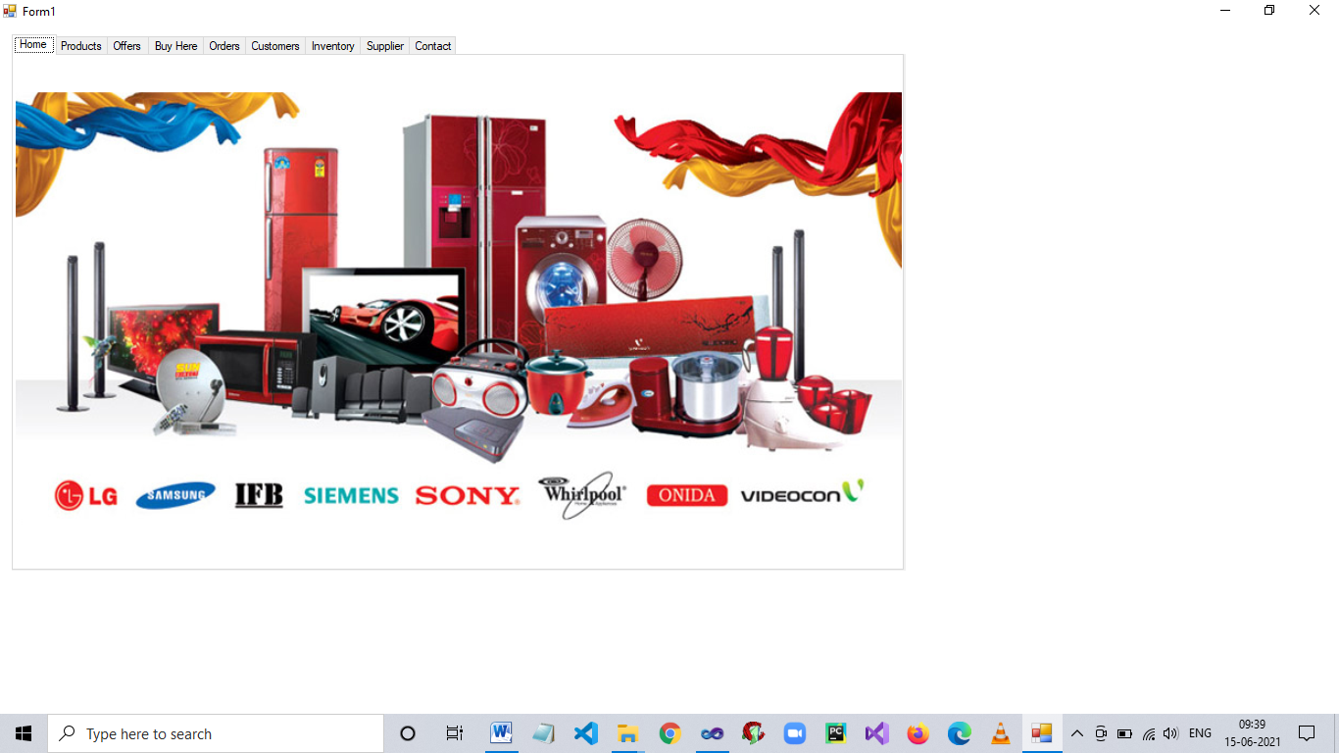

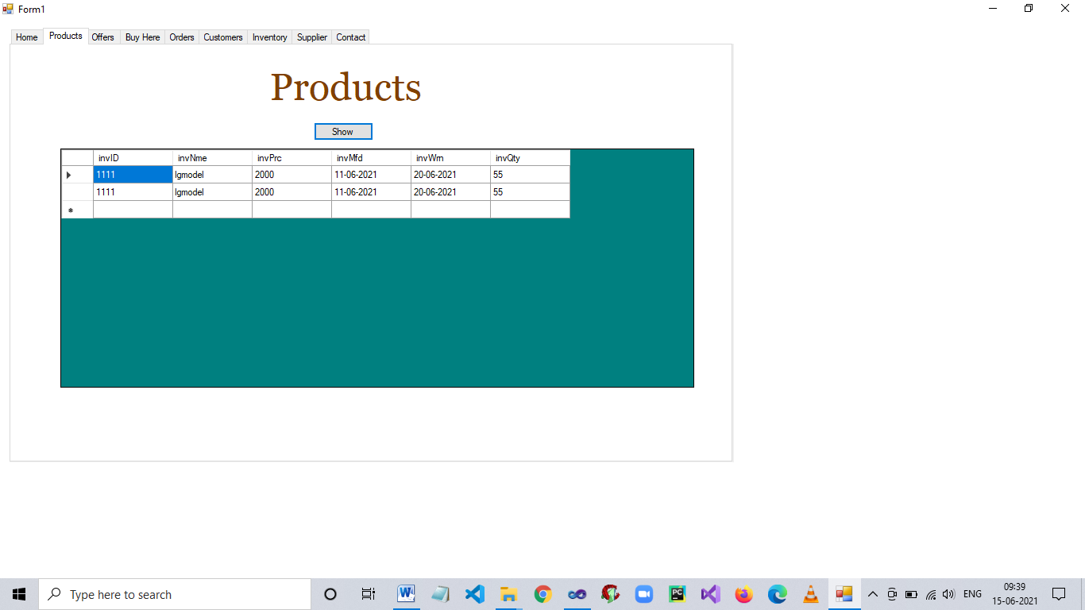

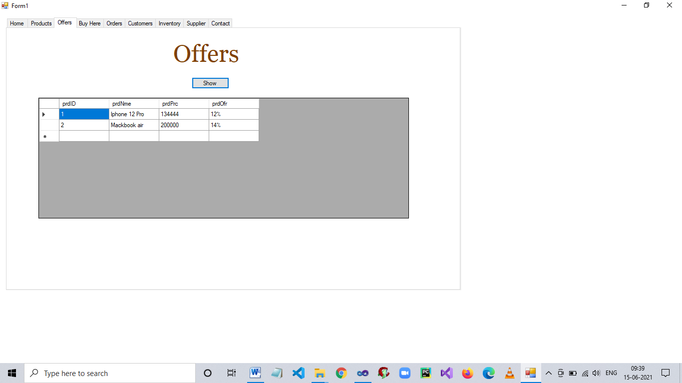

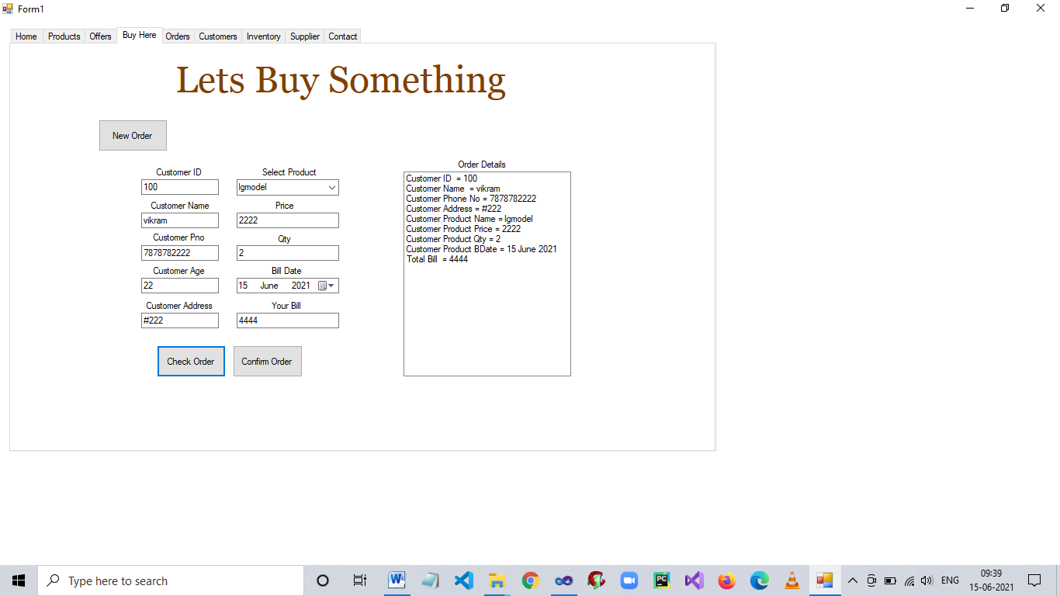

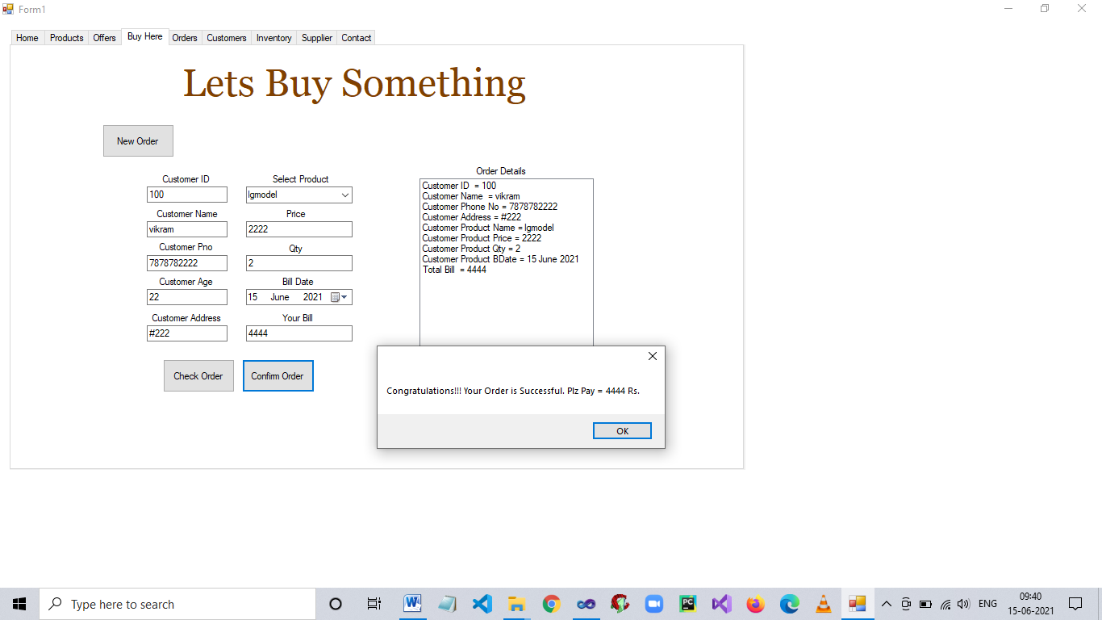

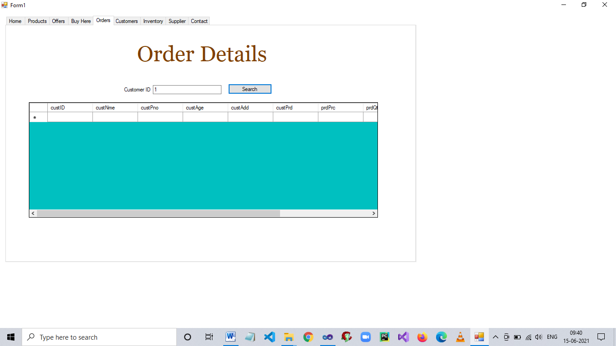

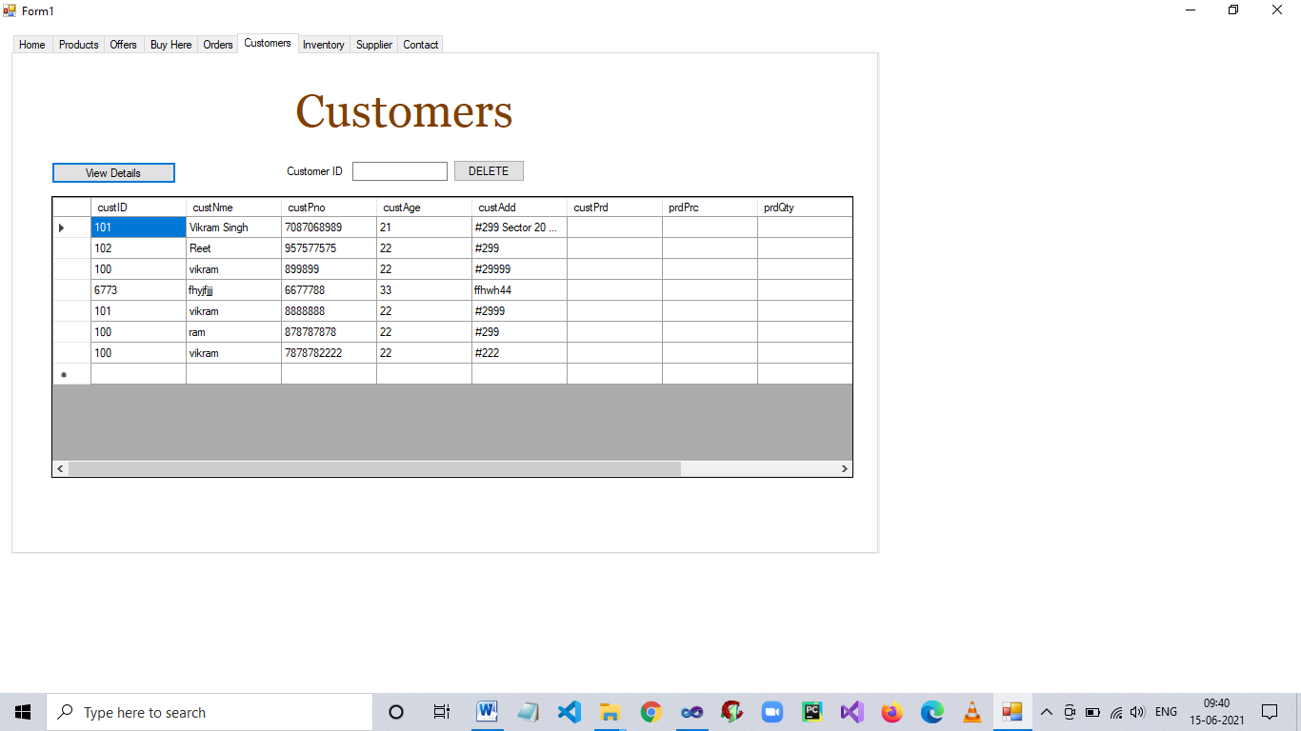

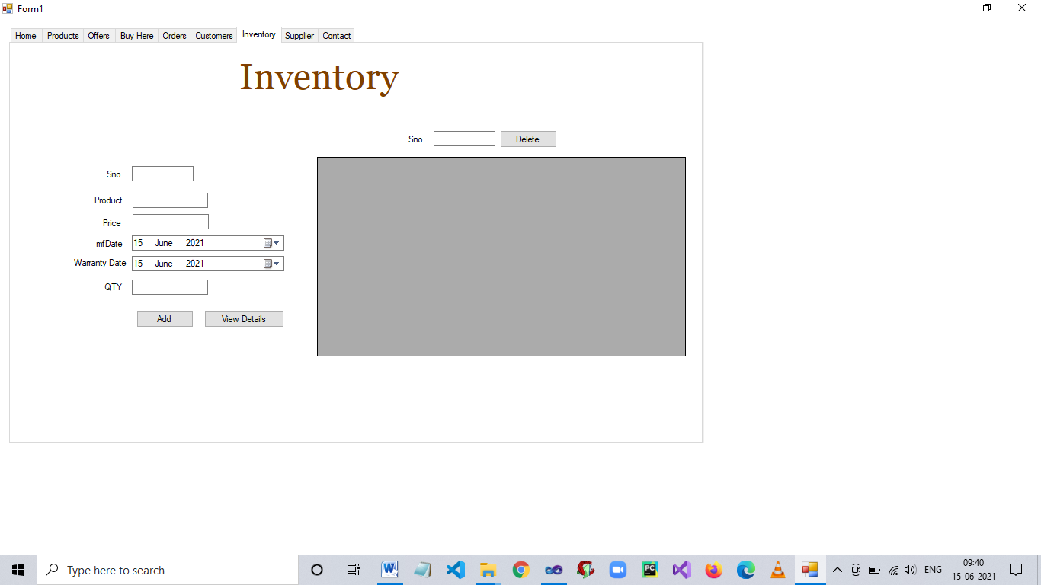

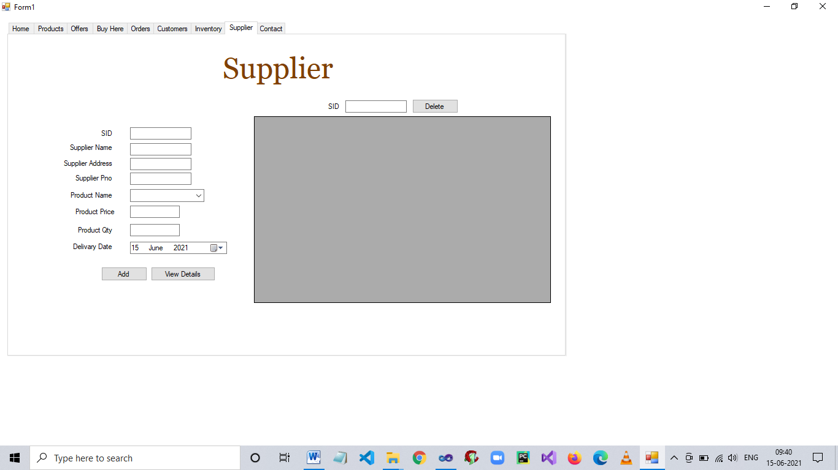

**CONCLUSION**

It was a wonderfull & learning experience for us while working on this project

Finally we conclude that this software is helpful for the people who require products & search for information in their cities. We enjoyed each & every bit of work

We had put into this project.

**BIBLIOGRAPHY**

ONLINE REFERCENCES

* www.Wikipedia.com
* www.w3school.com
* www.tutorialpoints.com
* [www.stackoverflow.com](http://www.stackoverflow.com/)

BOOKS REFERENCES

* VB.Net: The Complete Reference, Fifth Edition (BY : Vikram Singh)