**Code:**

#include <bits/stdc++.h>

using namespace std;

void bubble_sort(int* arr, int n) {

for (int i = n - 1; i >= 0; i--) {

int didSwap = 0;

for (int j = 0; j <= i - 1; j++) {

if (arr[j] > arr[j + 1]) {

swap(arr[j],arr[j+1]);

didSwap = 1;

}

}

if(!didSwap) break;

}

}

int main()

{

int n;

cout<<"Enter the number of elements: ";

cin>>n;

int arr[n];

cout<<"Enter the elements: ";

for(int i = 0; i < n ; i++) cin>>arr[i];

bubble_sort(arr, n);

cout << "After using bubble sort: " << "\n";

for (int i = 0; i < n; i++) cout << arr[i] << " ";

cout << "\n";

return 0;

}

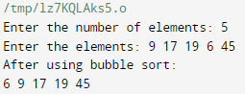**Output:**