**Code:**

#include <bits/stdc++.h>

using namespace std;

bool lSearch(vector<int> v, int n, int t){

for(int i = 0; i < n; i++)

{

if(v[i] == t) return true;

}

return false;

}

bool bSearch(vector<int> v, int n, int t){

int l = 0;

int h = n-1;

while(l<=h){

int m = (l + ((h-l)>>1));

if(v[m] == t) return true;

else if(v[m] < t) l = m+1;

else h = m-1;

}

return false;

}

int main() {

int n,t;

int choice = 0;

cout<<"Menu driven program for Linear and Binary search"<<endl;

cout<<"Enter the number of elements: ";

cin>>n;

vector<int> v(n);

cout<<"Enter the elements: ";

for(int i = 0; i< n; i++) cin>>v[i];

cout<<"What do you want to search? ";

cin>>t;

while(choice !=3)

{

cout<<"Select any one:-\n'1' for Linear Search\t'2' for Binary Search\t'3' Stop"<<endl;

cin>>choice;

switch(choice){

case 1:

(lSearch(v,n,t))?cout<<"Element present\n":cout<<"Element not present\n";

break;

case 2:

sort(v.begin(),v.end());

(bSearch(v,n,t))?cout<<"Element present\n":cout<<"Element not present\n";

break;

case 3:

cout<<"Terminated!";

exit(0);

default:

cout<<"Inavlid input"<<endl;

}

}

return 0;

}

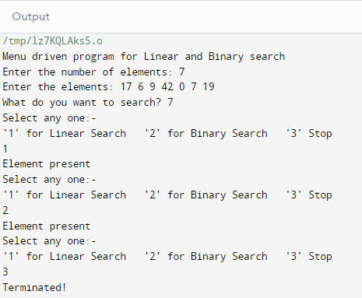**Output:**