Table of Contents
Problem Statement 1
Phase 1: Problem Understanding & Industry Analysis 3
Phase 2: Org Setup & Configuration Summary 6
Phase 3: Data Modeling & Implementation Report 10

Campus Recruitment Command Center
An Integrated System for Student Placements & Corporate Relations
  - Pawan Kumar Rajak

Problem Statement
Project Title: "Campus Recruitment Command Center - An Integrated System for Student Placements & Corporate Relations"
Industry: Higher Education
Project Type: B2S (Business-to-Student) & B2B (Business-to-Business) Salesforce Platform
Target Users: Training & Placement (T&P) Officers, Students, and the Head of Placements
Problem Statement
A university's Training & Placement (T&P) cell manages hundreds of corporate relationships and thousands of student applications using disconnected tools like spreadsheets, Google Forms, and email. This manual process results in communication gaps, missed application deadlines for students, and an inability for T&P officers to efficiently match the right students with the right opportunities. Furthermore, the constant influx of student queries via email overwhelms the T&P staff, leading to slow response times for critical questions.
To address this, the university wants to implement a Salesforce platform to:
- Centralize company and job posting information.
- Automate the student application and notification process.
- Streamline and automate the resolution of common student queries.
- Provide real-time dashboards for the Head of Placements to track success metrics.
Use Cases
1. Corporate & Recruiter Management
- Maintain a unified database of all visiting companies and their recruiter contact information.
- Track the status of engagement with new companies (e.g., Approached, MoU Signed, Visit Scheduled).
- Log all interactions, such as calls and meetings, with company representatives.
2. Job Posting & Application Management
- Create and manage detailed Job Postings with specific eligibility criteria (e.g., Branch, GPA, Graduation Year).
- Automatically notify eligible students via email when a new relevant job is posted.
- Allow students to apply for jobs through a simple, guided interface (a Screen Flow).
- Track the status of each student's application (e.g., Applied, Shortlisted, Offer Extended).
3. Automated Student Query Resolution
- Automatically create a "Query" record in Salesforce when a student sends an email to a designated placement helpdesk address (e.g., placements@university.edu).
- Send an automated initial email response acknowledging receipt of the query.
- Use a Flow to scan the query's subject for keywords (e.g., "Resume," "Eligibility," "Deadline") and send back a templated email with helpful links or standard answers, closing common queries without manual intervention.
4. Reporting & Analytics
- A master dashboard for the Head of Placements showing key metrics like:
  - Number of Companies Visiting
  - Total Job Openings vs. Applications
  - Branch-wise Placement Percentage
- Reports that track the placement funnel and T&P officer activity.

Phase 1: Problem Understanding & Industry Analysis
Date: September 10, 2025
1. Requirement Gathering
The primary goal of this project is to transform the university's manual and fragmented placement process into a streamlined, automated, and centralized system using the Salesforce platform.
Functional Requirements (What the system must do):
- Company & Recruiter Management: A central database to store and manage information about visiting companies (Accounts) and their recruiters (Contacts).
- Job Posting Management: T&P officers must be able to create, update, and manage job postings with specific eligibility criteria (e.g., Branch, GPA, required skills).
- Automated Student Notifications: The system must automatically email eligible students as soon as a new, relevant job is posted.
- Student Application Portal: Students need a simple, guided way to view and apply for open positions.
- Application Tracking: The system must track the status of each student's application (Applied, Shortlisted, Interviewing, Offer Extended, Rejected).
- Automated Query Handling: The system must automatically create a case/record from incoming student emails and provide an automated, templated response for common queries.
- Reporting & Analytics: The Head of Placements requires real-time dashboards to view key metrics like placement rates, company engagement, and application numbers.
Technical Requirements:
- The solution must be built on the Salesforce Lightning Platform.
- The system must enforce data security through a role-based model (T&P Officer vs. Student).
- The solution should be scalable to handle data for thousands of students and hundreds of companies.
2. Stakeholder Analysis
The success of the project depends on meeting the needs of its key users.
Stakeholder Role | Needs & Goals | Current Pain Points
T&P Officer | - Quickly add new companies and jobs. Reduce manual data entry and email tasks.Track all student applications in one place. | - Data is scattered across multiple spreadsheets. Manually filtering and emailing students is time-consuming and error-prone.Overwhelmed by repetitive student questions.
Student | - A single, reliable source for all job openings. Timely alerts for jobs they are eligible for. A clear and simple application process. | - Fear of missing deadlines due to communication gaps. Confusion from information on different platforms (email, WhatsApp, website). Slow response times for important queries.
Head of Placements | - High-level, real-time view of placement statistics. Data-driven insights to improve corporate relations. Professional reports for university management. | - Lack of accurate, real-time data for strategic decision-making. Reporting is a manual and time-consuming process at the end of the placement season.
3. Business Process Mapping
As-Is Process (Current State):
- A company recruiter emails job details to a T&P Officer.
- The T&P Officer manually checks a master student spreadsheet to find eligible candidates.
- The Officer composes and sends a bulk email to the filtered list.
- Students apply by replying to the email with their resumes.
- The T&P Officer tracks these applications in another spreadsheet.
- This process is slow, inefficient, and creates multiple versions of the truth.
To-Be Process (Future State with Salesforce):
- A T&P Officer creates a Job Posting record in Salesforce with defined eligibility criteria.
- SYSTEM ACTION: A Record-Triggered Flow instantly sends a templated email to all Contact records (Students) who meet the criteria.
- The student clicks a link in the email, launching a Screen Flow to apply.
- SYSTEM ACTION: Upon flow completion, an Application record is automatically created, linking the Student and the Job Posting.
- All data is instantly available on a real-time dashboard for the Head of Placements.
4. Industry-specific Use Case Analysis (Higher Education)
In the Higher Education sector, the Training & Placement cell is a critical function that directly impacts the university's reputation and ranking. This project addresses a core industry challenge: bridging the gap between academia and the corporate world effectively.
- Enhancing the Student Experience: A smooth, transparent, and professional placement process is a key differentiator for universities. This system directly enhances the student experience at the most critical final stage of their journey.
- Strengthening Corporate Partnerships: Providing corporate partners with a streamlined recruiting process makes the university a more attractive place to hire from, leading to better and more numerous job opportunities for students.
- Data-Driven Strategy: This system moves the T&P cell from a purely administrative function to a strategic one, allowing the Head of Placements to use data to identify trends and improve their outreach strategies.
5. AppExchange Exploration
A review of the Salesforce AppExchange was conducted to identify existing solutions.
- Salesforce Education Cloud: This is Salesforce's flagship product for the education industry. It is an extensive, enterprise-level solution that manages the entire student lifecycle, from admissions to alumni relations. While powerful, it is too large and complex for the specific, immediate needs of the T&P cell and the 5-day project scope.
- Third-Party Apps: Various apps exist for event management, email marketing, and form building.
Conclusion: A solution that is perfectly tailored to the university's unique placement process, can be developed rapidly, and avoids the cost and complexity of a large, pre-built package. This project will deliver maximum value by focusing directly on solving the T&P cell's most pressing problems.

Phase 2: Org Setup & Configuration Summary
Date: September 11, 2025
1. Core Company Configuration
The foundational settings for the Salesforce org were established to mirror the operational environment of the university's T&P Cell.
- Company Information: The org was configured with the university's name, default time zone (Asia/Kolkata), and locale to ensure all time-stamped data is accurate.
- Business Hours & Fiscal Year: Standard business hours (Mon-SAT, 12 AM - 12 AM) were set to enable future tracking of case/query response times. A standard fiscal year was confirmed for reporting consistency.
- Developer Org: A new Salesforce Developer Edition org was created to serve as the dedicated environment for this project.
2. Security Model Implementation
A multi-layered security model was configured to ensure data is accessible only to the appropriate users.
- Profiles: Two custom profiles were created by cloning the "Standard User" profile:
  - T&P Officer: For staff who will manage the system.
  - Student: For end-users who will interact with the system.
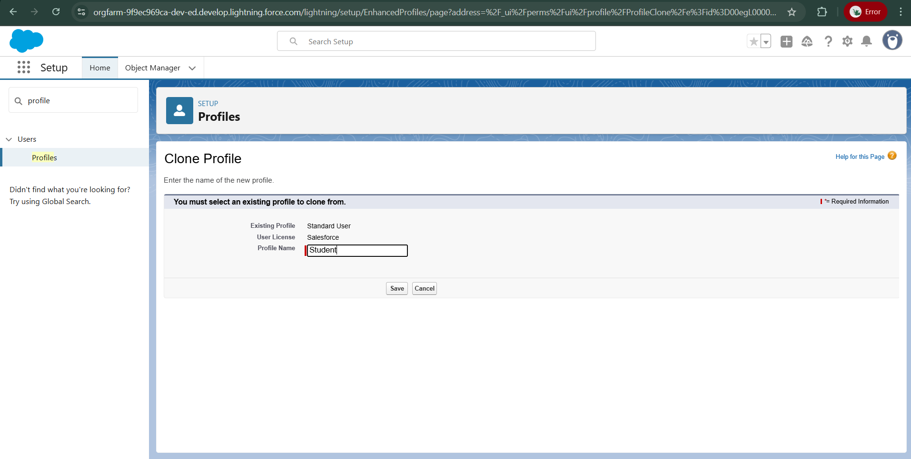
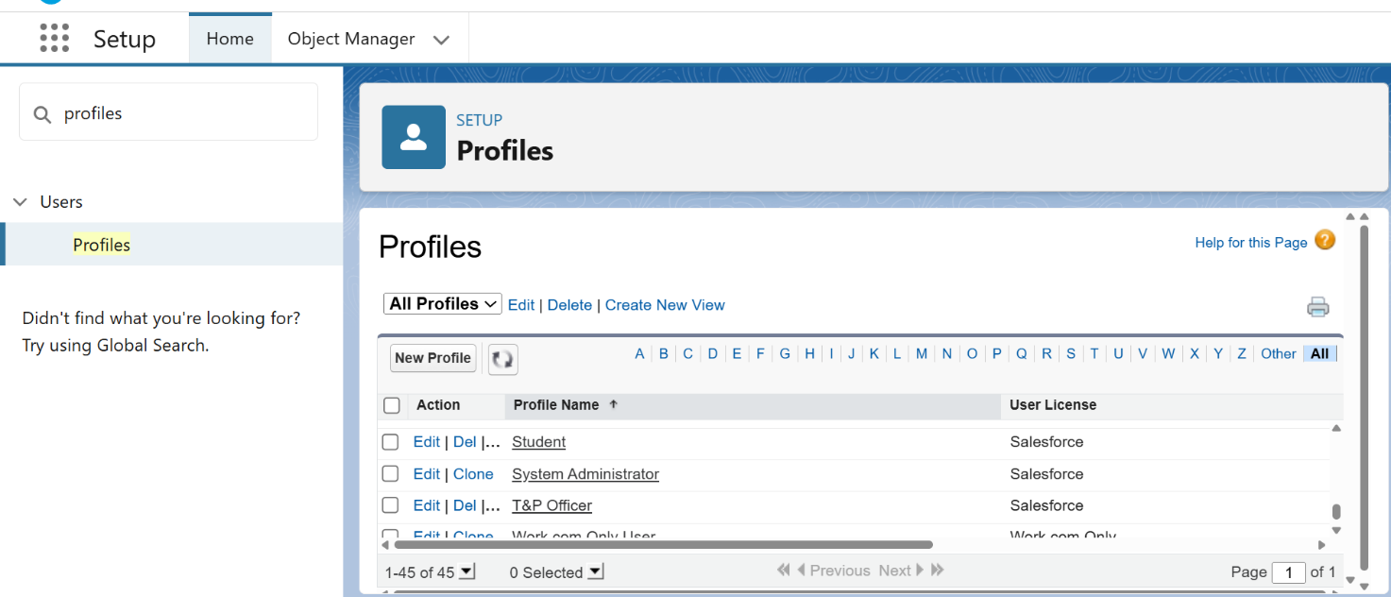

- Role Hierarchy: A top-down data visibility structure was created: CEO -> Head of Placements -> T&P Officer. This ensures management can view the records of their subordinates.
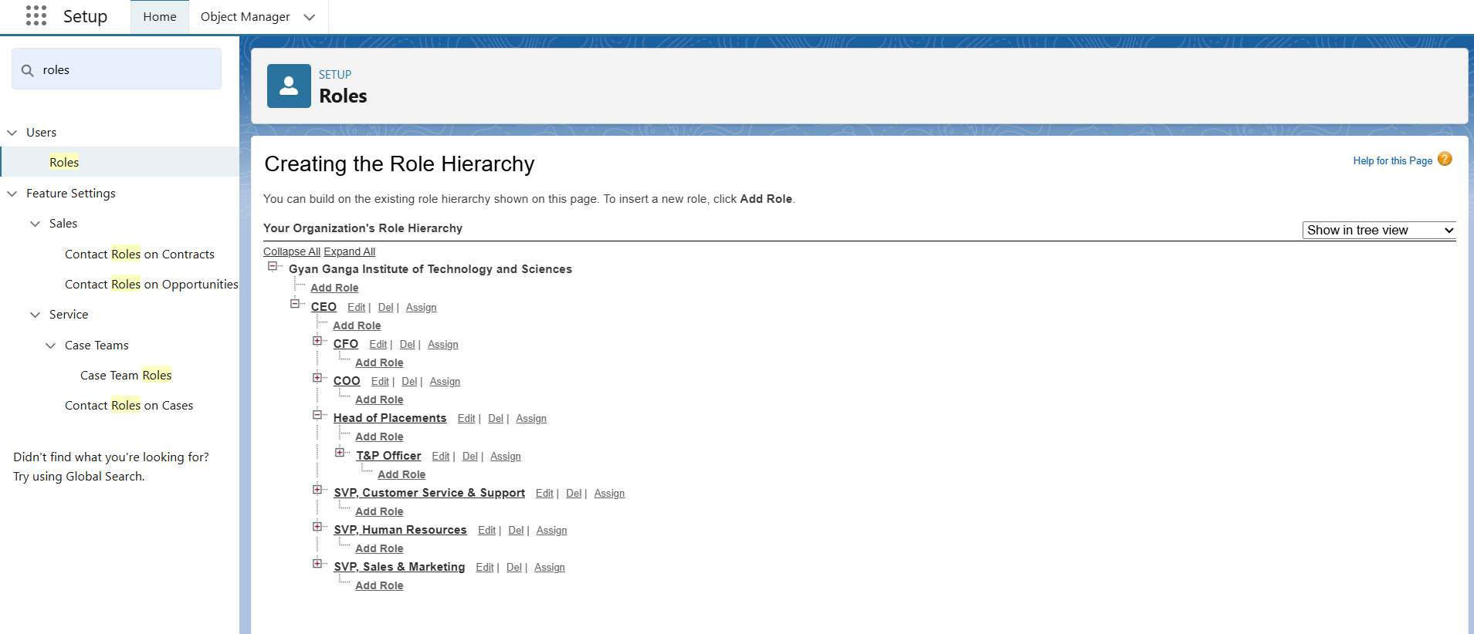

- Organization-Wide Defaults (OWD): A Private data model was established as the baseline. This is a security best practice, ensuring users can only see their own records by default unless explicitly granted access.
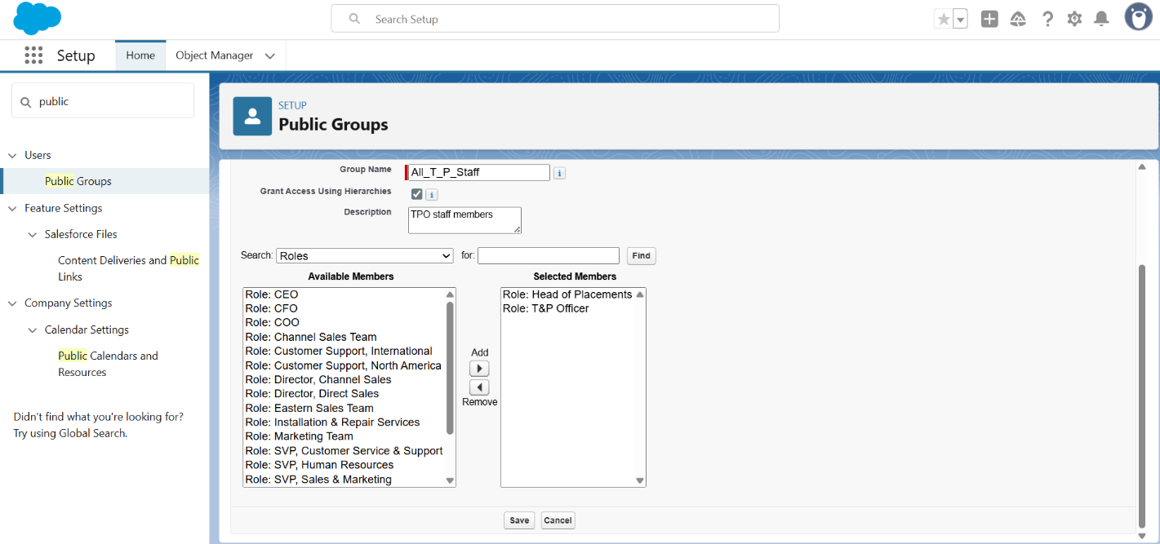

- Permission Set: A Permission Set named T&P Analytics Manager was created to grant specific, additive permissions (e.g., "Create and Customize Dashboards") to select users without changing their entire profile. This demonstrates a flexible approach to security.

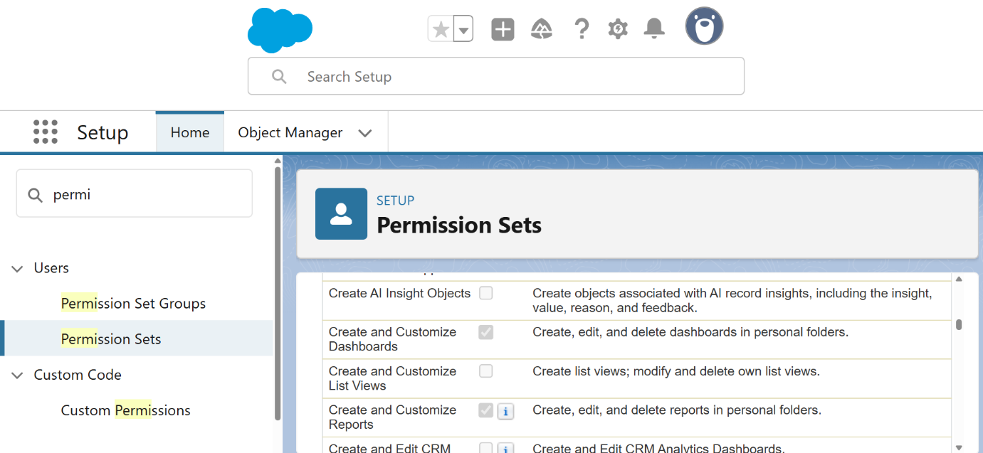

3. Deferred Configurations & Justification
Certain configurations mentioned in the project checklist were intentionally deferred to a later phase for strategic reasons.
- Sharing Rules: Sharing Rules are used to open up access to records that are locked down by a Private OWD. These rules are record-specific. Reason for Deferral: The custom objects (Job Posting, Application, T&P Query) have not been created yet. Sharing Rules for these objects will be configured in Phase 4 after the data model is built.
- Login IP Ranges: This security feature restricts user logins to specific IP addresses. Reason for Deferral: During the development phase, it is impractical to restrict IP ranges as development may occur from various locations. This is a production-level security measure that would be implemented post-development, before final deployment.
- Sandbox Usage & Deployment: These concepts relate to the development lifecycle in a team environment. Reason for Deferral: As a rapid, 5-day solo project, development is being done directly in a Developer Org for maximum efficiency. In a real-world team project, a sandbox-driven development and deployment strategy would be utilized.

Phase 3: Data Modeling & Implementation Report
Date: September 12, 2025
1. Overview
This document outlines the actions taken during the Data Modeling phase of the project. The objective was to create a robust, scalable, and secure data structure to support all functionalities of the Training & Placement (T&P) application. This involved configuring standard Salesforce objects, creating new custom objects and fields, establishing relationships, and enhancing the user interface.
2. Standard Object Configuration
Standard Salesforce objects were leveraged and configured to fit the project's specific terminology and data segregation needs.
- Account Object:
  - Action: The Account object was renamed to Company.
  - Justification: This provides a more intuitive user experience for T&P Officers, who primarily manage relationships with companies, not "accounts."
- Contact Object (with Record Types):
  - Action: Two record types were created on the Contact object: Student and Recruiter. Each record type was assigned a unique page layout (Student Layout and Recruiter Layout).
  - Justification: The Contact object stores two distinct types of people. Record Types are the Salesforce best practice for segregating them, allowing for different data fields and user experiences on the same object.
- Lead Object:
  - Action: The standard Lead object was not renamed or configured for this project's initial scope.
  - Justification: The primary focus is on managing relationships with established corporate partners (Companies) and student applications. While future enhancements could use Leads for tracking potential new corporate partners, it is not part of the core requirement for this 5-day build.
3. Custom Object & Field Creation
Three core custom objects were created to form the backbone of the application.
Object 1: Job Posting (Job_Posting__c)

Object 1: Job Posting (Job_Posting__c)
Field Label | API Name | Data Type | Details
Job Posting Name | Name | Text | The primary identifier/title of the job.
Company | Company__c | Master-Detail | A required link to the parent Company (Account) record.
Description | Description__c | Text Area (Long) | For the detailed job description.
Location | Location__c | Text | The city/location of the job.
Package (CTC) | Package_CTC__c | Currency | The offered Cost-to-Company.
Eligibility Branch | Eligibility_Branch__c | Picklist (Multiselect) | Values: Computer Science, Mechanical, Electronics, Civil.
Minimum GPA | Minimum_GPA__c | Number (2,1) | Required GPA for eligibility.
Status | Status__c | Picklist | Values: Open, Interviewing, Closed.

Object 2: Application (Application__c) – Junction Object
Field Label | API Name | Data Type | Details
Application ID | Name | Auto-Number | Format: APP-{0000}.
Job Posting | Job_Posting__c | Master-Detail | A required link to the parent Job_Posting__c record.
Student | Student__c | Master-Detail | A required link to the parent Contact (Student) record.
Status | Status__c | Picklist | Values: Applied, Shortlisted, Interview Scheduled, Offer Extended, Rejected.

Object 3: T&P Query (T_P_Query__c)
Field Label | API Name | Data Type | Details
Query ID | Name | Auto-Number | Format: Q-{00000}.
Student | Student__c | Lookup | An optional link to the Contact (Student) record.
Description | Description__c | Text Area (Long) | The full text of the student's question.
Status | Status__c | Picklist | Values: New, Automated Reply Sent, Manual Follow-up Needed, Closed.
Category | Category__c | Picklist | Values: Eligibility, Resume, Deadline, Technical Issue, Other.

4. Relationship Decisions (Master-Detail vs. Lookup)
The choice of relationship type is critical for data integrity.
- Master-Detail Relationship (MDR): Used on the Application object for its links to Job Posting and Contact.
  - Justification: An application is fundamentally dependent on both a job and a student. It cannot exist on its own. The MDR enforces this by ensuring an application record is automatically deleted if either its associated job or student is deleted (cascading delete). This also allows for rollup summary fields in the future.
- Lookup Relationship: Used on the T&P Query object to link to the Contact.
  - Justification: A query is related to a student, but it is also a historical record for the T&P cell. If a student's record is deleted after graduation, the T&P cell may still want to retain the query for analytics. A Lookup provides a looser connection that prevents the query from being auto-deleted, thus preserving historical data.
5. User Interface & Field-Level Security
- Page Layouts & Compact Layouts: Custom page layouts were created for the Student and Recruiter record types. A custom Compact Layout, Job Posting Highlights, was created to show key information at the top of the job posting page.
- Field-Level Security (FLS): FLS was configured to ensure users only see relevant data.
  - User-Driven Modification: Based on user requirements for transparency, the Package (CTC)__c field on the Job Posting object has been made Read-Only for the Student profile. This allows students to make informed decisions while preventing them from editing the data.
  - Internal Fields: The Category__c field on the T&P Query object was hidden from the Student profile as it is an internal classification field for T&P officers only.
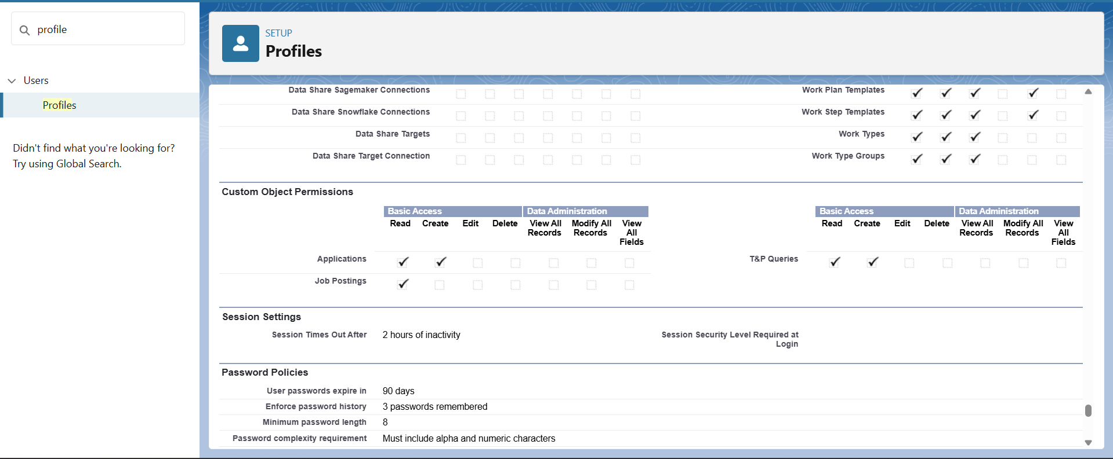
6. Schema Builder Visualization
The Schema Builder was used to view the complete data model. This provides a clear, visual blueprint of all objects and their intricate relationships, confirming the logical integrity of the application's architecture.
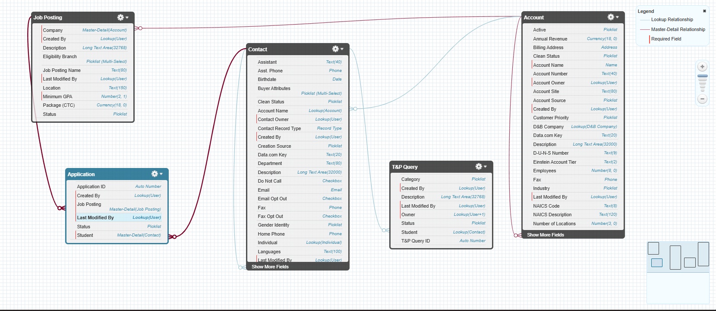
7. Excluded Concepts
- Hierarchical & External Objects: These relationship types were not applicable. Hierarchical relationships are specific to the User object, and External Objects are for integrating data from outside systems, which is beyond the scope of this self-contained project.

Phase 4: Process Automation Implementation Final Report
Date: September 17, 2025
1. Overview
This document provides a comprehensive summary of the process automation implemented during Phase 4. Building upon the secure data model from the previous phases, the focus was to embed the T&P Cell's business logic directly into the application. This was achieved by creating a suite of automations that enforce data quality, guide user actions, eliminate manual work, and ensure timely, professional communication. All automations were built using Salesforce Flow, adhering to modern best practices for scalability and maintenance.
2. Implemented Automations & Processes
A. Validation Rule: Preventing Data Inconsistency
A validation rule was implemented to protect data integrity and enforce a critical business process.
- Business Need: The T&P Cell cannot officially close a Job Posting if there are still students with active applications for that role. This prevents administrative errors and ensures no student is left in limbo.
- Implementation Steps:
  - A Roll-Up Summary Field named Active Application Count was created on the Job Posting object. This field provides a real-time count of all related Application records that are not in a final state (Offer Extended or Rejected).
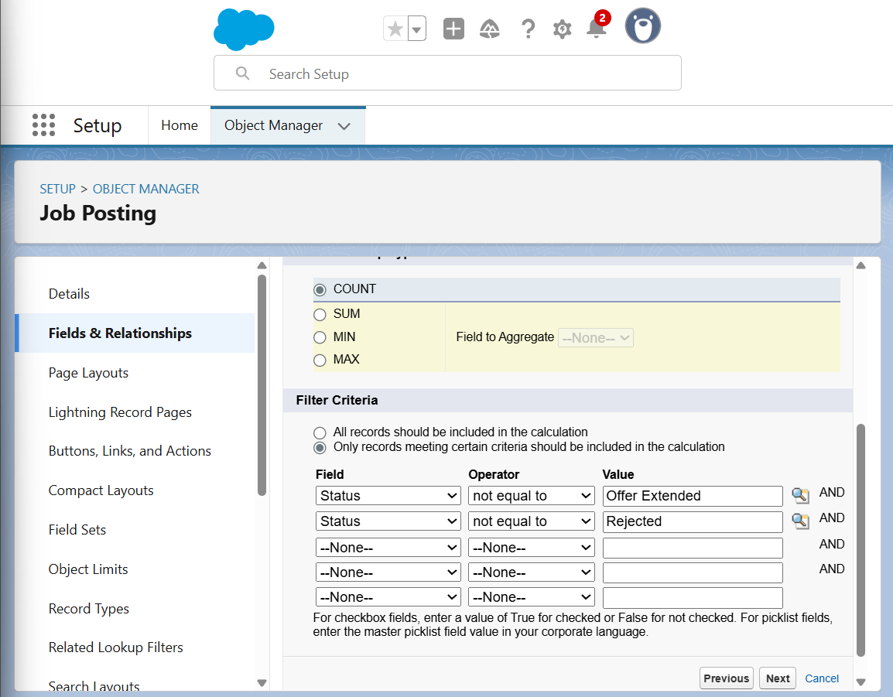
  - A Validation Rule was then created on the Job Posting object. This rule checks two conditions upon saving a record: if the Status is being changed to "Closed" AND if the Active Application Count is greater than 0. If both are true, the save action is blocked, and a clear error message is displayed to the user.
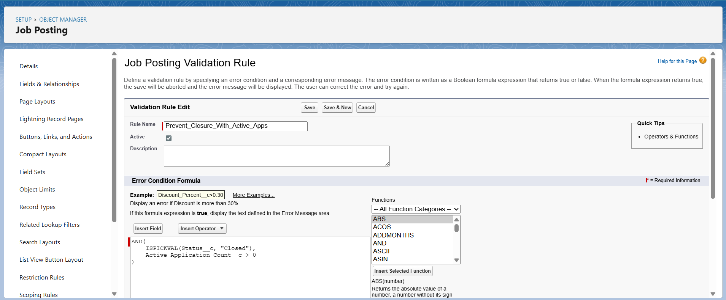
B. Screen Flow: A Guided Application Experience for Students
To enhance the student user experience and streamline the application process, a guided screen flow was developed.
- Business Need: Students require a simple, intuitive, and error-proof method to apply for jobs. A manual process of creating records would be inefficient and confusing.
- Implementation Steps:
  - A Screen Flow titled "Student Application Process" was built. It features a simple confirmation screen to ensure the student's intent.
  - The flow is intelligent, automatically capturing the recordId of the Job Posting it was launched from and the ContactId of the logged-in student user ($User.ContactId).
  - Upon confirmation, a Create Records element automatically generates a new Application record, correctly linking the student and job, and setting the initial Status to "Applied".
  - This flow was then made accessible by creating a Quick Action button labeled "Apply Now" and adding it to the Job Posting page layout, ensuring high visibility.
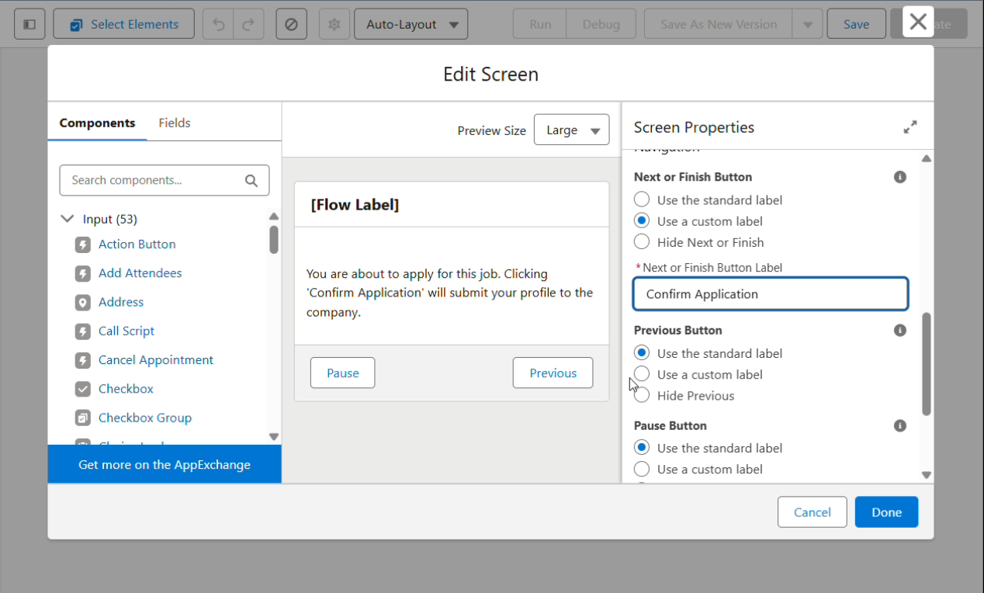
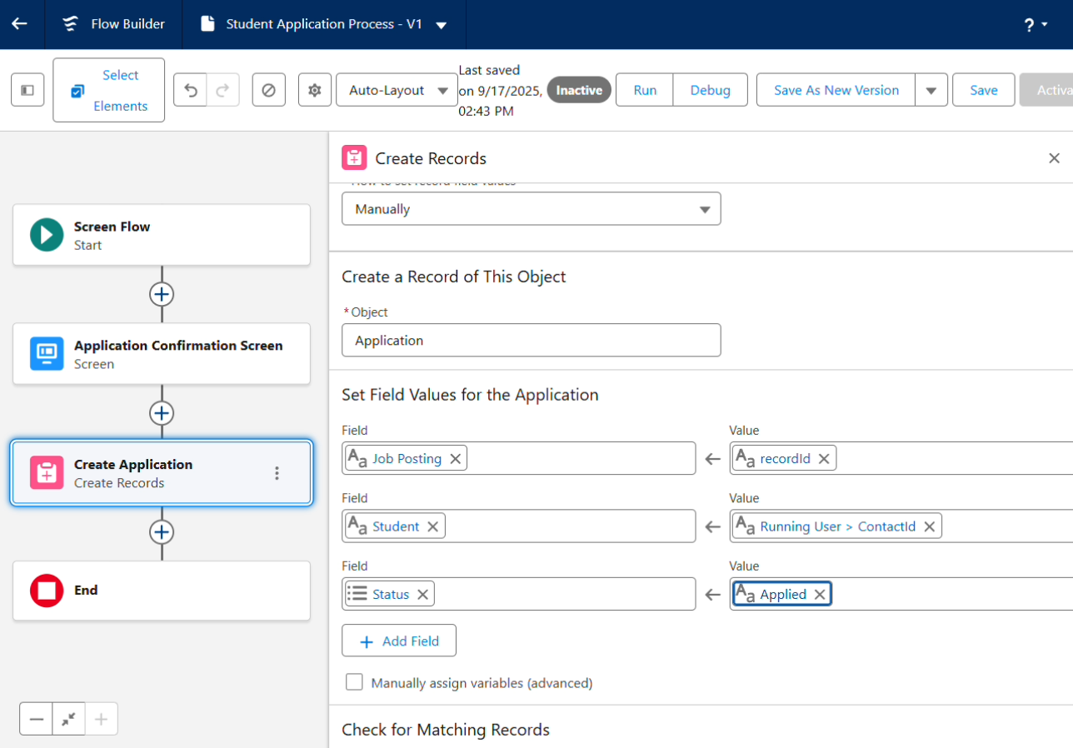
C. Approval Process & HTML Email Alert: Formalizing Job Postings
A formal approval process, supported by a professional HTML email alert, was created to ensure management oversight.
- Business Need: All new job postings must be reviewed and approved by the Head of Placements before they are made public to students, ensuring quality and consistency. The notification for this approval must be professional and actionable.
- Implementation Steps:
  - An HTML Email Template was created to provide a branded, easy-to-read notification. The template includes the university logo, merges in key details like the Job Title and Company, and features a prominent "View and Approve" button that links directly to the record in Salesforce.
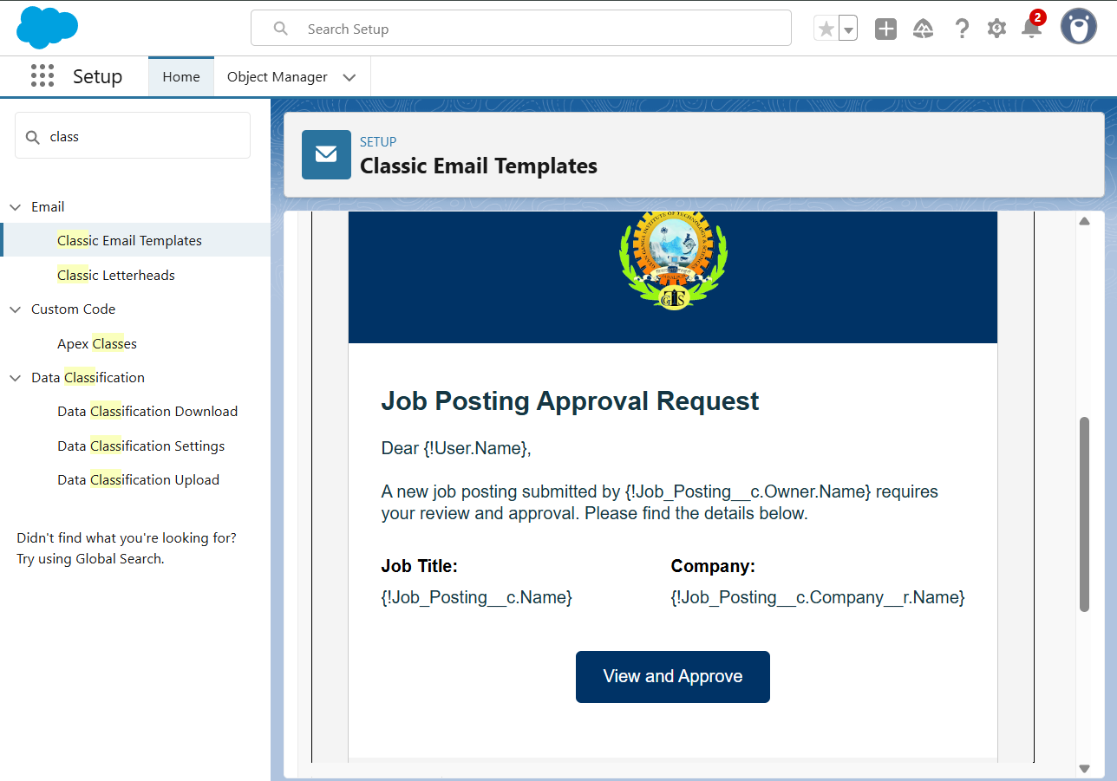
  - An Email Alert action was configured to use this HTML template and send it to any user with the Head of Placements role.
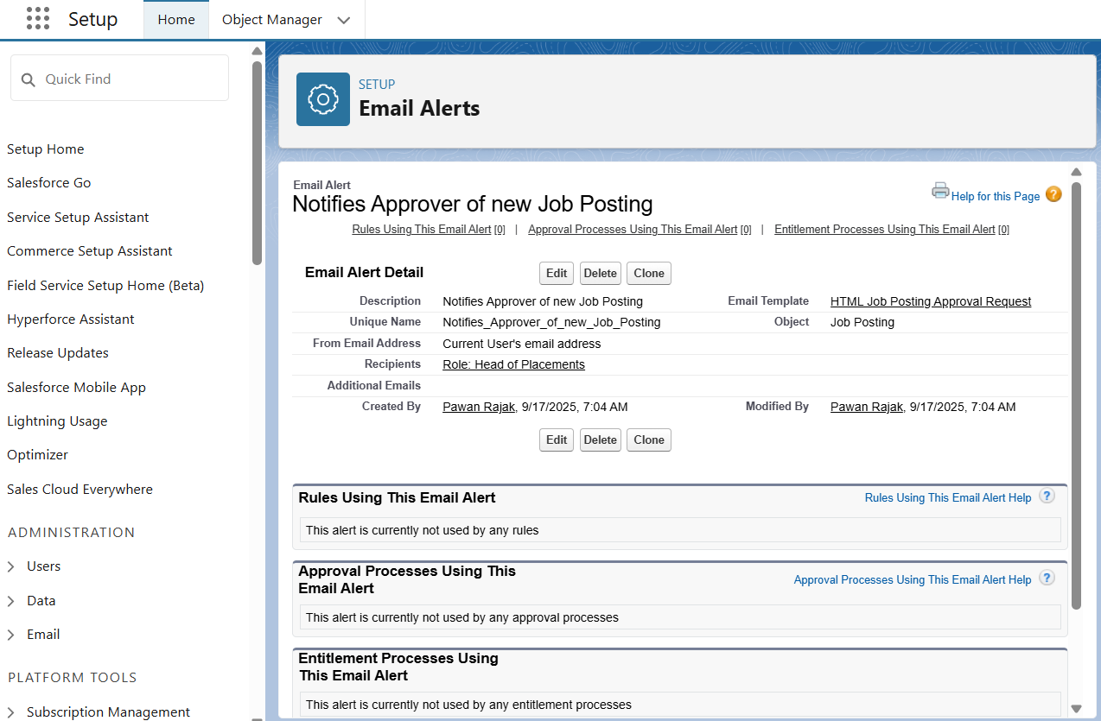
  - An Approval Process was configured on the Job Posting object. It triggers when a record's Status is set to "Submitted for Approval".
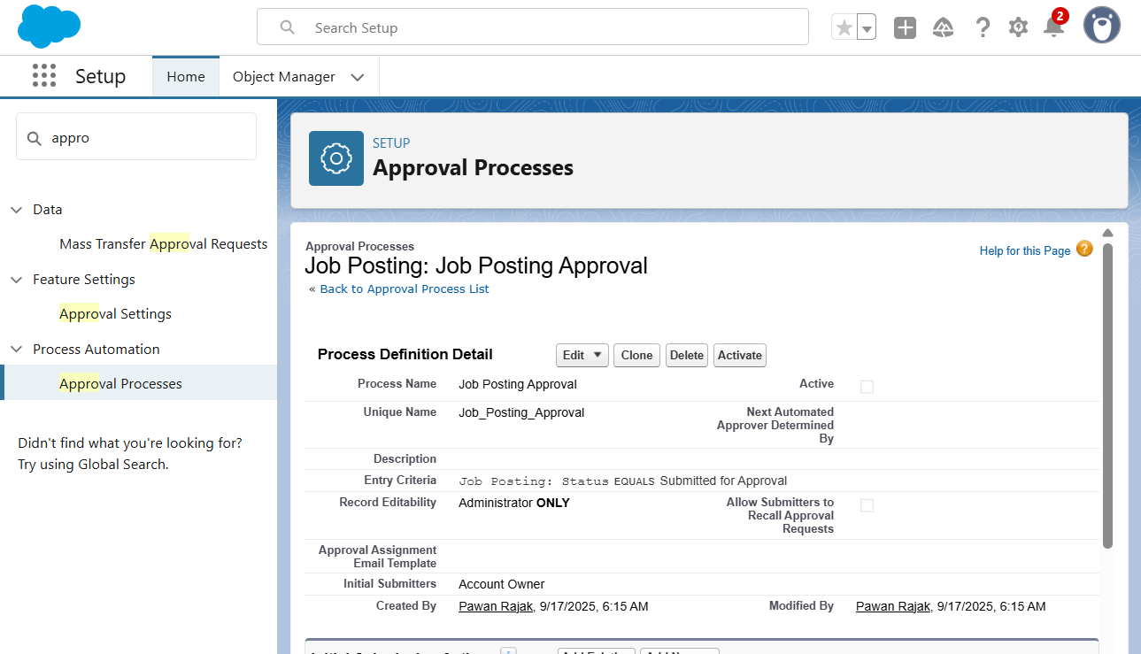
  - The approval request is automatically assigned to the submitter's manager via the Role Hierarchy.
  - The Email Alert was added to the "Initial Submission Actions," ensuring the approver is notified instantly.
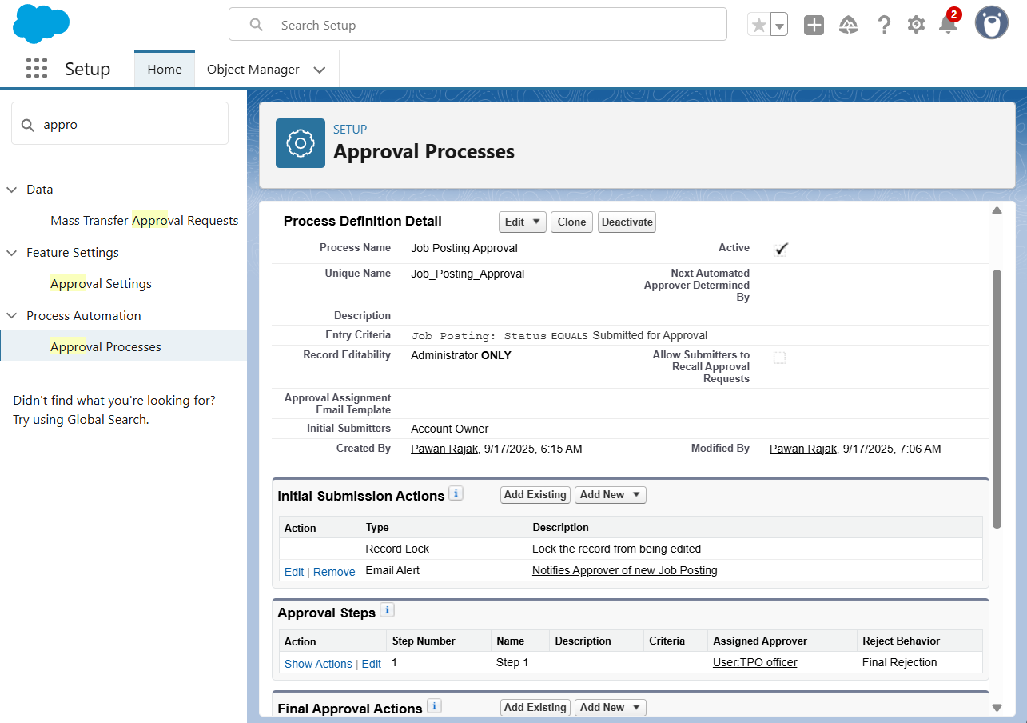

  - Field Updates were configured to automatically change the Status to "Open" upon approval or "Needs Rework" upon rejection.
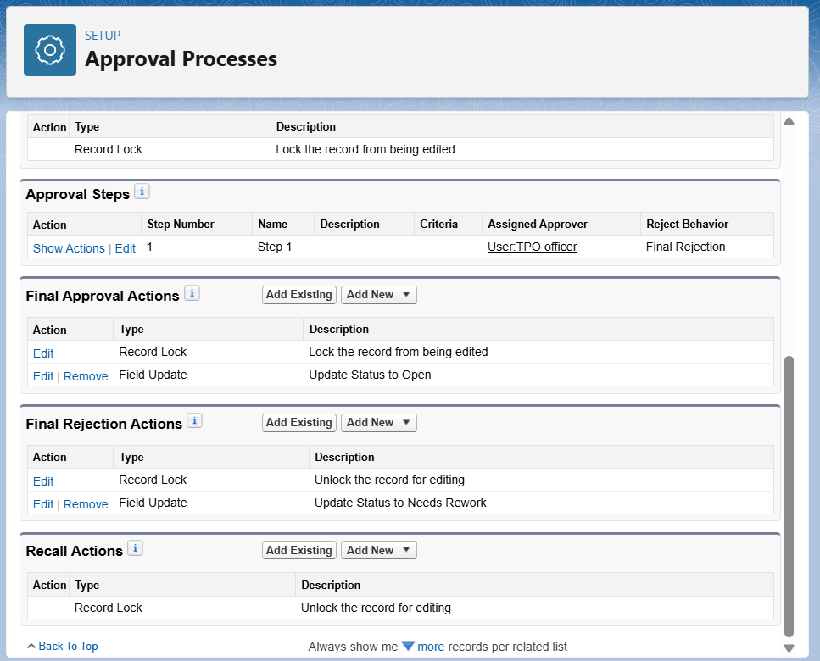
D. Record-Triggered Flow: Automated Task Creation
A background automation was created to ensure that critical student queries are assigned and tracked efficiently.
- Business Need: Queries related to technical issues need to be flagged and assigned for follow-up so they are not lost in the general queue.
- Implementation Steps (Simplified):
  - A Record-Triggered Flow was built on the T&P Query object that runs only when a new record is created with a Category of "Technical Issue".
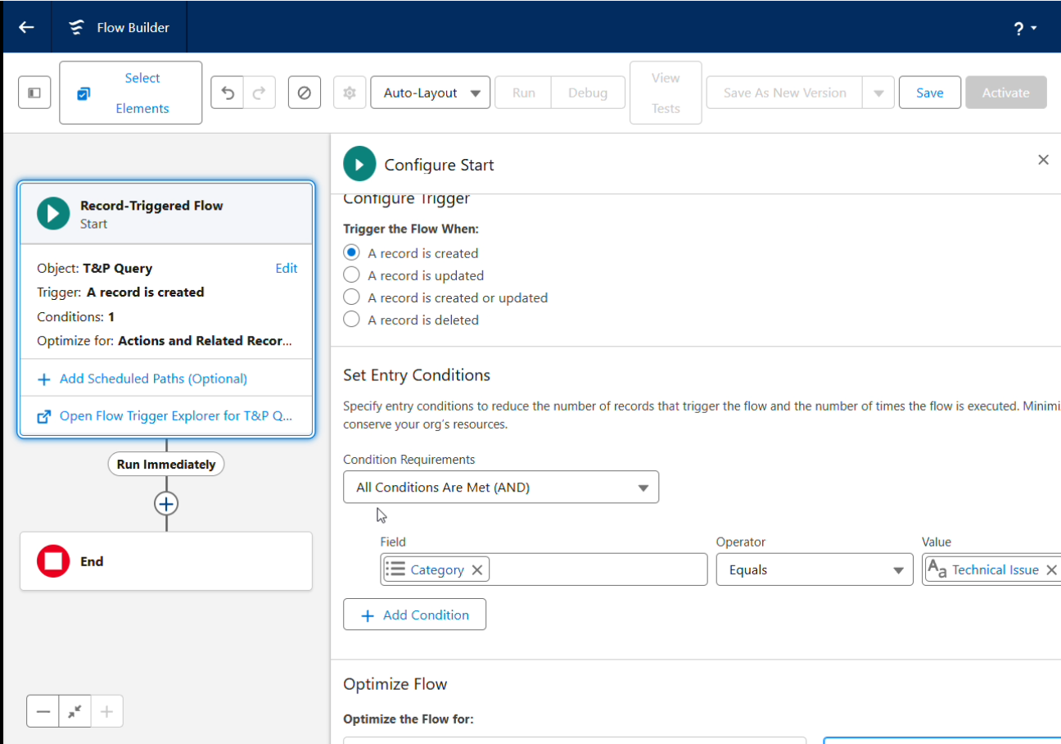
  - A Create Records element generates a new Task record.
  - To ensure clarity and trackability, the Task's Subject is set to a static text ("Follow up on new Technical Issue query"), and its Related To ID is dynamically set to the ID of the T&P Query record that triggered the flow ({!$Record.Id}). This creates a direct link between the query and the follow-up task.
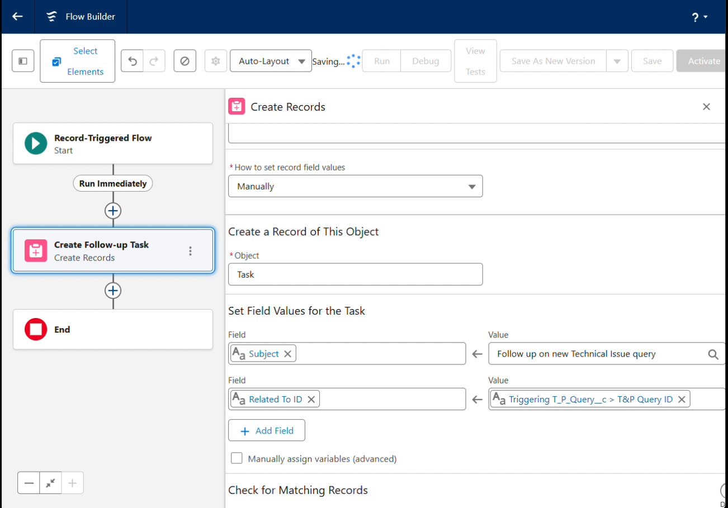
3. Strategically Excluded Concepts & Justification
- Legacy Tools (Workflow Rules & Process Builder): These older automation tools were intentionally not used.
  - Justification: Salesforce is actively retiring these tools in favor of Flow Builder. To ensure the application is modern, efficient, and future-proof, all automation was built in Flow. This aligns with industry best practices and simplifies future maintenance.
- Custom Notifications (In-App Alerts): The in-app notification feature was deferred for this phase.
  - Justification: After analyzing the primary user workflows, it was determined that email is the most critical and reliable communication channel for T&P Officers, who may not be logged into Salesforce at all times. To avoid "notification fatigue" and ensure that high-priority alerts (like an approval request) are never missed, the decision was made to centralize these actionable notifications in the email channel for this initial build. In-app notifications are a candidate for a future enhancement phase, pending user feedback on communication preferences.

