Fraud Detection Solution Wireframes

**Fraud Detection Dashboard**

**Wireframe 1 : Sign In**

This is for the authentication purpose of the Fraud detection dashboard. User can sign in using default username and password.

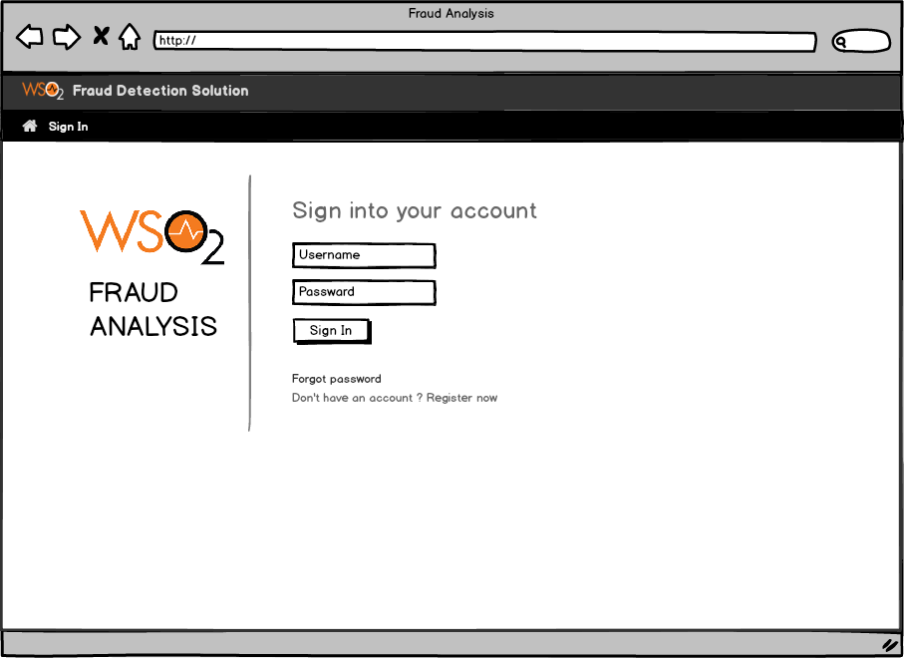

**Wireframe 2 : Fraudulent Transactions Page**

This page will shows the possible fraudulent transaction list using a tableview that has different transaction attributes. Here when a user clicks on a specific transaction it will move to the Investigation Graph page. (Wireframe 3)

When a new possible transaction comes it will appear as an alert on the dashboard and then the user can update the tableview with those new transactions.

Also a user can search for a specific transaction_ID , IP_address, credit_card from the search box in the Dashboard.

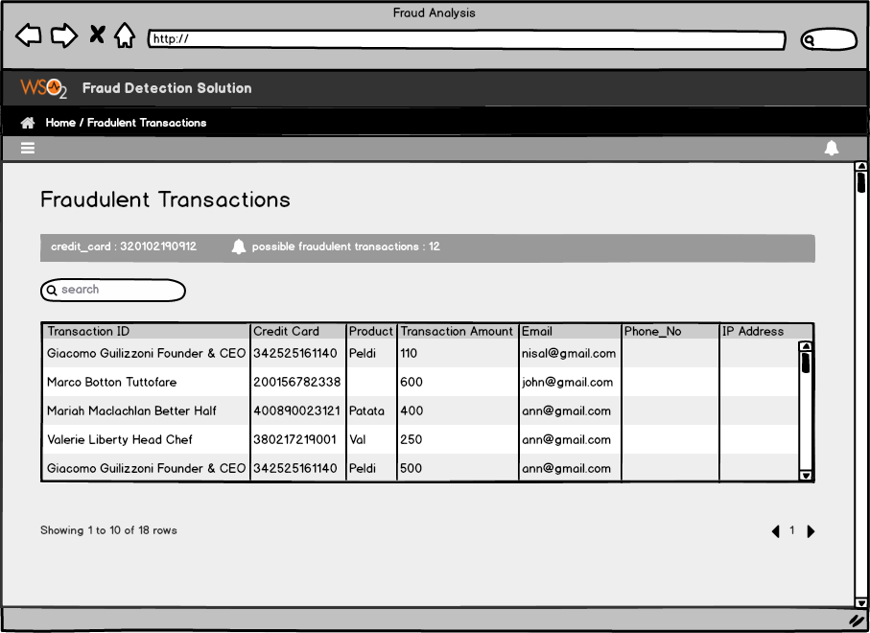

**Wireframe 3 : Graph Investigation Page**

This is for the Graph Investigation of the Fraud detection dashboard. So when a user clicks on a possible fraudulent transaction from that table view (Wireframe 2), it will show the graph investigation page if there is clear relationships found among that transaction.

This page will shows the transaction relationship graph with the details. Also it shows the no of nodes, no of relationships in the graph as a message.

User can get back to the transactions table view using the breadcrumb in the top of the dashboard.

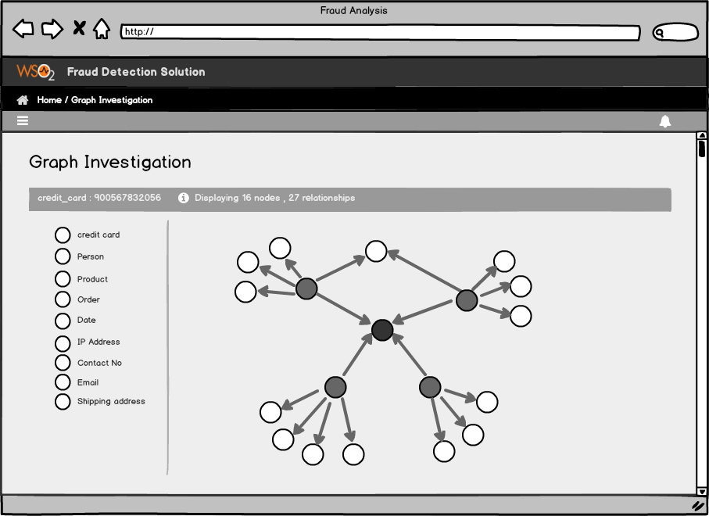

When a user clicks on a specific node of the graph it will shows the relevant details to that node. Also user can have zoom in, zoom out, mouse hover functionalities with the graph.