**Reporting Support for WSO2 Data Analytics Server**

**1.0 Introduction**

WSO2 DAS is the central solution for all the analytics solutions at WSO2 and it’s workflow is consist of three main phases as,

* Collecting data
* Analysing data
* Communicating results

At the phase of communicating results currently it has limited reporting capabilities. Basically a feature is required to read in data from DAS Analytics Tables and create different types of reports based on it. Also these reports would need to be exported as different formats like PDF, Docs, CSV etc…

So as a solution for this problem, we can use third party open source reporting tools like **Eclipse BIRT, Jasper** to generate different kind of reports. Considering their license Eclipse BIRT is ideal for this task, because it’s under the Eclipse public licence.

**2.0 Needed resources for Report Generation**

**Eclipse BIRT (Open Source Reporting Tool) :** Eclipse BIRT is an powerful open source reporting tool that consists of several components. The main components being the Report Designer and BIRT Runtime. BIRT also provides three extra components: a Chart Engine, Chart Designer, and Viewer. With these components you can create different kind of reporting including various visualizations.

**WSO2 DAS JDBC Driver :** DAS JDBC Driver can be used for connect WSO2 DAS data layer with third party reporting tools. So in order to create data source connection in Eclipse BIRT you need to add this JDBC driver jar.

**WSO2 Data Analytics Server :** WSO2 DAS has the analytics data and with that data you need to create the reports. So Before you going to create the Data source connection make sure WSO2 DAS is up and running.

**3.0 Using ‘WSO2 DAS JDBC Driver’ as the data source connector**

Here following Properties will need to create the jdbc connection using reporting tool,

* JDBC URL - **jdbc:dasjdriver:**[**https://localhost:9443/analytics/**](https://localhost:9443/analytics/)
* Username - **admin**
* Password - **admin**

**4.0 Eclipse BIRT Report Generation Process**

4.1 BIRT report creation

First you need to have eclipse including BIRT designs. Then you can start with ‘report project’ and proceed according to your report needs. BIRT's reporting layout design is nothing but an XML file with the extension <filename>**.rptdesign**.

Once you done with report design you can feed data into the report from WSO2 DAS using WSO2 DAS JDBC Driver.

4.2 Connection Creation using JDBC data source

After selecting the JDBC driver option as the data source then you have to configure the driver details relevant to DAS JDBC Driver. So first you have to add the driver jar

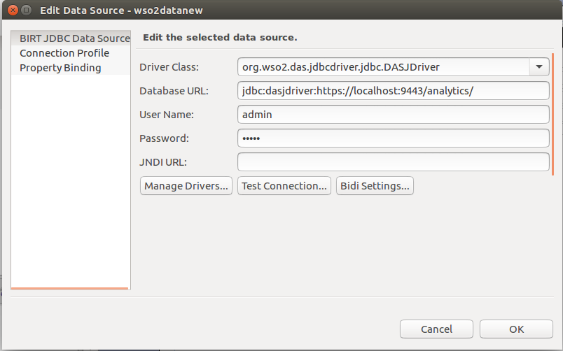

4.3 Data retrieving and customization

Here you can see the list of available data tables/streams in the WSO2 DAS. So then in the ‘Query Text’ Panel allow you to execute the query you need. After that Preview Results option allow you to view the data.

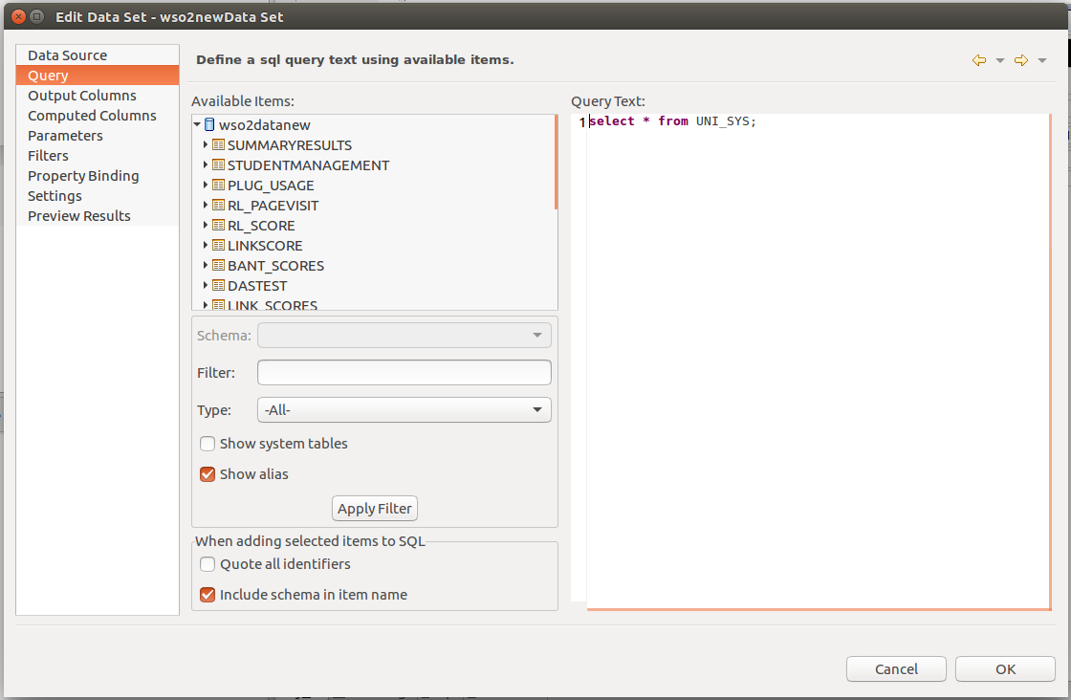

4.4 Preview and Export Reports using BIRT web viewer

The BIRT Web Viewer is an example application that illustrates generating and rendering BIRT design outputs in a web application. This viewer demonstrates report pagination, an integrated table of contents, report export to several formats and printing to local and server side printers.

BIRT provides output in HTML, Paginated HTML, PDF, XLS, DOC, PPT, ODS, ODP, ODT, and Postscript. Many other types of output are possible: ERich Text Format (RTF), Scalable Vector Graphic (SVG), images, and more.

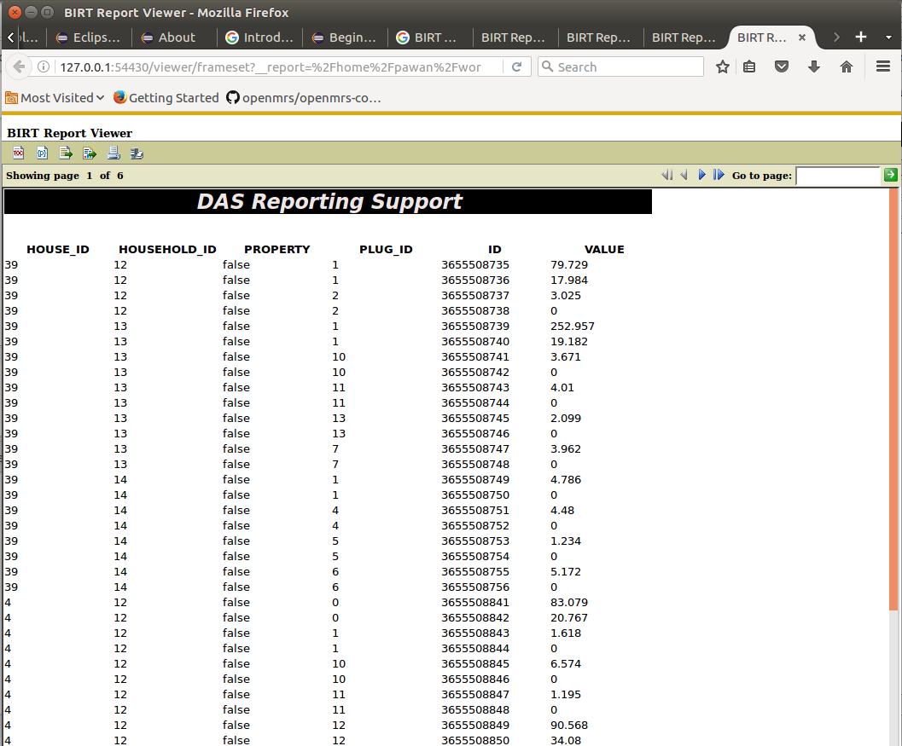

After that this report previews can be exported as a final report with the needed format.