**Reporting Support for DAS**

**Evaluation of Available Tools**

**1.0 Jasper Reports**

Jaspersoft Studio is an Eclipse-based report designer for JasperReports Library and JasperReports Server; it's available as an Eclipse plug-in or as a stand-alone application. Jaspersoft Studio allows you to create sophisticated layouts containing charts, images, subreports, crosstabs, and more. You can access your data through a variety of sources including JDBC, Table Models, JavaBeans, XML, Hibernate, Big Data (such as Hive), CSV, XML/A, as well as custom sources, then publish your reports as PDF, RTF, XML, XLS, CSV, HTML, XHTML, text, DOCX, or OpenOffice.

Similar to BIRT, JasperReport consists of several components such as the JasperReport Library, iReport Report Designer, JasperReport Studio, and JasperReport Server. The Library is a library of Java classes and APIs and is the core of JasperReport. iReport Designer and Studio as the report designers where iReport is a Netbeans plugin and standalone client, and Studio an Eclipse plugin. Note: iReport will be discontinued in December 2015, with Studio becoming the main designer component.

### **Key features : Pixel-Perfect Reports (JR)**

* Highly formatted print-ready reports for client statements and invoices can contain barcodes, charts, images, powerful expressions, and more
* Create reports from any data source, including Big Data, JDBC, XML, CSV, Hibernate, POJO
* Reports published in PDF, XLS, XLSX, XML, HTML, XHTML, CSV, DOC, ODT
* New Jaspersoft Studio, the next-generation iReport Designer for Eclipse, speeds development of pixel-perfect and advanced reports

**How to start with Jasper Reports**

* Obviously, Jasper Library needs to be added to our project and some sort of layout has to be generated before we are able to start reporting from Java code.
* Jasper's reporting layout design is nothing but an XML file with the extension <filename>**.jrxml**.
* This JRXML file is to be compiled to create <filename>.jasper. JRXML file can be compiled on the fly, dynamically from our Java code or we can use iReport or JasperStudio to visually design the JRXML file and then compile to create a Jasper file.
* Once compiled and <filename>.jasper are created, we are done and can feed data into the report from the Java code.

**Connect your own data layer with jasper**

**How to create and use a JRDataSource adapter**

Sometimes it is necessary to retrieve information from sources unsupported by any data adapters. In this case you can write your own java class to connect and query these sources, and then elaborate the extracted information to make them compatible with JasperReport. To do this you must define a custom data adapter specifying its class that implements the JRDataSource interface and some other information. Doing this, JasperReport will use this class to extract the information and will use it to fill the report.

(<http://community.jaspersoft.com/wiki/how-create-and-use-jrdatasource-adapter>)

**2.0 BIRT**

BIRT is part of the open source Eclipse project and was first released in 2004. BIRT is sponsored by Actuate, and receives contributions from IBM and Innovent Solutions.

BIRT consists of several components. The main components being the Report Designer and BIRT Runtime. BIRT also provides three extra components: a Chart Engine, Chart Designer, and Viewer. With these components you are able to develop and publish reports as a standalone solution. However, with the use of the Design Engine API, which you can include in any Java/Java EE application, you can add reporting features in your own applications.

**How to start with Birt**

* First you need to have eclipse including BIRT designs.
* Then you can start with ‘report project’ and proceed according to your report needs. BIRT's reporting layout design is nothing but an XML file with the extension <filename>**.rptdesign**.
* Once you done with report design you can feed data into the report from the Java code.

**Connect your own data layer with Birt**

In BIRT report Data - Databases, web services, Java objects all can supply data to your BIRT report. BIRT provides JDBC, XML, Web Services, and Flat File support, as well as support for using code to get at other sources of data. BIRT's use of the Open Data Access (ODA) framework allows anyone to build new UI and runtime support for any kind of tabular data. Further, a single report can include data from any number of data sources. BIRT also supplies a feature that allows disparate data sources to be combined using inner and outer joins.

**Extensibility**

The spectrum of reporting applications is enormous, and the BIRT team can never provide every feature needed by every application. BIRT's scripting support is one way to extend BIRT. Another is to create BIRT extensions that plug into BIRT. The project provides many extension points that can be used to extend BIRT.

## **Data Access**

BIRT uses the Data Tools Open Data Access (ODA) framework for adding custom data access methods. Data access extensions include a runtime component for getting the data. They can also include custom design-time UI for building a custom query. For example, a packaged application vendor can use ODA to build data access UI that works with the vendor's own data model.

**3.0 Pentaho**

Pentaho is a complete business intelligence (BI) Suite, covering the gamut from reporting to data mining. The Pentaho BI Suite encompasses several open source projects, of which Pentaho Reporting is one of them.

Like the other tools, Pentaho Reporting has a rich feature set, ready for use in enterprise organisations. From visual report editor to web platform to render and view reports to end users. And report formats like PDF, HTML and more, security and role management, and the ability to email reports to users.

The Pentaho BI suite also contains the Pentaho BI Server. This is a J2EE application which provides an infrastructure to run and view reports through a web-based user interface. Other components from the suite are out of scope for this article. They can be viewed on the [site from Pentaho](http://community.pentaho.com/), under the Projects menu. Pentaho is released as Enterprise and Community editions.

The Pentaho project provides its community with a forum, Jira bug tracker, and some other collaboration options. Pentaho runs on Java Enterprise Edition and can be used on Windows, Linux, and Mac. It’s latest release is version 5.0.7 from May 2014, and is licensed under GPL.

**4.0 Dynamic Reports**

Whilst using Dynamic Reports, developers need to execute functionality through scripting codes. So there is no requirement for a visual designer tool. Dynamic Reports allow the inheritance of one report from the other. It is an ideal reporting solution where ad hoc reporting is necessary. As the design elements are written with java codes, users can integrate additional logic to the code during the runtime. It does not demand huge knowledge of coding and thus enforces lesser learning curve. Dynamic Reports has a unique ability to allow the merger of static and dynamic design. Users can create one part in other reporting tool and the second in Dynamic Reporting. Users can avail the static report as the base of dynamic report or simply merge the dynamic report as a sub report.

After considering this can be highlighted as a powerful reporting tool that can be used as a report generation tool that has a many kind of usage that can be highlight as a result it can be.overall we can get a start as a one thing is possible that we have such a variety of solutions that can make a huge difference.

(<http://dynamicreports.sourceforge.net/>)

**5.0 OpenReports**

OpenReports is a Java based open source reporting tool and has web reporting capabilities. It is completely browser based reporting tool. With OpenReports users can dynamically generate reports and schedule report delivery as necessary. It is completely driven by pre-defined parameters. It supports output formats like PDF, XLS, HTML, RTF, CSV and most common image formats. It offers completely web based management of reports, parameters, data sources, users, and groups. OpenReports offer fine grained security control access to reports and administrator functionality. It has immense support for data drill down through HTTPS secured report generation URL. In addition, users can integrate external applications for scalable functionality. OpenReports has ReportService, which is service oriented architecture for generation and scheduling of reports. This service also helps in addition of reporting capability to new applications with tight integration.

(<http://sourceforge.net/projects/oreports/>)

**Comparison matrix : Birt / Jasper / Pentaho**

* ***Basic aspects comparison***

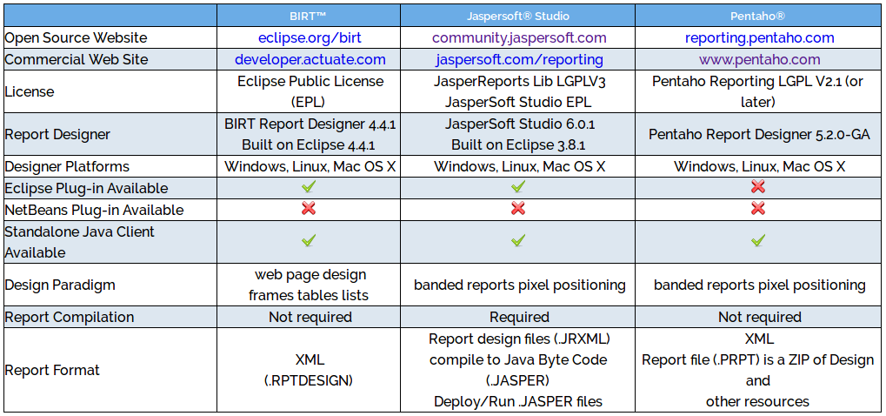

* ***Output Report Format comparison***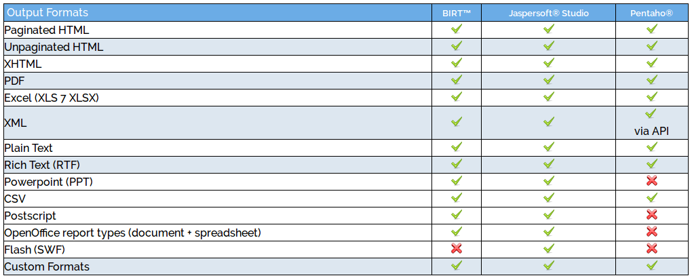

(<http://www.innoventsolutions.com/comparison-matrix.html>)

* ***Design Components comparison***

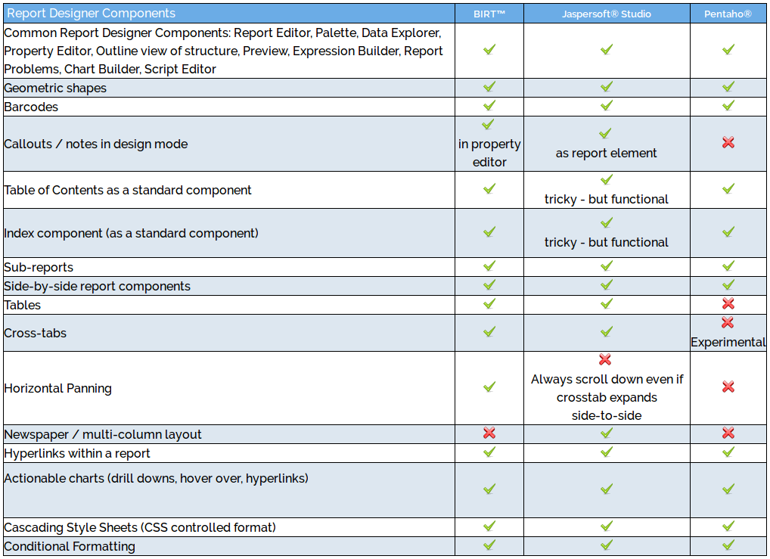

**References**

* <http://www.javareports.info/reviews-and-evaluations/list-of-open-source-java-reporting-tools/>
* <http://community.jaspersoft.com/documentation/tibco-jaspersoft-studio-user-guide/v630/introduction-jaspersoft-studio#jss-user_gettingstarted_1349621982_1026601>
* <http://blog.capterra.com/5-awesome-free-and-open-source-reporting-software-packages/>
* <http://www.innoventsolutions.com/comparison-matrix.html>
* <http://www.eclipse.org/birt/about/extensibility.php>
* <http://www.eclipse.org/articles/article.php?file=Article-BIRT-ExtensionTutorial1/index.html>