Trader Performance vs. Bitcoin Market Sentiment
A Quantitative Analysis of Hyperliquid Trading Behavior Across Fear & Greed Regimes
Data Science Internship Assignment
Prepared by: Pawan
B.Tech Information Technology · AI/ML Engineering Candidate
IEC College of Engineering & Technology, Greater Noida
Datasets: historical_data.csv (Hyperliquid trade data) · fear_greed_index.csv (Bitcoin Fear & Greed Index)
July 2026

Executive Summary
This analysis merged 211,224 Hyperliquid trade executions from 32 accounts (May 2023 – May 2025) with the Bitcoin Fear & Greed Index to test whether market-wide sentiment relates to trader performance, position sizing, and behavior.
Headline finding: performance does not follow a simple “fear is bad, greed is good” narrative. This trader cohort performed worst during Extreme Fear (76.2% win rate, $71.03 avg PnL/trade) and best during Extreme Greed (89.2% win rate, $130.21 avg PnL/trade), with Fear as a strong second-best regime (87.3% win rate) — a pattern closer to U-shaped than linear across the five sentiment states. This held up at the individual-trader level (median win rate rising from 82.3% to 93.8% between the two extremes), ruling out a pooling artifact.
The most actionable risk finding is a size/edge mismatch: traders hold their largest average positions during Fear ($7,816) and Extreme Fear ($5,350) — the regime with their weakest performance — and their smallest positions during Extreme Greed ($3,112), their best-performing regime. Buy/Sell behavior showed healthy discipline, with the sell share rising steadily from 48.9% in Extreme Fear to 55.1% in Extreme Greed, consistent with profit-taking into strength.
At the asset level, narrative/meme tokens (TRUMP, FARTCOIN, MELANIA, BERA, KAITO) were the single worst-performing symbol in every sentiment regime, while liquid mid-caps (SOL, ENA) topped the best-performer list — a pattern independent of sentiment. Sentiment score itself was a weak same-day PnL predictor (correlation = -0.098), and the strong Extreme Greed result was significantly concentrated in a single symbol, warranting caution before generalizing.
Recommendation: de-risk (reduce size/leverage) specifically during Extreme Fear, scale exposure toward regimes with demonstrated edge (Fear, Extreme Greed), apply tighter risk controls to narrative/meme-coin exposure regardless of sentiment, and use the sentiment index as a portfolio-level risk overlay rather than a standalone trading trigger.

1. Objective & Methodology

1.1 Objective
Explore the relationship between trader performance and Bitcoin market sentiment on Hyperliquid, uncover hidden behavioral patterns, and translate findings into actionable trading strategy recommendations.

1.2 Data Sources
- historical_data.csv — 211,224 individual trade executions across 32 accounts and 246 symbols, spanning 1 May 2023 to 1 May 2025. Fields include account, coin, execution price, size (tokens & USD), side, direction, closed PnL, fee, and timestamp.
- fear_greed_index.csv — daily Bitcoin Fear & Greed Index classification (Extreme Fear, Fear, Neutral, Greed, Extreme Greed) and numeric score (0–100), spanning 1 Feb 2018 to 2 May 2025.

1.3 Data Cleaning
- Checked for and removed exact duplicate rows in both datasets (none found).
- Parsed trade timestamps (DD-MM-YYYY HH:MM) and sentiment dates into proper datetime objects.
- Verified no missing values in either dataset and validated non-negative price/size ranges.
- Derived a day-level trade_date field from the trade timestamp for merging with the daily sentiment index.

1.4 Merging
Each trade was left-joined to the sentiment table on trade_date = date. Of 211,224 trades, only 6 (0.003%) had no matching sentiment record and were dropped — confirming near-complete date coverage.

1.5 Key Definitions & Assumptions
- Win rate and average PnL/trade are computed on closed trades only (Closed PnL ≠ 0). Trade-opening executions (~50.6% of rows) carry zero realized PnL by construction and are excluded from these two metrics, but included in trade-count and position-size metrics.
- No explicit leverage column exists in the source data. Size USD (notional trade value) is used throughout as a position-size / exposure proxy, and this substitution is flagged wherever leverage is discussed.

2. Exploratory Data Analysis

2.1 Distribution of Market Sentiment
Trading activity is not evenly spread across sentiment regimes: Fear days account for the largest share of trades (61,837), followed by Greed (50,303) and Extreme Greed (39,992), with Extreme Fear the least-traded regime (21,400 trades).
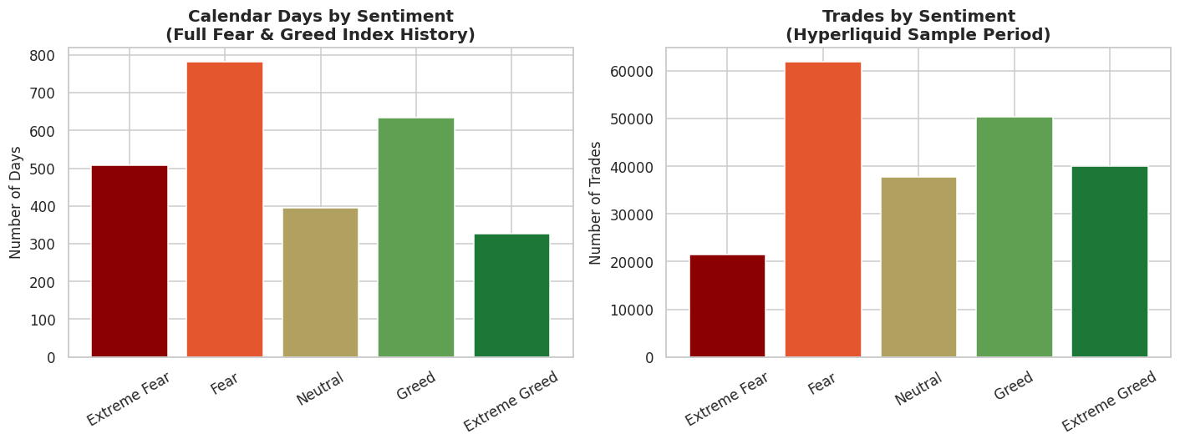
Figure 1. Calendar days vs. trades by sentiment regime.

2.2 Sentiment-wise Performance Summary
Sentiment | Total Trades | Closed Trades | Avg PnL/Trade | Total PnL | Win Rate | Avg Position Size
Extreme Fear | 21,400 | 10,406 | $71.03 | $739,110 | 76.2% | $5,349.73
Fear | 61,837 | 29,808 | $112.63 | $3,357,155 | 87.3% | $7,816.11
Neutral | 37,686 | 18,159 | $71.20 | $1,292,921 | 82.4% | $4,782.73
Greed | 50,303 | 25,176 | $85.40 | $2,150,129 | 76.9% | $5,736.88
Extreme Greed | 39,992 | 20,853 | $130.21 | $2,715,171 | 89.2% | $3,112.25

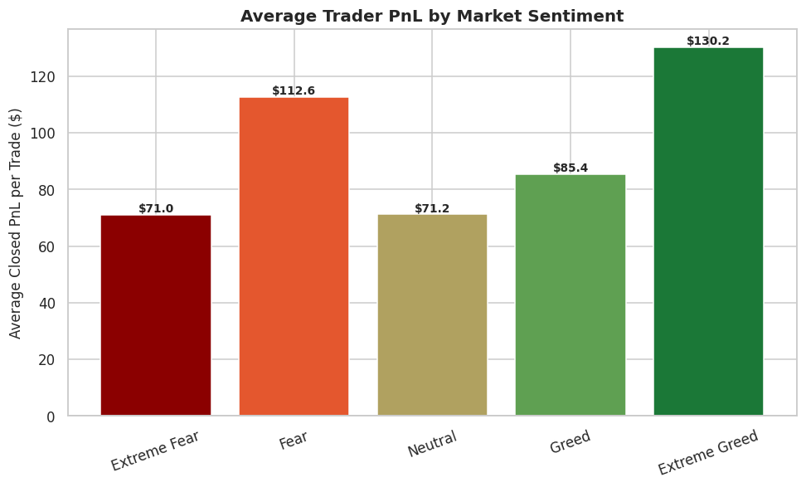
Figure 2. Average closed PnL per trade by sentiment.

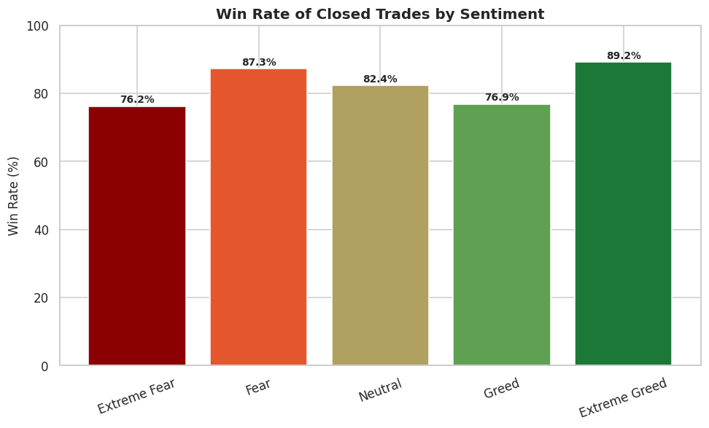
Figure 3. Win rate of closed trades by sentiment.
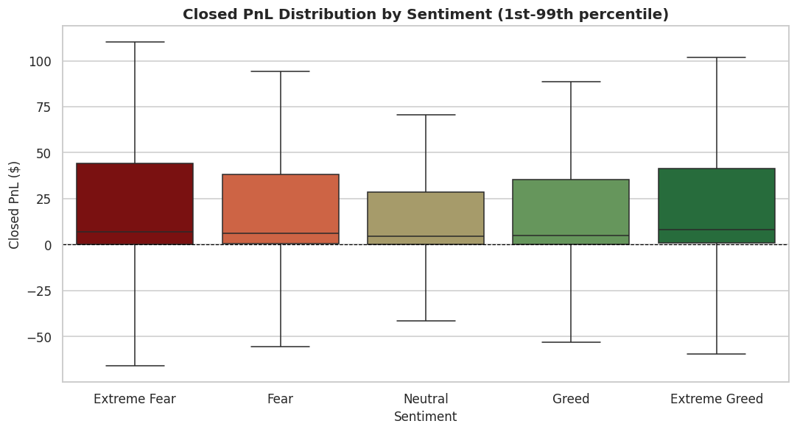
Figure 4. Distribution of closed PnL by sentiment (1st–99th percentile).

2.3 Position Size (Leverage Proxy) & Buy/Sell Behavior
Position size behaves inversely to performance: traders take their largest average positions in Fear ($7,816) and their smallest in Extreme Greed ($3,112), despite Extreme Greed being the best-performing regime by both win rate and average PnL.
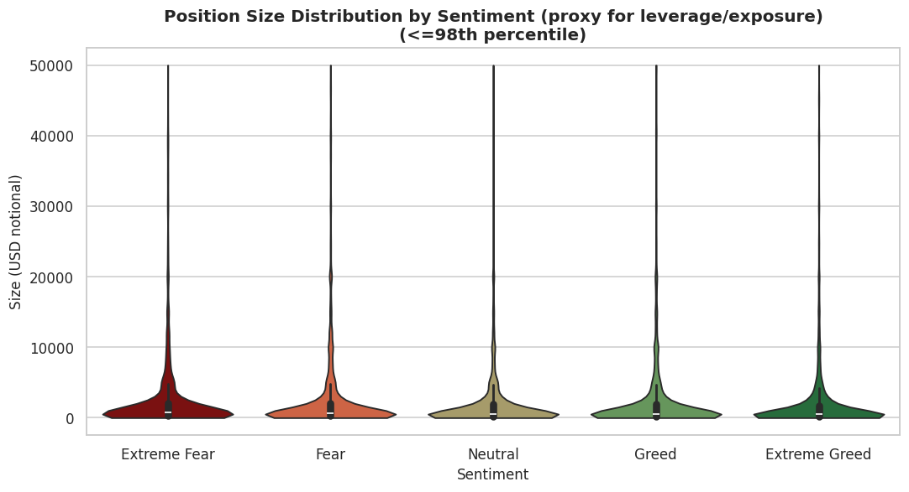
Figure 5. Position size distribution by sentiment (proxy for leverage/exposure).
Buy share falls steadily from 51.1% in Extreme Fear to 44.9% in Extreme Greed, with Sell share rising from 48.9% to 55.1% — consistent with profit-taking into strength rather than momentum-chasing.
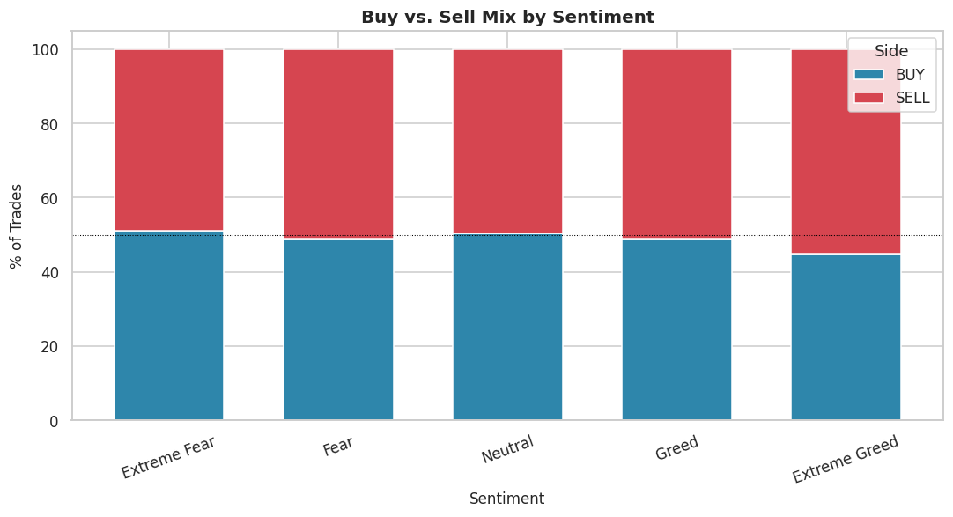
Figure 6. Buy vs. Sell mix by sentiment.

2.4 Symbol-Level Analysis
HYPE, the @107 index, BTC, ETH and SOL are the five most-traded symbols overall.
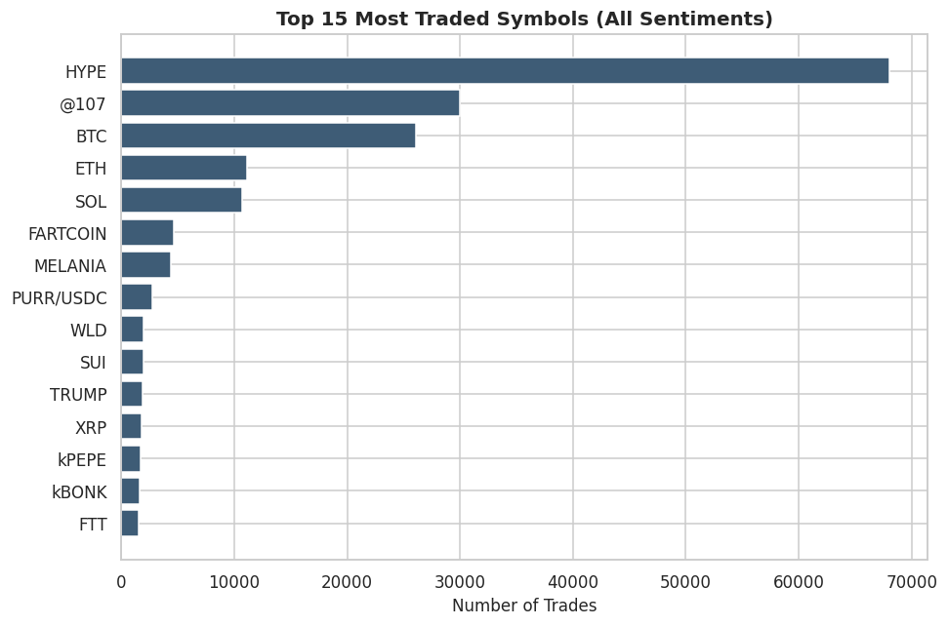
Figure 7. Top 15 most-traded symbols (all sentiments).

Best-Performing Symbol per Sentiment (min. 30 closed trades)
Sentiment | Symbol | Trades | Avg PnL | Total PnL
Extreme Fear | TRUMP | 75 | $421.84 | $31,638.04
Fear | ENA | 94 | $1,705.49 | $160,316.23
Neutral | MELANIA | 100 | $412.98 | $41,298.45
Greed | SOL | 507 | $890.91 | $451,690.01
Extreme Greed | @107 | 6,341 | $313.61 | $1,988,618.87

Worst-Performing Symbol per Sentiment (min. 30 closed trades)
Sentiment | Symbol | Trades | Avg PnL | Total PnL
Extreme Fear | FARTCOIN | 329 | -$419.50 | -$138,014.11
Fear | KAITO | 69 | -$215.95 | -$14,900.55
Neutral | BERA | 51 | -$423.86 | -$21,617.08
Greed | TRUMP | 369 | -$1,173.21 | -$432,914.84
Extreme Greed | MELANIA | 149 | -$125.68 | -$18,726.17

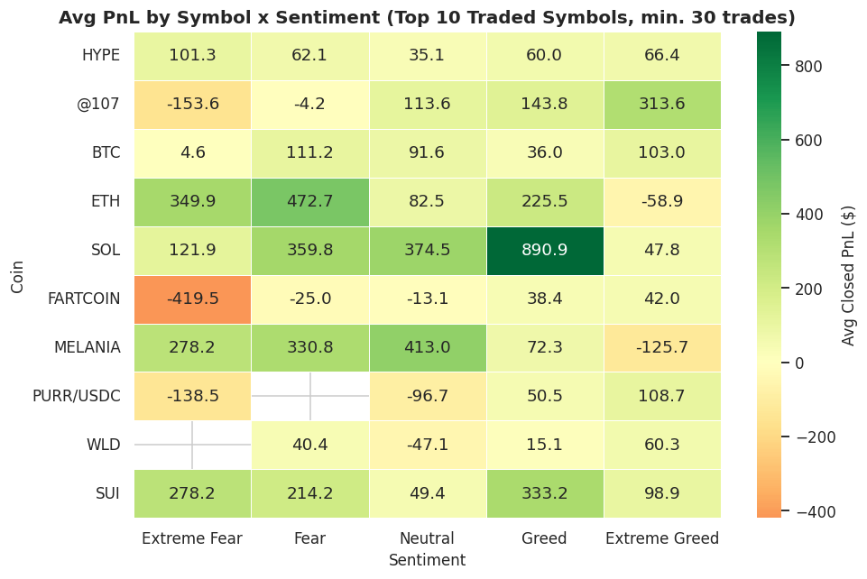
Figure 8. Average PnL by symbol × sentiment (top 10 traded symbols, min. 30 trades).

2.5 Correlation & Hidden Patterns
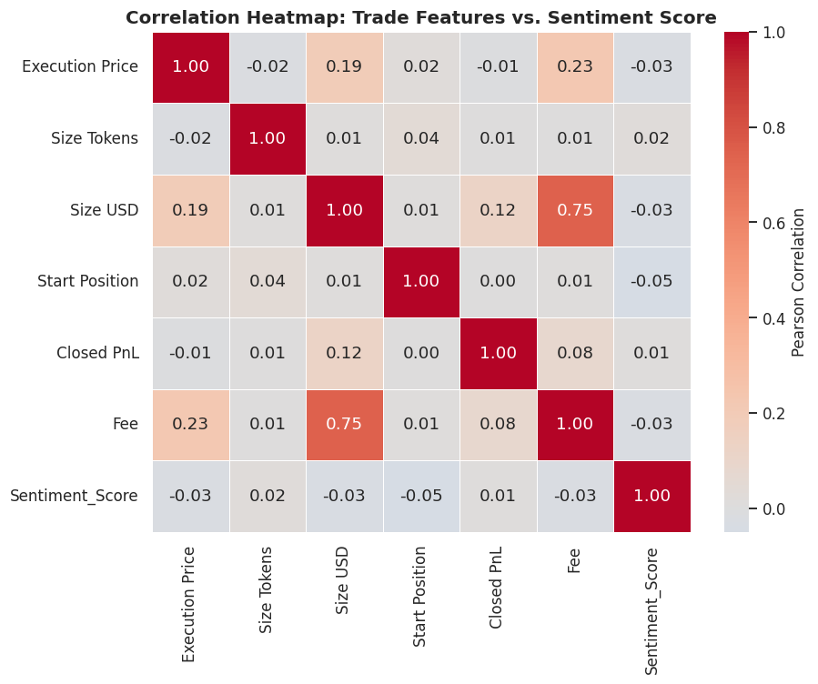
Figure 9. Correlation heatmap of numeric trade features and sentiment score.

The correlation between the daily sentiment score and same-day aggregate closed PnL is only -0.098 — essentially negligible — confirming that sentiment is a weak same-day directional signal even though the regime-level averages differ meaningfully.
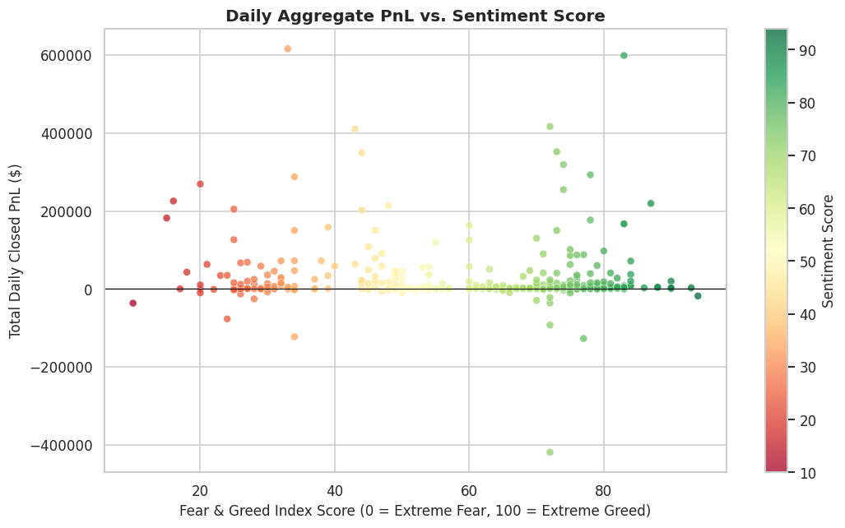
Figure 10. Daily aggregate PnL vs. sentiment score.
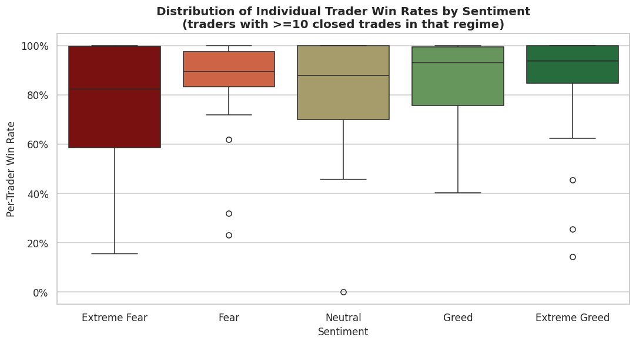
Figure 11. Distribution of individual trader win rates by sentiment (traders with ≥10 closed trades).

3. Business Insights & Hidden Patterns
1. Performance is U-shaped, not linear, across sentiment.
Win rate and avg PnL/trade are lowest in Extreme Fear (76.2% / $71.03) and highest in Extreme Greed (89.2% / $130.21), with Fear a strong second-best regime (87.3%) — the cohort performs best at emotional extremes (Fear and Extreme Greed), not steadily from fear to greed.
2. Traders size up exactly where their edge is weakest.
Average position size is largest in Fear ($7,816) and Extreme Fear ($5,350) — the two weakest-performing regimes by PnL/trade — and smallest in Extreme Greed ($3,112), the best-performing regime.
3. Selling pressure rises steadily as euphoria builds.
Buy share falls from 51.1% (Extreme Fear) to 44.9% (Extreme Greed); Sell share rises from 48.9% to 55.1% — a constructive, disciplined profit-taking pattern.
4. Sentiment score is a weak daily PnL predictor.
Same-day correlation between sentiment score and aggregate PnL is only -0.098, so sentiment works better as a multi-day regime overlay than a daily directional trigger.
5. Extreme Greed's strong result is concentrated in one symbol.
The coin @107 accounts for 6,341 of Extreme Greed's closed trades and ~$1.99M of its ~$2.72M total PnL (~73%) — the regime-level average is not broad-based.
6. Meme/narrative tokens are the consistent worst performers.
TRUMP, FARTCOIN, MELANIA, BERA and KAITO were the single worst-performing symbol in every sentiment regime, while liquid names like SOL and ENA topped the best-performer list — a pattern independent of market mood.
7. The pattern holds at the individual trader level.
Median per-trader win rate (traders with ≥10 closed trades in a regime) rises from 82.3% in Extreme Fear to 93.8% in Extreme Greed, confirming this is a cohort-wide behavioral pattern, not a pooling artifact from a few large accounts.

4. Trading Recommendations
- Treat Extreme Fear as the highest-risk regime, not a default buying opportunity. It has the lowest win rate (76.2%) and lowest avg PnL/trade ($71.03), yet the second-largest average position size. Cap size/leverage in this regime until a separate, regime-specific edge is validated.
- Align position sizing with realized, regime-specific edge. Scale size up in regimes with demonstrated higher win rate/PnL (Fear, Extreme Greed) and down in the weakest regime (Extreme Fear) — the reverse of the current pattern.
- Formalize the existing profit-taking discipline into strength. The natural rise in Sell% through Greed → Extreme Greed is healthy; codify it as a staged de-risking schedule tied to Fear & Greed index thresholds.
- Don't trade the sentiment index directly as a daily signal. With a same-day correlation of only -0.098, use sentiment as a regime/risk-sizing overlay (weeks-scale), not a directional entry trigger (day-scale).
- Apply tighter risk controls to meme/narrative-coin trades regardless of sentiment. TRUMP, FARTCOIN, MELANIA, BERA and KAITO were the worst performer in their respective regimes — the TRUMP cohort alone lost -$432,915 during Greed.
- Investigate the @107 concentration before trusting the “Extreme Greed = best regime” conclusion, since one symbol drives ~73% of that regime's total PnL.
- Operationalize the Symbol × Sentiment heatmap (Figure 8) as a live pre-trade checklist so traders can see at a glance whether a coin has historically performed well or poorly in the current sentiment regime.

5. Limitations & Assumptions
- No explicit leverage column exists in the source data; Size USD was used as an exposure/position-size proxy throughout. True leverage (position size ÷ margin/collateral) may tell a different story.
- Small, concentrated trader base: only 32 unique accounts. The very high win rates (76–89%) likely reflect a non-representative, possibly semi-professional or market-making cohort rather than retail behavior broadly, and should not be generalized without further validation.
- Symbol concentration: regime-level averages can be dominated by a handful of high-volume symbols/accounts (e.g., @107 in Extreme Greed); regime comparisons should be read alongside the symbol-level breakdown.
- Win rate is defined on closed trades only (Closed PnL ≠ 0); opening executions (~50.6% of rows) are excluded from win-rate/PnL-per-trade calculations but included in trade-count and size metrics.
- Sentiment is applied at daily granularity (one classification per calendar day); intraday sentiment shifts are not captured.

6. Conclusion
Market sentiment is meaningfully related to this trader cohort's performance, but not in the direction commonly assumed. Instead of a linear “fear = losses, greed = gains” relationship, performance is U-shaped across the sentiment spectrum, and the biggest actionable risk is a mismatch between position sizing and demonstrated edge — traders bet largest where they perform worst. Combined with a consistent drag from narrative/meme-coin exposure and a weak same-day sentiment–PnL correlation, the data supports using the Fear & Greed Index as a regime-level risk-sizing overlay — paired with disciplined, edge-aware position sizing and symbol selection — rather than as a standalone directional trading signal.

