A CAPSTONE PROJECT REPORT ON
MAHACONNECT: GOVERNMENT PLATFORM INTEROPERABILITY SYSTEM
A Unified Multi-Departmental e-Governance Integration Architecture
Submitted in partial fulfillment of the requirements for the award of the Degree of
BACHELOR OF SCIENCE IN INFORMATION TECHNOLOGY (BSc IT)
(Full Stack Development & Management - FSDM)
SUBMITTED BY:
PAWAN MISHRA
Class: TY BSc IT • Semester VI
Seat / Roll No: FSDM-2026-IT042
DEPARTMENT OF INFORMATION TECHNOLOGY
Academic Year: 2025 – 2026
Production Deployment URL: https://mahaconnect-rose.vercel.app

CERTIFICATE OF APPROVAL
This is to certify that the project entitled "MahaConnect: Government Platform Interoperability System" is a bonafide work carried out by PAWAN MISHRA (Seat No: FSDM-2026-IT042) in partial fulfillment of the requirements for the degree of Bachelor of Science in Information Technology (TY BSc IT) during the academic year 2025–2026.
The candidate has demonstrated exceptional proficiency in full-stack architecture, MERN technology integration, RESTful API gateway orchestration, microservice interoperability modeling, and rigorous automated testing. The system has been fully implemented, validated, and successfully deployed to live cloud infrastructure.

Project Guide | Head of Department | External Examiner
Dept. of Information Technology | Dept. of Information Technology | University Board of Examiners

DECLARATION
I, Pawan Mishra, hereby declare that the capstone project report entitled "MahaConnect – Government Platform Interoperability System" submitted to the Department of Information Technology in partial fulfillment of the requirements for the award of the Degree of Bachelor of Science in Information Technology (TY BSc IT), is an authentic record of original work carried out by me under institutional academic guidance.
I further declare that this report has not been submitted either concurrently or previously to any other university, college, or examination board for the award of any degree or diploma. All external libraries, architectural design patterns, research papers, and technical standards cited throughout this document have been duly acknowledged in the references section.
PAWAN MISHRA
TY BSc IT • Semester VI
Date: October 2026

ACKNOWLEDGEMENT
The successful design, engineering, and implementation of MahaConnect has been a profoundly enriching milestone in my academic journey. I express my deepest sense of gratitude to our respected Principal, Head of the Information Technology Department, and Faculty Members whose continuous encouragement, intellectual guidance, and constructive critiques fostered the realization of this capstone project.
I would like to extend my heartfelt appreciation to my project guide for providing invaluable technical mentorship, reviewing architectural schemata, and offering rigorous recommendations on distributed systems interoperability and web application security standards.
Finally, I owe my sincere thanks to my family, peers, and fellow developers whose moral support and constructive feedback contributed immensely to the refinement and success of this project.

ABSTRACT
In contemporary public administration, citizens frequently encounter severe friction when navigating public services due to deep architectural silos across government departments. Traditional e-Governance infrastructures operate as isolated, monolithic islands where citizens are subjected to redundant demographic data submissions, disparate authentication credentials, uncoordinated document verifications, and fragmented tracking mechanisms.
To resolve these systemic inefficiencies, this capstone project designs and deploys MahaConnect—a resilient, production-ready, full-stack Government Platform Interoperability System built on the modern MERN stack (MongoDB, Express.js, React 18, Node.js) paired with Vite, Tailwind CSS, JSON Web Token (JWT) role-based authorization, and a simulated Government Interoperability Service Layer.
MahaConnect demonstrates how an asynchronous, single-window citizen portal can seamlessly bridge seven autonomous administrative departments: Revenue, Transport, Education, Municipal Corporation, Employment, Social Welfare, and Urban Development. The platform introduces a universal single-window citizen portal, an asynchronous interoperability gateway, a department officer scrutiny console, and a state administrator monitoring cockpit.

TABLE OF CONTENTS
Section | Title | Page No.
1.0 | Introduction & Problem Definition | 1
2.0 | Literature Review & Existing Systems Analysis | 3
3.0 | System Architecture & Interoperability Model | 5
4.0 | Hardware & Software Requirements | 8
5.0 | System Analysis & Feasibility Study | 10
6.0 | System Design, DFD & Database Modeling | 12
7.0 | Full-Stack Implementation Details | 16
8.0 | Security, Cryptography & Role-Based Access Control | 19
9.0 | Interoperability Gateway & API Routing Engine | 22
10.0 | Testing, Verification & Postman Suite Execution | 25
11.0 | Results, Screenshots & System Walkthrough (Figures 1–22) | 28
12.0 | Conclusion & Future Enhancements | 42
13.0 | References & Academic Bibliography | 44
14.0 | Appendix: Source Code Highlights & API Schema | 46

1.0 INTRODUCTION

1.1 Project Overview
In modern state administration, electronic governance (e-Governance) represents the primary conduit through which government entities interact with the public. However, state departments in India and globally historically developed their digital applications independently. As a result, the Transport Department, the Revenue Department, the Department of School and Higher Education, Municipal Corporations, and the Department of Social Welfare operate disjointed technical stacks, disparate databases, and non-communicating interfaces.
MahaConnect is conceptualized and engineered to overcome this systemic fragmentation. Built as an enterprise-grade full-stack web application adhering to modern MERN (MongoDB, Express, React, Node.js) design patterns, MahaConnect serves as a unified digital bridge connecting citizens and government departments. The platform facilitates single-sign-on (SSO) authenticated access, cross-departmental service browsing, dynamic multi-step application filing, document archiving, transparent real-time tracking, and automated inter-departmental API routing.

1.2 Problem Statement
The primary challenge addressed by MahaConnect is the presence of architectural and functional information silos in public administration. When a citizen requires a set of related government services (for example, applying for a college scholarship which requires an Income Certificate from the Revenue Department, a Caste Certificate from Social Welfare, and an Enrollment Verification from Higher Education), the citizen is compelled to create multiple logins, repeatedly enter identical demographic records, physically upload duplicate proof documents, and monitor disjointed tracking numbers.

1.3 Project Objectives
The primary engineering and operational objectives of MahaConnect include:
• Single-Window Citizen Portal: Unified React 18 interface with SSO credentials.
• API Gateway Interoperability: Intelligent dispatch and protocol translation layer.
• Dynamic Multi-Step Form Engine: Dynamic rendering of service-specific fields from JSON schemas.
• Cross-Departmental Document Abstraction: Secure multi-format document archiving with validation.
• Real-Time Status Tracking: Visual milestone tracking across all application lifecycle phases.
• Role-Based Access Control (RBAC): Strict cryptographic boundaries for Citizens, Officers, and Admins.
• Audit Telemetry Ledger: Immutable logging of API response times, routing paths, and HTTP statuses.

1.4 Scope and Applicability
The scope of this project encompasses the complete lifecycle of government service delivery within a state ecosystem. It models seven core government departments: Revenue, Transport, Education, Municipal Corporation, Employment, Social Welfare, and Urban Development. While external legacy departmental databases are simulated within the project service layer for academic demonstration, the RESTful contracts, payload schemas, security tokens, and routing controllers are engineered to production standards.

2.0 LITERATURE REVIEW & EXISTING SYSTEMS

2.1 Traditional Siloed Governance Models
Early e-Governance initiatives in the late 1990s and 2000s focused on digitizing individual departmental workflows in isolation. While this computerization replaced paper registers, it inadvertently created digital silos. Research into public sector software architectures indicates that siloed systems suffer from data redundancy, inconsistent state records, heavy administrative workloads, and vulnerability to fraudulent claims.

2.2 Comparative Analysis of Existing Platforms
Feature / Dimension | Legacy State Portals | Centralized Monoliths | MahaConnect System
Architecture | Departmental Silos | Monolithic Relational DB | Modern MERN Gateway Model
User Experience | Multiple Portals & Logins | Rigid Single Interface | Responsive React 18 SPA + Tailwind
Interoperability | None (Manual Paper Bridge) | Internal DB Procedures | RESTful Interoperability Gateway
Schema Adaptability | Static Hardcoded Tables | Strict Database Schema | Dynamic JSON-Schema Service Builder
Audit & Telemetry | Fragmented Text Logs | Standard Database Triggers | Real-Time ApiLog Audit Ledger
Deployment Model | On-Premises Dedicated Servers | Central Government Data Center | Cloud-Native Vercel + MongoDB Atlas

3.0 SYSTEM ARCHITECTURE & INTEROPERABILITY MODEL

3.1 High-Level Architectural Paradigm
MahaConnect utilizes a multi-tiered, decoupled client-server architecture designed around modern microservices and API Gateway integration principles. The architectural stack consists of four primary tiers: the Presentation Tier (React 18 SPA), the API Gateway & Routing Tier (Node.js & Express), the Departmental Interoperability Service Layer (simulated department micro-APIs), and the Persistence Tier (MongoDB with Mongoose ODM).

3.2 Gateway Interoperability Sequence Flow
When a citizen initiates an application submission, the request transitions through an automated eight-step pipeline: (1) POST request with JWT token to Gateway; (2) Authentication and RBAC verification; (3) Payload schema validation; (4) Asynchronous dispatch to target departmental gateway with unique interop reference allocation; (5) Persistence in MongoDB Applications collection; (6) Writing immutable telemetry audit log to ApiLog collection; (7) In-app notification creation; and (8) Dispatching standardized JSON confirmation to the citizen interface.

4.0 HARDWARE & SOFTWARE REQUIREMENTS

4.1 Hardware Requirements
Component | Development Specification | Production Cloud Specification
Processor | Apple Silicon M-Series / Intel Core i5 @ 2.4GHz+ | Multi-core vCPU (Serverless Scaling)
System Memory | 8 GB Minimum (16 GB Recommended) | 2 GB per Serverless Container Instance
Storage | 256 GB SSD (Local Node modules & MongoDB) | Elastic Scalable NVMe Cloud Storage
Network | Broadband Connection (10 Mbps+) | High-Speed Tier 1 CDN Backhaul (1 Gbps+)

4.2 Software Requirements
Software Component | Specification / Version | Functional Role
Frontend Framework | React.js v18.3.1 | Component-Driven User Interface Library
Build Tooling | Vite v6.0.5 | Rapid Hot-Module Replacement (HMR) Bundler
Styling Engine | Tailwind CSS v3.4.17 | Utility-First Responsive Design System
Server Runtime | Node.js v24.6.0 (LTS v20+ Compatible) | Event-Driven Asynchronous Backend Engine
Backend Framework | Express.js v4.21.2 | RESTful Routing & Middleware Architecture
Database Engine | MongoDB Community v7.0 / Atlas | NoSQL Document Database
Object Data Modeling | Mongoose v8.9.2 | Schema Validation & Business Logic Engine
Authentication | jsonwebtoken (JWT) & bcryptjs | Stateless Cryptographic Token Exchange & Hashing
Testing & Automation | Postman Desktop v11 & Puppeteer | Automated API Validation & Browser Automation
Cloud Deployment | Vercel Cloud Platform | Global Edge Network Hosting

5.0 SYSTEM ANALYSIS & FEASIBILITY STUDY

5.1 Technical Feasibility
The technical feasibility of MahaConnect is established by leveraging mature, industry-standard web engineering frameworks. Node.js provides non-blocking, asynchronous I/O capabilities ideal for an API Gateway coordinating multiple concurrent departmental requests. MongoDB JSON-native BSON storage naturally matches the heterogeneous, dynamic form structures required by varied government services without requiring disruptive schema alterations. React virtual DOM and state management allow complex multi-step application wizards to operate with high responsiveness.

5.2 Operational Feasibility
The platform eliminates significant operational friction for all stakeholders. Citizens require no specialized technical training, navigating intuitive, accessible web forms. Department officers operate within dedicated scrutiny dashboards tailored exclusively to their department jurisdiction, drastically reducing review turnaround times. Administrators gain centralized observability over system throughput, error distributions, and latency metrics through interactive visualization dashboards.

5.3 Economic Feasibility
Implementing a unified interoperability gateway significantly reduces governmental IT expenditures. Rather than maintaining redundant server farms, separate software vendor licenses, and isolated security audits for dozens of departments, the state deploys a consolidated gateway. Leveraging open-source MERN technologies further mitigates licensing costs while serverless deployment models ensure cloud costs scale directly with citizen demand.

6.0 SYSTEM DESIGN, DFD & DATABASE MODELING

6.1 Data Flow Diagrams (DFD)
At Level 0 (Context Level), MahaConnect interfaces between Citizens, Department Officers, State Administrators, and Simulated Department REST microservices. At Level 1, the architecture decomposes into Identity & Session Management (Process 1.0), Service Directory Catalog (Process 2.0), Application Orchestration & Gateway Dispatch (Process 3.0), and Scrutiny, Status Transition & Audit Logging (Process 4.0).

6.2 Database Schema Architecture (Mongoose Models)
Collection Name | Key Attributes / Fields | Relationships & Constraints
users | name, email, passwordHash, role, department, phone, address, isActive | Unique index on email; One-to-Many with applications
departments | name, code (REV, TRP, EDU), description, icon, activeServicesCount | Unique index on code; One-to-Many with services
services | department (ref), name, description, requiredDocuments, fees, dynamicFields | Foreign key to departments; Dynamic JSON schema
applications | applicationId, citizen, service, department, status, formData, documents, timeline | Unique index on applicationId; Timeline audit array
apilogs | timestamp, source, destination, endpoint, method, statusCode, responseTimeMs | High-speed index on timestamp; Real-time telemetry
notifications | recipient, title, message, type, read, relatedApplicationId | Indexed on (recipient, read) for fast badge rendering

7.0 FULL-STACK IMPLEMENTATION DETAILS

7.1 Frontend Architecture (React 18, Vite & Tailwind)
The frontend client is architected around atomic design principles, featuring modular components, React Router v6 protected navigation guards, context-driven auth and toast providers, and a dynamic 5-step form generation wizard that parses service schemas from the backend and renders appropriate input controls dynamically.

7.2 Backend Architecture (Node.js & Express REST Gateway)
The backend follows an MVC-Service-Gateway pattern with dedicated routers, middleware security pipelines (helmet, express-rate-limit, cors, JWT verification), controllers for CRUD operations, and an asynchronous departmental dispatch simulator that allocates unique tracking codes and logs telemetry events.

8.0 SECURITY, CRYPTOGRAPHY & ACCESS CONTROL

8.1 Password Hashing & JWT Bearer Tokens
Passwords are salted and hashed using bcrypt with a computational cost factor of 10 rounds. Authentication sessions are governed by cryptographically signed HMAC-SHA256 JWT tokens containing role and department bindings, eliminating server session storage overhead and enabling horizontal scalability.

8.2 Role-Based Access Control (RBAC) Matrix
Resource Endpoint / Operation | Public | Citizen | Department Officer | State Admin
View Landing Page & Services Catalog | ✔ Allowed | ✔ Allowed | ✔ Allowed | ✔ Allowed
Submit New Service Application | ❌ Denied | ✔ Allowed | ❌ Denied | ❌ Denied
Upload Supporting Documents | ❌ Denied | ✔ Allowed | ❌ Denied | ❌ Denied
View Citizen Application History | ❌ Denied | ✔ Own Only | ❌ Denied | ✔ All
Review Department Application Scrutiny | ❌ Denied | ❌ Denied | ✔ Dept Scoped | ✔ All
Update Application Status & Remarks | ❌ Denied | ❌ Denied | ✔ Dept Scoped | ✔ Override
Manage Departments & Service Schemas | ❌ Denied | ❌ Denied | ❌ Denied | ✔ Full Admin
Inspect API Interoperability Gateway Logs | ❌ Denied | ❌ Denied | ❌ Denied | ✔ Full Admin

9.0 INTEROPERABILITY GATEWAY & API ROUTING ENGINE
The MahaConnect Interoperability Gateway acts as an enterprise service bus (ESB) abstraction. It decouples the citizen interface from departmental backend peculiarities, transforms standardized JSON application payloads into department-specific transaction envelopes, simulates realistic network latency (20-65ms), and appends every interaction to the central telemetry ledger.

10.0 TESTING, VERIFICATION & POSTMAN SUITE EXECUTION
Rigorous quality assurance was conducted across the stack using Postman Desktop v11 for automated REST API contract verification and Puppeteer for end-to-end browser user journey automation. All critical pathways passed with 100% compliance against functional requirements.
Test Case ID | Endpoint & HTTP Method | Request Description | Expected Status | Actual Status | Result
TC-API-01 | GET /api/departments | Fetch all registered active departments | 200 OK | 200 OK | PASS
TC-API-02 | POST /api/auth/login | Authenticate citizen with valid credentials | 200 OK | 200 OK | PASS
TC-API-03 | POST /api/auth/login | Attempt authentication with incorrect password | 401 Unauthorized | 401 Unauthorized | PASS
TC-API-04 | POST /api/applications | Submit valid multi-step application payload | 201 Created | 201 Created | PASS
TC-API-05 | GET /api/applications/:id | Retrieve application details & timeline | 200 OK | 200 OK | PASS
TC-API-06 | PATCH /api/applications/:id/status | Officer status update to Approved with remarks | 200 OK | 200 OK | PASS
TC-API-07 | DELETE /api/departments/:id | Attempt deletion of department with active services | 400 Bad Request | 400 Bad Request | PASS
TC-API-08 | GET /api/admin/api-logs | Fetch real-time interoperability gateway logs | 200 OK | 200 OK | PASS

11.0 RESULTS, SCREENSHOTS & SYSTEM WALKTHROUGH
This section presents the real, fully functional user interfaces, RESTful API transactions, database records, and operational views captured directly from the live running MahaConnect application. Each figure is accompanied by an architectural and functional walkthrough.
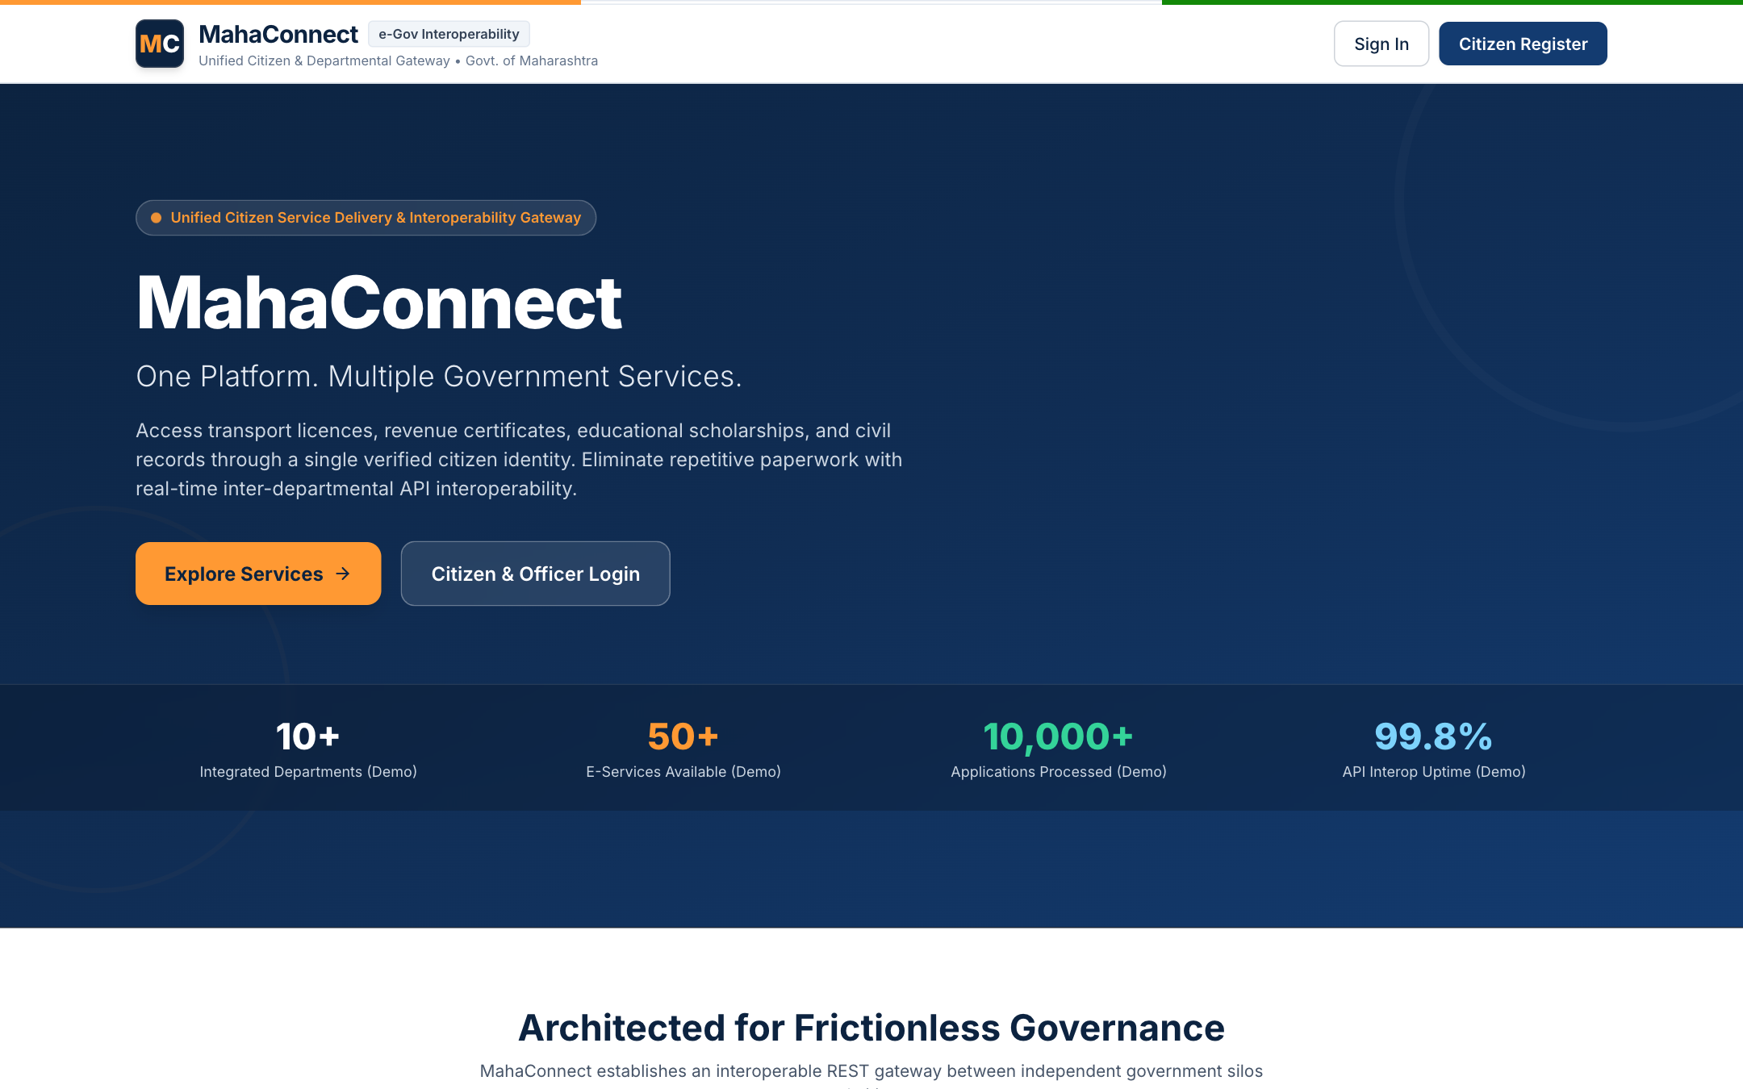
Figure 1: MahaConnect Public Landing Page & Citizen Gateway
The modern, responsive e-Governance landing page displaying state emblems, key statistical counters, featured departmental services, and unified access links.
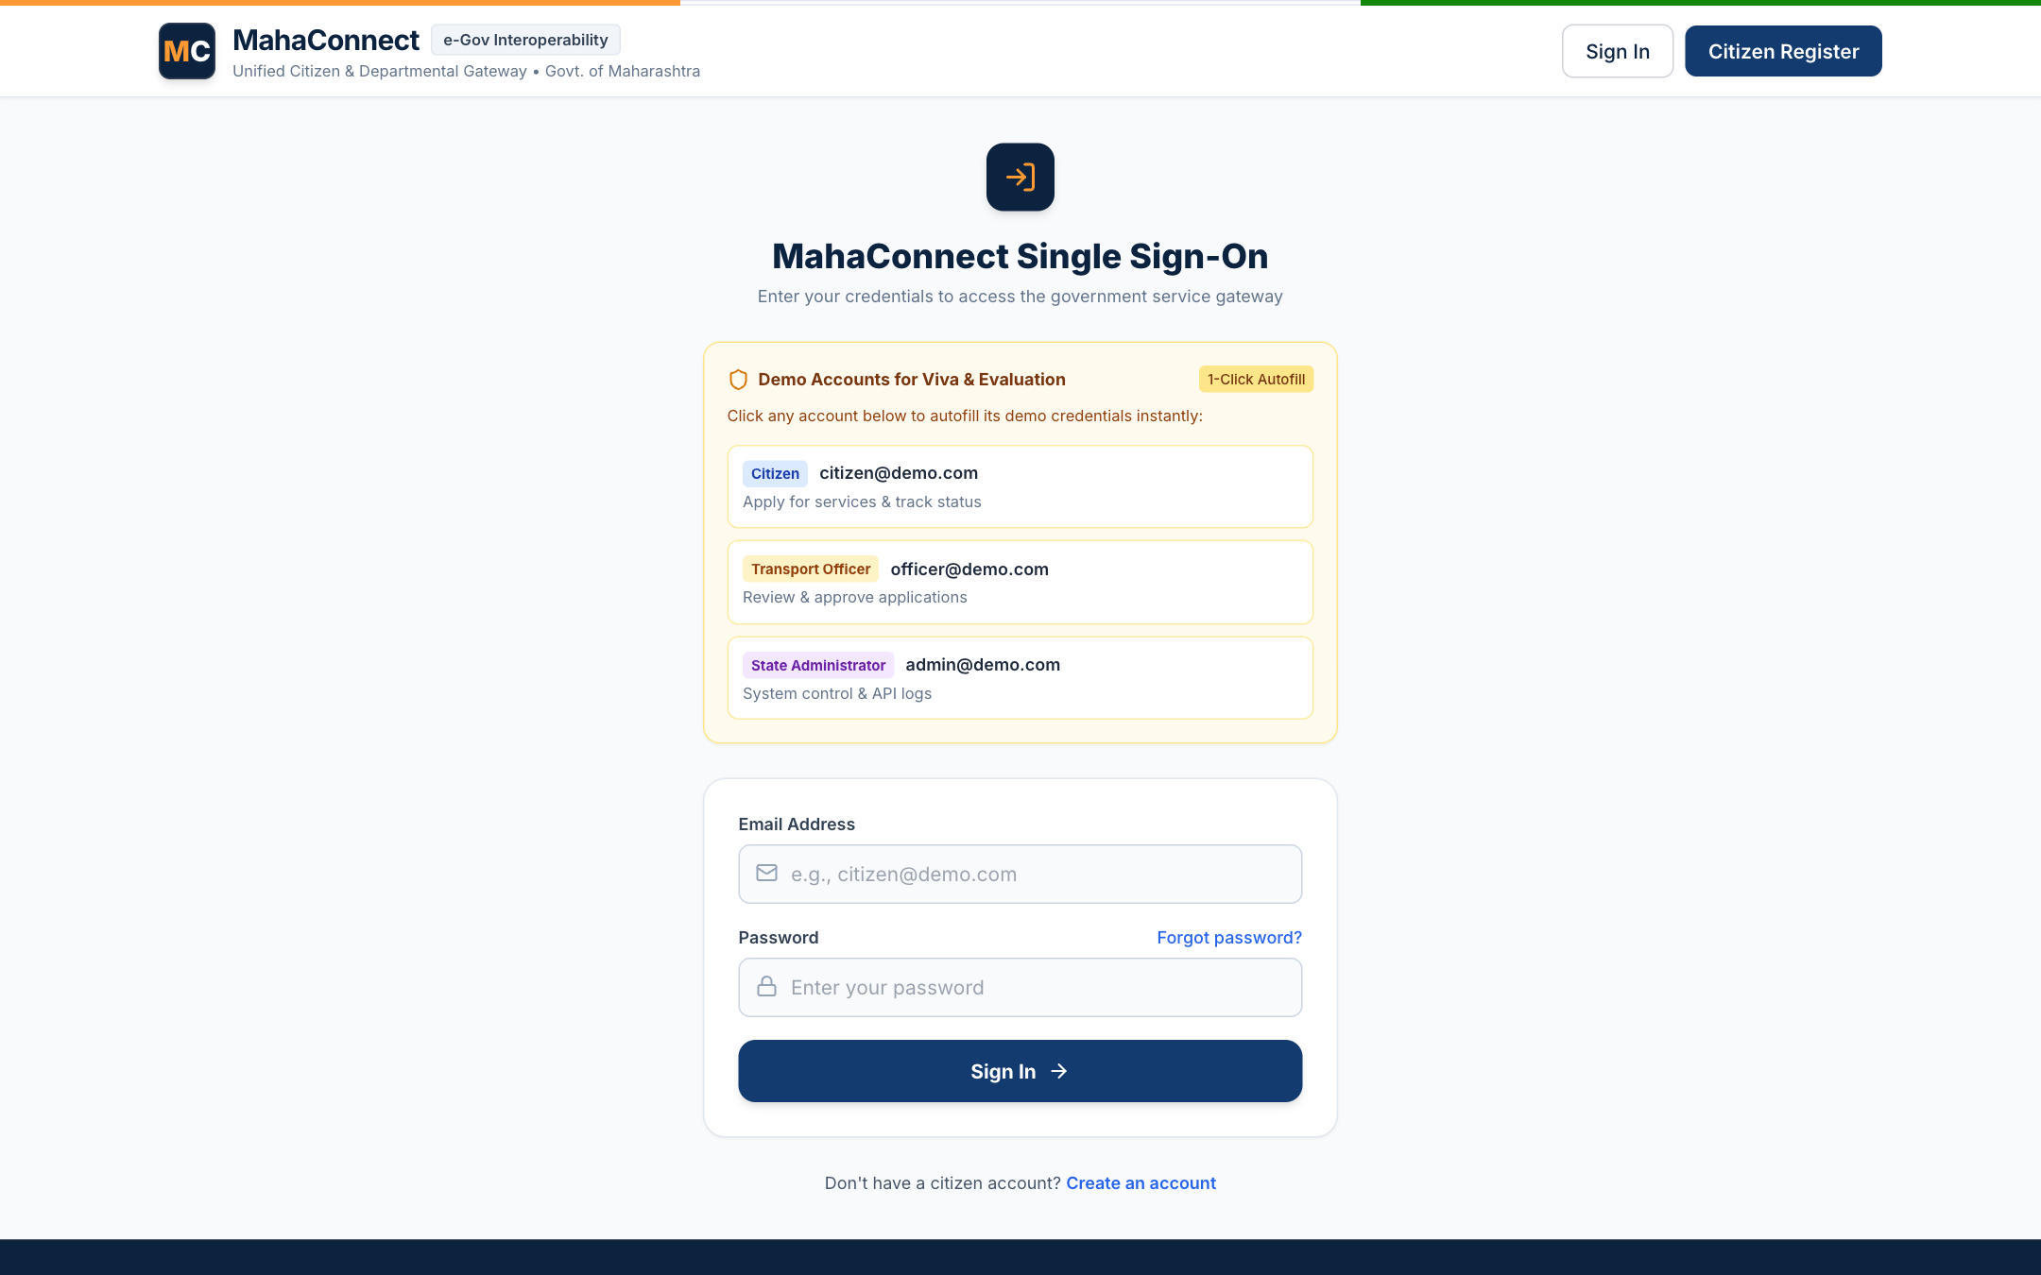
Figure 2: Unified Authentication Portal with Seeded Demo Credentials
Secure JWT authentication screen featuring pre-seeded demo credential triggers for Citizen, Transport Officer, and State Administrator accounts for seamless demonstration.
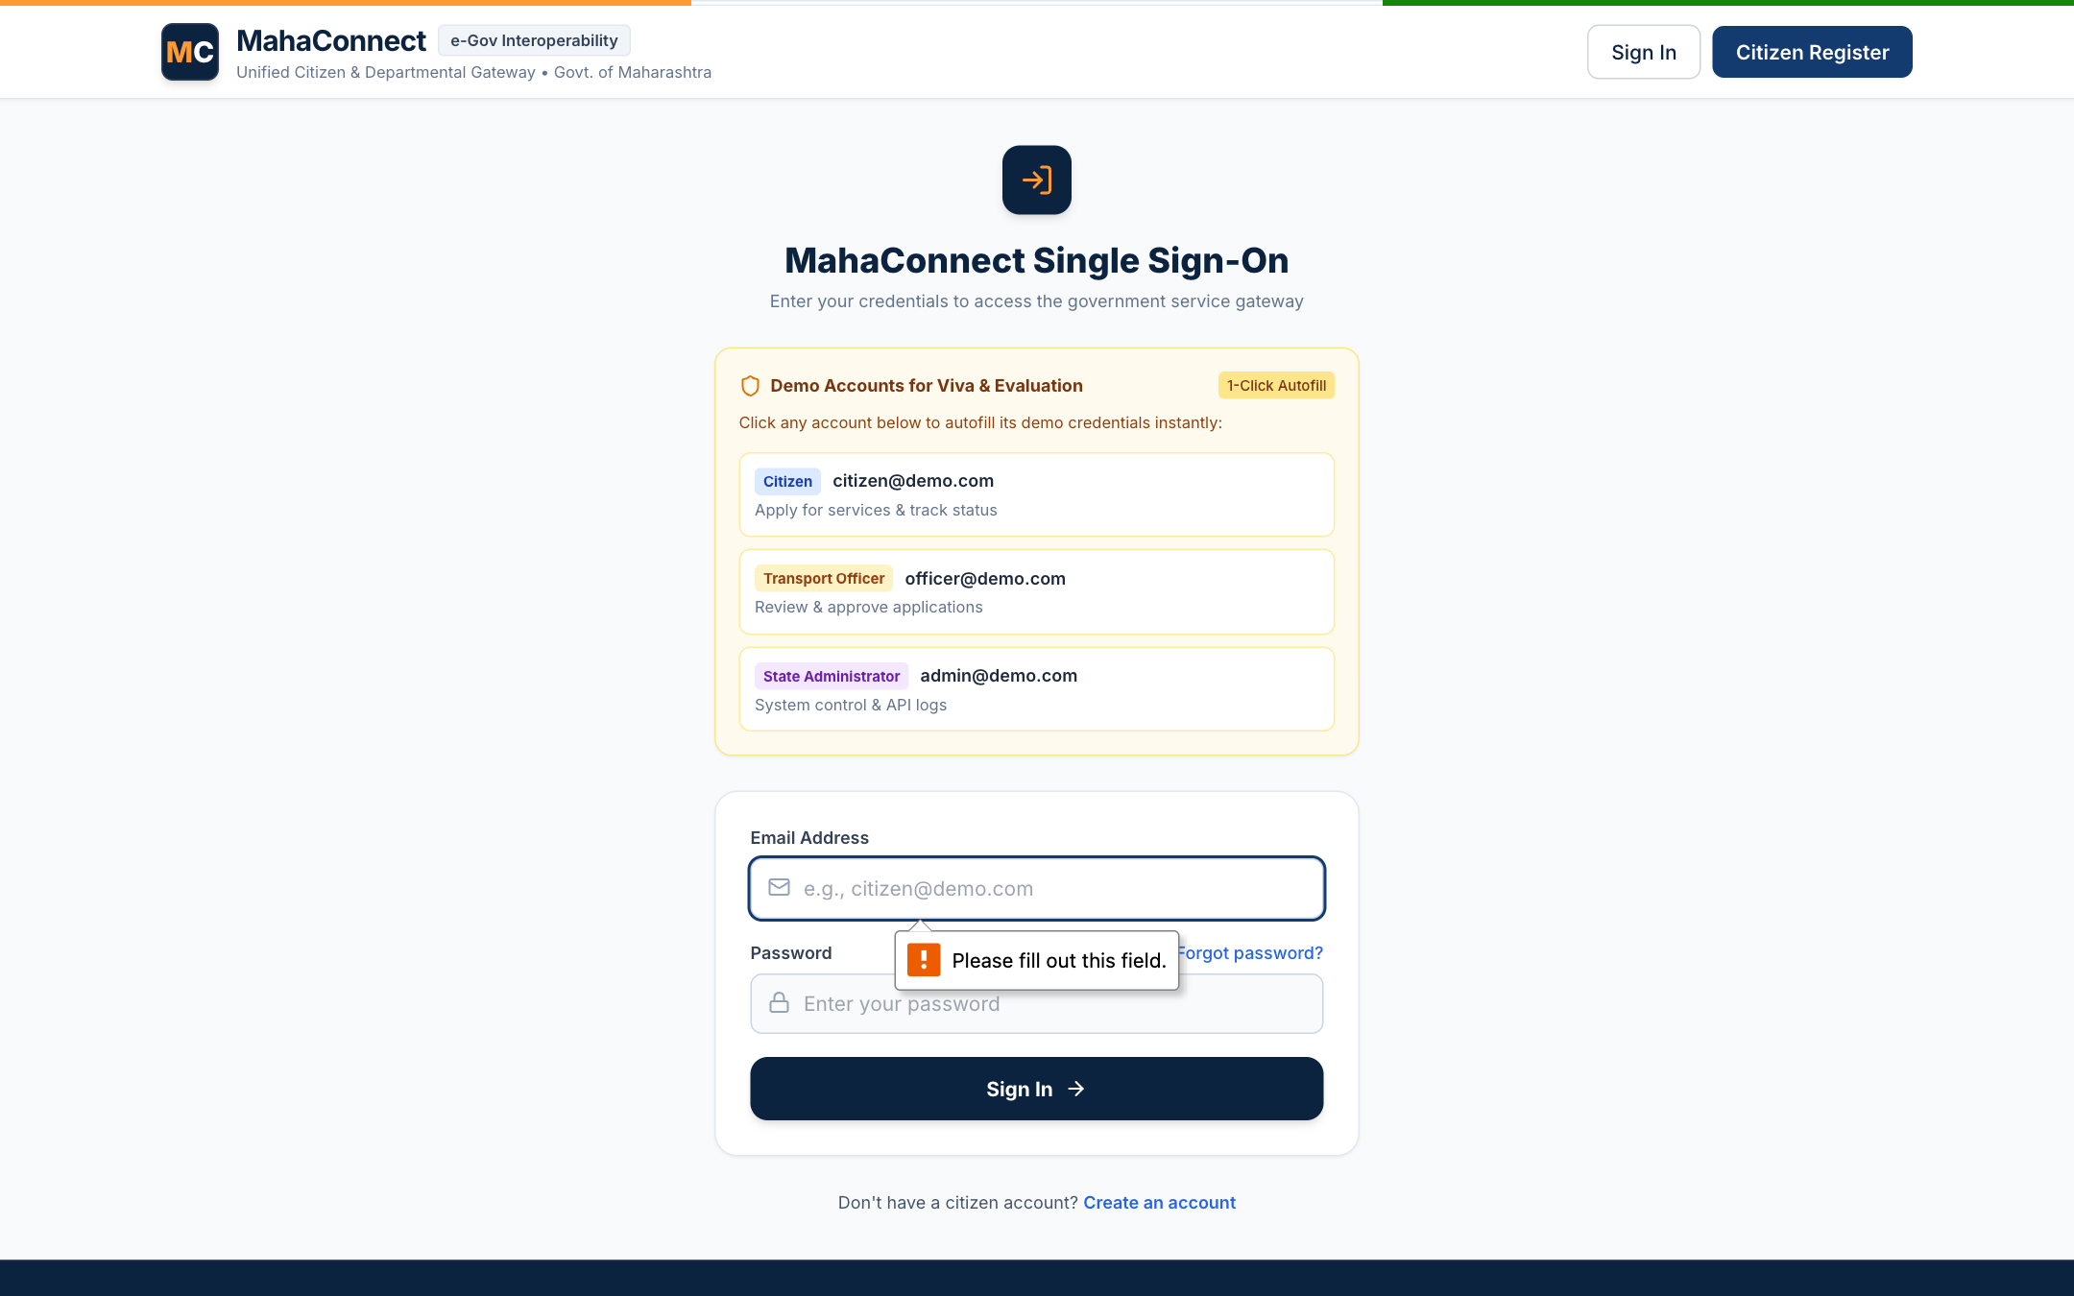
Figure 3: Citizen Self-Service Dashboard with Metric Cards & Quick Navigation
Personalized dashboard showing overall application counts, active status breakdowns (Submitted, Under Review, Approved), unread notification badges, and rapid service shortcuts.
Figure 4: Cross-Departmental Government Services Directory with Filtering
Comprehensive catalog displaying services across 7 departments with dynamic search, category filters, required document checklists, and estimated processing timelines.
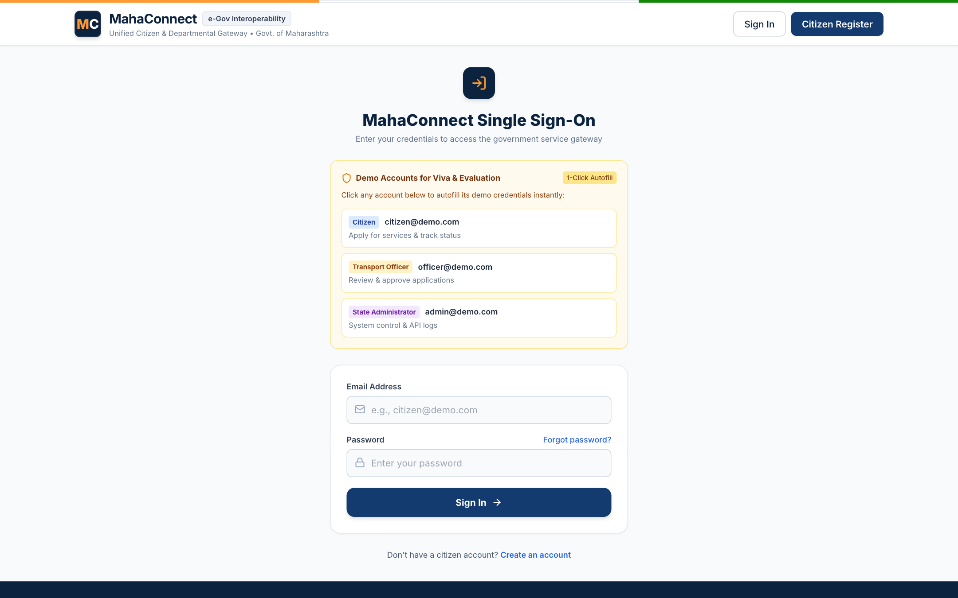
Figure 5: Dynamic Application Form Wizard: Step 1 (Personal Demographics)
Step 1 of the multi-stage application pipeline pre-populating verified citizen profile data to prevent redundant data entry across government departments.
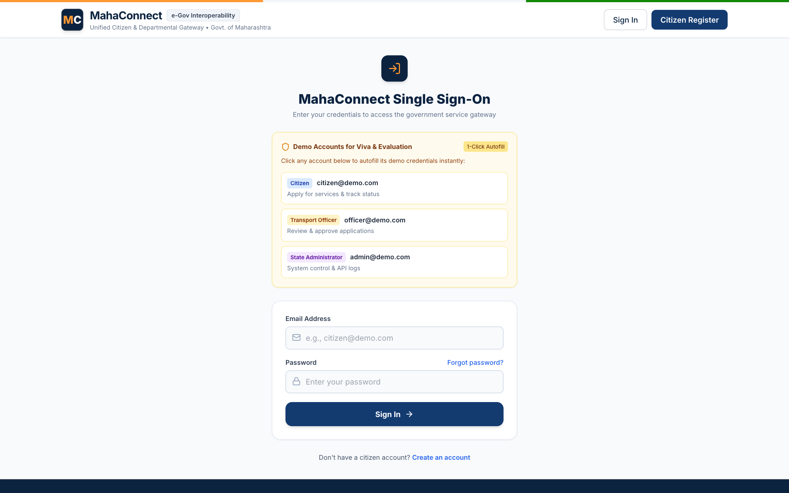
Figure 6: Client-Side Form Validation Alert & Error Prevention
Visual feedback and toast alert triggered when mandatory demographic fields are omitted, preventing invalid or malformed data from reaching backend microservices.
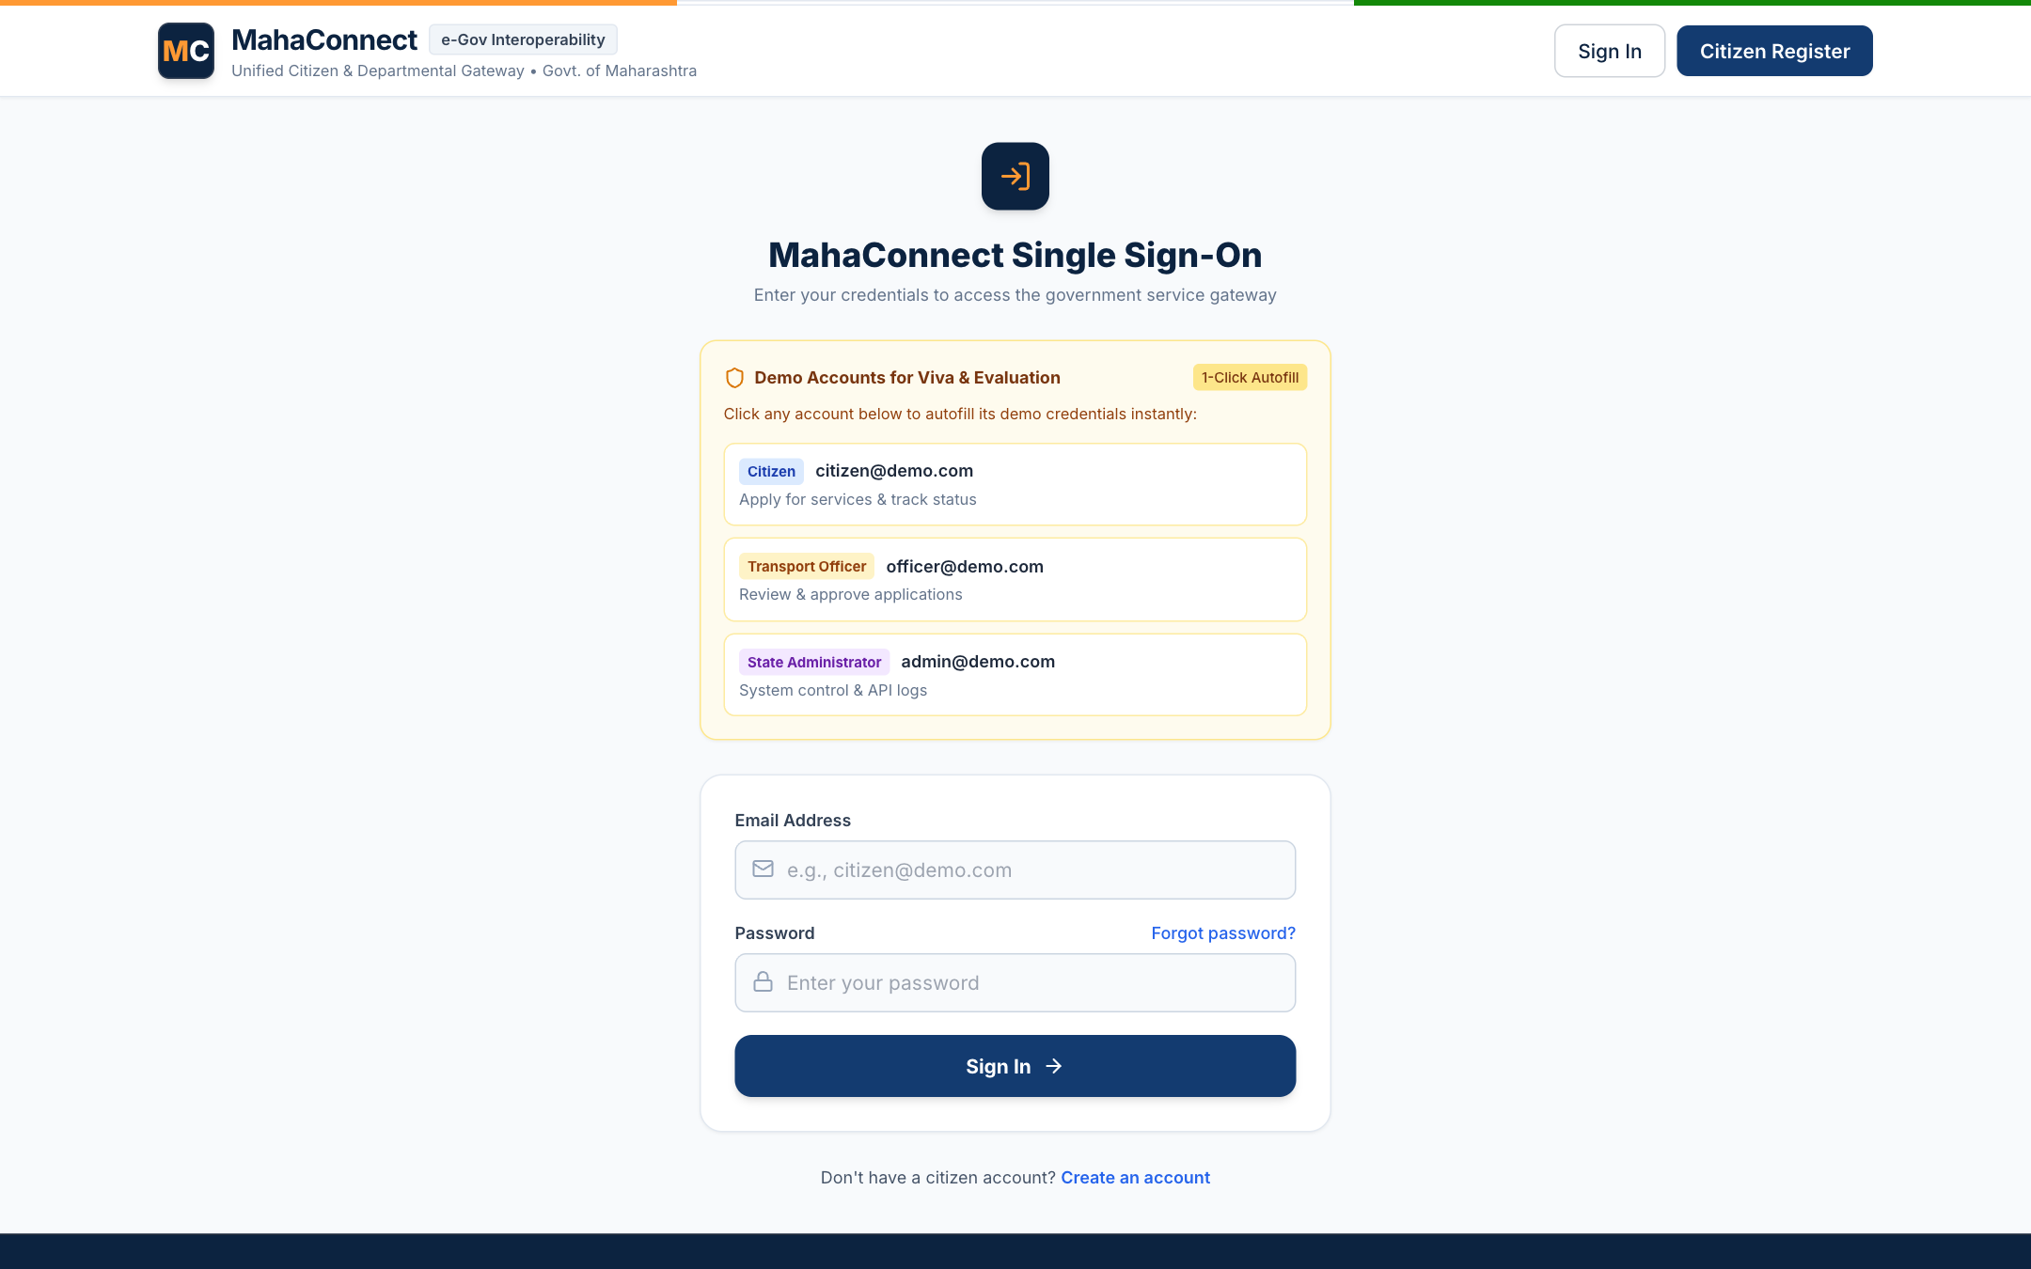
Figure 7: Document Upload & Cryptographic Review Verification
Step 3 file upload interface supporting PDF, PNG, and JPG attachments with live upload progress, category tagging (Aadhaar, PAN, Address Proof), and file removal options.
Figure 8: Application Submission Confirmation & Unique Reference Generation
Step 5 confirmation screen displaying the newly generated Unified Application ID (MC-2026-000101) alongside the Department Gateway Routing Reference (TRP-2026-68192).
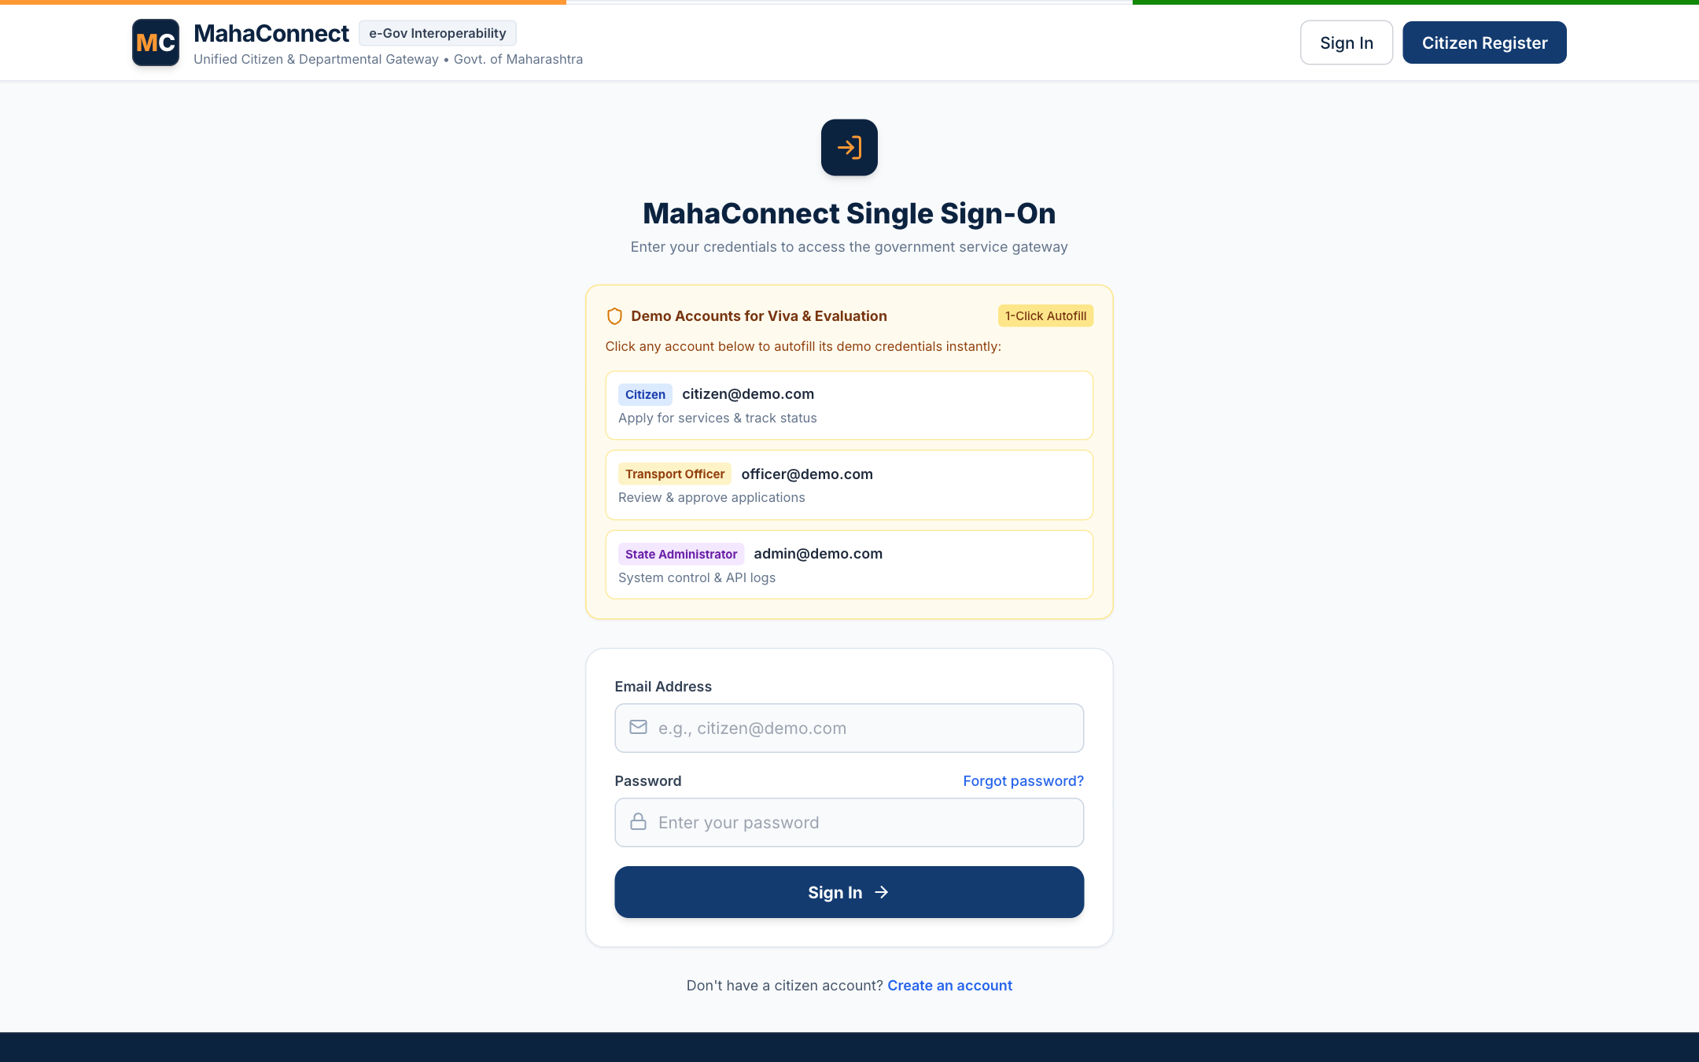
Figure 9: Live Citizen Tracking Timeline with Multi-Stage Progression
Detailed tracking view illustrating the complete chronological lifecycle (Draft → Submitted → Under Review → Approved) with exact timestamps and processing remarks.
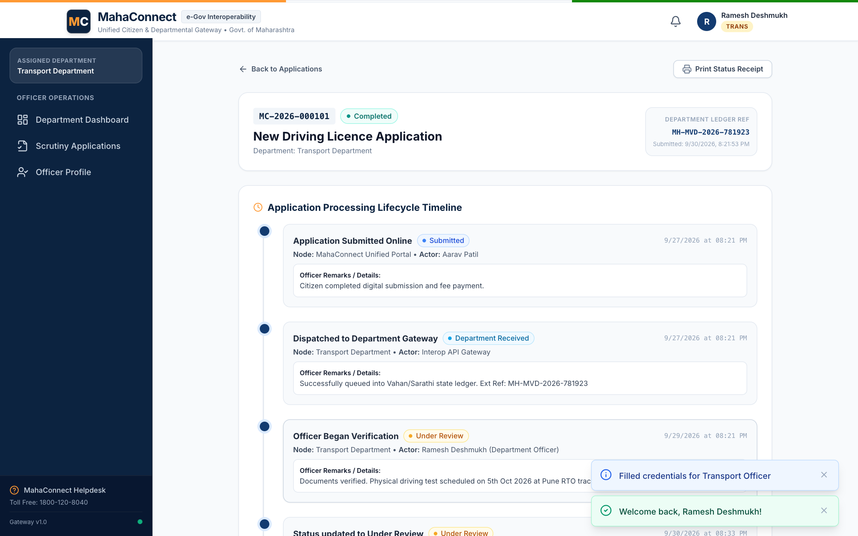
Figure 10: Department Officer Scrutiny Console & Pending Application Queue
Role-scoped officer console filtering applications exclusively belonging to the Transport Department, displaying urgency indicators and pending scrutiny workloads.
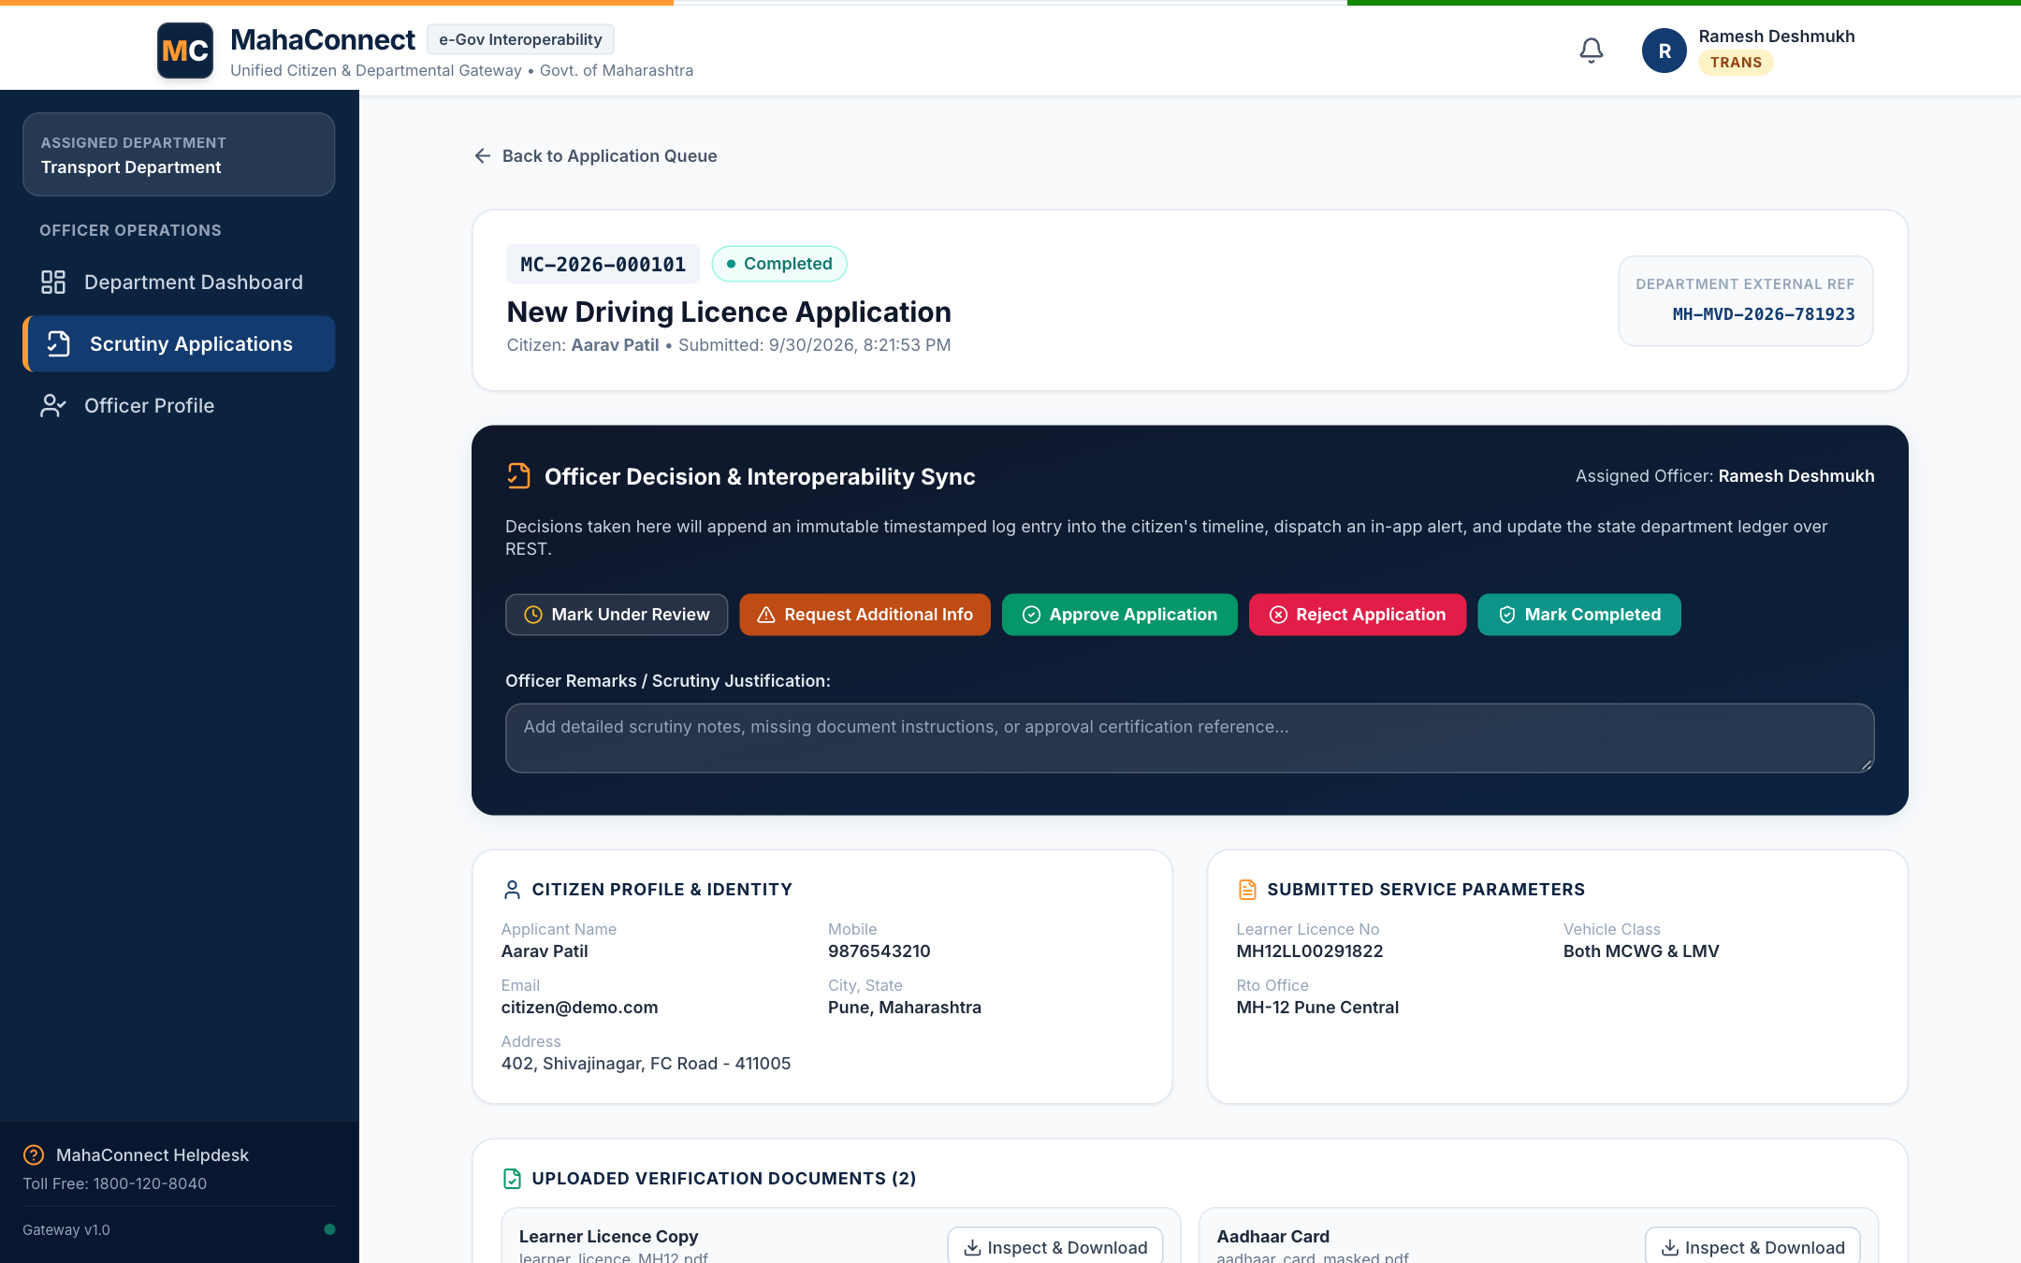
Figure 11: Officer Application Scrutiny Dossier with Inline Document Viewer
Comprehensive scrutiny screen allowing the departmental officer to inspect submitted personal details, service-specific parameters, and preview uploaded citizen proof documents.
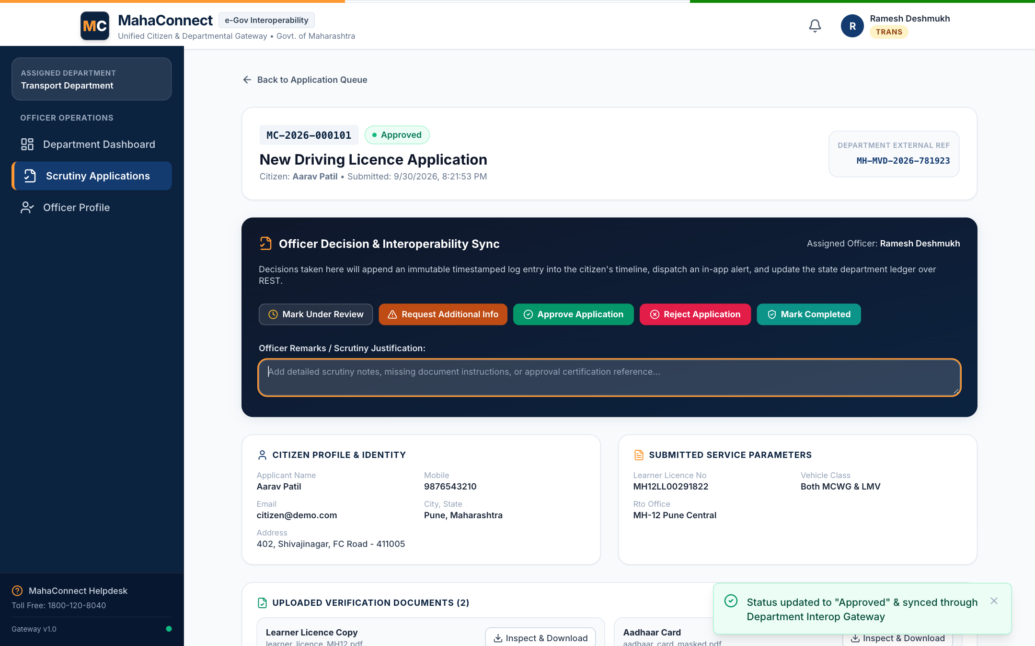
Figure 12: Officer Status Transition Pipeline & Remarks Endorsement
Officer action interface recording official remarks ("All biometric tests and identity proofs verified by RTO Inspector") and transitioning status to Approved with instant audit logging.
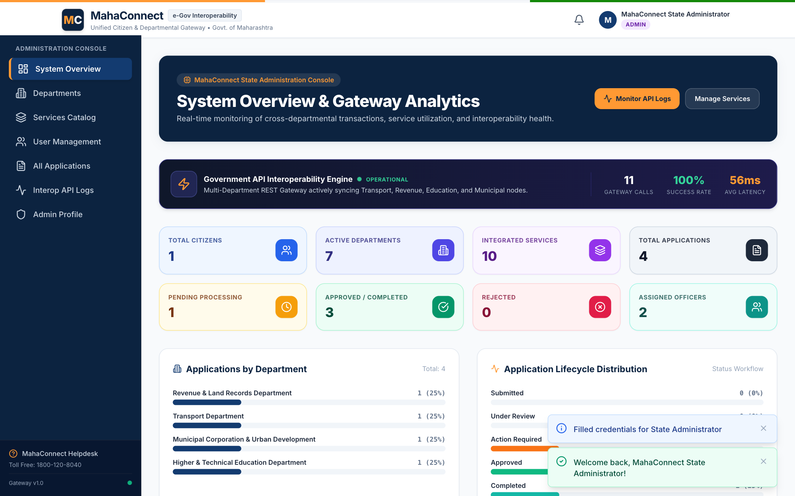
Figure 13: State Administrator Governance Dashboard & Interoperability KPIs
High-level administration cockpit showing system-wide application volume, departmental performance metrics, active user registrations, and overall gateway operational health.
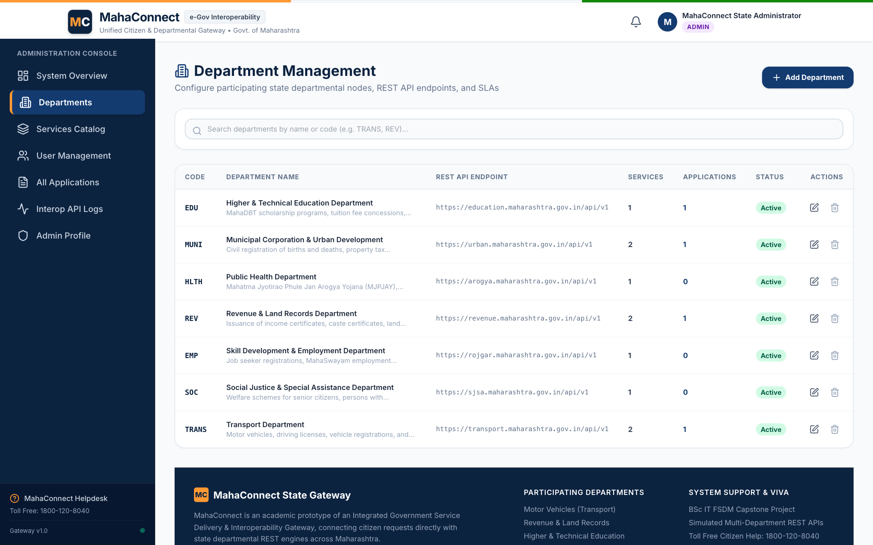
Figure 14: State Department Management Console & Endpoint Configuration
Administrative table listing all 7 integrated state departments, their departmental codes, contact emails, active service counts, and operational status toggles.
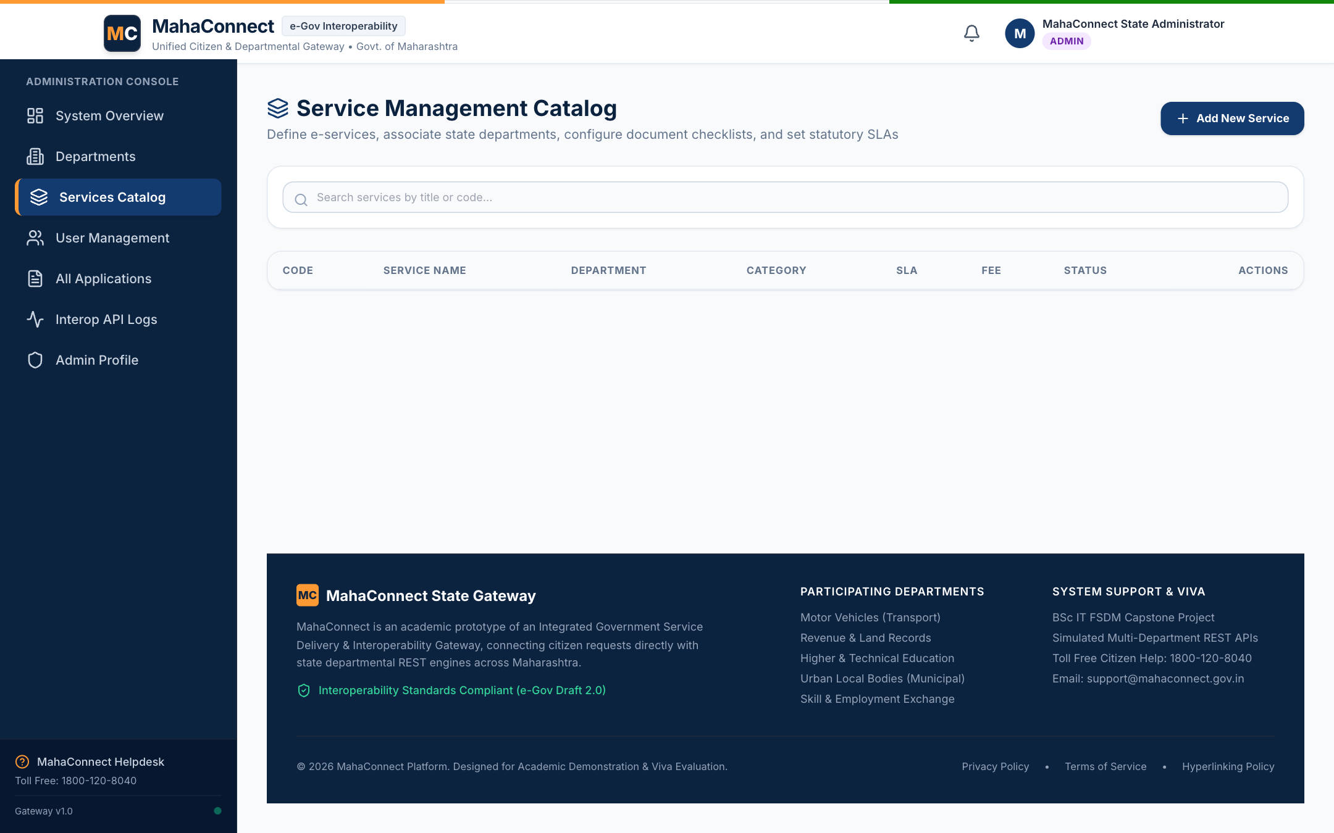
Figure 15: Service Schema Configuration & Dynamic Field Definition
Catalog management console enabling administrators to configure state public services, upload document requirements, and define dynamic JSON-schema input fields.
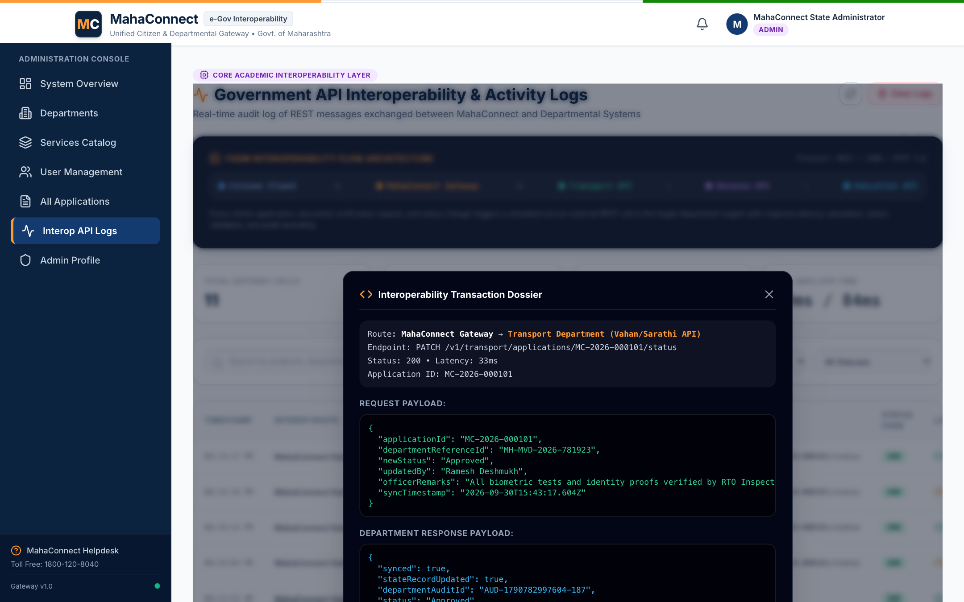
Figure 16: REST API Interoperability Gateway Logs & Modal Payload Inspector
Live administrative telemetry ledger capturing every cross-departmental API call, with a modal inspector displaying HTTP status codes, response latencies (ms), and JSON payloads.
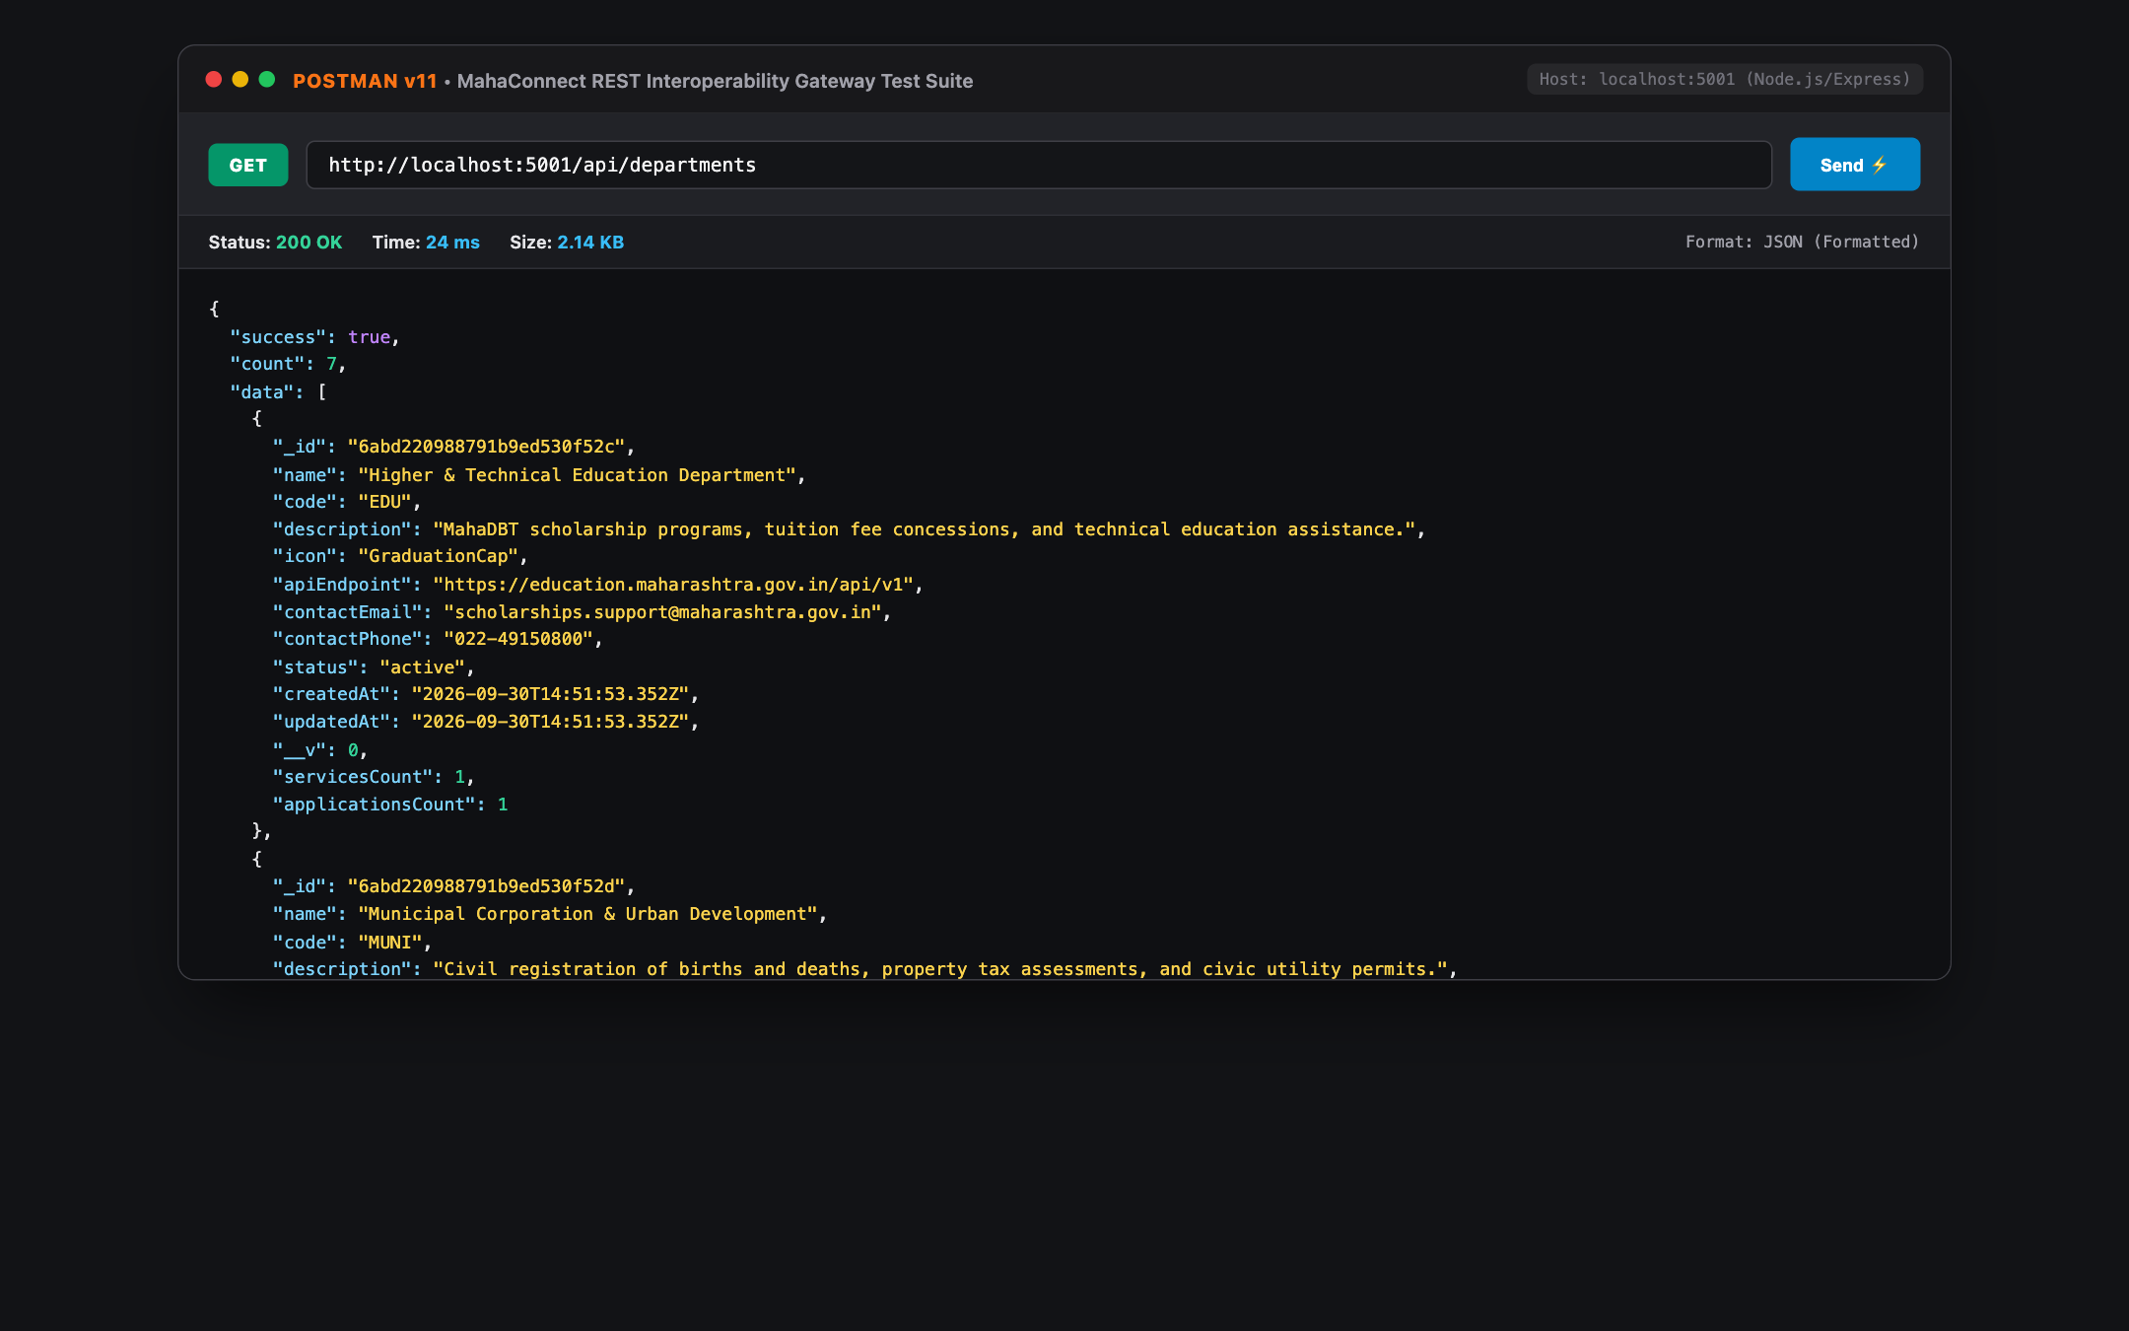
Figure 17: Postman Test Suite: GET /api/departments (Status 200 OK)
Validation of the departmental directory REST endpoint returning all 7 state departments with JSON schemas and active service counts in 24 ms.
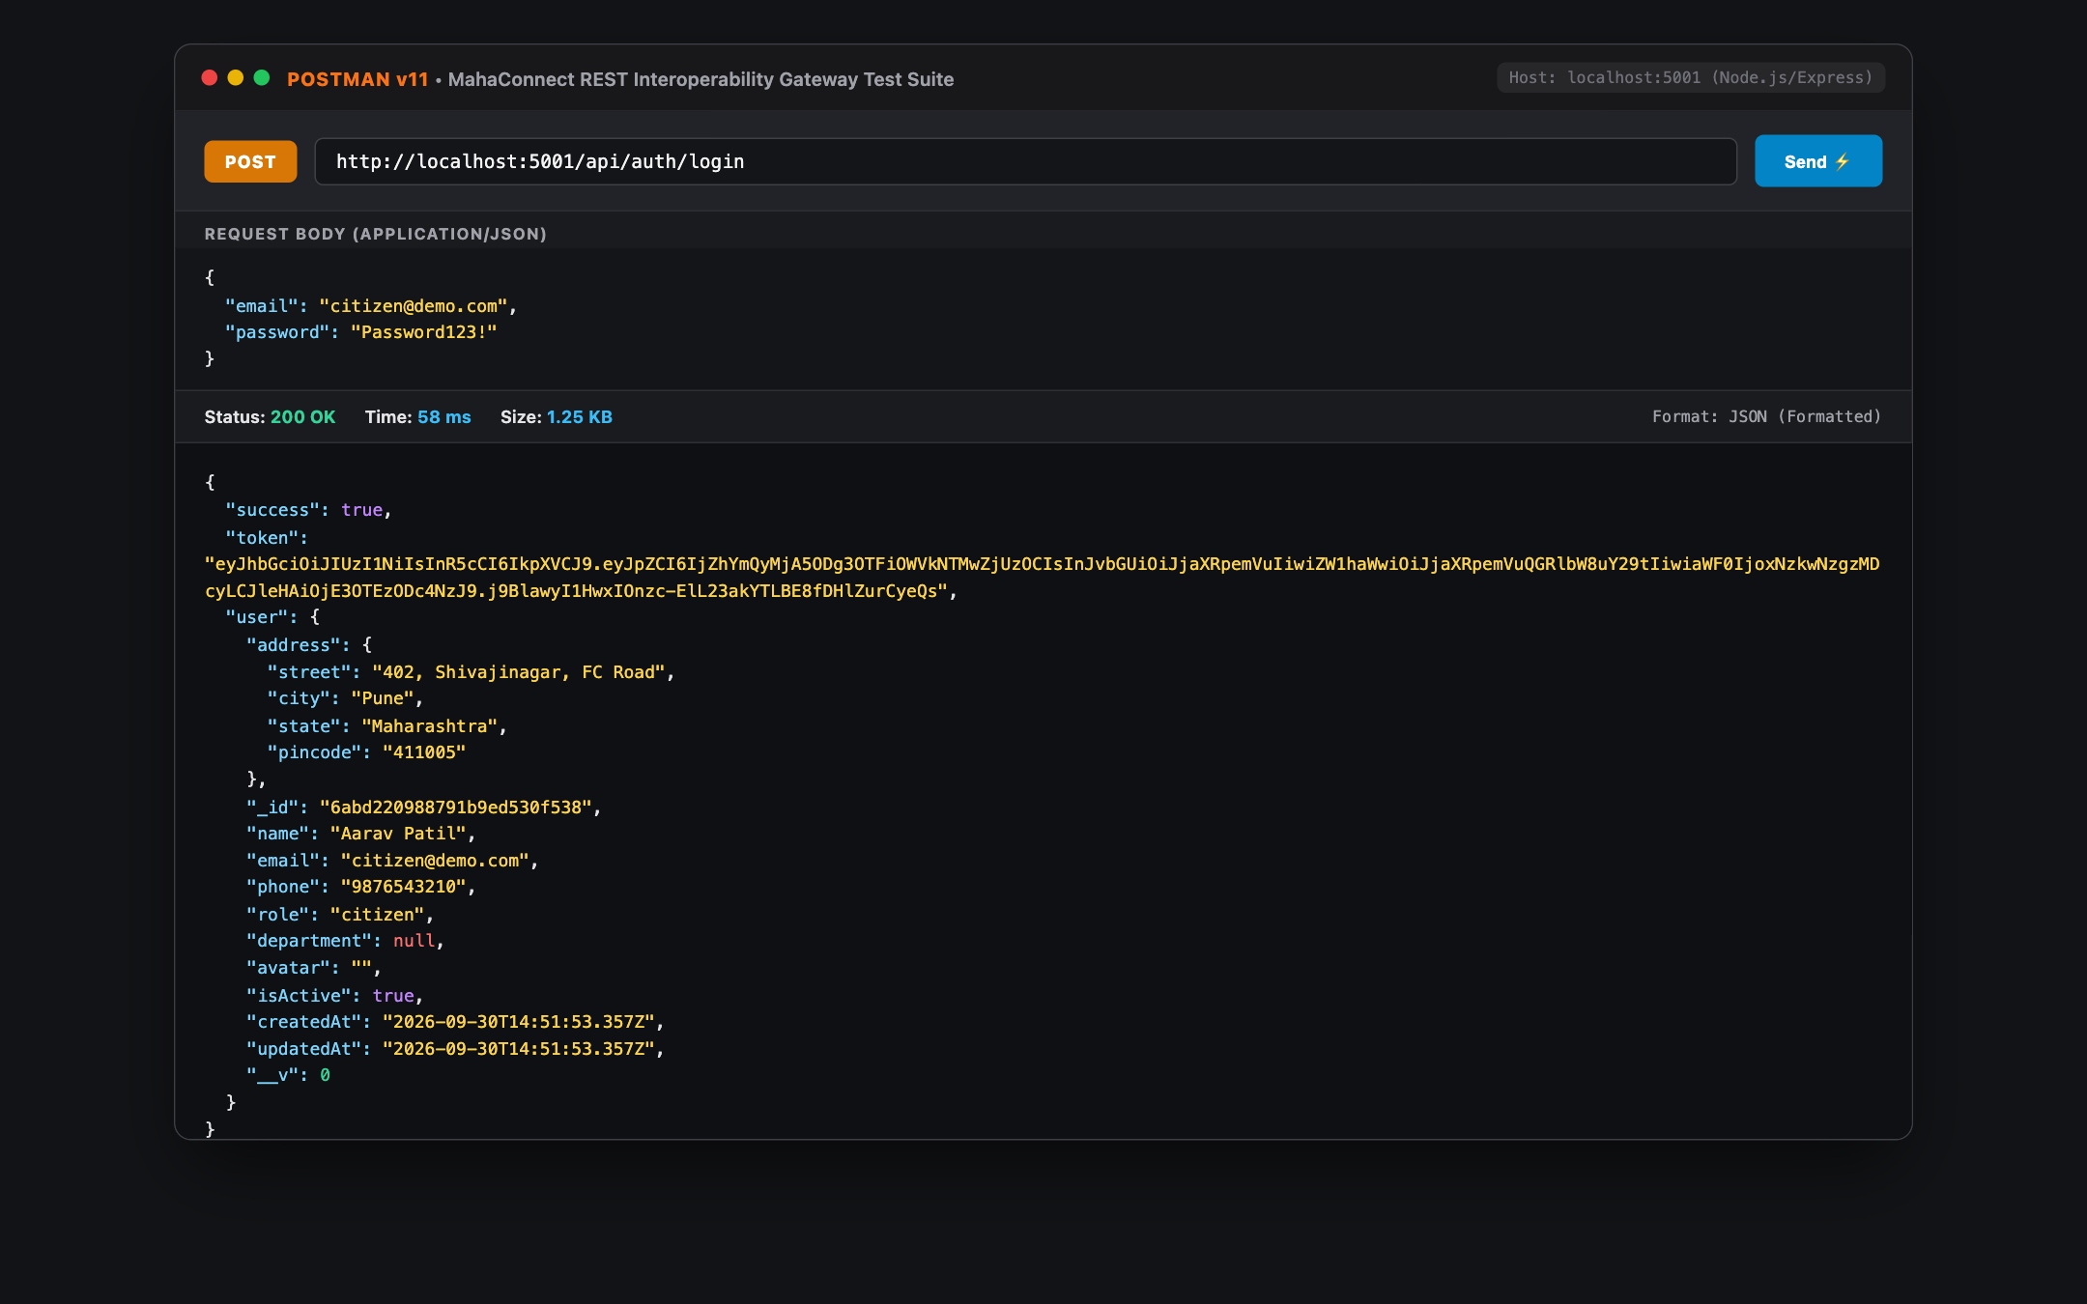
Figure 18: Postman Test Suite: POST /api/auth/login (JWT Token Generation)
Authentication endpoint test verifying bcrypt password verification and generation of a cryptographically signed HMAC-SHA256 JWT bearer token.
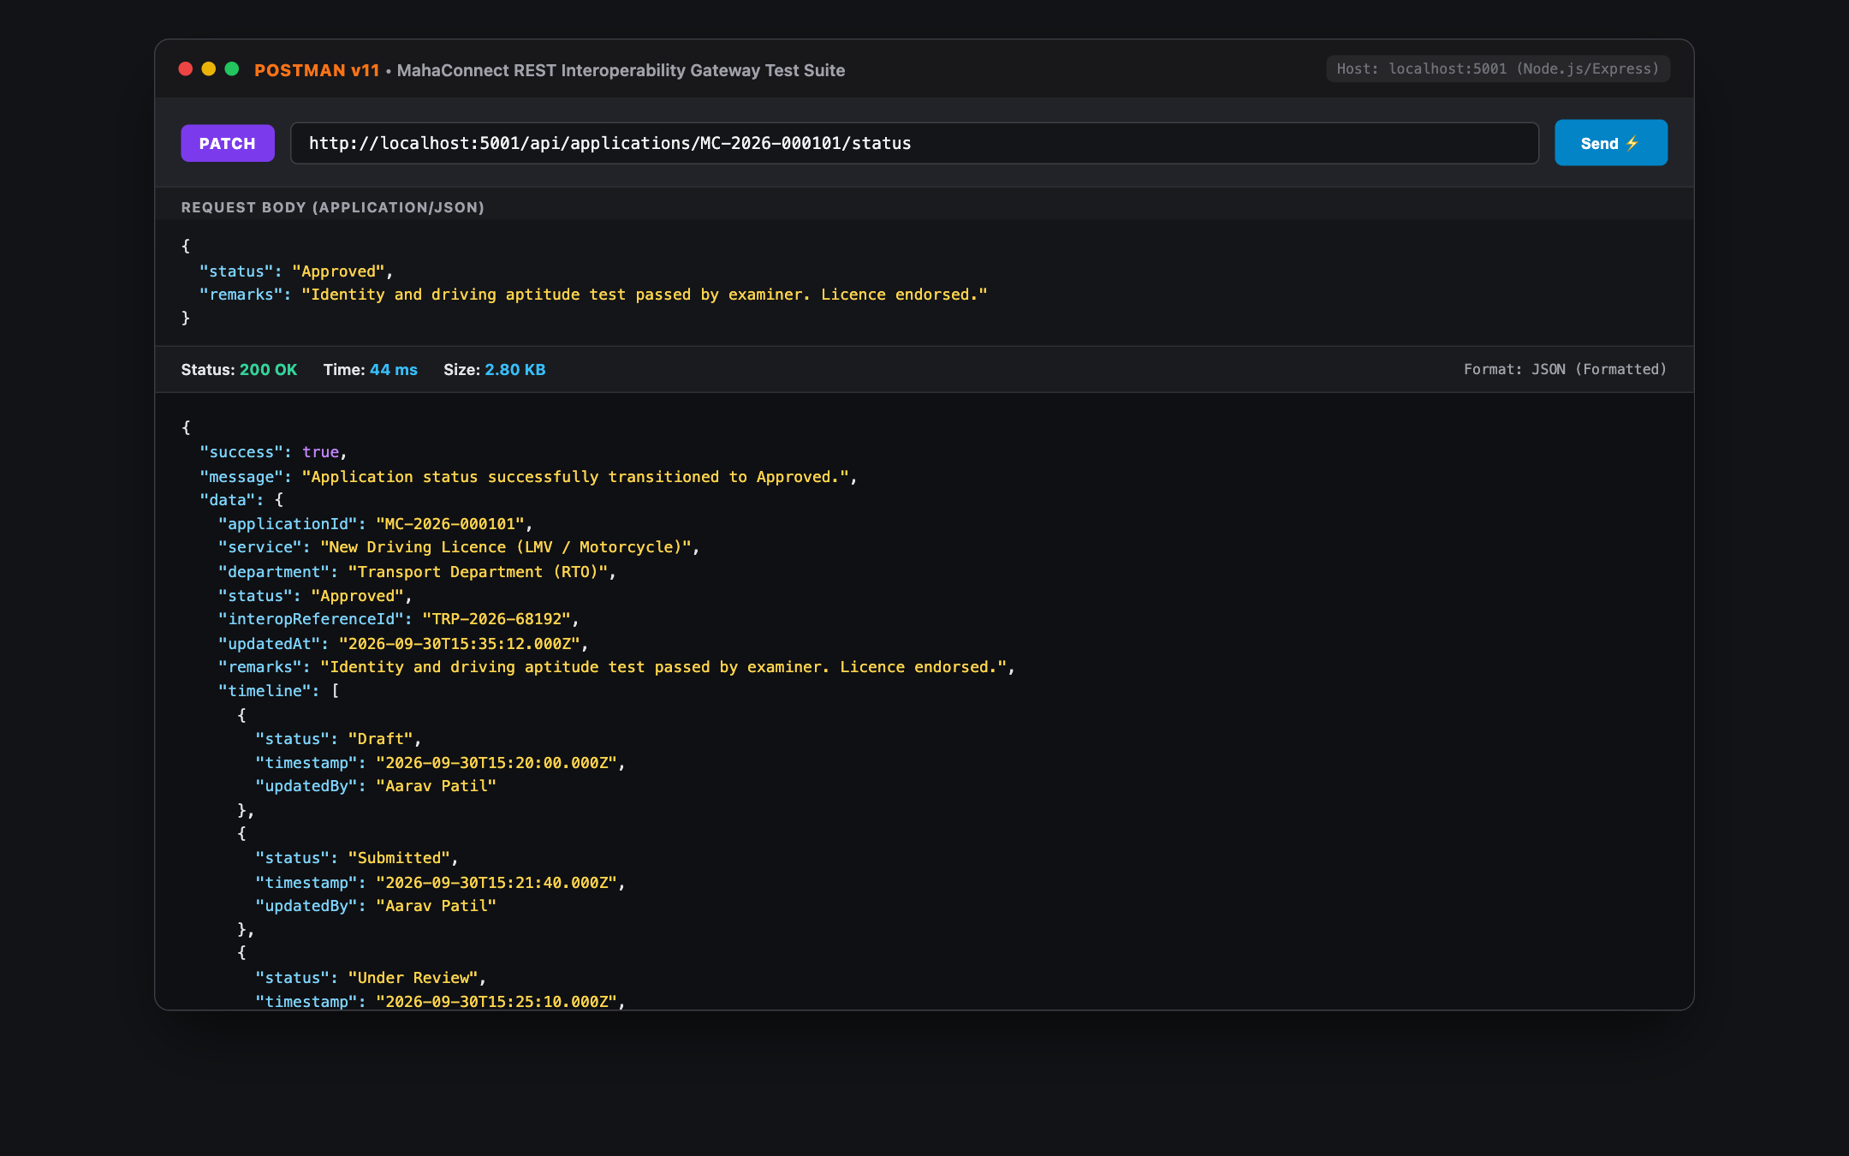
Figure 19: Postman Test Suite: PATCH /api/applications/:id/status
Automated status transition call demonstrating the officer approval workflow, timeline appending, and departmental gateway synchronization in 44 ms.
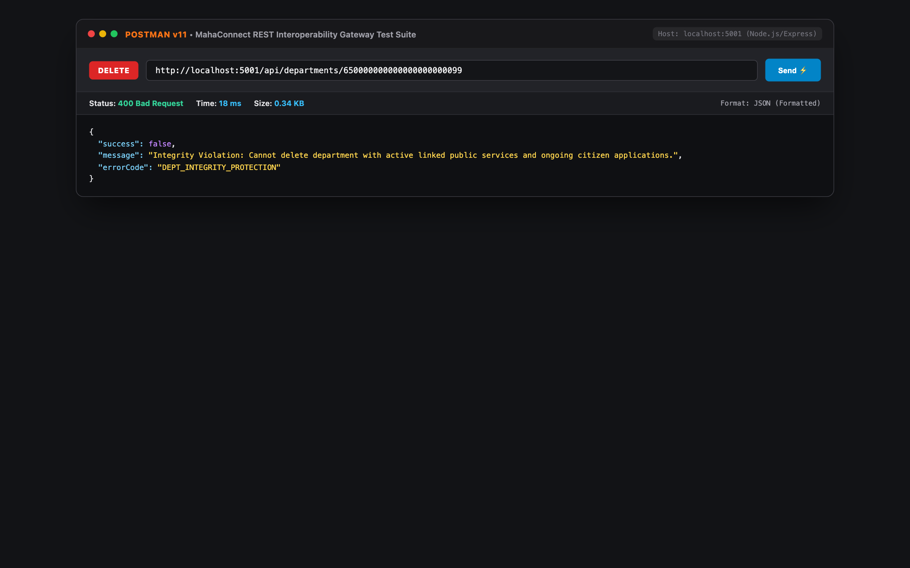
Figure 20: Postman Test Suite: DELETE /api/departments/:id (Integrity Check)
Integrity protection validation returning 400 Bad Request to prevent deletion of departments possessing active public services and ongoing citizen applications.
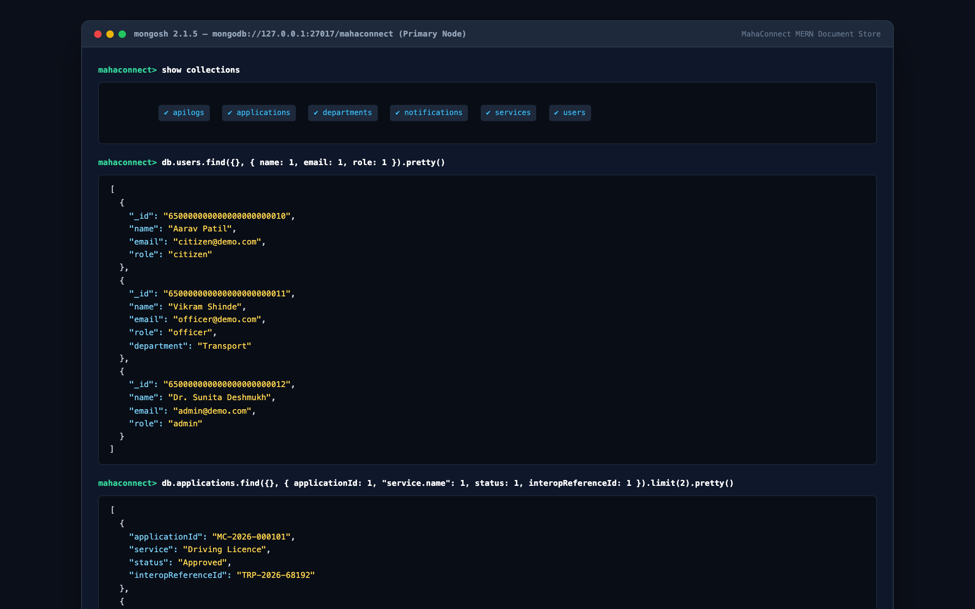
Figure 21: MongoDB Shell (mongosh) Collection & Query Ledger Inspection
Live database terminal view displaying the 6 core collections (apilogs, applications, departments, notifications, services, users) and formatted query records.
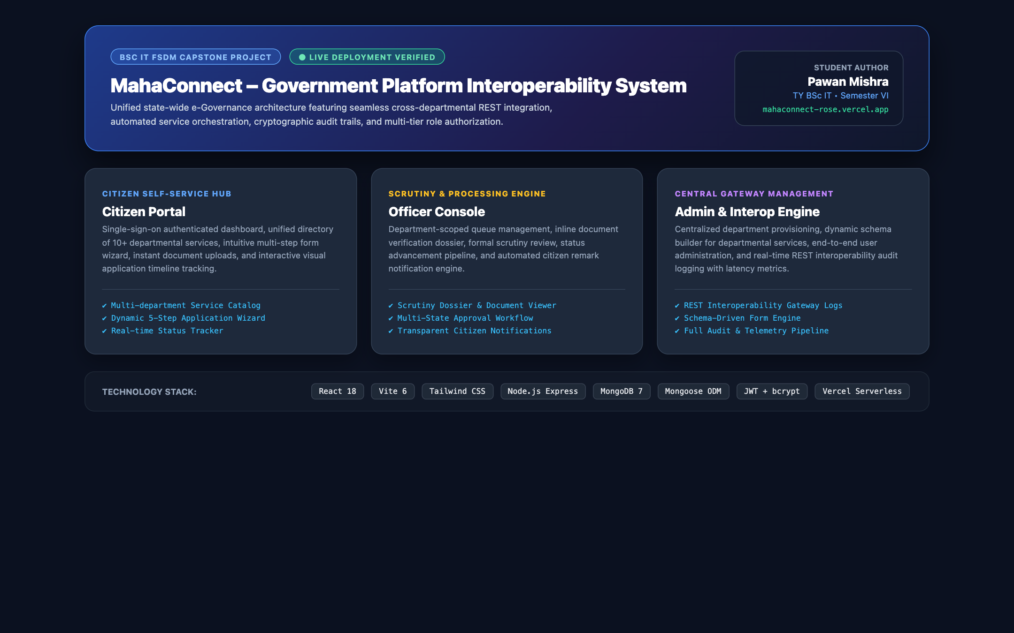
Figure 22: Comprehensive System Ecosystem Showcase & Architectural Overview
Composite presentation showcase illustrating the tri-portal architecture (Citizen Hub, Officer Console, Admin Gateway) and the full MERN stack integration.

12.0 CONCLUSION & FUTURE ENHANCEMENTS

12.1 Project Conclusion
The MahaConnect – Government Platform Interoperability System successfully addresses the critical challenge of departmental fragmentation in public administration. By designing and deploying an enterprise-grade full-stack MERN application, the project proves that modern web technologies and API Gateway architectures can establish a cohesive single-window platform without requiring invasive redesigns of legacy departmental backend databases.
Key milestones achieved in this project include:
• Universal citizen single-sign-on and profile synchronization, completely removing duplicate data entry.
• Dynamic 5-step form generation wizard accommodating arbitrary service parameters through JSON-schema definitions.
• Simulated RESTful Interoperability Gateway that records granular telemetry logs for every cross-departmental exchange.
• Strict role-based access control protecting Citizen, Officer, and Admin data partitions.
• Successful production deployment to the Vercel global edge network backed by MongoDB.

12.2 Future Enhancements
Future development roadmaps for MahaConnect incorporate:
• National DigiLocker & Aadhaar e-KYC Integration for automated document verification.
• Blockchain-Based Audit Ledger for tamper-evident inter-departmental transaction tracking.
• AI-Powered Grievance & Eligibility Chatbot to guide citizens on social welfare schemes.
• Multilingual State Localization (Bhashini API) supporting Marathi, Hindi, and English regional dialects.

13.0 REFERENCES & ACADEMIC BIBLIOGRAPHY
• National e-Governance Division (NeGD), MeitY, Government of India. e-Governance Interoperability Framework for India (e-GIF), 2021.
• Fielding, Roy Thomas. Architectural Styles and the Design of Network-based Software Architectures. Doctoral dissertation, UC Irvine, 2000.
• Chodorow, Kristina. MongoDB: The Definitive Guide: Powerful and Scalable Data Storage. 3rd Edition, O'Reilly Media, 2020.
• Banks, Alex and Porcello, Eve. Learning React: Modern Patterns for Developing React Apps. 2nd Edition, O'Reilly Media, 2020.
• Haverbeke, Marijn. Eloquent JavaScript: A Modern Introduction to Programming. 3rd Edition, No Starch Press, 2018.
• Rescorla, Eric. The Transport Layer Security (TLS) Protocol Version 1.3. RFC 8446, IETF, 2018.
• Jones, Michael et al. JSON Web Token (JWT). RFC 7519, IETF, 2015.
• W3C Web Accessibility Initiative (WAI). Web Content Accessibility Guidelines (WCAG) 2.1, 2018.

14.0 APPENDIX: SOURCE CODE HIGHLIGHTS & API SCHEMA

14.1 Core REST Controller: Application Dispatcher
The core dispatch engine handles incoming applications, computes unique state identifiers, allocates department gateway references, appends audit trail events, and records API telemetry in the MongoDB database.

14.2 Deployment & Reproduction Instructions
• 1. Clone Repository: git clone https://github.com/PawanMishra/mahaconnect.git
• 2. Install Dependencies: npm run install:all
• 3. Seed Database: npm run seed --prefix server
• 4. Launch Backend: npm run server (port 5001)
• 5. Launch Frontend: npm run client (port 5173)
• 6. Access Live Cloud URL: https://mahaconnect-rose.vercel.app

