**EXPERIMENT**

***Design a visitor counting system with the help of LDR for a hall. Assume that only one person can pass through the door at any time and also there are separate entry and exit doors. Note: The visitor count needs to be displayed on the serial monitor at all times***

***CIRCUIT DIAGRAM***

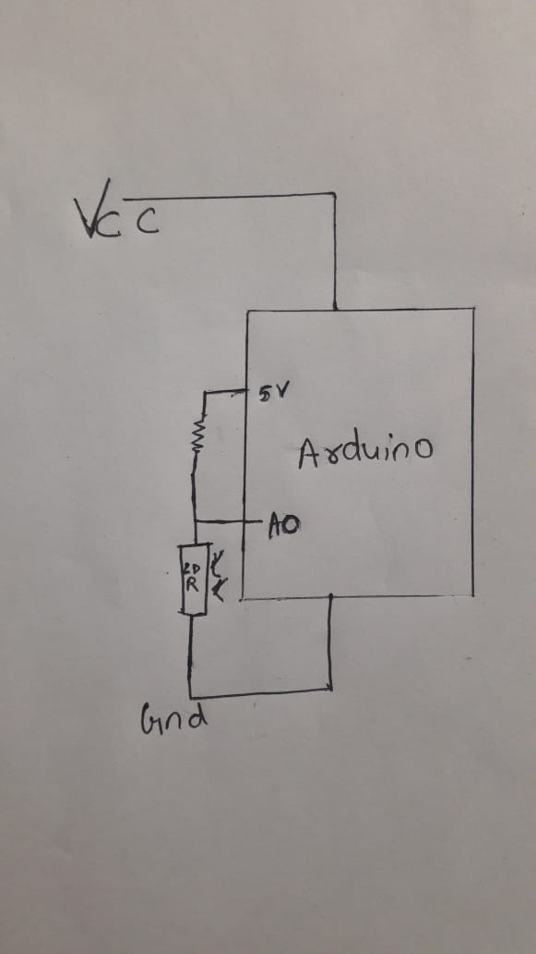

***THEORY***

***CONCEPT USED***

***A Light Dependent Resistor (LDR) or a photo resistor is a device whose resistivity is a function of the incident electromagnetic radiation.***

***As a person passes light through LDR becomes less so count increases.***

***Learning Outcomes*** ***and Observations***

***-About LDR and ardrino.***

***-Basic applications of LDR and ardrino .***

***OBSERVATIONS***

***-As value of LDR becomes less than certain value count increases.***

***PROBLEMS AND TROBLESHOOTING***

***A Certain value of LDR was not fixed so difficult to find a count.***

***PRECAUTIONS***

***-Components should be correctly placed.***

***-NO errors in coding.***

***-LDR should be grounded.***