Machine Learning is set of techniques to make computers better at doning things that humans(traditionally) can do better then machines.

Machine Learning involves making machines learn things link humans do.

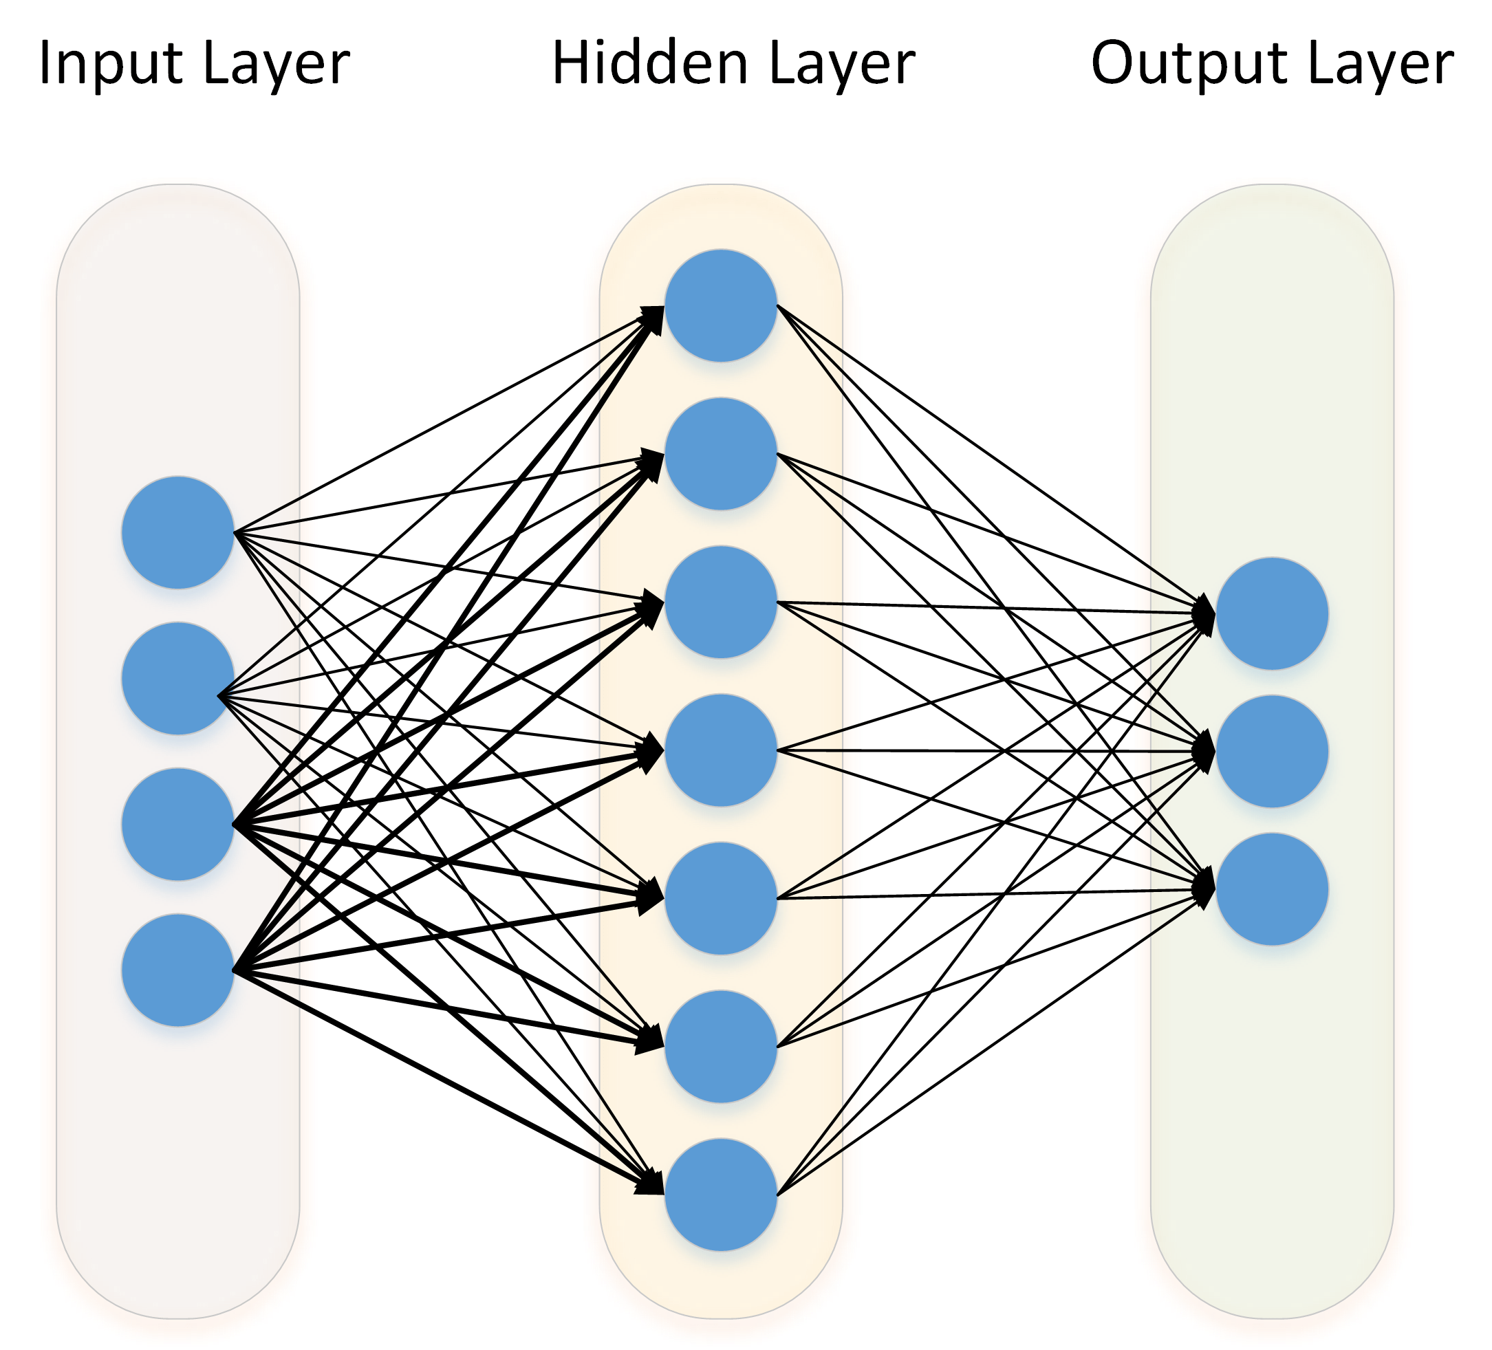

Set of techniques to extract knowledge from available data and use that knowledge to make decisions.

Machine Learning -deep Learning, Mathematical Models. example- spam filter, personal assignstent, youtube recommendation, and drive less car.