git remote add origin git@github.com:pawan1816/Linear-Regression-Multiple-Variables.git

git branch -M main

git push -u origin main

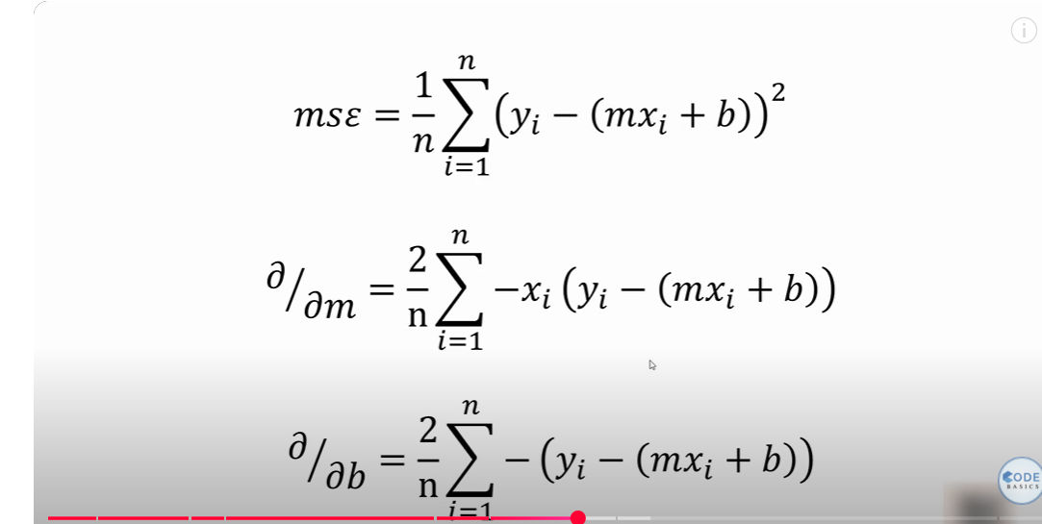

The above equation is for the Mean Square error (MSE) for finding the Best fit line in the linear regression with one dependent variable VS one independent variable and also for the one dependent variable VS many independent Variable.