ASSESSMENT-1

1. Create a VM with availability set using the custom image with chrome Pre-installed

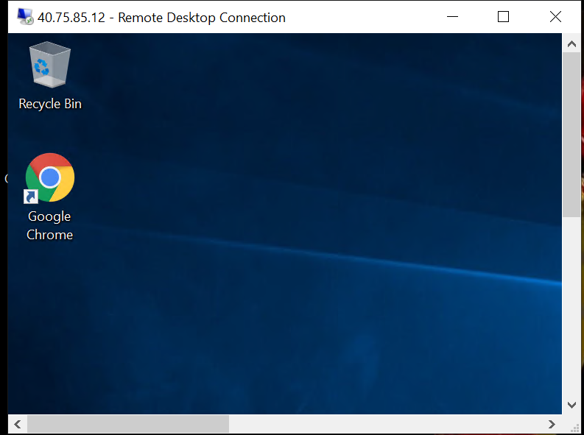

1. Created vm scalset with Standard_DS1_v2

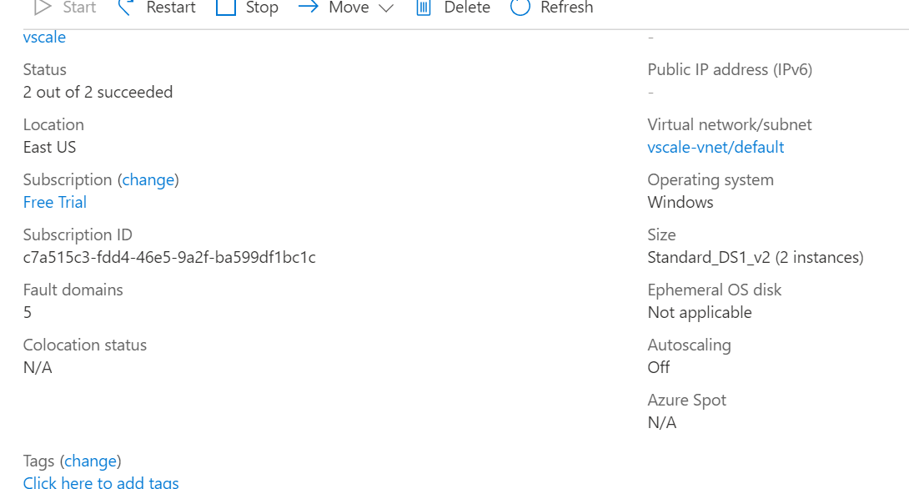

1. Create a blob storage account with GRS standard and enable the blob soft delete with 15 days retention period also it should be able to connect with Azure storage explorer

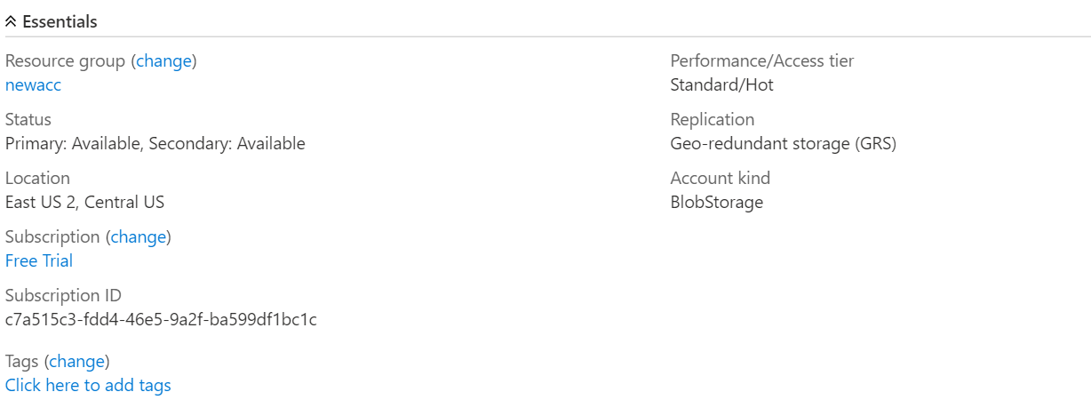

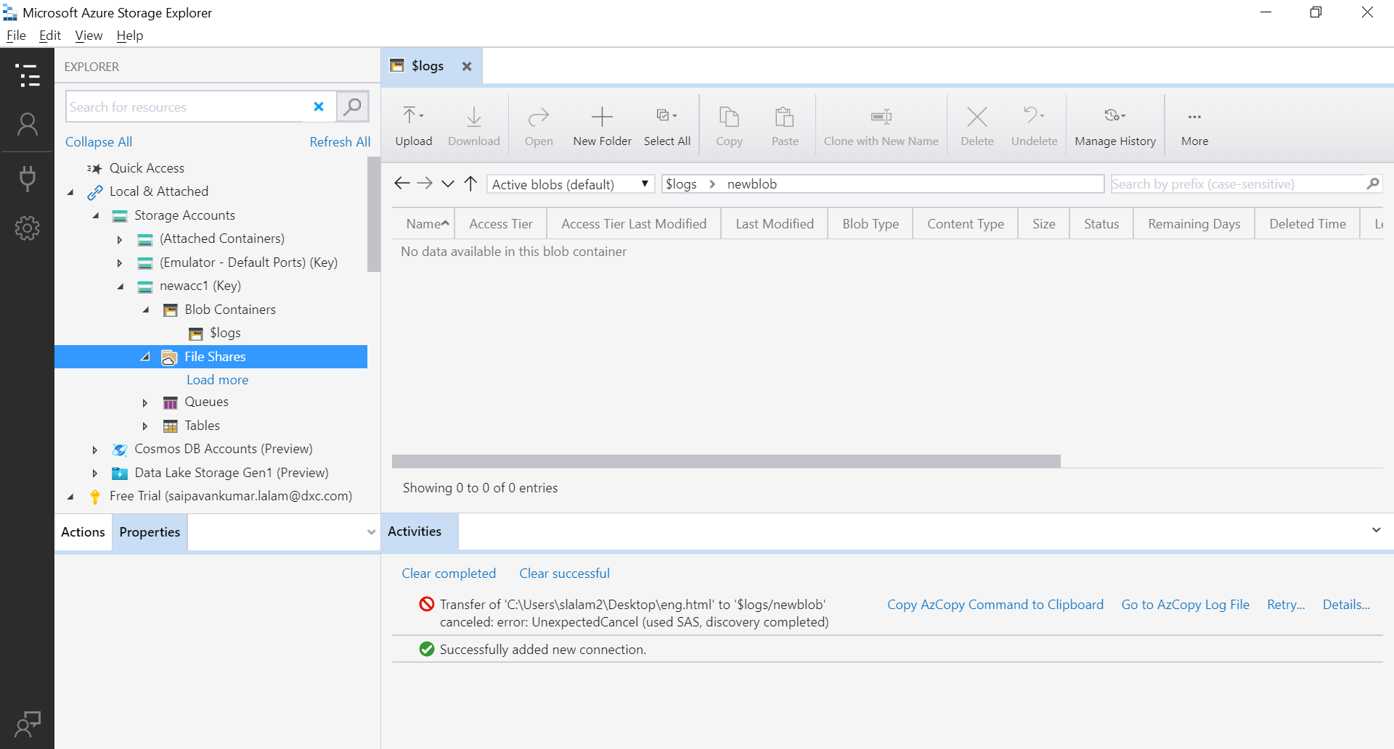

1. Configure the Vnet and create 3 subnets in the Vnet

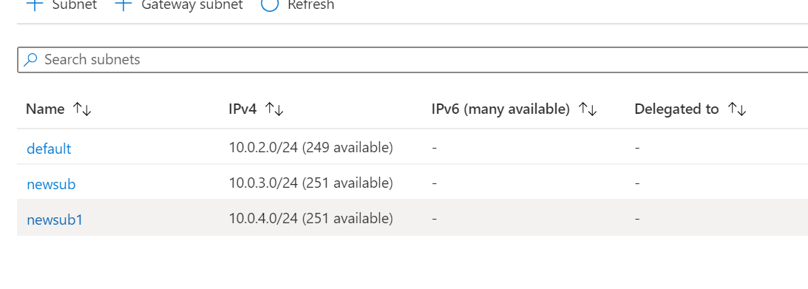

1. Create a traffic manager with performance routing method

