ASSESSMENT-2

1. **Create a P-T-S VPN and attach a VM to it**

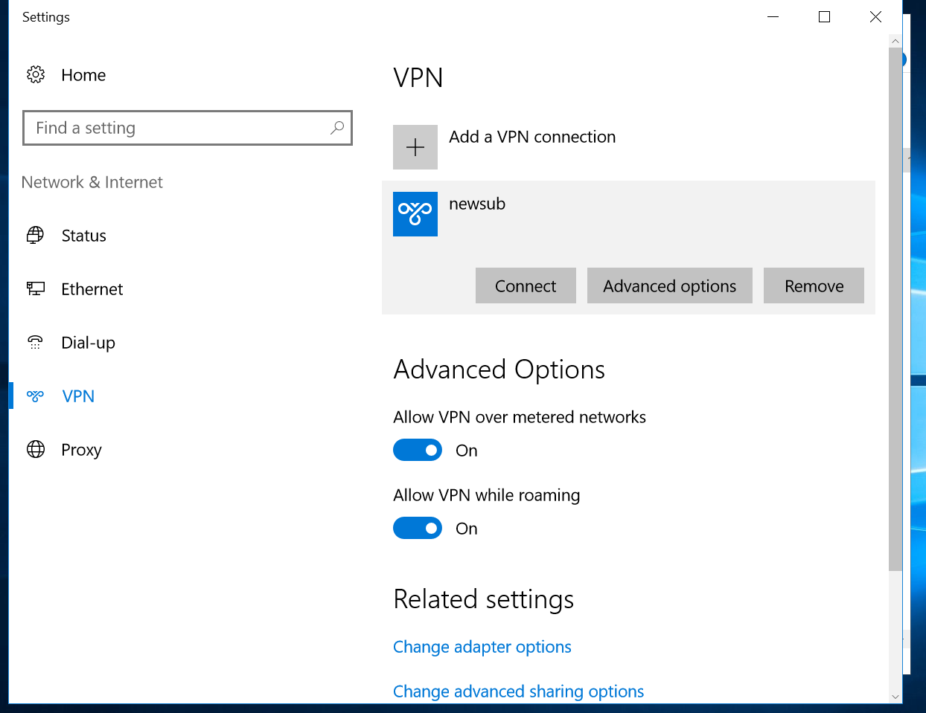

Here we can see that we have installed the point-to-site VPN in a virtual machine. In where we can install it through certificates and the public certificate key.

1. **create a two web application in west us and central Us then attach to the traffic manager with Priority routing method**

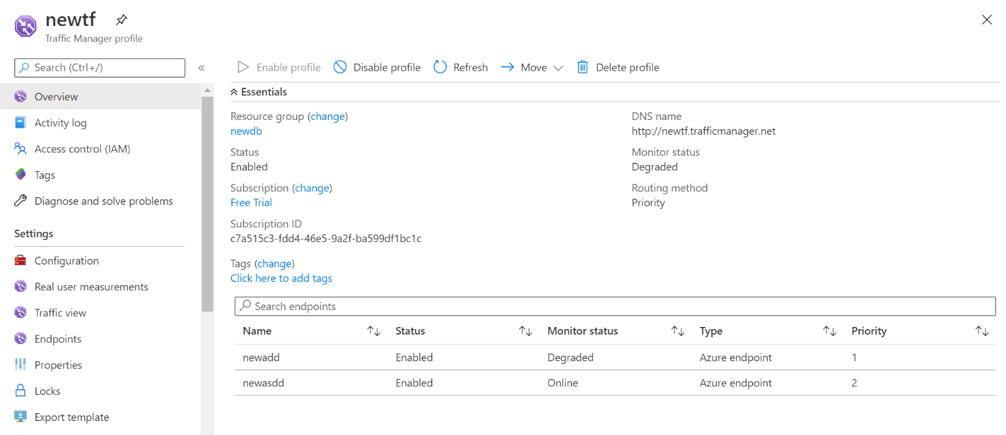

For this we firstly created two sample apps. And then in Traffic Manager Profile using the endpoints we added the two sample apps in the traffic manager with the Priority Routing method. So that the traffic will be shared according to the Priority.

1. **create a windows server with AD installed and integrate with Azure AD**

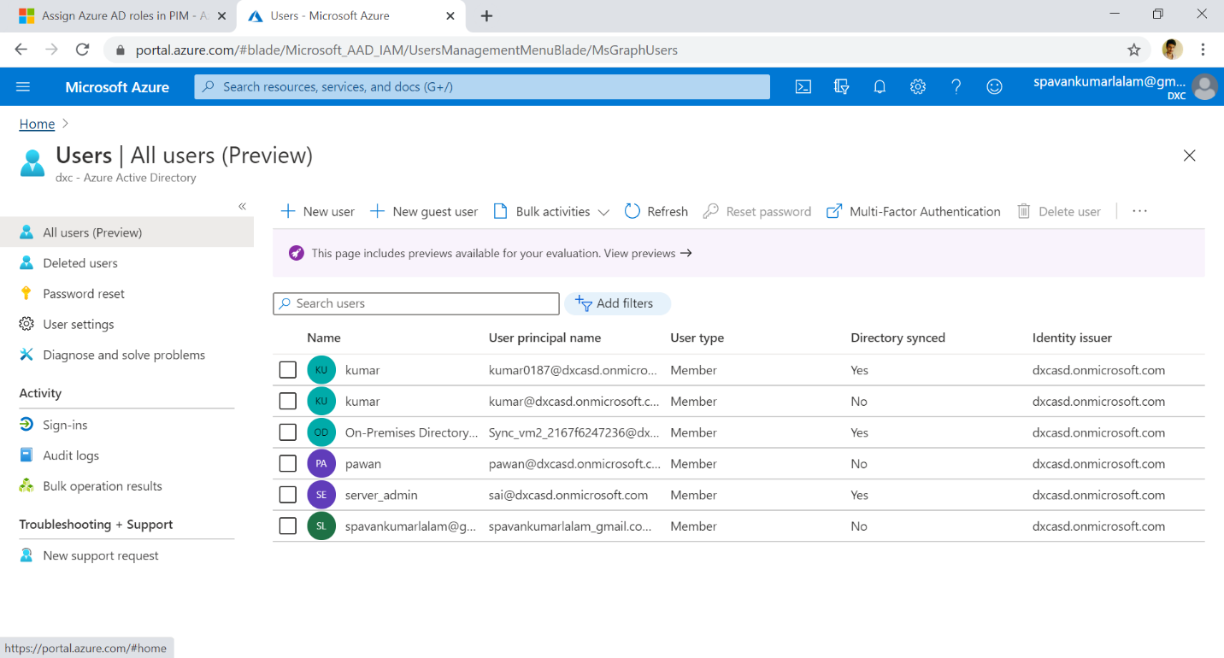

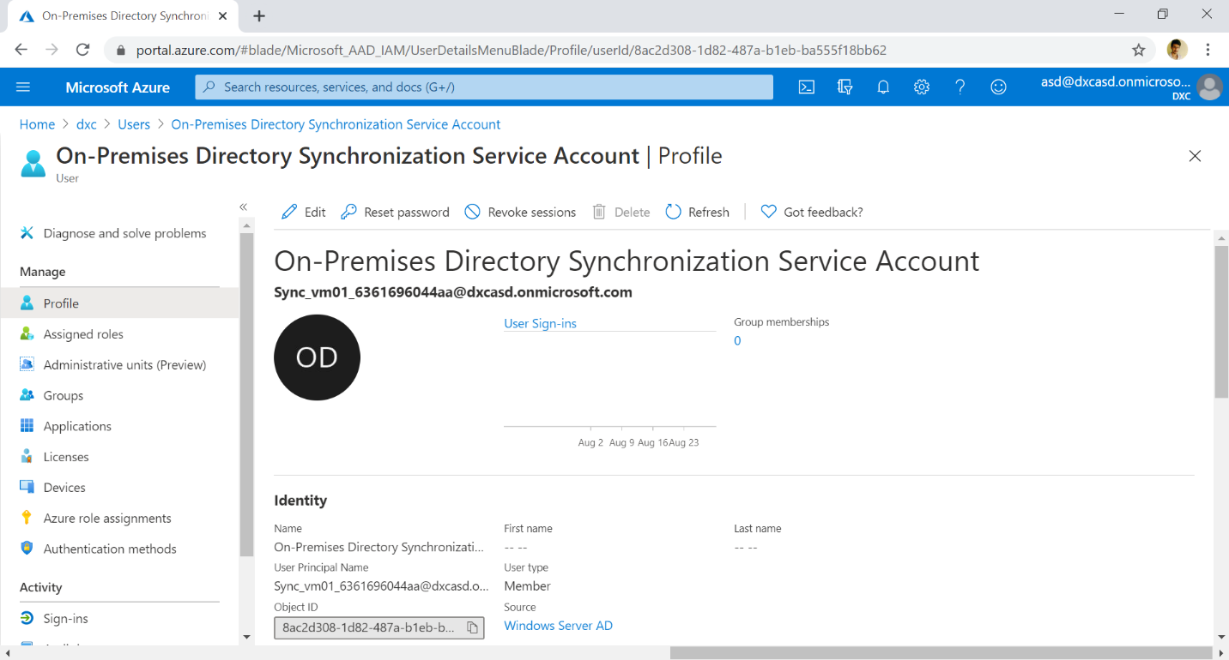

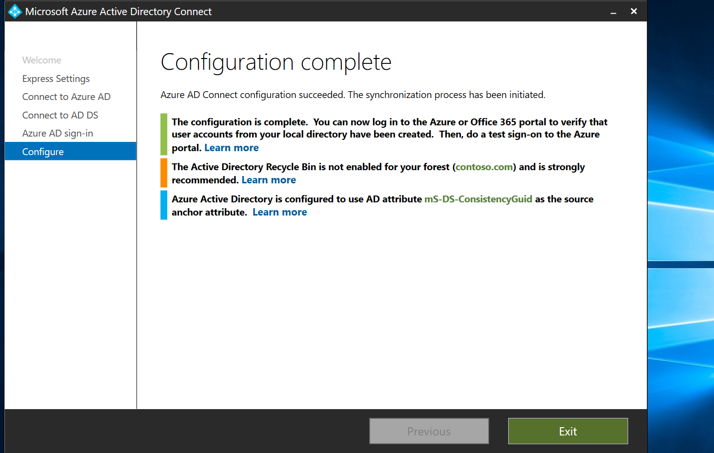

From the above snaps we will know that we have configured the on-premises AD and connected the AD to the Azure AD. So that we can control it through the cloud.

1. **configure a backup to the VM you installed AD**

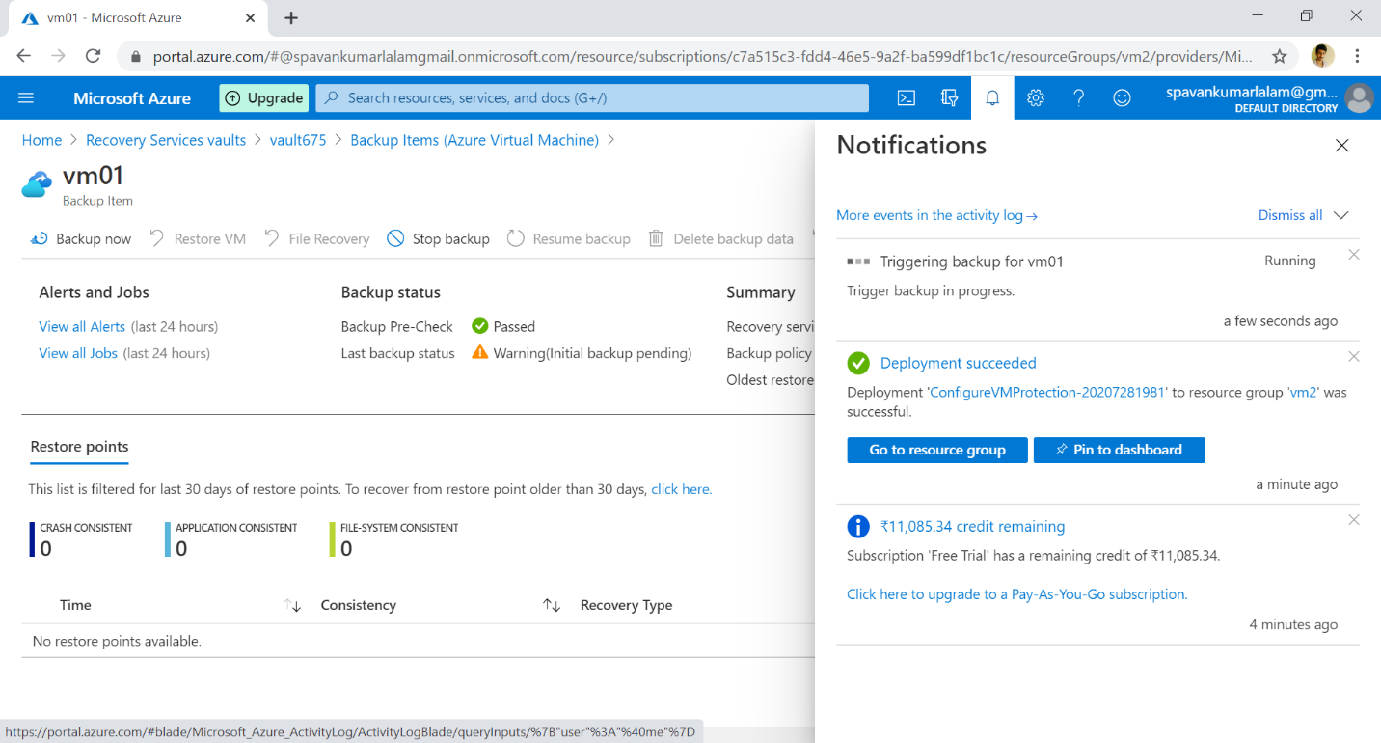

I have configured the Vm and triggered the Backup for the Vm. By this backup we can restore the Vm whenever any accidental deletion of Vm got happened.

1. **configure alerts for the VM**

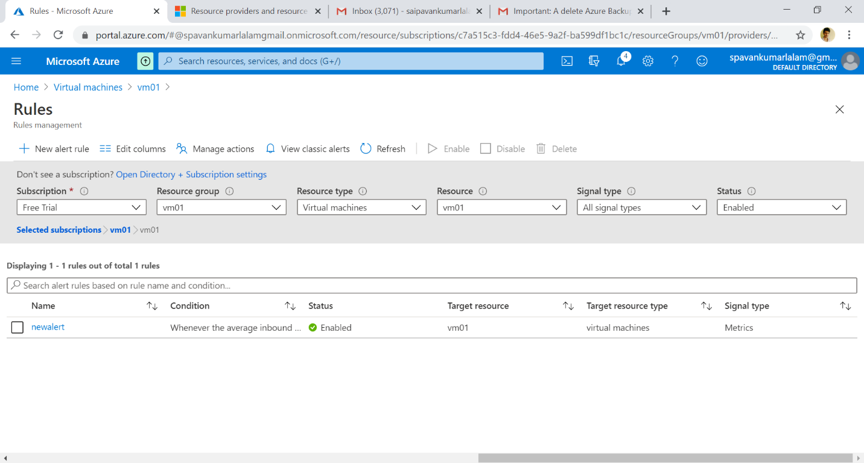

I have created an alert for the Vm. So whenever the condition got satisfied or the condition that we have created reaches its threshold it will automatically generates an alert showing that the condition that we have configured is satisfied. So that we can look into it and balance the condition.

1. **Apply any security policy to the subscription**

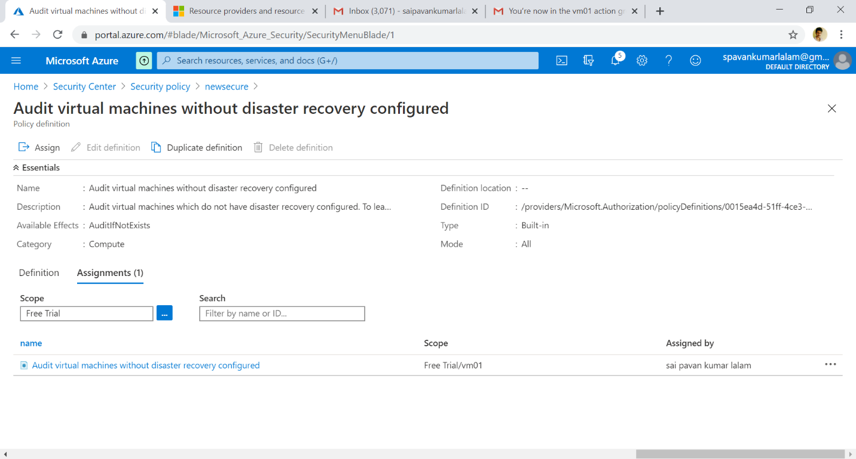

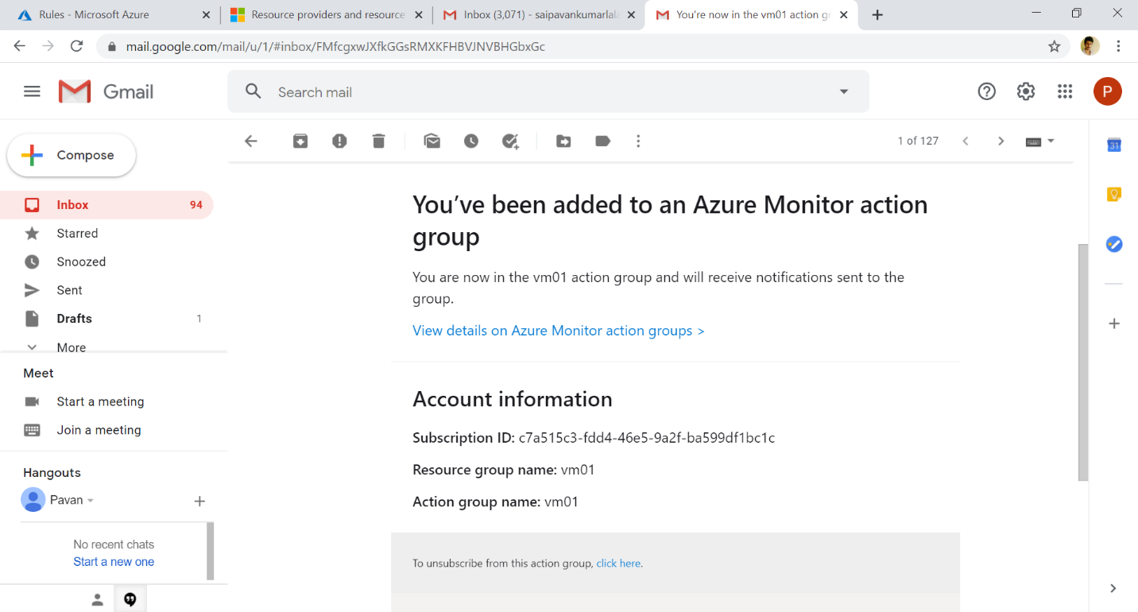

In this we have made a security policy with some condition to be satisfied. The Security policy is applied to the subscription which is assigned by the owner. Only owner have the privileges to change subscription and all..

1. **create a SQL server with database installed in the elastic pool**

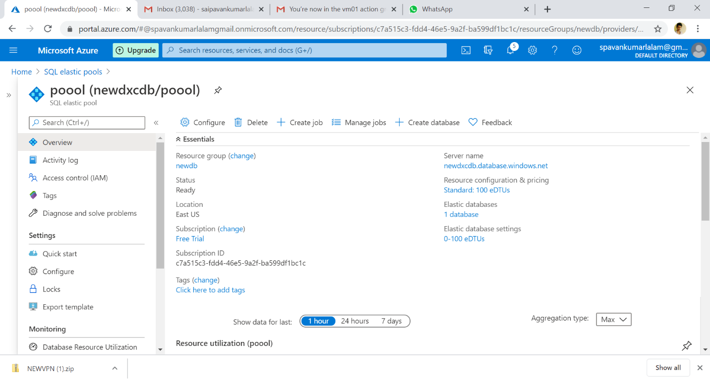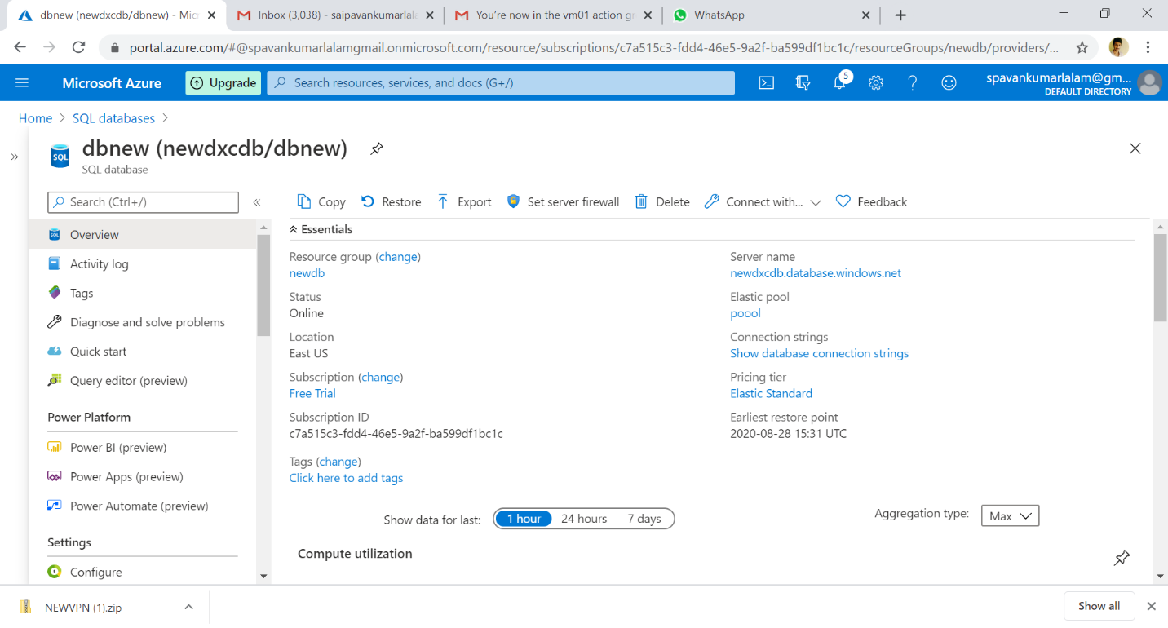

We firstly created a SQL server and then created a SQL database. We all know that a database consists of data in the form of structured manner i.e tables. And in the server, we have databases and Elastic pools. Now we placed the database in the elastic pool so that if any issue happened to the database hardware it will use the other databases hardware to respond accurately..