ASSIGNMENT

1. Creating a VM with Windows 2019 and Ds1-V2 standard

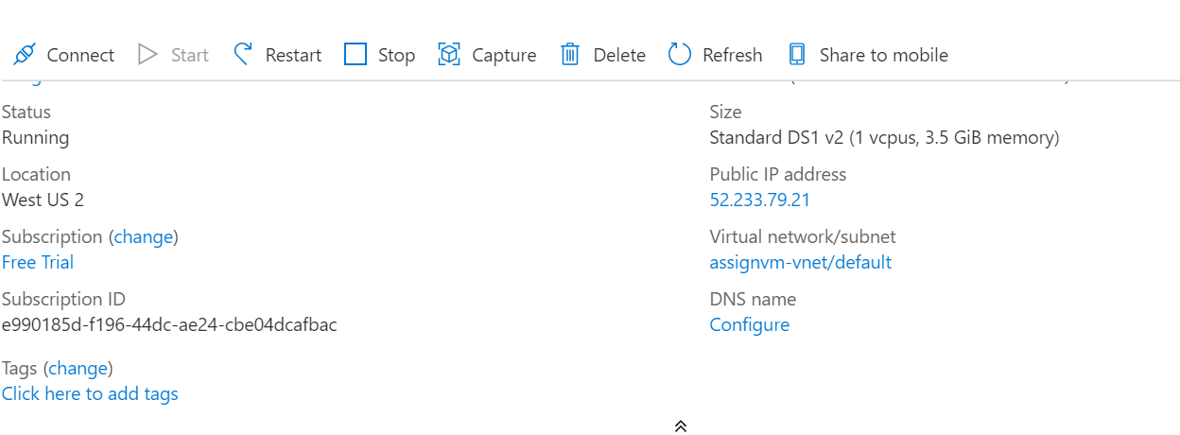

1. Attached an extra disk of 50GB and splitted it into 3 partitions.

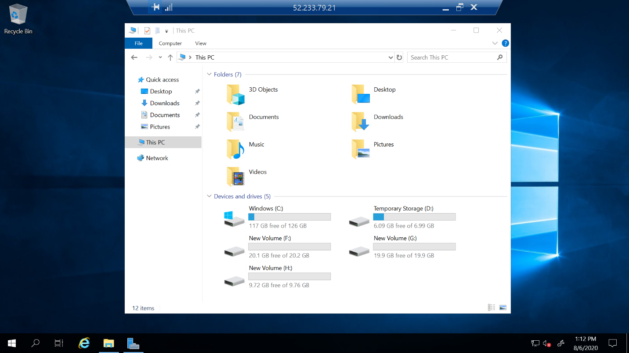

1. Auto shutdown mail received to the mail

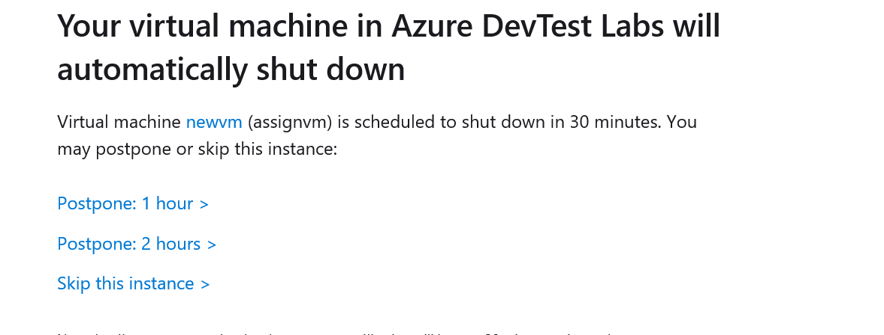

1. Logging in with 2 users

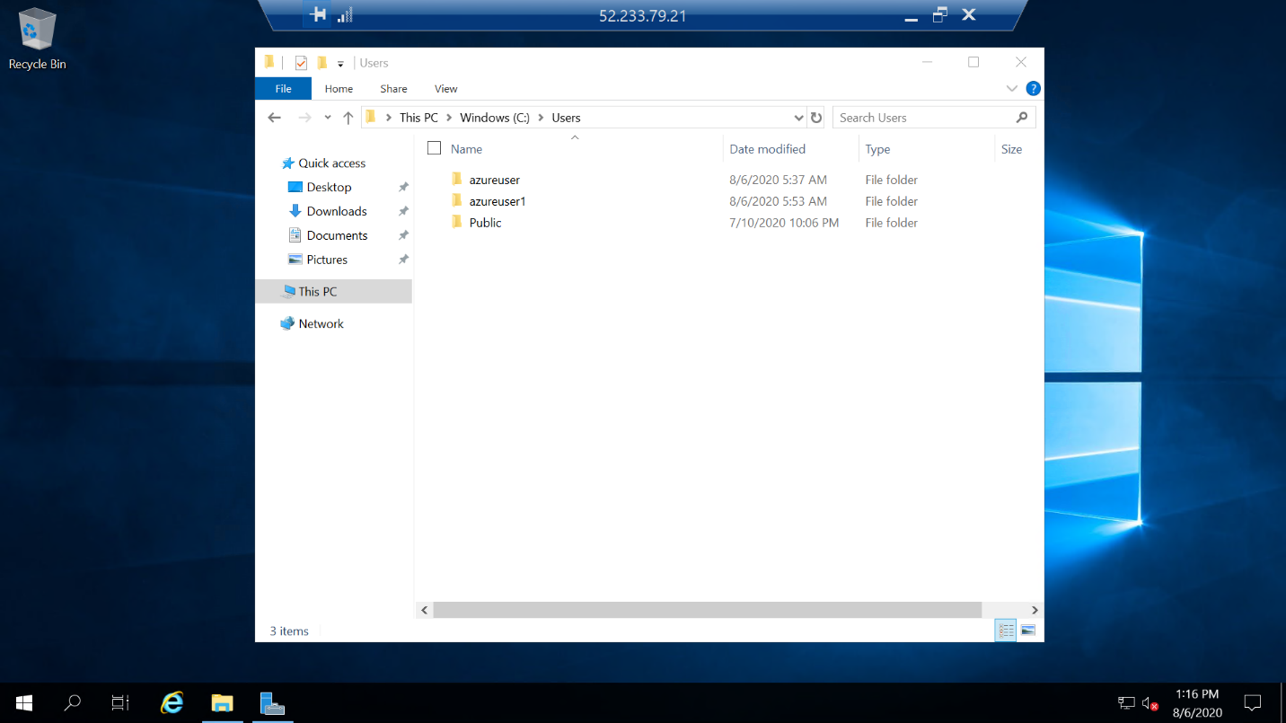

1. Installing Antimalware Extension

