


Retail Inventory Management Software System (RIMSS)
YCompany — Design Architecture Recommendation (DAR)
Version 1.0
Contents
1 Revision History 4
2 Contents 5
3 Introduction 6
3.1 Problem Statement 6
3.2 Objective and Scope of Document 6
3.2.1 Objective 6
3.2.2 Scope 6
4 Requirements at a Glance 8
4.1 Functional Requirements 8
4.2 Non-Functional Requirements 8
4.3 Assumptions 9
4.4 Constraints 9
5 Available Tools 11
5.1 Development Tools 11
5.2 Testing Tools 11
5.3 Collaboration and Project Management 12
5.4 Deployment and Hosting 12
5.5 Database and Storage 12
5.6 Monitoring and Analytics 12
6 Comparison Analysis 13
6.1 Frameworks and Libraries — Next.js (App Router) vs. plain React + Express 13
6.2 UI Library — Material UI 9 vs. Tailwind + Headless UI 13
6.3 Testing Tools — Vitest vs. Jest 13
6.4 Cloud Services — Vercel vs. AWS (ECS / Fargate) 14
6.5 Authentication — NextAuth (Auth.js) vs. Custom JWT 14
6.6 Payments — Stripe Checkout vs. PayPal Standard 14
6.7 Database — PostgreSQL vs. MongoDB 15
6.8 Observability — Sentry + GA4 + New Relic vs. single-vendor APM 15
7 Recommendation (as implemented) 16
7.1 Frontend 16
7.2 Backend (Route Handlers) 16
7.3 Authentication 16
7.4 Payments 16
7.5 Data layer (current → recommended) 17
7.6 Observability 17
7.7 Deployment 17
7.8 Quality gates 17
8 Architecture and Workflows 18
8.1 System Architecture (high level) 18
8.2 Module Map (src/) 19
8.3 Checkout Workflow (end-to-end) 20
8.4 Authentication Workflow 21
8.5 Search Workflow 22
8.6 Order Lifecycle 22
8.7 Deployment Topology 23
9 Continuous Support and Maintenance 24
9.1 Support Structure 24
9.2 Maintenance Activities 24
9.3 User Training and Documentation 24
9.4 Feedback and Improvement 24
9.5 Service Level Agreements (SLAs) 24
10 Risks 26
10.1 Technical Risks 26
10.2 Project Management Risks 26
10.3 Business Risks 26
10.4 Operational Risks 26
Appendix.A Appendix 27
A.1 Glossary of Terms 27
A.2 Relevant Documents 27
A.3 Diagrams and Charts 27
A.4 Contact Information 28
A.5 Additional Resources 28

Prepared by: Pawan Gupta — Nagarro Software Pvt. Ltd.
Document version: 1.0
Date: 25 May 2026

Revision History
Version | Date | Author / Contributor | Comments
1.0 | 25 May 2026 | Pawan Gupta | Re-baselined to reflect the as-built Next.js 16 / TypeScript implementation, Stripe, NextAuth and observability stack.
1.1 | 27 Aug 2026 | Pawan Gupta | Documented Elasticsearch search workflow (Elastic Cloud + in-memory fallback), Resend transactional notifications, and aligned as-built module map with the reference repository.

Contents
- Introduction
- Requirements at a Glance
- Available Tools
- Comparison Analysis
- Recommendation (as implemented)
- Architecture and Workflows
- Continuous Support and Maintenance
- Risks
- Appendix

Introduction
YCompany stands as a leading luxury countryside fashion brand, celebrated for its distinctive collections of high-quality clothing, shoes and accessories. Renowned for sweaters, moleskin clothing, corduroy apparel and tattersall shirts, YCompany has successfully evolved its product line to appeal to both traditional countryside customers and a younger, modern audience. This strategic diversification has reinforced its market presence and broadened its appeal. Despite this success, YCompany faced significant challenges with its previous online shopping infrastructure.

Problem Statement
The legacy YCompany storefront was constrained by several key issues that hindered a seamless online shopping experience:
- Lack of cross-platform support — inconsistent user experience across devices and screen sizes.
- High initial load time — first contentful paint regularly exceeded one minute on retail Wi-Fi.
- Unresponsive UI — UI lag and freezing during browsing and checkout.
- Inefficient product search — slow text search with no filtering or relevance ranking.
- No inventory awareness in the storefront — customers could add out-of-stock items to the cart.
These issues collectively impacted YCompany's ability to capture online sales and meet the expectations of modern consumers. In response, YCompany commissioned the Retail Inventory Management Software System (RIMSS) — a unified storefront and inventory experience built on a modern web stack.

Objective and Scope of Document

Objective
The primary objective of this document is to outline the high-level design and the as-implemented technical architecture of the RIMSS application for YCompany. It serves as a single reference for solution design, technology choices, non-functional requirements, deployment topology and supported workflows.
Key objectives:
- Address existing challenges — cross-platform support, initial load time, UI responsiveness and search efficiency.
- Enhance user experience — a seamless, responsive and intuitive online shopping flow.
- Improve performance — fast first paint, smooth interactions and instant filtering.
- Ensure scalability and reliability — stateless web tier deployable on Vercel and Kubernetes.
- Add inventory awareness (RMS) — per-SKU stock surfaced in the storefront and enforced at the cart.

Scope
- Solution overview — high-level description of features and capabilities.
- Technical design — App Router architecture, data flow, integration points (Stripe, NextAuth, Elastic Cloud search, Resend email, observability).
- Non-functional requirements — performance, security, accessibility, observability.
- Assumptions and constraints — including the demo data layer that will be replaced by Postgres.
- Scope of work — clear delineation of what is in repository vs. recommended follow-ups.

Requirements at a Glance

Functional Requirements
- User Management
- Registration and authentication — NextAuth v5 with Credentials plus optional OAuth (Google, GitHub, Facebook, Apple). Sessions are JWT-backed with a 7-day lifetime.
- User profile / account dashboard — order history, account details and sign-out (/account).
- Product Management
- Product catalog — name, description, image, price, brand, category, tags, SKU and stock.
- Search and filtering — server-side /api/products/search (rate-limited) via Elastic Cloud when ELASTICSEARCH_CLOUD_ID and ELASTICSEARCH_API_KEY are set, with automatic in-memory CatalogIndex fallback; filters by query, brand, price range and sort (relevance, price-asc, price-desc, name).
- PDP (product detail page) — /products/[slug] with related-product cross-sell and inventory state.
- Cart and Checkout
- Cart — React Context backed by localStorage, with clampAddQuantity() to respect per-SKU stock.
- Checkout — Stripe Checkout Session via /api/checkout, with coupon discounts and shipping options.
- Order Management
- Order creation — created on checkout.session.completed Stripe webhook (and via /api/orders/sync fallback when webhooks are not configured); sendOrderConfirmationEmail() fires on first idempotent create.
- Order history — /account lists orders for the signed-in user.
- Order detail and cancellation — /api/orders/[id] and /api/orders/[id]/cancel (only while status === "processing").
- Discounts and Promotions
- Coupon engine — server-validated coupons in src/lib/coupons.ts (WELCOME10, SAVE20, FREESHIP) exposed through /api/coupons/validate and mirrored into Stripe at session creation.
- Customer Support
- Footer contact link, support email and observability hooks for proactive issue detection.
- Transactional notifications
- Resend-backed HTML + plain-text emails for welcome (signup), order confirmation (Stripe webhook / orders sync) and order cancellation; console fallback when RESEND_API_KEY is unset.

Non-Functional Requirements
- Performance
- First contentful paint target under 3 seconds on 4G. Achieved with next/image, MUI package import optimization (optimizePackageImports), route-level loading.tsx, dynamic imports of the search UI and compress: true in next.config.ts.
- Search API responds with Cache-Control: public, max-age=30, stale-while-revalidate=60.
- Scalability — Stateless web tier (Vercel serverless or Kubernetes Deployment with replicas: 2); horizontal scaling on traffic.
- Usability — Fully responsive Material UI 9 layouts; mobile cart cards, collapsible filters, drawer navigation; semantic markup.
- Security
- Security headers: X-Frame-Options, X-Content-Type-Options, Referrer-Policy, Permissions-Policy.
- All API inputs validated with Zod.
- Stripe webhook signature verification.
- In-memory rate limiting (src/lib/rate-limit.ts) on /api/checkout and /api/products/search.
- Passwords hashed with bcryptjs; demo password hash is provisioned through AUTH_DEMO_PASSWORD_HASH.
- middleware.ts protects /account routes with a redirect to /login.
- Reliability — Kubernetes readiness/liveness probes on /; Sentry captures unhandled exceptions client and server side.
- Maintainability — Strict TypeScript, ESLint (eslint-config-next), Vitest with 90 % line / function and 85 % branch coverage thresholds enforced in CI.

Third-party services — Stripe, NextAuth providers, Elastic Cloud (optional), Resend (optional), Sentry, Google Analytics 4 and New Relic are integrated as no-ops or local fallbacks when their environment variables are not configured, allowing local development without credentials.
- Technology stack — Next.js 16 App Router with React 19 and TypeScript 5.
- Third-party services — Stripe, NextAuth providers, Sentry, Google Analytics 4 and New Relic are integrated as no-ops when their environment variables are not configured, allowing local development without credentials.
- User base — both existing customers and new visitors, on desktop and mobile.

Constraints
- Budget and time — must adhere to YCompany's defined release timeline.
- Legacy integration — orders persisted to a JSON store (data/orders.json) for demo; production database migration is identified as a follow-up.
- Image source — product imagery currently served from images.unsplash.com (allow-listed in next.config.ts); production assets should be replaced with brand-owned CDN URLs.

Available Tools

Development Tools
- Programming languages
- TypeScript 5 — strict mode across the codebase.
- JavaScript (ES2022+) — for build / config files only.
- Frameworks and libraries
- Next.js 16.2.3 — App Router, Server Components, Route Handlers, middleware, metadata, sitemap.ts, robots.ts, manifest.ts, standalone output.
- React 19 — Server Components, useTransition, useDeferredValue.
- Material UI 9 (@mui/material, @mui/icons-material, @mui/material-nextjs) with Emotion 11 for SSR-safe styling.
- TanStack Query 5 — client-side data fetching, mutations and caching.
- Zod 4 — runtime schema validation for every API route.
- NextAuth 5 (beta) — authentication and sessions.
- @elastic/elasticsearch 9 — optional Elastic Cloud product search (client, index mapping, query builder in src/lib/elasticsearch/).
- Resend — transactional email REST API (src/lib/email/send.ts) with branded templates; no-op console transport in dev.
- Stripe 22 — server SDK for Checkout Sessions, Coupons and Webhooks.
- bcryptjs — password hashing for the Credentials provider.
- Development environment
- Visual Studio Code / Cursor with TypeScript, ESLint and Vitest extensions.
- Version control
- Git + GitHub (PR-based workflow, Vercel preview deployments).
- Build and tooling
- Webpack dev server (next dev --webpack — required for NextAuth routes in Next.js 16).
- Babel / SWC — automatic via Next.js.
- Docker — multi-stage Dockerfile producing a Node 22 Alpine image from .next/standalone.

Testing Tools
- Vitest 4 — unit and component test runner (Jest-compatible API, native ESM, ~10× faster than Jest in this repo).
- React Testing Library 16 + @testing-library/jest-dom + @testing-library/user-event — user-centric component tests.
- jsdom 29 — browser environment for component tests.
- @vitest/coverage-v8 — V8 coverage with thresholds (lines: 90, functions: 90, branches: 85, statements: 90).

Collaboration and Project Management
- JIRA — backlog, sprint planning, defect triage.
- Microsoft Teams — daily standups, design syncs.
- GitHub Pull Requests — code review, CI checks, release notes.

Deployment and Hosting
- Vercel — primary hosting target with vercel.json, preview deployments per PR.
- Docker — node:22-alpine standalone runtime image.
- Kubernetes — k8s/ manifests (Deployment, Service, ConfigMap, Secret) for portable hosting.
- Elastic Cloud index (optional) — ycompany-products index seeded via npm run search:index from src/data/products.ts; searchProducts() facade in src/lib/search.ts falls back to in-memory searchCatalog() when ES is unavailable.
- GitHub Actions — recommended pipeline for lint → test:ci → build → deploy (Vercel CLI or kubectl apply).

Database and Storage
- JSON store (current) — data/orders.json plus seed module (src/lib/orders/seed.ts) for the demo experience; cached in globalThis.__ycompanyOrders between requests.
- PostgreSQL (recommended) — relational store for products, users and orders; introduced via Prisma or Drizzle in the next phase.
- Object storage / CDN — currently images.unsplash.com; production should move to an asset CDN such as Cloudflare R2 or Vercel Blob.

Monitoring and Analytics
- Sentry (@sentry/nextjs 10) — errors, performance traces and session replay; initialized in src/lib/observability/sentry-client.ts and wrapped via withSentryConfig.
- Google Analytics 4 — <GoogleAnalyticsProvider /> injects gtag.js only when NEXT_PUBLIC_GA_MEASUREMENT_ID is set. Custom events: add_to_cart, remove_from_cart, begin_checkout, purchase, search, login, view_item, apply_coupon, cancel_order.
- New Relic (newrelic 14) — APM agent preloaded via NODE_OPTIONS='-r newrelic' (npm script start:monitored) or when NEW_RELIC_LICENSE_KEY is set on the container.

Comparison Analysis
The following analyses validate the technology choices that shipped in the YCompany implementation.

Frameworks and Libraries — Next.js (App Router) vs. plain React + Express
Criterion | Next.js 16 (App Router) | React 19 + Express
Performance | Server Components, automatic code splitting, RSC streaming, Image optimization | Manual code splitting; bundle bloat unless heavily tuned
Scalability | Edge / serverless out of the box on Vercel; standalone build for K8s | Requires bespoke Node tier and CDN
Ease of use | Conventional file-based routing, built-in API routes, ESLint preset | Stitching together React + router + bundler + server
Cost | OSS; managed hosting tiers available | OSS, but operational cost is higher
Suitability | ✅ E-commerce with mixed SSR/CSR/static | ❌ Higher TCO for SEO-sensitive pages

Recommendation: Next.js (App Router) — selected and implemented.

UI Library — Material UI 9 vs. Tailwind + Headless UI
Criterion | Material UI 9 | Tailwind + Headless UI
Velocity | Pre-built accessible components, theming, SSR cache provider | Faster CSS authoring, but components must be assembled
Accessibility | ARIA primitives baked in | Quality depends on author
Theming | ThemeProvider with palette/typography tokens | Tailwind tokens, fully bespoke
Suitability | ✅ Rich e-commerce widgets needed quickly | ✅ For design-system heavy products

Recommendation: Material UI 9 — chosen for accessibility and component breadth.

Testing Tools — Vitest vs. Jest
Criterion | Vitest 4 | Jest
Performance | Native ESM, parallel workers, instant HMR for tests | CommonJS by default; ESM support requires transformers
TS / Vite | First-class Vite + TS integration | Needs ts-jest or @swc/jest
Features | Built-in coverage (V8), snapshot, mock, watch | Mature ecosystem, more plugins
Suitability | ✅ Aligns with Vite/Next 16 toolchain | ❌ Higher config cost on this project

Recommendation: Vitest — implemented in vitest.config.ts with jsdom, RTL setup and coverage thresholds.

Cloud Services — Vercel vs. AWS (ECS / Fargate)
Criterion | Vercel | AWS (ECS + ALB + CloudFront)
Setup | One-click import, automatic preview URLs | IaC, IAM, VPC, ALB, CloudFront, Route 53 wiring
Next.js fit | Native; Image Optimization, ISR, Edge functions | Requires custom server / OpenNext or Amplify Hosting
Scalability | Serverless autoscaling | Mature horizontal scaling
Cost | Free tier → usage based | Always-on baseline cost

Recommendation: Vercel for the primary deployment; Docker + Kubernetes manifests retained for enterprise / on-prem portability.

Authentication — NextAuth (Auth.js) vs. Custom JWT
Criterion | NextAuth v5 | Custom JWT
Providers | Credentials + 50+ OAuth providers | DIY
Sessions | JWT or DB sessions, CSRF + cookie hardening | Build it yourself
Edge support | Works with Next.js middleware | Manual
Suitability | ✅ Faster, safer, less code | ❌ More attack surface

Recommendation: NextAuth v5 (Credentials + OAuth: Google, GitHub, Facebook, Apple) — implemented.

Payments — Stripe Checkout vs. PayPal Standard
Criterion | Stripe Checkout | PayPal Standard
Developer UX | First-class TypeScript SDK, hosted Checkout, granular webhooks | Mature but older SDK ergonomics
Features | Coupons, Apple Pay, Google Pay, Subscriptions, Tax | Coupons via separate flow
Fraud / 3DS | Stripe Radar, automatic 3DS | Requires add-ons
Suitability | ✅ Best fit for a modern apparel storefront | ❌

Recommendation: Stripe Checkout — implemented with hosted UI, coupons and a signed webhook handler.

Database — PostgreSQL vs. MongoDB
Criterion | PostgreSQL | MongoDB
Data model | Strong relational fit for products, orders, lines, users | Document model, flexible schema
Querying | Mature SQL, joins, transactions, JSONB for flexible fields | Aggregation pipeline
Ops | Widely supported managed services (RDS, Supabase, Neon, Aurora) | Atlas managed service
Suitability | ✅ Recommended next step (Prisma or Drizzle) | ❌ Over-flexible for this domain

Recommendation: PostgreSQL — to be introduced when migrating off the JSON demo store.

Observability — Sentry + GA4 + New Relic vs. single-vendor APM
Criterion | Sentry + GA4 + New Relic (implemented) | Single-vendor APM
Errors | Sentry (replay, source maps, releases) | Less depth
Web analytics | GA4 (commerce events) | Limited
APM | New Relic agent on the server | Strong
Cost | Free tiers for each | One bill

Recommendation: Specialised stack (Sentry + GA4 + New Relic) for full-funnel visibility.

Recommendation (as implemented)
Based on the analyses above, the YCompany RIMSS application has been built and is recommended for production with the following stack:

Frontend
- Next.js 16 (App Router) with React 19 and TypeScript 5.
- Material UI 9 + Emotion (AppRouterCacheProvider for SSR style hydration).
- TanStack Query 5 for client-side mutations and cached server data.
- Built-in optimizations: next/image, optimizePackageImports, dynamic imports, route-level loading.tsx, server-rendered metadata, sitemap and manifest.

Backend (Route Handlers)
- GET /api/products/search — rate-limited catalog search; Elastic Cloud when configured, in-memory fallback; returns source ("elasticsearch" | "memory"), tookMs and Cache-Control headers.
- POST /api/checkout — creates a Stripe Checkout Session (with optional coupon and free-shipping rules).
- POST /api/webhooks/stripe — verifies signatures and persists paid orders.
- POST /api/auth/signup — user registration with rate limiting; triggers sendWelcomeEmail().
- POST /api/orders/sync — manual reconciliation when webhooks are not yet configured.
- GET /api/orders and GET /api/orders/[id], POST /api/orders/[id]/cancel — authenticated order operations.
- GET /api/products/search — rate-limited catalog search with cache headers.
- POST /api/coupons/validate — server validation for promo codes.
- GET/POST /api/auth/[...nextauth] — NextAuth v5 endpoints.
- Zod validates every request payload; rate limiting protects search and checkout.

Authentication
- NextAuth v5 with Credentials (bcrypt-hashed demo user) and optional OAuth providers (Google, GitHub, Facebook, Apple). JWT session strategy, 7-day TTL.
- middleware.ts enforces the /account route group.

Payments
- Stripe Checkout (hosted) with shipping options for US / CA / GB.
- Promotion codes mirrored into Stripe via stripe.coupons.create() per session.
- Signed webhooks at /api/webhooks/stripe create orders idempotently from checkout.session.completed.

Data layer (current → recommended)
- Current: in-memory cache with JSON persistence (data/orders.json). Suitable for demo and CI.
- Recommended next step: PostgreSQL via Prisma (or Drizzle) for products, users and orders. Mirror coupons to Stripe Promotion Codes.

Transactional notifications (Resend)
- Fire-and-forget delivery — email failures are logged but do not block API responses. Production requires a YCompany-verified sending domain in Resend.
- Triggers: welcome on POST /api/auth/signup; order confirmation on checkout.session.completed webhook and POST /api/orders/sync (idempotent — new orders only); cancellation on POST /api/orders/[id]/cancel.
- Templates in src/lib/email/templates.ts with HTML shell, escaped user content, order line items and CTA links.
- Resend REST adapter in src/lib/email/send.ts — posts to https://api.resend.com/emails when RESEND_API_KEY is set; EMAIL_FROM defaults to YCompany <onboarding@resend.dev> for development.

Observability
- Sentry for errors, traces and session replay (client and server).
- Google Analytics 4 for funnel and commerce analytics (add_to_cart, begin_checkout, purchase, search, apply_coupon, etc.).
- New Relic APM agent for server-side performance metrics.

Deployment
- Vercel as the primary target (vercel.json, iad1 region, security headers).
- Docker (node:22-alpine, standalone Next.js output) for portable runtimes.
- Kubernetes manifests (Deployment with replicas: 2, Service, ConfigMap, Secret, readiness / liveness probes) for enterprise hosting.

Quality gates
- Vitest for unit/component tests with V8 coverage thresholds (lines/functions ≥ 90 %, branches ≥ 85 %).
- ESLint (eslint-config-next, TypeScript rules) enforced in CI.
- TypeScript strict mode across the repository.

Architecture and Workflows

System Architecture (high level)
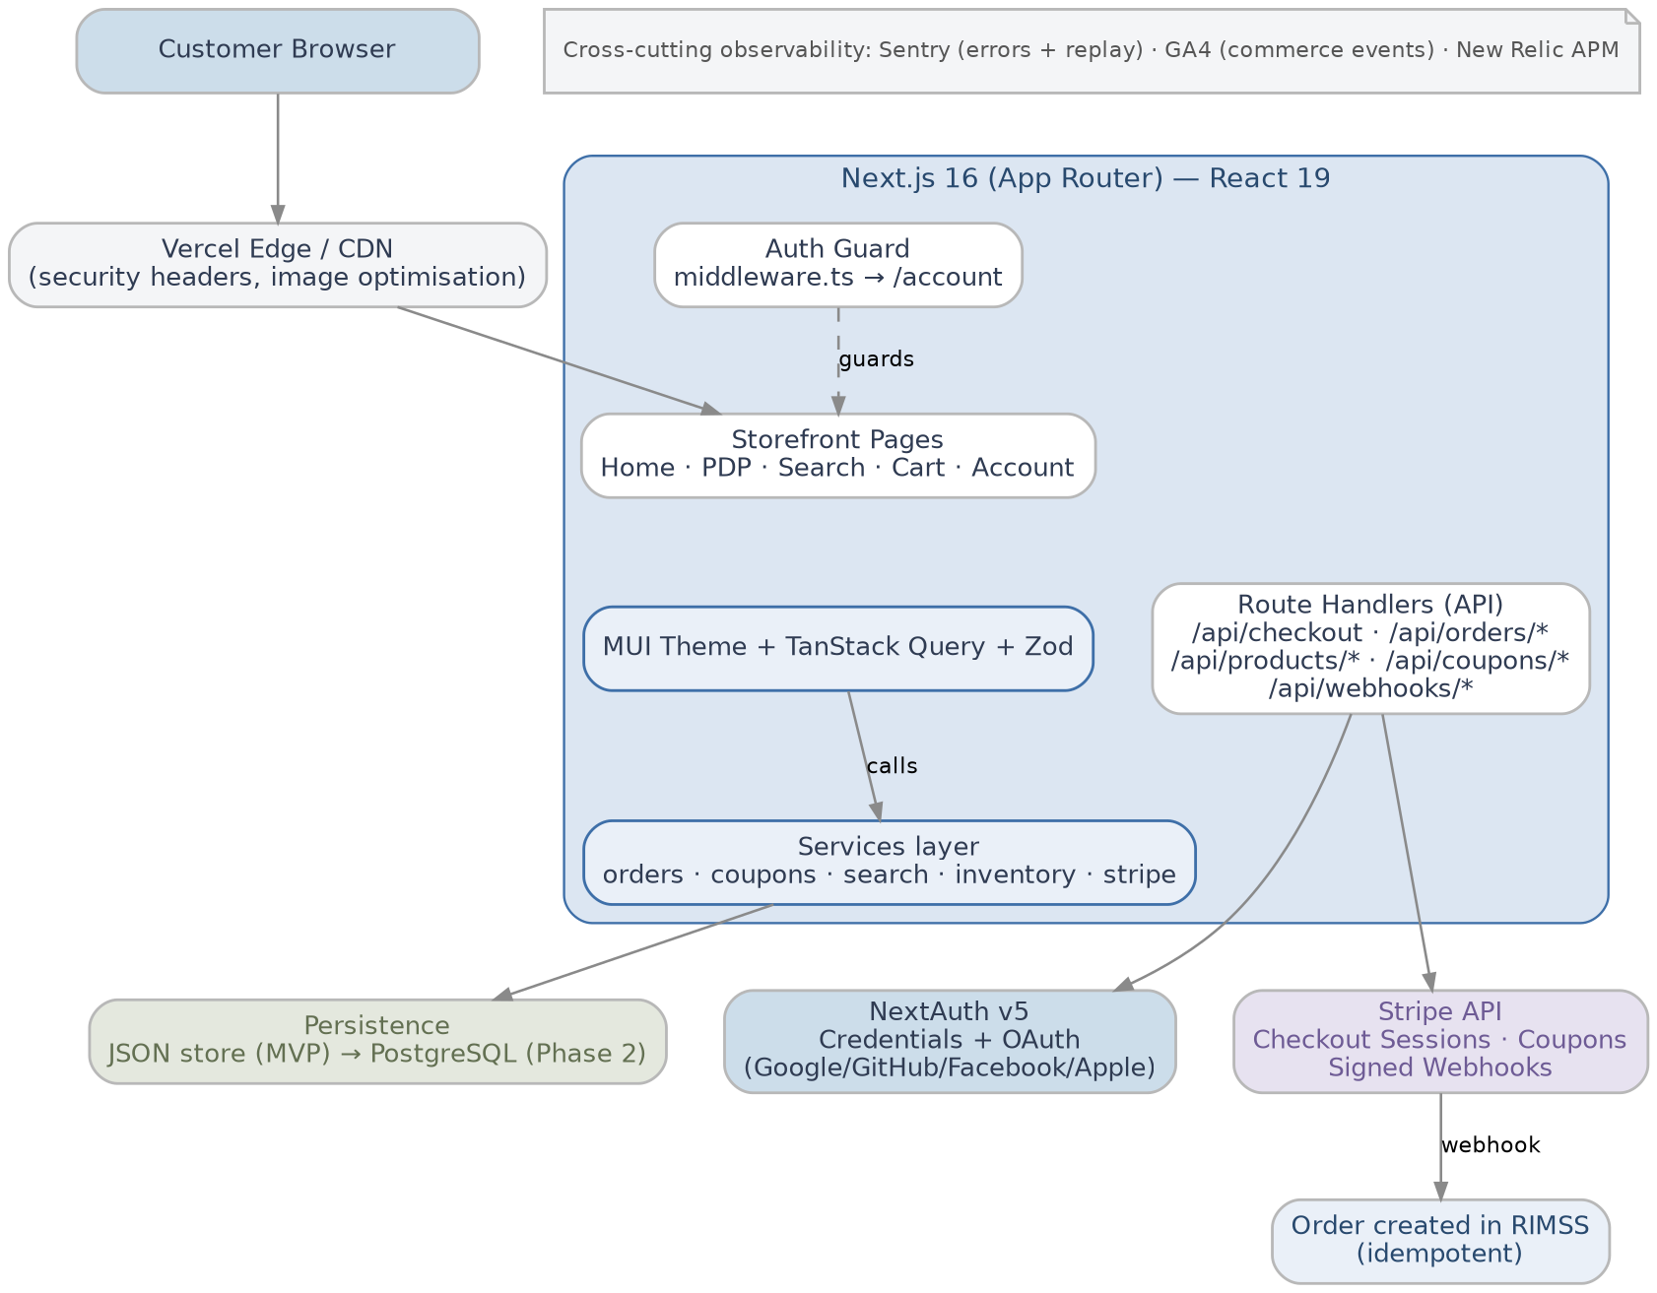

Module Map (src/)
Key search modules: src/lib/search.ts (facade), src/lib/search-index.ts (in-memory fallback), src/lib/elasticsearch/ (client, mapping, search query), src/hooks/api/use-product-search.ts, src/app/search/SearchClient.tsx.
Key email modules: src/lib/email/send.ts (Resend transport), src/lib/email/templates.ts, src/lib/email/notifications.ts; wired from signup route, Stripe webhook, orders sync and cancel route.
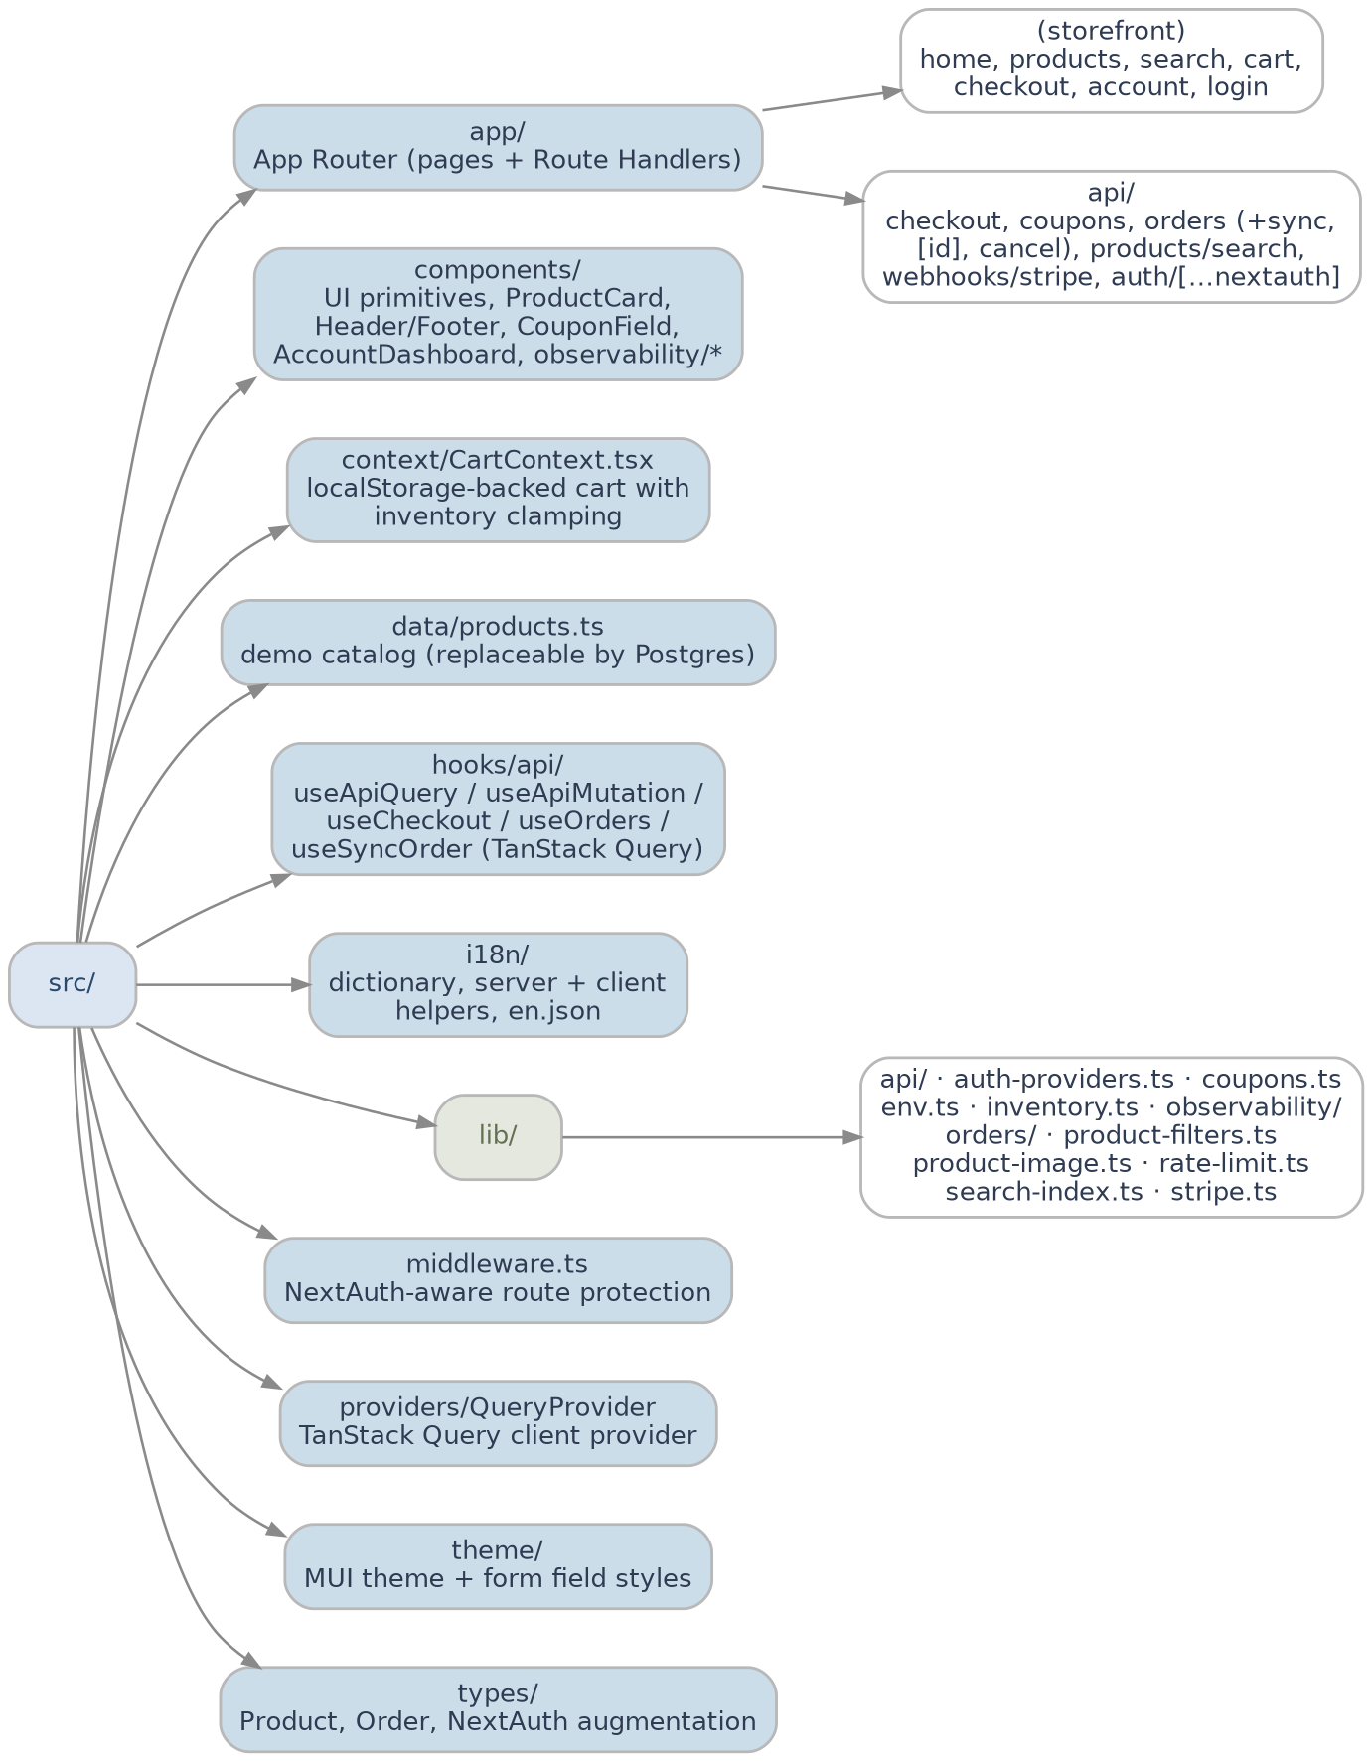

Checkout Workflow (end-to-end)
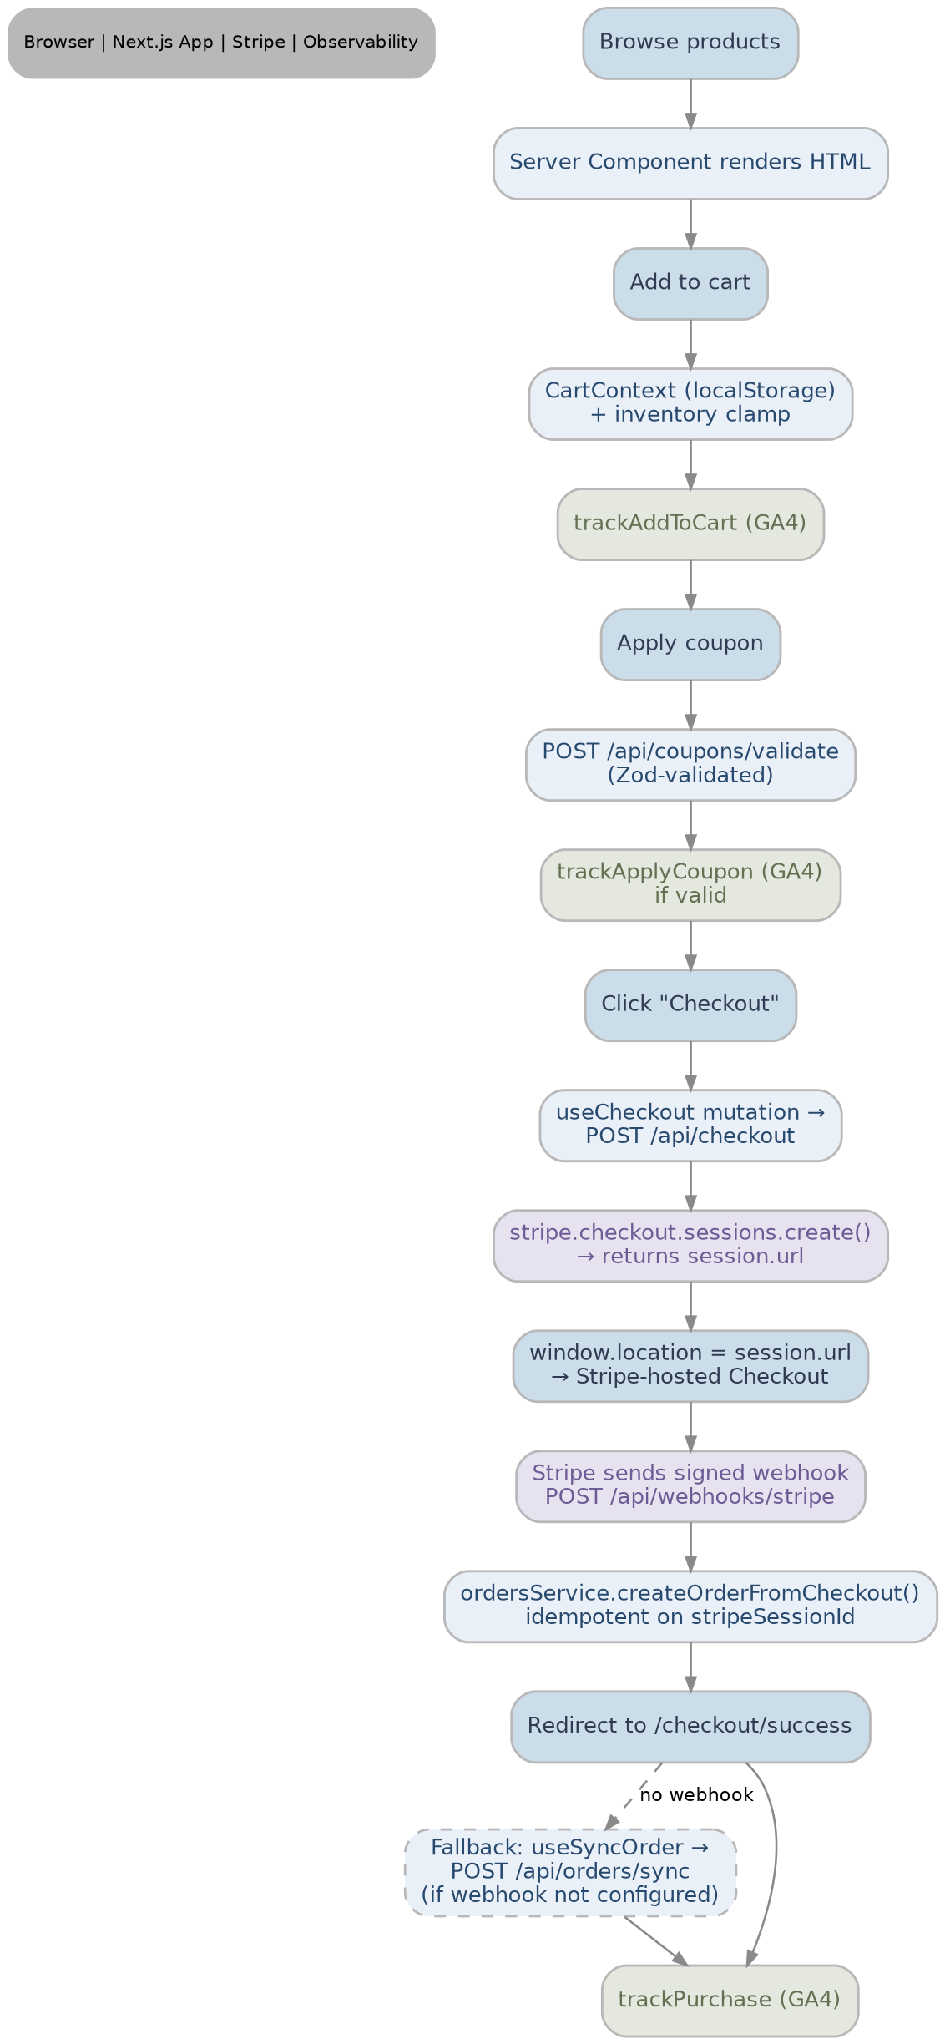

Authentication Workflow
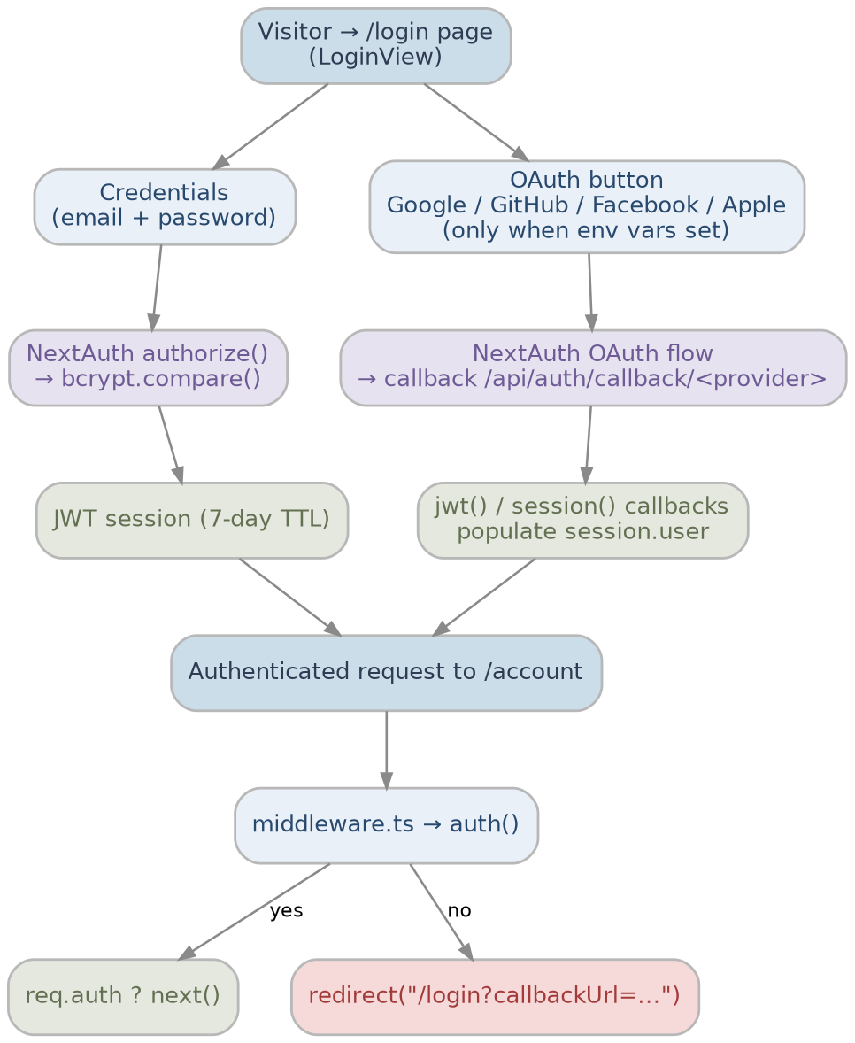

Search Workflow
User types in /search → SearchClient debounces input (300 ms via use-debounce), syncs filters to the URL with router.replace, and fetches results through useProductSearch (TanStack Query).
GET /api/products/search?q=&brands=&min=&max=&sort= → rateLimit("search:" + ip, 120/min) → parseFiltersFromSearchParams() (Zod) → searchProducts(filters).
Primary path (when ELASTICSEARCH_CLOUD_ID + ELASTICSEARCH_API_KEY are set): searchElasticsearch() queries index ycompany-products using multi_match, bool_prefix, phrase_prefix and wildcard substring matching on name^3, brand^2, material^2, tags, description, category and SKU; brand terms and price range filters; sort by relevance (_score), priceCents or name.keyword.
Fallback path: if Elasticsearch is not configured or client.search() throws, searchProducts() automatically uses searchCatalog() against the in-memory CatalogIndex — same filters and sort semantics for demos and resilience.
Response: { products, total, tookMs, source, queryString } with Cache-Control: public, max-age=30, stale-while-revalidate=60. Index bootstrap: npm run search:index (scripts/index-products.ts). Header autocomplete (getProductSuggestions) and sidebar brand facet counts (getBrandFacetCounts) remain in-memory by design.
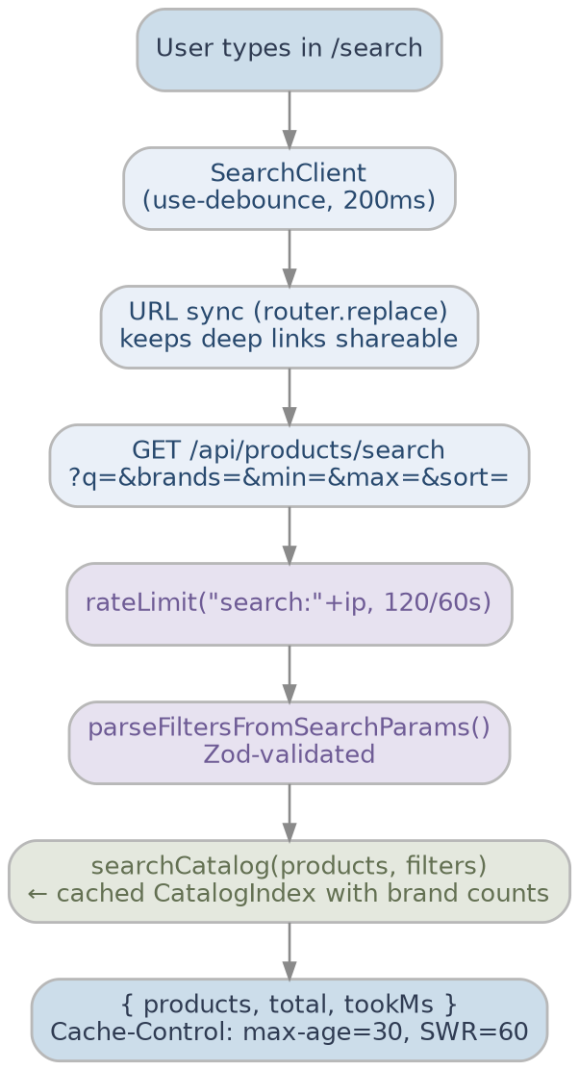

Transactional Notifications Workflow (Resend)
Cancellation → POST /api/orders/[id]/cancel (auth-guarded, status === processing) → sendOrderCancellationEmail().
Checkout success fallback → POST /api/orders/sync → same idempotent order creation + confirmation email when webhooks are unavailable locally.
Paid checkout → POST /api/webhooks/stripe (checkout.session.completed) → createOrderFromCheckout() (idempotent) → sendOrderConfirmationEmail() on newly created orders only.
Signup → POST /api/auth/signup → createUser() → sendWelcomeEmail() → sendEmail() → Resend API (or console log).

Order Lifecycle
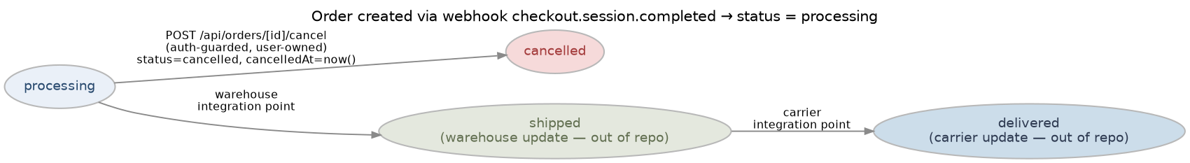

Deployment Topology
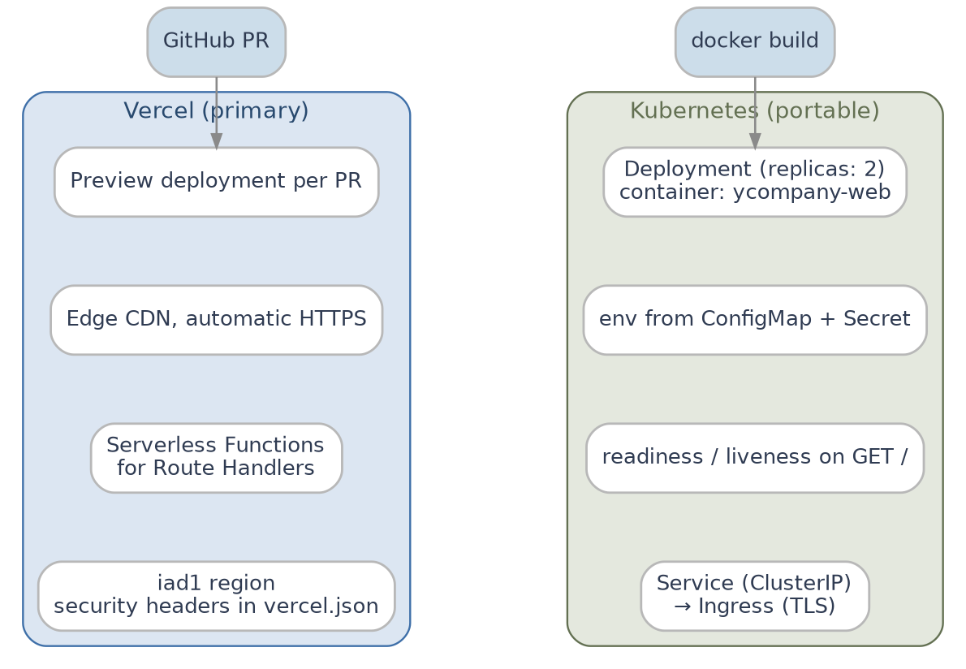

Continuous Support and Maintenance

Support Structure
- Help-desk support — dedicated queue for customer issues during business hours.
- Technical support — engineering on-call for production incidents, surfaced through Sentry alerts and New Relic dashboards.
- Escalation procedures — P1 (site outage) → on-call lead within 15 min; P2 → next business day; P3 → backlog.

Maintenance Activities
- Regular updates — monthly dependency review (Next.js, React, NextAuth, Stripe SDK, MUI); patch releases applied within the sprint.
- Bug fixes — tracked in JIRA, fixed via PRs that include Vitest coverage and Sentry release association.
- Performance monitoring — Vercel Analytics, New Relic dashboards and GA4 funnels reviewed weekly.
- Backup and recovery — once PostgreSQL is introduced, nightly automated snapshots with 7-day retention.
- Security patches — GitHub Dependabot and weekly npm audit; security headers reviewed each release.

User Training and Documentation
- User training — onboarding guide for retail staff using the cancellation and order views; refreshed each release.
- Technical documentation — README.md, PLAN.md, docs/DEPLOY-VERCEL.md, this DAR, and inline JSDoc.

Feedback and Improvement
- User feedback — collected via the support form and GA4 events; reviewed in monthly product reviews.
- Continuous improvement — every sprint allocates capacity for performance budgets, A11y audits and tech-debt items.

Service Level Agreements (SLAs)
Severity | Definition | Response | Resolution target
P1 | Site down or checkout broken | 15 min | 4 hours
P2 | Major feature degraded | 1 hour | 1 business day
P3 | Minor defect, no workaround needed | 1 day | Next sprint
P4 | Cosmetic / enhancement | 3 days | Backlog

Risks

Technical Risks
- Integration challenges — Stripe / NextAuth provider misconfiguration.
- _Mitigation:_ environment validation in src/lib/env.ts, integration tests in CI, graceful "no-op" behaviour when credentials are absent.
- System performance — server-rendered pages slow under spikes.
- _Mitigation:_ MUI package import optimization, next/image, route-level loading.tsx, search response caching (Cache-Control: max-age=30, SWR=60), Vercel autoscaling and Kubernetes HPA.
- Security vulnerabilities — third-party CVEs, prompt injection on inputs.
- _Mitigation:_ Zod validation on every input, signed Stripe webhooks, security headers, in-memory rate limiter (planned upgrade to Upstash Redis), Dependabot.

Project Management Risks
- Scope creep — change-control via JIRA backlog grooming and pull-request templates.
- Resource availability — paired ownership of critical modules (auth, payments).
- Timeline delays — release trains with explicit "ready for QA" criteria.

Business Risks
- User adoption — A/B testing on key surfaces, GA4 funnel review.
- Cost overruns — Vercel usage alerts and per-environment budgets.
- Regulatory compliance — GDPR / CCPA cookie banner and data export endpoints planned ahead of EU launch.

Operational Risks
- Data migration (JSON → PostgreSQL) — dual-write window with reconciliation script.
- System downtime — Kubernetes rolling deploys and Vercel atomic deploys.
- Vendor reliability — Stripe and NextAuth providers are status-monitored; fallbacks exist for analytics outages.

- Appendix
  - Glossary of Terms
- RIMSS — Retail Inventory Management Software System; the YCompany storefront with inventory awareness.
- RSC — React Server Components; rendered on the server, no JavaScript shipped for the component itself.
- App Router — Next.js 13+ routing model under src/app/, replaces the legacy pages/ router.
- Route Handler — route.ts file exporting HTTP methods (GET, POST, …) inside src/app/api/.
- JWT — JSON Web Token; the session strategy used by NextAuth v5.
- OAuth — Open Authorization; protocol used by the Google / GitHub / Facebook / Apple providers.
- Stripe Checkout — Stripe-hosted, PCI-scoped payment page consumed via Checkout Sessions.
- Webhook — Signed asynchronous HTTP callback (/api/webhooks/stripe) that creates the order on payment.
- SLA — Service Level Agreement (see §7.5).
  - Relevant Documents
- README.md — setup, scripts, observability, deploy summary.
- PLAN.md — phased roadmap, problem-to-solution mapping, next steps.
- docs/DEPLOY-VERCEL.md — step-by-step Vercel deployment guide.
- k8s/*.yaml — Kubernetes manifests (Deployment, Service, ConfigMap, Secret).
- Dockerfile — multi-stage build for the standalone Next.js runtime.
- vitest.config.ts — test runner and coverage thresholds.
  - Diagrams and Charts
Diagram | Section
System Architecture | §6.1
Module Map | §6.2
Checkout Workflow | §6.3
Authentication Workflow | §6.4
Search Workflow | §6.5
Order Lifecycle | §6.6
Deployment Topology | §6.7
Transactional Notifications | §6.5.1 (Resend workflow)

  - Contact Information
- Lead Developer: Pawan Gupta — pawan.gupta@nagarro.com — +91 98112 83937
  - Additional Resources
- Training materials — internal onboarding deck and Loom walk-throughs of the checkout flow.
- FAQs — collated in README.md and docs/DEPLOY-VERCEL.md troubleshooting tables.
- Support documentation — runbooks for Sentry triage, Stripe webhook replay and New Relic dashboards.
This appendix consolidates the supporting material for the RIMSS implementation, ensuring that all relevant artefacts are readily accessible to stakeholders and engineering teams.

