RFP Response — Solution Approach

YCompany — Retail Inventory Management Software System (RIMSS)
Version 1.0.0
Contents
2 Revision History 5
3 Preface 6
4 Introduction 7
4.1 Document Purpose 7
4.2 Document Scope 7
4.3 Audience 8
5 Problem Statement and Goals 9
5.1 Pain points in the current state 9
5.2 Business goals 9
5.3 Solution objectives mapped to pain points 9
6 Solution Overview 11
6.1 Capabilities delivered 11
6.2 Conceptual architecture 11
6.3 Why this approach 12
7 Solution Architecture 13
7.1 Logical components 13
7.2 API surface (Route Handlers) 13
7.3 End-to-end checkout workflow 14
7.4 Authentication workflow 15
7.5 Search workflow 16
7.6 Order lifecycle 16
7.7 Deployment topology 17
8 Technology Stack 18
8.1 Stack summary 18
8.2 Rationale per choice 18
9 Implementation Approach 20
9.1 Methodology — Agile / Scrum 20
9.2 Phased delivery plan 20
9.3 Sprint cadence and Definition of Done 21
9.4 Team composition 21
9.5 Governance and reporting 22
10 Quality Assurance Approach 23
10.1 Test strategy 23
10.2 Coverage targets and CI gates 23
10.3 Code review 23
10.4 Test environments 24
11 Security and Compliance Approach 25
11.1 Application security 25
11.2 Data protection 25
11.3 Compliance 25
11.4 Secret rotation 26
12 DevOps and Deployment Approach 27
12.1 Source control and branching 27
12.2 CI/CD pipeline (GitHub Actions) 27
12.3 9.3 Environments 28
12.4 9.4 Release management 28
12.5 Containerised / Kubernetes runtime 28
13 Observability and Operations 29
13.1 Telemetry signals 29
13.2 Service Level Objectives (SLOs) 29
13.3 Incident response 29
13.4 Continuous improvement 30
14 Project Management and Governance 31
14.1 Decision making 31
14.2 RACI summary 31
14.3 11.3 Reporting cadence 31
14.4 Tooling 32
15 Risk Management 33
15.1 Technical risks 33
15.2 Project management risks 33
15.3 Business risks 33
15.4 Operational risks 34
16 Assumptions, Dependencies and Constraints 35
16.1 Assumptions 35
16.2 Dependencies 35
16.3 Constraints 35
17 Commercials and Effort (summary) 36
18 Glossary 37
16. Appendix 38
16.1 Reference architecture documents 38
16.2 Module map (src/) 38
16.3 Contact 39
16.4 Additional resources 39

Prepared for: YCompany — Luxury Countryside Fashion
Prepared by: Pawan Gupta — Nagarro Software Pvt. Ltd.
Document version: 1.0
Date: 25 May 2026

Revision History
Version | Date | Author / Contributor | Comments
0.1 | 14 May 2026 | Pawan Gupta | Initial draft of the Solution Approach for the YCompany RIMSS RFP response.
1.0 | 25 May 2026 | Pawan Gupta | Reviewed and finalised; technology stack confirmed against the implemented reference solution.
1.1 | 27 Aug 2026 | Pawan Gupta | Added Elasticsearch search workflow (Elastic Cloud + in-memory fallback) and Resend transactional email notifications; aligned with the reference implementation.

Preface
This Solution Approach document is Nagarro's formal response to YCompany's Request for Proposal (RFP) for the Retail Inventory Management Software System (RIMSS). It describes the end-to-end solution we propose to deliver — covering business context, solution architecture, technology stack, delivery methodology, quality assurance, security, DevOps, observability, governance, and risk management.
The proposal is grounded in a working reference implementation already built on the same stack (Next.js 16, React 19, TypeScript, Material UI 9, NextAuth v5, Stripe, Vitest, Docker, Kubernetes, Vercel, Sentry, Google Analytics 4 and New Relic). Every approach described here is therefore proven on running code, not aspirational — see the YCompany — Design Architecture Recommendation (DAR) document for the as-built architecture.

Introduction
YCompany is a leading luxury countryside fashion brand with a distinctive portfolio — sweaters, moleskin clothing, corduroy apparel and tattersall shirts — that has successfully evolved to appeal to both traditional countryside customers and a younger, modern audience. Despite the brand's commercial strength, the existing online storefront falls short on cross-platform support, performance, UI responsiveness and search efficiency, limiting online sales and customer satisfaction.
YCompany has therefore invited proposals for a new Retail Inventory Management Software System (RIMSS) — a unified, performant, mobile-first storefront with end-to-end inventory awareness, secure payments, social login, observability and a clear runway to a production data platform.

Document Purpose
This document is the Solution Approach chapter of Nagarro's RFP response. It is intended to give YCompany's evaluation panel a clear, technical and methodological view of:
- What we will build (solution overview, scope, architecture).
- How we will build it (delivery methodology, team, governance, ceremonies).
- How we will assure quality (testing strategy, coverage targets, code review).
- How we will operate it (CI/CD, deployment topology, observability, incident response).
- How we will manage risk (technical, project, business and operational risks).

Document Scope
In scope of this Solution Approach:
- High-level and detailed solution architecture for the storefront, APIs, auth, payments, inventory and observability.
- Technology stack with rationale.
- Delivery methodology (Agile / Scrum), team composition and governance.
- Quality, security and compliance approach.
- DevOps approach including environments, CI/CD pipeline and release management.
- Risk and assumption register.
Out of scope of this document (covered separately):
- Commercial proposal, effort estimates and pricing — see the companion Estimates workbook.
- Detailed test cases and test data — see the Test Plan to be produced in Sprint 0.
- Statement of Work and contractual terms — captured in the SOW document.

Audience
Audience | What they will find useful
YCompany business sponsors | Sections 1, 2, 3 (intent, scope, solution overview)
YCompany IT / architecture reviewers | Sections 4, 5, 7, 8 (architecture, tech stack, security, DevOps)
YCompany delivery / PMO | Sections 6, 11, 12, 13 (delivery, governance, risks, assumptions)
Nagarro delivery team | Entire document plus the DAR for as-built design details

Problem Statement and Goals

Pain points in the current state
The legacy YCompany storefront suffers from the following well-documented issues:
- Lack of cross-platform support — the experience is not consistent across devices and viewport sizes; mobile checkout drop-off is unusually high.
- High initial load time — first contentful paint frequently exceeds one minute on retail Wi-Fi, driving bounce rates up.
- Unresponsive UI — janky scrolling, freezing forms and slow interaction feedback degrade the brand experience.
- Inefficient product search — search is slow, with no relevance ranking or filtering, frustrating customers looking for specific lines such as moleskin, corduroy or tattersall.
- No inventory awareness in the storefront — customers can add out-of-stock items to the cart and are only told at checkout.
- No unified observability — incidents are detected by customer complaints rather than telemetry.

Business goals
YCompany's strategic outcomes for the new platform are:
- Lift online conversion by delivering a fast, mobile-first storefront with sub-3-second first contentful paint on 4G.
- Protect brand experience with a consistent, accessible, modern UI across all viewports.
- Reduce post-purchase issues by surfacing inventory in real time and preventing out-of-stock orders.
- Open new sales channels through frictionless social sign-in and one-click hosted checkout.
- Reduce operational risk with full-funnel observability (errors, performance and commerce events).
- Future-proof the platform with a stack that supports scale, internationalisation, headless commerce and microservices growth.

Solution objectives mapped to pain points
Legacy issue | Solution objective
Lack of cross-platform support | Responsive MUI layouts, touch-first controls, viewport metadata, PWA-ready manifest.
High initial load time | next/image, MUI package import optimization, route-level loading.tsx, dynamic imports.
Unresponsive UI | Debounced search, useDeferredValue for results, memoised components, optimistic UI via React Query.
Inefficient product search | Elastic Cloud full-text search (optional) with automatic in-memory fallback; /api/products/search with relevance ranking, brand/price filters, sort and cache headers.
No inventory awareness | Per-SKU stock model and clampAddQuantity() enforced from PDP, cart and checkout.
No unified observability | Sentry (errors), Google Analytics 4 (commerce funnel), New Relic (APM) with no-op fallbacks.

Solution Overview
We propose a Next.js 16 App Router storefront, deployed primarily on Vercel with a portable Docker / Kubernetes runtime, fronting a stateless API layer of Route Handlers that integrate with Stripe Checkout, NextAuth v5 (Credentials + Google / GitHub / Facebook / Apple), and a relational data platform (PostgreSQL, post-MVP).

Capabilities delivered
Capability area | What we deliver
Customer storefront | Home, PDP, category, search, cart, checkout success, account dashboard.
Authentication | NextAuth v5 with Credentials (bcrypt) + OAuth providers (Google, GitHub, Facebook, Apple) when configured.
Catalog + search | Product model with stock + SKU; Elastic Cloud search when configured, otherwise in-memory CatalogIndex; /api/products/search with caching; header autocomplete uses in-memory suggestions.
Cart | React Context with localStorage persistence and per-SKU stock clamping.
Checkout + payments | Stripe hosted Checkout Sessions with coupons, free-shipping rules and signed webhooks.
Orders | Order creation on checkout.session.completed; user-scoped order list, detail and cancellation APIs.
Coupons / promotions | Server-validated coupons (WELCOME10, SAVE20, FREESHIP) mirrored into Stripe at session creation.
Account | Order history, account dashboard, sign-out; route protected via middleware.ts.
Observability | Sentry (errors + replay), GA4 (commerce events), New Relic (APM); all are env-gated no-ops.
Security | Security headers, Zod validation, signed webhooks, rate limiting, bcrypt password hashing.
Transactional notifications | Resend-backed HTML + plain-text emails for welcome (signup), order confirmation (Stripe webhook / sync) and order cancellation; console fallback when RESEND_API_KEY is unset.

Conceptual architecture

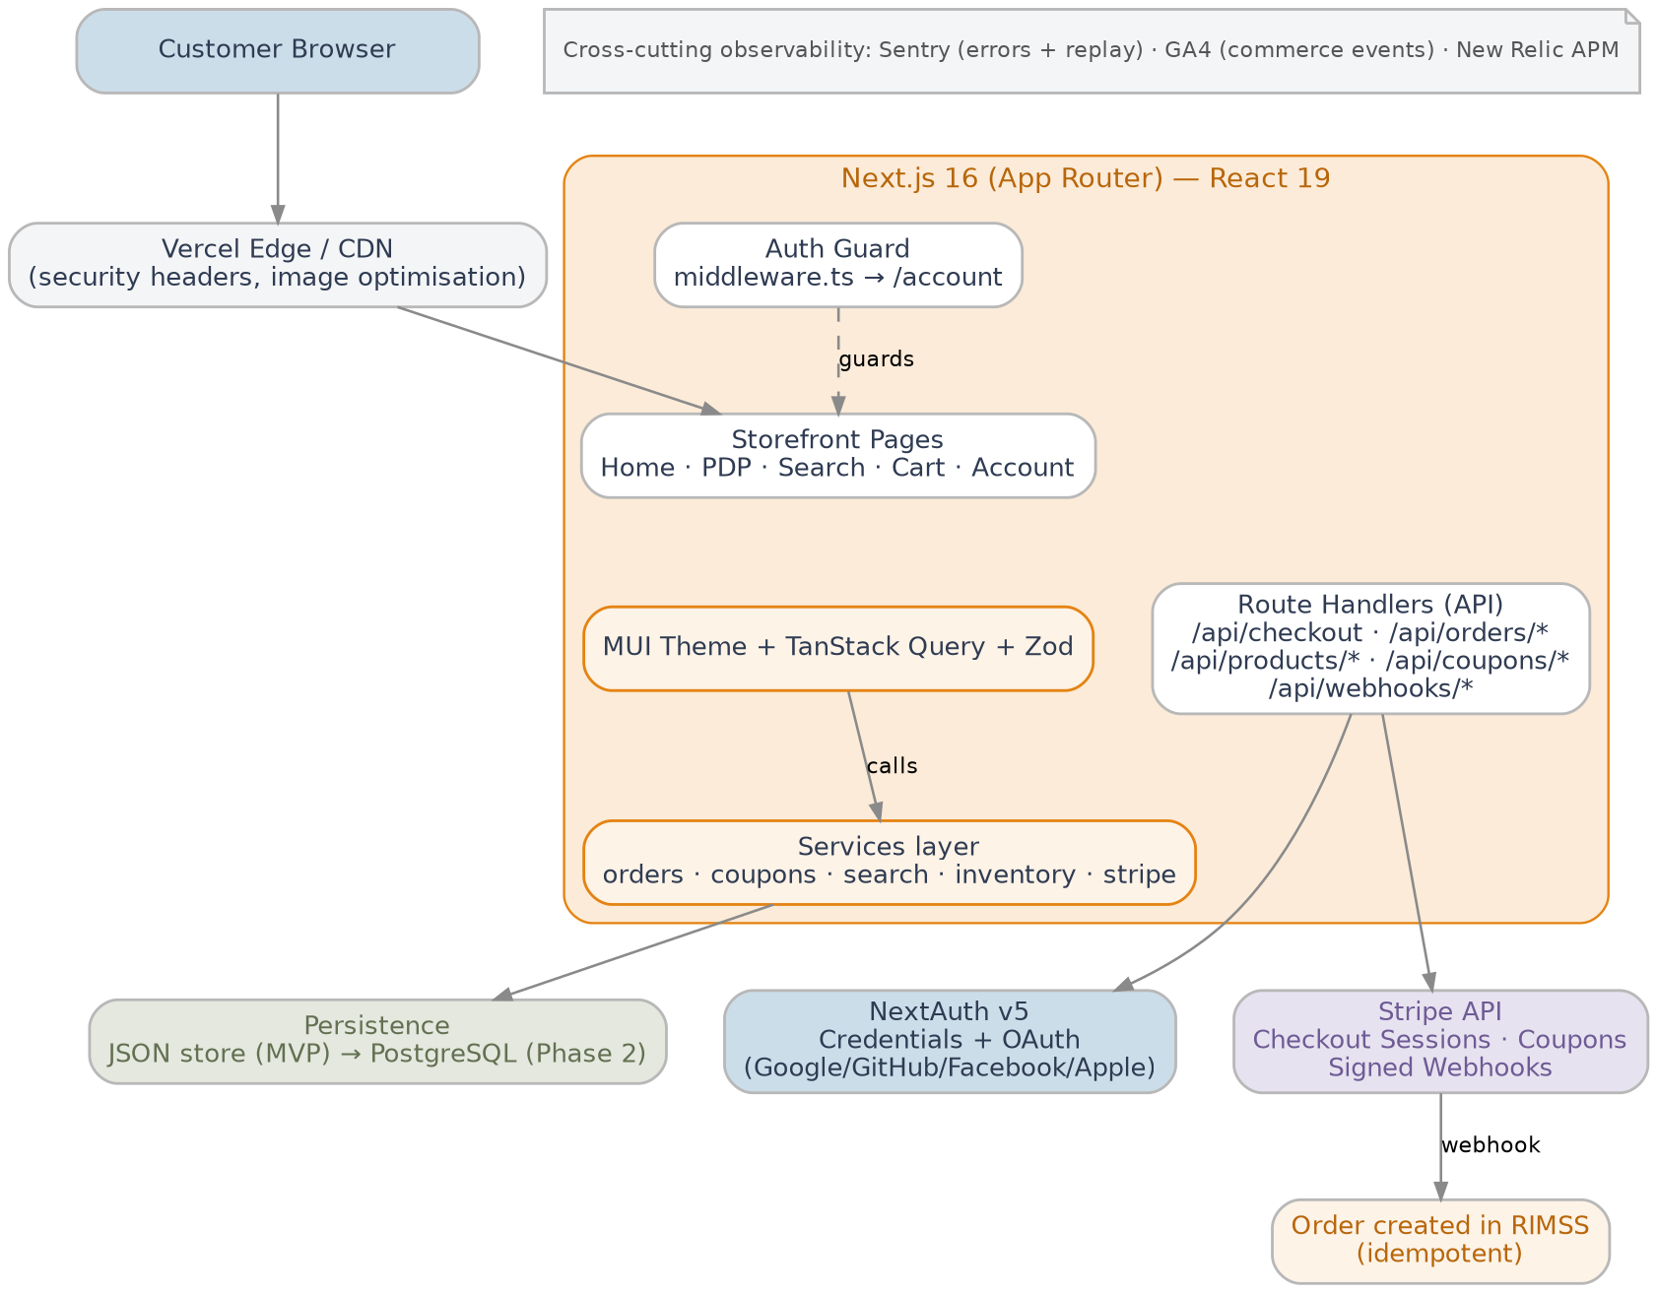

Why this approach
- Time to market — App Router + hosted Stripe Checkout collapses weeks of work (PCI, payment forms, 3DS) into a small, secure integration.
- Performance by default — Server Components, edge caching and image optimisation hit the load-time targets out of the box.
- Operational simplicity — Vercel as primary host, with Docker + Kubernetes manifests retained for enterprise hosting portability.
- Proven on this stack — a fully working reference implementation already exists in the repository, de-risking estimates and scope.

Solution Architecture

Logical components
Component | Responsibility
Storefront UI | Server-rendered pages, MUI components, responsive layouts, next/image, route-level loading.tsx.
Route Handlers (API) | Server-side endpoints for checkout, orders, coupons, products and webhooks; Zod-validated and rate-limited.
Auth layer | NextAuth v5 providers, JWT sessions (7-day TTL), bcrypt password hashing, middleware.ts guard.
Cart context | Client-side React Context, localStorage persistence, inventory clamping.
Search index | Elastic Cloud index (ycompany-products) when ELASTICSEARCH_CLOUD_ID + ELASTICSEARCH_API_KEY are set; searchProducts() facade with automatic fallback to in-memory CatalogIndex; brand facet counts remain in-memory.
Payments | Stripe Checkout Sessions, coupons mirrored per session, signed webhooks for fulfilment.
Order service | Idempotent order creation from checkout.session.completed; user-scoped queries; cancellation rules.
Observability | Sentry (errors + replay), GA4 (commerce events), New Relic (APM); all gated on env variables.
Persistence | MVP: JSON store with in-memory cache. Phase 2: PostgreSQL via Prisma / Drizzle.
Email / notifications | Resend REST adapter (src/lib/email/send.ts) with branded templates; triggered from signup, Stripe checkout.session.completed webhook, order sync fallback and order cancellation routes.

API surface (Route Handlers)
Endpoint | Method | Purpose
/api/auth/[...nextauth] | GET/POST | NextAuth v5 — credentials + OAuth callbacks.
/api/checkout | POST | Validate cart, create Stripe Checkout Session (with coupon + shipping).
/api/coupons/validate | POST | Server-validate a promo code against rules in src/lib/coupons.ts.
/api/products/search | GET | Rate-limited catalog search with cache headers.
/api/orders | GET | List orders for the signed-in user.
/api/orders/[id] | GET | Fetch one user-owned order.
/api/orders/[id]/cancel | POST | Cancel an order while status === "processing".
/api/orders/sync | POST | Reconcile a paid Stripe session when webhooks are not configured.
/api/webhooks/stripe | POST | Verify Stripe signature and create the order idempotently.

End-to-end checkout workflow

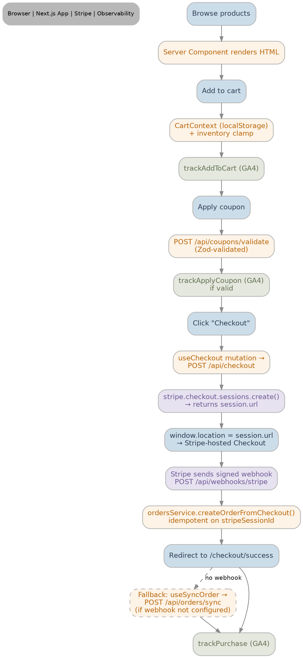

Authentication workflow

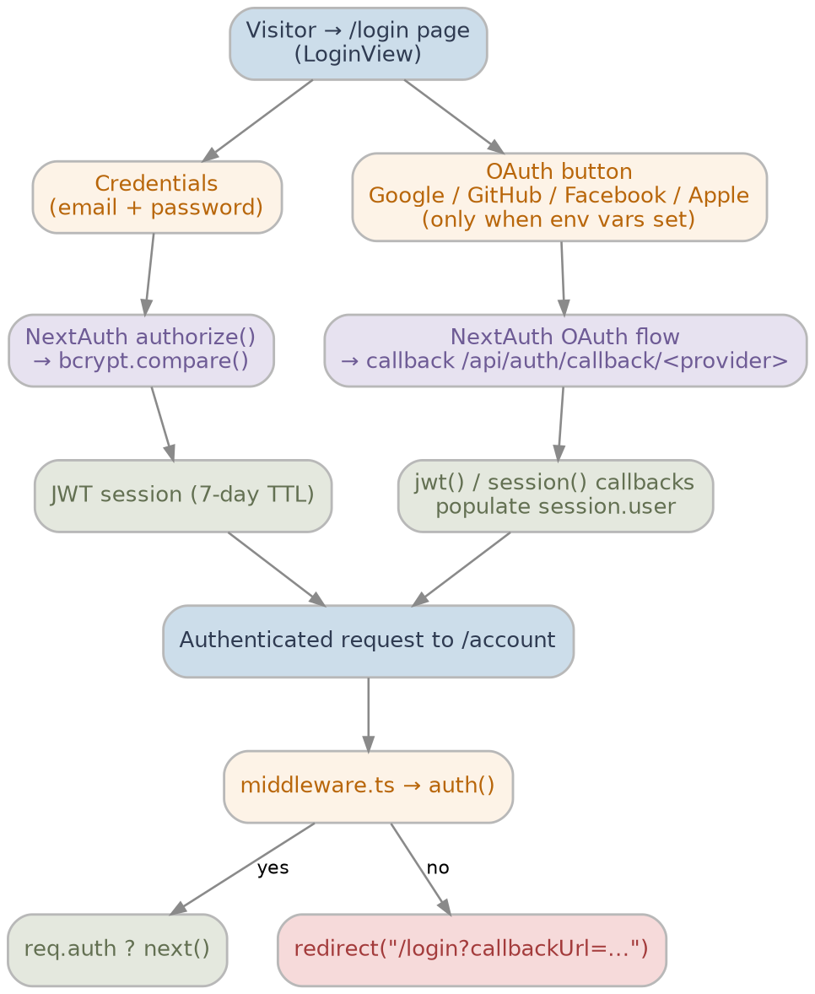

Search workflow
The /search route uses SearchClient with a 300 ms debounce (use-debounce), URL sync via router.replace for shareable deep links, and useProductSearch (TanStack Query) to call the search API.
GET /api/products/search?q=&brands=&min=&max=&sort= applies rate limiting (120 requests per IP per minute), Zod-validated parseFiltersFromSearchParams(), then delegates to searchProducts() in src/lib/search.ts.
When ELASTICSEARCH_CLOUD_ID and ELASTICSEARCH_API_KEY are configured, searchElasticsearch() queries the ycompany-products index using multi_match, bool_prefix, phrase_prefix and wildcard substring matching on name, brand, material, tags, description, category and SKU — with brand terms and price range filters and sort by relevance, price or name.
If Elasticsearch is not configured or the query fails, the facade automatically falls back to searchCatalog() against the in-memory CatalogIndex (same behaviour as local demos). The JSON response includes products, total, tookMs, source ("elasticsearch" | "memory") and queryString, with Cache-Control: max-age=30, stale-while-revalidate=60.
Index bootstrap: npm run search:index reads src/data/products.ts, recreates the Elastic index with PRODUCT_INDEX_MAPPINGS and bulk-indexes one document per product. Header autocomplete suggestions still use in-memory getProductSuggestions(); brand facet counts in the search sidebar use getBrandFacetCounts() from the CatalogIndex, not ES aggregations.
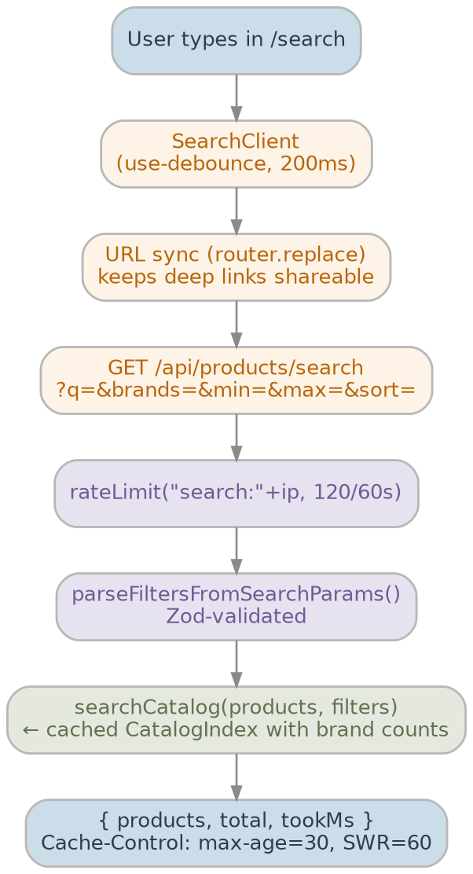

Transactional notifications (Resend)
Transactional email is implemented in the reference solution using Resend (https://resend.com). When RESEND_API_KEY is set, sendEmail() posts to https://api.resend.com/emails with HTML and plain-text bodies; EMAIL_FROM defaults to YCompany <onboarding@resend.dev> for development.
Without RESEND_API_KEY, emails are logged to the server console so local and CI runs remain fully testable without external dependencies.
Notification triggers and templates (src/lib/email/notifications.ts, templates.ts):
- • Welcome email — sent after successful POST /api/auth/signup (sendWelcomeEmail).
- • Order confirmation — sent when an order is first created from checkout.session.completed (Stripe webhook) or POST /api/orders/sync fallback (sendOrderConfirmationEmail; idempotent — only on newly created orders).
- • Order cancellation — sent after POST /api/orders/[id]/cancel succeeds while status is processing (sendOrderCancellationEmail).
All templates use a shared branded HTML shell with escaped user content, order line items, totals and a CTA back to the storefront. Failures are logged but do not block the originating API response (fire-and-forget). Production requires a YCompany-verified sending domain in Resend.

Order lifecycle
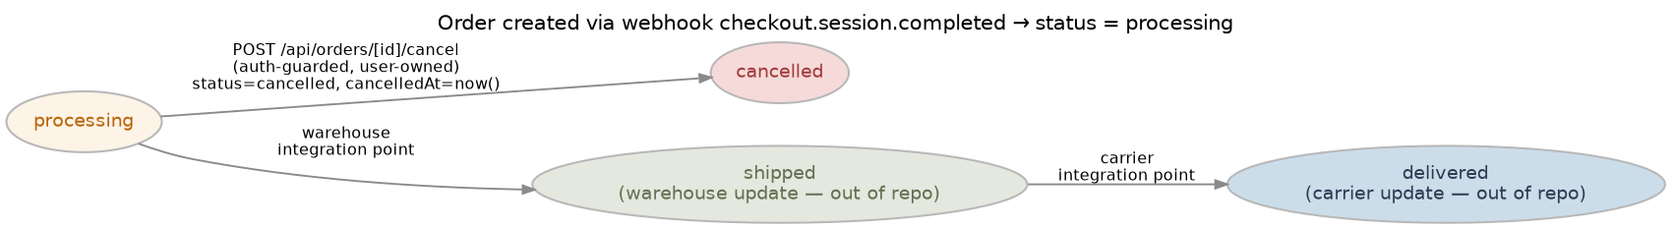

Deployment topology
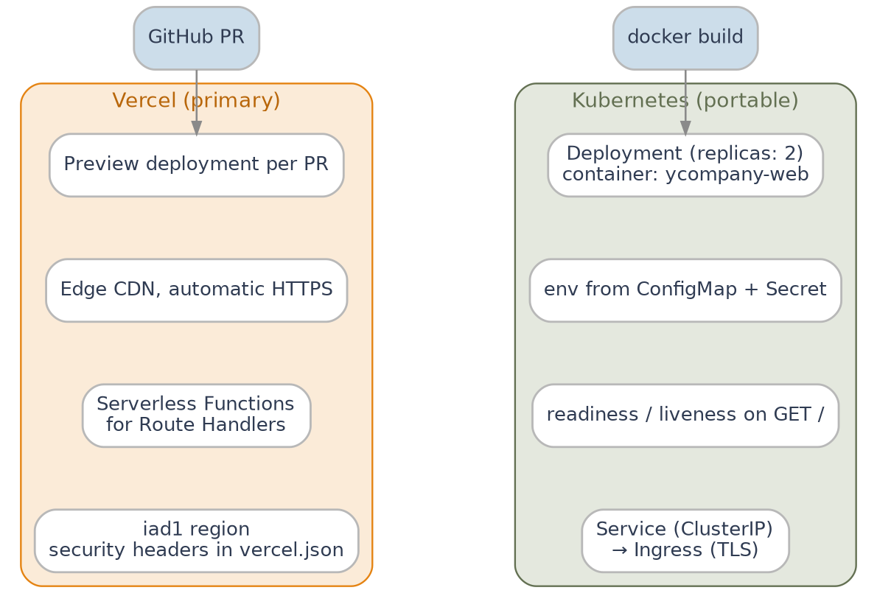

Technology Stack

Stack summary
Layer | Choice
Language | TypeScript 5 (strict mode)
Framework | Next.js 16 (App Router) with React 19
UI library | Material UI 9 + Emotion 11 (AppRouterCacheProvider for SSR)
Data fetching | TanStack Query 5
Validation | Zod 4
Authentication | NextAuth v5 — Credentials + Google / GitHub / Facebook / Apple OAuth
Payments | Stripe 22 (hosted Checkout + signed webhooks)
Password hashing | bcryptjs
Testing | Vitest 4 + React Testing Library 16 + jsdom 29 + V8 coverage
Lint / types | ESLint (eslint-config-next), TypeScript strict
Build / runtime | Webpack dev server, Next.js standalone output, Node 22 Alpine container
CI/CD | GitHub Actions (lint → test → build → deploy)
Hosting (primary) | Vercel (vercel.json, region iad1, security headers)
Hosting (portable) | Docker image + Kubernetes manifests (Deployment, Service, ConfigMap, Secret)
Observability | Sentry, Google Analytics 4, New Relic (all env-gated)
Search (optional) | Elastic Cloud (@elastic/elasticsearch) with npm run search:index seeding; in-memory CatalogIndex fallback
Transactional email | Resend API (RESEND_API_KEY, EMAIL_FROM); dev console fallback when unset

Rationale per choice
- Next.js 16 (App Router) — fastest route to a server-rendered, edge-cached storefront with first-class image optimisation, route loading states and Route Handlers for a tight API surface. Native fit with Vercel and the standard for modern React e-commerce.
- TypeScript strict — enforced types reduce regression risk in checkout and order code paths.
- Material UI 9 — accessible, themable, SSR-safe components, large ecosystem and matched velocity for an apparel storefront.
- TanStack Query 5 — robust cache, retry and mutation primitives that pair with Route Handlers.
- Zod — single source of truth for runtime + compile-time validation on every API surface.
- NextAuth v5 — covers Credentials and 50+ OAuth providers; CSRF and cookie hardening built in; works with middleware.ts for route protection.
- Stripe (hosted Checkout) — keeps Nagarro and YCompany out of PCI scope while still supporting Apple Pay / Google Pay, 3DS, coupons and webhooks.
- Vitest — native ESM, Vite-aligned toolchain, instant watch; significantly faster than Jest on this codebase and easier to configure for the Next.js + RTL combination.
- Sentry + GA4 + New Relic — multi-lens telemetry: defects (Sentry), commerce funnel (GA4), and server APM (New Relic), each free at the relevant tier.
- Resend — simple REST transactional email with dev console fallback; keeps MVP notifications out of PCI and SMTP complexity.
- Elastic Cloud (optional) — relevance-ranked full-text search at scale with a safe in-memory fallback for demos and resilience.

Implementation Approach

Methodology — Agile / Scrum
We propose an Agile / Scrum delivery model with two-week sprints, a per-sprint demo and retrospective, and continuous demos on the Vercel preview environment.
Ceremony | Frequency | Output
Sprint planning | Each sprint | Committed sprint backlog with acceptance criteria.
Daily standup | Daily | Cross-role unblockers; max 15 min.
Backlog refinement | Weekly | Estimated, ready-for-sprint stories with INVEST criteria.
Sprint review/demo | Each sprint | Live demo of shipped increments on the preview environment.
Retrospective | Each sprint | Three action items per sprint, tracked through to closure.
Scrum of Scrums | Weekly | Cross-team coordination once parallel workstreams begin.

Phased delivery plan
We propose a four-phase delivery, with the MVP available for production beta at the end of Phase 2.
Phase | Duration | Outcome
Phase 0 | 1 week | Discovery, environment setup, repo, CI/CD pipeline, design system tokens, observability scaffolding.
Phase 1 | 4 weeks | Storefront (home, PDP, category, search, cart, auth) on demo data; Stripe Checkout sandbox; foundational tests.
Phase 2 | 4 weeks | PostgreSQL data layer migration (Prisma/Drizzle), admin CMS for products + coupons, production Resend domain verification and email deliverability hardening.
Phase 3 | 4 weeks | PostgreSQL data layer migration (Prisma/Drizzle), admin CMS for products + coupons, transactional email.
Phase 4 | 4 weeks | Wishlist, reviews, internationalisation hooks, advanced analytics, performance budget enforcement.

Sprint cadence and Definition of Done
A story is Done only when all the following are true:
- Acceptance criteria demonstrated on the Vercel preview URL.
- TypeScript strict passes; ESLint passes.
- Vitest unit/component tests added or updated; coverage thresholds met (lines/functions ≥ 90 %, branches ≥ 85 %).
- Manual exploratory test pass on mobile and desktop viewports.
- PR reviewed and approved by at least one engineer outside the author's pair.
- Telemetry events added (where applicable) and visible in GA4 / Sentry test environment.
- Documentation updated (README.md, PLAN.md or the appropriate runbook).

Team composition
The recommended team for a 4-month engagement to MVP launch:
Role | FTE | Responsibility
Engagement Manager | 0.25 | Commercials, escalation, monthly steering committee.
Tech Lead / Solution Architect | 1.00 | Architecture, code reviews, technical risk management, hiring decisions.
Senior Full-Stack Engineer (Next.js) | 2.00 | Storefront + API delivery, ownership of payments and auth modules.
Full-Stack Engineer | 1.00 | Catalog, cart, account and supporting features.
QA Engineer (automation focused) | 1.00 | Test plan, Vitest coverage, Playwright e2e (Phase 2+), regression suite.
DevOps Engineer | 0.50 | CI/CD, Vercel + Kubernetes config, secret management, observability hookup.
UI/UX Designer | 0.50 | Design system tokens, storefront flows, A11y reviews.
Product Owner (YCompany side) | 0.50 | Acceptance criteria, prioritisation, content sign-off.

Governance and reporting
- Weekly status report — burn-down, velocity, risks, open decisions.
- Bi-weekly sprint demo — invite open to all YCompany stakeholders.
- Monthly steering committee — financial, commercial, scope and strategic alignment.
- Quarterly business review — performance against business KPIs.
- Single source of truth — JIRA for backlog/sprints, Confluence (or Microsoft Teams Wiki) for living documentation, GitHub for code and PR history.

Quality Assurance Approach

Test strategy
We adopt a layered test strategy aligned with the test pyramid.
Layer | Tool | Scope
Unit + component tests | Vitest + React Testing Library | Pure functions, hooks, components, contexts, coupon engine.
Integration tests | Vitest with Route Handler fixtures | Auth callbacks, checkout, coupons, orders endpoints.
End-to-end (E2E) | Playwright (introduced in Phase 2) | Critical journeys: browse → cart → checkout → account.
Accessibility | axe-core in CI (Phase 2) | WCAG 2.1 AA on home, PDP, search, cart, checkout, account.
Performance | Lighthouse CI | Performance, A11y, Best Practices, SEO budgets per route.
Security | npm audit, Dependabot, Snyk (opt) | Dependency CVEs and SAST scanning per PR.

Coverage targets and CI gates
The CI pipeline blocks any PR that fails any of the following:
- npm run lint — ESLint with eslint-config-next and TypeScript rules.
- tsc --noEmit — TypeScript strict.
- npm run test:ci — Vitest with V8 coverage thresholds: lines ≥ 90 %, functions ≥ 90 %, statements ≥ 90 %, branches ≥ 85 %.
- npm run build — Next.js production build (with env vars validated).
- Playwright smoke (Phase 2+).
- Lighthouse budget (Phase 2+).

Code review
- Every change is delivered through a Pull Request — no direct pushes to main.
- At least one approval is required from an engineer outside the author's pair.
- Review checklist focuses on: correctness, tests, security, accessibility, performance, observability hooks, documentation.
- Tech Lead pairs are routed for changes to checkout, payments, auth and webhooks.

Test environments
Environment | Purpose
Local | Engineer's machine; Stripe CLI for webhooks; no production secrets.
PR preview | Per-PR Vercel deployment with Stripe test mode and dummy auth providers.
Integration | Shared environment for QA regression; reset weekly.
Staging | Production parity; used for UAT and pre-release performance testing.
Production | Vercel production deployment; restricted access; observability live.

Security and Compliance Approach

Application security
- HTTP security headers — X-Frame-Options: SAMEORIGIN, X-Content-Type-Options: nosniff, Referrer-Policy: strict-origin-when-cross-origin, Permissions-Policy: camera=(), microphone=(), geolocation=(), and X-DNS-Prefetch-Control: on (all in next.config.ts).
- Input validation — Zod schemas on every Route Handler payload (search filters, checkout body, coupon code, orders).
- Rate limiting — in-memory bucket limiter on /api/checkout (20/min/IP) and /api/products/search (120/min/IP). Will graduate to Upstash Redis in Phase 3.
- Password hashing — bcryptjs for the Credentials provider; demo hash supplied via AUTH_DEMO_PASSWORD_HASH.
- JWT sessions — NextAuth JWT strategy, 7-day TTL; signed with AUTH_SECRET.
- Route protection — middleware.ts redirects unauthenticated traffic from /account back to /login with a callbackUrl.
- Stripe webhooks — every webhook signature is verified before any state change; orders are idempotent on stripeSessionId.

Data protection
- Customer PII is minimised; we store only email, display name, image (when supplied via OAuth) and order data.
- No card data ever transits or rests on YCompany infrastructure — payments are taken on Stripe's hosted Checkout.
- Secrets are managed via Vercel environment variables (production) and Kubernetes Secret objects (portable runtime).
- Sentry sendDefaultPii: false keeps personal identifiers out of error telemetry.

Compliance
- PCI DSS — out of scope by design (hosted Checkout / SAQ A).
- GDPR / CCPA — we will deliver a cookie consent banner, privacy notice, data export and account deletion APIs in Phase 3.
- WCAG 2.1 AA — accessibility audits performed before every release; axe-core in CI from Phase 2.
- OWASP ASVS L1 — used as the minimum target; security checklist enforced in PR reviews.

Secret rotation
- AUTH_SECRET — rotated quarterly; both old and new accepted for 24 h via dual-key support.
- STRIPE_SECRET_KEY / STRIPE_WEBHOOK_SECRET — rotated on personnel changes; tested on staging before production cut-over.
- OAuth client secrets — rotated annually or on partner request.

DevOps and Deployment Approach

Source control and branching
- GitHub monorepo for the storefront, infrastructure manifests and documentation.
- Trunk-based with short-lived feature branches; main always deployable.
- Conventional Commits + Squash merges keep main history clean and changelog-friendly.

CI/CD pipeline (GitHub Actions)

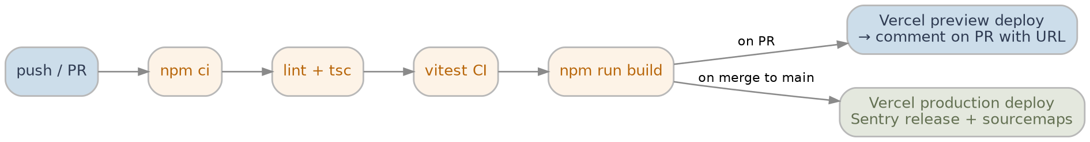

9.3 Environments
Environment | Trigger | URL pattern
Preview | Every PR | https://ycompany-<sha>.vercel.app
Staging | Merge to main (auto) | https://staging.ycompany.com
Production | Manual approval after staging green | https://www.ycompany.com

9.4 Release management
- Releases follow semantic versioning.
- Each merge to main triggers a Vercel production deploy with an automatically created Sentry release for source-map symbolication.
- A weekly release notes summary is posted to the YCompany Teams channel.

Containerised / Kubernetes runtime
For YCompany teams that prefer a self-hosted runtime, the same code base produces a node:22-alpine standalone container. Kubernetes manifests deliver:
- Deployment with replicas: 2 (HPA recommended).
- Service (ClusterIP) and Ingress (TLS) — bring-your-own ingress controller.
- ConfigMap for non-secret env vars; Secret for secrets.
- Readiness and liveness probes on GET /.

Observability and Operations

Telemetry signals
Signal | Tool | Purpose
Errors | Sentry | Client + server exceptions, session replay, release attribution.
Metrics | New Relic | APM, throughput, latency, error rate, infrastructure metrics.
Commerce | Google Analytics 4 | add_to_cart, remove_from_cart, begin_checkout, purchase, search, apply_coupon, etc.
Logs | Vercel / stdout | Structured Route Handler logs; can be shipped to Datadog/Loki on K8s.
Synthetics | Vercel Monitors | Continuous probes on critical routes (Phase 3).

Service Level Objectives (SLOs)
- Availability — 99.9 % monthly availability for the storefront.
- Latency — p95 First Contentful Paint &lt; 3 seconds on 4G.
- Checkout success rate — &gt; 98 % of Stripe Checkout sessions that begin reach complete.
- Error budget — 0.1 % monthly; consumption is tracked in the monthly steering committee.

Incident response
Severity | Definition | Response | Resolution target
P1 | Site down or checkout broken | 15 min | 4 hours
P2 | Major feature degraded | 1 hour | 1 business day
P3 | Minor defect, no workaround needed | 1 day | Next sprint
P4 | Cosmetic / enhancement | 3 days | Backlog

- On-call rotation for engineering after Phase 2 launch.
- Sentry alerts trigger PagerDuty (or equivalent) → on-call engineer acknowledges within SLA.
- Post-incident review (blameless) within 5 business days for every P1/P2 event.

Continuous improvement
- Weekly observability review (errors, slow queries, conversion drop-offs).
- Monthly performance budget review.
- Quarterly chaos / DR drill (Phase 3+).

Project Management and Governance

Decision making
- Engagement Manager (Nagarro) + YCompany Sponsor form the joint Steering Committee.
- Tech Lead owns all technical decisions; design decisions are recorded as lightweight ADRs (Architecture Decision Records) in the repo.
- Scope changes follow a formal Change Request process documented in the PMO playbook.

RACI summary
Activity | Nagarro EM | Nagarro Tech Lead | Nagarro QA | YCompany PO | YCompany Sponsor
Sprint planning / refinement | C | A | C | R | I
Backlog prioritisation | I | C | I | A | C
Architectural decisions | I | A | C | C | I
Code review & merge | I | A | C | I | I
Release approval to production | C | R | C | A | I
Incident response P1/P2 | C | A | R | I | I
Change request approval | R | C | I | C | A

R = Responsible · A = Accountable · C = Consulted · I = Informed

11.3 Reporting cadence
- Daily — JIRA standup notes posted to Teams.
- Weekly — written status report (RAG, scope, schedule, cost, risk).
- Bi-weekly — sprint demo + retro action items.
- Monthly — steering committee deck.
- Quarterly — business review against KPIs.

Tooling
Need | Tool
Backlog & sprints | JIRA
Documentation | Confluence / GitHub docs/ folder
Source control | GitHub
CI/CD | GitHub Actions
Communication | Microsoft Teams
Observability | Sentry, GA4, New Relic
Incident routing | PagerDuty (or YCompany's preferred tool)

Risk Management

Technical risks
- Integration with Stripe — misconfiguration of webhooks could cause orders to be missed.
- _Mitigation:_ signed webhook verification, idempotent order creation, /api/orders/sync fallback, monitoring of checkout.session.completed event count.
- Performance regressions — adding features can erode performance budgets.
- _Mitigation:_ Lighthouse CI per PR (Phase 2+), MUI package import optimisation enforced, next/image mandatory for product imagery.
- OAuth provider downtime — third-party login outages impact sign-in.
- _Mitigation:_ Credentials login always available as fallback; status page polled; clear UX messaging.
- Inventory drift — the demo JSON store will not survive concurrent updates.
- _Mitigation:_ migrate to PostgreSQL in Phase 3 with row-level locks; pre-Phase-3 production traffic is throttled.

Project management risks
- Scope creep — uncontrolled additions during stakeholder demos.
- _Mitigation:_ formal Change Request process; sprint demos focused on committed items; PO empowered to defer.
- Resource availability — key engineers may take leave during the engagement.
- _Mitigation:_ paired ownership of critical modules (auth, payments, checkout); succession plan for tech lead.
- Decision latency — slow approvals from business stakeholders can block sprints.
- _Mitigation:_ steering committee with defined SLAs for decisions; escalation path documented.

Business risks
- User adoption — customers may resist a new UX.
- _Mitigation:_ phased rollout with A/B testing on key surfaces; GA4 funnel monitoring; rapid response to friction signals.
- Cost overruns — Vercel usage spikes or unexpected Stripe fees.
- _Mitigation:_ Vercel usage alerts; monthly cost review; Stripe fee modelling baked into the commercial proposal.
- Regulatory compliance — GDPR / CCPA changes during the engagement.
- _Mitigation:_ legal review checkpoint each quarter; cookie banner + data export endpoints planned for Phase 3.

Operational risks
- System downtime — incident during peak shopping windows.
- _Mitigation:_ Vercel atomic deploys + Kubernetes rolling deploys; freeze windows for major releases during Black Friday week; documented rollback playbook.
- Vendor reliability — third-party outages.
- _Mitigation:_ all third-party integrations are env-gated no-ops, so the storefront keeps serving even when Sentry/GA4/Stripe degrade.
- Data loss — accidental deletion of orders.
- _Mitigation:_ PostgreSQL nightly snapshots (Phase 3); 7-day retention; tested restore drill quarterly.

Assumptions, Dependencies and Constraints

Assumptions
- YCompany will nominate a Product Owner with a minimum of 50 % availability for the duration of the engagement.
- YCompany will provide brand assets (logos, fonts, photography licences) by the end of Sprint 0.
- Stripe is the agreed payment processor and Stripe accounts (test + live) will be provisioned by YCompany.
- OAuth provider apps (Google, GitHub, Facebook, Apple) will be registered by YCompany; Nagarro will supply redirect URIs.
- Hosting on Vercel is acceptable; if YCompany prefers self-hosted Kubernetes, the existing manifests will be the starting point.
- Observability vendors (Sentry, GA4, New Relic) will be provisioned by YCompany and credentials shared securely.

Dependencies
Dependency | Owner | Required by
Stripe test + live accounts | YCompany | Sprint 1
OAuth provider apps | YCompany | Sprint 2
Brand assets (logos, fonts, photography) | YCompany | End of Sprint 0
Production domain + DNS | YCompany | Phase 2 release
Sentry / GA4 / New Relic accounts | YCompany | Phase 2 release
Resend account + verified sending domain | YCompany | Production release (reference impl uses onboarding@resend.dev for dev)
Email provider for transactional email | YCompany | Phase 3
Elastic Cloud trial / production cluster (optional) | YCompany / Nagarro | When full-text search beyond in-memory demo is required

Constraints
- Initial budget and timeline confirmed in the commercial proposal; any expansion follows the Change Request process.
- The MVP must support modern evergreen browsers (Chrome, Safari, Edge, Firefox — last two major versions) and iOS Safari / Android Chrome on the last two major OS versions. IE 11 is explicitly out of scope.
- All customer-facing copy will be sourced from YCompany; Nagarro provides placeholder lorem only in early sprints.

Commercials and Effort (summary)
A detailed effort breakdown, role rates, blended rate and project commercials are provided in the companion Estimates workbook (separate Excel deliverable). At a glance:
- Engagement model — Time & Materials with a not-to-exceed (NTE) ceiling per phase.
- Engagement duration — 16 weeks to MVP launch, with an optional 12-week hardening + Phase 3/4 extension.
- Pricing — onsite + offshore blended rate, billed monthly against signed timesheets and the agreed Statement of Work.
- Acceptance criteria — per phase, signed off by the YCompany Product Owner against agreed acceptance criteria.
Note: commercial terms are summarised here for completeness. The authoritative figures are in the Estimates-Template.xltm workbook and the Statement of Work.

Glossary
- RIMSS — Retail Inventory Management Software System, the YCompany storefront with inventory awareness.
- RFP — Request For Proposal.
- MVP — Minimum Viable Product; the first production release with the smallest feature set that delivers measurable value.
- DAR — Design Architecture Recommendation; the technical design document accompanying this Solution Approach.
- App Router — Next.js 13+ routing model under src/app/, replacing the legacy pages/ router.
- Route Handler — route.ts file exporting HTTP methods (GET, POST, …) inside src/app/api/.
- RSC — React Server Components; rendered on the server, no JavaScript shipped for the component itself.
- JWT — JSON Web Token; the session strategy used by NextAuth v5.
- OAuth — Open Authorization; protocol used by the Google / GitHub / Facebook / Apple providers.
- Stripe Checkout — Stripe-hosted, PCI-scoped payment page consumed via Checkout Sessions.
- Webhook — Signed asynchronous HTTP callback (/api/webhooks/stripe) that creates the order on payment.
- SLO / SLA — Service Level Objective / Agreement.
- RACI — Responsibility assignment matrix: Responsible, Accountable, Consulted, Informed.

16. Appendix

16.1 Reference architecture documents
- DAR — YCompany RIMSS — full as-built design (DAR - YCompany.pdf / DAR - YCompany.docx).
- README.md — engineering setup, scripts, observability and deploy summary.
- PLAN.md — phased roadmap, problem-to-solution mapping, next steps.
- docs/DEPLOY-VERCEL.md — step-by-step Vercel deployment guide.
- **k8s/*.yaml** — Kubernetes manifests (Deployment, Service, ConfigMap, Secret).
- Dockerfile — multi-stage build for the standalone Next.js runtime.
- vitest.config.ts — test runner and coverage thresholds.

16.2 Module map (src/)

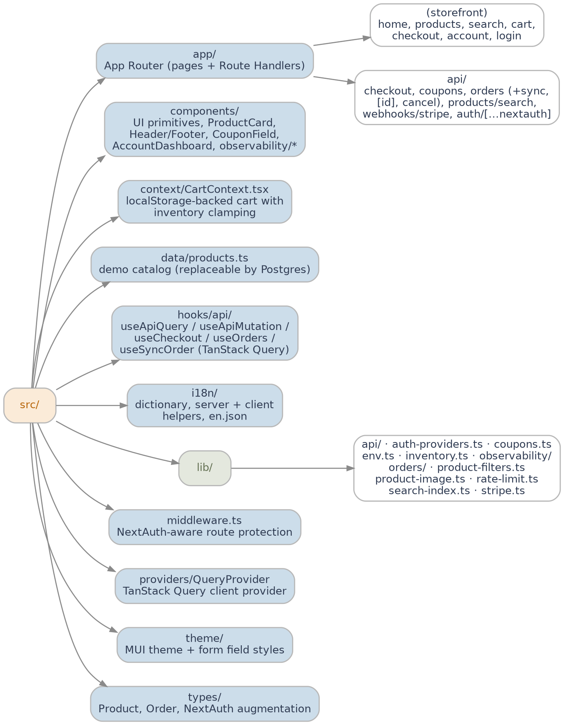

16.3 Contact
- Engagement Lead: Pawan Gupta — pawan.gupta@nagarro.com — +91 98112 83937

16.4 Additional resources
- Stripe Checkout documentation and webhook reference.
- NextAuth.js v5 (Auth.js) documentation.
- Next.js 16 App Router release notes.
- WCAG 2.1 AA quick reference.
- OWASP ASVS L1 checklist.
This appendix consolidates the supporting material for Nagarro's RIMSS Solution Approach, ensuring that the YCompany evaluation team has all relevant references at hand alongside the main document.

