Permissions in Linux OS

permissions are divided in 2 sub sections that are normal permissions and special permissions

Types of Normal permissions

First we will see what are different file and directory permissions available in linux system.

There are three basic permissions in linux system that are read, write and execute.

Read--- r
write---- w
exucute ----x

means as shown abouve rwx are the notations of particular file and directory. And it should be use as it is as mentioned.

Types of owners and the way that we have to use them in permissions

As we already know there are three owners in linux and this are

General user
Group
Other user

Now lets use a command ls -l (this will show all files and directories in existing pwd)

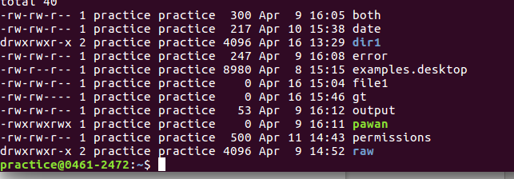

at start dash means its we have to assume that its showing file permissions

at start d means it showing directory permissions

now lets obser the file pawan and see the notaations.

-rwxrwxrwx

at start the dash means we have to consider this permissions are a file permissions.

Then take as group of three means , first three letters are always alloted to general user(owner of the file), second three letters are always alloted to group of that file, third three letters of that files are alloted to the other users.

Owner ----- rwx
group ------ rwx
other -------- rwx

Lests assume that -rw-rw-r-x

this means user only have read and write permissions and it doesnt have any execute command.

Command to change permissions and how to use them

There are three basic commands in linux to change permissions

1 chmod
2 chown
3 chgrp

1 chmod

chmod command is used change the permissions of a file and directory

we can use chmod by 2 ways there is numeric method and other is absolute method

a. numeric metod
b. absolute method

most followed method is absolute method because it is more simple and easy to use, but numeric method we have to remind about a octal code , which quite difficult sometimes.

Now before use chmod using absolute method one must know about topologies of this

user ---- u
group ---g
others --- o
all ----- a
add permissions --- +
remove permissions -- -
set as previous ----- =
Always keep in mind that who what which

whom to allot
what to do like add , remove ,set
which permissions

this will clear after example.

Lets check using ls -l

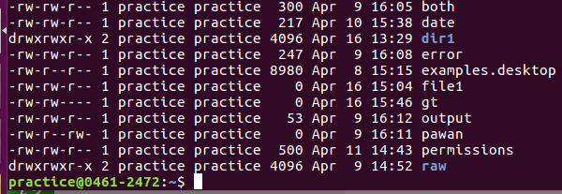

the fil pawan have

-rw-r--rw- permissions

means user of the file can can read write
group of the file can read only
other can read and wite .

suppose i want to give acces of write to the group

then i will execute

chmod g+w pawan

in that case to assighn all owners we have to exucute like

chmod a+x pawan

means all owner group and other will allot exucute command.

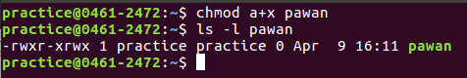

This is the single way to allot th permissions .

Now will leans about the numeric way to exucute them

0 ---
1 --x
2 -w
3 -wx
4 r--
5 r-x
6 rw-
7 rwx

just use this instead of this a+x

like chmod 774 pawan

means pawan file will get rwxrwxr--

2 chown

this command can be used to change ownership of the file.

Here we can observe that pawan file is ownerd by practice user and it is also under the practice group.

This are the three ways to use this command.

chown newownername filename

chown ownername:groupname filename

chown :groupname

3. chgrp

this command is used change the group ownership

to use this command just

chgrp newgroup filename

Special Permissions

There are three types of special permissions in Linux which are

suid (means set user id)

sgid (means set group id)

sticky bit

now lets see them one by one

1 . suid --- it means set user id it basically indicates special permissions for user.

- This are special permissiosn which are alloted or given to the exucutable files which allows other user to exucute this file like he is the owner of that file.

- Files which is have suid bit set it shows s instead of x in user like

(files which already have suid permissions are known as permissions 4000 files)

to find the permissions 4000 files (suid files) we have a command

find / -perm -4000

to give this permission

chmod u+s pawan

2. sgid --- it means set group id it basically indicates special permissions for group.

Applicable on directory
and for groups

suppose if a sgid bit is set on a dir, then any user will create a file or dir under this dir then the group owner will be that person whose sgid bit is set.

Follow the following steps
- add 2 users
- add one group
- add both users in that group usermod -aG
- veryfi both users are the members of this group cat /etc/group
-create one dir in root home directory
- and change groupowner of that dir to the new group that just we created using chown
- now sgid bit on that new dir in root home chmod g+s
- now swith to user 1 and create 1 file and 1 dir under that dir using that user
- now switch to user 2 and create 1 file and 1 dir under the same dir using that user
- now go to root and make a long list using ls -l
- we can observe that whoever create a file and dir in that sgbit seted dir the grouponwer of each file will be same as we seted before

- Files which is have suid bit set it shows s instead of x in group like

(files which already have sgid permissions are known as permissions 6000 files)

to find the permissions 6000 files (sgid files) we have a command

find / -perm -6000

to give this permission execute

chmod g+s pawan

3 . Sticky bit

1 always applicable to directory
2 must be a shareable directory means must be accesable with all user group and others.
3. always apply by root user

Follow the following steps to understand it
1 create 1 folder in /home -------(which shareable and onyone can access it)
2 give perm 777 to this folder

3 now in this folder create 1 file and 1 dir from 3 users each
4 Now delete files and from differnt user and we can observe that the files are able to delete
5in this way the files in sharebale dir are not safe because anyone can delete them to safegaurd this files we set sticky bit on this
6 using sticky bit only the owner of this files can delete this files.

