**I-SHOP-WEB BASED PROJECT**

**Abstract:**

Online shopping an easy and comfortable way of shopping from a large range of products. It provides an automated system on web for searching products, view details and place order online.

**Proposed Model:**

A new and smarter shopping model was developed for a better online shopping experience.

**SDLC (Software Development Life Cycle):**

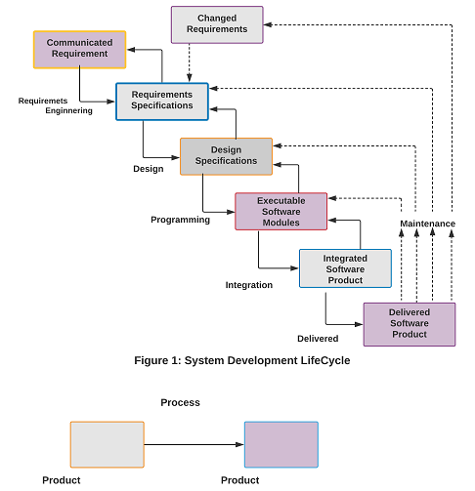

**Advanced System Capability:**

1. The ability to update customer records.

2. The ability to view and update order status.

3. The status of orders can be changed, from ‘pending’ to ‘delivered’.

4. Control over the addition, removal and modification o categories, products, manufacturers, customers, and product reviews.

**State Transition Diagram:**

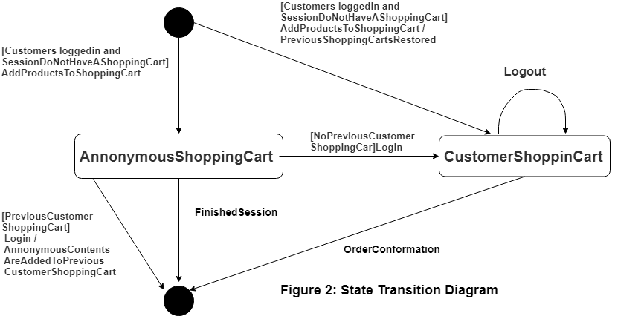

1. Customer selects products and adds to shopping cart without login, which is anonymous cart.

2. Customer Login and Starts selecting products, which is known as Customer Shopping Cart.

3. Order Confirmation happens only for Customer Shopping Cart.

**Modules Implementation:**

|  |  |
| --- | --- |
| **Module Name**   * Registration * Products Browse * Products Search * Shopping Cart * Shipping * Billing * Login | **Description**   * Allows users and customers to register on the I-Shop Website. * Shows list of Products categories to select and browse. * Provides option for searching products based on search term. * Shows the customer shopping cart with products and bill summary to. * For Vendors from various locations ship the products. * Allows vendors to define shipping charges in bill. * Customer can login to place order. |

**Database Models Diagram:**

1. Conceptual Model
2. Physical
3. Logical
4. Entity

**Conceptual Model:**

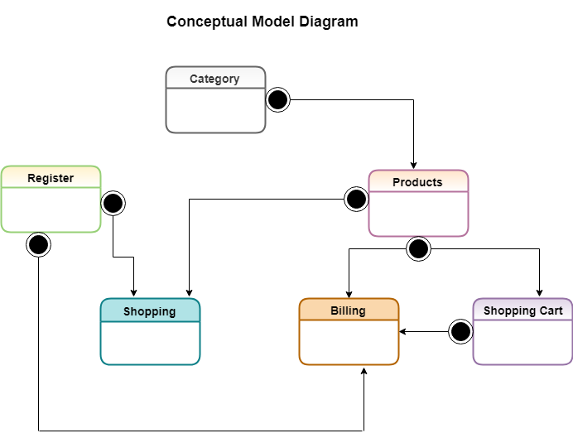

**Physical Model:**

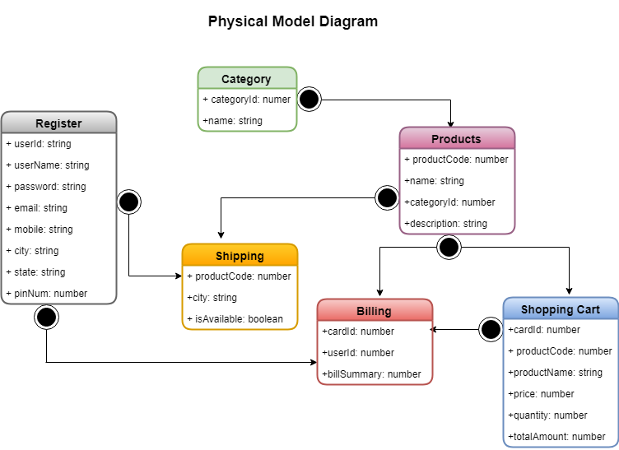

**Logical Model:**

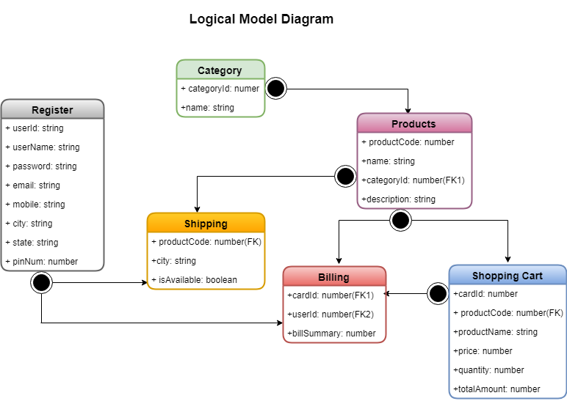

**ER-Model Diagram:**

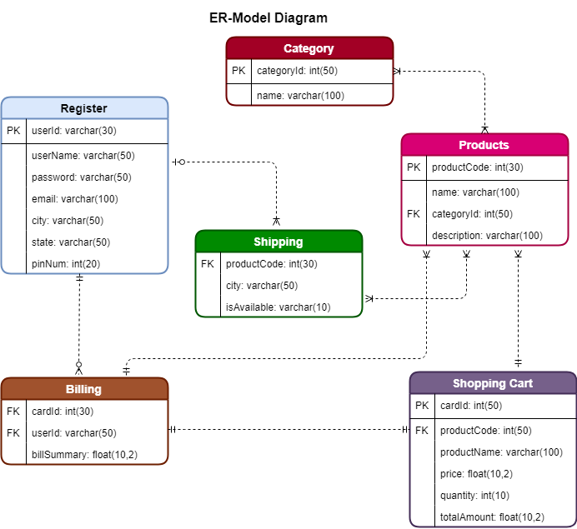

**Use Case Diagram:**

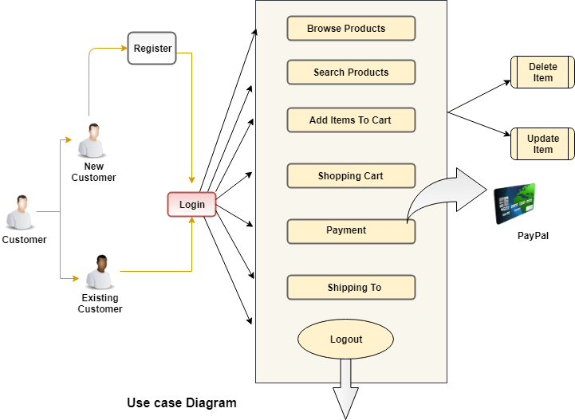

**Activity Diagram:**

