

**Change Request Document for Insight EasyJet Work Assignment Automation**

|  |
| --- |
| Notices and Copyright |
| *This document contains information, which is the proprietary property of Teleperformance. This document is received in confidence and its contents cannot be disclosed or copied without the prior written consent of Teleperformance.*  *Nothing in this document constitutes a guaranty, warranty, or license, express or implied. Teleperformance disclaims all liability for all such guaranties, warranties, and licenses, including but not limited to: Fitness for a purpose; merchantability; not infringement of intellectual property or other rights of any third party; indemnity; and all others. The reader is advised that third parties can have intellectual property rights that are relevant to this document and the technologies discussed herein and is advised to seek the advice of competent legal counsel, without obligation of Teleperformance.*  *Teleperformance retains the right to make changes to this document at any time, without notice Teleperformance makes no warranty for the use of this document and assumes no responsibility for any errors that can appear in the document nor does it make a commitment to update the information contained herein.*  ***COPYRIGHT***  *Copyright ©Teleperformance. All rights reserved.*  ***TRADEMARKS***  *Other product and corporate names may be trademarks of other companies and are used only for explanation and to the owners' benefit, without intent to infringe.* |

Document Control

**Document Change History**

|  | Change Details | | | Review Details | | Approval Details | |
| --- | --- | --- | --- | --- | --- | --- | --- |
| Version | Change Description | Date | Author | Reviewed By | Review Date  dd-mm-yyyy | Approved By | Approval Date  dd-mm-yyyy |
| 1.0 | Initial Draft | 16-03-2021 | Shahul Pathan | Mukesh B | 28-05-2021 |  |  |
| 1.1 | Updated Threshold limit |  |  |  |  |  |  |

**Template Change History**

|  | Change Details | | | Review Details | | Approval Details | |
| --- | --- | --- | --- | --- | --- | --- | --- |
| Version | Change Description | Date | Author | Reviewed By | Review Date  dd-mm-yyyy | Approved By | Approval Date  dd-mm-yyyy |
| 1 | New template | 26-05-18 | Amit Sarotra | Sanjay W | 26-05-18 | Sriniwas N | 28-05-18 |
| 2 | Converted to Teleperformance logo & format | 24-10-18 | Sanjay Welling | Sriniwas N | 24-10-18 | Sriniwas N | 24-10-18 |

General Information:

|  |  |  |
| --- | --- | --- |
| **CR Number:** | **Date Submitted:** 22-03-2021 | **Project ID: Insight WAT** |
| **Originator: Mukesh B** | **Phone:** | **CR Title:** |
| **Project Name:** EasyJet Auto Assignment | **Date Updated:** 17-03-2021 | **Updated By:**  Shahul Pathan |
| **Type of Change:**  Clarify Requirements Misinterpreted Requirements Add Requirements  Remove Requirements  Change Approach Process Change Design error / Inadequacy | | |

Proposed Change

|  |  |
| --- | --- |
| **Baseline Description:** | The EasyJet operation team requires to automate the manual assignment of task to agents in Insight LMS |
| **Detail Change Description:** | The EasyJet operation team currently receives an excel sheet with all the PNR numbers which are required to be actioned are then manually assigned to agents/TL on an excel sheet. |
| **Reason for Change:** | Manual allocation of task is time consuming and AHT tacking is not accurate, AHT is calculated for disposition and not for the entire process. Live Dashboard to keep a track of processed cases. |
| **CR Priority:** | High |

# Summary

Below is summary of the understanding of the change requirement proposed for Auto-assignment of task in Insight LMS for Easyjet

**Insight LMS – Assignment Automation**

When an easyJet customer fill a webform through website or by connecting to an agent by call or chat to get a refund back to the original mode of payment whenever flights in the booking got disrupted, cancelled, or affected due to schedule change then customer is eligible to get a full refund accordingly.

Currently the team receives an automated excel report from the client i.e., daily, where the team assigns the cases manually to the advisors. Advisors then filter their name from the excel file and process the cases on client system and then dispose them on activity tracker in Insight. Disposition data extracted, share the relevant outcomes with the client and for tracking purpose of the work allocation for the day.

# Changes Proposed:

# Uploading interface

* Supervisor should have an option to upload the assignment data on to the system.
* Queue wise data to be uploaded (*3 queues* - *Flight refunds, Failed vouchers & OMOP*)

(*format attached below*)



* User should have an option to choose the queue from the drop-down list
* Should have a browse option to locate and choose the file from the system
* Should have an option to ‘Upload’ the file
* Cases should flow in ‘FIFO’ format (*as per date and time*)

# Work Assignment Flow

* Once the agent is logged in activity tracker, he will select the queue from the drop down
* Below mentioned queues will be available for the user to choose from:
  + Flight Refund
  + Failed Voucher
  + OMOP
* Below two drop down fields should auto-populate *(can be removed or greyed out)*
* Agent will select the queue and click start to begin with his work assigned in his queue

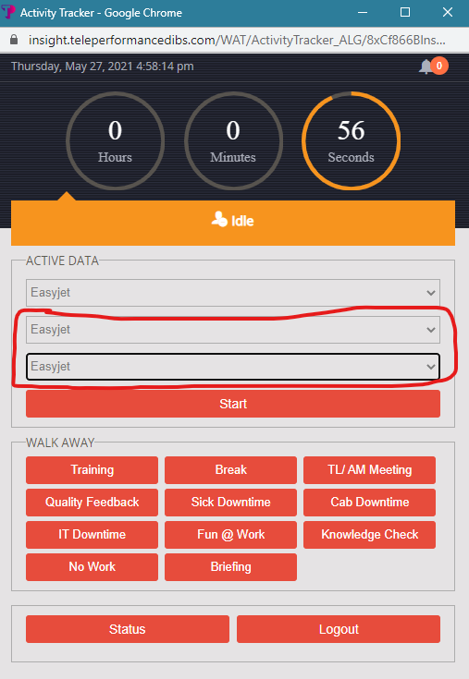

* On clicking start he will be redirected to assignment window where he can see the unique PNR/data to be worked upon
* Work assigned will flow into his queue one at a time (FIFO)

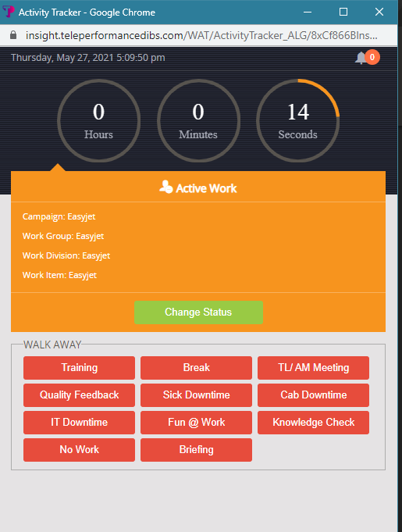

Work assigment should show under this box

Also it should show the queue the specialist is working on , we can replace Campaign with Queue ( Example : Queue :Flight Refund/Failed Voucher/OMOP )

* Agent will see the details required to work on the customer query/complain in client system
* Agent should be able to copy the information from this window and paste on client system
* User should be able to view the processing information on the screen
* Request Date
* PNR
* Customer Email Address (In Flight Refund activity)
* Sectors (In Failed Voucher & OMOP activity)
* Language
* User should be able to see a single line view in case of ‘Refund’ or grid view in case of multiple sectors

# Disposition

* Once the PNR is processed in the client system, he will click on change status on activity screen
* This will take the user to the disposition screen
* PNR details should auto populate as per the queue assigned in the following fields i.e., Booking Reference, Language, Pax email address (it will be same as Booking Reference No.)
* Correct PNR, Outcome and Comment box will be filled by the agent as free text
* Agent will select the correct outcome and put remarks in comment box (if required)
* All the cases will either be disposed as Complete or Escalated
* User can ‘Complete and Next’ or ‘Escalated and Next’ to go back to the home screen to work on the other PNR
* User can ‘‘Complete and Walk Away’ or ‘Escalated and Away’ to go on break or logout

|  |  |
| --- | --- |
| **Wrap up** | **Requirement** |
| Booking reference | Auto fill as per the assignment |
| Language | Auto fill as per the assignment |
| Outcome | Choose Option |
| Comment | Free Text |
| Pax e-mail address | Auto fill as per the assignment |
| Correct PNR | Auto fill as per the assignment |

|  |  |
| --- | --- |
| **REFUND** | |
| PNR | K1ZML17 |
| Email Address | [xyz@tracel.com](mailto:xyz@tracel.com) |

* Outcomes should populate as per the queue assigned *(as per the below attached file)*



# Aux Management

* User should start getting cases only after click ‘Start”
* User Should have option to select other AUX
* Workflow should stop after selecting any other AUX except Productive AUX
* Productive AUX should be removed

# Reporting

* Work Group, Work Division, Work Item to be removed from the existing report
* Activity Start and Activity End Time to be replaced by Transaction Start and Transaction End Time
* Wrap Up Start Time and Wrap Up End Time to be added in the report
* Total Time to be added in the report
* Queue column needs to be added in the report



# Live Dashboard

* Team Manager should be able to view the dashboard with live no of cases processed
* Team Manager Should be able to view the PNR cases completed against assigned Team Leader
* Team Manager Should be able to view hourly wise production (should have filter to select time range)

Below is the Histogram for your reference:

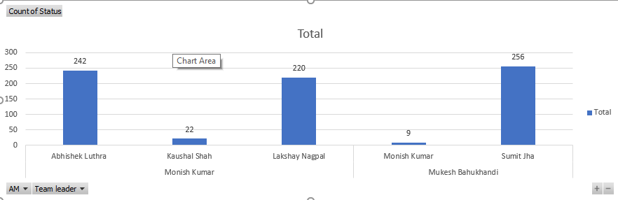

* Team Manager Should be able to view the PNR cases completed against assigned Team leader and advisors

Below is the Histogram for your reference

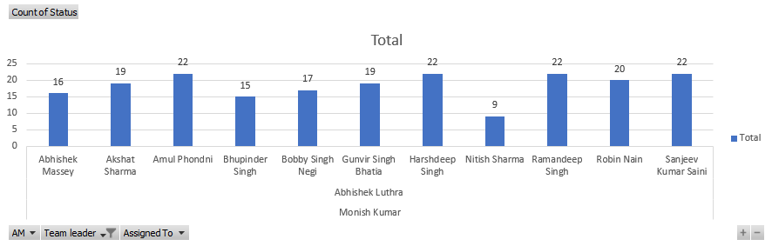

* Team Managers should have an option to apply filter (AM, Queue, TL wise, Agent wise etc.)
* Team Leaders should have an option to apply filter (Queue, TL wise, Agent wise etc.)

*(If supervisor needs more details, user can download the report)*

**EPH Calculation: No of transaction processed/ Productive AUX in hours**

|  |  |
| --- | --- |
| **EPH (Time in Hrs)** | |
| **Transaction Processed** | 100 |
| **Productive AUX** | 6 |
| **EPH (1 hour/AHT)** | 16.67 |

|  |  |  |  |  |  |
| --- | --- | --- | --- | --- | --- |
| **Advisor** | **Date** | **Time** | **Queue** | **No of Cases** | **EPH/AHT** |
|  |  |  |  |  |  |
|  |  |  |  |  |  |

**The End**