ECA14 – EMBEDDED SYSTEMS

CO1 – SYSTEM ARCHITECTURE-BASED ENGINEERING DESIGN ASSIGNMENT

Design of a Networked Embedded System Architecture for a Luxury Automobile Using CAN and CAN FD

Course Outcome – CO1

Submitted by: B. Pawan Kumar
Register Number: 192465055
Department: CSE-Cyber security
Date: 04/11/2026

INTRODUCTION
Modern automobiles use several embedded systems to control functions such as engine operation, braking, safety monitoring, body control and infotainment. Each function is managed by a dedicated Electronic Control Unit (ECU). These ECUs exchange information through an automotive communication network.
The communication system must provide reliable data transmission, fast response to important messages, message prioritization, fault handling and support for future high-data-rate applications. This assignment proposes a distributed embedded-system architecture for a luxury automobile using suitable processing architectures and CAN/CAN FD communication.

STAGE 1 – INTERPRET THE SYSTEM REQUIREMENTS

1.1 Major Functional Requirements
- Engine control – monitor and control engine operation.
- Braking control – manage braking according to driver input and vehicle conditions.
- Safety monitoring – detect dangerous conditions and generate warnings.
- Body control – manage lights, windows, door locks and other body functions.
- Infotainment – provide navigation, audio, display and multimedia functions.
- Communication – allow all ECUs to exchange information.
- Fault detection – identify communication and component failures.

1.2 Role of Individual ECUs
ECU | Main responsibilities | Typical inputs / outputs
Engine ECU | Monitors engine temperature and speed; controls fuel injection and ignition. | Inputs: engine sensors. Outputs: fuelinjection and ignition commands.
Braking ECU | Monitors wheel speeds and controls braking functions, including ABS support. | Inputs: wheel-speed and brake signals. Outputs: braking-control commands and status.
Safety ECU | Monitors vehicle safety information and coordinates safety-related warnings or requests. | Inputs: braking, engine and safety data. Outputs: warnings and safety requests.
Body-Control ECU | Controls headlights, indicators, windows, door locks and interior lighting. | Inputs: switches and body sensors.  Outputs: lighting and body actuators.
Infotainment ECU | Manages navigation, audio, multimedia and display functions. | Inputs: user commands and permitted vehicle data. Outputs: display and audio.

1.3 Real-Time Communication Requirements
Real-time communication is important because some vehicle operations must respond within a limited time. Wheel-speed information must reach the braking controller quickly. Engine and safety information must be exchanged reliably. Safety-related messages require higher priority, while infotainment data can tolerate comparatively longer delays. Therefore, the network must support priority-based message transmission.

1.4 Processing, Memory and I/O Requirements
Processing requirements include sensor-data processing, control calculations, communication management, fault detection and real-time decision-making. Memory requirements include program memory, RAM for temporary data and Flash memory for configuration and diagnostic information.
Inputs include temperature sensors, wheel-speed sensors, pressure sensors and driver switches. Outputs include fuel injectors, braking actuators, warning indicators, headlights, windows and infotainment displays.

1.5 Reliability and Fault-Tolerance Requirements
- Error detection and fault monitoring.
- Watchdog timers and message-timeout detection.
- Redundant safety monitoring where required.
- Safe or degraded operation during critical faults.
- Diagnostic reporting to the appropriate controller.

1.6 Communication Between Safety-Critical and Non-Safety-Critical ECUs
Safety-critical functions include engine control, braking and safety monitoring. Infotainment and multimedia are comparatively non-safety-critical. Safety-related messages must receive higher priority. The architecture should separate safety-critical and non-safety-critical networks using appropriate gateways, access controls and message validation.

1.7 Constraints Affecting Processor and Protocol Selection
Important constraints include processing speed, memory capacity, power consumption, cost, communication speed, real-time response, reliability, automotive operating conditions and future expansion requirements.

Stage 1 Deliverable – System Requirement Statement
The proposed automotive embedded system must connect engine, braking, safety, body-control and infotainment ECUs through a reliable communication network. It must provide real-time message exchange, priority-based communication, fault detection, safety monitoring and support for future high-data-rate applications.

STAGE 2 – ANALYZE AND SELECT THE EMBEDDED ARCHITECTURE

2.1 Microcontroller (MCU)
A microcontroller contains a processor, memory and input/output peripherals on a single chip. It offers low power consumption, low cost, fast response to control signals and convenient sensor/actuator interfacing. Its processing capability and memory are more limited than those of high-performance processors. It is suitable for engine, braking and body-control ECUs.

2.2 Microprocessor (MPU)
A microprocessor is mainly a processing unit and generally uses external memory and peripherals. It offers high processing capability and supports complex operating systems and applications. However, it can require more power and additional components. It is suitable for advanced infotainment and navigation systems.

2.3 Digital Signal Processor (DSP)
A DSP is designed to perform mathematical and signal-processing operations efficiently. It is suitable for audio processing and sensor-signal analysis. It may be unnecessary for simple control functions and can require additional design effort.

2.4 System-on-Chip (SoC)
An SoC integrates several components, such as processors, memory controllers and communication interfaces, into one chip. It supports complex applications and provides high integration, but can increase design complexity, cost and thermal-management requirements.

2.5 Comparison of Processing Architectures
Parameter | MCU | MPU | DSP | SoC
Processing capability | Medium | High | High for signal processing | High
Memory | Usually on-chip | Often external | Depends on design | Integrated resources
Power consumption | Low | High | Medium | Medium to high
Real-time response | Very good | Depends on system design | Very good for signal processing | Depends on architecture
Integration | High | Lower | Medium | Very high
Cost / complexity | Low | High | Medium | High
Automotive  suitability | Very good | Good for complex systems | Good for signal processing | Very good for advanced systems

2.6 Design Decision 1 – Processor Selection
I recommend a mixed architecture using automotive-grade MCUs for the engine, braking, safety and body-control ECUs, and an SoC or suitable MPU-based platform for the infotainment ECU.
MCUs provide predictable real-time control, sensor and actuator interfaces, and comparatively low power consumption. An SoC provides the processing capacity required for infotainment. This mixed architecture balances performance, cost and reliability. A DSP may also be used where advanced signal-processing requirements justify it.

STAGE 3 – DEVELOP THE NETWORKED SYSTEM ARCHITECTURE

3.1 Proposed System Architecture
The automobile uses a distributed architecture. Each ECU performs a specific function and communicates with other ECUs through communication buses.
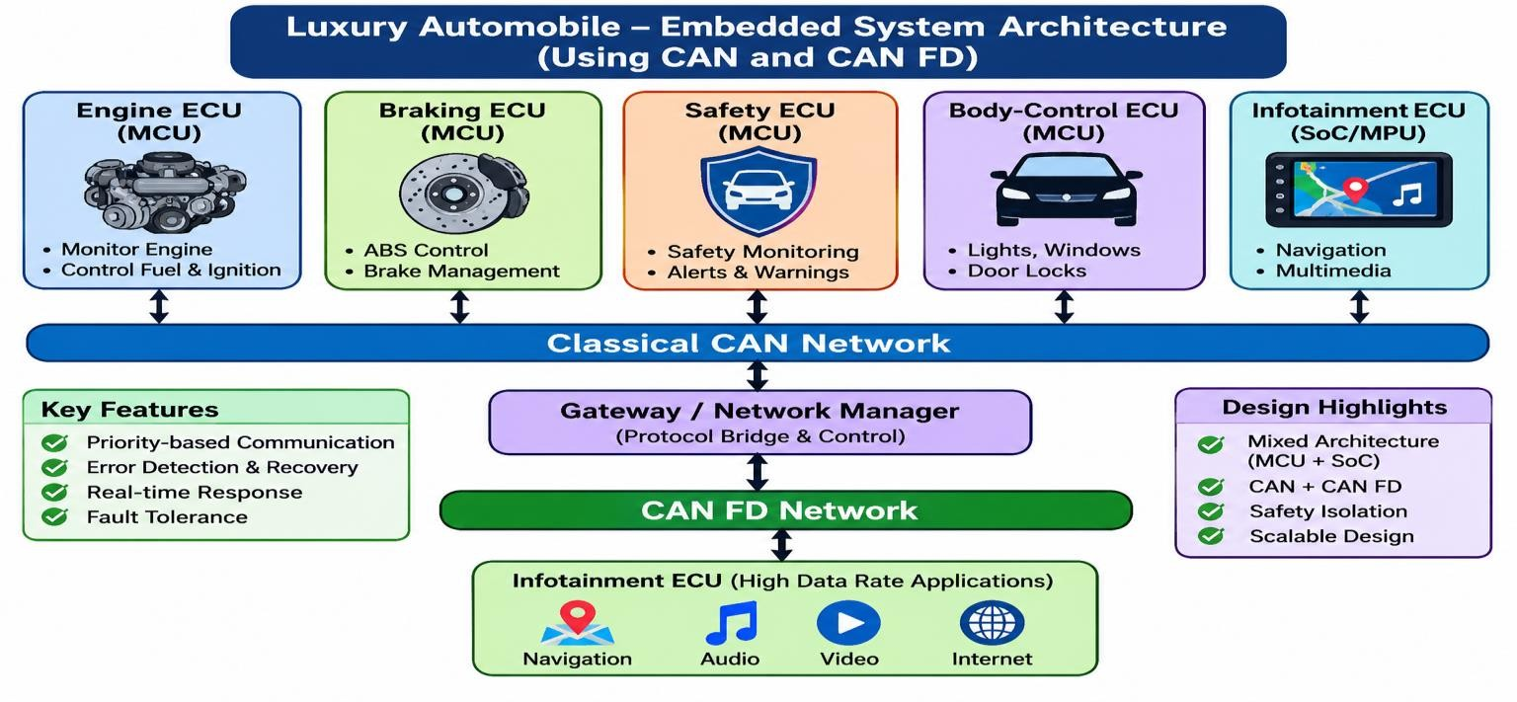
Note: This is a proposed logical architecture. The exact physical bus arrangement and gateway implementation must be finalized during detailed vehicle design.

3.2 Function of Each ECU

Engine ECU
Controls engine-related operations. It receives information from engine sensors and controls fuelinjection and ignition actuators.

Braking ECU
Receives wheel-speed and braking-related sensor information, controls braking functions and communicates relevant status.

Safety ECU
Monitors important vehicle conditions, receives information from other ECUs and generates safety warnings or control requests.
Body-Control ECU
Manages lights, indicators, windows, door locks and other electrical body functions.

Infotainment ECU
Manages navigation, audio, multimedia and display operations, and exchanges permitted vehicle information.

3.3 Information Exchanged Between ECUs
Sender ECU | Receiver ECU | Information
Engine ECU | Safety ECU | Engine operating status
Braking ECU | Safety ECU | Braking and wheel-speed status
Safety ECU | Other ECUs | Safety warnings and requests
Body-Control ECU | Other ECUs | Lighting and body status
Gateway | Infotainment ECU | Selected vehicle information
Infotainment ECU | Gateway | Navigation and multimedia-related data

3.4 Direction of Data Flow
- Sensors collect information from the vehicle.
- The corresponding ECU processes the sensor information.
- The ECU generates a data message.
- The message is transmitted through the communication network.
- The receiving ECU checks and processes the message.
- The receiving ECU performs the required action.

3.5 Role of the Communication Bus
The communication bus connects multiple ECUs and allows them to exchange information. Its functions include data sharing, message prioritization, error detection, reduced wiring complexity, reliable communication and support for distributed control.

3.6 Separation of Safety-Critical and Non-Safety-Critical Functions
Braking and safety communication should use a dedicated control network. Engine-control messages should receive suitable priority. Infotainment traffic should not overload the safety-critical network. A gateway should control communication between networks, with appropriate isolation and message validation.

STAGE 4 – ANALYZE CAN AND CAN FD

4.1 Classical CAN
CAN stands for Controller Area Network. It is a message-based communication protocol used to exchange data between embedded controllers in vehicles. It supports multi-master communication, identifier-based priority arbitration, error detection and automatic retransmission in suitable error conditions. Classical CAN supports up to 8 data bytes in a data frame.

4.2 CAN FD
CAN FD stands for Controller Area Network Flexible Data-Rate. It supports larger data payloads, up to 64 bytes per frame, and can use a faster data-phase bit rate through Bit Rate Switching. The achievable data rate depends on the network design, transceivers, cable length and timing configuration.

4.3 Comparison of Classical CAN and CAN FD
Parameter | Classical CAN | CAN FD
Maximum payload | 8 bytes | 64 bytes
Identifier | 11-bit or 29-bit | 11-bit or 29-bit
Arbitration phase | Nominal bit rate | Nominal bit rate
Data phase | Same nominal bit rate | Can use a faster bit rate
Bit Rate Switching | Not supported | Supported
Error detection | CRC-based error detection | Improved CRC protection for longer frames
Message priority | Identifier-based | Identifier-based
Typical use | Traditional vehicle control | Higher-data-rate vehicle applications

4.4 CAN Arbitration
CAN uses priority-based arbitration. A lower numerical identifier generally has higher priority. CAN uses dominant (0) and recessive (1) bits. During arbitration, each transmitting ECU monitors the bus. If an ECU transmits a recessive bit but detects a dominant bit, it loses arbitration and stops transmitting. This is non-destructive bitwise arbitration.
Example: Safety ECU identifier 0x080, Engine ECU identifier 0x120 and Infotainment ECU identifier 0x500. The Safety ECU wins arbitration because it has the lowest numerical identifier. The other ECUs wait until the bus becomes available.

4.5 Situation 1 – Simultaneous Transmission
- All ECUs begin transmitting when the bus is available.
- They compare their transmitted identifier bits with the bus.
- Lower-priority ECUs detect that they have lost arbitration and stop transmitting.
- The Safety ECU completes its higher-priority transmission.
- Other ECUs retry when the bus becomes available.
This provides priority-based bus access. However, message deadlines must still be verified under worst-case bus loading.

4.6 Situation 2 – Data Exceeding Classical CAN Capacity
Classical CAN supports a maximum of 8 data bytes per frame. Larger application data must be divided into multiple frames or transferred using a suitable larger-payload protocol. CAN FD supports up to 64 bytes in a single data frame and can reduce the number of frames required.

4.7 Design Decision 2 – Communication Protocol Selection
I recommend a hybrid architecture using Classical CAN for safety-critical control communication and a separate CAN FD network for applications that require larger data payloads and higher throughput.
Classical CAN is suitable for small control messages, while CAN FD supports larger data transfers. Separate networks reduce interference between infotainment traffic and safety-related traffic.
Important compatibility point: Classical-CAN-only nodes should not be placed on a bus where they must receive CAN FD frames. Separate compatible bus segments and a gateway should be used when both protocol types are required.

STAGE 5 – FORMAL MODELING OF THE EMBEDDED SYSTEM

5.1 Selected Safety-Critical Function
The selected function is Electronic Braking Control. The braking system responds to driver braking input and vehicle conditions. It receives sensor information and generates appropriate braking-control outputs.

5.2 Selected Formal Modeling Technique
A Finite State Machine (FSM) is selected. An FSM represents a system using states, inputs, outputs and transitions. It is suitable for modeling systems that operate through clearly defined states. 5.3 System States
Idle State
The braking system is active and waiting for braking input.
Brake Request State
The driver presses the brake pedal and the ECU receives the request.
Sensor Checking State
The ECU checks wheel-speed and other required sensor information.
Brake Control State
The ECU calculates and applies the required braking control.

ABS Control State
When wheel-lock conditions are detected, the ABS function adjusts braking pressure according to the designed control strategy.
Fault State
The ECU detects a sensor, actuator or communication fault and activates the defined fault response.

Safe Operation State
The system follows its validated degraded or safe operating strategy and informs the appropriate vehicle controller.

5.4 Inputs and Outputs
Inputs | Outputs
Brake pedal signal | Brake actuator command
Wheel-speed sensor | Braking status message
Vehicle-speed information | Warning indicator
ABS-related condition | ABS control command
Sensor fault signal | Fault notification
Communication status | Diagnostic information

5.5 FSM State Transition Table
Present state | Input / event | Next state | Action
Idle | Brake pressed | Brake Request | Read brake input
Brake Request | Valid sensor data | Sensor Checking | Check sensor values
Sensor Checking | Normal condition | Brake Control | Calculate braking command
Brake Control | Wheel-lock condition | ABS Control | Activate ABS strategy
ABS Control | Normal wheel condition | Brake Control | Continue braking control
Any active state | Critical fault | Fault State | Detect and report fault
Fault State | Validated recovery condition | Safe Operation | Follow approved degraded strategy
Brake Control | Brake released | Idle | End braking request

5.6 FSM Diagram
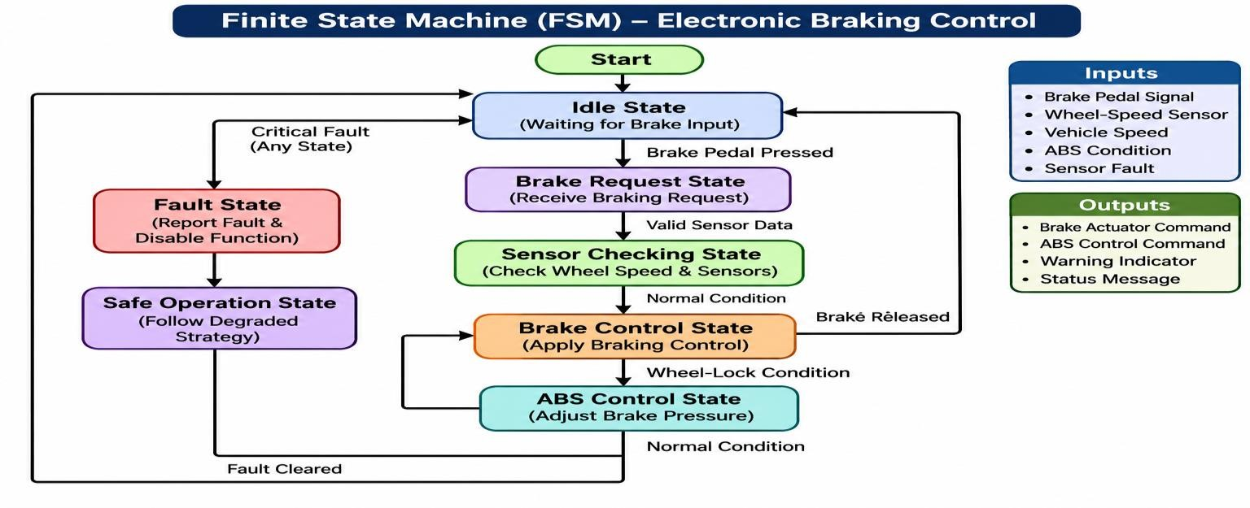

5.7 Transitions and Actions
When the driver presses the brake pedal, the system leaves the Idle state.
The ECU checks sensor values before generating the braking command.
Under normal conditions, the system enters Brake Control.
When a wheel-lock condition is detected, ABS Control is activated.
When a critical fault is detected, the system enters the Fault state.
The system then follows the validated safe-operation strategy.
The exact braking response and recovery conditions must be validated against the vehicle's safety requirements.

5.8 Concurrent Activities
Wheel-speed monitoring, brake-pedal monitoring, sensor-data processing, communication with other ECUs, fault monitoring and diagnostic logging may occur concurrently. They can be implemented using separate software tasks or interrupt-driven operations with suitable scheduling and synchronization.

5.9 Design Decision 3 Formal Modeling Technique
I recommend a Finite State Machine because it clearly represents the different operating conditions of the electronic braking system. It helps developers understand system behavior, input conditions, state transitions, output actions, fault conditions and recovery behavior. It also makes design verification and testing easier.

STAGE 6 VERIFY AND CRITICALLY EVALUATE THE ARCHITECTURE

6.1 Real-Time Performance
The system must respond to important vehicle events within their specified deadlines. Safety-related messages must receive suitable priority. The design should use appropriate ECU processing capacity, priority-based CAN arbitration, efficient message scheduling, communication-delay monitoring and worst-case timing analysis. Actual response time must be measured and verified during testing.

6.2 Communication Reliability
CAN and CAN FD provide error-detection mechanisms. Reliability can be improved through CRC checking, bit monitoring, acknowledgement checking, error-frame handling, message-timeout monitoring, bus-off detection and recovery procedures.

6.3 CAN Arbitration
The ECU with the highest-priority identifier wins arbitration. This supports priority-based communication without destroying the winning message. Lower-priority messages can experience delays under heavy bus loading, so bus utilization and worst-case message latency must be analyzed.

6.4 Error Handling
Possible communication errors include bit errors, stuff errors, CRC errors, form errors and acknowledgement errors. The CAN controller detects errors and follows its error-handling mechanisms. Software should also monitor missing messages and invalid data.

6.5 Fault Tolerance
Fault tolerance can be improved using watchdog timers, sensor plausibility checking, communication timeout detection, redundant safety monitoring, fault-status reporting and validated degraded operating modes.

6.6 Redundancy
Redundancy may include independent monitoring of critical sensor information, redundant power supplies where required, independent watchdog supervision and backup communication paths where justified. Redundancy must be designed to avoid common-cause failures.

6.7 Scalability
Additional ECUs can be connected through suitable network segments and gateways. CAN FD can support applications requiring larger data payloads. Expansion must consider bus loading, bandwidth and compatibility.

6.8 Processing Requirements
MCUs are suitable for dedicated real-time control functions. The infotainment SoC provides higher processing capability for multimedia and navigation. This avoids using an unnecessarily powerful processor for simple control tasks.

6.9 Power and Memory Constraints
Each ECU must be selected according to its processing and memory requirements. Low-power MCUs are suitable for many control applications. Infotainment systems may require more RAM and Flash memory. Power-management methods should reduce unnecessary energy consumption.

6.10 Suitability for Safety-Critical Applications
The architecture separates safety-critical control functions from non-critical infotainment functions and provides message prioritization, error detection and fault monitoring. However, the architecture alone does not prove vehicle safety. Detailed safety analysis, hardware validation, software testing and applicable automotive safety-standard compliance are required before production.
6.11 Failure Scenario 1 Communication Bus Failure Affected component: CAN communication network.
Possible effect: ECUs may not receive required messages; vehicle-status information may become unavailable; some control functions may enter a degraded condition.
Mitigation: Monitor message timeouts, detect bus-off conditions, use network diagnostics, apply validated fallback strategies and inform the driver or vehicle controller when required.
Reliable operation: The affected ECU identifies missing communication and enters its defined degraded operating mode rather than treating outdated information as valid.
6.12 Failure Scenario 2 Sensor Failure Affected component: Wheel-speed sensor.
Possible effect: Incorrect wheel-speed information may affect braking-system calculations and reduce availability of some braking assistance functions.
Mitigation: Perform sensor plausibility checks, monitor abnormal values, use additional validated sensor information where available, generate a fault message and activate the approved degraded braking strategy.
Reliable operation: The braking ECU detects the fault and follows validated fallback behavior. The driver is informed when required.

6.13 Failure Scenario 3 ECU Failure
Affected component: Engine ECU or another control ECU.
Possible effect: Loss of the ECU control function, missing communication messages or unavailable status information.
Mitigation: Use watchdog supervision, monitor ECU communication, detect missing messages, provide independent safety monitoring where required and enter a validated safe or degraded operating mode.

6.14 Verification Table
Test No. | Test condition | Expected result | Verification method
1 | Normal engine operation | Engine ECU operates correctly | Functional testing
2 | Simultaneous CAN messages | Highest-priority message wins arbitration | CAN analysis
3 | Large data transmission | CAN FD transfers supported larger payload | Communication testing
4 | Sensor failure | Fault is detected and reported | Fault-injection testing
5 | CAN communication  failure | Timeout or bus fault is detected | Network testing
6 | Brake request | Correct FSM transition occurs | State-machine testing
7 | Wheel-lock condition | ABS control state is activated | Functional simulation
8 | ECU reset or failure | Defined fault response is initiated | System testing

Critical Evaluation
The proposed architecture provides a suitable foundation for a distributed automotive embedded system. MCUs for real-time control and an SoC for infotainment provide a balance between performance and complexity. The hybrid communication approach supports both smaller control messages and larger data transfers. Further validation is required for worst-case communication latency, bus utilization, ECU processing load, fault recovery time, hardware reliability and safety requirements.

FINAL ENGINEERING DECISION
Would You Deploy This Architecture?
DECISION: YES I recommend the proposed architecture for further engineering development and validation before production deployment.
System requirements
The architecture supports engine, braking, safety, body-control and infotainment functions.

Embedded architecture
MCUs are selected for dedicated real-time control, while an SoC or MPU-based platform supports infotainment.
Real-time communication
CAN provides priority-based communication for control-related information.

CAN/CAN FD suitability
A hybrid architecture supports small control messages and larger data payloads using separate compatible networks.
Formal modeling
The FSM represents electronic braking states, events and transitions.
Fault tolerance
Watchdogs, timeout detection, sensor checking and validated degraded modes improve reliability.
Scalability
Additional ECUs and CAN FD applications can be supported through suitable network expansion.

Implementation complexity
The mixed architecture increases integration effort but provides a practical balance between cost, performance and reliability.

Further Improvements Before Production
Perform detailed worst-case timing analysis.
Validate all ECU hardware and software.
Test CAN and CAN FD network loading.
Verify safety-related failure responses.
Perform environmental and electromagnetic compatibility testing.
Complete the required automotive safety assessments.

CONCLUSION
This assignment presented a distributed embedded-system architecture for a luxury automobile. The proposed system consists of five major ECUs: Engine ECU, Braking ECU, Safety ECU, Body-Control ECU and Infotainment ECU. Different processing architectures were compared, and a mixed MCU and SoC-based design was selected.
Classical CAN and CAN FD were analyzed. A hybrid communication architecture was recommended to support real-time control communication and applications requiring larger data payloads. An FSM was developed for the electronic braking function to represent its operating states, inputs, outputs and transitions.
Finally, the architecture was evaluated using communication, fault-tolerance, reliability, scalability and verification criteria. The proposed architecture provides a suitable engineering foundation for a modern networked automobile, subject to detailed safety validation and testing.

