Following our earlier conversation, I have the following feedback points on the training portal.

1. Uploading documents works to some extent, but I cannot upload the course brochure. Is there a limit on the size of the documents that can be uploaded?

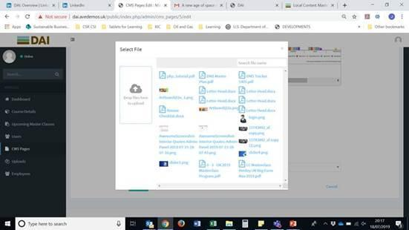

**Note: Course Brochure can be upload only one**

**Katam – There are two questions here.**

1. **Where can I upload ‘Course Brouchers’? – They requested to have a separate folder structure for Course Brouchers, Example, Travel Docs, Registration Forms and Course Materials.**
2. **What is the file size limit for any document that could be uploaded.**

**Comment(22-07-2019):**

1. **if we will go with each field to upload in separate directory then we need to do the upload module functionality for each field.  
     
   So this will be time taking to work for each field. please guide me about this.**

**2. I set 20MB size limit there. previously it was 2MB. I increase this to 20 MB.**

1. I tried to upload the brochure on the Uploads page, to see if it was an issue with the button on the Masterclass CMS page but it didn’t work here either:

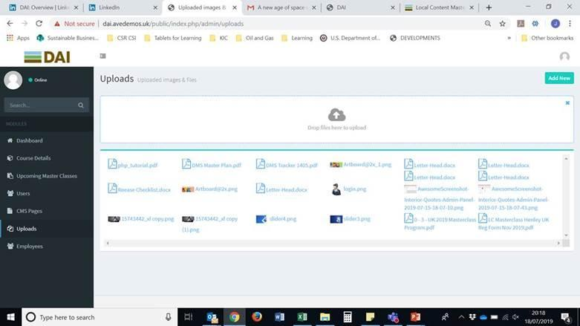

I have attached the course brochure to this email so that you can see the size of the file. It is the only reason I can think of that the system will not allow the upload as I was able to upload the other files. Can you please fix this.

**Note: Till 20 MB file can be upload now**

**Katam – Question: Did you guys checked the size of the document that client sent? It is only 4MB.**

**Comment(22-07-2019):**

**I check size till 3.4 BM**

1. Once I uploaded the registration form on Upcoming Masterclasses, when I try to click the link on the front end (Registration page), this happens:

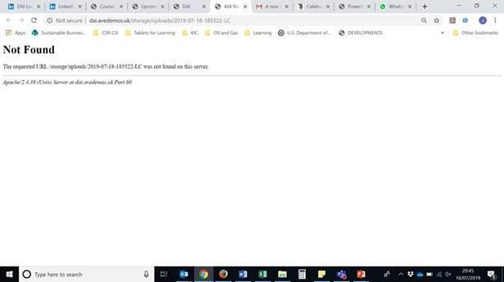

When I tried on Firefox, the box wouldn’t even click so I am not sure what the issue is here – certainly doesn’t appear that it is a Chrome issue.

**Note: Please check now**

**Katam – What do you mean by ‘Please check now’? Is this fixed and an issue?**

**Comment(22-07-2019): This is fixed, it was working fine some how the file name had modified so it was creating issue. I have checked to upload other documents other documents are working fine with upload and I have remove this document from upload module.**

1. Also, I notice that the only file type that it will allow me to upload are PDFs. The registration form is a Word document. How can I upload this?

**Katam – I didn’t see any update on this question? Is this fixed and addressed?**

**Comment(22-07-2019): On any upload section the doc file already working there , I have tested it and if you will see in upload module there are doc files already there has been uploaded.**

1. On the Community of Practice page, there are a couple of issues with inserting the link for the LinkedIn page.

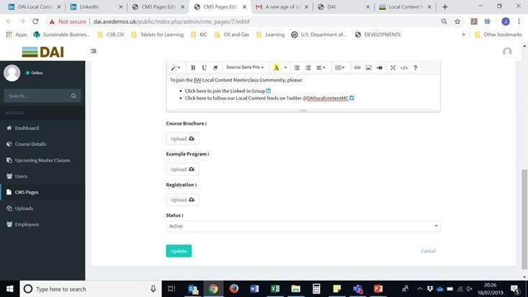

There is an icon for LinkedIn but to insert the link makes this icon disappear:

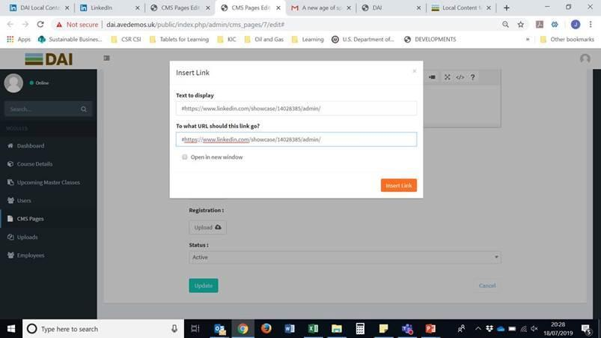

The Text to Display box copies whatever I insert into the second box so that the user end only shows the URL:

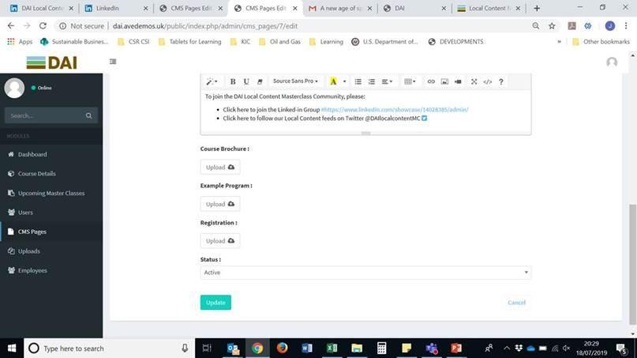

Which looks pretty terrible:

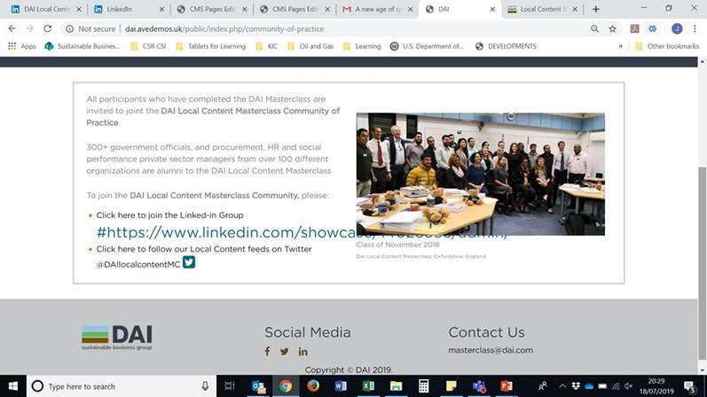

Moreover, when you click that hyperlink from the front end, this happens:

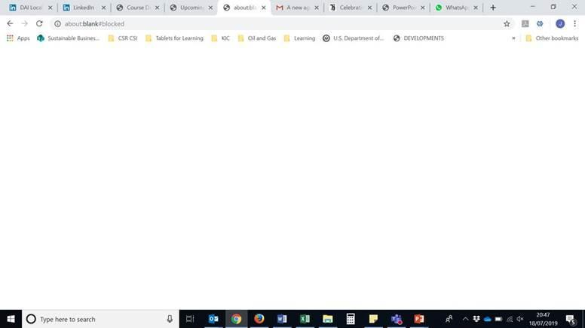

**Note: I have fix this issue**

**Katam – What fix has been given here?**

**Comment(22-07-2019):   
if you need to give any icon for the link then click where you want that icon in editor and then click on link button you will get two text boxes in popup, in that in top text box put icon code whatever you are using and in the bottom text box you put the link url then it will work.**

Also, on the admin side, why are there buttons to upload Course Brochure etc. on the Community of Practice admin page? These should not be here – please remove as they do not serve any function:

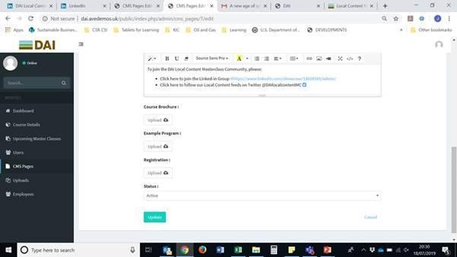

**Note: This can not be controlled because the pages are common . so could not be control**

**Katam – Be much in detail and clear. To be honest I didn’t understand anything that you are trying to convey.**

**Comment(22-07-2019): cms pages is a module and that have the some fields as showing in the image. so these fields could not be manage for a specific page. these will be available for each page.**

**if you need separate fields for each then each page will have separate module as per Application standard right now.**

1. All of the CMS pages have the option to be Active or Inactive – please remove this option as I don’t want these pages to be accidentally removed from the front end:

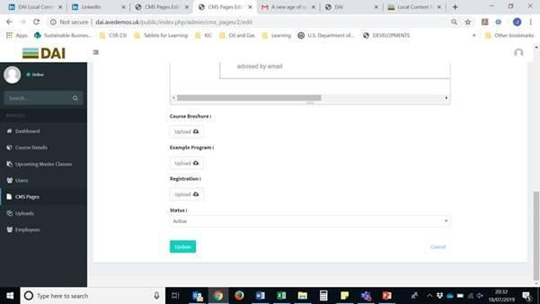

**Katam – Is this fixed as per the request?**

**Comment(22-07-2019): Yes It is fixed. if you are still getting this then please clear your browser cache.**

1. I am having some issues logging in. I created a username for myself and received an email with the password which I entered. At first it allowed me to do this on Firefox but not on Chrome. Various things have happened. First this:

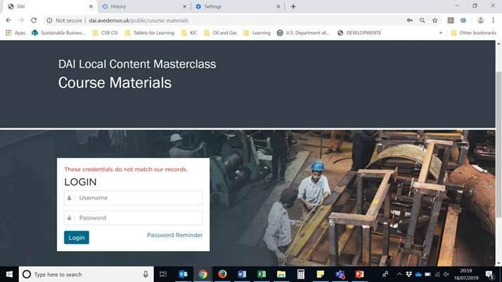

Even after I cleared the cache, this came up:

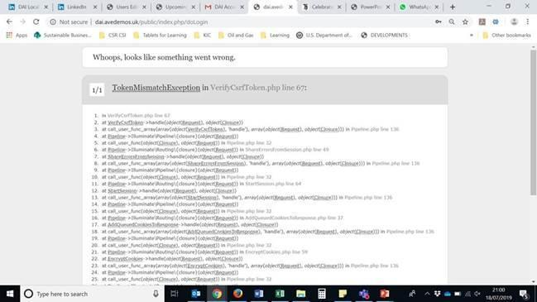

**Note: This is issue with the laravel because if you open login page for some time the it error comes. I will check some solution for this.**

**Katam – if this is the issue with the framework, why did you guys used this frame work?**

**Comment(22-07-2019): I have fixed it already. if the scrf token will expire then it will return to login page**

On Firefox I can get as far as this page but it will not allow me to click on the Course Materials button to download the files which I have uploaded on the admin side. Why is this button not working?

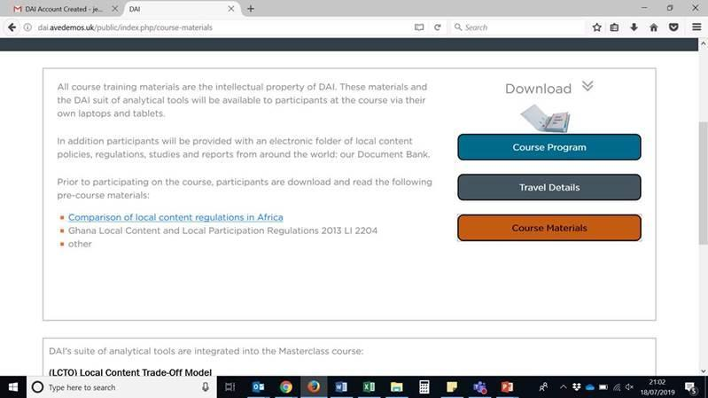

**Note: DONE**

**Katam – What do you mean by ‘Done’? Did you fixed this issue? If yes, what was the root cause?**

**Comment(22-07-2019): there I did not get anything to fix and if the course material are there then click on the “Course material” button then list of course material will show otherwise it will not show list**