Dear Kishore,

Bad news, and extremely disappointing, given our recent discussions. I have tried to look through the portal and test it out as per Katam’s assurances that everything is now ready. I will summarise below:

1. When I click on the tab for course materials, this comes up:

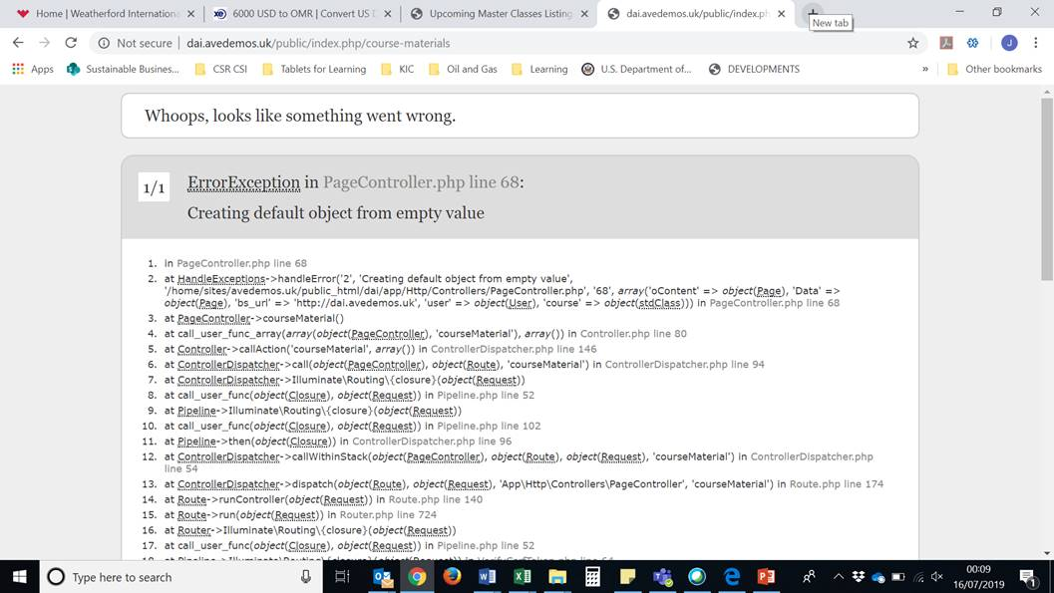

I logged in on the back end. I tried to create a user but when I entered the details, no drop down appeared to allocate the course. What happened to the menu to add somebody to a course?

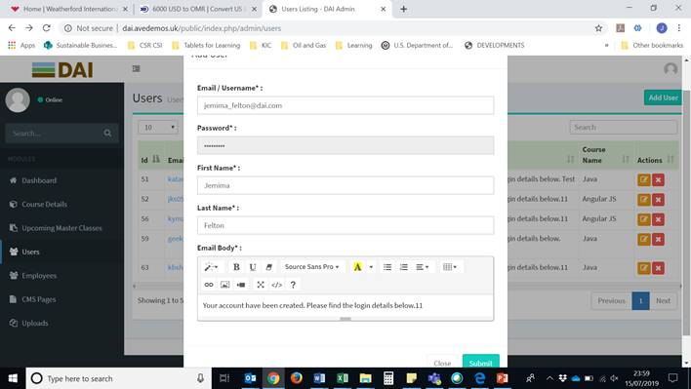

Moreover, when I submitted the details, I got this page:

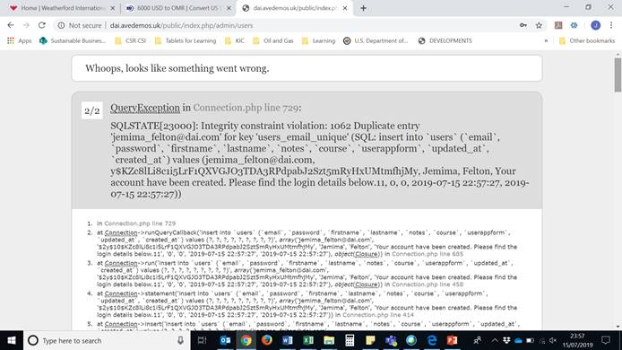

I added a course to Upcoming Masterclasses from the list and when I tried to add a file (registration form), the button isn’t working. None of the upload buttons are working on any of the CMS pages:

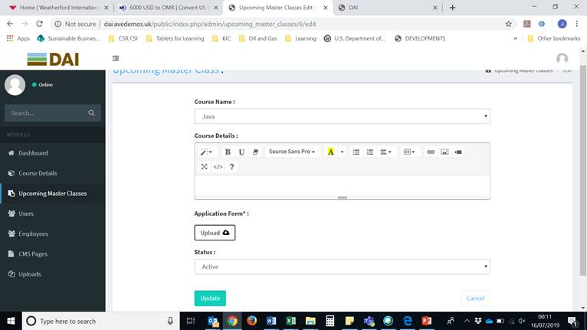

I am now trying to remove the dummy files from this menu:

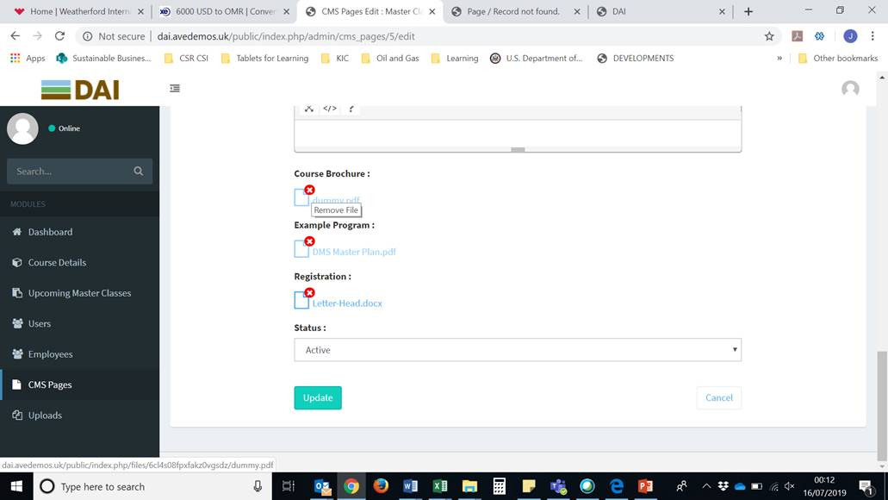

But when I click on the red X to remove them, I get this page, otherwise I just get the file downloading each time, rather than removing it:

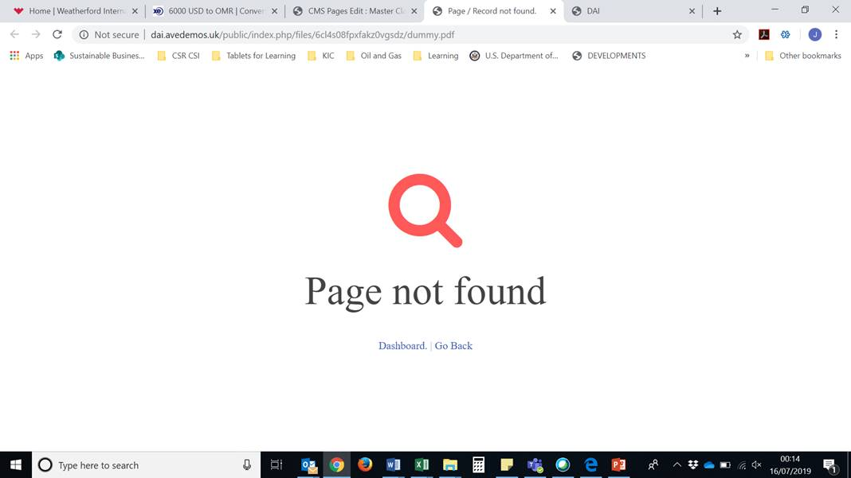

There is more but I see little point in filling an email with more of this.

What is going on? I thought you were delivering the final solution. Katam assured me that it was ready to go, that I was simply testing it out. I am not going to check anything else because this clearly isn’t working.

I would like to know the reason why.