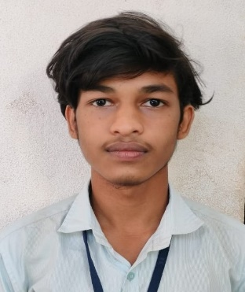

**PAWAN**

# Chandthimar House, Bantwal Post and Taluk, Dakshina Kannada, Karnataka – 574211

# 8431364807 | pawanbangera561@gmail.com

**DIPLOMAS Y HOBBIES**

**Formaciones :** Diplomados, Congresos, xxxxxxxxxx xxxxxx xxxxxxxxx xxxxxxxxxxxxxxxxx

**Hobbies:** xxxxxxxxxxxxxxxxxxxxxxxxxxxxxx



**TECHNICAL SKILLS**

**OBJECTIVE**

* AI & ML
* Python
* Java
* HTML
* Project Management
* Computer Network
* MS Word
* PowerPoint

# Enthusiastic and dedicated AI & ML Diploma student seeking opportunities to apply academic knowledge and skills in a real-world environment. Eager to contribute to innovative projects and learn from experienced professionals in the field.

**ACADAMIC QUALIFICATION**

* Holy Saviour English Medium School,Agrar

SSLC

76.96%

2021

* Government Polytechnic Bantwal

Diploma in Computer Science & Engineering

77.80% (up to 5th sem)

2024

**PERSONNEL PROFILE**

* Father’s Name : Damodar
* Mother’s Name : Geetha
* Date of Birth :08/02/2006
* Gender : Male
* Fluent : Kannada ,Hindi ,

English & Tulu

**CERTIFICATES**

**PROJECT**

* Introduction to Artificial Intelligent from Infosys Spring Board
* Data visualization using Python from Infosys Spring Board
* Explore Machine Learning using Python from Infosys Spring Board

Mini Project : Gold Price Prediction

In this Mini Project we have started the program by exploring the data and analyzing it by using preprocessing method and graphically represented the dataset. After preprocessing we divided the dataset into train & test set and also we applied Linear Regression, RandomForestClassifier and ANN models to find the best accuracy and compared it by Bar graph. In this comparision we got the best accuracy in ANN model about 99%.

**DECLARATION**

**DEF Solutions**| 20XX – 20XX

I here by declare that above given particulars are true to the best of my knowledge.

**Place : BANTWAL**

**Date :**

**(PAWAN)**

**Dear Job Seeker,**

Vice President of Operations

* Salesforce CRM
* SAP ERP
* Tableau
* Asana

English: Native

Spanish: Bilingual

French: Intermediate

If you're having difficulty composing your resume, here are some free resources available that can assist you in creating a strong resume that highlights your suitability for the position to potential employers:

* [How to Make a Good Resume](https://www.my-resume-templates.com/how-to-make-a-resume/?utm_source=Word_Doc&utm_medium=Model_CV_Link&utm_campaign=MDC_Downloads)
* [Skills to Put on a Resume](https://www.my-resume-templates.com/skills-to-put-on-a-resume/?utm_source=Word_Doc&utm_medium=Model_CV_Link&utm_campaign=MDC_Downloads)
* [Resume Objective Examples](https://www.my-resume-templates.com/resume-objective-examples/?utm_source=Word_Doc&utm_medium=Model_CV_Link&utm_campaign=MDC_Downloads)

Also, discover other free downloadable and ready-to-fill CV templates in Word format:

* [Basic Resume Templates](https://www.my-resume-templates.com/basic-resume-templates/?utm_source=Word_Doc&utm_medium=Model_CV_Link&utm_campaign=MDC_Downloads)
* [Modern Resume Templates](https://www.my-resume-templates.com/modern-resume-samples/?utm_source=Word_Doc&utm_medium=Model_CV_Link&utm_campaign=MDC_Downloads)
* [Creative Resume Templates](https://www.my-resume-templates.com/creative-cv-templates/?utm_source=Word_Doc&utm_medium=Model_CV_Link&utm_campaign=MDC_Downloads)
* [Professional Resume Templates](https://www.my-resume-templates.com/career-resume-templates/?utm_source=Word_Doc&utm_medium=Model_CV_Link&utm_campaign=MDC_Downloads)
* [Europass CV](https://www.my-resume-templates.com/europass-cv/?utm_source=Word_Doc&utm_medium=Model_CV_Link&utm_campaign=MDC_Downloads)

Best regards,

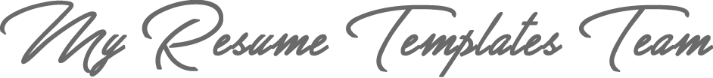

[www.my-resume-templates.com](https://www.modelos-de-curriculum.com/?utm_source=Word_Doc&utm_medium=Model_CV_Link&utm_campaign=MDC_Downloads)

**COPYRIGHT - PLEASE READ THIS MESSAGE**

©These examples of free resume templates are the property of Azurius S.L. You may   
download and modify them without any problem if they are for personal use.

Do not forget to remove this copyright notice before modifying and printing your CV.

You cannot resell these examples or their derivatives. You cannot make them available on other websites without our consent. For any related questions, please write to us at contact@my-resume-templates.com

Discover more resume templates at [www.my-resume-templates.com](https://www.my-resume-templates.com/)