Government of Karnataka

**DEPARTMENT OF TECHNICAL EDUCATION**

**GOVERNMENT POLYTECHNIC BANTWAL**

**BANTWAL, DAKSHINA KANNADA-574211**

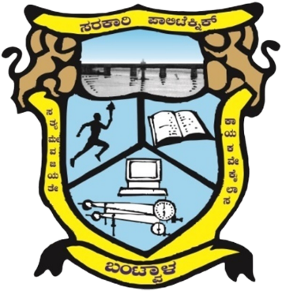

INTERNSHIP REPORT (20CS61S)

**ON**

**ARTIFICIAL INTELLIGENCE AND MACHINE LEARNING**

**Diploma in**

**“Computer Science &Engineering”**

**By**

|  |  |  |  |  |  |  |  |  |  |  |
| --- | --- | --- | --- | --- | --- | --- | --- | --- | --- | --- |
| **Name** | **PAWAN** | | | | | | | | | |
| **Register No.** | **1** | **6** | **3** | **C** | **S** | **2** | **1** | **0** | **3** | **4** |