#include <bits/stdc++.h>

using namespace std;

void F(string input_string, int &ind, bool &check);

void E(string input_string, int &ind, bool &check)

{

if ((input_string[ind]) == 'i')

{

ind++;

F(input_string, ind, check);

}

}

void F(string input_string, int &ind, bool &check)

{

char l = input_string[ind];

if (l == '+')

{

ind++;

if (input_string[ind] == 'i')

{

ind++;

F(input_string, ind, check);

}

else

{

cout << "error" << endl;

check = true;

return;

}

}

else

{

return;

}

}

int main()

{

cout << "Enter the string:";

string st;

cin >> st;

int ind = 0;

bool check = false;

st += '$';

E(st, ind, check);

if (!check && st[ind] == '$')

{

cout << "parsing successful" << endl;

}

else

{

cout << "parsing unsuccessful" << endl;

}

return 0;

}

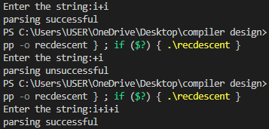

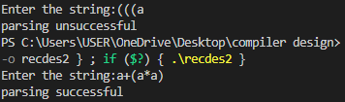

#include <bits/stdc++.h>

using namespace std;

// E->TE'

// E'->+TE/epsilon

// T->FT'

// T'->*FT'/epsilon

// F->(E)/id

void Edash(string input_string, int &ind, bool &check);

void T(string input_string, int &ind, bool &check);

void Tdash(string input_string, int &ind, bool &check);

void F(string input_string, int &ind, bool &check);

void E(string input_string, int &ind, bool &check)

{

T(input_string, ind, check);

Edash(input_string, ind, check);

}

void Edash(string input_string, int &ind, bool &check)

{

char l = input_string[ind];

if (l == '+')

{

ind++;

T(input_string, ind, check);

Edash(input_string, ind, check);

}

else

{

check = true;

return;

}

check=false;

}

void T(string input_string, int &ind, bool &check)

{

F(input_string, ind, check);

Tdash(input_string, ind, check);

}

void Tdash(string input_string, int &ind, bool &check)

{

char l = input_string[ind];

if (l == '*')

{

ind++;

F(input_string, ind, check);

Tdash(input_string, ind, check);

}

else

{

check = true;

return;

}

check=false;

}

void F(string input_string, int &ind, bool &check)

{

if (isalnum(input_string[ind]))

{

ind++;

}

else if (input_string[ind] == '(')

{

ind++;

E(input_string, ind, check);

if (input_string[ind] == ')')

{

ind++;

}

else

{

check = true;

return;

}

check=false;

}

else

{

cout<<"error"<<endl;

check=true;

return;

}

}

int main()

{

cout << "Enter the string:";

string st;

cin >> st;

int ind = 0;

bool check = false;

st += '$';

E(st, ind, check);

if (!check && st[ind] == '$')

{

cout << "parsing successful" << endl;

}

else

{

cout << "parsing unsuccessful" << endl;

}

return 0;

}