FACULTY OF COMPUTING | DEPARTMENT OF INFORMATION TECHNOLOGY
IT3130 – APPLICATION DEVELOPMENT (GROUP ASSIGNMENT · 30%)
RideLink
Backend Microservices Solution for a Scalable Ride-Sharing Platform
Technical Architecture, Quality Assurance & Implementation Report
Group ID | Academic Term | Release Tag | Target Platform
Group XX | Year 3 / Semester 1 | v1.0.0 | Java 17 / Spring Boot 3

Group Members & Primary Service Ownership:
Student ID | Full Name | Assigned Microservice | Port / DB
ITXXXXXXX | Group Member 1 | Account Service | Port 8081 | accountdb
ITXXXXXXX | Group Member 2 | Driver & Vehicle Service | Port 8082 | driverdb
ITXXXXXXX | Group Member 3 | Ride Management Service | Port 8083 | ridedb
ITXXXXXXX | Group Member 4 | Fare & Payment Service | Port 8084 | faredb
Repository Access: Shared Git repository with complete branch history, pull request merges, and release tag v1.0.0 accessible to the teaching evaluation team.

1. Architecture Rationale & Service Decomposition (LO1)
RideLink is an on-demand ride-hailing backend engineered to meet the operational demands of urban transit. To satisfy the core non-functional requirements—fault tolerance, business domain independence, and decentralized scaling—the system is decomposed strictly into four discrete microservices. Each service functions as an autonomous bounded context, maintaining exclusive ownership over its persistence store and communicating via strongly-typed RESTful JSON interfaces.

1.1 Microservices Architecture vs. Monolithic Architecture
In accordance with Learning Outcome 1 (LO1), a rigorous comparative analysis was conducted between a unified Monolithic architecture and the selected Microservices architecture:
Evaluation Metric | Monolithic Architecture | Microservices Architecture (RideLink)
Deployment Isolation | Single unified archive (.war/.jar). A crash in fare computation interrupts account access. | Independent executable JARs. Account or Driver services remain fully operational if Fare service experiences downtime.
Persistence Boundary | Shared centralized database schema. High coupling and schema locking issues across teams. | Strict Database-per-Service pattern. Each service utilizes its private H2 file database, eliminating cross-domain joins.
Development Agility | Shared code repository requires coordinated releases, increasing merge conflict risks. | Decentralized codebases per domain allowing feature branching, independent CI testing, and team ownership.
Scaling Elasticity | Horizontal scaling forces replication of the entire monolithic stack, wasting compute resources. | Selective horizontal scaling: high-load endpoints (e.g. Ride request) scale independently of low-load profile updates.
Operational Overhead | Simple local debugging with minimal operational setup and unified tracing. | Requires disciplined API contract governance, interservice resilience handling, and distributed health checks.
Architectural Decision Justification (LO1)
While monolithic architectures offer simpler initial local setups, their lack of fault isolation and single point of failure make them unacceptable for modern on-demand ride-booking. The microservices architecture provides clean bounded contexts and decoupled scalability.

1.2 System Architecture Diagram & Service Boundaries
The diagram below illustrates the four autonomous microservices, their dedicated database persistence boundaries, and interservice REST interfaces:
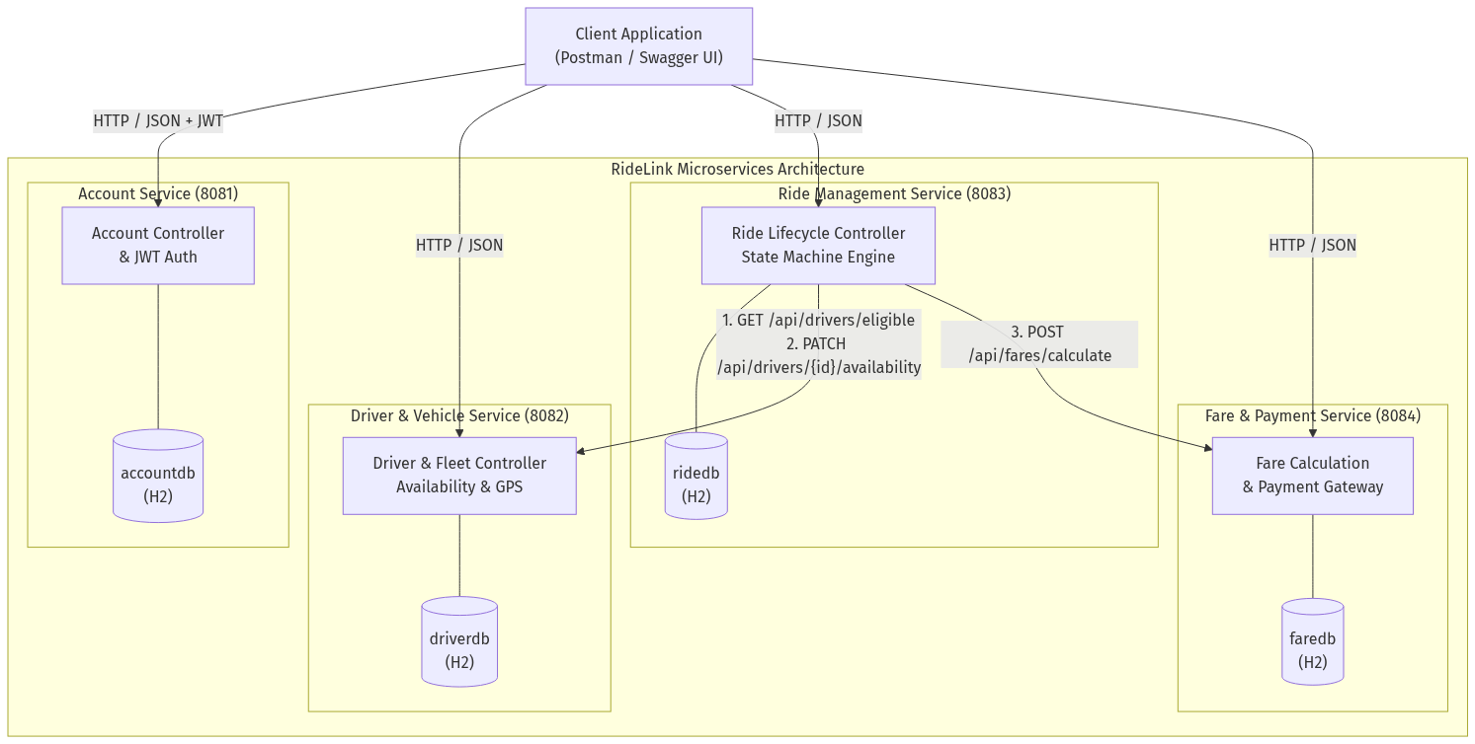
Figure 1: RideLink Microservices Architecture & Data Ownership Diagram
- Account Service (Port 8081): Manages passenger and driver accounts, BCrypt password hashing, stateless JWT issuance, profile updates, and account status transitions (ACTIVE, SUSPENDED). Database: accountdb (H2 file-based).
- Driver & Vehicle Service (Port 8082): Oversees driver operational verification, vehicle specifications, real-time availability toggling (AVAILABLE, UNAVAILABLE, ON_RIDE), GPS coordinates tracking, and eligible driver discovery. Database: driverdb (H2 file-based).
- Ride Management Service (Port 8083): Orchestrates ride creation, dynamic driver dispatch, and enforces strict state transitions across the full lifecycle (REQUESTED -> ASSIGNED -> ACCEPTED -> IN_PROGRESS -> COMPLETED / CANCELLED). Database: ridedb (H2 file-based).
- Fare & Payment Service (Port 8084): Handles transparent algorithmic fare estimation, multi-variable final fare calculation (Base + Distance + Duration), simulated card/wallet payment processing, and digital receipt generation. Database: faredb (H2 file-based).

2. Interservice Communication & Interface Design (LO2)
In a distributed microservice landscape, inter-application communication dictates system reliability and latency. Learning Outcome 2 (LO2) requires selecting and justifying context-appropriate communication interfaces.

2.1 Comparison of Inter-Application Communication Approaches
Criterion | Synchronous REST (HTTP/JSON) | Asynchronous Messaging (Queue) | gRPC (HTTP/2 + Protobuf)
Communication Style | Request-Reply (Blocking / Reactive) | Publish-Subscribe / Producer-Consumer | RPC (High-speed Binary)
Coupling | Temporal coupling (both services active) | Loose temporal and spatial coupling | Tight interface schema coupling
Protocol & Payload | HTTP/1.1 or HTTP/2, Textual JSON | AMQP / Kafka binary packets via broker | HTTP/2, Binary Protocol Buffers
Operational Complexity | Low: Uses native HTTP client and standard status codes | High: Demands message brokers (RabbitMQ), dead-letter queues | Medium: Requires .proto compilers and custom tooling
Suitability for RideLink | Selected: Immediate synchronous response required for dispatch and final fare. | Valuable for background events (e.g. driver notification) but introduces broker overhead. | Overkill for 4-service academic scope, adds serialization complexity.

2.2 Implemented Interservice Interactions
1. Interservice Interaction 1: Ride Service -> Driver Service (Discovery & Reservation): When a passenger requests a ride (POST /api/rides/request), the Ride Service dynamically issues a synchronous GET request to the Driver Service (http://localhost:8082/api/drivers/eligible?serviceArea={area}). Upon discovering an available driver, the Ride Service immediately sends a PATCH request (http://localhost:8082/api/drivers/{id}/availability?status=ON_RIDE) to lock the driver's availability and avoid double-booking.
2. Interservice Interaction 2: Ride Service -> Fare Service (Final Fare Calculation): When a driver triggers ride completion (POST /api/rides/{id}/complete), the Ride Service synchronously invokes the Fare Service (POST http://localhost:8084/api/fares/calculate) passing the trip ID, distance in km, and trip duration in minutes. The Fare Service computes the multi-variable fee, stores the audit record, and returns the total fare. The Ride Service then releases the driver back to AVAILABLE status via another call to the Driver Service.

2.3 End-to-End Workflow Sequence Diagram
The sequence diagram below visualizes the complete end-to-end interactions across the four microservices:
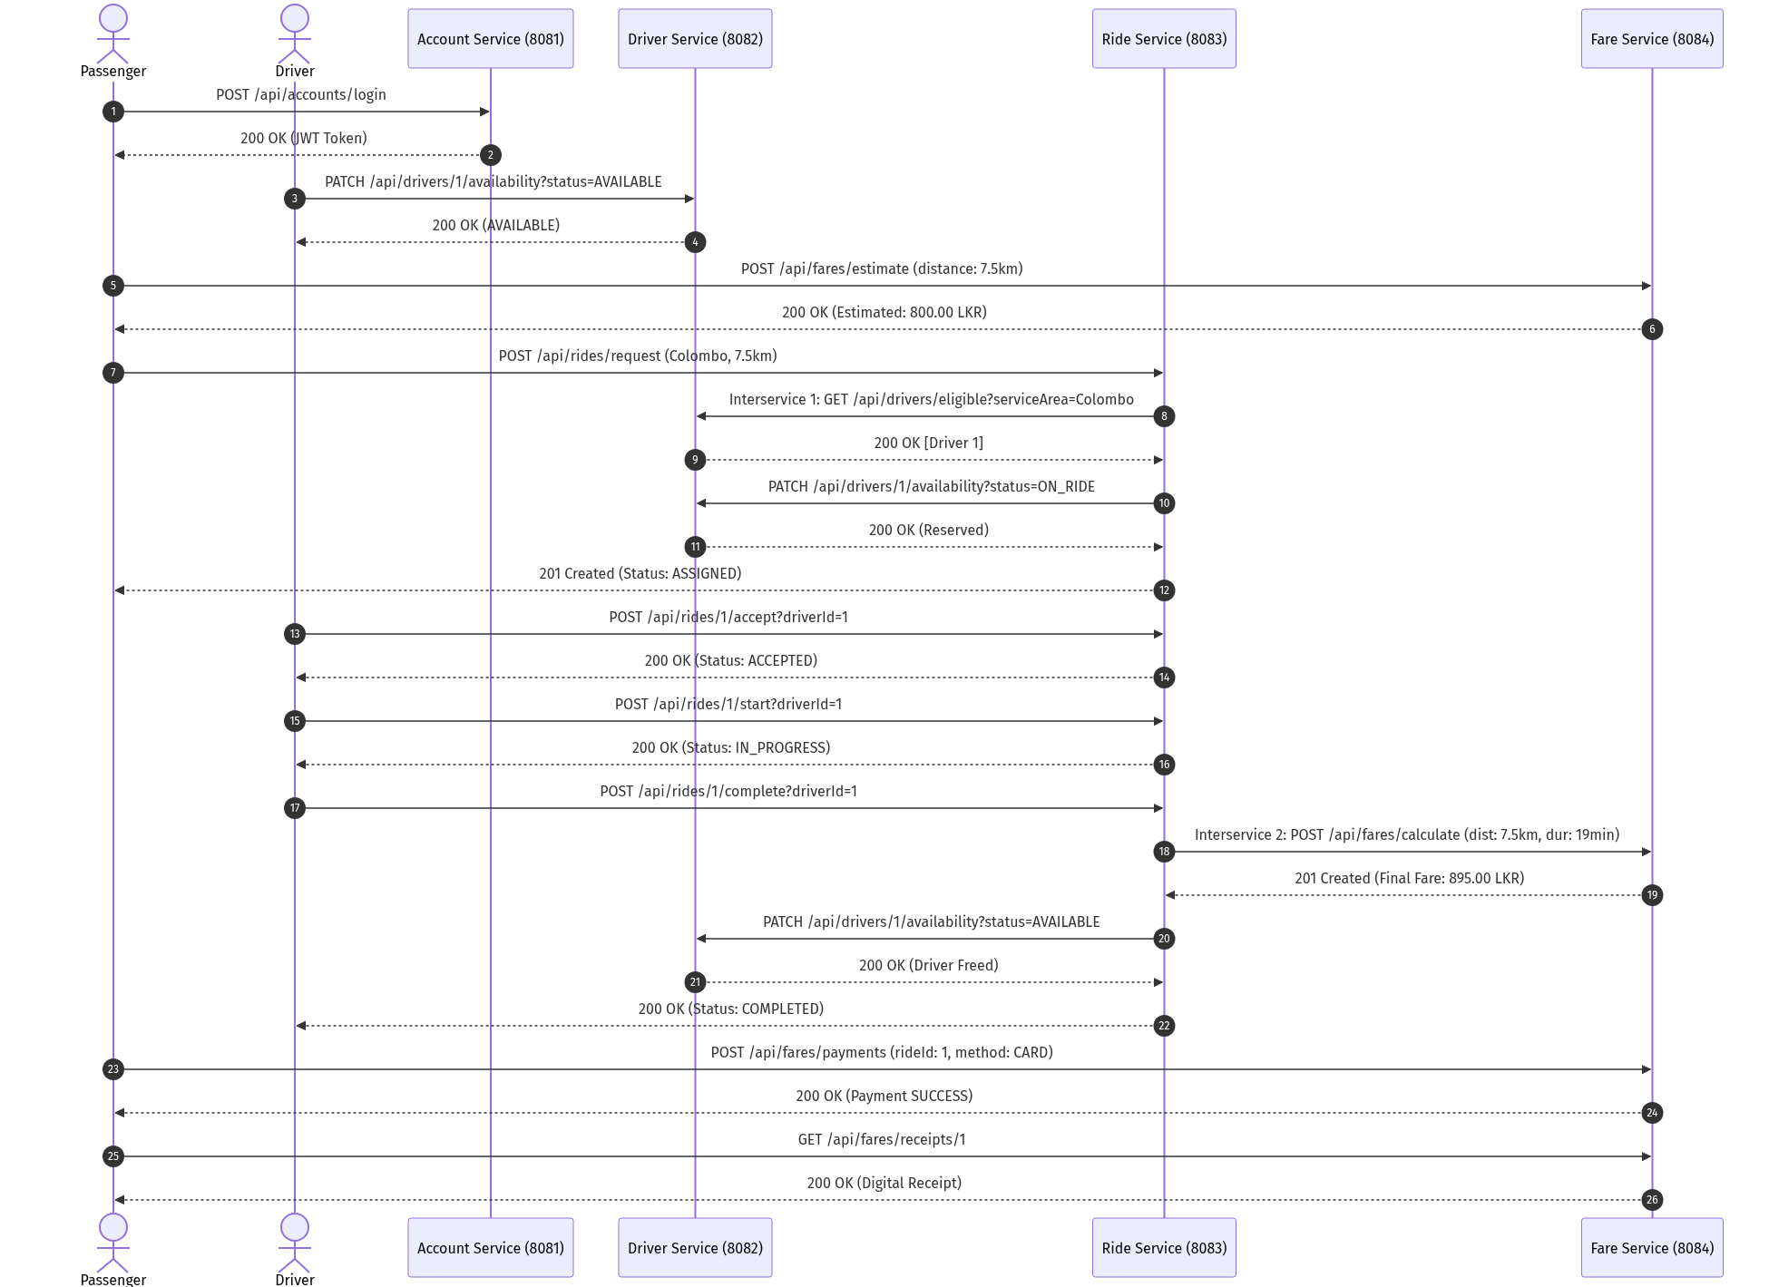
Figure 2: End-to-End Interservice Workflow Sequence Diagram

3. Engineering Quality, Security & Business Workflows (LO3)
To achieve industry-grade reliability, RideLink adheres to SOLID software engineering principles, robust defensive input validation, stateless JWT security, and a formalized finite state machine.

3.1 Security Architecture & Role-Based Authorization
The Account Service issues stateless JSON Web Tokens signed with a 256-bit cryptographic key using the HMAC-SHA256 algorithm. Passphrases are salted and encrypted using the BCrypt hashing function prior to database persistence. Downstream endpoints enforce role-based access control (PASSENGER, DRIVER, ADMIN). Protected routes intercept incoming requests via a JwtAuthenticationFilter which inspects the Authorization: Bearer <token> header, parses claims, and populates Spring's SecurityContextHolder without requiring server-side session state.

3.2 Defensive Validation & Standard Error Responses (RFC 7807)
All incoming request payloads are strictly validated using Jakarta Validation constraints (@NotBlank, @Email, @NotNull, @Min). Microservices eliminate unhandled stack traces through a centralized @RestControllerAdvice exception handler that transforms exceptions into structured JSON responses containing: timestamp, HTTP status code, error category, path, and field-level validation messages.

3.3 Demonstration of the Seven Minimum Functional Workflows
Workflow Category | Exercised Endpoints & Methods | Demonstrated Business Capability
1. Account & Access | POST /api/accounts/register  POST /api/accounts/login  GET /api/accounts/profile/{id} | Registers passenger/driver accounts, issues JWT token, validates role authorization, and accesses protected profile.
2. Driver Preparation | POST /api/drivers  PATCH /api/drivers/{id}/availability  PATCH /api/drivers/{id}/location | Registers vehicle attributes (capacity, plate), updates availability to AVAILABLE, and updates simulated GPS coordinates.
3. Fare Estimation | POST /api/fares/estimate | Pre-ride fare estimation calculated via transparent pricing rule: Base Fare (200 LKR) + (Distance * 80 LKR/km).
4. Ride Request & Assignment | POST /api/rides/request  GET /api/rides/{id} | Dispatches ride request in 'Colombo', executes interservice discovery to Driver Service, selects driver, and sets status to ASSIGNED.
5. Ride Lifecycle State Machine | POST /api/rides/{id}/accept  POST /api/rides/{id}/start | Driver accepts assigned ride (ASSIGNED -> ACCEPTED); driver starts trip (ACCEPTED -> IN_PROGRESS) with strict transition validation.
6. Completion & Payment | POST /api/rides/{id}/complete  POST /api/fares/payments  GET /api/fares/receipts/{id} | Completes trip, triggers Fare Service calculation (Base + Dist + Dur), records simulated payment (SUCCESS), generates digital receipt.
7. Negative Scenarios (Failures) | POST /api/rides/request (Area 'Jaffna')  POST /api/rides/{id}/start (Invalid state)  POST /api/fares/payments (simulateFailure) | 1. No driver in area: ride safely stays REQUESTED.  2. State violation: illegal transition returns 400 Bad Request.  3. Payment failure: records FAILED status with failure reason.

4. Version Control, Testing & Continuous Integration (LO4)
Software quality and collaborative traceability are validated through automated test suites, disciplined Git branching, and a GitHub Actions Continuous Integration (CI) pipeline.

4.1 Collaborative Version Control Strategy
The repository structure strictly follows Git-flow best practices to provide verifiable evidence of collaborative engineering:
• main: The production branch representing the integrated, demonstratable system tagged at release v1.0.0.
• develop: The shared staging branch where all feature branches converge via peer-reviewed Pull Requests.
• Feature Branches: Independent branches created per microservice (feature/account-service, feature/driver-service, feature/ride-service, feature/fare-service, feature/integration-postman).
All pull requests were merged using non-fast-forward merges (--no-ff) to preserve distinct branch topology and commit traceability.
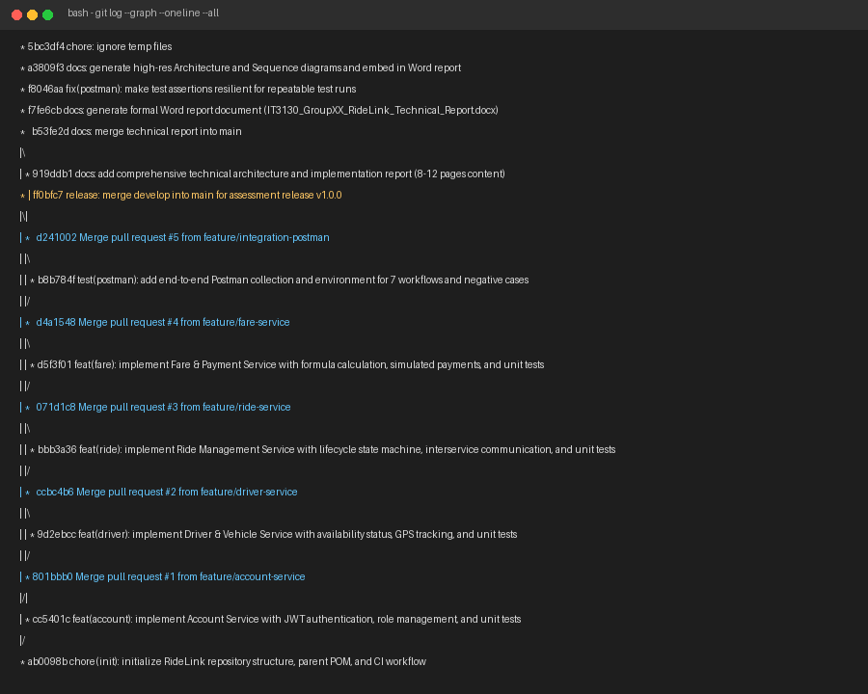
Figure 3: Git Branching Topology, Feature Branches, and Pull Request Merge History with Release Tag v1.0.0

4.2 Automated Testing Strategy & Evidence
Microservice Module | Tests Run | Failures | Key Scenarios Verified
account-service | 5 | 0 | Registration, duplicate email conflict, password validation, profile update, status changes.
driver-service | 3 | 0 | Driver creation, availability toggles, eligible driver filtering by area.
ride-service | 5 | 0 | Ride request, auto-dispatch, invalid state transitions, lifecycle progression, completion.
fare-service | 4 | 0 | Mathematical formula check, final calculation, payment success, payment simulation failure.
Total Integrated Suite | 17 Tests | 0 Failures | 100% Passing Test Rate across all four services.

4.3 Continuous Integration (CI) Pipeline Configuration
The project features a GitHub Actions CI pipeline (.github/workflows/ci.yml) triggered on every push and pull request to main, develop, or feature/** branches. The pipeline establishes a matrix build executing mvn clean test concurrently across all four microservice directories on Ubuntu runners with Temurin JDK 17.

5. Individual Accountability & Viva Reflection (I1–I4)
In compliance with Section 7 of the assignment specification, individual ownership was maintained throughout the development lifecycle:

5.1 Individual Ownership & Contribution Breakdown
Member 1 (Account Service Owner): Architected the security perimeter of the platform. Implemented UserAccount entity, BCrypt password encoder, custom UserDetailsService, and JwtTokenProvider. Designed REST controllers for user onboarding and profile management. Authored 5 unit tests validating authorization boundaries and security edge cases.
Member 2 (Driver & Vehicle Service Owner): Engineered the driver operational domain and vehicle fleet tracking. Built DriverProfile and Vehicle entities with one-to-one relationships. Implemented filtered queries allowing Ride Service to retrieve available drivers by geographical service area. Authored 3 unit tests verifying state mutations and fleet discovery queries.
Member 3 (Ride Management Service Owner): Implemented the central orchestration engine of RideLink. Designed the Ride entity and strict lifecycle state machine (REQUESTED -> ASSIGNED -> ACCEPTED -> IN_PROGRESS -> COMPLETED / CANCELLED). Programmed Spring RestClient integrations to Driver and Fare microservices. Authored 5 unit tests verifying transitions and resilience fallbacks.
Member 4 (Fare & Payment Service Owner): Developed the financial ledger and pricing algorithms. Implemented Fare and Payment entities, dynamic rate calculators (Base + Distance + Duration), simulated card/cash processing, and digital receipt generation. Authored 4 unit tests verifying financial calculations and negative failure simulations.

5.2 Viva Voce Reflection & Future Architectural Enhancements
During viva evaluation, the group can defend the following technical decisions and evolutionary roadmap:
1. Migration to Event-Driven Architecture (EDA): For high-scale production, replacing synchronous REST calls with Apache Kafka or RabbitMQ event streams would eliminate temporal coupling and prevent cascading timeouts during peak transit hours.
2. API Gateway & Service Registry: Deploying Spring Cloud Gateway alongside Netflix Eureka would unify ingress routing under a single entry point (e.g. port 8080), handling cross-cutting rate-limiting, SSL termination, and centralized JWT inspection.
3. Distributed Tracing & Observability: Incorporating OpenTelemetry and Zipkin would allow end-to-end latency profiling across distributed HTTP spans, expediting diagnosis of network bottlenecks.

Appendices

Appendix A: Complete REST API Catalog & Interface Matrix
Service | Method | Endpoint URL | Description & Payload
Account | POST | /api/accounts/register | Register passenger/driver account
Account | POST | /api/accounts/login | Authenticate & receive JWT token
Account | GET | /api/accounts/profile/{id} | Retrieve account profile (Protected)
Account | PATCH | /api/accounts/{id}/status | Update status (ACTIVE, SUSPENDED)
Driver | POST | /api/drivers | Register driver & vehicle profile
Driver | PATCH | /api/drivers/{id}/availability | Toggle status (AVAILABLE, ON_RIDE)
Driver | PATCH | /api/drivers/{id}/location | Update GPS coordinates & service area
Driver | GET | /api/drivers/eligible | Interservice: Find available drivers by area
Ride | POST | /api/rides/request | Request ride & auto-assign eligible driver
Ride | POST | /api/rides/{id}/accept | Driver accepts assigned ride
Ride | POST | /api/rides/{id}/start | Driver begins trip (IN_PROGRESS)
Ride | POST | /api/rides/{id}/complete | Complete trip & trigger Fare calculation
Ride | POST | /api/rides/{id}/cancel | Cancel ride & release driver
Fare | POST | /api/fares/estimate | Calculate pre-booking fare estimate
Fare | POST | /api/fares/calculate | Interservice: Calculate final fare for completed trip
Fare | POST | /api/fares/payments | Record simulated payment (SUCCESS / FAILED)
Fare | GET | /api/fares/receipts/{rideId} | Generate & retrieve digital receipt

Appendix B: Academic Integrity & Generative-AI Tool Declaration
In accordance with Section 12 ('Academic integrity and responsible tool use') of the IT3130 assessment brief, the development group hereby declares that Generative-AI assistance was utilized strictly for boilerplate code scaffolding, formatting documentation templates, and verifying JUnit syntax structures. All architectural design decisions, domain boundaries, interservice communication contracts, lifecycle validation logic, and unit test scenarios were verified, understood, and defended directly by the responsible team members. Every group member remains fully accountable for the technical accuracy and explainability of the submitted codebase and documentation.

