Introduction

* **MessageBuilder** can be used to generate the CSV message structure.
* Tool accepts the message structure specification in excel format. Below information also describes how to prepare structure specification in excel file.
* Currently this tool only supports CSV message structure. But as part of further enhancement, the user will be able to create INHOUSE message structure.

Structure Specification In Excel

* Create a new excel file and store it in some folder.
* Open excel file and go to sheet1 tab.
* Below screenshot describes the message structure specification format.

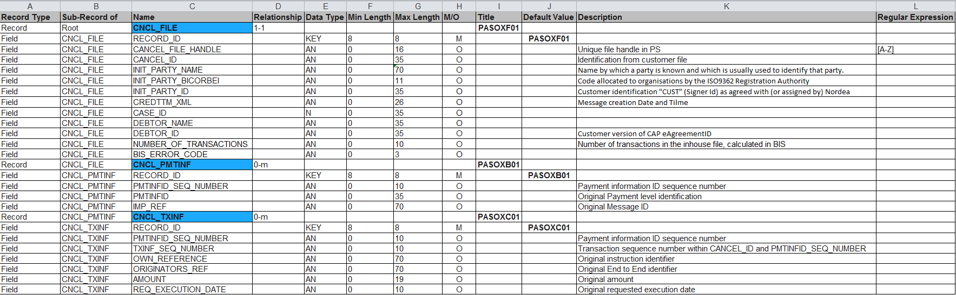

1. First row will always be the header record. And it must contain the columns as specified in the above screenshot (Column name does not matter but position of column does).
2. Below description for each column:

* **Record Type** :

User need to mention if the row has the record or field information.

Acceptable values for this column is either “**Record**” or “**Field**”.

* **Sub-Record Of** :

In order to specify if the record/field of the current row is sub-record of a particular record then user has to specify the record name (get it from **Name** column) in this column.

If the record is first record then put “**Root**” as shown in above screenshot.

* **Name** :

User has to mention the record/field name in this column.

* **Relationship** :

Relationship defines the minimal and maximal number of occurrences of a particular record/field. Below are the acceptable values for allowed relationships, and they are:

* “**1-1**” for one-to-one relationship.
* “**1-m**” for one-to-many relationship.
* “**m-m**” for many-to-many relationship.
* “**0-1**” for zero-to-one relationship.
* “**0-m**” for zero-to-many relationship.
* **Data Type** :

Tool supports only alphanumeric and numeric datatypes for fields. More datatypes will be added in later release.

* Put “**AN**” for alphanumeric datatype
* Put “**N**” for numeric datatype
* **Min Length** :

It allows numeric value(only Integer) to specify the minimum allowed digits of the particular field.

* **Max Length** :

It allows numeric value(only Integer) to specify the maximum allowed digits of the particular field.

* **Mandatory/Optional** :

It specifies whether record/field is mandatory or optional. The first/root record will always be mandatory by default.

* Put “**M**” for mandatory.
* Put “**O**” for optional.
* **Title** :

Allows any string for title.

* **Default** **Value** :

Put default value for particular field if any.

* **Description** :

User may put the description about the particular record/field which would be more helpful for other users to understand the significance of the record/field.

* **Regular Expression** :

User may apply a regular expression on particular field which would.

Tool Guide

1. Double click on MessageBuilder.jar application file. Below application screen will appear on window.

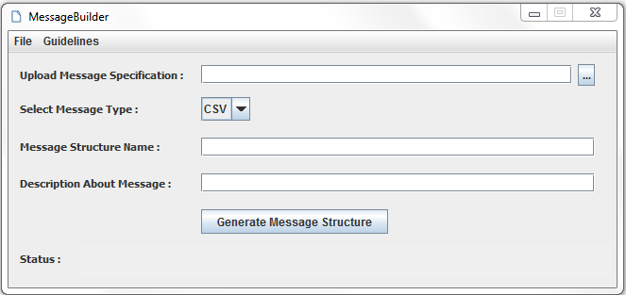

1. In the menu bar you can see the two menus i.e File menu and Guidelines menu.

* You can close the application using **Exit** option in File menu.

1. Once the specification excel document is ready, you can drag that file into the textfield or you can browse the file using browse button located in top right position to the textfield.
2. Select the Message type from combobox. Currently tool only creates the CSV message structure.
3. Provide message structure name in the textfield.(Required field)
4. Provide message description. (Optional)
5. Click on “Generate Message Structure” button to create a new structure.
6. Output file path will be shown in the bottom part of the application.