**STAT-656 Assignment -5**

Submited by

A. Pawan Dixit

UIN: 224004020

**Part 2: Python**

1. **A listing of your python code.**

**from** Class_tree **import** DecisionTree

**from** Class_replace_impute_encode **import** ReplaceImputeEncode

**from** sklearn.tree **import** DecisionTreeClassifier

**from** sklearn.tree **import** export_graphviz

**from** sklearn.model_selection **import** train_test_split

**from** sklearn.model_selection **import** cross_val_score

**from** sklearn.metrics **import** accuracy_score, precision_score, recall_score

**from** sklearn.metrics **import** f1_score, confusion_matrix, classification_report

**from** pydotplus **import** graph_from_dot_data

**import** graphviz

**import** pandas as pd

**import** numpy as np

file_path = '/Users/Pawan/Desktop/MS Folder 😇😇✈️/4th Sem/STAT 656/Week 5/'

df = pd.read_excel(file_path+"CreditHistory_Clean.xlsx")

**print**("Authentication Data with %i observations & %i attributes.\n" %df.shape, df.head())

# Replace str values of atrribute 'purpose' with float values

list_1 = [0,1,2,3,4,5,6,7,8,9,10]

df['purpose'].replace(['0','1','2','3','4','5','6','7','8','9','X'],list_1, inplace = True)

attribute_map = {

    'age':[0,(1, 120),[0,0]],

    'amount':[0,(0, 100000),[0,0]],

    'duration':[0,(1,1000),[0,0]],

    'checking':[2,(1, 2, 3, 4),[0,0]],

    'coapp':[2,(1,2,3),[0,0]],

    'depends':[1,(1,2),[0,0]],

    'employed':[2,(1,2,3,4,5),[0,0]],

    'existcr':[2,(1,2,3,4),[0,0]],

    'foreign':[1,(1,2),[0,0]],

    'good_bad':[1,('bad', 'good'),[0,0]],

    'history':[2,(0,1,2,3,4),[0,0]],

    'housing':[2,(1,2,3,),[0,0]],

    'installp':[2,(1,2,3,4),[0,0]],

    'job':[2,(1,2,3,4),[0,0]],

    'marital':[2,(1,2,3,4),[0,0]],

    'other':[2,(1,2,3),[0,0]],

    'property':[2,(1,2,3,4),[0,0]],

    'purpose':[1,(0,1,2,3,4,5,6,7,8,9,10),[0,0]],

    'resident':[2,(1,2,3,4),[0,0]],

    'savings':[2,(1,2,3,4,5),[0,0]],

    'telephon':[1,(1,2),[0,0]] }

encoding = None # Categorical encoding:  Use 'SAS', 'one-hot' or None

scale    = None  # Interval scaling:  Use 'std', 'robust' or None

scaling  = 'No'  # Text description for interval scaling

rie = ReplaceImputeEncode(data_map=attribute_map, nominal_encoding=encoding,

                          interval_scale = scale, display=False)

#features_map = rie.draft_features_map(df)

encoded_df = rie.fit_transform(df)

# First Integer Designates Data Type

# 0=Interval, 1=Binary, 2=Nominal, 3=Other (No Changes, do not include)

#good_bad is the name of the binary target

varlist = ['good_bad']

X = encoded_df.drop(varlist, axis=1)

y = encoded_df[varlist]

X_train, X_validate, y_train, y_validate = train_test_split(X,y,test_size = 0.3, random_state=7)

# 10 fold CV for trees with different 'max_depth' varying from 1 to 10

**for** m **in** range(0,10):

    dtc = DecisionTreeClassifier(criterion='gini', max_depth = m+1,min_samples_split=5, min_samples_leaf=5)

    dtc = dtc.fit(X_train,y_train)

    features = X_train.columns.values.tolist()

    classes = ['Good', 'Bad']

    FI = list();

**for** i **in** range(0,20):

        FI.append(dtc.feature_importances_[i])

    len(FI)

    FI_df = pd.DataFrame({'Feature':features,'Importance':FI})

    predictions = dtc.predict(X_validate)

    dtc_10_f1 = cross_val_score(dtc, X_train, y_train, cv=10,scoring='f1')

    dtc_10_accuracy = cross_val_score(dtc, X_train, y_train, cv=10,scoring='accuracy')

    dtc_10_precision = cross_val_score(dtc, X_train, y_train, cv=10,scoring='precision')

    dtc_10_recall = cross_val_score(dtc, X_train, y_train, cv=10,scoring='recall')

    dot_data = export_graphviz(dtc, filled=True, rounded=True,class_names=classes, feature_names = features, out_file=None)

    #write tree to png file 'credit_history_tree'

    graph_png = graph_from_dot_data(dot_data)

    graph_path = '/Users/Pawan/Desktop/MS Folder 😇😇✈️/4th Sem/STAT 656/Week 5/'

    graph_png.write_png(graph_path+'credit_history_tree_'+str(m+1)+'.png')

    #Display tree in pdf file 'credit_history_tree.pdf'

    #graph_pdf = graphviz.Source(dot_data)

    #graph_pdf.view('credit_history_tree') #Displays tree

    Matrix = np.empty([10,4])

**for** n **in** range(0,10):

        Matrix[n,0] = dtc_10_precision[n]

        Matrix[n,1] = dtc_10_recall[n]

        Matrix[n,2] = dtc_10_f1[n]

        Matrix[n,3] = dtc_10_accuracy[n]

    Index = ['1st Fold','2nd Fold','3rd Fold','4th Fold','5th Fold','6th Fold','7th Fold','8th Fold','9th Fold','10th Fold'];

    Columns = ['Precision', 'Recall/TPR', 'F1_Score', 'Accuracy']

    Matrix = pd.DataFrame(Matrix, index = Index, columns = Columns)

**print**('\n\nTable of metrics for 10 Folds CV of model with MAX_TREE_DEPTH = '+str(m+1)+'\n')

**print**(Matrix)

**print**('\nAvg_Precision = '+ str(Matrix['Precision'].mean()))

**print**('Avg_Recall = '+ str(Matrix['Recall/TPR'].mean()))

**print**('Avg_F1 = '+ str(Matrix['F1_Score'].mean()))

**print**('Avg_Accuracy = '+ str(Matrix['Accuracy'].mean()))

# Best model based on 10-fold CV results

dtc = DecisionTreeClassifier(criterion='gini', max_depth = 8,min_samples_split=5, min_samples_leaf=5)

dtc = dtc.fit(X_train,y_train)

features = X_train.columns.values.tolist()

classes = ['Good', 'Bad']

FI = list();

**for** i **in** range(0,20):

    FI.append(dtc.feature_importances_[i])

len(FI)

FI_df = pd.DataFrame({'Feature':features,'Importance':FI})

**print**('\nDisplaying Feature Importance for the best Model:\n')

**print**(FI_df)

predictions = dtc.predict(X_validate)

acc = accuracy_score(y_validate, predictions)

pre = precision_score(y_validate, predictions)

tpr = recall_score(y_validate, predictions)

f1 =  f1_score(y_validate,predictions)

Matrix = np.empty([1,4])

Matrix[0,0] = pre

Matrix[0,1] = tpr

Matrix[0,2] = f1

Matrix[0,3] = acc

Index = ['Max_depth_8'];

Columns = ['Precision', 'Recall/TPR', 'F1_Score', 'Accuracy']

Matrix = pd.DataFrame(Matrix, index = Index, columns = Columns)

**print**("\n\nA table of metrics calculated for best model\n")

**print**(Matrix)

1. **A table of the metrics (recall, accuracy, precision and F1) calculated for each of your 10 cross-validation folds.**

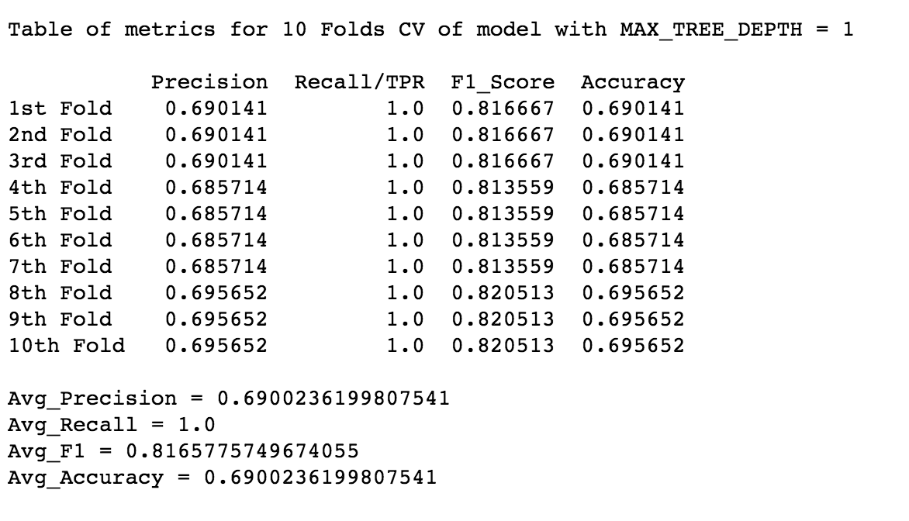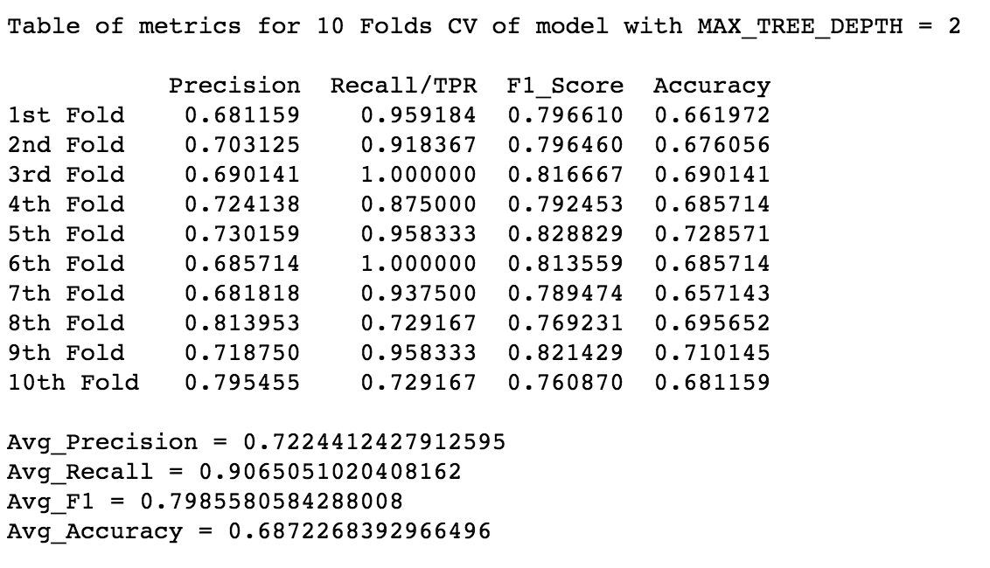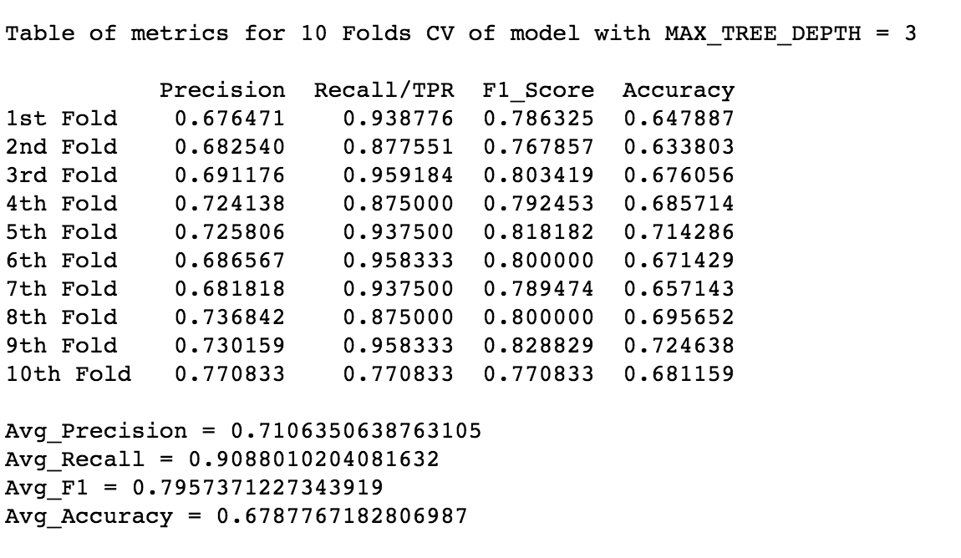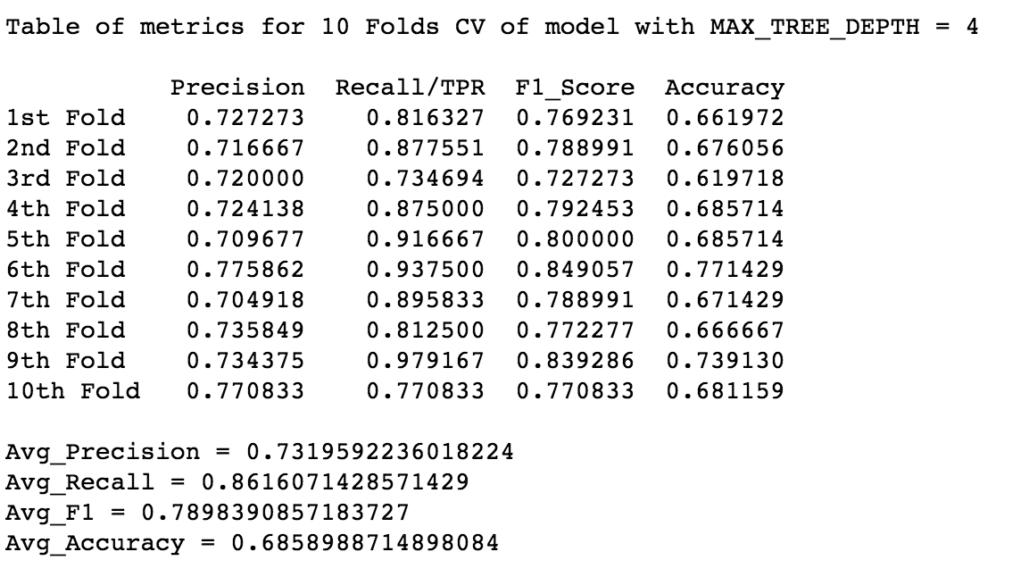

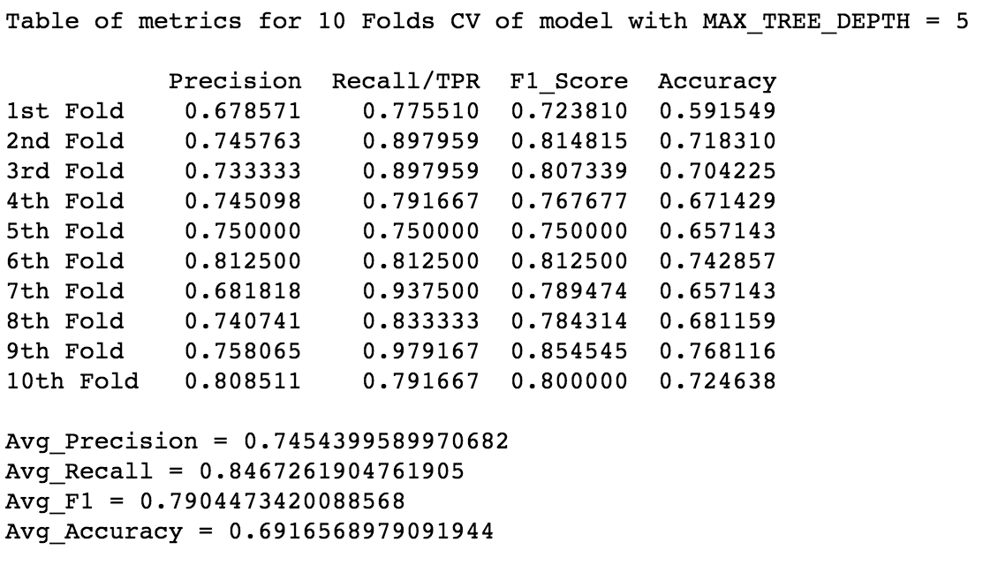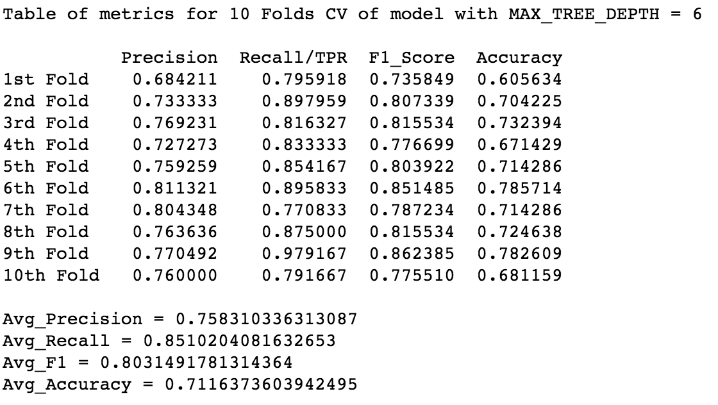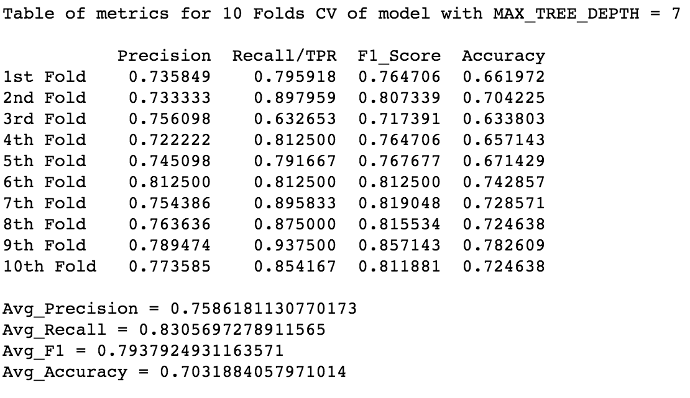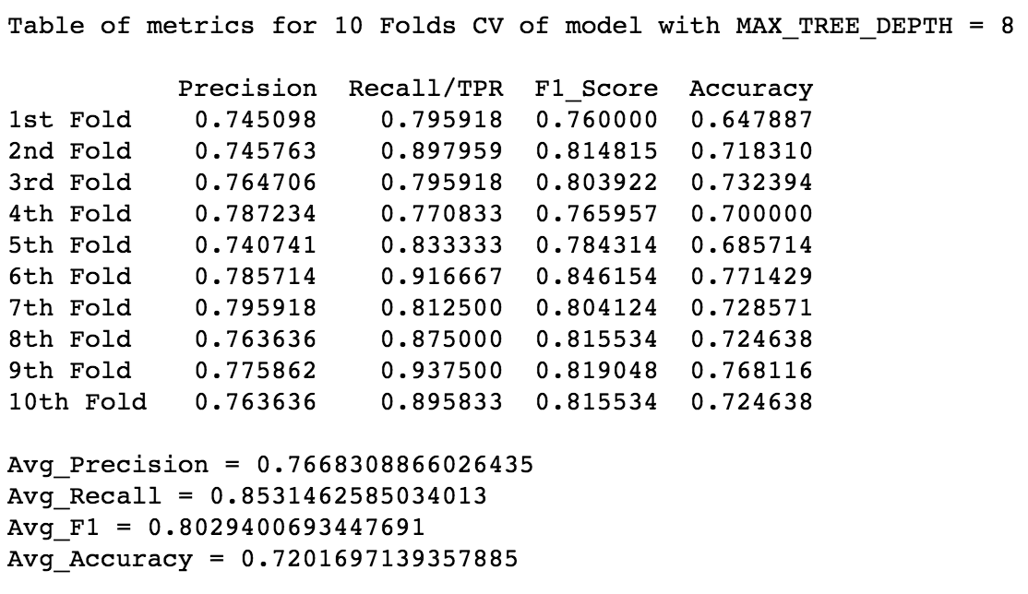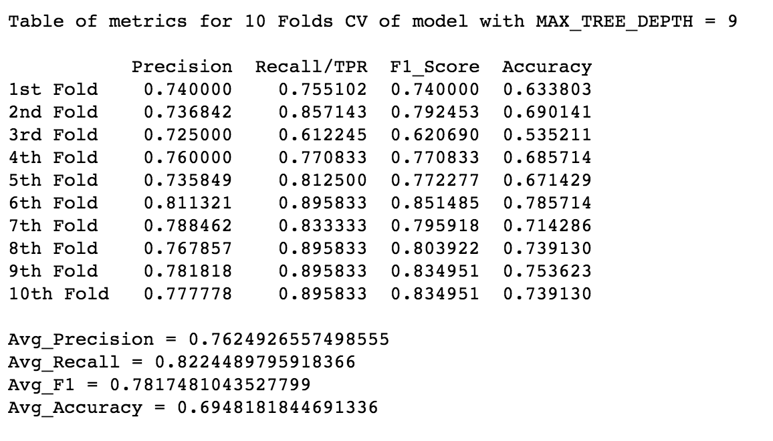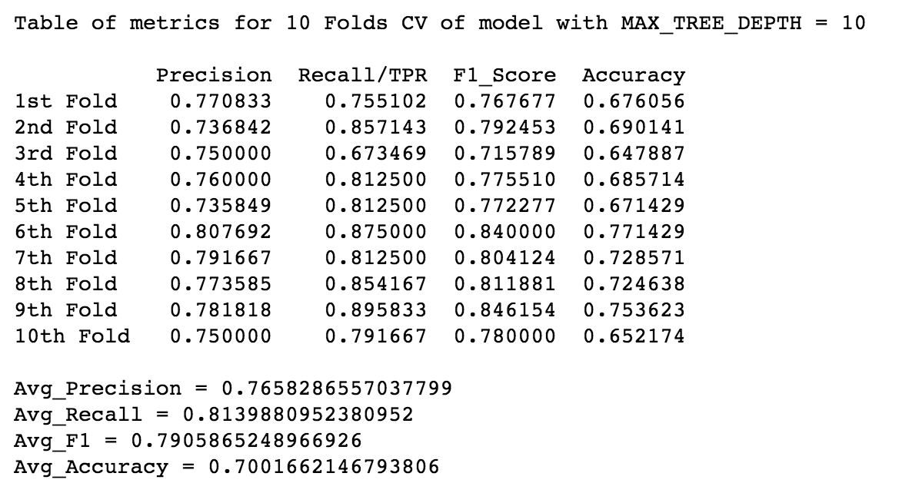

1. **Describe which model you selected from Cross-Validation, and why.**

Model with maximum tree depth 8 has been selected as the best model as it has yielded an accuracy of 72% over 10-folds cross validation. Other metrics also support this decision.

1. **A table of the metrics (recall, accuracy, precision and F1) for the 70/30 split using your selected model.**

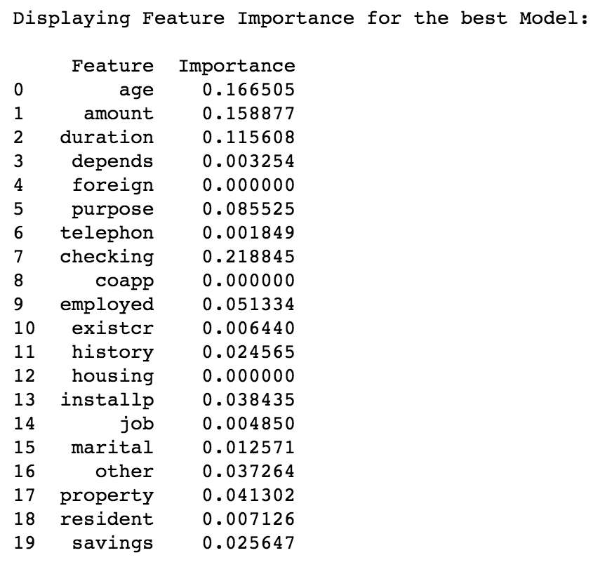

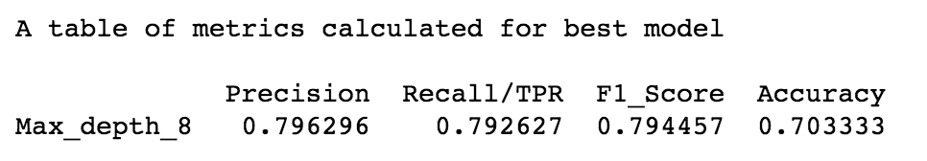

1. **A screen shot of your tree.**