HL7 FHIR Resource Editor

Developed By: Pawan Gurjar

Contents

1. Purpose 1

2. Application Foundation 1

3. Application Functions 1

2.1. Create Json/xml message 2

2.2. Resource tree 2

2.3. View element property 3

2.4. Add/edit element value 3

2.5 Add resource extension 4

2.6 Add element extension 4

2.7 Choice elements 5

2.8 Save resource instance. 5

2.9 Load the saved instance. 6

2.10 Service Client 6

# Purpose

The purpose of this document is to provides information about the application which has been developed to simplify the process of creating the json/xml messages for the FHIR® based resources.

FHIR® is an interoperability standard intended to facilitate the exchange of healthcare information between healthcare providers, patients, caregivers, payers, researchers, and anyone else involved in the healthcare ecosystem.

# Application Foundation

The application is based on the Microsoft Dot Net framework (Version 4.5) and the schema definitions provided by the HL® for the FHIR® resources.

# Application Functions

FHIR resources provide the mechanism to exchange the healthcare information in different formats like json, xml and turtle. However, when it comes to creating the messages for these resources, it becomes a very tedious task considering the resource structure and message syntax etc.

This application has been developed to create the json/xml messages in a hassle-free manner which can help reduce the effort while testing the rest services.

This tool also provides the service client functionality to send the request to rest service. The idea was to avoid the use of separate tool like postman.

Below sections depict the application functionality.

## 2.1. Create Json/xml message

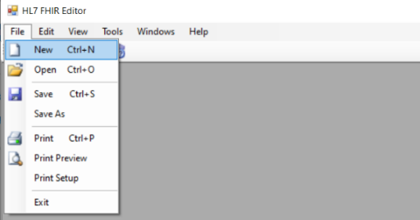

Select FHIR® version.

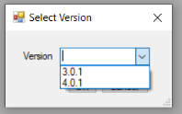

The resources are loaded based on the version selected above. Select the required resource for which the json/xml request has to be created.

## 2.2. Resource tree

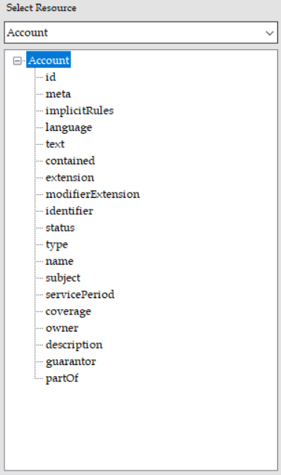

## 2.3. View element property

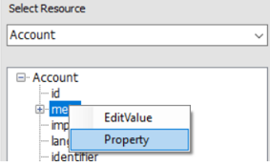

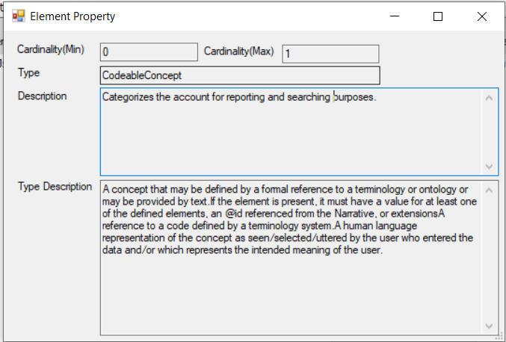

## 2.4. Add/edit element value

Right click or double click the node to edit the value for the field.

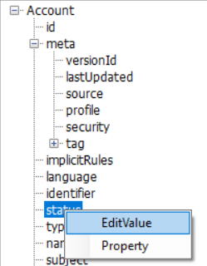

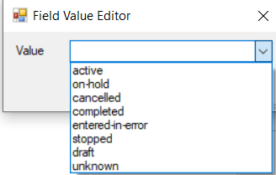

As we edit the field value, the json is created automatically in the service request box. Also, the node is highlighted so that we can know which fields are having the value.

## 2.5 Add resource extension

Application allows to select the value type for the resource extension.

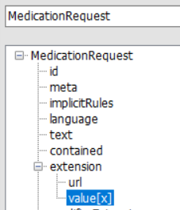

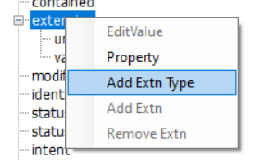

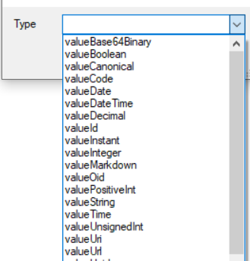

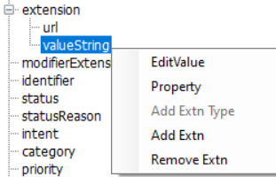

## 2.6 Add element extension

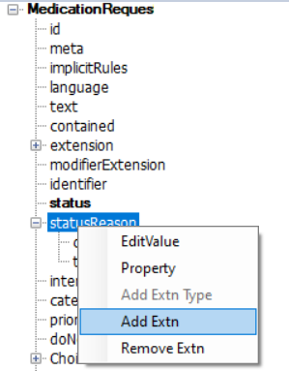

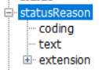

## 2.7 Choice elements

The choice provides the functionality to choose only one of the elements in the list. If value is provided in the other field, then the previous value is removed from the json/xml.

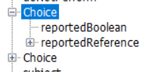

Below snapshots show the json and xml created in the service request pane.

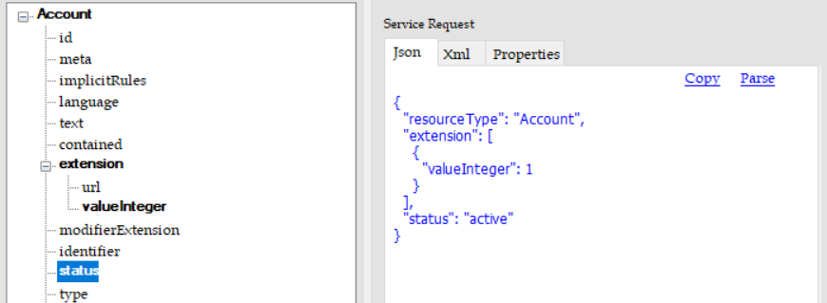

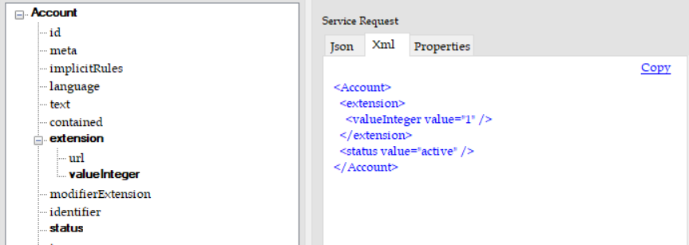

## 2.8 Save resource instance.

Save the resource instance for later use.

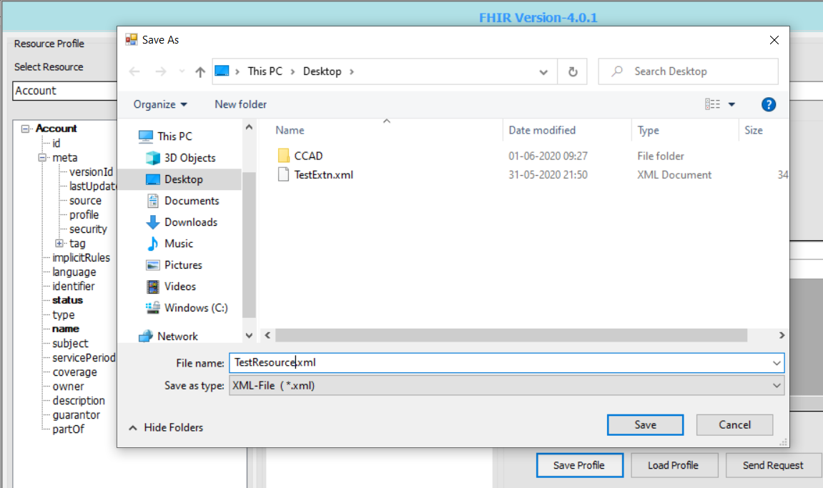

## 2.9 Load the saved instance.

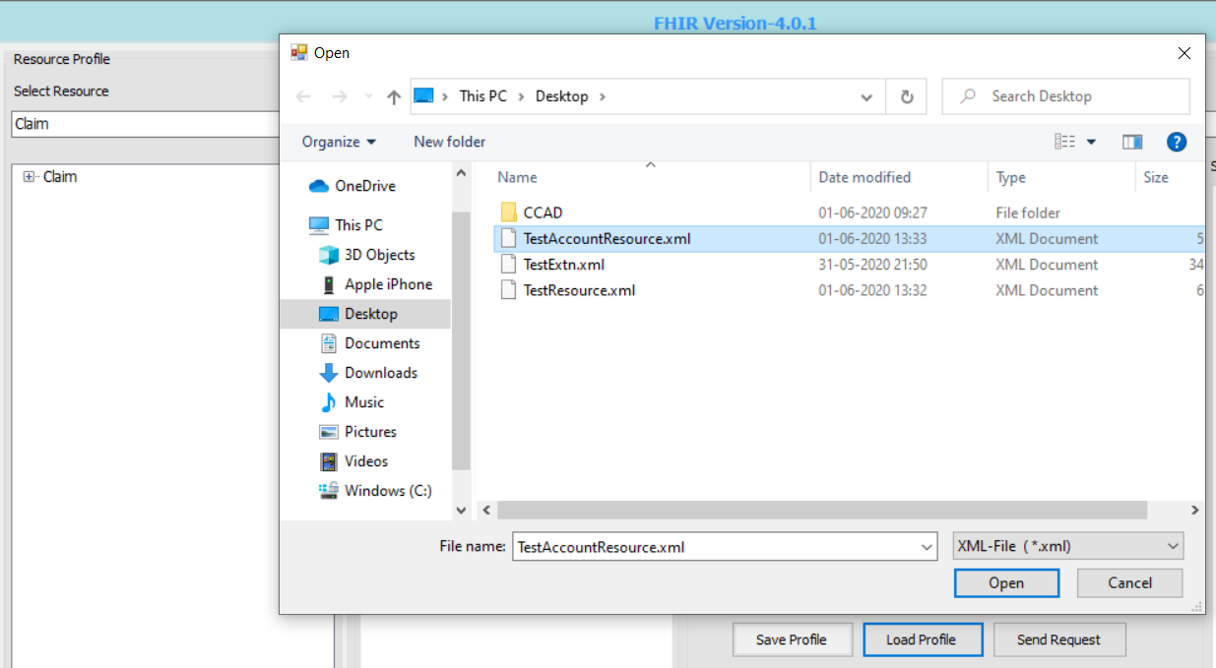

## 2.10 Service Client

The application also provides the service client to eliminate the use of additional tools like postman etc.

Provide the rest api endpoint to send the request to the service.



Select method, e.g POST, GET etc.

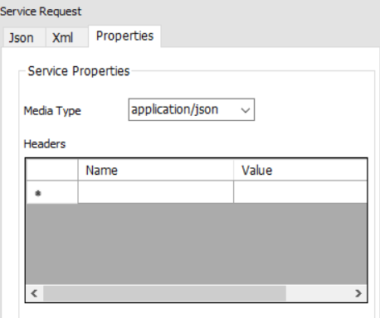

Send the request.



The response is shown in the service response box

