

Student Management System
Technical Developer Documentation
Version 1.0 · Python CLI Application · April 2026
L3 Section A

Pawan Gyawali (26008001)
Kshitiz Yadav (25068609)
Bibek Kushwaha (26002337)
Prakanju Mani Niraula (25068589)

1. Project Overview
Student Management System (SMS) is a multi-purpose command line application in python. It allows administrators, teachers and students to communicate with academic records via a terminal interface. It handles user accounts, academic grades, extra-curricular activities (ECA), analytics, and CSV reporting, all supported by flat-text file storage and atomic write guarantees and automated backups with time stamps.
1.1 Purpose and Goals
· Role-based access control that implements distinct capability limits among Admin, Teacher and Student users.
· Safe management of credentials based on PBKDF2-HMAC-SHA256 password hashing.
· Crash-safe data is written through atomic file replacement patterns.
· In-memory analytics and visual charting (matplotlib/pandas) with no API dependencies.
· Zero-configuration first-run configuration that bootstraps an administrative account in an interactive manner.
1.2 Technology Stack
Component | Technology | Purpose
Language | Python 3.x | Core runtime
Data persistence | Plain-text files (.txt, pipe-delimited) | Flat-file database
Analytics & Charts | pandas ≥ 2.0, matplotlib ≥ 3.8, numpy ≥ 1.24 | Data analysis and visualization
Password hashing | hashlib (PBKDF2-HMAC-SHA256) | Credential security
Terminal I/O | ANSI escape codes, getpass | Styled CLI, masked input

1.3 Directory Structure
Student Management System/
├── main.py # Entry point; menu routing
├── auth.py # Authentication, lockout, first-run setup
├── core.py # User class hierarchy (Admin, Teacher, Student)
├── database.py # File-based CRUD and backup engine
├── analytics.py # Statistics, charts, CSV export
├── ui.py # ANSI styling, prompts, layout helpers
├── Data/
├── users.txt / passwords.txt / grades.txt / eca.txt / logs.txt
├── backup/ Auto-generated timestamped backups
Exports/ CSV report output directory
2. Architecture Overview
The application adheres to a layered architecture and to strict dependency flow (unidirectional only). ui.py is a pure utility layer which is imported by all the modules.database.py is the only file that reads/writes files. Core and analytics.py contain business logic and main.py ties it all together with menu functions.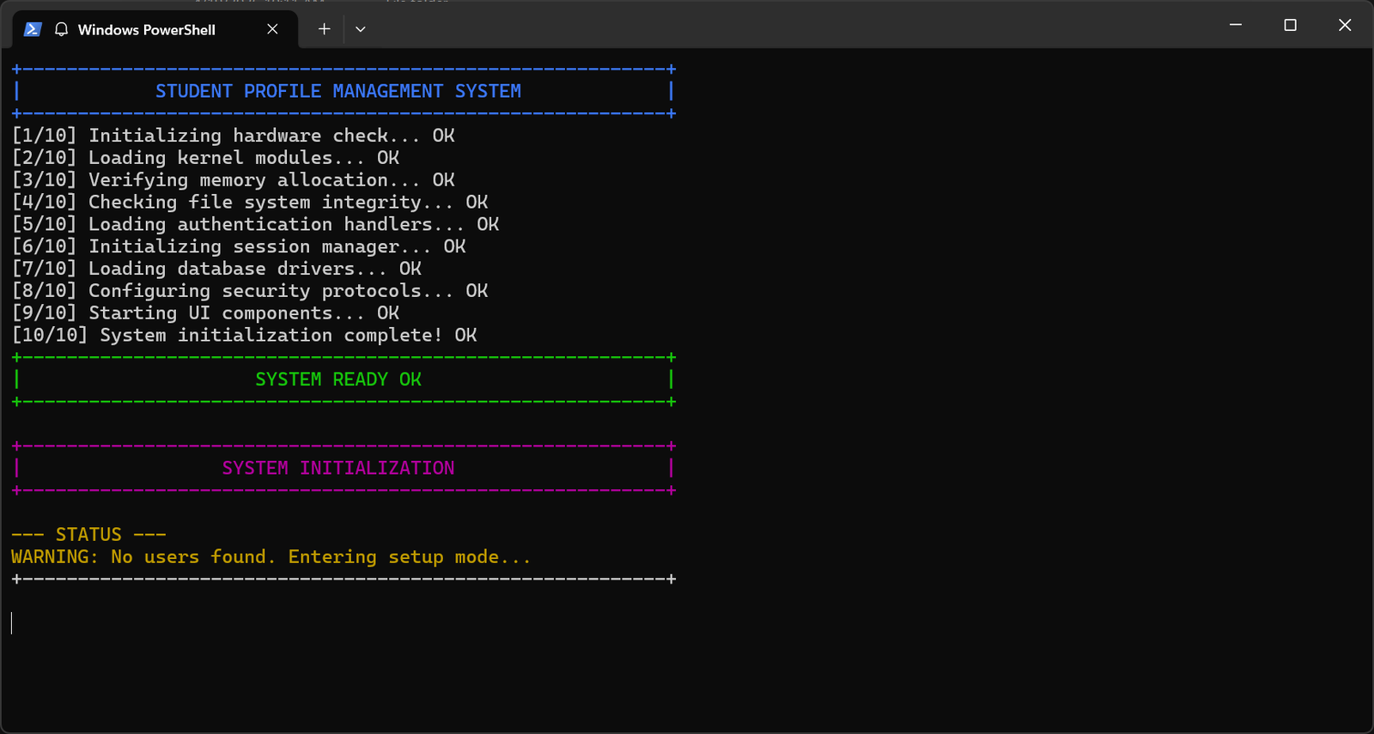

3. Module Reference
3.1 ui.py: Terminal UI & Utilities
A stateless utility module imported by every other module. Provides ANSI color constants, terminal layout helpers, password hashing, and input validation. Has no project-level imports.
Function | Description
hash_password(password) | PBKDF2-HMAC-SHA256 hash with 16-byte random salt. Returns "salt_hex:key_hex".
verify_password(password, stored) | Verifies against PBKDF2 (new) and plain SHA-256 (legacy) formats.
validate_email / validate_username / validate_password | Regex/length validation for all credential fields.
print_menu(title, options, user) | Renders user info bar → page header → menu options in a bordered frame.
boot_system() / logout_sequence() | Animated startup and logout sequences with staged progress messages.
error / success / warning(text) | Wrap text in colorized "ERROR:", "SUCCESS:", or "WARNING:" prefix strings.

3.2 database.py: File-Based Persistence Layer
Implements a flat-file database using five pipe-delimited text files. The Database class is instantiated once as a module-level singleton (db = Database()) and imported by all data-access modules.
All mutating operations use _atomic_write() — writes to a temp file then uses os.replace() (atomic on POSIX) to swap into place. Before every write, _backup_all() creates timestamped copies of all four primary data files in Data/backup/.
Live Data File Screenshots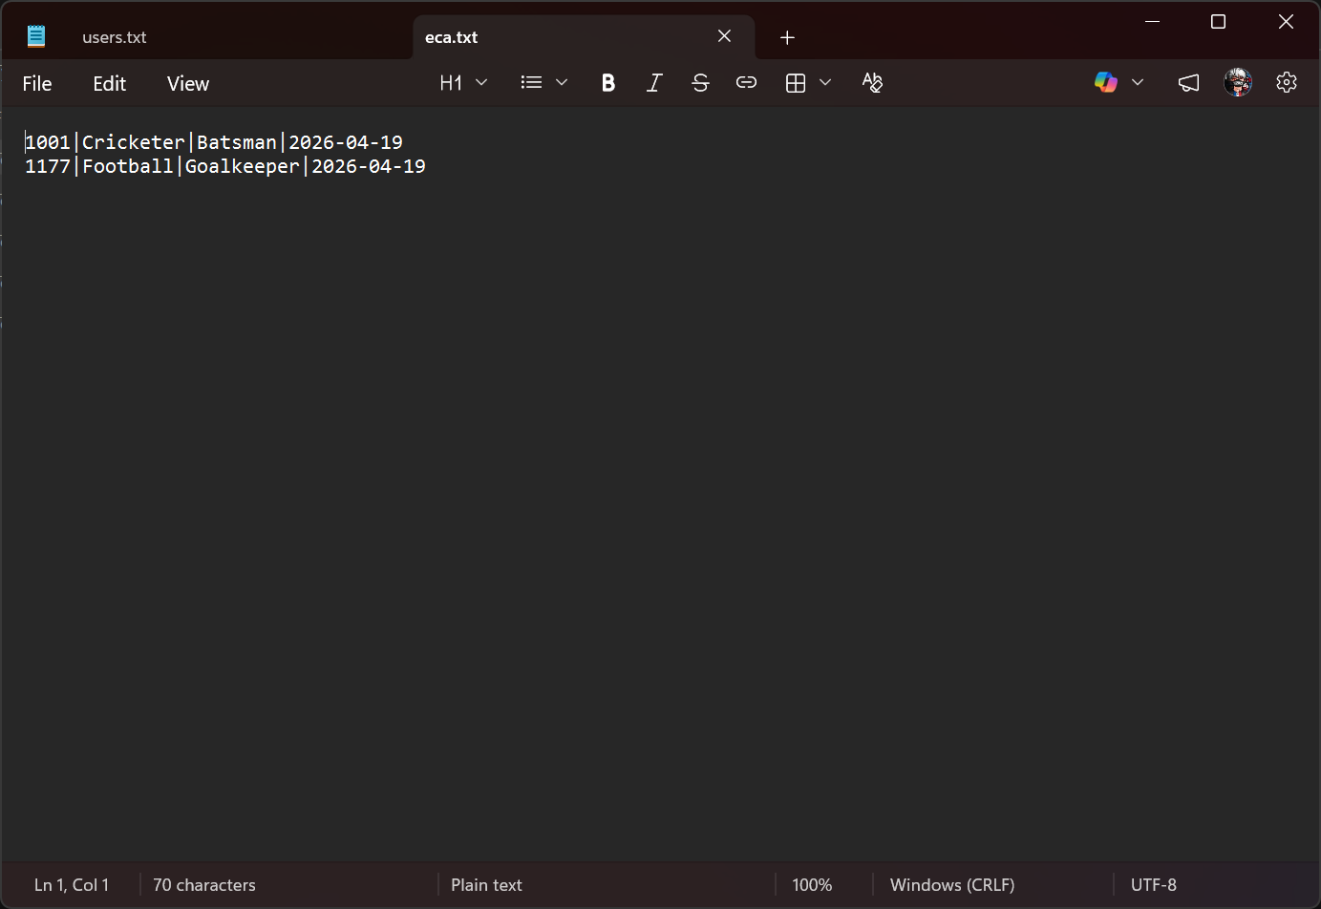
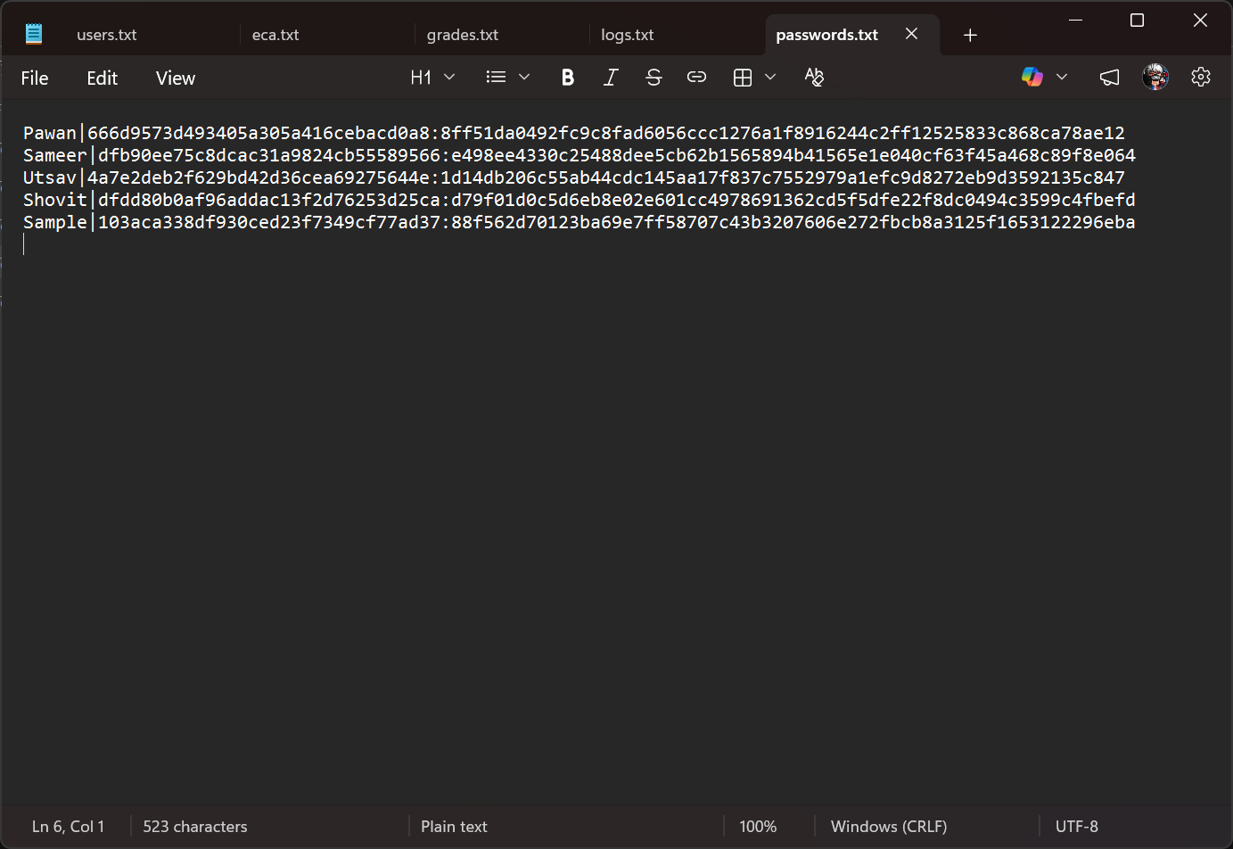
grades.txt — grade ledger with subject and score
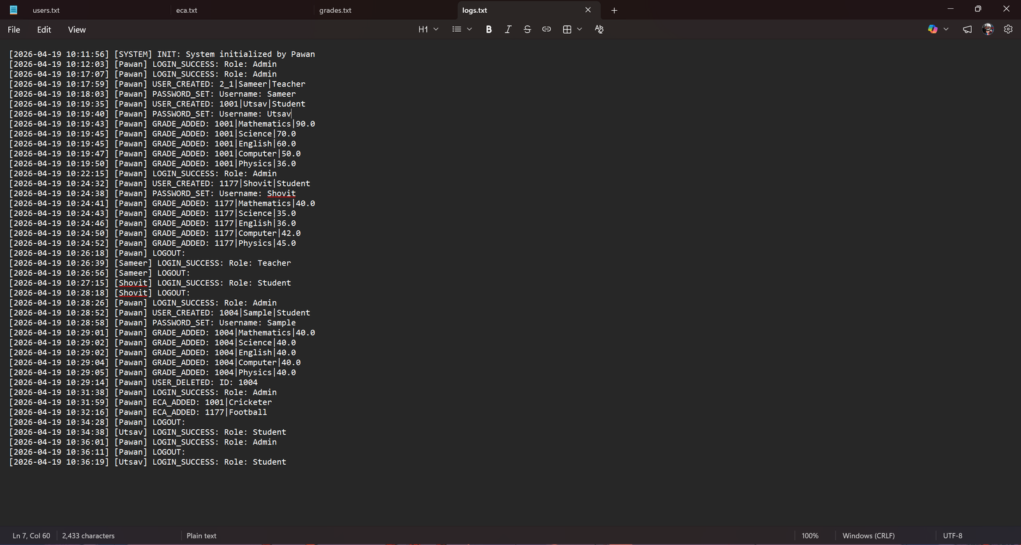
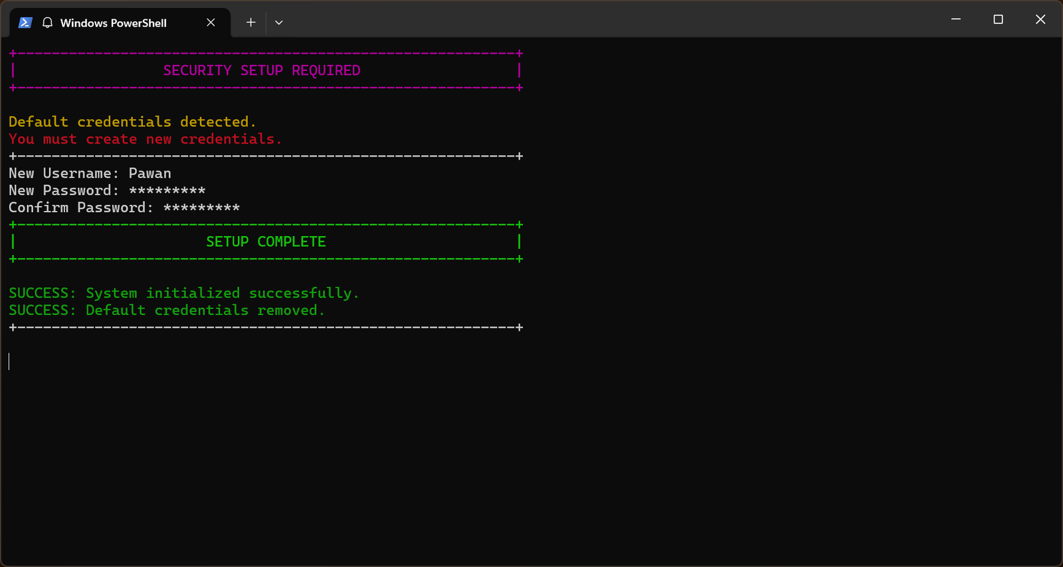

3.3 Auth.py Authentication & Access Control
It has two classes: Auth (authentication engine with lockout logic) and AccessControl (static role-permission mapping). The 3rd and subsequent attempts lock the account in 60 seconds. Force_credential_change() will initially need a non-default admin username and password (≥8 chars).
Role | Key Permissions
Admin | view_all_data, edit_grades, delete_users, update_own_profile, view_analytics, view_logs, manage_eca, add_users
Teacher | view_all_data, edit_grades, update_own_profile, view_analytics, manage_eca
Student | update_own_profile only

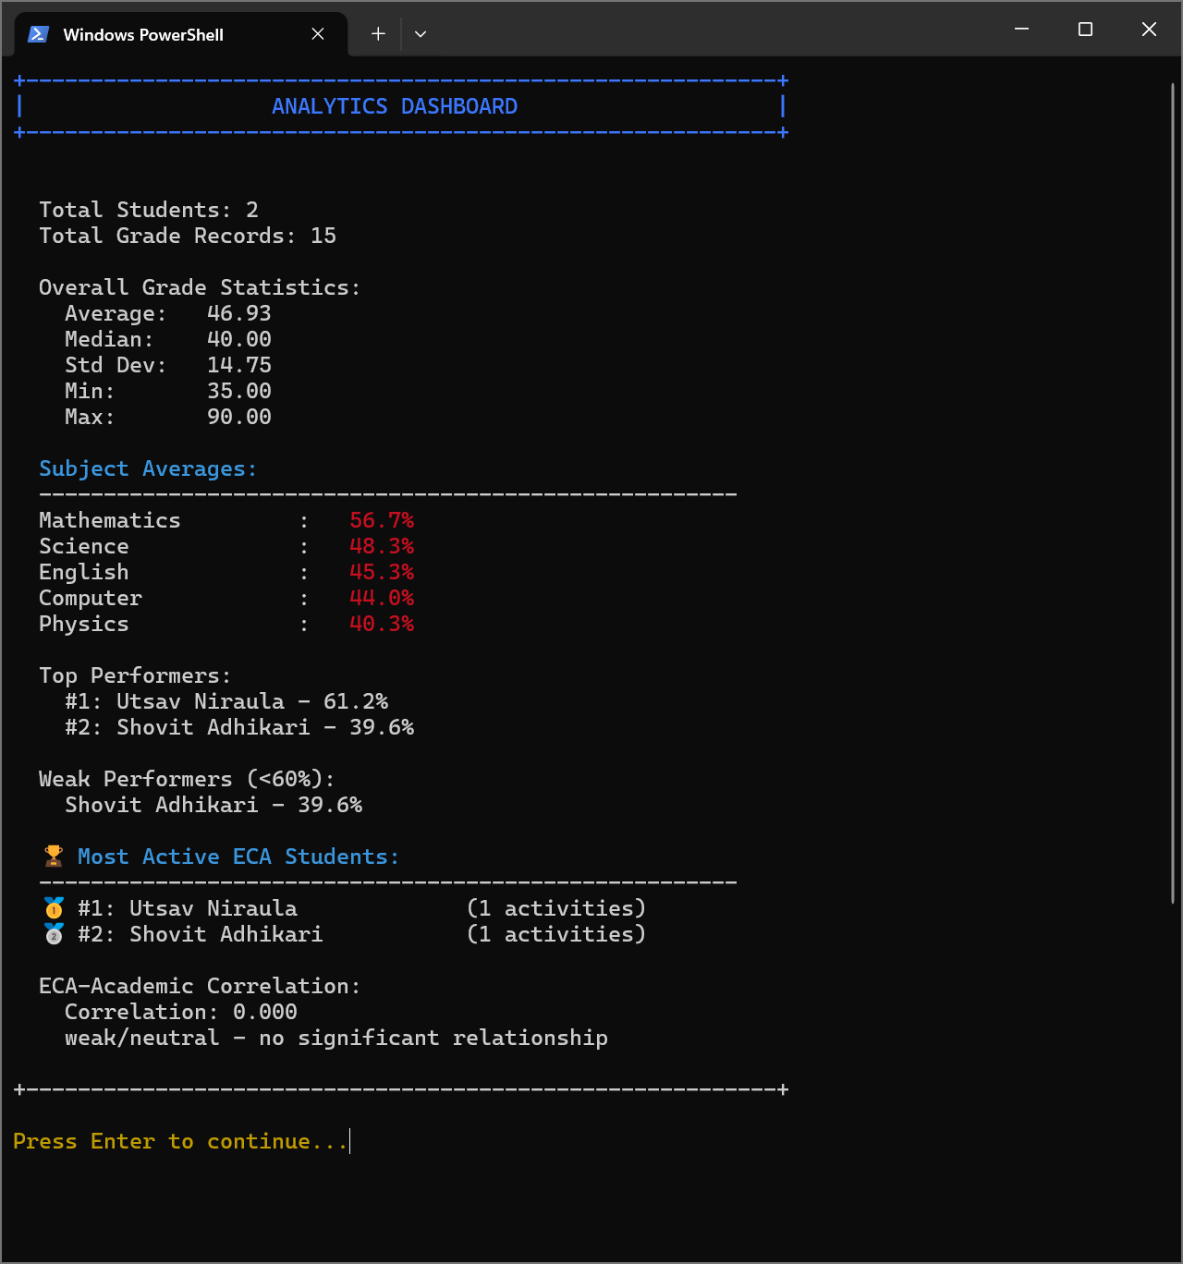
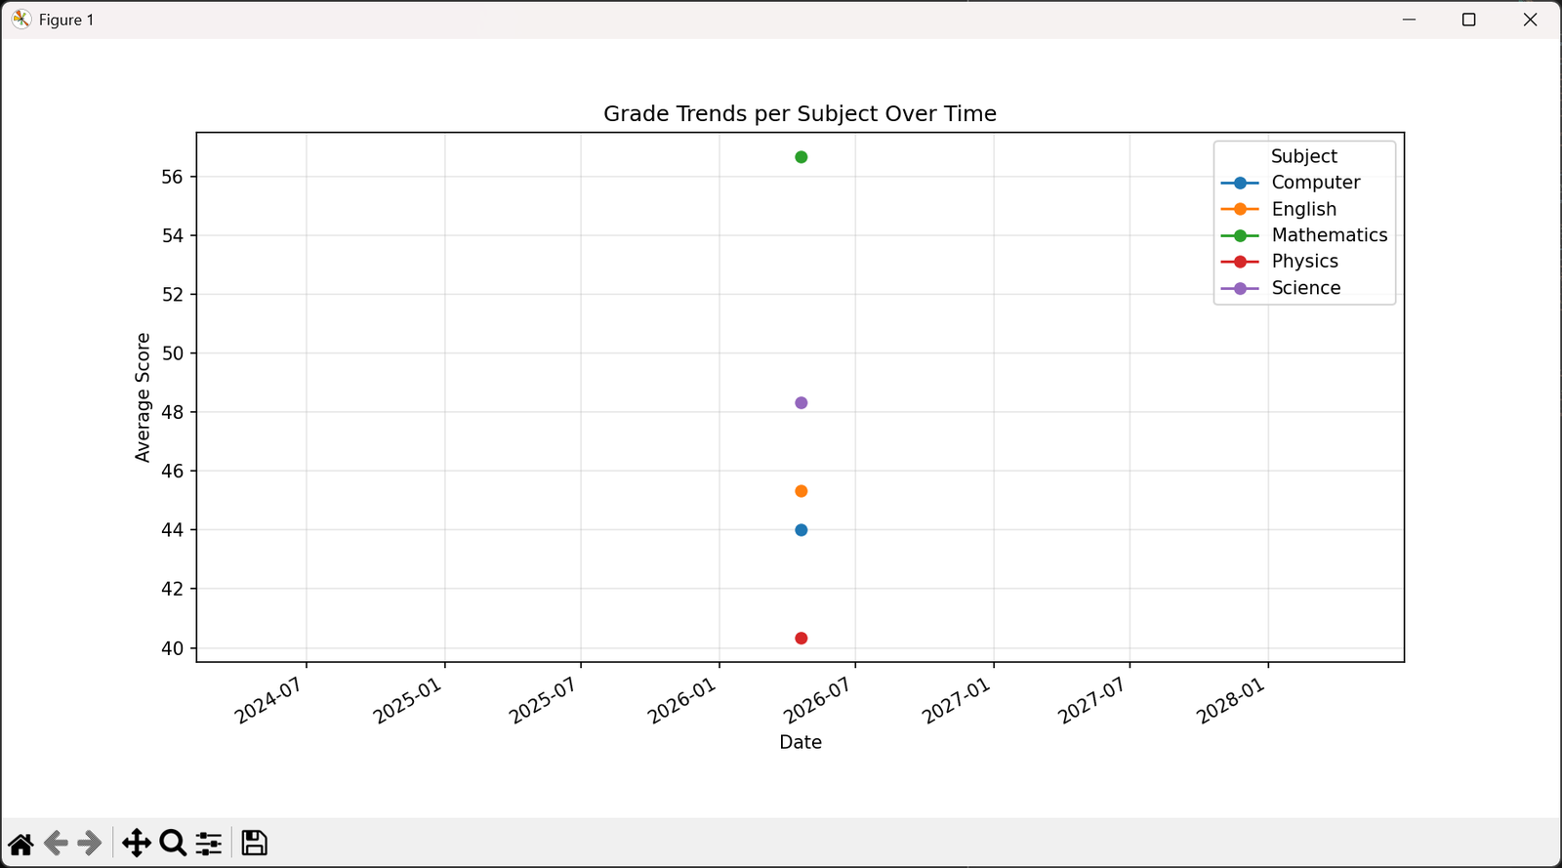
Security setup complete — new admin credentials saved
3.4 core.py — Domain Model (User Hierarchy)
Implements a three-level inheritance hierarchy. The factory function get_user_object() instantiates the correct subclass at login time.
User (base)
├── Student # View own grades, ECA, performance; export CSV
└── Teacher # View all students; update grades; manage ECA; analytics
└── Admin # Full CRUD: add/delete users, set passwords

3.5 analytics.py — Analytics & Reporting Engine
The Analytics class computes statistics, generates matplotlib charts, and exports CSVs. It reads data through the db singleton and returns Python dicts/lists.
Method | Description
get_performance_rankings() | Calculates per-student averages, sorts descending, assigns rank.
get_top_performers(count=5) | Slices head of rankings list.
get_weak_performers(threshold=60) | Filters rankings where average < threshold.
get_subject_averages() | Groups all grade records by subject, computes per-subject mean.
get_most_active_eca_students(limit=5) | Sorts eca_count descending, joins with user names.
analyze_eca_academic_correlation() | Computes Pearson r between ECA count and avg grade; classifies into 5 bands.
plot_grade_trends() | Pandas pivot table → matplotlib multi-line chart (date × score by subject).
plot_eca_vs_grades() | Scatter plot with numpy polynomial trend line and Pearson r in title.
generate_performance_alerts(drop_threshold=15) | Flags students who dropped ≥15% vs previous best in any subject.
export_performance_to_csv(student_id=None) | Exports to Exports/. All students or one. Cols: id, name, subject, score, date, teacher_id.

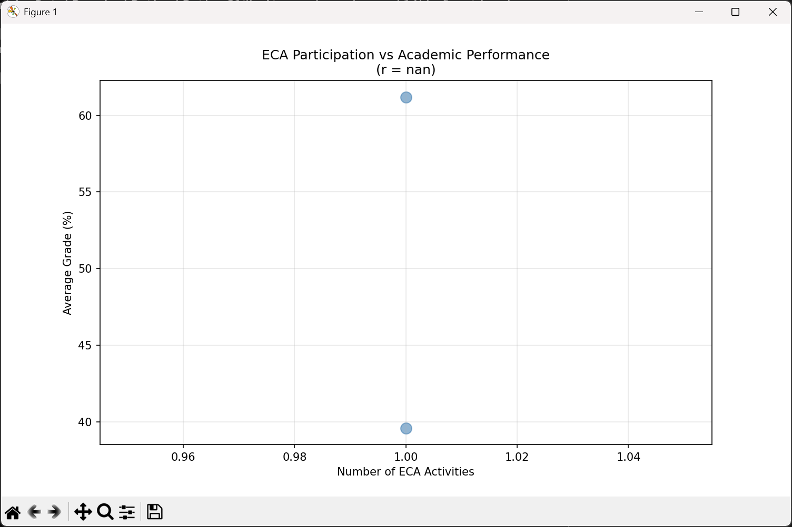

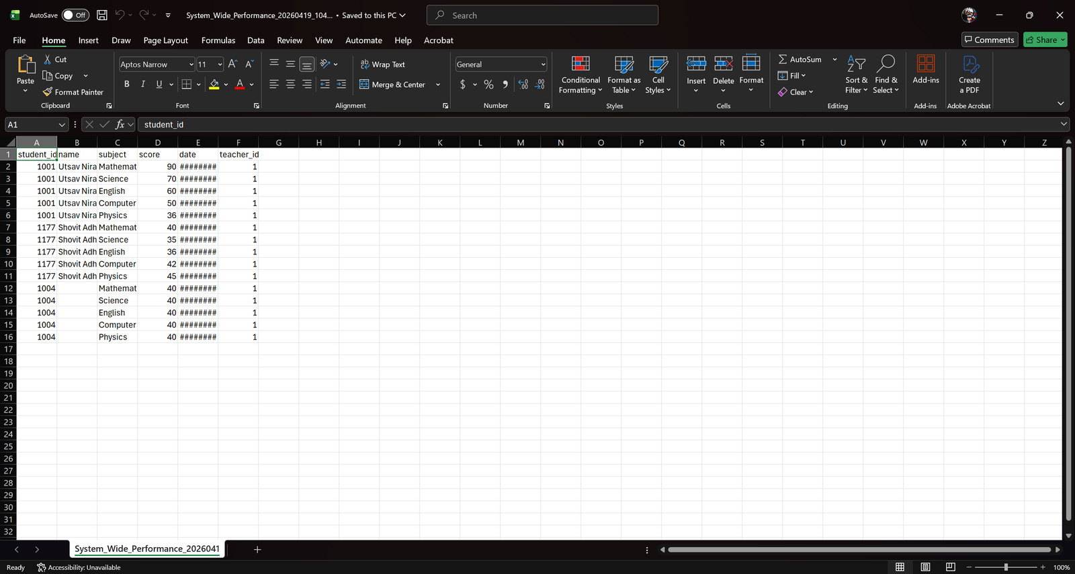

3.6 main.py — Application Entry Point & Menu Router
Contains the entry point main() and all menu loop functions. Validates user input and delegates to user object methods — no business logic here.
Role | Menu Options
Admin | 1. User Management 2. Academic Management 3. Search & Filter 4. Analytics & Reports 5. Settings 6. Logout
Teacher | 1. Academic Management 2. Search & Filter 3. Analytics & Reports 4. Settings 5. Logout
Student | 1. My Profile 2. My Grades 3. My ECA 4. Performance Analysis 5. Export My Grades 6. Settings 7. Logout

4. Data Storage Format
All data is stored as plain-text, pipe-delimited (|) files in the Data/ directory. Each line represents one record. Empty lines are skipped during reading. Every write triggers _backup_all(), creating timestamped copies in Data/backup/.
File Formats
users.txt → id|username|role|name|email|phone
passwords.txt → username|salt_hex:key_hex
grades.txt → student_id|subject|score|date|teacher_id
eca.txt → student_id|activity|role|date
logs.txt → [YYYY-MM-DD HH:MM:SS] [username] ACTION: details
Sample Records
1|Pawan|Admin|System Administrator|admin@school.edu|0000000000
1001|Mathematics|90.0|2026-04-19|1
1001|Cricketer|Batsman|2026-04-19
[2026-04-19 10:12:00] [Pawan] LOGIN_SUCCESS: Role: Admin

5. Role Dashboard Screenshots

User Management
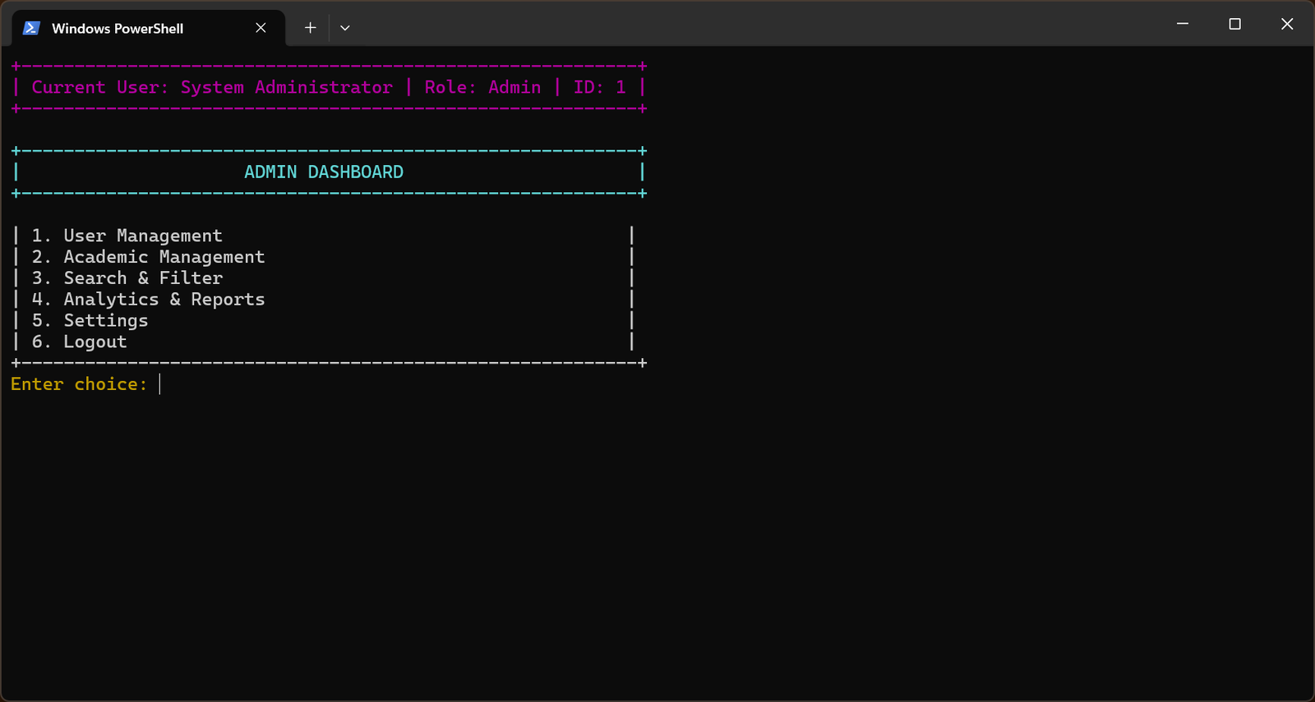
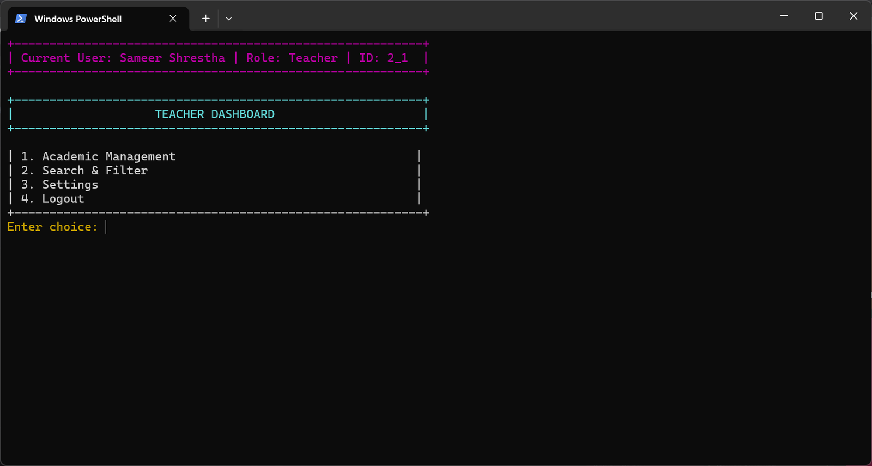
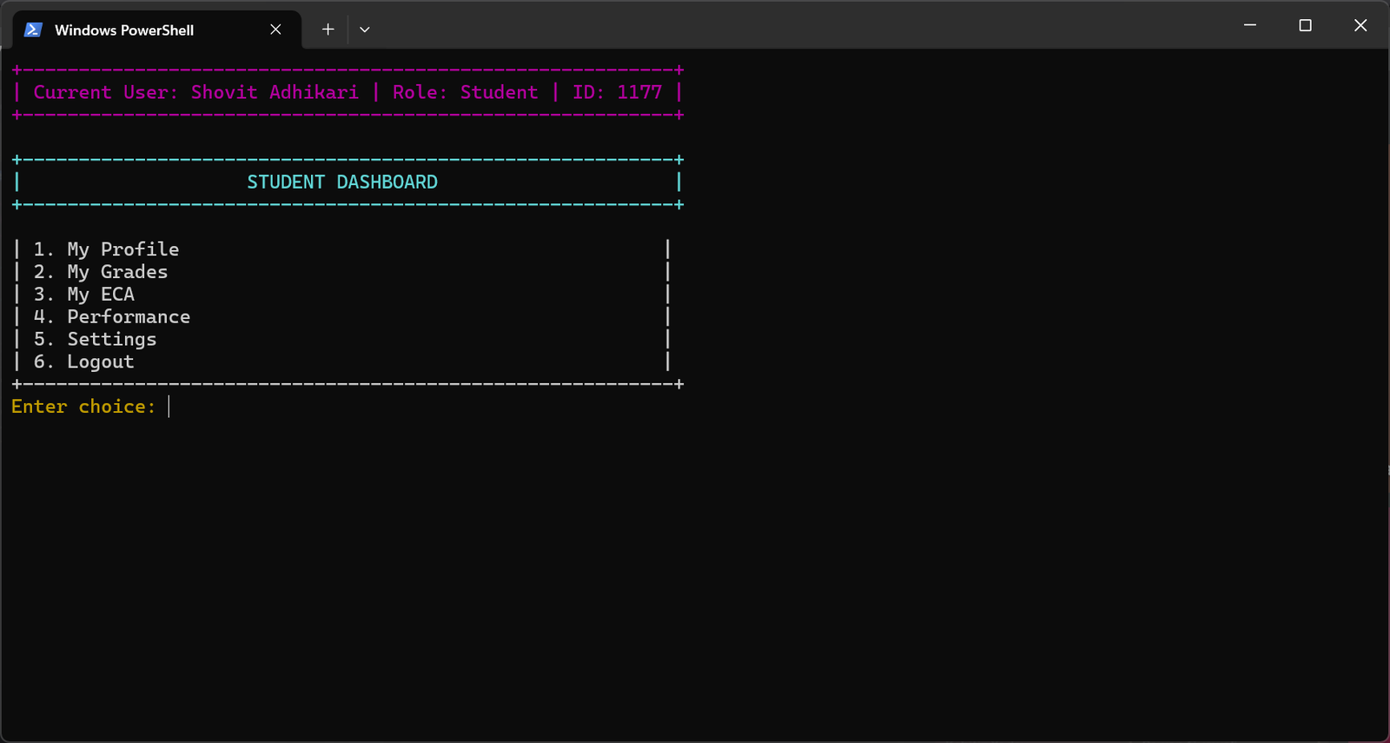
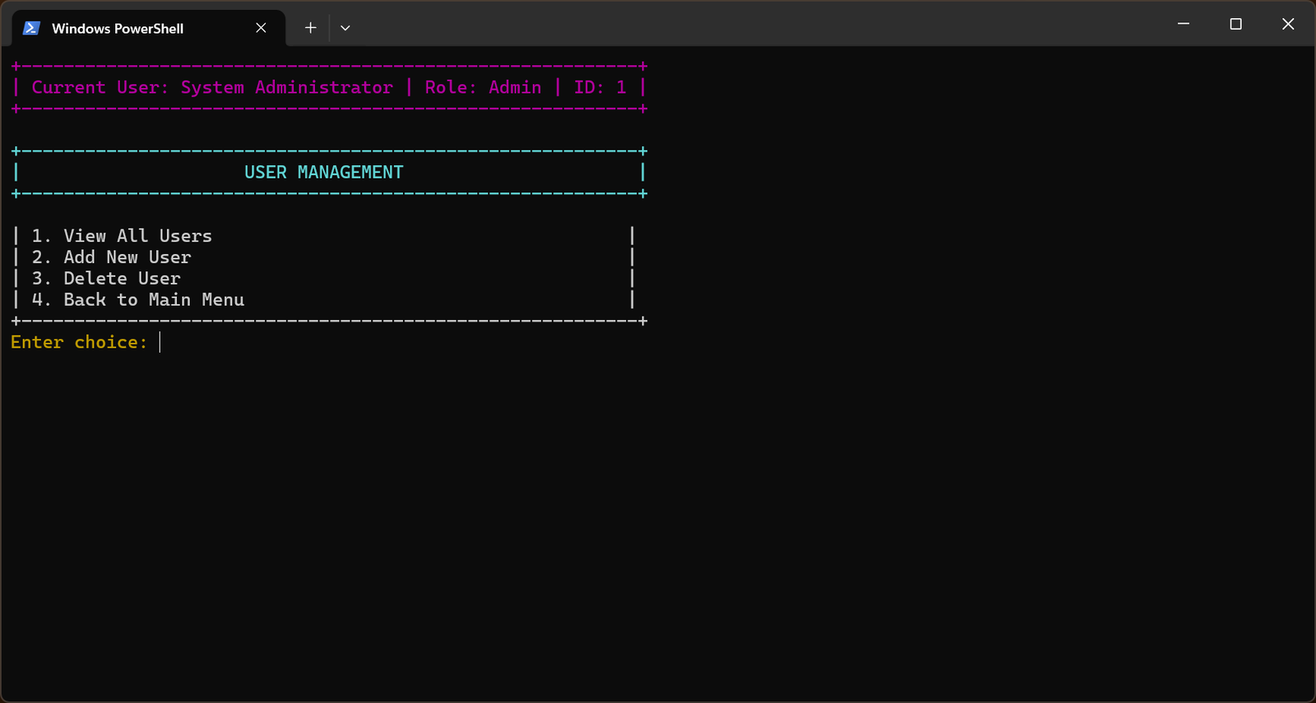
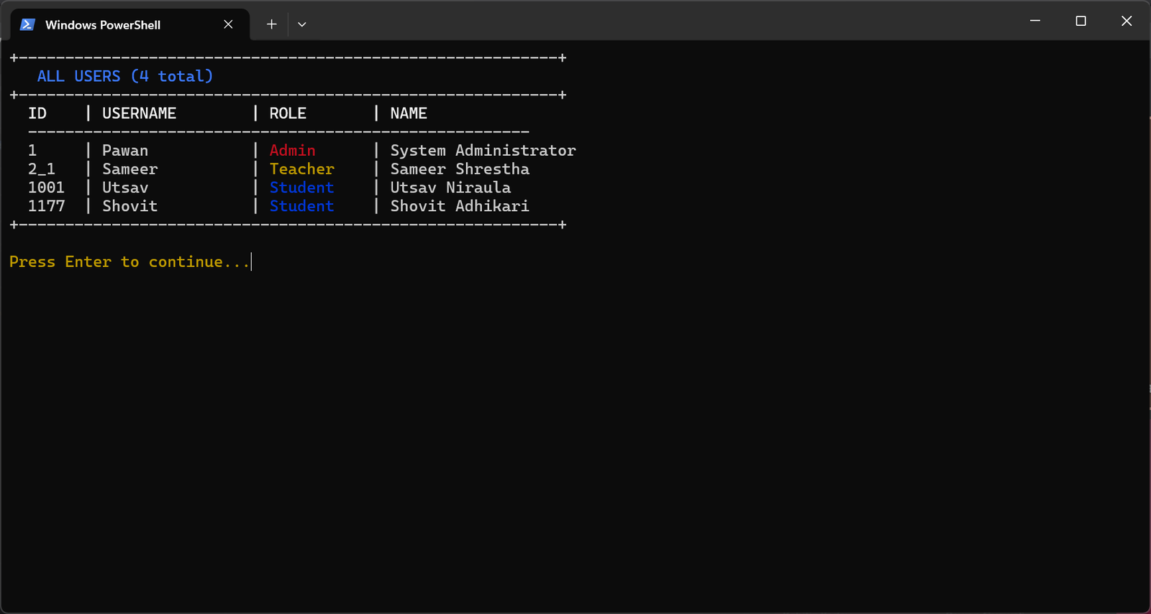

Academic Management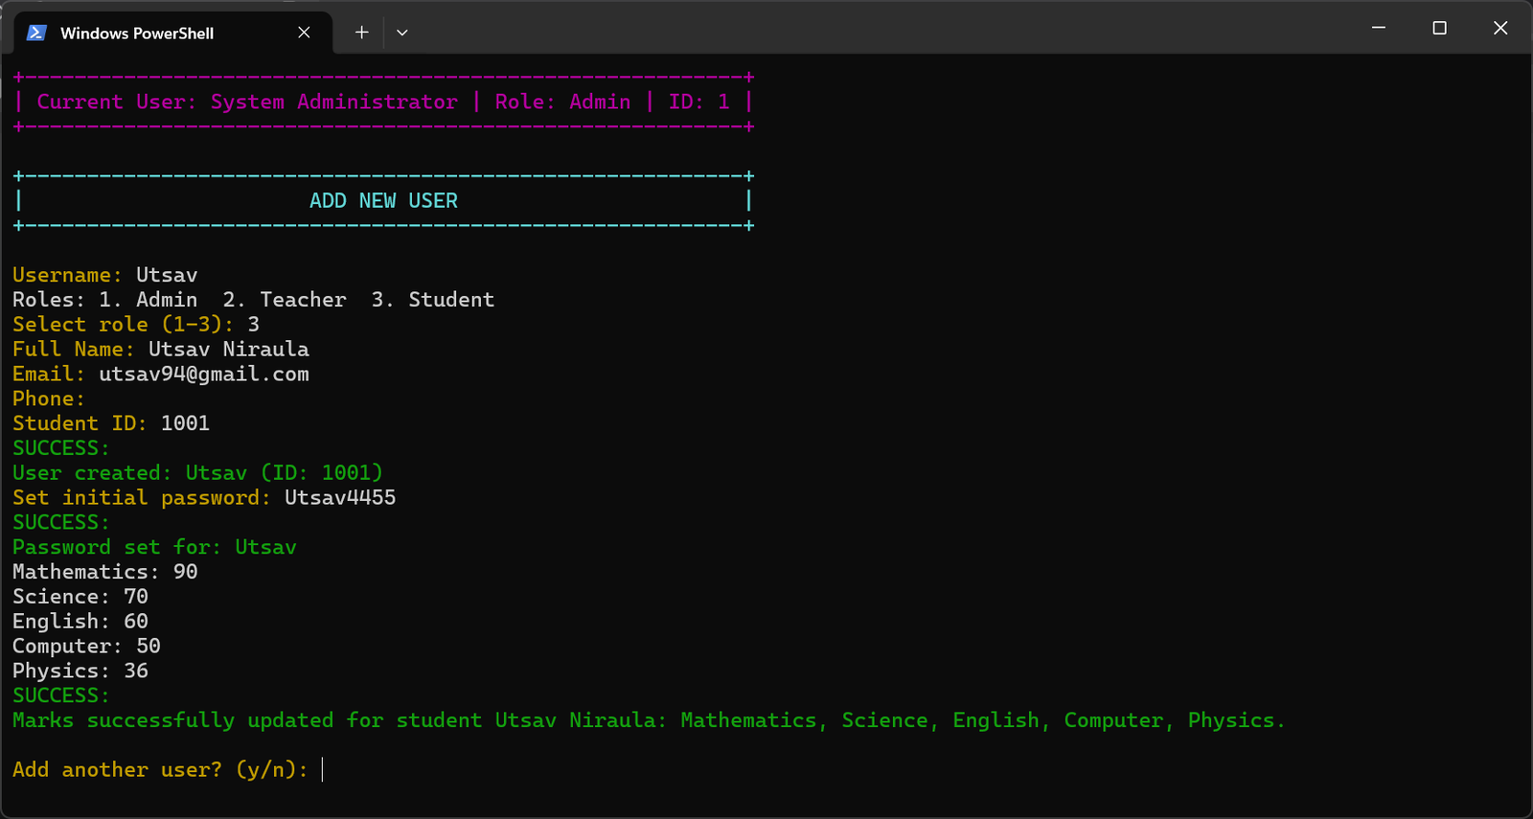
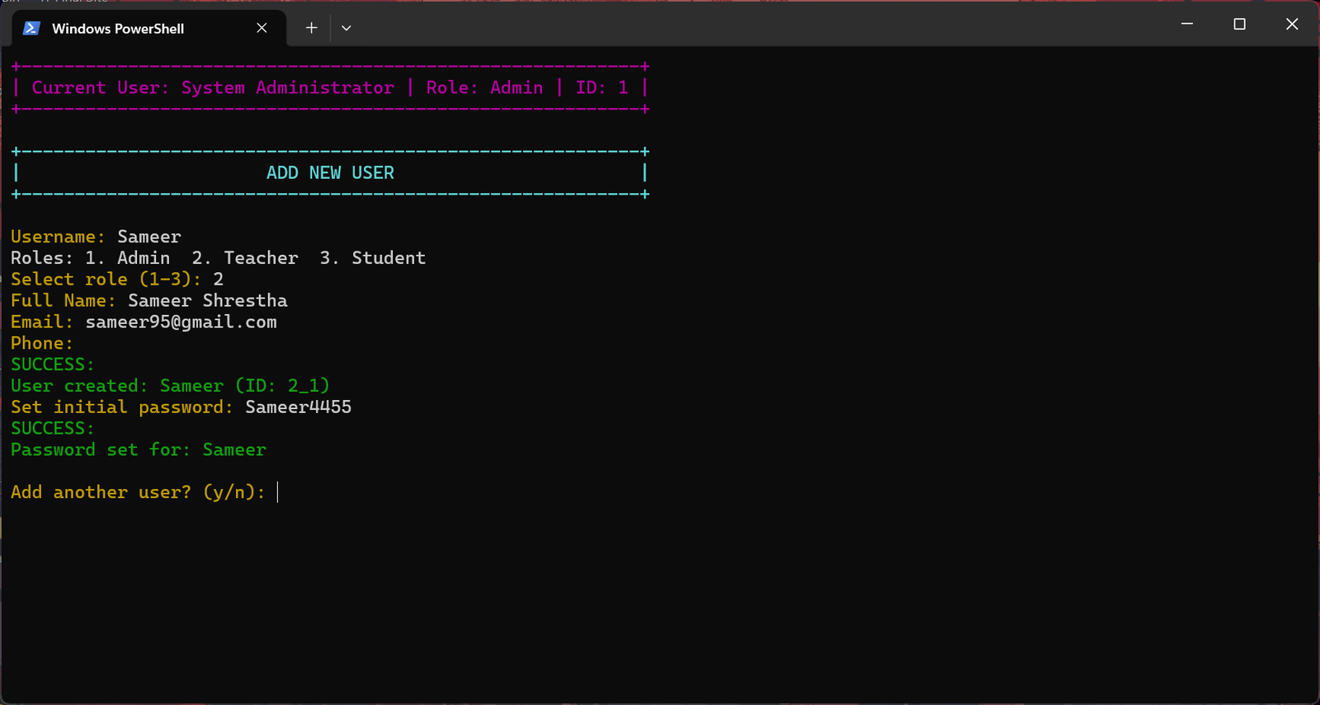
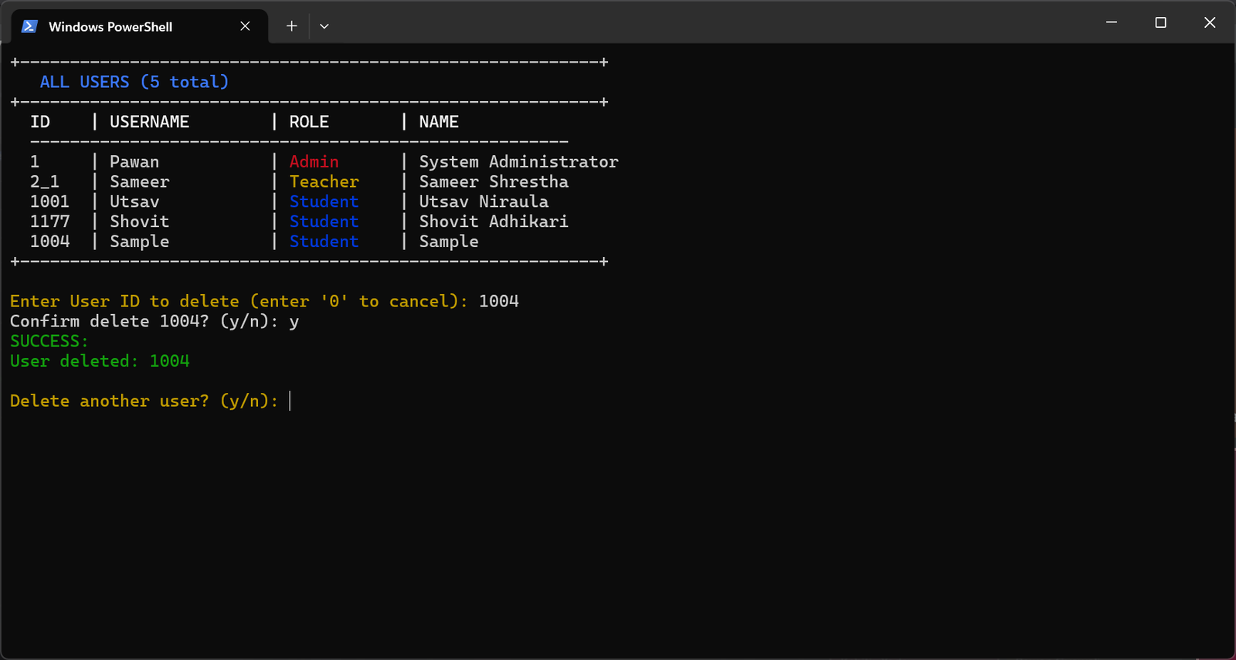

Student Self Service
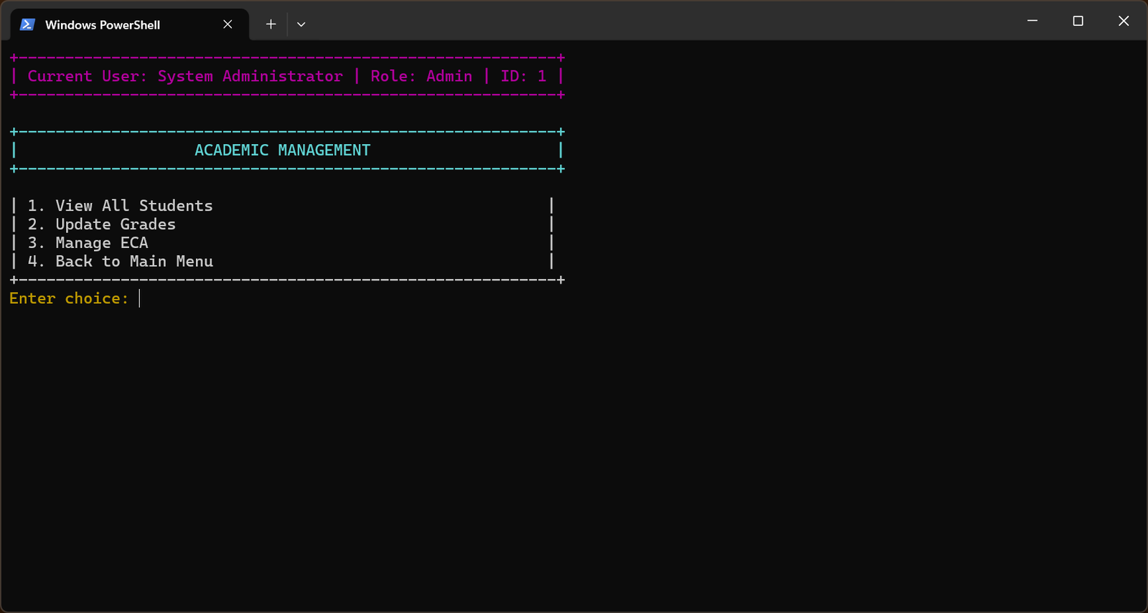
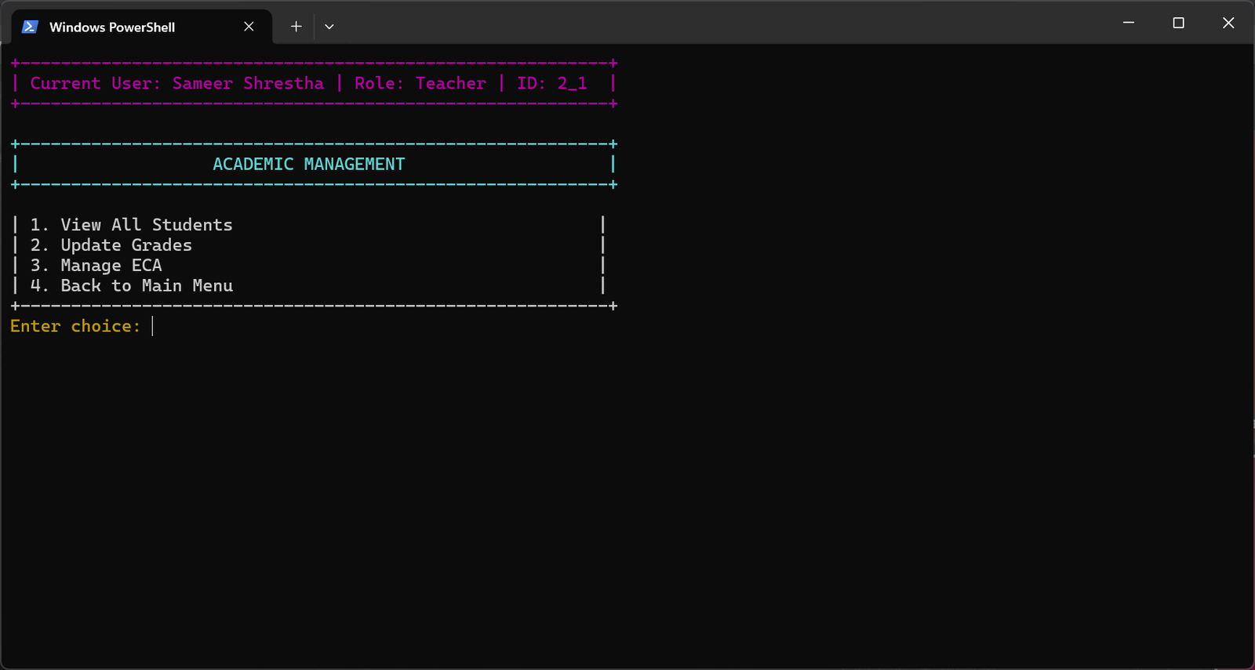
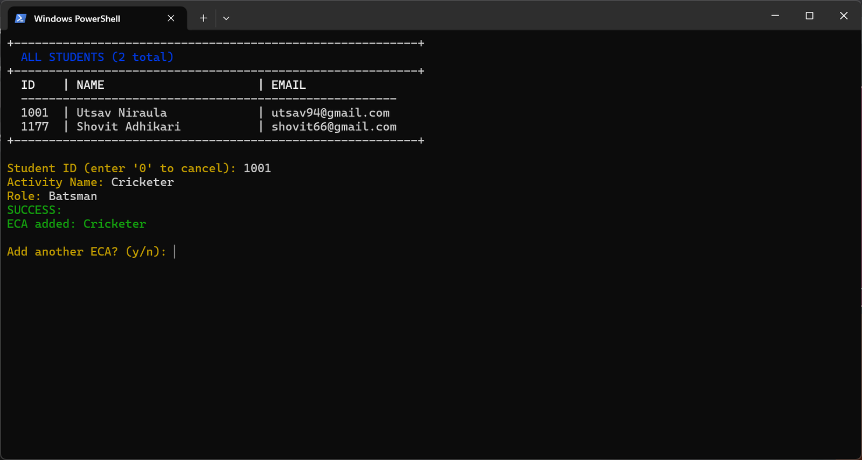
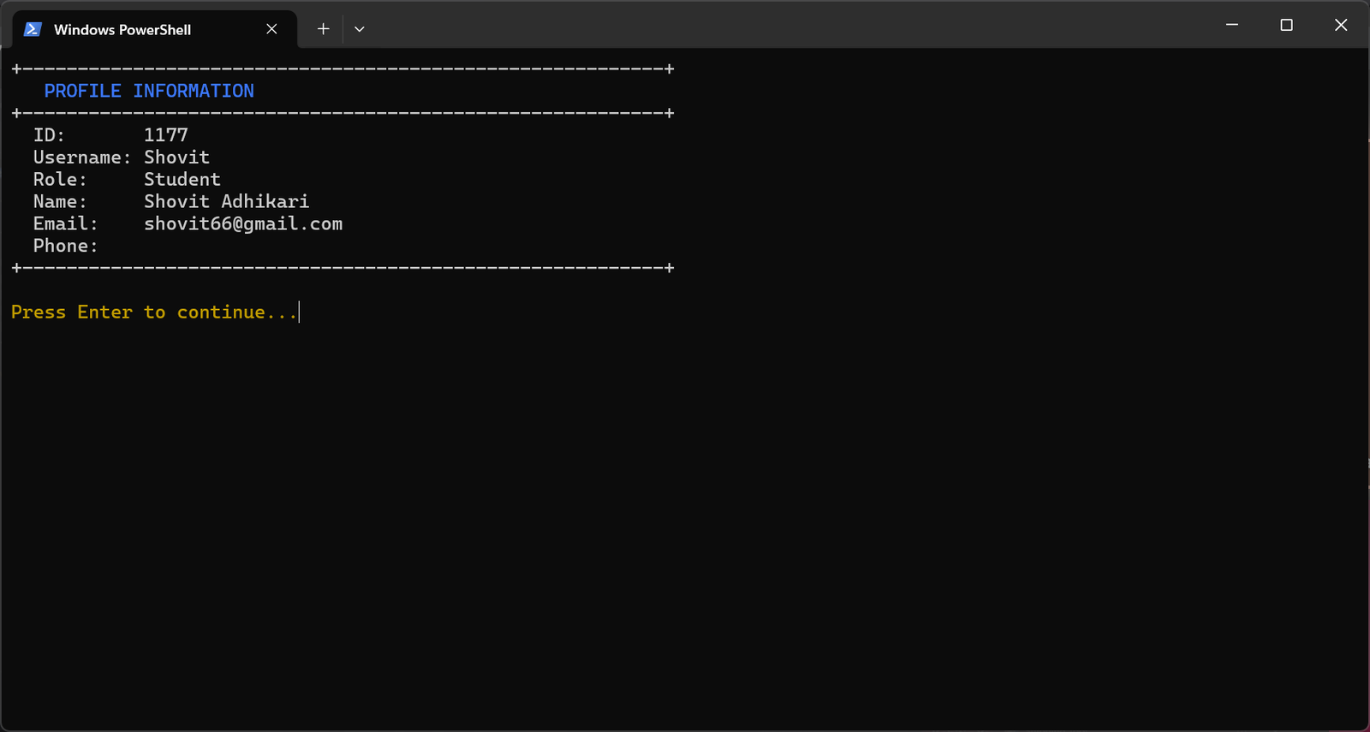

6. Role-Based Feature Matrix
Access is enforced via AccessControl.check_permission() at the method level in auth.py.
Feature | Admin | Teacher | Student
View all users | Yes | No | No
Add / Delete users | Yes | No | No
Set user password | Yes | No | No
View all students | Yes | Yes | No
Update student grades | Yes | Yes | No
Add ECA activity | Yes | Yes | No
Search & filter students | Yes | Yes | No
View analytics dashboard | Yes | Yes | No
Generate charts | Yes | Yes | No
Performance alerts | Yes | Yes | No
Export system-wide CSV | Yes | Yes | No
View / Update own profile | Yes | Yes | Yes
Change own password | Yes | Yes | Yes
View own grades / ECA | No | No | Yes
View own performance stats | No | No | Yes
Export own grades (CSV) | No | No | Yes

7. Setup & Installation
Prerequisites
· Python 3.8 or higher
· pip (Python package manager)
· A terminal supporting ANSI escape codes (Linux, macOS, Windows Terminal, or modern cmd.exe)
Installation
# 1. Extract the project
unzip Student_Management_System.zip && cd "Student Management System"

# 2. Creating a virtual environment (recommended)
python -m venv venv && source venv/bin/activate

# 3. Install dependencies
pip install -r requirements.txt # pandas>=2.0, matplotlib>=3.8, numpy>=1.24

# 4. Run
python main.py
First-Run Setup
On first launch is_first_run() returns True (users.txt does not exist). The system displays temporary credentials (admin / admin) and requires the operator to: (1) authenticate with defaults, (2) choose a permanent username (not "admin", 3–20 alphanumeric chars), (3) set a password (≥8 chars, confirmed twice). Default credentials are then discarded. The Data/ and Data/backup/ directories are created automatically.

8. Extending the System
Adding a New Role
1. Define a new class extending User (or Teacher) in core.py.
2. Add a permission entry in AccessControl.PERMISSIONS in auth.py.
3. Add the new role to role_map in add_new_user_menu() in main.py.
4. Add a branch in get_user_object() in core.py.
Adding a New Subject
The subjects list is hardcoded in main.py. Move it to a constant in database.py and import where needed.
Migrating to a Relational Database
Database class wraps all file I/O in a clean API. To migrate: subclass Database with identical public method signatures and substitution of internals of the type of atomic write with SQL queries. Any modifications made to auth.py, core.py, analytics.py or main.py are unnecessary provided that the API contract is maintained.
Substituting the CLI with a Web Interface.
Business logic in core.py and analytics.py returns plain Python dicts/lists with no terminal output. A web framework (Flask, FastAPI) could replace main.py and ui.py while reusing all data and business layers unchanged.

9. Conclusion
The Student Management System provides a fully-fledged academic record management system and is production-ready in the confines of a pure Python CLI. The system is reliable and secure without depending on a database engine or API layer, as role-based access control, crash-safe atomic file writes, and a layered architecture with a strong separation of concerns provide the system with reliability and security.
The three-role hierarchy (Admin, Teacher, and Student) maintains strict ability limits and presents the user experience in an intuitive and context-specific way. The analytics and reporting engine delivers actionable information in the form of performance rankings, ECA correlation analysis, grade trend charts, and automated performance alerts all produced out of flat-file data available in standard scientific Python libraries.
The architecture is designed to be extensible: Database may be replaced by a relational backend without affecting business logic and core.py/analytics.py layers are framework-neutral and a migration to a web interface would be simple in the future. The zero-configuration first-run option reduces the barrier to deployment, and the automatic timestamped backup system ensures that there is integrity of data throughout the application lifecycle.
All in all, the SMS illustrates the ability of an effectively designed, modular design to address real-life academic management needs effectively - as a functional tool, as well as a sound basis of further development.

