Cluster Management

View Nodes

kubectl get nodes -o wide

Describe Node (Deep inspection)

kubectl describe node <node-name>

Key things to analyze:
- Capacity vs Allocatable
- Conditions (Ready, MemoryPressure, DiskPressure)
- Running Pods
- Labels & Taints

Metrics (if metrics-server installed)

kubectl top nodes
kubectl top pods -A

Node Labels and Selectors

kubectl label node <node-name> env=prod

apiVersion: v1
kind: Pod
metadata:
name: nginx-node-selector
spec:
nodeSelector:
env: prod
containers:
- name: nginx
image: nginx

Crictl for node management

crictl interacts directly with container runtime (containerd / CRI-O).

Configure crictl
sudo vi /etc/crictl.yaml

Basic commands

# List containers
crictl ps

# List images
crictl images

# Inspect container
crictl inspect <container-id>

# Logs
crictl logs <container-id>

# Pull image
crictl pull nginx

Running Static Pods
Static Pods are managed by kubelet, not API server.
Static Pod location
/etc/kubernetes/manifests/

Create Static Pod

sudo vi /etc/kubernetes/manifests/nginx-static.yaml

apiVersion: v1
kind: Pod
metadata:
name: nginx-static
labels:
app: static-nginx
spec:
containers:
- name: nginx
image: nginx
ports:
- containerPort: 80

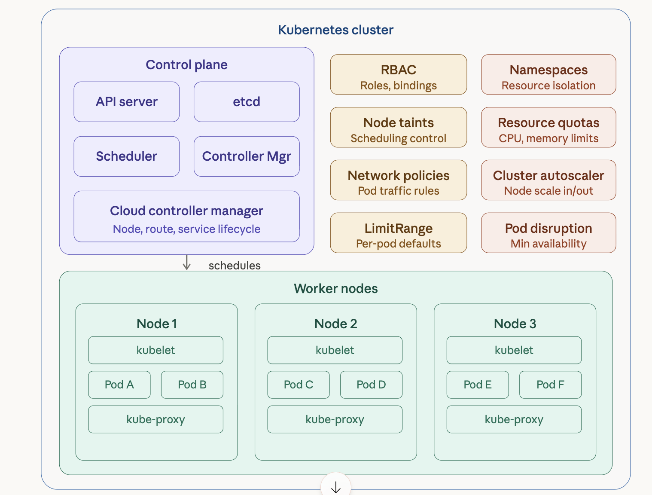
Namespaces (logical cluster partitioning)
Namespaces isolate resources by team, environment, or application. Most cluster-scoped governance features are applied per-namespace.
# =================================================================
# Namespaces — logical isolation within a single cluster
# =================================================================

# -----------------------------------------------------------------
# 1. Development namespace
# -----------------------------------------------------------------
apiVersion: v1
kind: Namespace
metadata:
name: development
labels:
environment: dev
team: backend
managed-by: platform-team
annotations:
description: "Development workloads — non-production"
contact: "platform-team@company.com"
---
# -----------------------------------------------------------------
# 2. Staging namespace
# -----------------------------------------------------------------
apiVersion: v1
kind: Namespace
metadata:
name: staging
labels:
environment: staging
team: backend
---
# -----------------------------------------------------------------
# 3. Production namespace
# -----------------------------------------------------------------
apiVersion: v1
kind: Namespace
metadata:
name: production
labels:
environment: prod
team: backend
tier: critical
---
# -----------------------------------------------------------------
# 4. Monitoring namespace
# -----------------------------------------------------------------
apiVersion: v1
kind: Namespace
metadata:
name: monitoring
labels:
purpose: observability

RBAC (Role-Based Access Control)
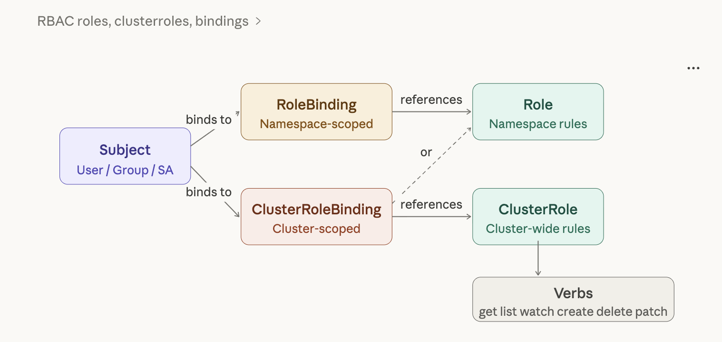
RBAC controls who can do what inside the cluster. It has four key resources: Role, ClusterRole, RoleBinding, and ClusterRoleBinding.

# =================================================================
# RBAC — Role-Based Access Control
# =================================================================

# -----------------------------------------------------------------
# 1. ServiceAccount — identity for a workload inside the cluster
# -----------------------------------------------------------------
apiVersion: v1
kind: ServiceAccount
metadata:
name: app-service-account
namespace: development
labels:
app: my-app
automountServiceAccountToken: false # opt-in explicitly per pod
---
# -----------------------------------------------------------------
# 2. Role — namespace-scoped permissions
# Grants read-only access to pods and logs in 'development'
# -----------------------------------------------------------------
apiVersion: rbac.authorization.k8s.io/v1
kind: Role
metadata:
name: pod-reader
namespace: development
rules:
- apiGroups: [""] # "" = core API group
resources: ["pods", "pods/log", "pods/status"]
verbs: ["get", "list", "watch"]
- apiGroups: ["apps"]
resources: ["deployments", "replicasets"]
verbs: ["get", "list", "watch"]
- apiGroups: [""]
resources: ["configmaps"]
verbs: ["get", "list"]
---
# -----------------------------------------------------------------
# 3. Role — developer with deploy rights in development namespace
# -----------------------------------------------------------------
apiVersion: rbac.authorization.k8s.io/v1
kind: Role
metadata:
name: developer
namespace: development
rules:
- apiGroups: ["", "apps", "batch"]
resources:
- pods
- deployments
- replicasets
- services
- configmaps
- jobs
- cronjobs
verbs: ["get", "list", "watch", "create", "update", "patch", "delete"]
- apiGroups: [""]
resources: ["secrets"]
verbs: ["get", "list"] # can read but not modify secrets
- apiGroups: [""]
resources: ["pods/exec", "pods/portforward"]
verbs: ["create"] # allows kubectl exec and port-forward
---
# -----------------------------------------------------------------
# 4. ClusterRole — cluster-wide, for viewing nodes and namespaces
# -----------------------------------------------------------------
apiVersion: rbac.authorization.k8s.io/v1
kind: ClusterRole
metadata:
name: cluster-viewer
rules:
- apiGroups: [""]
resources: ["nodes", "namespaces", "persistentvolumes"]
verbs: ["get", "list", "watch"]
- apiGroups: ["storage.k8s.io"]
resources: ["storageclasses"]
verbs: ["get", "list", "watch"]
- apiGroups: ["metrics.k8s.io"]
resources: ["nodes", "pods"]
verbs: ["get", "list"]
---
# -----------------------------------------------------------------
# 5. ClusterRole — admin for specific namespaces (reusable)
# -----------------------------------------------------------------
apiVersion: rbac.authorization.k8s.io/v1
kind: ClusterRole
metadata:
name: namespace-admin
rules:
- apiGroups: ["", "apps", "batch", "autoscaling", "networking.k8s.io"]
resources: ["*"]
verbs: ["*"]
- apiGroups: ["rbac.authorization.k8s.io"]
resources: ["roles", "rolebindings"]
verbs: ["get", "list", "watch", "create", "update", "patch", "delete"]
---
# -----------------------------------------------------------------
# 6. RoleBinding — bind 'pod-reader' Role to a specific user
# -----------------------------------------------------------------
apiVersion: rbac.authorization.k8s.io/v1
kind: RoleBinding
metadata:
name: read-pods-binding
namespace: development
subjects:
- kind: User # User | Group | ServiceAccount
name: jane@company.com # case-sensitive, matches --user in kubeconfig
apiGroup: rbac.authorization.k8s.io
- kind: Group
name: qa-team
apiGroup: rbac.authorization.k8s.io
roleRef:
kind: Role # Role | ClusterRole
name: pod-reader
apiGroup: rbac.authorization.k8s.io
---
# -----------------------------------------------------------------
# 7. RoleBinding — bind 'developer' Role to a ServiceAccount
# -----------------------------------------------------------------
apiVersion: rbac.authorization.k8s.io/v1
kind: RoleBinding
metadata:
name: developer-binding
namespace: development
subjects:
- kind: ServiceAccount
name: app-service-account
namespace: development
- kind: User
name: bob@company.com
apiGroup: rbac.authorization.k8s.io
roleRef:
kind: Role
name: developer
apiGroup: rbac.authorization.k8s.io
---
# -----------------------------------------------------------------
# 8. ClusterRoleBinding — bind 'cluster-viewer' to ops-team group
# -----------------------------------------------------------------
apiVersion: rbac.authorization.k8s.io/v1
kind: ClusterRoleBinding
metadata:
name: ops-cluster-viewer
subjects:
- kind: Group
name: ops-team
apiGroup: rbac.authorization.k8s.io
roleRef:
kind: ClusterRole
name: cluster-viewer
apiGroup: rbac.authorization.k8s.io
---
# -----------------------------------------------------------------
# 9. ClusterRoleBinding — grant namespace-admin to a team per namespace
# (use RoleBinding referencing a ClusterRole for namespace-scoped grant)
# -----------------------------------------------------------------
apiVersion: rbac.authorization.k8s.io/v1
kind: RoleBinding
metadata:
name: dev-namespace-admin
namespace: development
subjects:
- kind: Group
name: backend-team
apiGroup: rbac.authorization.k8s.io
roleRef:
kind: ClusterRole # ClusterRole used in a RoleBinding = namespace-scoped
name: namespace-admin
apiGroup: rbac.authorization.k8s.io

ResourceQuota and LimitRange
ResourceQuota caps total resource consumption per namespace. LimitRange sets default and maximum resource limits per individual container or Pod.
# =================================================================
# ResourceQuota — namespace-level resource ceilings
# =================================================================

# -----------------------------------------------------------------
# Development namespace quota (generous)
# -----------------------------------------------------------------
apiVersion: v1
kind: ResourceQuota
metadata:
name: dev-quota
namespace: development
spec:
hard:
# Compute
requests.cpu: "8" # total CPU requested by all pods
requests.memory: 16Gi
limits.cpu: "16" # total CPU limits for all pods
limits.memory: 32Gi

# Object counts
pods: "40"
services: "20"
secrets: "30"
configmaps: "30"
persistentvolumeclaims: "15"
services.loadbalancers: "2"
services.nodeports: "5"

# Storage
requests.storage: 100Gi
standard.storageclass.storage.k8s.io/requests.storage: 80Gi

# Scope selectors — apply quota only to non-terminating pods
scopeSelector:
matchExpressions:
- operator: NotIn
scopeName: PriorityClass
values: ["system-node-critical", "system-cluster-critical"]
---
# -----------------------------------------------------------------
# Production namespace quota (strict)
# -----------------------------------------------------------------
apiVersion: v1
kind: ResourceQuota
metadata:
name: prod-quota
namespace: production
spec:
hard:
requests.cpu: "32"
requests.memory: 64Gi
limits.cpu: "64"
limits.memory: 128Gi
pods: "100"
services: "30"
secrets: "50"
configmaps: "50"
persistentvolumeclaims: "30"
services.loadbalancers: "5"
requests.storage: 500Gi
---
# =================================================================
# LimitRange — per-pod/container defaults and maximums
# =================================================================

# -----------------------------------------------------------------
# Development LimitRange
# -----------------------------------------------------------------
apiVersion: v1
kind: LimitRange
metadata:
name: dev-limitrange
namespace: development
spec:
limits:
# Container-level limits
- type: Container
default: # applied when container has no limits set
cpu: "500m"
memory: "256Mi"
defaultRequest: # applied when container has no requests set
cpu: "100m"
memory: "64Mi"
max: # container cannot exceed these
cpu: "2"
memory: "2Gi"
min: # container must request at least these
cpu: "50m"
memory: "32Mi"
maxLimitRequestRatio: # limits / requests ratio cannot exceed this
cpu: "4"
memory: "4"

# Pod-level limits (sum of all containers)
- type: Pod
max:
cpu: "4"
memory: "4Gi"
min:
cpu: "50m"
memory: "32Mi"

# PVC limits
- type: PersistentVolumeClaim
max:
storage: 20Gi
min:
storage: 1Gi
---
# -----------------------------------------------------------------
# Production LimitRange (tighter defaults, higher maxes)
# -----------------------------------------------------------------
apiVersion: v1
kind: LimitRange
metadata:
name: prod-limitrange
namespace: production
spec:
limits:
- type: Container
default:
cpu: "1"
memory: "512Mi"
defaultRequest:
cpu: "250m"
memory: "128Mi"
max:
cpu: "8"
memory: "8Gi"
min:
cpu: "100m"
memory: "64Mi"
- type: PersistentVolumeClaim
max:
storage: 100Gi
min:
storage: 1Gi

Node management: labels, taints, and tolerations
Node labels enable scheduling targeting. Taints repel pods from nodes unless the pod has a matching toleration — essential for dedicated node pools.
# =================================================================
# Node Labels, Taints, Tolerations, and Affinity
# =================================================================

# -----------------------------------------------------------------
# Apply labels and taints to nodes imperatively:
#
# kubectl label node node1 node-role=gpu dedicated=ml-workloads
# kubectl label node node2 node-role=high-memory tier=premium
# kubectl label node node3 disk=ssd zone=us-east-1a
#
# kubectl taint node node1 dedicated=gpu:NoSchedule
# NoSchedule — new pods without matching toleration won't schedule
# PreferNoSchedule — avoid scheduling but not hard block
# NoExecute — existing pods evicted if no toleration
#
# kubectl taint node node2 high-memory=true:NoSchedule
# -----------------------------------------------------------------

# -----------------------------------------------------------------
# 1. Pod with nodeSelector (simple label targeting)
# -----------------------------------------------------------------
apiVersion: v1
kind: Pod
metadata:
name: nodeselector-demo
namespace: development
spec:
nodeSelector:
disk: ssd
zone: us-east-1a
containers:
- name: app
image: nginx:alpine
---
# -----------------------------------------------------------------
# 2. Pod with nodeAffinity (expressive scheduling rules)
# -----------------------------------------------------------------
apiVersion: v1
kind: Pod
metadata:
name: node-affinity-demo
namespace: development
spec:
affinity:
nodeAffinity:
# HARD rule — pod will NOT schedule if not satisfied
requiredDuringSchedulingIgnoredDuringExecution:
nodeSelectorTerms:
- matchExpressions:
- key: kubernetes.io/arch
operator: In
values: ["amd64", "arm64"]
- key: zone
operator: In
values: ["us-east-1a", "us-east-1b"]

# SOFT rule — scheduler prefers but won't enforce
preferredDuringSchedulingIgnoredDuringExecution:
- weight: 80 # higher weight = stronger preference
preference:
matchExpressions:
- key: disk
operator: In
values: ["ssd"]
- weight: 20
preference:
matchExpressions:
- key: node-role
operator: In
values: ["high-performance"]

# Pod anti-affinity — spread pods across nodes for HA
podAntiAffinity:
requiredDuringSchedulingIgnoredDuringExecution:
- labelSelector:
matchExpressions:
- key: app
operator: In
values: ["node-affinity-demo"]
topologyKey: kubernetes.io/hostname # one pod per node

containers:
- name: app
image: nginx:alpine
---
# -----------------------------------------------------------------
# 3. Pod targeting a GPU node with taint toleration
# -----------------------------------------------------------------
apiVersion: v1
kind: Pod
metadata:
name: gpu-workload
namespace: development
spec:
tolerations:
- key: "dedicated"
operator: "Equal" # Equal | Exists
value: "gpu"
effect: "NoSchedule" # NoSchedule | PreferNoSchedule | NoExecute

# Tolerate all taints on a node (use sparingly)
# - operator: "Exists"
# effect: "NoSchedule"

# Allow pod to run on a node with NoExecute taint for 60s
- key: "node.kubernetes.io/not-ready"
operator: "Exists"
effect: "NoExecute"
tolerationSeconds: 60

nodeSelector:
node-role: gpu

containers:
- name: gpu-app
image: nvidia/cuda:12.0-base
resources:
limits:
nvidia.com/gpu: "1" # requires NVIDIA device plugin
---
# -----------------------------------------------------------------
# 4. Deployment with topologySpreadConstraints (k8s 1.19+)
# Ensures pods spread evenly across zones
# -----------------------------------------------------------------
apiVersion: apps/v1
kind: Deployment
metadata:
name: spread-demo
namespace: production
spec:
replicas: 6
selector:
matchLabels:
app: spread-demo
template:
metadata:
labels:
app: spread-demo
spec:
topologySpreadConstraints:
- maxSkew: 1 # max difference between zones
topologyKey: topology.kubernetes.io/zone
whenUnsatisfiable: DoNotSchedule # DoNotSchedule | ScheduleAnyway
labelSelector:
matchLabels:
app: spread-demo
- maxSkew: 1
topologyKey: kubernetes.io/hostname # also spread across nodes
whenUnsatisfiable: ScheduleAnyway
labelSelector:
matchLabels:
app: spread-demo
containers:
- name: app
image: nginx:alpine
resources:
requests:
cpu: "100m"
memory: "64Mi"

Network Policies
Network policies control traffic between Pods, namespaces, and external IPs. By default all traffic is allowed — a NetworkPolicy adds restrictions.
# =================================================================
# Network Policies
# Requires a CNI plugin that supports NetworkPolicy (Calico, Cilium,
# Weave Net, etc.). Flannel alone does NOT enforce NetworkPolicies.
# =================================================================

# -----------------------------------------------------------------
# 1. Default deny all ingress — start with zero-trust
# -----------------------------------------------------------------
apiVersion: networking.k8s.io/v1
kind: NetworkPolicy
metadata:
name: default-deny-ingress
namespace: production
spec:
podSelector: {} # {} matches ALL pods in the namespace
policyTypes:
- Ingress # only ingress rules; egress remains open
---
# -----------------------------------------------------------------
# 2. Default deny all egress
# -----------------------------------------------------------------
apiVersion: networking.k8s.io/v1
kind: NetworkPolicy
metadata:
name: default-deny-egress
namespace: production
spec:
podSelector: {}
policyTypes:
- Egress
---
# -----------------------------------------------------------------
# 3. Allow DNS egress (always needed when denying all egress)
# -----------------------------------------------------------------
apiVersion: networking.k8s.io/v1
kind: NetworkPolicy
metadata:
name: allow-dns-egress
namespace: production
spec:
podSelector: {}
policyTypes:
- Egress
egress:
- ports:
- port: 53
protocol: UDP
- port: 53
protocol: TCP
---
# -----------------------------------------------------------------
# 4. Allow frontend → backend traffic only
# -----------------------------------------------------------------
apiVersion: networking.k8s.io/v1
kind: NetworkPolicy
metadata:
name: backend-allow-frontend
namespace: production
spec:
podSelector:
matchLabels:
tier: backend # applies to backend pods
policyTypes:
- Ingress
ingress:
- from:
- podSelector:
matchLabels:
tier: frontend # only allow from frontend pods
ports:
- protocol: TCP
port: 8080
---
# -----------------------------------------------------------------
# 5. Allow backend → database traffic only
# -----------------------------------------------------------------
apiVersion: networking.k8s.io/v1
kind: NetworkPolicy
metadata:
name: db-allow-backend
namespace: production
spec:
podSelector:
matchLabels:
tier: database
policyTypes:
- Ingress
ingress:
- from:
- podSelector:
matchLabels:
tier: backend
ports:
- protocol: TCP
port: 5432
---
# -----------------------------------------------------------------
# 6. Allow monitoring namespace to scrape metrics from all pods
# -----------------------------------------------------------------
apiVersion: networking.k8s.io/v1
kind: NetworkPolicy
metadata:
name: allow-monitoring-ingress
namespace: production
spec:
podSelector: {} # all pods in production
policyTypes:
- Ingress
ingress:
- from:
- namespaceSelector:
matchLabels:
purpose: observability # matches monitoring namespace label
ports:
- port: 9090 # Prometheus scrape port
protocol: TCP
- port: 8080
protocol: TCP
---
# -----------------------------------------------------------------
# 7. Allow egress to external HTTPS (e.g. external APIs)
# -----------------------------------------------------------------
apiVersion: networking.k8s.io/v1
kind: NetworkPolicy
metadata:
name: allow-external-https
namespace: production
spec:
podSelector:
matchLabels:
allow-external: "true"
policyTypes:
- Egress
egress:
- ports:
- port: 443
protocol: TCP
- to:
- ipBlock:
cidr: 0.0.0.0/0
except:
- 10.0.0.0/8 # block internal RFC1918 ranges
- 172.16.0.0/12
- 192.168.0.0/16
---
# -----------------------------------------------------------------
# 8. Combined ingress + egress policy for an API service
# -----------------------------------------------------------------
apiVersion: networking.k8s.io/v1
kind: NetworkPolicy
metadata:
name: api-service-policy
namespace: production
spec:
podSelector:
matchLabels:
app: api-server
policyTypes:
- Ingress
- Egress
ingress:
- from:
- namespaceSelector:
matchLabels:
kubernetes.io/metadata.name: production
podSelector:
matchLabels:
tier: frontend
ports:
- port: 3000
protocol: TCP
egress:
- to:
- podSelector:
matchLabels:
tier: database
ports:
- port: 5432
protocol: TCP
- ports: # allow DNS
- port: 53
protocol: UDP

Pod Disruption Budgets (PDB)
PDBs guarantee that a minimum number of Pod replicas remain available during voluntary disruptions such as node drains, rolling updates, or cluster upgrades.
# =================================================================
# PodDisruptionBudgets — protect availability during disruptions
# =================================================================

# -----------------------------------------------------------------
# 1. minAvailable — at least N pods must remain running
# -----------------------------------------------------------------
apiVersion: policy/v1
kind: PodDisruptionBudget
metadata:
name: frontend-pdb
namespace: production
spec:
minAvailable: 2 # integer: at least 2 pods always up
# minAvailable: "80%" # or as a percentage of desired replicas
selector:
matchLabels:
app: frontend
tier: web
---
# -----------------------------------------------------------------
# 2. maxUnavailable — at most N pods may be disrupted at once
# -----------------------------------------------------------------
apiVersion: policy/v1
kind: PodDisruptionBudget
metadata:
name: backend-pdb
namespace: production
spec:
maxUnavailable: 1 # at most 1 pod can be down at a time
# maxUnavailable: "25%" # or as percentage
selector:
matchLabels:
app: backend-api
---
# -----------------------------------------------------------------
# 3. Database PDB — very strict, only 0 allowed unavailable
# -----------------------------------------------------------------
apiVersion: policy/v1
kind: PodDisruptionBudget
metadata:
name: postgres-pdb
namespace: production
spec:
minAvailable: "67%" # for a 3-replica StatefulSet: always 2 up
selector:
matchLabels:
app: postgres
---
# -----------------------------------------------------------------
# 4. Combined Deployment + PDB example
# -----------------------------------------------------------------
apiVersion: apps/v1
kind: Deployment
metadata:
name: ha-app
namespace: production
spec:
replicas: 5
selector:
matchLabels:
app: ha-app
template:
metadata:
labels:
app: ha-app
tier: backend
spec:
containers:
- name: app
image: myapp:1.0
resources:
requests:
cpu: "200m"
memory: "128Mi"
limits:
cpu: "500m"
memory: "256Mi"
affinity:
podAntiAffinity:
requiredDuringSchedulingIgnoredDuringExecution:
- labelSelector:
matchLabels:
app: ha-app
topologyKey: kubernetes.io/hostname
---
apiVersion: policy/v1
kind: PodDisruptionBudget
metadata:
name: ha-app-pdb
namespace: production
spec:
maxUnavailable: 1
selector:
matchLabels:
app: ha-app

Horizontal Pod Autoscaler (HPA) and Vertical Pod Autoscaler (VPA)
HPA scales the number of pod replicas based on CPU, memory, or custom metrics. VPA adjusts the resource requests/limits of existing pods.

# =================================================================
# Horizontal Pod Autoscaler (HPA) and Vertical Pod Autoscaler (VPA)
# Requires: metrics-server installed (for CPU/memory based HPA)
# kubectl apply -f https://github.com/kubernetes-sigs/metrics-server/releases/latest/download/components.yaml
# =================================================================

# -----------------------------------------------------------------
# 1. HPA v2 — CPU and memory based scaling
# -----------------------------------------------------------------
apiVersion: autoscaling/v2
kind: HorizontalPodAutoscaler
metadata:
name: backend-hpa
namespace: production
spec:
scaleTargetRef:
apiVersion: apps/v1
kind: Deployment
name: backend-api # must match deployment name
minReplicas: 2
maxReplicas: 20
metrics:
# CPU utilization based scaling
- type: Resource
resource:
name: cpu
target:
type: Utilization
averageUtilization: 70 # scale up when avg CPU > 70% of request

# Memory utilization based scaling
- type: Resource
resource:
name: memory
target:
type: Utilization
averageUtilization: 80

behavior:
scaleUp:
stabilizationWindowSeconds: 60 # wait 60s before scaling up again
policies:
- type: Percent
value: 100 # double replicas at most per period
periodSeconds: 60
- type: Pods
value: 4 # add at most 4 pods per period
periodSeconds: 60
selectPolicy: Max # use the more aggressive policy

scaleDown:
stabilizationWindowSeconds: 300 # wait 5min before scaling down
policies:
- type: Percent
value: 25 # remove at most 25% of replicas
periodSeconds: 60
selectPolicy: Min # use the more conservative policy
---

# -----------------------------------------------------------------
# 2. HPA with custom metrics (Prometheus Adapter or KEDA required)
# -----------------------------------------------------------------
apiVersion: autoscaling/v2
kind: HorizontalPodAutoscaler
metadata:
name: queue-processor-hpa
namespace: production
spec:
scaleTargetRef:
apiVersion: apps/v1
kind: Deployment
name: queue-processor
minReplicas: 1
maxReplicas: 50
metrics:
# External metric from Prometheus Adapter
- type: External
external:
metric:
name: rabbitmq_queue_messages_ready
selector:
matchLabels:
queue: "job-queue"
target:
type: AverageValue
averageValue: "30" # scale up when >30 messages per replica

# Pod-level custom metric
- type: Pods
pods:
metric:
name: http_requests_per_second
target:
type: AverageValue
averageValue: "100"
---
# -----------------------------------------------------------------
# 3. VPA — Vertical Pod Autoscaler
# Requires VPA CRDs and admission controller installed:
# git clone https://github.com/kubernetes/autoscaler
# ./autoscaler/vertical-pod-autoscaler/hack/vpa-up.sh
# -----------------------------------------------------------------
apiVersion: autoscaling.k8s.io/v1
kind: VerticalPodAutoscaler
metadata:
name: backend-vpa
namespace: production
spec:
targetRef:
apiVersion: apps/v1
kind: Deployment
name: backend-api
updatePolicy:
updateMode: "Auto" # Off | Initial | Recreate | Auto
# Off — only provides recommendations, no changes
# Initial — sets resources only at pod creation
# Recreate — evicts pods to apply new recommendations
# Auto — same as Recreate (in-place update when supported)

resourcePolicy:
containerPolicies:
- containerName: "*" # applies to all containers
minAllowed:
cpu: "50m"
memory: "64Mi"
maxAllowed:
cpu: "4"
memory: "4Gi"
controlledResources: ["cpu", "memory"]
controlledValues: RequestsAndLimits # or RequestsOnly
---
# -----------------------------------------------------------------
# 4. Cluster Autoscaler — scales node count (cloud-specific)
# Deploy via Helm or cloud provider managed node groups.
# Below is the Cluster Autoscaler Deployment for AWS EKS.
# -----------------------------------------------------------------
apiVersion: apps/v1
kind: Deployment
metadata:
name: cluster-autoscaler
namespace: kube-system
labels:
app: cluster-autoscaler
spec:
replicas: 1
selector:
matchLabels:
app: cluster-autoscaler
template:
metadata:
labels:
app: cluster-autoscaler
spec:
serviceAccountName: cluster-autoscaler
containers:
- name: cluster-autoscaler
image: registry.k8s.io/autoscaling/cluster-autoscaler:v1.29.0
command:
- ./cluster-autoscaler
- --v=4
- --stderrthreshold=info
- --cloud-provider=aws
- --skip-nodes-with-local-storage=false
- --expander=least-waste # least-waste | random | most-pods | priority
- --node-group-auto-discovery=asg:tag=k8s.io/cluster-autoscaler/enabled,k8s.io/cluster-autoscaler/my-cluster
- --balance-similar-node-groups
- --scale-down-enabled=true
- --scale-down-delay-after-add=10m
- --scale-down-unneeded-time=10m
- --scale-down-utilization-threshold=0.5
env:
- name: AWS_REGION
value: us-east-1
resources:
requests:
cpu: "100m"
memory: "300Mi"

limits:
cpu: "100m"
memory: "300Mi"

