Assignment Cover Sheet

|  |  |
| --- | --- |
| DETAILS | |
| **SUBJECT CODE:** | FINC71-302 |
| **SUBJECT NAME:** | Finance Applications and Analysis |
| **SEMESTER:** | 232 |
| **DUE DATE:** | August 3, 2023 |
| **DATE SUBMITTED TO iLEARN:** | August 3, 2023 |
| **TIME SUBMITTED TO iLEARN:** |  |

|  |
| --- |
| DECLARATION: |
| **“**I acknowledge and agree that I have read and understood the University’s Academic Integrity Policy and Discipline Regulations, and that the submitted work is my own and does not breach these regulations**”** |

|  |  |  |  |
| --- | --- | --- | --- |
|  | | | |
| **Name:** | Pawandeep Kaur | **Signature and date:** | Pawandeep Kaur  August 3,2023 |
| Upon submission of this assessment, you acknowledge and agree to the following:  I declare that I am the person as indicated by the student identification number associated with this assessment submission;   * I acknowledge and agree that I have read and understood the University’s Academic Integrity Policy and Discipline Regulations, and that the submitted work is my own and does not breach these regulations; * I will not share this assessment or my answers at any time, even after the conclusion of the assessment and * I acknowledge that the assessor may: * Communicate a copy of this assessment item to a plagiarism checking service which may then retain a copy of the item on its database for the purpose of future plagiarism checking; and * Submit the assessment item to other forms of plagiarism checking. | | | |
|  | | | |

**Project 2**

Pawandeep Kaur (13873143)

Bond University

FINC71-302 Finance Applications and Analysis

Christopher Bilson

August 3, 2023

# **Introduction**

There are number of methods available to perform valuation of the company. We are investigating the stock of Woolworths Group using Dividend Discount Model (DDM). The primary objective of the analysis is to explore the sensitivity of the model's outcomes to various inputs and estimates using Monte Carlo simulation. There are several inputs in the model, but the main causes of uncertainty are the dividend growth rate(g) and discount rate (rate of return). Monte Carlo simulations allows us to simulate different scenarios by incorporating randomness in both dividend growth rate and discount rate. By applying sensitivity analysis, we aim to assess the impact of errors or uncertainties in the model inputs on the conclusions drawn from the analysis.

DDM is a widely used financial model for valuing stocks based on future expected dividends. It assumes that future dividends will follow a certain growth rate, and the present value of these dividends is calculated using a discount rate to determine the stock's fair value.

To conduct the sensitivity analysis, we will vary the model inputs, such as the dividend growth rate and the discount rate, to assess how changes in these parameters affect the model's output, i.e., the estimated fair value of Woolworths Group's stock. Additionally, we will consider the sources of uncertainty in these inputs and explore their impact on the conclusions drawn from the model.

## **Company Description**

Woolworths Group Limited is a prominent retailer in Australia and New Zealand, operating supermarkets, general merchandise stores, and hotels. With over 1,450 stores, it serves millions of customers each week. The company's revenue was $60.8 billion in 2021, driven by strong performance in its four key segments: Australian Food, Australian B2B, New Zealand Food, and BIG W. Woolworths' growth and strategic focus on customer experience have been key to its success, although it faced challenges in some expansion attempts.

# **2.0 Methodology**

## **2.1 Historical Data**

For the purpose of this study, we have collected historical data of Woolworths Group from Bloomberg. As a starting point, we are considering ten-year data. The first component comprises weekly stock price data, which spans from 1st July 2013 to 30th June 2023. This dataset provides a comprehensive record of Woolworths Group's weekly stock prices over a ten-year period, allowing for an in-depth analysis of the company's market performance, price fluctuations, and trends over time. The reason behind using the weekly data instead of monthly or yearly data is that weekly data provides higher frequency of information compared to the monthly or yearly data as well as help capture the short-term fluctuations and price movements. On the other hand, Daily stock price data can be more volatile and noisier due to intraday fluctuations, market noise, and short-term trading activities. Using weekly data smoothes out some of this noise, making it easier to identify longer-term trends and patterns.

The second component of the historical data is the annual dividend data for Woolworths Group, covering the years from 2013 to 2022 which is obtained from the cash flow statement of the company listed on Bloomberg. This dataset contains information on the dividends distributed by the company each year over the ten-year period. It is an essential dataset for understanding the historical pattern of Woolworths Group's dividend payments and how they have evolved over the years.

## **Formulae Used**

### **Historical Returns**

Periodic Returns are calculated by using the formula:

Return=P1/P0-1

However, for our analysis we have calculated the continuous returns using the formula:

Log Returns=LN(P1/P0)

### **2.2.2 Dividend Per Share**

Total number of shares for Woolworths group as depicted on Bloomberg is 1218.7 million. Both the dividends and total shares are in millions so dividends per share can be measured by:

(Total Dividends Paid Out in Past Year) / (Outstanding Shares).

### **2.2.3 Historical Growth Rate**

g = (D1-D0)/D0

Here, D0 is the dividend paid at period 0 and D1 is the latest dividend paid.

## **Model**

As stated earlier we are using dividend discount model (DDM) to first predict the future dividends and determine the value of a company's stock by discounting the total future dividends back to their present value. We are performing this analysis by utilising Microsoft Excel’s functionalities.

To start with, we assumed that the data we have obtained follows a normal distribution. The following steps needs to be performed.

**Step 1:** The first step is to calculate discount rate (Rate of Return) which we have calculated by taking the average of historical returns.

**Step 2:** Next, we are projecting the dividends for 100 periods in future.

**Step 3:** We need dividend growth rate which we have obtained from the historical dividends of the company for the past 10 years.

**Step 4:** We then predict the next dividend amount and present value of the dividends using the following formulas

Dividend Amount = Previous year’s dividend*(1+ current period’s growth rate)

Present Value = Dividend Amount/ (1+discount rate) ^period

**Step 5:** We then add up the present values estimated over the 100 periods to get the projected share price.

**Step 6:** Finally, we perform sensitivity analysis using the Monte Carlo simulations. We have done 500 simulations for this analysis. In the simulation, the uncertain variables which in our case are Dividend Growth rate and Discount Rate are described using probability distribution (in our case assumed to be normal) and are described by mean and standard deviation. The growth rate is randomly drawn, and result is calculated and saved. This is repeated until a specified number of times (we are using 500 simulations).

Following numbers have been obtained by using the formulas listed above:

|  |  |  |
| --- | --- | --- |
| **Current Stock Price** | 39.13 | Share price at the end of period being studied |
| **Discount Rate (weekly)** | 0.000653 | Average of the weekly returns calculated from the historical stock price data |
| **Discount Rate (Yearly)** | 0.033958 | Converted the weekly discount rate to annual by multiplying it to 52 |
| **Standard Deviation of Returns** | 0.026619 | Standard deviation of the weekly returns calculated from the historical stock price data |
| **Dividend (D0)** | 0.82629 | Latest Dividend paid per share |
| **Initial Dividend Growth Rate(mean)** | 0.022 | Average of growth rate of dividends paid between 2013 and 2022 |
| **Standard Deviation of Dividend Growth Rate** | 0.341 | Standard deviation of growth rate of dividends paid between 2013 and 2022 |

# **3.0 Results and Discussion**

In the first scenario, only the growth rate is randomised keeping the discounting factor constant. Using D0 listed in the above table first dividend amount was projected and then discounted back to its present value. This was repeated for 100 periods. Next, the projected stock price was obtained by taking a summation of discounted dividends amounts for 100 periods. Finally, Monte Carlo simulation was used to estimate the value of options. Most of the forecasted prices are less than the actual stock price of $39.13 per share as shown in the chart below.

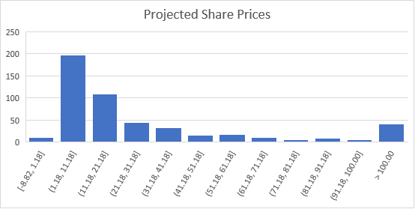

Next, we modelled the dividends with variable discount rate and the projected share prices are even below the previous range. This could be due the increased uncertainty in the model.

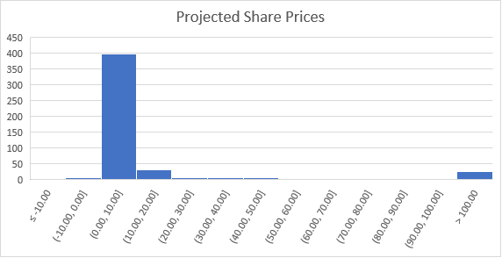

So far, one of the critical assumptions that we made is the dividend growth rate. we have assumed that our data follows a normal distribution and we have estimated the future dividend growth rate and discount rate using the mean and standard deviation obtained from the historical data. However, in reality, dividend growth rates may not always conform to a particular distribution, and the assumption of a symmetric and normal distribution might not be appropriate. This could be reason behind the unpredictable results obtained so far.

So, we incorporate another technique by assigning probabilities to the historical growth rates and calculate cumulative distribution function (CDF).

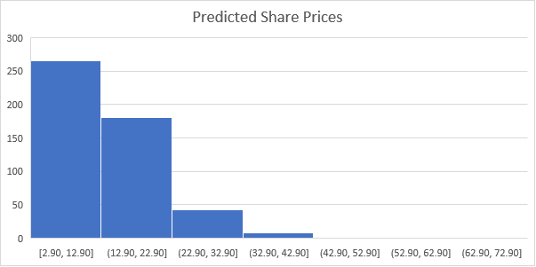

Again, most of the forecasted share prices are far less than the latest actual share price. Comparative to the assumption of normal probability distribution, no negative or extremely high prices have been projected.

The results we have obtained so far highlights the limitations of Dividend Discount Model and the issues inherited in the assumptions made by the model. This lies in the Gordon Growth formula itself which is:

**Price= Dividends/ (rate of return-growth)**

The discount rate (r) should be higher than the dividend growth rate(g) to make sense and provide a reasonable valuation of the stock. This is true in our case; however, the difference is marginal. In practical terms, the discount rate should be significantly higher than the dividend growth rate.

As the growth rate (g) approaches the rate of return (r), the stock price starts to rise significantly, following an exponential trend. When g is close to r, the stock price tends to increase substantially. However, if the growth rate surpasses the rate of return, the share price turns negative, which indicates a problematic scenario for investors.

This explains the unstable results we have obtained so far. Some of the prices were in the range of hundreds and thousands and some of the prices were negative.

Another issue worth highlighting is that the average historical rate of return we estimated from the data is only 3.4% which is well below risk free rate of $4.021% of the country. When company's discount rate is lower than the risk-free rate, it suggests that the company is perceived to be extremely safe or low risk compared to the government bonds. However, this scenario is unrealistic and raises questions about the accuracy of the discount rate because in practice, the discount rate for a company's stock should typically be higher than the risk-free rate. This reflects the fact that investors expect a higher return from investing in a riskier asset like a company's stock compared to a risk-free asset.

# **5.0 Conclusion**

To conclude, predicting future dividend growth rate is inherently uncertain over extended periods. Firstly, the assumption that future dividend growth will follow a specific distribution based on historical data may not accurately capture unpredictability of market. Also, Monte Carlo simulation as we have seen is highly sensitive to the inputs such as assumed dividend growth rate. Small changes in this input have led to significantly different outcomes. Moreover, most of the dividend growth models assume constant discount rate and when discount rate was randomised along with growth rate, the predicted prices were highly unstable. This concludes that Dividend discount Model works well when the assumptions made by the model holds. However, when one or more of these assumptions are violated, it does not provide accurate valuation of the company.

# **References**

Bloomberg L.P. (n.d.). [WoolWorths Group.] [Data set]. Retrieved July 29, 2023 from Bond University Bloomberg terminal.