Automated Pallet Detection System

OGT Assignment Report
Name: Rakesh
Submission: OGT Assignment

Introduction
Computer Vision is a field of Artificial Intelligence that enables machines to interpret visual information from images or videos. In this project, an Automated Pallet Detection System was developed using object detection techniques. The goal of this system is to automatically detect pallets in images and mark them using bounding boxes.

Problem Statement
Warehouses contain large numbers of pallets used for transporting goods. Manually counting pallets is time consuming and prone to human error. This project aims to build an AI model capable of automatically detecting pallets in images.
  - Detect pallets in images
  - Draw bounding boxes around pallets
  - Count pallets automatically

Dataset
The dataset used for training the model was obtained from the Roboflow Universe pallet dataset. The dataset contains labeled images of wooden pallets.
  - Total Images: 364
  - Training Images: 327
  - Validation Images: 21
  - Test Images: 16
  - Class: pallet

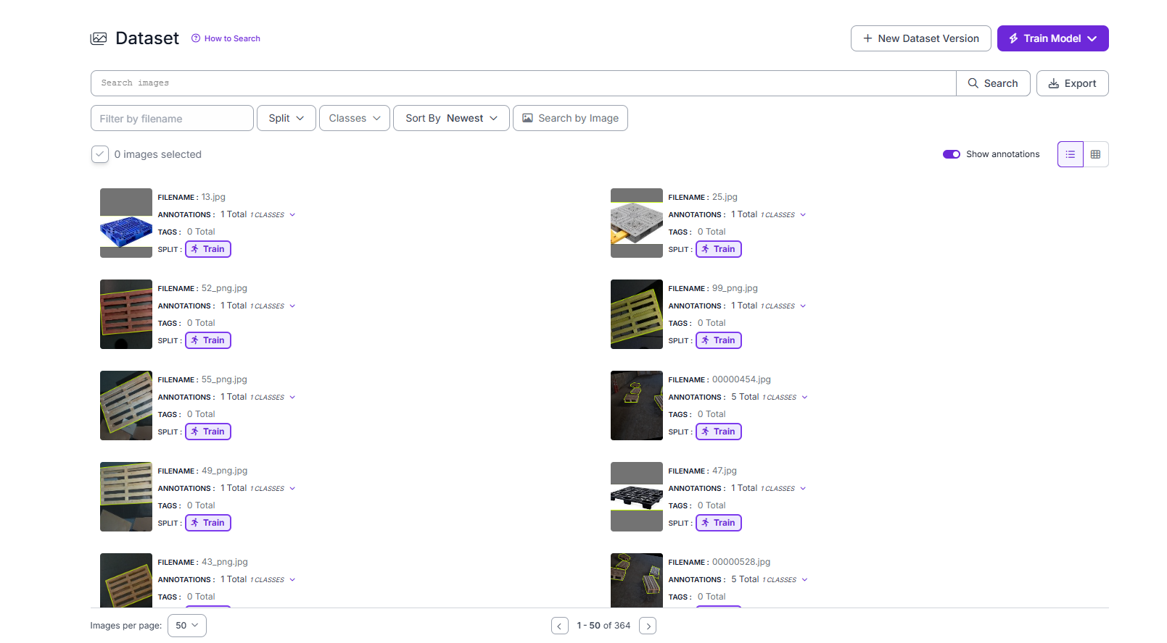5. Data Annotation
Images in the dataset were annotated using bounding boxes. Each pallet in the images was labeled with the class name 'pallet'. Annotation helps the model learn the exact location of pallets in the image.
Insert Screenshot Here: Annotated image with bounding boxes.

Model Training
The object detection model was trained using the RF-DETR Nano architecture available on the Roboflow platform. The model learns to identify pallets by analyzing patterns in the training images.
  - Model: RF-DETR Nano
  - Platform: Roboflow
  - Dataset Version: v1
  - Images Used: 364

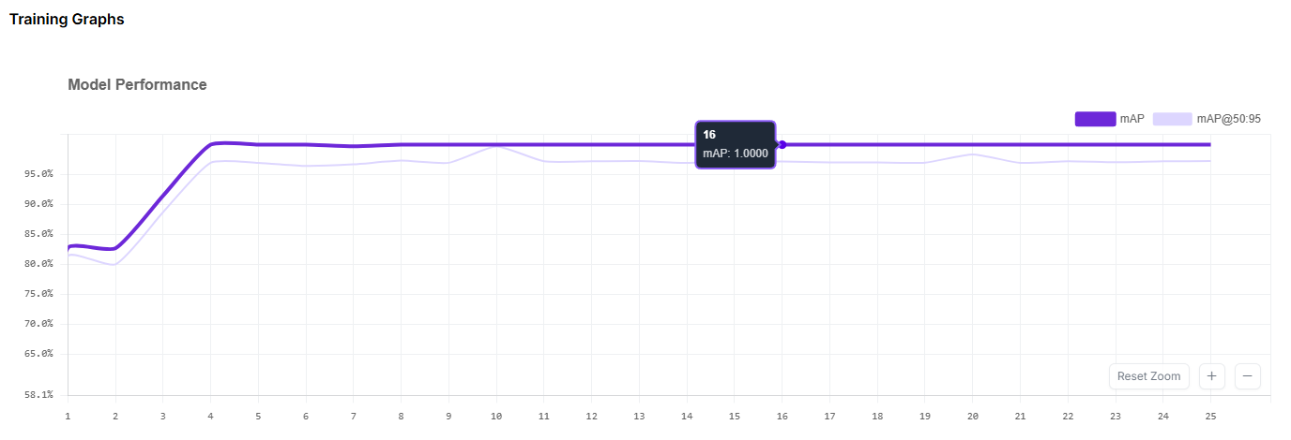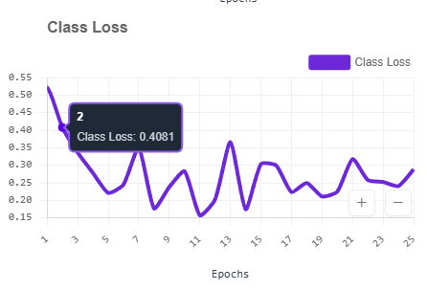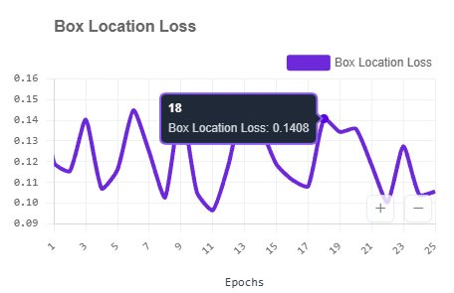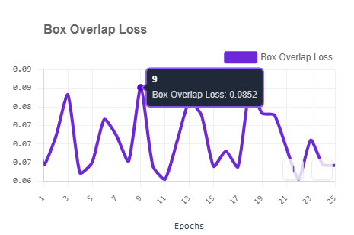

Model Evaluation
After training, the model was evaluated using standard object detection metrics.
  - Precision: 97.5%
  - Recall: 100%
  - mAP@50: 100%


Results
The trained model successfully detects pallets in images. Bounding boxes are drawn around pallets along with confidence scores.
Insert Screenshot Here: Detection result showing pallets detected.

Applications
  - Warehouse automation
  - Logistics and supply chain monitoring
  - Inventory management
  - Smart warehouse systems

Conclusion
In this project, an automated pallet detection system was developed using computer vision techniques. The RF■DETR Nano model achieved high accuracy in detecting pallets. This demonstrates the effectiveness of deep learning for real■world object detection applications.

