ABSTRACT

This paper compares and contrasts two technologies for delivering broadband wireless Internet access services:”3G” VS.”WiFi”. The former, 3G, refers to the collection of third generation mobile technologies that are designed to allow mobile operators to offer integrated data and voice services over mobile networks .The latter, WiFi, refers to the 802.11b wireless Ethernet standard that was designed to support wireless LANs. Although the two technologies reflect fundamentally different service, industry and architectural design goals, origins and philosophies, each has recently attracted a lot of attention as candidates for the dominant platform for providing broadband wireless access to the Internet. It remains an open question as to the extent to which these two technologies are in competition or, perhaps, may be complementary. If they are viewed as in competition, then the triumph of one at the expense of the other would be likely to have profound implications for the evolution of the wireless internet
and structure of the service provider industry.

INTRODUCTION
The two most important phenomena impacting telecommunications over the past decade have been explosive parallel growth of both the internet and mobile telephone services. The internet brought the benefits of data communications to the masses with email, the web, and ecommerce; while mobile service has enabled “follow-me anywhere/always on” telephony. The internet helped accelerate the trend from voicecentric to data-centric networking. Data already exceeds voice traffic and the data share continues to grow. Now these two worlds are converging. This convergence offers the benefits of new interactive multimedia services coupled to the flexibility and mobility of wireless. To realize the full potential of this convergence, however, we need broadband access connections.
Here we compare and contrast two technologies that are likely to play important roles: Third Generation mobile (“3G”) and Wireless Local Area Networks (“WLAN”). The former represents a natural evolution and extension of the business models of existing mobile providers. In contrast, the WiFi approach would leverage the large installed base of WLAN infrastructure already in place. We use 3G and WiFi as shorthand for the broad classes of related technologies that have two quiet distinct industry origins and histories.
Speaking broadly, 3G offers a vertically –integrated , top –down , service – provider approach to delivering wireless internet access , while WiFi offers an end –user –centric , decentralized approach to service provisioning. We use these two technologies to focus our speculations on the potential tensions between these two alternative world views. The wireless future will include a mix of heterogenous wireless access technologies. Moreover, we expect that the two world views will converge such that vertically-integrated service providers will integrate WiFi or other WLAN technologies into their 3G or wire line infrastructure when this make sense. The multiplicity of potential wireless access technologies and /or business models provided some hope that we may be able to realize robust facilities – based competition for broadband local access services. If this occurs, it would help solve the “last mile” competition problem that hasBeen deviled telecommunication policy.

SOME BACKGROUND ON WiFi AND 3G
3G:
3G is a technology for mobile service providers. Mobile services are provided by service providers that own and operate their own wireless networks and sell mobile services to and –users. Mobile service providers use licensed spectrum to provide wireless telephone coverage over some relatively large contiuous geographic service area. Today it may include the entire country. From a user’s perspective, the key feature of mobile service is that it offers ubiquitous and continuous coverage. To support the service, mobile operators maintain a network of interconnected and overlapping mobile base stations that hand-off customers as those customers move among adjacent cells.
Each mobile base station may support user’s upto several kilometers away. The cell towers are connected to each other by a backhaul network that also provides interconnection to the wire line Public Switched Telecommunications Network (PSTN) and other services. The mobile system operator owns the end-to-end network from the base stations to the backhaul networks to the point of interconnection to the PSTN. Third Generations (3G) mobile technologies will support higher bandwidth digital communications. To expand the range and capability of data services that can be supported by digital mobile systems, service providers will have to upgrade their networks to one of the 3G technologies which can support data rates of from 384Kbps up to 2Mbps.

WiFi
WiFi is the popular name for the wireless Ethernet 802.11b standard for WLANs. WiFi allows collections of PCs, terminals ,and other distributed computing devices to share resources and peripherals such as printers, access servers etc. One of the most popular LAN technologies was Ethernet
. 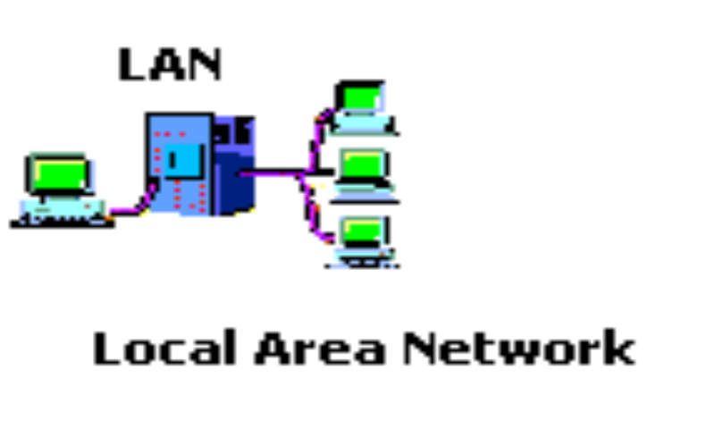
WiFi LANs operate using unlicensed spectrum in the 2.4 GHz band . The current generation of WLANs supports upto 11Mbps, data rates within 300 feet of the base station. Most typically, WLANs are deployed in a distributed way to offer last –few – hundred – feet connectivity to a wire line backbone corperate or campus network.
Typically, the WLANs are implemented as part of a private network. The base station equipment is owned and operated by the end-user community .Although each base station can support connections only over a range of few hundred feet, it is possible to provide continuous coverage over a wider area by using multiple base stations. Still, the WLAN technology was not designed to support high-speed hand – off associated with users moving between base station coverage areas.
There has been an emergence of a number of service providers that are offering WiFi services for a fee in selected local areas . In addition, there is a growing movement of so – called “Free Nets” where individuals or organizations are providing open access to subsidized WiFi networks

HOW ARE WiFi AND 3G SAME
From the preceding discussion, it might appear that 3G and WiFi address completely different user needs in quiet distinct markets that do not overlap. While this was certainly more true about earlier generations of mobile services when compared with wired LANs or earlier versions of WLANs , it is increasingly not the case. The end- user does not care what technology is used to support his service. What matter is that both of these technologies are providing platforms for wireless access to the internet and other communication services? We shall focus on the ways in which the two technologies may be thought of as similar.
A.BOTH ARE WIRELESS
Both technologies are wireless which
(1) Avoids need to install cable drops to each device when compared to wire line alternatives.
(2) Facilities mobility, Wireless infrastructure may be deployed more rapidly than wire line alternatives to respond to new market opportunities or changing demand.
Wireless technologies also facilitate mobility. This includes both
(1) The ability to move devices around having to move cables and furniture and
(2) The ability to stay continuously connected over wider serving areas.
3G offers much narrower bandwidth but over a wider covering area and with more support for rapid movement between base stations. Although it is possible to cover a wide area with WiFi , it is most commonly deployed in a local area with one or a few base stations being managed as a separate WLAN .
This has implications for the magnitude of initial investment required to bring up WLAN or 3G wireless service .It is unclear at this time which type of network might be lower cost for equivalent scale deployments.
B. BOTH ARE ACCESS TECHNOLOGIES.
Both 3G and WiFi are access or edge/network technologies. This means they offer alternatives to the last- mile wireline network. Beyond the last –mile , both rely on similar network connections and transmission support infrastructure. For 3G, the wireless link is from the end- user device to the cell base station ( up to a few kilometers) and then dedicated wireline facilities to interconnect base station to the carrier’s backbone network and ultimately to the internet cloud. It is possible to view 3G as an access service.
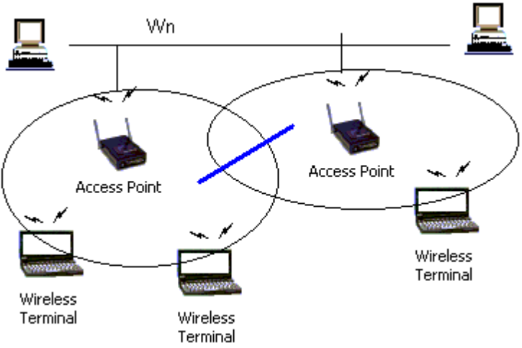
For WiFi , the wireless link is a few hundred feet from the end-user device to the base station. The base station is then connected either into the wireline LAN or enterprise network infrastructure or to a wireline access line to a carrier’s backbone network and then eventually to the internet . Wireless service are part of an end-to-end value chain that includes , in its coarsest delineation atleast
(1) The internet backbone ( the cloud )
(2) The second mile network providers (ILEC ,mobile , cable, or a NextGen carrier
(3) The last mile access facilities ( and, beyond them, the end-user devices ).
C. BOTH OFFER BROADBAND DATA SERVICE
Both 3G and WiFi support broadband data service, although the data rate offered by WiFi (11Mbps ) is substantially higher than the couple of hundred Kbps expected from 3G services .
The key is that both will offer sufficient bandwidth to support a comparable array of services , including real – time voice, data , and streaming media . In this sense both will support “broadband “ where we define this as “faster than what we had before”.
Both services will also support “always on “ connectivity which is another very important aspect of broadband service . This is even more important than the raw throughput supported .
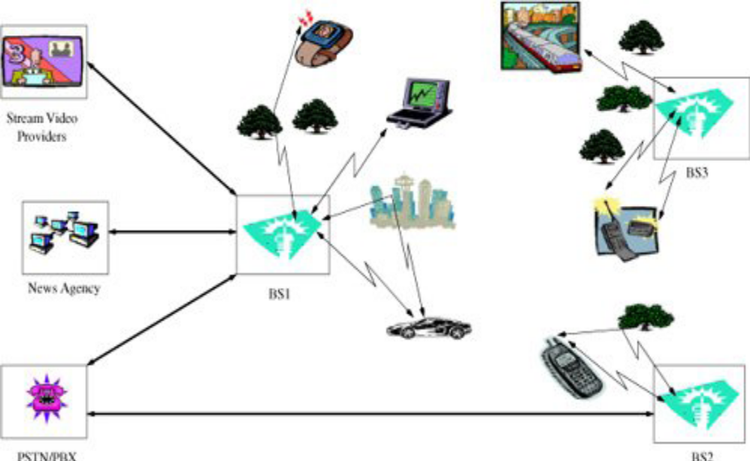
HOW THEY ARE DIFFERENT
We shall consider several of the important ways in which the WiFi and 3G approaches to offering broadband wireless access services are substantively different.
A . CURRENT BUSINESS MODELS / DEPLOYMENT ARE
DIFFERENT
3G represents an extension of the mobile service provider model. The basic business model is the telecommunication services model . The 3G business model is close to the wireline telephone business. The service is conceptualized usually as a mass – market offering to both residential and business customers on a subscription basis . The 3G deployment and serving provisioning model is one of top-down , vertically – integrated , and centralized planning and operation.
In contrast, WiFi comes out of the data communications industry ( LANs) which is a bi-product of the computer industry . The basic business model is one of equipment makers who sell boxes to customers. Only recently have WLANs being targeted as a mass market offering to home users.
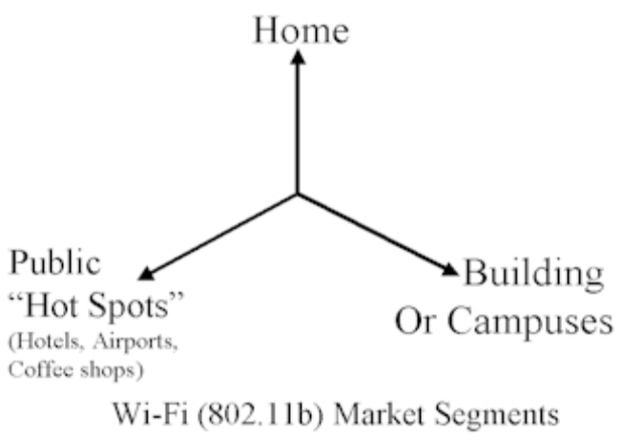
With respect to deployment, 3G will require substantial investment in new infrastructure to upgrade existing 2G networks. For WiFi , it is hoped that deployment can piggy-back on the large existing base of WLAN equipment already in the field . In both the cases, end – user will need to buy suitable interface devices (PC cords for 3G or WiFi access) .
The prevailing business model for 3G services and infrastructure is vertically integrated, this need not be the case for WiFi .
B. SPECTRUM POLICY AND MANAGEMENT.
This is one of the key distinctions between 3G and WiFi . 3G and other mobile technologies use licensed spectrum, while WiFi uses unlicensed shared spectrum. This has important implications for
(1) Cost of service
(2) Quality of service (QOS ) and congestion management
(3) Industry structure
With licensed spectrum, the licensee is protected from interference from other service providers . In contrast, the unlicensed spectrum used by WiFi imposes strict power limits on users and forces users to accept interference from others. Hence WiFi network cannot control potential interference from other WiFi service providers or the RF sources that are sharing the unlicensed spectrum.

C. STATUS OF TECHNOLOGY DEVELOPMENT DIFFERENT.
The two technologies differ with respect to their stage of development in a number of ways .
1. DEPLOYMENT STATUS.
While 3G licenses have been awarded in a number of markets at a cost of billions of dollars to the licensees, it has only limited progress with respect to service deployment. In contrast, we have a large installed base of WiFi networking equipment that is growing rapidly.

2. EMBEDDED SUPPORT FOR SERVICES.
Important difference between 3G and WiFi is their embedded support for voice services . 3G was expressly designed as an upgrade technology for wireless voise telephony networks. In contrast, WiFi provides a lower layer data communication service that can be used as the substrate on which to layer services such as voice telephony. Another potential advantage of 3G over WiFi is that 3G offers better support for secure / private communications that does WiFi.
3. STANDARDIZATIO
Formal standards picture for 3G is perhaps more clear than for WLAN . For 3G , there‘s relatively a small family of internationally sanctioned standards, collectively referred to as WCDMA . WiFi is one of the families of continuously evolving 802.11 x wireless Ethernet standards. It may appear that the standards picture for WLANs is less clear than for 3G.
4. SERVICE/BUSINESS MODEL
3G is more developed than WiFi as a business and service model. It represents an extension of the existing service provider industry to new services, and as such, does not represent a radical departure from underlying industry structure. In contrast, WiFi is more developed with respect to the upstream supplier markets, at least with respect to WLAN equipment.
SOME IMPLICATIONS FOR INDUSTRY STRUCTURE AND
PUBLIC POLICY
1. WiFi is good for competition
2. WiFi and 3G can compliment each other for a mobile provider.
3. Policy is key.
4. Spectrum Success of WiFi is potentially good for multimedia content.
5. Technical progress favors heterogeneous future.

CONCLUSION
This article offers a qualitative comparision of two wireless technologies that can be viewed simultaneously as substitute and / or complimentary paths for evolving to broad band wireless access. The two technologies are 3G , which is the preferred upgrade path for mobile providers , and WiFi , one of the many WLAN technologies. The goal of the analysis is to explore two divergent world views for the future of wireless access and to speculate on the likely success and possible interactions between the two technologies in the future. First, both technologies are likely to succeed in the market place. This means that the wireless future will include heterogeneous access technologies. Second we expect 3G mobile providers to integrate WiFi technology into their networks thus expecting these two technologies to be complimentary in their successful mass market deployment .Third, we also expect WiFi to offer competition to 3G providers because of the lower enter costs associated with establishing WiFi networks. This may take form of new type of service providers (e.g.,Boingo) , in end- user organized networks (e.g.,
FreeNet aggregation). The threat of such WiFi competition is beneficial to prospects for the future of last mile competition.

REFERENCES
1. Workshop “competition in wireless : spectrum , service and technology
wars , university of Florida, Feb 20,2002.
2. From the internet sites of MIT.

