**Task-2: Perform the task-1 using EFS instead of EBS service on the AWS Create/launch Application using Terraform**

#Task-2

#

#Perform the task-1 using EFS instead of EBS service on the AWS.

#Create/launch Application using Terraform.

#

#1. Create Security group which allow the port 80.

#2. Launch EC2 instance.

#3. In this Ec2 instance use the existing key or provided key and security group which we have created in step 1.

#4. Launch one Volume using the EFS service and attach it in your vpc, then mount that volume into /var/www/html

#5. Developer have uploded the code into github repo also the repo has some images.

#6. Copy the github repo code into /var/www/html

#7. Create S3 bucket, and copy/deploy the images from github repo into the s3 bucket and change the permission to public readable.

#8 Create a Cloudfront using s3 bucket(which contains images) and use the Cloudfront URL to update in code in /var/www/html

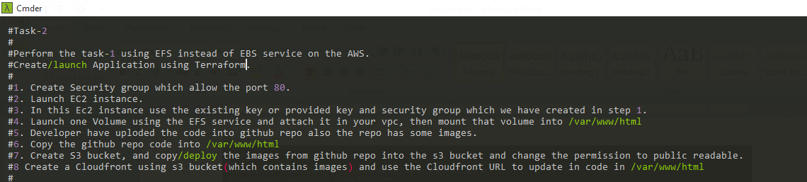

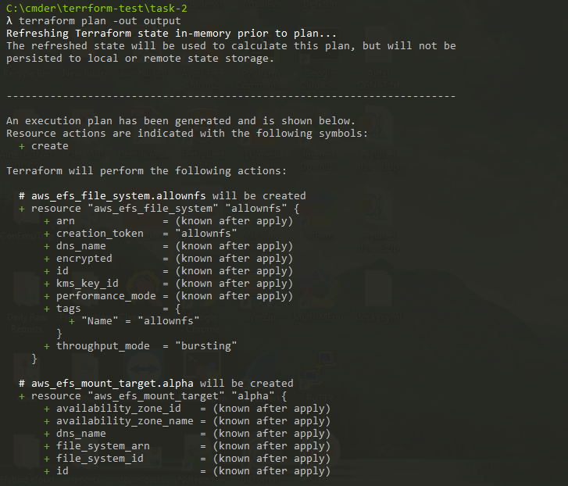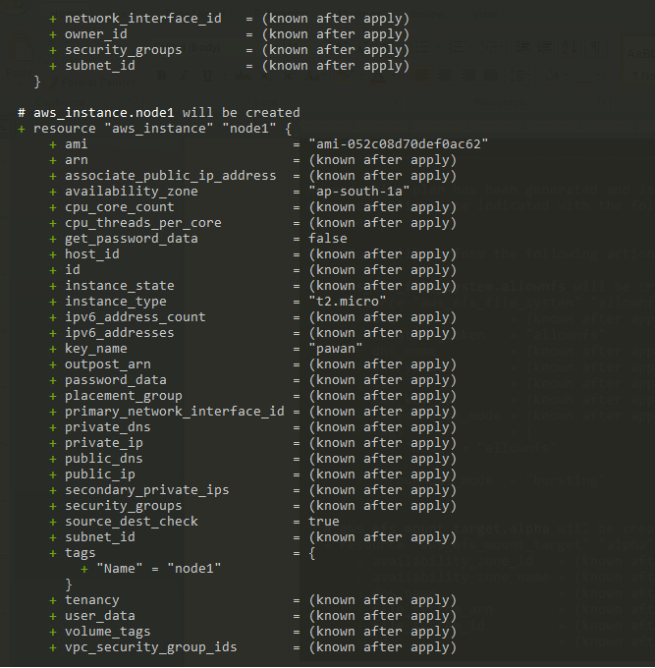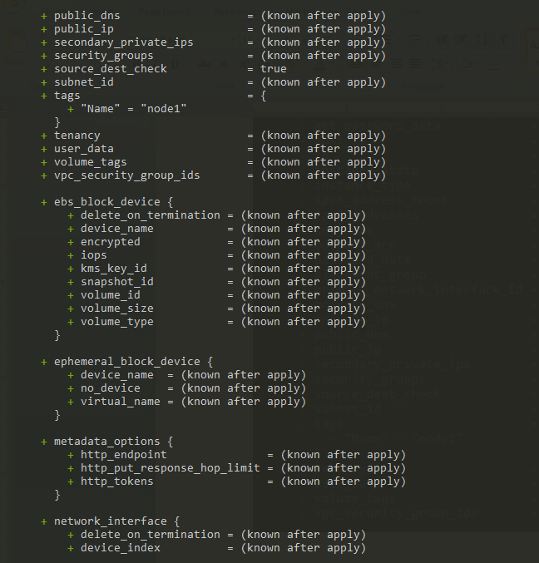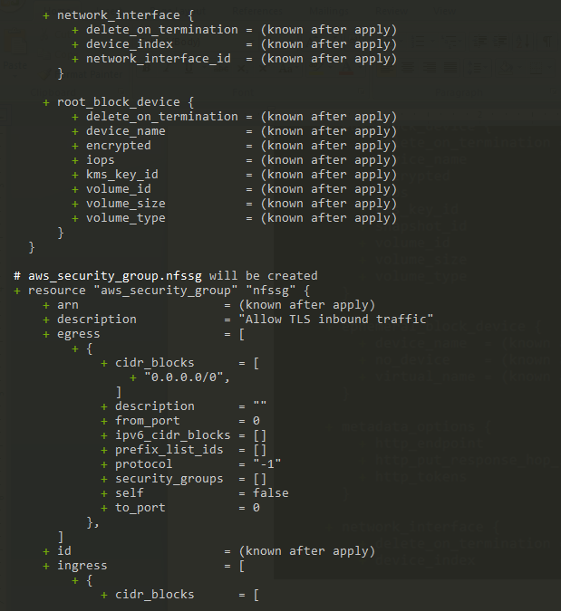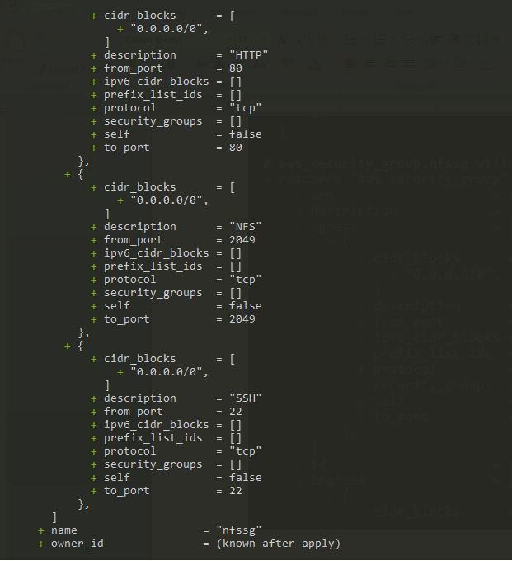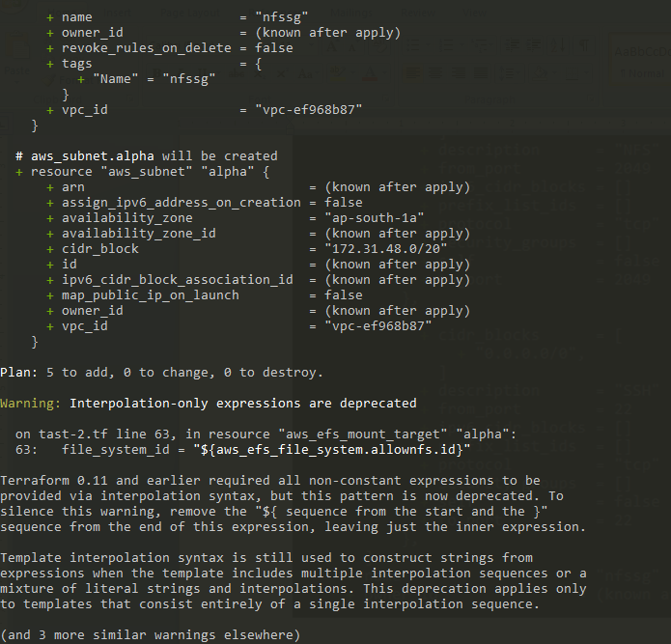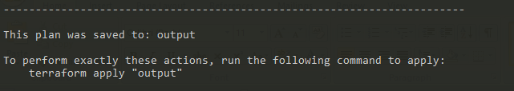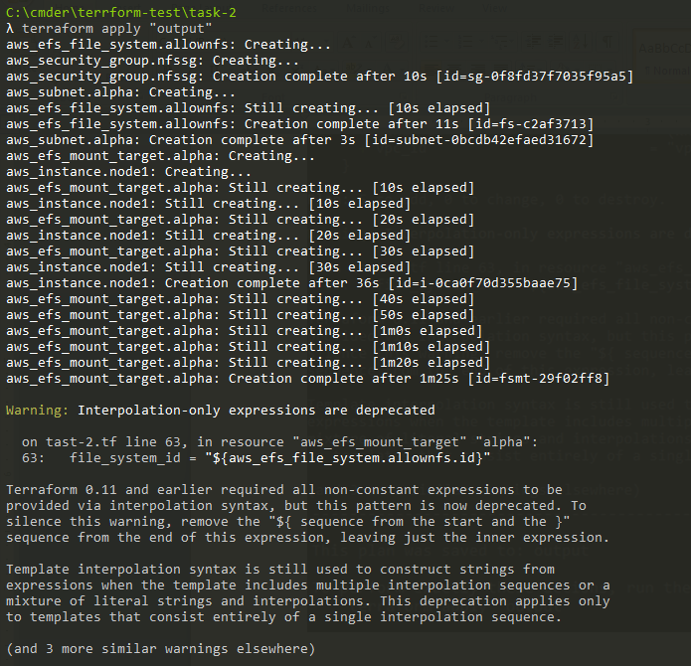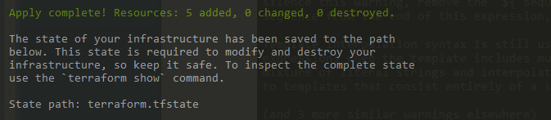

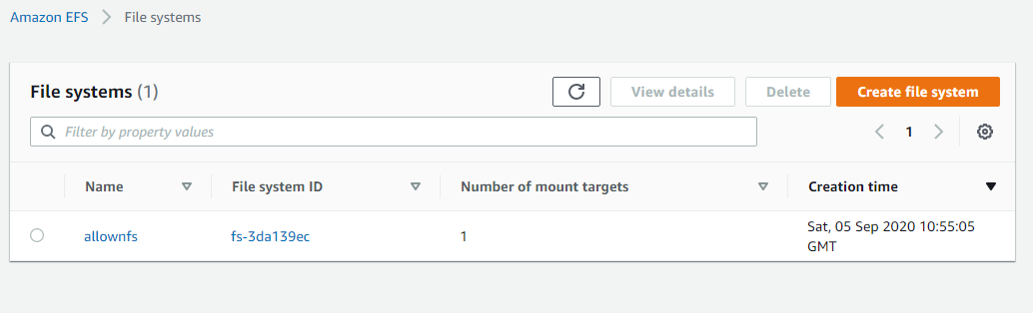

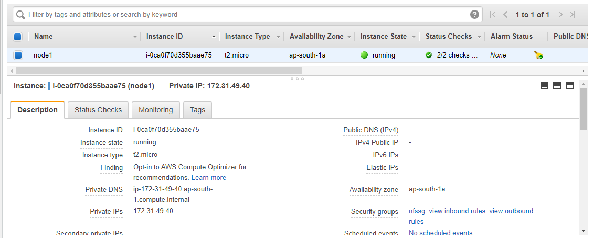

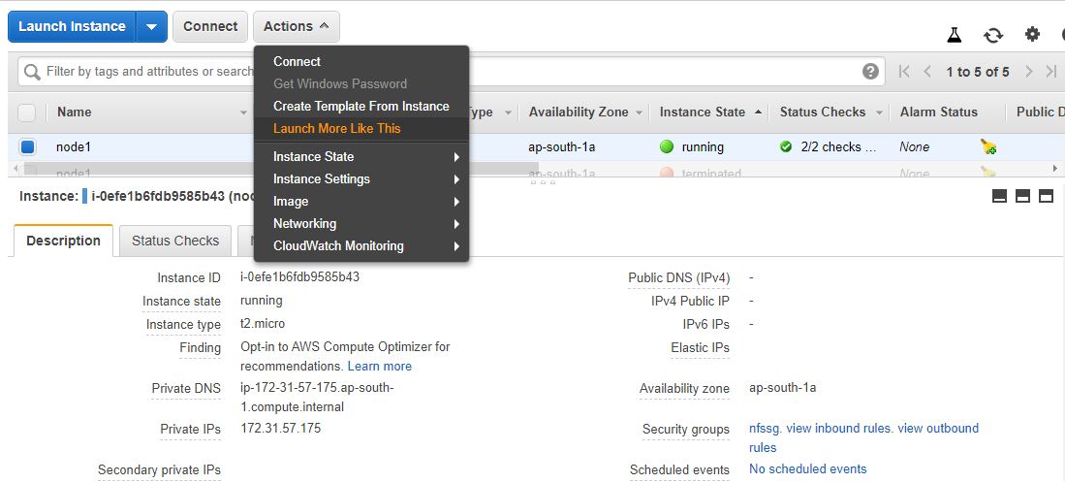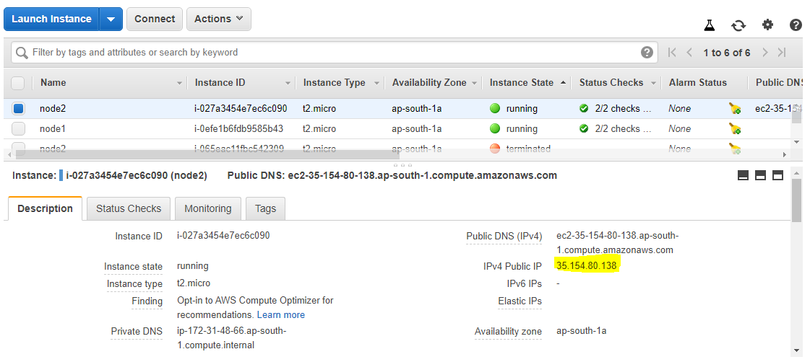

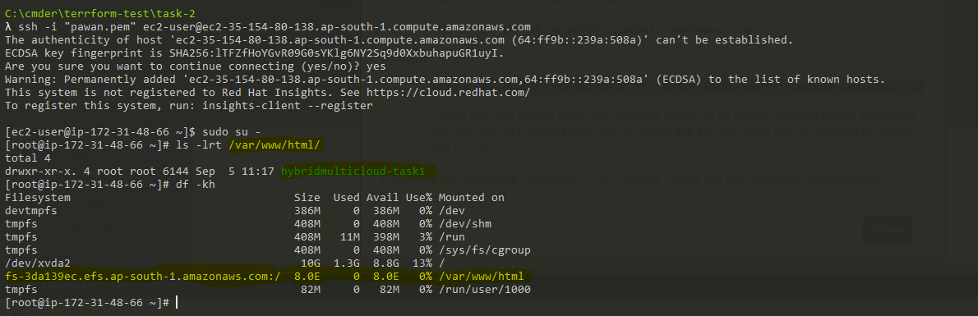

6. Copy the github repo code into /var/www/html

7. Create S3 bucket, and copy/deploy the images from github repo into the s3 bucket and change the permission to public readable.

8 Create a Cloudfront using s3 bucket(which contains images) and use the

Cloudfront URL to update in code in /var/www/html

