Skill – 5

PHYSICIAN & DEPARTMENT TABLES

STEP 1: CREATE PHYSICIAN TABLE

CREATE TABLE physician ( employeeid INT PRIMARY KEY, name VARCHAR(100),position VARCHAR(100),ssn VARCHAR(20)
);

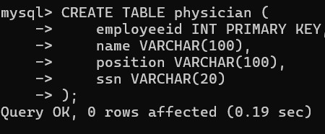

STEP 2: INSERT DATA INTO PHYSICIAN

INSERT INTO physician VALUES
(1,'John Dorian','Staff Internist','111111111'),
(2,'Elliot Reid','Attending Physician','222222222'),
(3,'Christopher Turk','Surgical Attending
Physician','333333333'),
(4,'Percival Cox','Senior Attending Physician','444444444'),
(5,'Bob Kelso','Head Chief of Medicine','555555555'),
(6,'Todd Quinlan','Surgical Attending Physician','666666666'),
(7,'John Wen','Surgical Attending Physician','777777777'),
(8,'Keith Dudemeister','MD Resident','888888888'),
(9,'Molly Clock','Attending Psychiatrist','999999999');
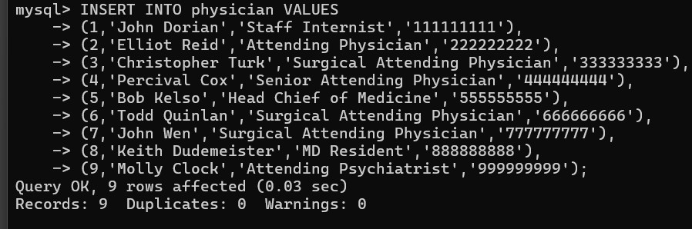

STEP 3: CREATE DEPARTMENT TABLE

CREATE TABLE department ( departmentid INT PRIMARY KEY, name VARCHAR(100), head INT
);

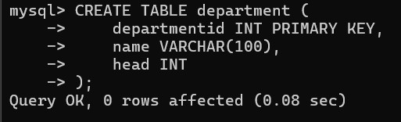

STEP 4: INSERT DATA INTO DEPARTMENT

INSERT INTO department VALUES
(1,'General Medicine',4),
(2,'Surgery',7),
(3,'Psychiatry',9);

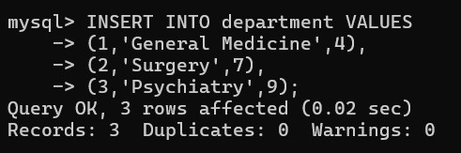

QUESTION 1 - INNER JOIN

SCENARIO:
The hospital administration wants a report showing each department and its department head.
QUERY:

SELECT d.name AS Department,
p.name AS Head_Physician
FROM department d
JOIN physician p
ON d.head = p.employeeid;

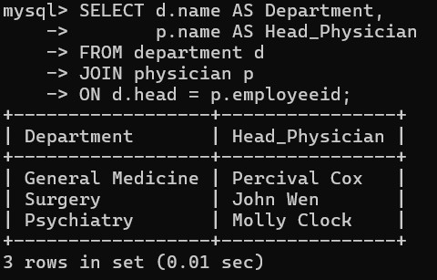

QUESTION 2 - WHERE CLAUSE

SCENARIO:
The HR department wants a list of all physicians working as Surgical Attending Physicians.
QUERY:

SELECT *
FROM physician
WHERE position='Surgical Attending Physician';

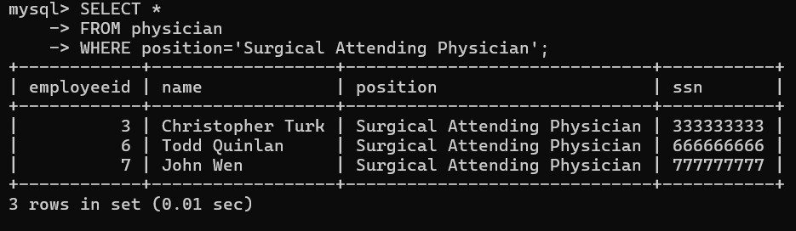

QUESTION 3 - WHERE + LIKE

SCENARIO:
Management wants to identify physicians whose names start with 'John'.
QUERY:

SELECT *
FROM physician
WHERE name LIKE 'John%';

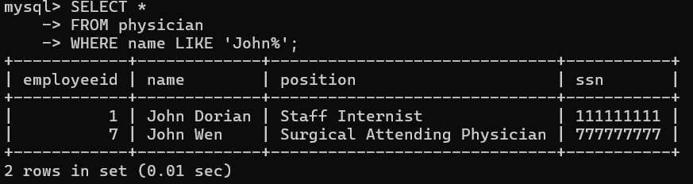

QUESTION 4 - COUNT()

SCENARIO:
The hospital wants to know the total number of physicians currently employed.
QUERY:

SELECT COUNT(*) AS Total_Physicians
FROM physician;

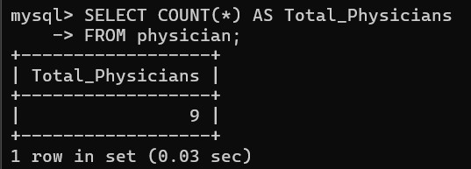

QUESTION 5 - COUNT DISTINCT

SCENARIO:
HR wants to know how many different job positions exist in the hospital.
QUERY:

SELECT COUNT(DISTINCT position)
FROM physician;

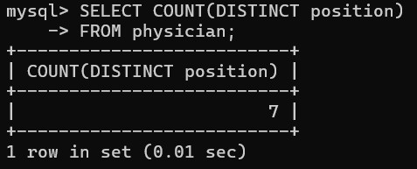
QUESTION 6 - GROUP BY
QUESTION 6 - GROUP BY

SCENARIO:
The HR manager wants to know how many physicians
are working in each position.

QUERY:

SELECT position,
COUNT(*) AS Total_Employees
FROM physician
GROUP BY position;

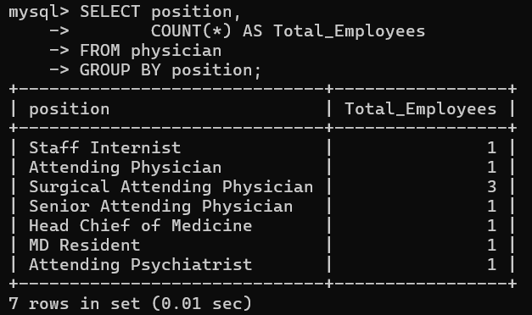

QUESTION 7 - GROUP BY + HAVING

SCENARIO:
The HR team wants to find positions occupied
by more than one physician.

QUERY:

SELECT position,
COUNT(*) AS Total_Employees
FROM physician
GROUP BY position
HAVING COUNT(*) > 1;

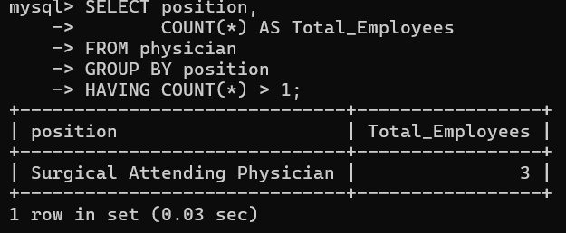

QUESTION 8 - ORDER BY

SCENARIO:
Hospital management wants an alphabetical
directory of physicians.

QUERY:

SELECT *
FROM physician
ORDER BY name ASC;

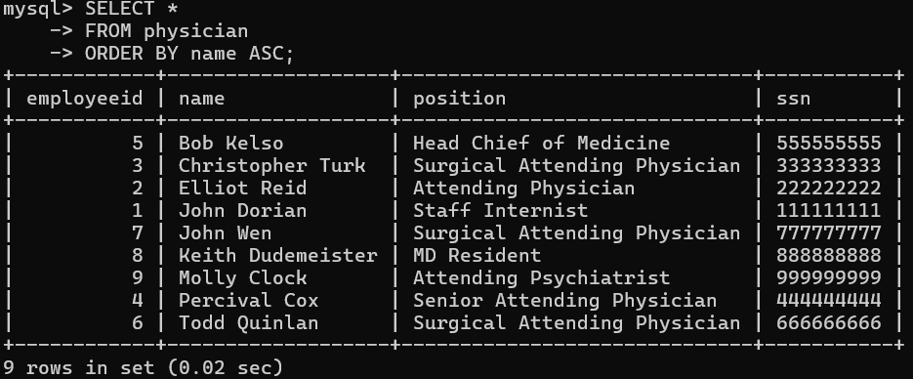

QUESTION 9 - ORDER BY DESC

SCENARIO:
Management wants to see physician records
sorted by employee ID from highest to lowest.

QUERY:

SELECT *
FROM physician
ORDER BY employeeid DESC;

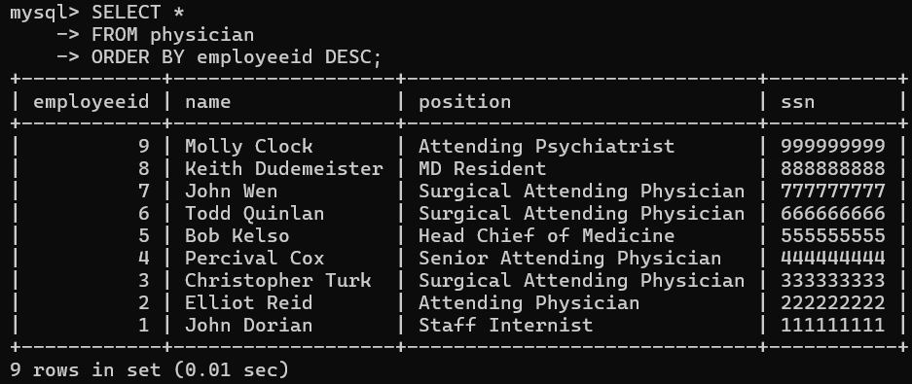

QUESTION 10 - WHERE + IN

SCENARIO:
The CEO wants details of department heads only.

QUERY:

SELECT *
FROM physician
WHERE employeeid IN
(
SELECT head
FROM department
);

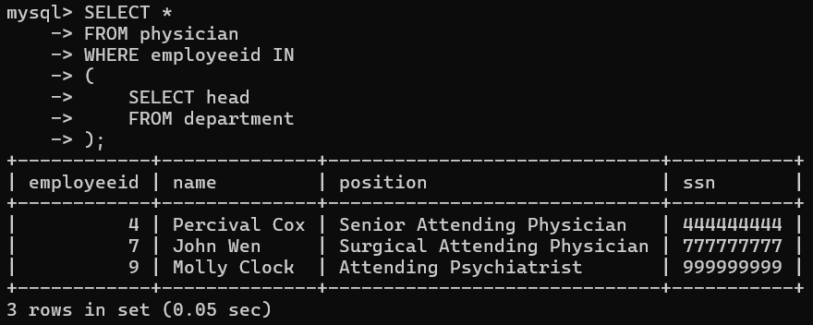

QUESTION 11 – SUBQUERY

SCENARIO:
Find physicians who are not department heads.

QUERY:

SELECT *
FROM physician
WHERE employeeid NOT IN
(
SELECT head
FROM department
);

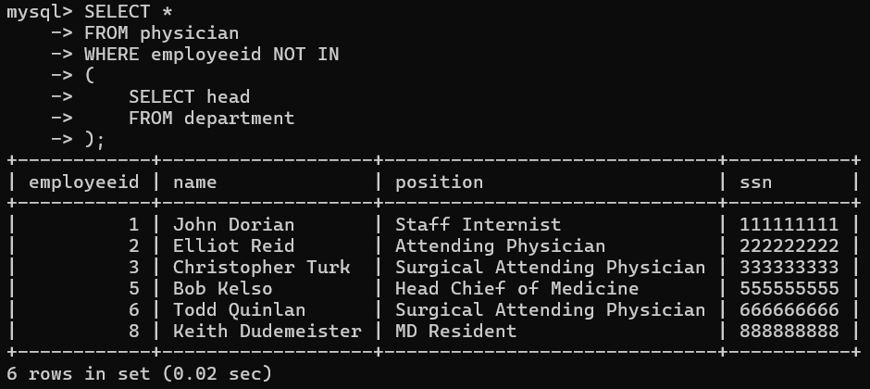

QUESTION 12 - GROUP BY + ORDER BY

SCENARIO:
HR wants to see positions ranked by number
of employees.

QUERY:

SELECT position,
COUNT(*) AS Total_Employees
FROM physician
GROUP BY position
ORDER BY Total_Employees DESC;

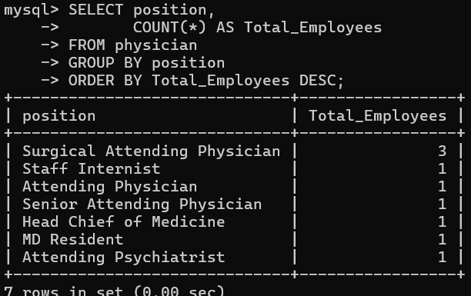

QUESTION 13 - WHERE + LIKE

SCENARIO:
The administration wants all physicians whose
position contains the word 'Attending'.

QUERY:

SELECT *
FROM physician
WHERE position LIKE '%Attending%';

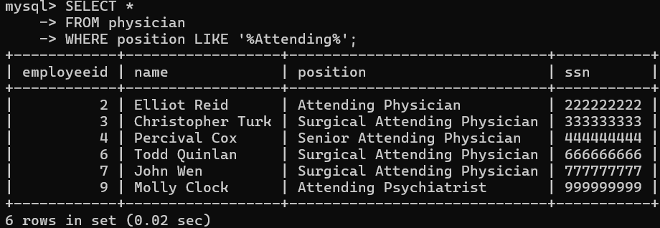

QUESTION 14 - JOIN + WHERE

SCENARIO:
The hospital wants to know who heads the
Surgery department.

QUERY:

SELECT p.name
FROM physician p
JOIN department d
ON p.employeeid=d.head
WHERE d.name='Surgery';

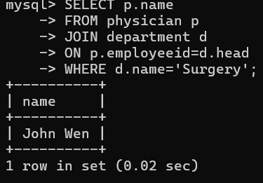

QUESTION 15 - JOIN + ORDER BY

SCENARIO:
Hospital administration wants department names
and head physicians sorted by department name.

QUERY:

SELECT d.name,
p.name
FROM department d
JOIN physician p
ON d.head=p.employeeid
ORDER BY d.name;

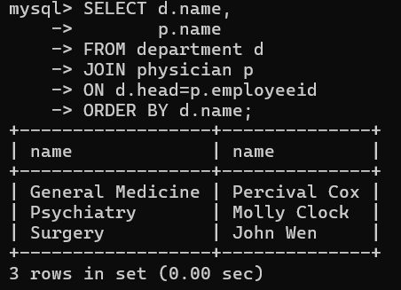

QUESTION 16 - WHERE + NOT LIKE

SCENARIO:
Find physicians who are not involved in surgery.

QUERY:

SELECT *
FROM physician
WHERE position NOT LIKE '%Surgical%';

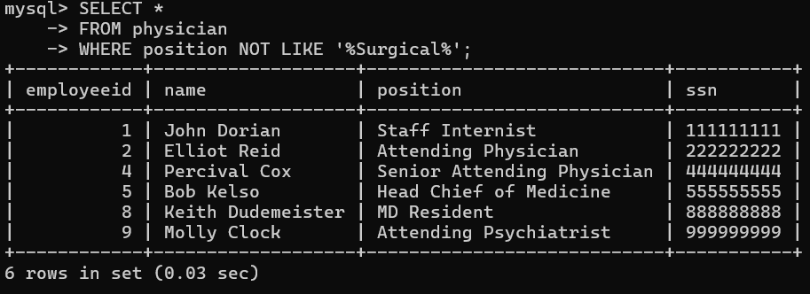

QUESTION 17 - COUNT + HAVING

SCENARIO:
Find positions having at least 2 employees.

QUERY:

SELECT position,
COUNT(*) AS Total
FROM physician
GROUP BY position
HAVING COUNT(*) >= 2;

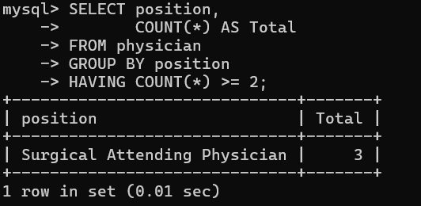

QUESTION 18 - EXISTS

SCENARIO:
Find departments that currently have a valid head.

QUERY:

SELECT *
FROM department d
WHERE EXISTS
(
SELECT 1
FROM physician p
WHERE p.employeeid=d.head
);

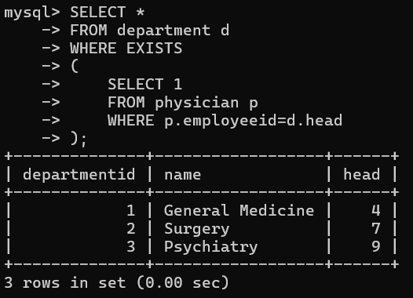

QUESTION 19 - MAX()

SCENARIO:
Management wants the highest employee ID
currently assigned.

QUERY:

SELECT MAX(employeeid)
FROM physician;
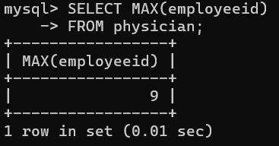

QUESTION 20 - MIN()

SCENARIO:
Management wants the earliest employee ID
currently assigned.

QUERY:

SELECT MIN(employeeid)
FROM physician;

