UNIVERSITY OF MUMBAI
VIVEK COLLEGE OF COMMERCE (AUTONOMOUS)
Department of Information Technology

A PROJECT REPORT (BLACK BOOK)
ON
LIFEOS — Behavioural Intelligence & Strategic Goal Operating System
Submitted in partial fulfilment of the requirements for the degree of
Bachelor of Science (Information Technology)

Submitted by
Pawan Kumar Mahto
Roll / Seat Number: IT2425

Under the guidance of
Mrs. Maria Muthukumar

Academic Year 2026–2027

CERTIFICATE

This is to certify that the project entitled “LIFEOS — Behavioural Intelligence & Strategic Goal Operating System” is a bonafide work carried out by Pawan Kumar Mahto (Roll / Seat Number:25 / IT2425) of Vivek College of Commerce (Autonomous), Department of Information Technology, in partial fulfilment of the requirements for the degree of Bachelor of Science (Information Technology) of the University of Mumbai during the academic year 2026–2027.
The work has been carried out under my guidance and, to the best of my knowledge, has not been submitted elsewhere for any other degree.

Project Guide
Mrs. Maria Muthukumar

Head of Department
Mrs. Maria Muthukumar

External Examiner

Principal
Dr. Vijetha Shetty

Date: Place: Mumbai College Seal
DECLARATION
I, Pawan Kumar Mahto, hereby declare that the project report entitled “LIFEOS — Behavioural Intelligence & Strategic Goal Operating System” is a record of work carried out by me for the degree of Bachelor of Science (Information Technology) at Vivek College of Commerce (Autonomous), University of Mumbai. The software was developed by me individually, and this report describes the system as implemented in the submitted source code. Planned features are identified as future work and are not presented as implemented.

Sources used in the literature review and references are acknowledged.

Signature:
Pawan Kumar Mahto (25 / IT2425)
Date:

APPROVAL / EXAMINATION PAGE
This project report entitled “LIFEOS — Behavioural Intelligence & Strategic Goal Operating System” by Pawan Kumar Mahto is approved for the degree of Bachelor of Science (Information Technology).

______________________________
Internal Examiner
[INTERNAL EXAMINER NAME]

______________________________
External Examiner

Date:

ACKNOWLEDGEMENT

I would like to thank my project guide, Mrs. Maria Muthukumar, for her guidance and support throughout this project, and the Department of Information Technology of Vivek College of Commerce (Autonomous) for providing the opportunity and facilities to carry out this work.
I also thank the maintainers of the open-source tools and frameworks used in the project, and my family and friends for their encouragement.

Pawan Kumar Mahto

ABSTRACT
Everyday self-management is usually spread across separate applications for tasks, habits, health records, screen-time control and reflection, which makes it difficult to relate day-to-day behaviour to long-term goals. LIFEOS is a web-based personal operating system that brings these areas into one application. It is implemented as a Next.js 16 / React 19 client and an Express 5 / TypeScript API using MongoDB through Mongoose, and exposes 139 route definitions across 23 route modules and 36 data models.
The system provides authentication with refresh-token rotation, tasks, habits with streaks, focus sessions, manually recorded health data, digital-wellbeing records and urge interventions, journaling with timeline and replay views, strategic goals with milestones, a daily mission, periodic reports and insights, groups, challenges and achievements. A goal can be expanded into a plan of milestones, tasks and habits selected from rule-based templates, which is applied only after the user accepts it. An AI settings layer stores a user-supplied API key in encrypted form, and the AI report and coach endpoints produce structured text from the user’s stored data; calls to an external language model are not yet implemented.
The service layer is verified by 103 automated test cases in 17 files. Native mobile functionality, operating-system-level application blocking, wearable and health-platform integration, and language-model integration are identified as future work. Project effort is estimated with Basic COCOMO and the recorded phase milestones are presented as a Gantt chart.
Keywords: personal informatics, goal management, habit tracking, digital wellbeing, Next.js, Express, MongoDB, TypeScript.

TABLE OF CONTENTS
CHAPTER 1 — INTRODUCTION 1
1.1 Introduction 1
1.2 Background 1
1.3 Problem Statement 1
1.4 Motivation 1
1.5 Proposed Solution 2
1.6 Aim 2
1.7 Objectives 2
1.8 Scope 2
1.9 Target Users 2
1.10 Significance of the Project 3
1.11 Limitations 3
1.12 Organization of the Report 3
CHAPTER 2 — LITERATURE REVIEW 4
2.1 Overview 4
2.2 Personal Informatics 4
2.3 Goal Setting 4
2.4 Habit Formation and Behaviour Models 4
2.5 Gamification 4
2.6 Digital Wellbeing 4
2.7 Existing System Categories 5
2.8 Research Gap and Proposed Contribution 5
CHAPTER 3 — REQUIREMENTS, METHODOLOGY & PROJECT PLANNING 6
3.1 Existing System 6
3.2 Problems in Existing System 6
3.3 Proposed System 6
3.4 Functional Requirements 6
3.5 Non-Functional Requirements 7
3.6 Hardware Requirements 7
3.7 Software Requirements 8
3.8 Development Methodology 8
3.9 Project Development Lifecycle 8
3.10 Project Planning 8
3.11 Gantt Chart 9
3.12 COCOMO Model 10
3.13 Feasibility Analysis 11
3.14 Risk Analysis 11
CHAPTER 4 — SYSTEM DESIGN 12
4.1 System Architecture 12
4.2 High-Level Architecture 12
4.3 Frontend Architecture 12
4.4 Backend Architecture 13
4.5 Database Architecture 13
4.6 Authentication Architecture 14
4.7 API Architecture 14
4.8 Module Architecture 14
4.9 Data Flow 14
4.10 Entity Relationship / Database Relationship Diagram 15
4.11 Use Case Diagram 16
4.12 Activity Diagrams 16
4.13 Sequence Diagrams 17
4.14 Class / Component Diagrams 17
4.15 Security Design 17
CHAPTER 5 — IMPLEMENTATION 18
5.1 Development Environment 18
5.2 Frontend Implementation 18
5.3 Backend Implementation 18
5.4 Database Implementation 18
5.5 Authentication 18
5.6 Authorization 19
5.7 Validation 19
5.8 Task Module 19
5.9 Habit Module 19
5.10 Focus Module 19
5.11 Health Module 20
5.12 Digital Wellbeing 20
5.13 Journal 20
5.14 Goal System 20
5.15 AI Features 21
5.16 Reports / Analytics 21
5.17 Security Implementation 21
5.18 Error Handling 21
5.19 API Implementation 22
CHAPTER 6 — TESTING 23
6.1 Testing Strategy 23
6.2 Unit Testing 23
6.3 Integration Testing 23
6.4 API Testing 24
6.5 Authentication Testing 24
6.6 Validation Testing 24
6.7 Database Testing 24
6.8 Frontend Testing 24
6.9 Security Testing 24
6.10 Functional Testing 24
6.11 Test Cases 25
6.12 Test Results 26
6.13 Defect Identification and Resolution 27
CHAPTER 7 — RESULTS & DISCUSSION 28
7.1 Implemented Features 28
7.2 System Demonstration 29
7.3 Functional Results 33
7.4 UI Results 33
7.5 Performance Observations 34
7.6 Security Results 34
7.7 User Experience 34
7.8 Module-wise Results 34
7.9 Limitations 34
7.10 Discussion 34
CHAPTER 8 — CONCLUSION & FUTURE SCOPE 35
8.1 Conclusion 35
8.2 Objectives Achieved 35
8.3 Current System Limitations 35
8.4 Future Enhancements 35
8.5 Native Mobile Application 35
8.6 Health Integrations 35
8.7 Advanced Digital Wellbeing 36
8.8 Advanced Behaviour Intelligence 36
8.9 AI Coach 36
8.10 Predictive Analytics 36
8.11 Wearable Integration 36
8.12 Future Research Directions 36
REFERENCES 36
APPENDIX A — API ENDPOINTS 38
APPENDIX B — DATABASE SCHEMAS 40
APPENDIX C — TEST CASES 41
APPENDIX D — ADDITIONAL SCREENSHOTS 46
APPENDIX G — COCOMO CALCULATIONS 47

LIST OF FIGURES
Figure 3.1 — Recorded milestone schedule (author-reported commit dates)
Figure 4.1 — High-level architecture of LifeOS
Figure 4.2 — Request processing sequence through the layers
Figure 4.3 — Authentication and token-rotation flow
Figure 4.4 — Database relationship overview
Figure 4.5 — Use case diagram (single actor: authenticated user)
Figure 4.6 — Goal planning flow
Figure 4.7 — Digital urge and intervention flow (user-entered)
Figure 6.1 — Terminal output of the test run
Figure 7.1 — Authentication page
Figure 7.2 — Main dashboard
Figure 7.3 — Strategic goals
Figure 7.4 — Missions (daily)
Figure 7.5 — Missions (weekly)
Figure 7.6 — Focus sessions
Figure 7.7 — Health trackers
Figure 7.8 — Digital detox
Figure 7.9 — Journal
Figure 7.10 — Analytical reports
Figure D.1 — Additional screen (to be added)

LIST OF TABLES
Table 2.1 — Categories of existing tools and their limitations
Table 3.1 — Functional requirements
Table 3.2 — Non-functional requirements and verified status
Table 3.3 — Software requirements (from package.json and README)
Table 3.4 — Lifecycle activities and evidence
Table 3.5 — Phase milestones
Table 3.6 — Basic COCOMO (Organic) calculation
Table 3.7 — Risk analysis
Table 4.1 — Mongoose models by domain
Table 5.1 — Principal API resources
Table 6.1 — Test files and test-case counts
Table 6.2 — Selected test cases
Table 6.3 — Known limitations identified during review
Table 7.1 — Module implementation status
Table 8.1 — Objectives and outcome
Table A.1 — API endpoints by module
Table B.1 — Goal model (goal.model.ts)
Table B.2 — Habit fields (types/habit.types.ts)
Table C.1 — achievement.test.ts (4 cases)
Table C.2 — ai.test.ts (6 cases)
Table C.3 — auth.test.ts (7 cases)
Table C.4 — challenge.test.ts (7 cases)
Table C.5 — digital-detox.test.ts (4 cases)
Table C.6 — emergency-mode.test.ts (4 cases)
Table C.7 — focus.test.ts (6 cases)
Table C.8 — foundation.test.ts (5 cases)
Table C.9 — group.test.ts (7 cases)
Table C.10 — habit.test.ts (8 cases)
Table C.11 — health.test.ts (7 cases)
Table C.12 — journal.test.ts (6 cases)
Table C.13 — notification.test.ts (6 cases)
Table C.14 — report.test.ts (6 cases)
Table C.15 — task.test.ts (6 cases)
Table C.16 — timeline.test.ts (8 cases)
Table C.17 — user.test.ts (6 cases)

LIST OF ABBREVIATIONS
Table — Abbreviations
Abbreviation | Full form
API | Application Programming Interface
Bcrypt | Password hashing function
COCOMO | Constructive Cost Model
CORS | Cross-Origin Resource Sharing
CRUD | Create, Read, Update, Delete
CSS | Cascading Style Sheets
JWT | JSON Web Token
KLOC | Thousand Lines of Code
LOC | Lines of Code
ODM | Object Document Mapper
REST | Representational State Transfer
TS / TSX | TypeScript / TypeScript JSX
UI / UX | User Interface / User Experience
Zod | TypeScript-first schema validation library

CHAPTER 1 — INTRODUCTION

1.1 Introduction
LifeOS is a web-based personal operating system for managing goals, tasks, habits, focus sessions, health records, digital behaviour, journal entries and periodic reports from a single application. It is implemented as a Next.js client (lifeos-client) and an Express.js API server (lifeos-server) backed by MongoDB. The project was developed by a single student as the final-year project for the B.Sc. (Information Technology) programme.
The central idea is a continuous loop of Goal, Plan, Act, Track, Analyse, Reflect and Adapt. Instead of keeping a to-do list in one application, a habit tracker in another and a sleep log in a third, LifeOS stores these records under one user account so that they can be summarised together in reports, insights and a daily mission.

1.2 Background
Personal productivity and wellbeing tools are usually specialised. Task managers handle deadlines, habit trackers handle streaks, and health or screen-time utilities handle body or device data. Research on personal informatics describes the effort of collecting, integrating and reflecting on such data as a significant barrier for users (Li, Dey and Forlizzi, 2010). When the data is spread across unrelated applications, the user has to perform the integration manually.

1.3 Problem Statement
Users who wish to improve their routines must use several disconnected tools. Progress towards a long-term goal is rarely connected to the day-to-day tasks, habits, sleep, focus time and digital usage that influence it, and reflection (journaling and periodic review) is usually separate from tracking. There is therefore no single place where a user can set a goal, record daily behaviour and see how the two relate.

1.4 Motivation
The motivation for LifeOS is to build and evaluate a unified, user-controlled data model for personal behaviour, and to demonstrate a full-stack TypeScript implementation with authentication, validation, layered architecture and automated tests. As a final-year project it also provides practice in requirement analysis, system design and software testing.

1.5 Proposed Solution
LifeOS provides modules for authentication, tasks, habits, focus sessions, health tracking, digital wellbeing, journaling, strategic goals, daily/weekly missions, reports and insights, groups and challenges, and an AI settings layer. The modules share one MongoDB database and one authenticated API, which allows the reports and mission modules to aggregate data from several domains (Chapter 5).

1.6 Aim
To design, implement and test a web-based personal operating system that connects goals with the tasks, habits, health and digital-behaviour records that support them.

1.7 Objectives
- Design a layered REST API (routes, controllers, services, repositories) with MongoDB persistence.
- Implement secure authentication using JSON Web Tokens with refresh-token rotation.
- Implement task, habit, focus, health, digital-wellbeing and journal modules with user-scoped data access.
- Implement a strategic goal module with milestones and a user-approved plan that can create tasks and habits.
- Provide aggregated daily, weekly, monthly and yearly reports and a daily mission.
- Build a responsive web client for these modules.
- Verify the service layer with an automated test suite.

1.8 Scope
The scope of this report is the web implementation as it exists in the submitted source code. Health data is entered manually, digital-wellbeing data is user-entered, and the AI-related features operate on data stored in the LifeOS database. Native mobile functionality, wearable integration and operating-system-level controls are outside the current scope and are described as future work in Chapter 8.

1.9 Target Users
The intended users are students and working individuals who want to organise goals and daily routines and who are comfortable recording their own data. Group and challenge modules also address users who prefer shared accountability.

1.10 Significance of the Project
The project demonstrates how separate behavioural domains can be stored and queried through one coherent data model, and provides a working base that can later be extended with native device integrations. It is also a complete example of a layered Node.js/TypeScript application with a test suite covering its service layer.

1.11 Limitations
- LifeOS is a web application; it cannot monitor other applications or block them at operating-system level.
- Health, sleep, mood and screen-time values are manual entries. No wearable or health-platform integration exists.
- The goal planner selects from predefined, keyword-matched plan templates and does not call an external language model.
- No formal performance, load or usability study was carried out, and no frontend automated tests exist.

1.12 Organization of the Report
Chapter 2 reviews related work. Chapter 3 presents requirements, methodology, the project schedule (Gantt chart) and the COCOMO effort estimate. Chapter 4 describes the system design and Chapter 5 the implementation. Chapter 6 reports testing, Chapter 7 presents results with the implementation-status table, and Chapter 8 gives the conclusion and future scope. References and appendices follow.

CHAPTER 2 — LITERATURE REVIEW

2.1 Overview
This chapter summarises published work and existing application categories relevant to LifeOS. Existing applications are described by category rather than by feature-by-feature comparison, because their feature sets change over time.

2.2 Personal Informatics
Li, Dey and Forlizzi (2010) proposed a stage-based model of personal informatics systems with the stages of preparation, collection, integration, reflection and action, and observed that problems in an early stage propagate to later ones. LifeOS maps onto this model: modules collect data, reports and insights integrate it, and the journal and review functions support reflection.

2.3 Goal Setting
Locke and Latham (2002) summarise decades of research showing that specific and appropriately challenging goals improve performance, and that feedback on progress is important. LifeOS represents goals with a category, deadline, status and ordered milestones, and reports progress against them.

2.4 Habit Formation and Behaviour Models
Lally et al. (2010) studied habit formation in real-world conditions and found that automaticity increases with repetition over a variable period, and that an occasional missed day did not materially harm the process. Fogg (2009) describes behaviour as the product of motivation, ability and a prompt. These findings motivate LifeOS features such as per-day habit completion records, streak tracking, skip and undo operations, and notification records, but LifeOS does not claim to validate them experimentally.

2.5 Gamification
Deterding et al. (2011) define gamification as the use of game-design elements in non-game contexts. LifeOS includes achievements, challenges with leaderboards and group participation as light gamification elements.

2.6 Digital Wellbeing
Roffarello and De Russis (2019) reviewed digital-wellbeing tools and discussed the limitations of simple usage dashboards. Commercial operating systems provide screen-time dashboards and app limits at the OS level; browsers cannot access that data. LifeOS therefore records usage, budgets, detox sessions and urge interventions entered by the user, which gives less automatic coverage but allows reflection on why usage occurs.

2.7 Existing System Categories
Table 2.1 — Categories of existing tools and their limitations
Category | Typical purpose | Limitation relevant to LifeOS
Task and note managers | Task lists, projects, notes | Limited link to habits, health and reflection
Habit trackers | Streaks and reminders | Habits seldom linked to long-term goals
Health and fitness apps | Sleep, activity, nutrition | Separate from tasks and focus data
OS screen-time tools | Usage limits and reports | Device-bound; not integrated with goals or journal
AI assistants | General conversation | No persistent access to the user’s own structured routine data unless integrated

Table 2.1 summarises these categories. They are generalisations of tool types and do not describe any particular product.

2.8 Research Gap and Proposed Contribution
The reviewed work addresses data collection, goal setting, habit formation and digital wellbeing separately. The gap addressed by LifeOS is practical rather than theoretical: storing these domains under one account and one API so that goals can be turned into tasks and habits, and so that reports and the daily mission can draw from several domains. The contribution is a working implementation and its evaluation through automated service-layer tests; no claim is made about measured improvements in user behaviour.

CHAPTER 3 — REQUIREMENTS, METHODOLOGY & PROJECT PLANNING

3.1 Existing System
Without an integrated tool, a user typically combines a task manager, a habit tracker, a health application, device screen-time settings and a notebook. Each stores its data in its own format and none can answer questions that cross domains, for example how sleep, focus time and task completion varied over a week.

3.2 Problems in Existing System
- Data is fragmented across applications and cannot be viewed together.
- Long-term goals are not connected to daily tasks and habits.
- Reflection and tracking are separate activities.
- Digital-behaviour tools are device-bound and do not capture the reason for usage.

3.3 Proposed System
LifeOS is a single web application with one account, one API and one database. Records from all modules are stored per user, and the report, insight and mission services read from several modules. The user remains in control of what is recorded; the system does not collect device data automatically.

3.4 Functional Requirements
The requirements in Table 3.1 were derived from the implemented routes and services and the project documentation (PRD, TRD and API documents supplied with the source code).
Table 3.1 — Functional requirements
ID | Requirement | API base path
FR1 | Register, log in, log out, refresh tokens, reset and change password | /auth, /users
FR2 | Create, update, complete and soft-delete tasks | /tasks
FR3 | Create habits; complete, skip, undo, pause, resume; streak tracking | /habits
FR4 | Start and end focus sessions linked to tasks; record distractions | /focus
FR5 | Log water, sleep and mood; body metrics, activity and mindfulness entries | /health, /health/expansion
FR6 | Record digital usage, budgets, detox sessions and urge interventions | /digital-detox, /digital-wellbeing
FR7 | Create, search and analyse journal entries | /journals, /journal-analysis
FR8 | Create goals with milestones; generate, review and apply a plan; goal report | /goals
FR9 | Generate, review and tick off daily, weekly and community missions | /daily-mission
FR10 | Daily, weekly, monthly and yearly reports; behavioural insights | /reports, /insights
FR11 | Life timeline and life replay with reflections | /life-timeline, /life-replay
FR12 | Groups, challenges, leaderboards and achievements | /groups, /challenges, /achievements
FR13 | In-app notifications and preferences; emergency mode | /notifications, /emergency-mode
FR14 | Store an encrypted user-supplied AI key; AI report, coach and health-analysis endpoints | /ai
FR15 | Export and delete user data | /users/export, /users/me

3.5 Non-Functional Requirements
Table 3.2 — Non-functional requirements and verified status
Attribute | Requirement | Status in current code
Security | Authenticated access, hashed credentials, input validation, HTTP hardening | JWT access/refresh tokens, bcrypt hashing, Zod validation, Helmet, CORS, rate limiting present
Maintainability | Layered, typed code | TypeScript; routes, controllers, services, repositories, validators; ESLint and Prettier configured
Usability | Responsive interface | Tailwind-based responsive layout and mobile navigation component; no formal usability study
Reliability | Predictable errors | Central error handler and typed error classes; service-layer tests
Performance | Acceptable response times | Not formally measured
Scalability | Ability to grow | Stateless API and indexed MongoDB collections; not load-tested

3.6 Hardware Requirements
The following are suggested for development and use, not measured minimums: a computer with a dual-core processor, 8 GB RAM and 2 GB free disk space; an internet connection if MongoDB Atlas is used.

3.7 Software Requirements
Table 3.3 — Software requirements (from package.json and README)
Component | Specification
Runtime | Node.js 18 or later, npm 9 or later
Server | Express 5.2, TypeScript 6.x, Mongoose 9.9, Zod 4.5, Helmet 8.3, express-rate-limit 8.7, jsonwebtoken 9.0, bcrypt 6.0, tsx
Client | Next.js 16.3.4 (App Router), React 19.2.8, TypeScript 5.x, Tailwind CSS 4, TanStack React Query 5, Zustand 5, React Hook Form, Recharts, Framer Motion, Lucide React, Axios
Database | MongoDB (local or Atlas)
Tooling | ESLint, Prettier, Husky pre-commit hook, Git
Browser | A current version of a mainstream web browser

3.8 Development Methodology
The project followed an incremental, phase-based development approach. This is inferred from the repository history supplied by the author, which is organised as numbered phases (Phase 0 to Phase 11) with each phase adding one or more modules to a working system, and from the requirement and design documents (PRD, TRD, architecture, API, schema and design documents) that are dated at the start of the project. No sprint records or formal Agile artefacts were kept, so the project is not described as Scrum or any other named Agile framework.

3.9 Project Development Lifecycle
Table 3.4 — Lifecycle activities and evidence
Activity | Evidence in the project
Requirement analysis | PRD and TRD documents
Design | Architecture, database-relationship, backend-schema, API, app-flow and design documents
Development | Phased commits: setup, backend foundation, authentication, then feature modules
Integration | Client feature folders consume the /api/v1 endpoints through Axios services
Testing | tests/ folder with 17 test files (103 test cases)
Documentation | Project documents and this report

3.10 Project Planning
Planning was documentation-first: the requirement and design documents were prepared at the start (file dates 5 September 2026), followed by implementation in phases. Table 3.5 lists the phase milestones as supplied by the author from the Git history (65 commits in total). The Git history itself was not included in the submitted source archive, so these dates are author-reported rather than independently verified.

3.11 Gantt Chart
Figure 3.1 shows the recorded milestone schedule. Each bar marks the date on which the phase was recorded in the commit history. The chart reports only recorded dates and does not infer activity on other days. The documentation row marks the date of this report.
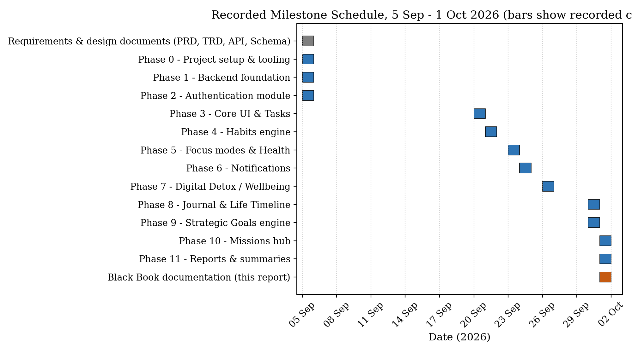
Figure 3.1 — Recorded milestone schedule (author-reported commit dates)
Table 3.5 — Phase milestones
Activity | June | July | August | September
Requirement Gathering | ████
System Analysis & Design |  | ████
Backend API Development |  | ██ | ██
Frontend UI Development |  |  | ████
Integration & Testing |  |  |  | ███
Documentation |  |  |  | ███

The recorded milestones span 5 September to 1 October 2026, a calendar span of 27 days.

3.12 COCOMO Model
COCOMO (Constructive Cost Model) is a software effort and cost estimation model proposed by Boehm (1981). It is used here only to estimate the effort that a project of this size would conventionally require. It is not the development methodology of LifeOS; the methodology is described in Section 3.8.

3.12.1 Size Estimation
Size was measured from the submitted source code by counting physical lines (including blank lines and comments) in TypeScript, TSX and CSS files, excluding tests, generated files and dependencies: 32,655 lines (server src: 14,244; client src: 18,411). The count includes comments and blank lines, so it overstates logical source lines; it is used as an approximation of delivered size.

3.12.2 Mode Selection
The Organic mode was selected. The project is a data-oriented web application built by one small team (one developer) using well-understood technologies, with modest hardware and interface constraints and no real-time or embedded requirements. Basic COCOMO coefficients for Organic mode are a = 2.4, b = 1.05, c = 2.5 and d = 0.38.

3.12.3 Calculation
Table 3.6 — Basic COCOMO (Organic) calculation
Parameter | Formula | Value
Estimated LOC | Measured (excluding tests) | 32,655
KLOC | LOC / 1000 | 32.655
Effort (E) | 2.4 × KLOC^1.05 | 93.3 person-months
Development time (T) | 2.5 × E^0.38 | 14.0 months
Average staffing | E / T | 6.7 persons
Illustrative cost | E × assumed monthly cost (INR 30,000 per person-month) | INR 27,98,850

The monthly cost figure is an assumption chosen for illustration; no actual salary or resource cost data exist for this academic project, and the cost row should be replaced if the university prescribes a rate.

3.12.4 Assumptions and Limitations
- Basic COCOMO uses size alone and ignores cost drivers such as team experience, tools and reuse; the result is an order-of-magnitude estimate.
- Lines of code include comments and blank lines and may include framework boilerplate.
- The actual project was completed by one developer within about 27 calendar days of recorded commits, much shorter than the COCOMO estimate of 14.0 months for a conventional team. The difference reflects the model’s assumptions about conventional development productivity and the use of modern frameworks and tooling; the estimate should be read as the effort a conventional project of this size would be expected to need, not as the effort actually spent.

3.13 Feasibility Analysis
Technical feasibility: all components are open-source and widely documented, and the implementation shows the stack is sufficient. Economic feasibility: development used open-source tools; no purchase cost was recorded. Operational feasibility: the web client runs in a browser and requires only user data entry. Schedule feasibility: the project was delivered within the academic period.

3.14 Risk Analysis
Table 3.7 — Risk analysis
Risk | Impact | Mitigation / current status
Scope larger than available time | Incomplete modules | Native, wearable and OS-level features deferred to future scope
Security weaknesses | Account or data compromise | Hashed passwords, rotating refresh tokens, validation, rate limiting; no formal penetration test
Data loss | Loss of user records | Depends on database hosting backups; not implemented in the application
Inaccurate user-entered data | Misleading insights | Reports state the data used; manual entry is documented as a limitation
Third-party dependency changes | Build failures | Versions declared in package.json; lock files present

CHAPTER 4 — SYSTEM DESIGN

4.1 System Architecture
LifeOS uses a client–server architecture. The browser loads a Next.js client which calls a REST API under /api/v1 using Axios. The API is an Express application that processes each request through security and validation middleware, then through controllers, services and repositories to MongoDB. There is no message queue, cache, microservice or external AI service in the current code.

4.2 High-Level Architecture
Figure 4.1 shows the main components. The server also exposes an unauthenticated /api/health endpoint that returns the service status.
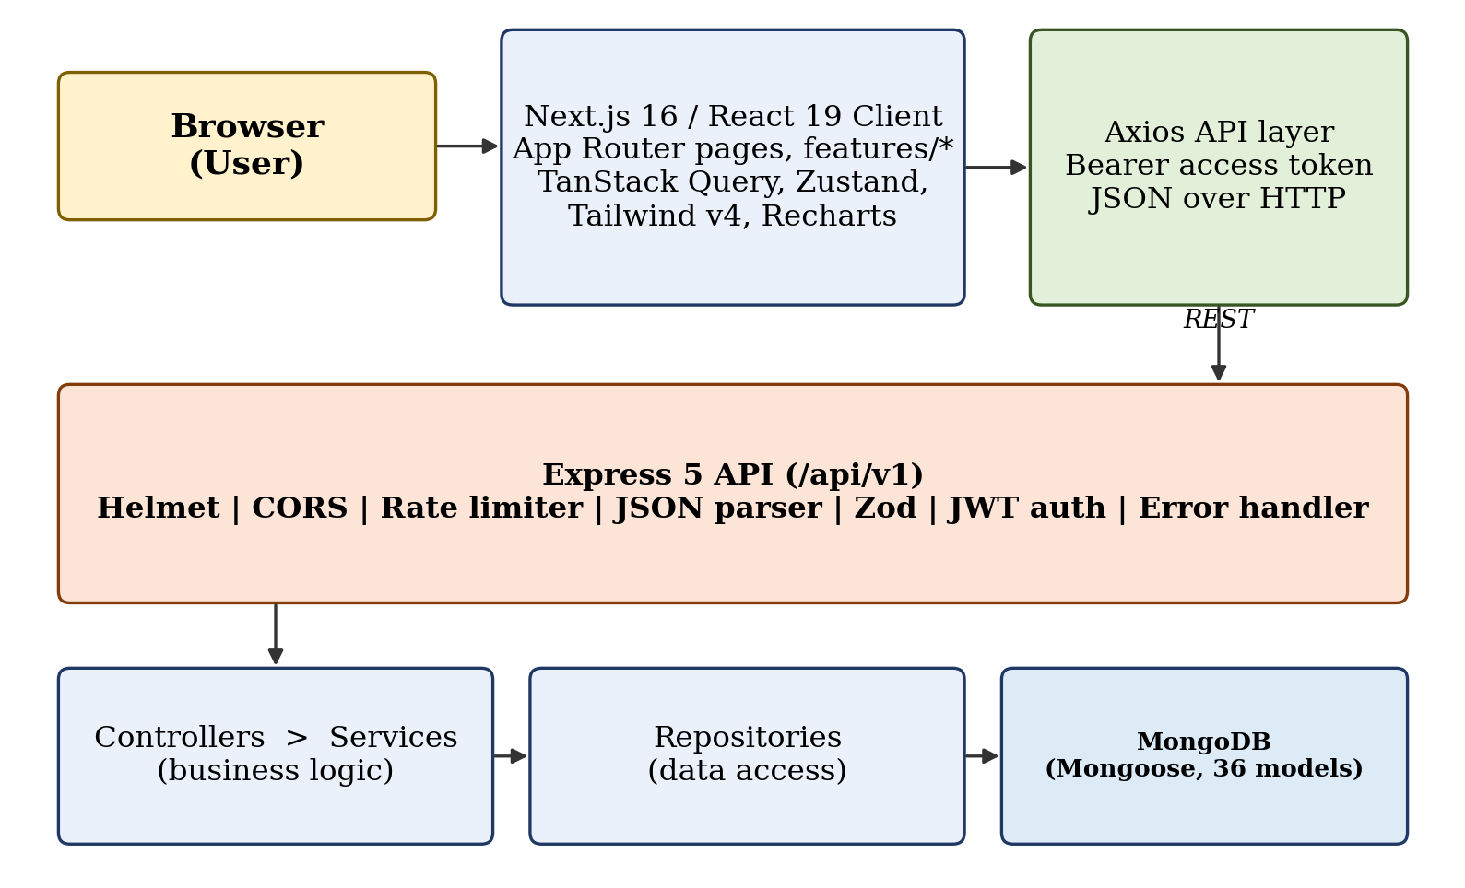
Figure 4.1 — High-level architecture of LifeOS

4.3 Frontend Architecture
The client uses the Next.js App Router with route groups: (auth) for login, registration and password recovery, and (dashboard) for authenticated pages. The dashboard group contains pages for dashboard, tasks, habits, focus, health, journal, goals, missions, daily-mission, digital-detox, detox, reports, insights, timeline, life-replay, challenges, groups, achievements, notifications, emergency, ai-coach and settings. Feature code is organised under src/features/<module>, each with components and an API services layer; shared UI components, layout components (sidebar, topbar, mobile navigation, command palette) and providers (theme and React Query) are held separately. The client source contains 137 TypeScript/TSX files.

4.4 Backend Architecture
The server source is organised by responsibility: routes (24 files including the index), controllers (23), services (23), repositories (26), models (36), validators (20), types (22), middleware (4), utils (4) and config (3). Routes bind URLs to middleware and controllers; controllers translate HTTP to service calls; services hold business rules; repositories encapsulate Mongoose queries.
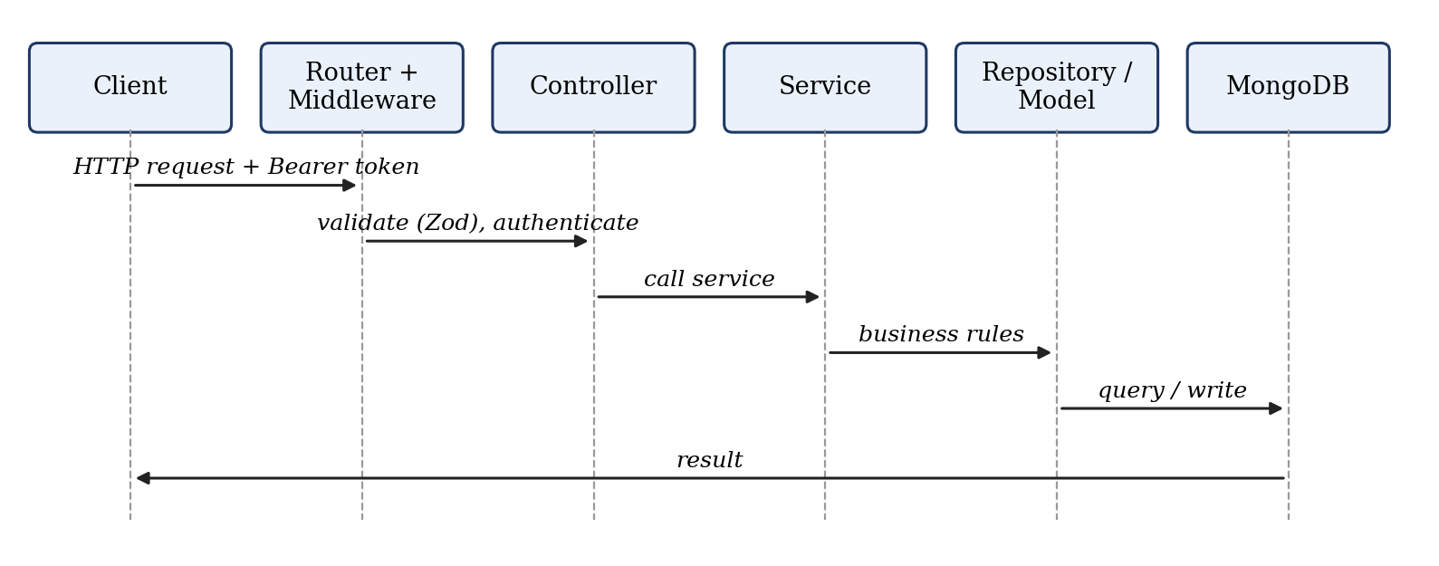
Figure 4.2 — Request processing sequence through the layers

4.5 Database Architecture
MongoDB is accessed through Mongoose. The 36 models are listed by domain in Table 4.1. Thirty-five of them reference the User collection through a userId field, which scopes every query to the authenticated user.
Table 4.1 — Mongoose models by domain
Domain | Models
Identity and settings (3) | user, ai-settings, notification-preferences
Tasks, habits, focus (4) | task, habit, habit-history, focus-session
Health (5) | sleep-log, water-log, mood-log, body-metric, mindfulness-session
Digital wellbeing (6) | digital-detox, detox-session, digital-budget, screen-time-log, usage-log, urge-intervention
Journal and timeline (4) | journal, journal-analysis, timeline, life-replay
Goals and missions (2) | goal (with embedded milestones), daily-mission
Reports and insights (4) | report, behaviour-insight, personal-baseline, activity-log
Social and gamification (6) | group, group-member, vote, challenge, challenge-participant, achievement
System (2) | notification, emergency-mode

4.6 Authentication Architecture
Authentication uses a short-lived access token (default 15 minutes) and a longer-lived refresh token (default 7 days), both configured through environment variables. Only a bcrypt hash of the current refresh token is stored on the user document. When a refresh request arrives, the presented token is compared with the stored hash; a mismatch is treated as possible token reuse and clears the stored hash, forcing a new login. A successful refresh issues a new pair and replaces the hash (refresh-token rotation).
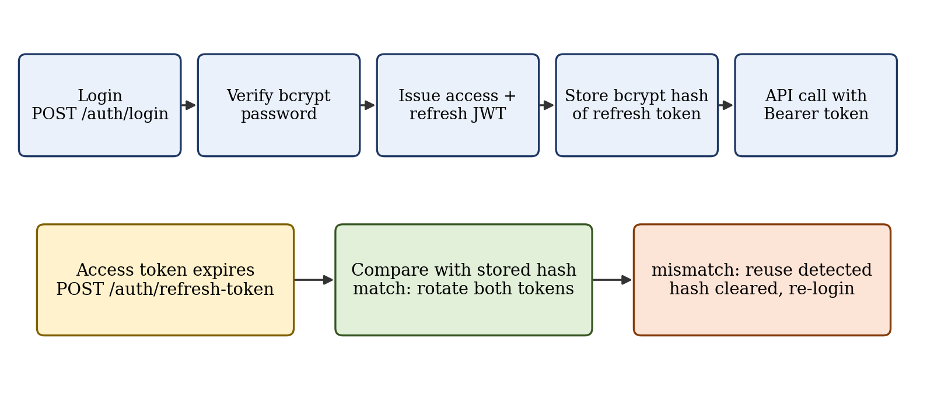
Figure 4.3 — Authentication and token-rotation flow

4.7 API Architecture
All endpoints are mounted under /api/v1 across 23 route modules and contain 139 route definitions (Appendix A). Responses use a common success/error envelope produced by helper functions, and validation failures return HTTP 422 with a list of field errors. Authentication endpoints and the general API use separate rate limiters (Section 5.17).

4.8 Module Architecture
Each module follows the same vertical slice: validator, route, controller, service, repository, model and client feature folder. Cross-module reads occur in services that need several domains: the report, insights, daily-mission, goal-report and AI services read from task, habit, focus, health, detox and goal models.

4.9 Data Flow
A user action in the client calls a service function in src/features, which sends an Axios request with the access token. The server validates the body, authenticates the token, executes the service, and returns the result, which React Query caches and displays. Reports are computed on request from stored records for the chosen period.

4.10 Entity Relationship / Database Relationship Diagram
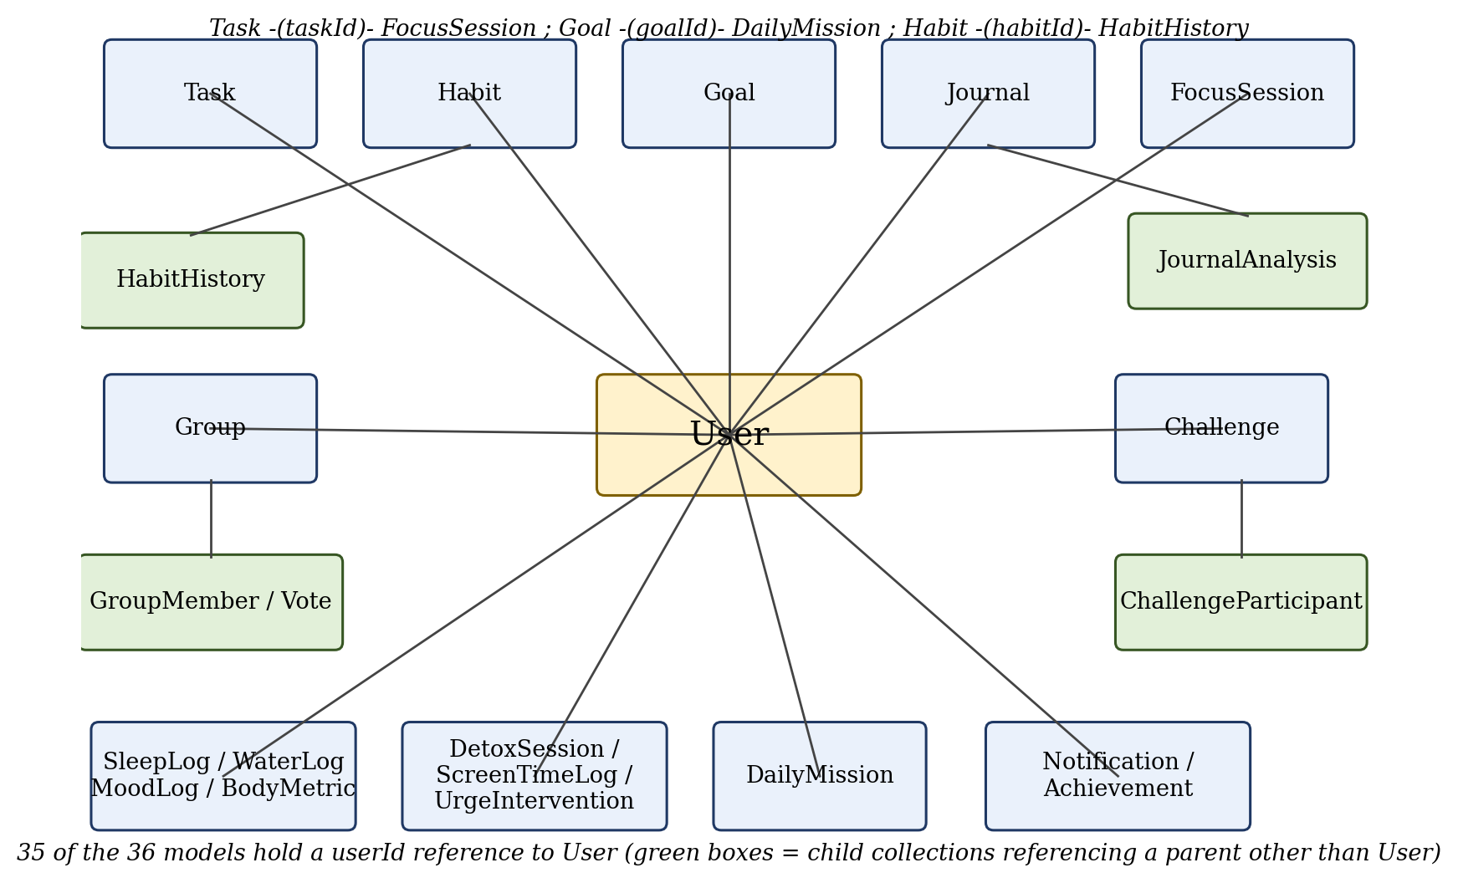
Figure 4.4 — Database relationship overview
Figure 4.4 shows that the User collection is the root of ownership. Child references between other collections are: FocusSession to Task, HabitHistory to Habit, DailyMission to Goal, JournalAnalysis to Journal, GroupMember and Vote to Group, and ChallengeParticipant to Challenge. Milestones are embedded in the Goal document rather than stored in a separate collection.

4.11 Use Case Diagram
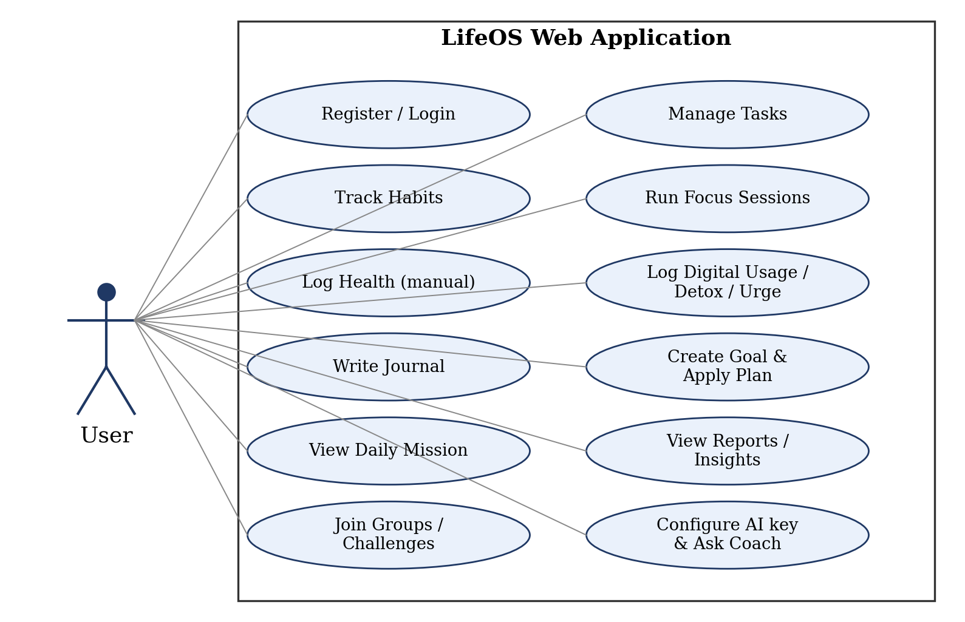
Figure 4.5 — Use case diagram (single actor: authenticated user)

4.12 Activity Diagrams
The goal activity flow is shown in Figure 4.6. The user creates a goal, requests a plan, reviews it, and only then applies it; applying the plan replaces the goal’s milestones and creates tasks and habits. Nothing is created without the user’s call to the apply endpoint.
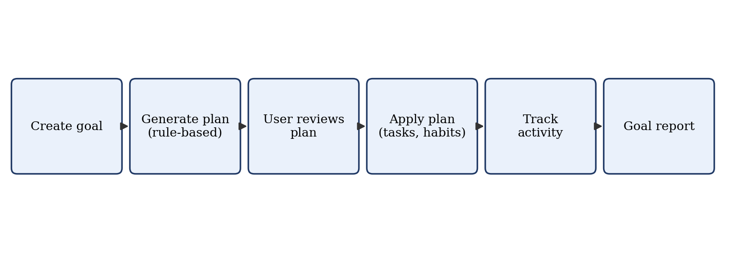
Figure 4.6 — Goal planning flow
The digital-wellbeing flow is shown in Figure 4.7. All steps are initiated by user input; no device monitoring takes place.
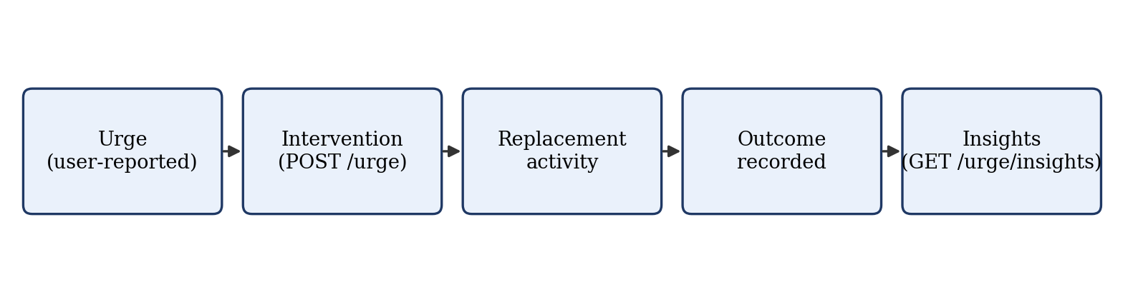
Figure 4.7 — Digital urge and intervention flow (user-entered)

4.13 Sequence Diagrams
Figure 4.2 (Section 4.4) shows the generic request sequence used by all modules, and Figure 4.3 shows the authentication sequence.

4.14 Class / Component Diagrams
Class diagrams are not reproduced separately because the service and repository classes follow one pattern (a service class receiving a repository in its constructor, which allows test doubles to be injected). The component structure is shown in Figure 4.1.

4.15 Security Design
- Passwords are hashed with bcrypt; refresh tokens are stored only as hashes.
- Request bodies, queries and parameters are validated with Zod schemas.
- Helmet sets HTTP security headers; CORS is restricted to the configured origin.
- express-rate-limit applies a general limiter and a stricter limiter on authentication routes.
- User-supplied AI keys are encrypted with AES-256-GCM before storage and are not returned by the settings endpoint.
- Every data query is scoped by userId; tests confirm that other users’ tasks, habits and health logs cannot be accessed.

CHAPTER 5 — IMPLEMENTATION

5.1 Development Environment
Development used Node.js with TypeScript, tsx for running and testing, ESLint and Prettier for code quality, and a Husky pre-commit hook. The server runs on port 5000 and the client on port 3000. Configuration is read from environment variables (PORT, NODE_ENV, MONGODB_URI, JWT secrets and expiries, CORS_ORIGIN) validated with a Zod schema in config/env.ts.

5.2 Frontend Implementation
The client is built with Next.js 16 and React 19. Server state is managed with TanStack React Query, UI state with Zustand, forms with React Hook Form and Zod, charts with Recharts, and motion with Framer Motion. Styling uses Tailwind CSS 4 with shared UI primitives and a light/dark theme provider. A command palette component supports keyboard navigation.

5.3 Backend Implementation
The Express application is assembled in app.ts: Helmet, CORS, the general rate limiter, JSON parsing (10 MB limit), request logging, the health endpoint, the versioned router, a 404 handler and the central error handler.

5.4 Database Implementation
Schemas define required fields, enumerations, defaults and indexes. For example, the Goal schema stores category and status enumerations, a deadline, a progress value and embedded milestones with title, completion flag and order, and is indexed by userId and status.

5.5 Authentication
The refresh-token rotation logic is implemented in AuthService.refreshTokens. The snippet below shows the reuse check and rotation.
const isValid = await bcrypt.compare(refreshToken, user.refreshTokenHash);
if (!isValid) {
// Possible token reuse attack - revoke all tokens
await this.userRepo.updateRefreshTokenHash(user._id.toString(), undefined);
throw new UnauthorizedError('Refresh token reuse detected. Please log in again.');
}
const newAccessToken = generateAccessToken(tokenPayload);
const newRefreshToken = generateRefreshToken(tokenPayload);
const newHash = await bcrypt.hash(newRefreshToken, 10);
await this.userRepo.updateRefreshTokenHash(user._id.toString(), newHash);

If the presented token does not match the stored hash, the stored hash is removed so that all existing refresh tokens become unusable; otherwise a new pair is issued and the hash replaced. Password change also clears the hash, revoking active sessions.

5.6 Authorization
The authenticateUser middleware reads the Bearer token, verifies it and attaches the decoded payload to the request. A requireRoles middleware exists for role checks. Resource ownership is enforced in the services by querying with the authenticated userId, and a ForbiddenError is raised when a user attempts to access another user’s record.

5.7 Validation
export const validateRequest = (schemas: IRequestSchemas) => {
return (req, _res, next) => {
try {
if (schemas.body) req.body = schemas.body.parse(req.body);
// query and params are parsed the same way
next();
} catch (error) { next(error); }
};
};

Routes declare Zod schemas for body, query and params. Parsed values replace the raw request values, and a ZodError is converted by the error handler into an HTTP 422 response listing each failing field.

5.8 Task Module
Tasks support creation, retrieval, filtering by status, update, completion with a completedAt timestamp, and soft deletion (an isDeleted flag excludes the task from later queries).

5.9 Habit Module
Habits store frequency (daily, weekly or monthly), target days, current and longest streak, completion rate and pause state. A HabitHistory record is written for each completion. The service prevents completing a habit twice on the same day, supports undoing an accidental completion with streak restoration, resets the current streak when a habit is skipped, and supports pause and resume. A streak-freeze feature is not present in the code.

5.10 Focus Module
A focus session can be started against a task, ended with recorded distractions and notes, queried as the current active session, and listed with daily analytics. Starting a session against another user’s task is rejected.

5.11 Health Module
Water, sleep and mood logs are created, listed, updated and deleted by the user. Sleep duration is calculated in minutes from sleep and wake times, and a log whose wake time is not after the sleep time is rejected. A summary endpoint returns consolidated metrics. The health-expansion routes record body metrics, activity and mindfulness sessions, also by manual entry. Heart rate, step counts, wearable integration and health-platform APIs are not implemented and are listed as future work.

5.12 Digital Wellbeing
Two route modules support this area. digital-detox handles settings and manual usage entries and an opportunity-cost view. digital-wellbeing records usage, budgets, urge events (with intervention and insights) and detox session start and end. The module records what the user reports; it does not read device screen time and cannot block applications, because a web page has no access to other applications or operating-system controls. These capabilities belong to a future native application.

5.13 Journal
Journal entries can be created, searched, updated and deleted. Separate journal-analysis routes analyse an entry and return recurring themes. The life-timeline and life-replay modules present historical records and allow a reflection to be attached to a period.

5.14 Goal System
Goals have a title, description, category, deadline, status, progress and ordered milestones. The generate-plan endpoint returns a plan (milestones, tasks and habits) selected from predefined templates by keyword matching on the goal title and category, for example web development, AI/data science and health or fitness goals. The user reviews the plan, and the apply-plan endpoint then stores the milestones and creates the tasks and habits, as shown below.
goal.milestones = newMilestones;
goal.progress = this.calculateProgress(goal.milestones);
await goal.save();
for (const taskData of acceptedPlan.tasks) {
await Task.create({ userId, title: taskData.title,
status: 'Pending', priority: 'High', dueDate: goal.deadline });
}
for (const habitData of acceptedPlan.habits) {
await Habit.create({ userId, title: habitData.title,
frequency: habitData.frequency === 'weekly' ? 'Weekly' : 'Daily' });
}

The plan is applied only when the user sends the accepted plan to the apply endpoint, so the user stays in control. The planner is rule-based; it is not a language-model service. A goal report endpoint summarises the goal’s progress and related task and habit counts.

5.15 AI Features
The ai module stores per-user settings: provider (OpenAI, Gemini, Claude, Groq or OpenRouter), model, an enabled flag and an API key encrypted with AES-256-GCM using a key derived from a server secret. The weekly-report, coach and health-analysis endpoints read the user’s recent tasks, habits, focus sessions, water logs, baseline and mission, and return structured text in FACT, INFERENCE and RECOMMENDATION sections. When there is no recorded data the coach returns a statement that it does not have enough data. In the inspected code these responses are generated from templates over the stored data; calls to an external language-model provider are not implemented, so provider selection is groundwork for future integration.

5.16 Reports / Analytics
The report service computes daily, weekly, monthly and yearly ranges and aggregates tasks, habits, focus sessions, water, sleep, mood, screen-time, goals and missions into a report summary and a dashboard summary. The insights module provides a personal baseline, patterns, trends and an attention view. The daily-mission service classifies the day type, selects a primary mission, generates supporting goals and a reminder, and exposes weekly and community missions and a review operation.

5.17 Security Implementation
export const standardLimiter = rateLimit({
windowMs: 15 * 60 * 1000,
max: process.env.NODE_ENV === 'development' ? 10000 : 300,
});
export const authLimiter = rateLimit({
windowMs: 15 * 60 * 1000,
max: process.env.NODE_ENV === 'development' ? 500 : 30,
});

Outside development, the general limiter allows 300 requests and the authentication limiter 30 requests per client per 15 minutes. Helmet and CORS are applied globally in app.ts.

5.18 Error Handling
Custom error classes (such as BadRequestError, NotFoundError, UnauthorizedError and ForbiddenError) carry an HTTP status. The central handler maps them to a uniform error response, formats Zod errors as HTTP 422 with field paths, and handles Mongoose cast errors; unknown routes return a not-found error.

5.19 API Implementation
Appendix A lists the 139 route definitions by module. Table 5.1 summarises the principal resources.
Table 5.1 — Principal API resources
Base path | Representative operations
/auth | register, login, refresh-token, logout, forgot-password, reset-password
/tasks | list, create, get, update, complete, delete
/habits | list, create, update, complete, skip, undo, pause, resume, delete
/goals | list, create, get, update, ai-plan, apply-plan, report
/daily-mission | generate, today, weekly, community, toggle, review, history
/reports | dashboard, and one report per period type

CHAPTER 6 — TESTING

6.1 Testing Strategy
Testing in the current project is automated unit testing of the server-side service layer, supplemented by manual use of the client during development. Tests use the native Node.js test runner executed through tsx (npm test runs tsx --test tests/**/*.test.ts). Services receive their repositories through the constructor, and the tests substitute in-memory mock repositories, so the tests exercise business rules without a running MongoDB instance.

6.2 Unit Testing
There are 17 test files in lifeos-server/tests containing 103 test cases (counted from the source files). Table 6.1 lists the count for each file.
Table 6.1 — Test files and test-case counts
Test file | Area | Test cases
achievement.test.ts | Achievements | 4
ai.test.ts | AI settings | 6
auth.test.ts | Authentication | 7
challenge.test.ts | Challenges | 7
digital-detox.test.ts | Digital wellbeing | 4
emergency-mode.test.ts | Emergency mode | 4
focus.test.ts | Focus | 6
foundation.test.ts | Foundation (JWT, validation) | 5
group.test.ts | Groups | 7
habit.test.ts | Habits | 8
health.test.ts | Health | 7
journal.test.ts | Journal | 6
notification.test.ts | Notifications | 6
report.test.ts | Reports | 6
task.test.ts | Tasks | 6
timeline.test.ts | Life timeline | 8
user.test.ts | Users / settings | 6
Total |  | 103

6.3 Integration Testing
Automated HTTP-level integration tests against a running Express application and database are not present in the repository. Integration between client and server was checked manually during development. This is recorded as a limitation.

6.4 API Testing
No automated API-level test collection (for example Postman or supertest) is included. The 139 route definitions were exercised through the client application and through the service-layer tests that mirror controller calls.

6.5 Authentication Testing
The authentication suite covers registration with a hashed password, rejection of duplicate email, login success and failure, token refresh, logout invalidation, and forgot/reset password. The foundation suite verifies signing and verification of access and refresh tokens and rejection of tampered tokens.

6.6 Validation Testing
The foundation suite verifies that Zod schemas validate request payloads and that a ZodError is passed to next() for invalid payloads. Business-rule validation is tested in the services, for example rejection of a sleep log whose wake time is not after the sleep time.

6.7 Database Testing
Because repositories are mocked, schema constraints and indexes are not exercised by automated tests. Database behaviour was checked manually against MongoDB during development.

6.8 Frontend Testing
The client has no automated test script or test files. Frontend verification was manual. ESLint and Prettier are configured for static checks.

6.9 Security Testing
Security-related behaviour is covered by service-layer tests: password hashing, token verification and tampering, refresh-token invalidation, cross-user access rejection for tasks, habits and health logs, and AES-256-GCM encryption round-trip. No penetration test, dependency audit report or automated rate-limit test is included.

6.10 Functional Testing
Functional behaviour of each module is covered by the suites in Table 6.1: for example a habit streak increments on completion and cannot be completed twice on the same day, and a focus session cannot be started against an unauthorised task.

6.11 Test Cases
Table 6.2 lists the test cases of six representative suites, extracted from the test source. The complete list for every suite is given in Appendix C. The test-case title states the expected behaviour, and the status reflects the author-reported test run in Section 6.12.
Table 6.2 — Selected test cases
ID | Module | Test case (expected behaviour) | Status
TC001 | Authentication | Should register a new user with hashed password | Passed
TC002 | Authentication | Should reject registration with duplicate email | Passed
TC003 | Authentication | Should login with correct password and return tokens | Passed
TC004 | Authentication | Should reject login with wrong password | Passed
TC005 | Authentication | Should refresh tokens when valid refresh token is provided | Passed
TC006 | Authentication | Should logout and invalidate refresh token | Passed
TC007 | Authentication | Should handle forgot password and reset password successfully | Passed
TC008 | Tasks | Should create a new task successfully | Passed
TC009 | Tasks | Should retrieve task by ID for the owner | Passed
TC010 | Tasks | Should reject access to another user’s task with ForbiddenError | Passed
TC011 | Tasks | Should mark task as completed and set completedAt timestamp | Passed
TC012 | Tasks | Should list tasks with status filter | Passed
TC013 | Tasks | Should soft delete task and exclude it from retrieval | Passed
TC014 | Habits | Should create a habit with default 0 streak and 0% completion rate | Passed
TC015 | Habits | Should prevent cross-user access to habit details | Passed
TC016 | Habits | Should complete habit, increment streak and update completion rate | Passed
TC017 | Habits | Should prevent completing the same habit multiple times on the same day | Passed
TC018 | Habits | Should revert/undo accidental habit completion and restore streak | Passed
TC019 | Habits | Should pause and resume a habit correctly | Passed
TC020 | Habits | Should reset current streak upon skipping a habit | Passed
TC021 | Habits | Should soft delete habit and exclude it from active list | Passed
TC022 | Health | Should log water intake and correctly aggregate daily totals in ml | Passed
TC023 | Health | Should prevent updating or deleting water log by non-owner | Passed
TC024 | Health | Should log sleep and automatically calculate duration in minutes | Passed
TC025 | Health | Should reject sleep log if wakeTime is before or equal to sleepTime | Passed
TC026 | Health | Should log mood with score and note | Passed
TC027 | Health | Should prevent non-owner from updating mood log | Passed
TC028 | Health | Should return consolidated health summary with real metrics | Passed
TC029 | Focus | Should start a new focus session linked to a valid task | Passed
TC030 | Focus | Should reject starting focus session with an unauthorized task | Passed
TC031 | Focus | Should find the current active running session | Passed
TC032 | Focus | Should end the focus session, recording distractions and notes | Passed
TC033 | Focus | Should retrieve focus sessions list and calculate real daily analytics | Passed
TC034 | Focus | Should delete a focus session by owner and reject non-owner deletion | Passed
TC035 | Foundation (JWT, validation) | Should sign and verify access token correctly | Passed
TC036 | Foundation (JWT, validation) | Should sign and verify refresh token correctly | Passed
TC037 | Foundation (JWT, validation) | Should reject invalid or tampered access token | Passed
TC038 | Foundation (JWT, validation) | Should validate request payloads using Zod schema | Passed
TC039 | Foundation (JWT, validation) | Should pass ZodError to next() on invalid payload | Passed

6.12 Test Results
The author-reported execution of the suite with the command above produced: 103 tests passed, 0 failed, total duration 6.96 seconds and exit code 0. These figures were supplied by the author from a local run. The tests were not re-run in the environment used to prepare this report because the project’s dependencies were not installed there, so the result is author-reported rather than independently reproduced. Screenshots of the terminal output should be added by the author at this point.
[INSERT SCREENSHOT 6.1: Terminal output of the test run]
Add a screenshot of `npm test` output (103 passed, 0 failed)
Figure 6.1 — Terminal output of the test run

6.13 Defect Identification and Resolution
The review of the code for this report identified the following points. They are recorded here as known limitations of the current version, not as resolved defects.
Table 6.3 — Known limitations identified during review
Item | Description | Planned handling
Encryption secret fallback | The AI-key encryption routine falls back to a fixed default secret if neither ENCRYPTION_SECRET nor JWT_SECRET is set | Require a dedicated ENCRYPTION_SECRET in configuration
Duplicate client routes | Both /detox and /digital-detox pages exist | Consolidate into one route
Unused configuration | Cloudinary environment variables are declared but no upload feature or dependency exists | Implement media upload or remove the variables
Test coverage | No integration, API, database or frontend automated tests | Add supertest and component tests

CHAPTER 7 — RESULTS & DISCUSSION

7.1 Implemented Features
Table 7.1 gives the implementation status of each module, determined from the source code, routes and tests. The classification is: Implemented (working in the current project), Partial (some of the intended functionality exists), Future (not in the current code).
Table 7.1 — Module implementation status
Module | Status | Evidence
Authentication | Implemented | auth.service.ts, auth routes, JWT rotation; 7 tests. Password-reset delivery by email is not implemented (no mail dependency)
Dashboard and reports | Implemented | report.service.ts, /reports/dashboard; 6 tests
Tasks | Implemented | task service, /tasks; 6 tests
Habits | Implemented | habit service, history model; 8 tests. No streak-freeze
Focus | Implemented | focus service, /focus; 6 tests
Health | Partial | Water, sleep, mood CRUD; manual body metrics, activity and mindfulness; no heart rate, steps or wearables
Digital wellbeing | Partial | Manual usage, budgets, detox sessions, urge interventions; no automatic tracking or blocking
Journal and timeline | Implemented | journal, journal-analysis, timeline, life-replay modules; 6 + 8 tests
Goals | Implemented | goal model, service and routes, milestones, goal report
Goal planner (“AI plan”) | Partial | Rule-based templates; user applies plan; no language-model call
AI settings and AI endpoints | Partial | Encrypted key storage, provider/model settings; template-based coach, weekly report and health analysis over stored data; no external model call; 6 tests
Missions | Implemented | daily-mission service and routes
Insights | Implemented | insights routes: baseline, patterns, trends, attention
Groups, challenges, achievements | Implemented | services and routes; 7 + 7 + 4 tests
Notifications | Partial | Stored in-app notifications and preferences; 6 tests; no push or desktop notifications
Emergency mode | Implemented | emergency-mode service; 4 tests
Media upload (Cloudinary) | Not implemented | Environment variables only
Native mobile application | Future | No native code
Wearables / health platforms | Future | No integration code

7.2 System Demonstration
The following figures are to be inserted from the running application at the addresses shown. They are left as placeholders in this document.
[INSERT SCREENSHOT 7.1: Authentication page]
http://localhost:3000/login — login form
Figure 7.1 — Authentication page
[INSERT SCREENSHOT 7.2: Main dashboard]
http://localhost:3000/dashboard — active goal card and today’s mission
Figure 7.2 — Main dashboard
[INSERT SCREENSHOT 7.3: Strategic goals]
http://localhost:3000/goals — goal roadmap with milestone progress
Figure 7.3 — Strategic goals
[INSERT SCREENSHOT 7.4: Missions (daily)]
http://localhost:3000/missions — primary mission, rationale and checklist
Figure 7.4 — Missions (daily)
[INSERT SCREENSHOT 7.5: Missions (weekly)]
http://localhost:3000/missions (Weekly tab) — milestone-derived weekly targets
Figure 7.5 — Missions (weekly)
[INSERT SCREENSHOT 7.6: Focus sessions]
http://localhost:3000/focus — timed session and distraction tracking
Figure 7.6 — Focus sessions
[INSERT SCREENSHOT 7.7: Health trackers]
http://localhost:3000/health — sleep, hydration and mood cards
Figure 7.7 — Health trackers
[INSERT SCREENSHOT 7.8: Digital detox]
http://localhost:3000/digital-detox — screen budget versus usage
Figure 7.8 — Digital detox
[INSERT SCREENSHOT 7.9: Journal]
http://localhost:3000/journal — guided prompt templates and mood tags
Figure 7.9 — Journal
[INSERT SCREENSHOT 7.10: Analytical reports]
http://localhost:3000/reports — today overview and summaries
Figure 7.10 — Analytical reports

7.3 Functional Results
All modules listed as implemented in Table 7.1 expose working endpoints and have corresponding client pages. The service-layer suite passed in the author-reported run.

7.4 UI Results
The client provides a sidebar and top bar for desktop and a mobile navigation component, light and dark themes, a command palette and chart-based reports. No formal usability evaluation was conducted.

7.5 Performance Observations
No formal performance testing was conducted and no response-time benchmarks are claimed. The only timing recorded is the 6.96-second duration of the unit-test run.

7.6 Security Results
The security controls listed in Section 4.15 are present in the code and the associated unit tests passed in the author-reported run. No external security assessment was performed.

7.7 User Experience
No user study or user statistics are available; experience was assessed informally by the developer.

7.8 Module-wise Results
Module results are given in Table 6.1 (test cases) and Table 7.1 (status). The project contains 36 data models, 139 route definitions across 23 route modules, 21 client feature folders and approximately 32.7 KLOC of application code excluding tests.

7.9 Limitations
- Web-only: no operating-system-level monitoring, blocking or native notifications.
- Manual data entry for health and digital usage.
- Rule-based planning; AI endpoints do not call an external model.
- Testing is limited to service-layer unit tests.

7.10 Discussion
The project meets its main objective of integrating several behavioural domains under one authenticated API and data model, and the goal-to-task/habit flow, reports and missions demonstrate the connection between domains. The results do not show that the system improves user behaviour, because no user evaluation was carried out. The rule-based planner and template-based AI endpoints are useful for demonstrating the intended data flow, but they are less flexible than a real language-model integration.

CHAPTER 8 — CONCLUSION & FUTURE SCOPE

8.1 Conclusion
LifeOS is a working full-stack web application that unifies goals, tasks, habits, focus, health records, digital-behaviour records, journaling, missions, reports and social features in one account. It is implemented with Next.js, Express and MongoDB, secured with JWT rotation, validation and rate limiting, and verified at service level by 103 automated tests.

8.2 Objectives Achieved
Table 8.1 — Objectives and outcome
Objective | Outcome
Layered REST API with MongoDB | Achieved: 139 route definitions, 36 models
Secure authentication with refresh rotation | Achieved
Task, habit, focus, health, wellbeing, journal modules | Achieved; health and wellbeing are manual-entry (partial)
Goal module with user-approved plan | Achieved using rule-based templates
Reports and daily mission | Achieved
Responsive web client | Achieved; no formal usability study
Automated verification | Achieved for the service layer only

8.3 Current System Limitations
The limitations are those in Section 7.9. They are the starting point for the future work below.

8.4 Future Enhancements
The items in Sections 8.5 to 8.12 are planned work and are not part of the current implementation. Additional near-term items are: dedicated encryption-secret configuration, email delivery for password reset, media upload, integration and frontend automated tests, and consolidation of the duplicate detox pages.

8.5 Native Mobile Application
A native application would allow push notifications, background tasks, offline storage and device APIs that a web page cannot access.

8.6 Health Integrations
Heart rate, step counts and sleep data could be imported through Apple HealthKit and Android Health Connect, replacing manual entry for these metrics.

8.7 Advanced Digital Wellbeing
A native application could read device usage (iOS Screen Time, Android UsageStats) and, where the platform allows, enforce application limits during detox sessions. This is not possible from the web implementation.

8.8 Advanced Behaviour Intelligence
Existing baseline, pattern and trend services could be extended with statistical analysis across domains, for example relating sleep duration to next-day focus time.

8.9 AI Coach
The stored provider and encrypted-key settings could be connected to an actual language-model API. Prompts would be built from the user’s own records, outputs validated, and recommendations kept subject to user approval, as the goal-plan flow already does.

8.10 Predictive Analytics
With sufficient longitudinal data, models could estimate goal-completion likelihood or habit-lapse risk. This requires data collection over time and validation before any claim is made.

8.11 Wearable Integration
Direct wearable integration would depend on the native or health-platform integrations in Section 8.6.

8.12 Future Research Directions
A user study could evaluate whether the integrated view changes goal progress or habit adherence compared with separate tools, and whether intervention prompts for digital urges reduce usage.

REFERENCES
Boehm, B. W. (1981). Software Engineering Economics. Englewood Cliffs, NJ: Prentice-Hall.
Deterding, S., Dixon, D., Khaled, R. and Nacke, L. (2011). From game design elements to gamefulness: defining “gamification”. Proceedings of the 15th International Academic MindTrek Conference. ACM.
Fogg, B. J. (2009). A behavior model for persuasive design. Proceedings of the 4th International Conference on Persuasive Technology. ACM.
Jones, M., Bradley, J. and Sakimura, N. (2015). JSON Web Token (JWT). RFC 7519. IETF.
Lally, P., van Jaarsveld, C. H. M., Potts, H. W. W. and Wardle, J. (2010). How are habits formed: modelling habit formation in the real world. European Journal of Social Psychology, 40(6), 998–1009.
Li, I., Dey, A. and Forlizzi, J. (2010). A stage-based model of personal informatics systems. Proceedings of the SIGCHI Conference on Human Factors in Computing Systems (CHI 2010). ACM.
Locke, E. A. and Latham, G. P. (2002). Building a practically useful theory of goal setting and task motivation. American Psychologist, 57(9), 705–717.
Roffarello, A. M. and De Russis, L. (2019). The race towards digital wellbeing: issues and opportunities. Proceedings of the CHI Conference on Human Factors in Computing Systems. ACM.
OWASP Foundation. OWASP Top 10. https://owasp.org/Top10/
Official documentation: Next.js (https://nextjs.org/docs), React (https://react.dev), Express (https://expressjs.com), MongoDB (https://www.mongodb.com/docs), Mongoose (https://mongoosejs.com/docs), Zod (https://zod.dev), TanStack Query (https://tanstack.com/query).

APPENDIX A — API ENDPOINTS
The table lists every route definition read from lifeos-server/src/routes (139 in total, derived programmatically from the route files). Paths are relative to each base path.
Table A.1 — API endpoints by module
Base path | Count | Endpoints (METHOD path)
/api/v1/achievements | 2 | GET /; GET /:achievementId
/api/v1/ai | 7 | GET /settings; POST /settings; PATCH /settings; DELETE /settings; POST /reports/weekly; POST /coach; POST /health-analysis
/api/v1/auth | 6 | POST /register; POST /login; POST /refresh-token; POST /logout; POST /forgot-password; POST /reset-password
/api/v1/challenges | 9 | POST /; GET /; GET /:challengeId; PATCH /:challengeId; DELETE /:challengeId; POST /:challengeId/join; POST /:challengeId/leave; PATCH /:challengeId/progress; GET /:challengeId/leaderboard
/api/v1/daily-mission | 8 | POST /generate; GET /weekly; GET /community; PATCH /toggle; GET /today; PUT /:id/review; GET /history; DELETE /:id
/api/v1/digital-detox | 5 | GET /settings; PATCH /settings; GET /usage; POST /usage; GET /opportunity-cost
/api/v1/digital-wellbeing | 7 | POST /usage; GET /usage/summary; POST /budget; POST /urge; GET /urge/insights; POST /detox/start; POST /detox/end
/api/v1/emergency-mode | 3 | GET /status; POST /enable; POST /disable
/api/v1/focus | 5 | GET /; GET /current; POST /start; POST /end; DELETE /:id
/api/v1/goals | 7 | GET /; POST /; GET /:id; PUT /:id; POST /:id/ai-plan; POST /:id/apply-plan; GET /:id/report
/api/v1/groups | 10 | POST /; GET /; POST /join; GET /:groupId; PATCH /:groupId; DELETE /:groupId; POST /:groupId/leave; DELETE /:groupId/members/:userId; PATCH /:groupId/members/:userId; POST /:groupId/goals/vote
/api/v1/habits | 10 | GET /; POST /; GET /:habitId; PATCH /:habitId; POST /:habitId/complete; POST /:habitId/skip; POST /:habitId/undo; PATCH /:habitId/pause; PATCH /:habitId/resume; DELETE /:habitId
/api/v1/health/expansion | 6 | POST /body-metrics; GET /body-metrics; POST /activity; GET /activity/summary; POST /mindfulness; GET /mindfulness/insight
/api/v1/health | 13 | GET /summary; GET /water; POST /water; PATCH /water/:id; DELETE /water/:id; GET /sleep; POST /sleep; PATCH /sleep/:id; DELETE /sleep/:id; GET /mood; POST /mood; PATCH /mood/:id; DELETE /mood/:id
/api/v1/insights | 6 | GET /baseline; POST /baseline; GET /patterns; GET /trends; GET /attention; GET /
/api/v1/journal-analysis | 3 | GET /themes; POST /:journalId/analyze; GET /:journalId/analysis
/api/v1/journals | 6 | GET /; GET /search; POST /; GET /:journalId; PATCH /:journalId; DELETE /:journalId
/api/v1/life-replay | 3 | GET /history/:period; GET /:period; POST /:id/reflection
/api/v1/notifications | 8 | GET /preferences; PATCH /preferences; GET /; GET /unread; GET /unread-count; PATCH /read-all; PATCH /:notificationId/read; DELETE /:notificationId
/api/v1/reports | 2 | GET /dashboard; GET /:type
/api/v1/tasks | 6 | GET /; POST /; GET /:taskId; PATCH /:taskId; PATCH /:taskId/complete; DELETE /:taskId
/api/v1/life-timeline | 2 | GET /; GET /:entryId
/api/v1/users | 5 | GET /me; PATCH /me; POST /change-password; GET /export; DELETE /me

APPENDIX B — DATABASE SCHEMAS
The 36 Mongoose models are listed in Table 4.1. Two representative schemas are summarised below.
Table B.1 — Goal model (goal.model.ts)
Field | Type | Notes
userId | ObjectId → User | required, indexed
title, description | String | title required
category | Enum | career, education, health, fitness, personal, finance, relationships, creativity, other
deadline | Date | required
status | Enum | active, completed, paused, abandoned (default active)
milestones[] | Embedded | title, completed (default false), order
progress | Number | default 0

Table B.2 — Habit fields (types/habit.types.ts)
Field | Type
userId | ObjectId → User
title, description | String
frequency | Daily / Weekly / Monthly
reminderTime | String (optional)
targetDays | Number
currentStreak, longestStreak, completionRate | Number
isPaused, isDeleted | Boolean

APPENDIX C — TEST CASES
All test cases extracted from the 17 test files (total 103).
Table C.1 — achievement.test.ts (4 cases)
# | Test case
1 | should list all predefined achievement badges with unlock status
2 | should manually unlock a badge and update unlock percentage
3 | should retrieve a single unlocked achievement by ID
4 | should prevent cross-user access to unlocked achievement details

Table C.2 — ai.test.ts (6 cases)
# | Test case
1 | should verify AES-256-GCM encryption and decryption roundtrip
2 | should return disabled AI state when user has not configured BYOK settings
3 | should save encrypted AI settings without returning the plain-text key
4 | should update AI provider model configuration
5 | should delete AI settings and clear stored key
6 | should reject AI coach queries when AI is not configured or disabled

Table C.3 — auth.test.ts (7 cases)
# | Test case
1 | should register a new user with hashed password
2 | should reject registration with duplicate email
3 | should login with correct password and return tokens
4 | should reject login with wrong password
5 | should refresh tokens when valid refresh token is provided
6 | should logout and invalidate refresh token
7 | should handle forgot password and reset password successfully

Table C.4 — challenge.test.ts (7 cases)
# | Test case
1 | should create a challenge and automatically enroll the creator as a participant
2 | should allow another user to join the challenge
3 | should prevent joining the same challenge twice
4 | should update user progress and mark as completed when reaching 100%
5 | should return ranked leaderboard sorted by progress
6 | should allow a participant to leave the challenge
7 | should prevent non-creators from deleting the challenge

Table C.5 — digital-detox.test.ts (4 cases)
# | Test case
1 | should return default detox settings when first accessed
2 | should update detox settings and per-app limits
3 | should log screen time and calculate usage percentage and threshold warning
4 | should accurately calculate opportunity cost from screen time saved

Table C.6 — emergency-mode.test.ts (4 cases)
# | Test case
1 | should return inactive state when no emergency mode record exists
2 | should enable emergency mode, snapshot detox settings, and activate Focus Lock
3 | should disable emergency mode and restore prior settings snapshot
4 | should be idempotent when enabling emergency mode that is already active

Table C.7 — focus.test.ts (6 cases)
# | Test case
1 | should start a new focus session linked to a valid task
2 | should reject starting focus session with an unauthorized task
3 | should find the current active running session
4 | should end the focus session, recording distractions and notes
5 | should retrieve focus sessions list and calculate real daily analytics
6 | should delete a focus session by owner and reject non-owner deletion

Table C.8 — foundation.test.ts (5 cases)
# | Test case
1 | should sign and verify access token correctly
2 | should sign and verify refresh token correctly
3 | should reject invalid or tampered access token
4 | should validate request payloads using Zod schema
5 | should pass ZodError to next() on invalid payload

Table C.9 — group.test.ts (7 cases)
# | Test case
1 | should create a group with unique invite code and set creator as Owner
2 | should allow another user to join the group via valid invite code
3 | should reject joining with an invalid invite code
4 | should reject duplicate join attempts by the same user
5 | should allow Owner or Admin to update member role
6 | should allow group members to vote on weekly goals
7 | should allow non-owner members to leave the group and prevent owner from leaving without transfer

Table C.10 — habit.test.ts (8 cases)
# | Test case
1 | should create a habit with default 0 streak and 0% completion rate
2 | should prevent cross-user access to habit details
3 | should complete habit, increment streak and update completion rate
4 | should prevent completing the same habit multiple times on the same day
5 | should revert/undo accidental habit completion and restore streak
6 | should pause and resume a habit correctly
7 | should reset current streak upon skipping a habit
8 | should soft delete habit and exclude it from active list

Table C.11 — health.test.ts (7 cases)
# | Test case
1 | should log water intake and correctly aggregate daily totals in ml
2 | should prevent updating or deleting water log by non-owner
3 | should log sleep and automatically calculate duration in minutes
4 | should reject sleep log if wakeTime is before or equal to sleepTime
5 | should log mood with score and note
6 | should prevent non-owner from updating mood log
7 | should return consolidated health summary with real metrics

Table C.12 — journal.test.ts (6 cases)
# | Test case
1 | should create a journal entry with mood and tags
2 | should prevent another user from accessing the journal entry
3 | should search entries across title, content, and tags
4 | should filter entries by mood
5 | should update journal entry content and tags
6 | should soft delete journal entry and exclude it from searches

Table C.13 — notification.test.ts (6 cases)
# | Test case
1 | should return default preferences when first accessed
2 | should update preferences correctly
3 | should deliver system notifications unconditionally
4 | should suppress disabled task reminders per user preferences
5 | should mark an individual notification as read
6 | should mark all notifications as read and delete notification

Table C.14 — report.test.ts (6 cases)
# | Test case
1 | should compute correct daily period start and end
2 | should compute weekly period starting on Monday
3 | should compute correct monthly period (first to last day of month)
4 | should generate a report and store it in repository
5 | should return zero summary when no data exists
6 | should generate reports for all four period types

Table C.15 — task.test.ts (6 cases)
# | Test case
1 | should create a new task successfully
2 | should retrieve task by ID for the owner
3 | should reject access to another user’s task with ForbiddenError
4 | should mark task as completed and set completedAt timestamp
5 | should list tasks with status filter
6 | should soft delete task and exclude it from retrieval

Table C.16 — timeline.test.ts (8 cases)
# | Test case
1 | should return an empty timeline with clean pagination when no entries exist
2 | should record timeline entries and return them in reverse chronological order
3 | should prevent duplicate timeline entries for the exact same source milestone
4 | should filter timeline entries by entryType
5 | should filter timeline entries by date range (from / to)
6 | should paginate timeline results properly
7 | should retrieve a single timeline entry by ID for the owner
8 | should reject retrieval of another user’s timeline entry with NotFoundError

Table C.17 — user.test.ts (6 cases)
# | Test case
1 | should initialize user and fetch profile with safe fields
2 | should update profile settings including theme, language, and timezone
3 | should reject password change when current password is incorrect
4 | should change password successfully with valid current password
5 | should export complete user data archive in JSON format per FR-023
6 | should delete user account permanently per FR-025

APPENDIX D — ADDITIONAL SCREENSHOTS
[INSERT SCREENSHOT D.1: Additional screen (to be added)]
Insert further screenshots here
Figure D.1 — Additional screen (to be added)

APPENDIX G — COCOMO CALCULATIONS
The calculation and assumptions are given in Section 3.12 (Table 3.6). The Gantt chart is given in Section 3.11 (Figure 3.1).

