
School of Computer Sciences and Engineering
Department of Computer Science and Application

A PROJECT REPORT
ON

"Crop Disease Prediction System Using Deep Learning"

UNDER THE FACULTY OF COMPUTER SCIENCE & APPLICATION

Submitted by
______________
Pawan Mali (230105311070)
Shantanu Gaikwad (230105311072)
Patel Abdul Raziq Mazhar (230105311067)

Guide
___________________
Mr. Mritunjay Ranjan
Professor
Department of Computer Science and Application
School of Computer Sciences and Engineering
Sandip University, Nashik

BCS Sem-VI
Academic Year 2025 - 2026


Trimbak Road, A/p - Mahiravani, Tal. & Dist. – Nashik, Pin – 422 213
School of Computer Sciences and Engineering
Department of Computer Science and Application
website: http://www.sandipuniversity.edu.in

CERTIFICATE

This is to certify that Mr/ Ms. Pawan Mali, PRN No. 230105311070 Student of TY BSC CS AIML & VR Semester-VI has successfully completed the Project work on Title Crop Disease Prediction System Using Deep Learning under my guidance. This report submitted to Department of Computer Science and Application, School of Computer Sciences and Engineering, Sandip University, Nashik in the AY 2025-26 for partial fulfillment and requirement for the End Semester Examination.

Mr. Mritunjay Ranjan Dr. Vaibhav Sonje
Project Guide Associate Dean, CSA

External Examiner Dean, SOCSE


Trimbak Road, A/p - Mahiravani, Tal. & Dist. – Nashik, Pin – 422 213
School of Computer Sciences and Engineering
Department of Computer Science and Application
website: http://www.sandipuniversity.edu.in

CERTIFICATE

This is to certify that Mr/ Ms. Shantanu Gaikwad, PRN No. 230105311072 Student of TY BSC CS AIML & VR Semester-VI has successfully completed the Project work on Title Crop Disease Prediction System Using Deep Learning under my guidance. This report submitted to Department of Computer Science and Application, School of Computer Sciences and Engineering, Sandip University, Nashik in the AY 2025-26 for partial fulfillment and requirement for the End Semester Examination.

Mr. Mritunjay Ranjan Dr. Vaibhav Sonje
Project Guide Associate Dean, CSA

External Examiner Dean, SOCSE


Trimbak Road, A/p - Mahiravani, Tal. & Dist. – Nashik, Pin – 422 213
School of Computer Sciences and Engineering
Department of Computer Science and Application
website: http://www.sandipuniversity.edu.in

CERTIFICATE

This is to certify that Mr/ Ms. Patel Abdul Raziq Mazhar, PRN No. 230105311067 Student of TY BSC CS AIML & VR Semester-VI has successfully completed the Project work on Title Crop Disease Prediction System Using Deep Learning under my guidance. This report submitted to Department of Computer Science and Application, School of Computer Sciences and Engineering, Sandip University, Nashik in the AY 2025-26 for partial fulfillment and requirement for the End Semester Examination.

Mr. Mritunjay Ranjan Dr. Vaibhav Sonje
Project Guide Associate Dean, CSA

External Examiner Dean, SOCSE


Trimbak Road, A/p - Mahiravani, Tal. & Dist. – Nashik, Pin – 422 213
School of Computer Sciences and Engineering
Department of Computer Science and Application
website: http://www.sandipuniversity.edu.in

DECLARATION

I/We hereby declare that the Project work titled Crop Disease Prediction System Using Deep Learning submitted to Sandip University, Nashik is a record of an original work done by me/us under the guidance of Mr. Mritunjay Ranjan, Department of Computer Science and Application, School of Computer Sciences and Engineering, Sandip University in the AY 2025-26 for a partial fulfillment of requirement for the Completion of End Semester Examination.

This report has not been submitted to any other University or Institute for the award of any degree or diploma.

Student Name: 1. Pawan Mali (230105311070)
2. Shantanu Gaikwad (230105311072)
3. Patel Abdul Raziq Mazhar (230105311067)

Date: 18-10-2025
Place: Nashik


Trimbak Road, A/p - Mahiravani, Tal. & Dist. – Nashik, Pin – 422 213
School of Computer Sciences and Engineering
Department of Computer Science and Application
website: http://www.sandipuniversity.edu.in

ACKNOWLEDGEMENT

I/We would like to express my/our special thanks of gratitude to our Project guide Mr. Mritunjay Ranjan, Department of Computer Science and Application, School of Computer Sciences and Engineering, Sandip University, Nashik for his able guidance and support in completing this report.

I/We would like to extend my gratitude to Dr. Amol Potgantwar, Director, SOCSE, Dr. Vaibhav Sonje, Associate Dean, SOCSA for providing me/us with all the facility that was required to complete this report successfully.

I/We also thank the management of Sandip University, Nashik for providing me/us infrastructure and lab facility for the completion of this Project.

At last but not the least, I/we am/are thankful to all faculty members, staff, and friends who have been always helping and encouraging me/us throughout the period of this project.

Name of Student: 1. Pawan Mali (230105311070)
2. Shantanu Gaikwad (230105311072)
3. Patel Abdul Raziq Mazhar (230105311067)

Abstract

Agriculture remains a critical sector of the Indian economy, and crop diseases pose one of the most significant threats to agricultural productivity and food security. Traditional methods of disease identification rely on manual inspection by experts, which is time-consuming, expensive, and inaccessible to rural farmers. This project focuses on developing a Crop Disease Prediction System that applies deep learning and computer vision techniques to automatically classify crop diseases from leaf images. The system employs MobileNetV2 with Transfer Learning, trained on the PlantVillage dataset containing over 16,000 labeled images across 16 disease categories. The tool also includes a Streamlit-based web interface for easy image upload and instant prediction, along with an Oracle SQL database for persistent storage of results, enabling data-driven agricultural decision-making. The model achieves a validation accuracy of 93.44%.

TABLE OF CONTENT

Chapter | Chapter Name | Page No
1 | Introduction
1.1 | Research Problem / Existing System
1.2 | Objectives
1.3 | Scope of Work
1.4 | Operating Environment (HW & SW)
1.5 | Description of Technology Used
2 | Literature Review
2.1 | Existing Research
2.2 | Research Gaps
3 | Methodology
3.1 | User Requirement Specification
3.2 | Data Collection
3.3 | Pre-processing
3.4 | Feature Extraction
3.5 | Sequence / System Flow Diagram
3.6 | Deployment Diagram
3.7 | Component / Architecture Diagram
4 | Result and Implementation
4.1 | Methods / Techniques
4.2 | Implementation
4.3 | Entity Relationship (ER) Diagram
4.4 | UML / Data Flow Diagram
4.5 | Module Specification
4.6 | Program Code
4.7 | User Interface Design / Output
5 | Conclusion
5.1 | Summary / Conclusion
5.2 | Limitations
5.3 | Future Enhancements
6 | Bibliography / References
7 | Appendices
8 | Annexure — Progress Sheet

List of Figure

Fig. No | Figure Name | Page No.
1 | System Flow Diagram
2 | Deployment / Architecture Diagram
3 | Entity Relationship (ER) Diagram
4 | Data Flow Diagram (DFD)
5 | Prediction Result Screenshot
6 | Confidence Bar Chart
7 | Oracle SQL Output

List of Table

Table. No. | Table Name | Page No.
1 | Hardware Specification
2 | Software Requirements
3 | Technology Stack
4 | Model Training Results
5 | Test Cases and Output

Chapter 1: Introduction
Agriculture is the backbone of the Indian economy, supporting the livelihoods of millions of farmers across the country. However, crop diseases remain one of the most devastating challenges faced by the agricultural sector, causing significant yield losses and economic hardship every year. Early and accurate identification of plant diseases is essential for effective disease management and crop protection. Traditional methods of diagnosis depend heavily on manual inspection by trained agricultural experts, a process that is slow, costly, and inaccessible to most small-scale and rural farmers.

This project aims to create a Crop Disease Prediction System that detects diseases using a deep learning model (MobileNetV2 with Transfer Learning trained on the PlantVillage dataset) and visualizes prediction insights using Matplotlib bar charts within a Streamlit web interface. Farmers are able to identify diseased crops, get confidence scores, and store prediction records in an Oracle SQL database for future reference and trend analysis.

1.1 Research Problem / Existing System
Current approaches to crop disease detection suffer from several limitations. Manual expert inspection requires trained agricultural scientists to physically visit farms for visual diagnosis — a process that is accurate but extremely slow, expensive, and geographically restricted. Laboratory testing, while highly accurate, takes days to weeks and is completely inaccessible to most farmers. Traditional mobile applications like Google Lens provide basic plant identification but lack disease-specific accuracy and treatment guidance.

Commercial platforms such as Tableau, Power BI, and Adobe Analytics are designed for business data visualization and are not adapted for real-time agricultural disease detection. Traditional machine learning approaches using SVM, KNN, and Random Forest with hand-crafted image features show limited accuracy and poor generalization across different crop environments. There is a clear gap for an intelligent, accessible, and automated crop disease detection system.

1.2 Objectives
- To develop a deep learning model using MobileNetV2 and Transfer Learning for accurate crop disease classification from leaf images
- To train the model on the PlantVillage dataset and achieve validation accuracy above 90%
- To build a user-friendly web interface using Streamlit for easy image upload, prediction display, and confidence chart
- To provide instant disease prediction with confidence score and top 3 possible diagnoses bar chart
- To integrate Oracle SQL database for persistent storage of all prediction results and image records
- To make the application accessible on both desktop and mobile browsers without any installation

1.3 Scope of Work
The scope of this project covers end-to-end development of an AI-powered crop disease prediction system. The system supports 16 disease classes from the PlantVillage dataset including diseases affecting Tomato, Potato, and Pepper plants. The web application accepts leaf images in JPG, JPEG, and PNG formats and provides real-time predictions with confidence scores.

The project scope includes model training, web application development, database integration, and deployment guidance. Future scope includes expansion to more crop types, treatment recommendations, cloud deployment, and mobile application development. The system is intended for use by small to medium-scale farmers, agricultural workers, and agri-tech businesses.

1.4 Operating Environment
1.4.1 Hardware Specification

Table 1: Hardware Specification
Component | Specification
Processor (CPU) | Intel Core i3 or AMD equivalent (i5 recommended)
RAM | 4 GB minimum, 8 GB recommended
Storage | 10 GB free space (20 GB recommended for dataset)
Graphics | Integrated graphics (NVIDIA GPU optional for faster training)
Monitor | Standard 15-inch display or above, 1024 x 768 resolution

1.4.2 Software Specification

Table 2: Software Requirements
Software | Version | Purpose
Python | 3.13 | Core programming language
TensorFlow CPU | 2.20.0 | Deep learning framework
Keras | 3.13.2 | Neural network model API
Streamlit | 1.51.0 | Web application interface
Oracle Database | 11g / 19c / XE | Database management system
oracledb | 3.4.2 | Python to Oracle connector
Pillow (PIL) | 12.0.0 | Image loading and resizing
NumPy | 2.3.4 | Numerical array operations
Matplotlib | 3.10.7 | Confidence bar chart generation
OpenCV | 4.13.0 | Computer vision processing
VS Code | Latest | Code development environment

1.5 Description of Technology Used
Python 3.13
Python is the core programming language used in this project. It provides a rich ecosystem of libraries for machine learning, image processing, web development, and database connectivity, making it the ideal choice for building an end-to-end AI application.

TensorFlow and Keras
TensorFlow is an open-source deep learning framework developed by Google. Keras, which is integrated into TensorFlow, provides a high-level API for building and training neural networks. These libraries are used to build, train, and deploy the MobileNetV2 crop disease classification model.

MobileNetV2 (Transfer Learning)
MobileNetV2 is a lightweight convolutional neural network architecture designed for mobile and embedded vision applications. It uses inverted residual blocks with linear bottlenecks, achieving strong performance with fewer parameters. Transfer learning from ImageNet pre-trained weights is used to significantly reduce training time while maintaining high accuracy.

Streamlit
Streamlit is a Python-based open-source framework for building interactive web applications for machine learning and data science. It requires no HTML, CSS, or JavaScript knowledge, making it ideal for rapidly deploying AI-powered tools that are accessible through any web browser including on mobile devices.

Oracle SQL and oracledb
Oracle SQL is a relational database management system used to store all prediction results persistently. The oracledb Python library provides the connection between the Python application and the Oracle database, enabling INSERT and SELECT operations on three linked tables.

Chapter 2: Literature Review
2.1 Existing Research
Crop disease detection using machine learning and deep learning has been an active area of research over the past decade. Early work in this field relied on traditional image processing techniques combined with classical machine learning algorithms such as Support Vector Machines (SVM), K-Nearest Neighbors, and Random Forests. These methods required extensive manual feature engineering and showed limited generalization across different crop types and environmental conditions.

Hughes and Salathé (2015) introduced the PlantVillage dataset, a large publicly available repository of 54,306 images covering 14 crop species and 26 diseases, which became the benchmark for plant disease detection research. Mohanty et al. (2016) demonstrated that Convolutional Neural Networks trained on PlantVillage could achieve accuracy exceeding 99% under controlled conditions using architectures like AlexNet and GoogLeNet.

Ferentinos (2018) showed that Transfer Learning using pre-trained CNN models including VGG and Inception could achieve high accuracy with reduced training time. Too et al. (2019) conducted a comprehensive comparison of CNN architectures and found DenseNet to achieve 99.75% accuracy on the PlantVillage dataset.

Sandler et al. (2018) introduced MobileNetV2, a lightweight architecture designed for mobile applications using inverted residual blocks and linear bottlenecks. Ramcharan et al. (2017) demonstrated the viability of mobile-based disease detection by deploying a Transfer Learning model on smartphones for cassava disease detection in Tanzania with 93% accuracy.

Visualization tools such as Streamlit, Plotly Dash, and interactive dashboards have increasingly been adopted to make machine learning results accessible to non-technical users. Recent work emphasizes the importance of integrating prediction systems with database backends for persistent storage, trend analysis, and decision support.

2.2 Research Gaps
Despite the significant advances in deep learning-based crop disease detection, several research gaps remain that this project aims to address:

- Most existing research achieves high accuracy in controlled laboratory settings but lacks deployment as accessible web or mobile applications that farmers can use directly in the field
- Few systems integrate database storage for prediction history, which is essential for monitoring disease trends and patterns over time and across regions
- Most proposed systems are presented as research prototypes without practical user interfaces suitable for non-technical agricultural users
- There is a lack of end-to-end systems that combine deep learning prediction, interactive visualization, and structured database storage in a single accessible tool
- Mobile browser accessibility is rarely considered, limiting the reach of existing solutions to farmers who predominantly use smartphones

Chapter 3: Methodology
3.1 User Requirement Specification
The system is designed to meet the following user requirements gathered from an analysis of the needs of farmers, agricultural workers, and agricultural technology developers:

Functional Requirements:
- The system shall allow users to upload a leaf image in JPG, JPEG, or PNG format
- The system shall preprocess the uploaded image and classify it into one of 16 disease categories
- The system shall display the predicted disease name, crop type, health status, and confidence percentage
- The system shall display a bar chart showing the top 3 disease predictions with confidence scores
- The system shall save prediction results, top 3 predictions, and image information to an Oracle SQL database
- The system shall be accessible through a web browser on both desktop and mobile devices

Non-Functional Requirements:
- The prediction response time shall be less than 5 seconds for a standard uploaded image
- The system shall achieve at least 90% validation accuracy on the PlantVillage dataset
- The user interface shall be intuitive and require no technical expertise to operate
- The database shall store all prediction records reliably with proper relationships and constraints

3.2 Data Collection
The PlantVillage dataset was used for training and validation. The dataset was downloaded from Kaggle and consists of 20,687 total images across 16 disease classes covering three crop types: Tomato, Potato, and Pepper Bell. The dataset was split into 80% training (16,526 images) and 20% validation (4,161 images) using a Python script that randomly distributed images from each class folder.

Table 3: Technology Stack Summary
Category | Technology | Purpose
ML Framework | TensorFlow / Keras | Model building and training
Base Model | MobileNetV2 | Transfer learning architecture
UI Framework | Streamlit | Web application interface
Database | Oracle SQL | Prediction result storage
DB Connector | oracledb | Python-Oracle connection
Image Processing | Pillow (PIL) | Image loading and resizing
Data Handling | NumPy | Array operations and math
Visualization | Matplotlib | Confidence bar chart
Dataset | PlantVillage | 16 crop disease classes

3.3 Pre-processing
All images underwent the following pre-processing steps before being fed to the MobileNetV2 model:

- Image Loading: PIL (Pillow) library opens the uploaded image and converts it to RGB format to ensure consistent 3-channel color input
- Resizing: All images are resized to 224 x 224 pixels, which is the standard input size required by MobileNetV2
- Normalization: Pixel values are scaled from the range [0, 255] to [0.0, 1.0] by dividing by 255, which improves model convergence during training
- Batch Dimension: A batch dimension is added using tf.expand_dims, converting the array shape from (224, 224, 3) to (1, 224, 224, 3) for model input
- Data Augmentation (Training Only): Random horizontal flips, rotations (±10%), and zoom (±10%) were applied to the training set to improve generalization

3.4 Feature Extraction
Feature extraction is performed by the MobileNetV2 base model. The pre-trained MobileNetV2 (trained on ImageNet with 1.4 million images across 1,000 classes) serves as a powerful feature extractor. Its convolutional layers learn to detect low-level features such as edges, textures, and shapes in early layers, and high-level features such as spots, lesions, and discoloration patterns in deeper layers.

The base model's weights are frozen during initial training (transfer learning), meaning only the custom top layers learn from the PlantVillage data. This approach dramatically reduces training time and prevents overfitting on the relatively small agricultural dataset. The GlobalAveragePooling2D layer converts the feature maps output by MobileNetV2 into a 1D feature vector, which is then processed by the Dense classification layers.

3.5 Sequence / System Flow Diagram
The system flow diagram below shows the step-by-step sequence of operations from the user uploading an image to receiving a prediction result and optionally saving it to the Oracle database.

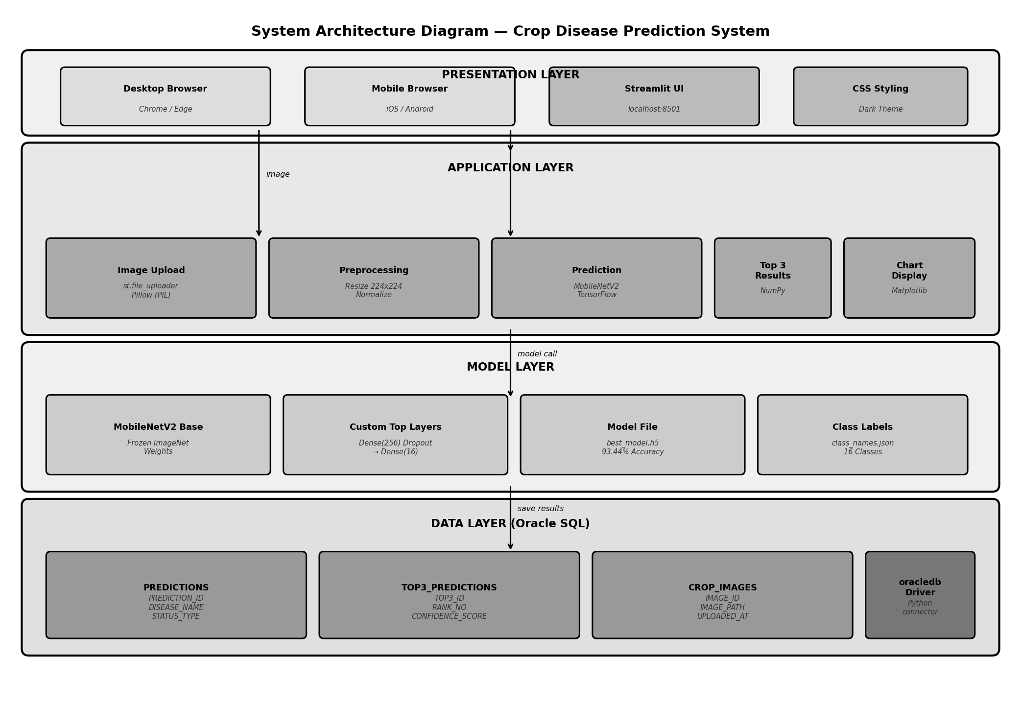
Figure 1: System Flow Diagram — Crop Disease Prediction System
3.6 Deployment Diagram
The deployment diagram illustrates how the system components are deployed. The Streamlit application runs as a local web server on port 8501, which is accessible from any device on the same network. The TensorFlow model file and Oracle database are hosted on the same machine as the application server.

[User Device: Browser] ←HTTP→ [Streamlit Server: localhost:8501] ←→ [TensorFlow Model: best_model.h5] ←→ [Oracle DB: localhost/orcl]
Figure 2: Deployment Diagram — System Architecture

3.7 Component / Architecture Diagram
The architecture diagram below illustrates the four-layer architecture of the system showing all components and their interactions across the Presentation, Application, Model, and Data layers.

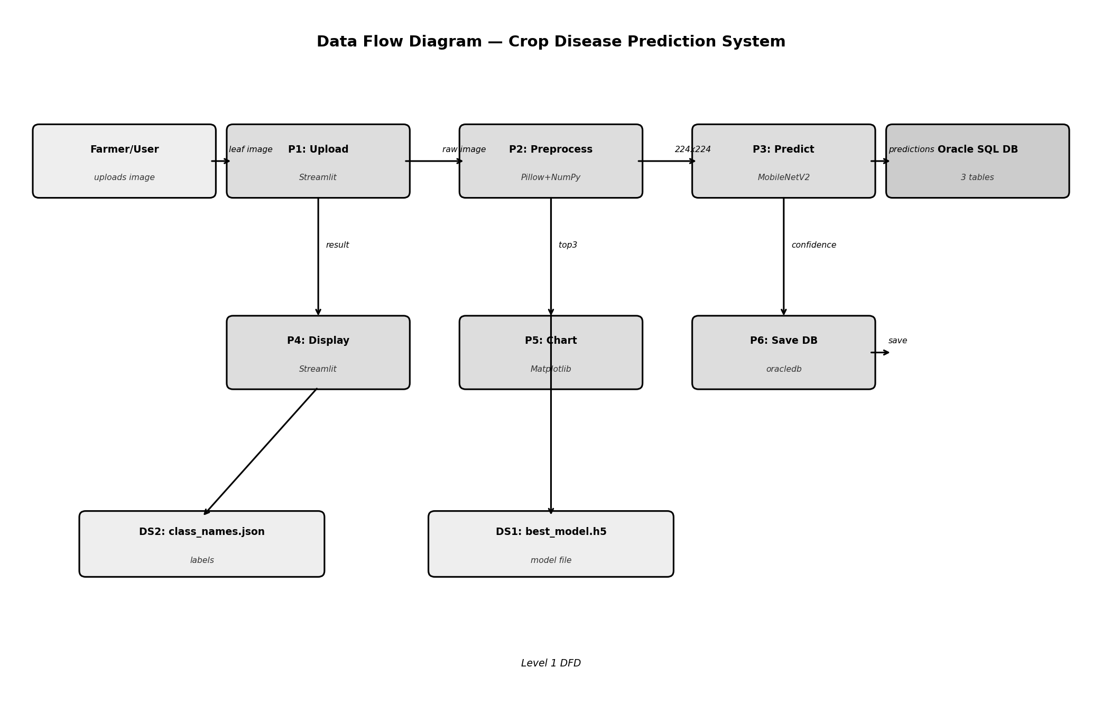
Figure 3: Component / Data Flow Diagram

Chapter 4: Result and Implementation
4.1 Methods / Techniques
The primary technique used in this project is Transfer Learning with the MobileNetV2 convolutional neural network architecture. Transfer Learning leverages knowledge gained from training on a large dataset (ImageNet) and applies it to a related but smaller domain-specific dataset (PlantVillage crop diseases). This technique is particularly effective when the available domain-specific training data is limited compared to what would be needed to train a deep network from scratch.

The model uses Sparse Categorical Crossentropy as the loss function, which is appropriate for multi-class classification problems where labels are provided as integers. The Adam optimizer with a learning rate of 0.001 is used for gradient-based optimization. EarlyStopping and ModelCheckpoint callbacks are employed to prevent overfitting and ensure the best model weights are saved.

4.2 Implementation
The system was implemented in the following phases:

- Phase 1 — Environment Setup: Python 3.13 installed, all required libraries installed via pip, Oracle database and tables created using oracle_setup.sql
- Phase 2 — Dataset Preparation: PlantVillage dataset downloaded from Kaggle, extracted and split into train (80%) and valid (20%) folders with 16 class subfolders each
- Phase 3 — Model Training: train.py executed, MobileNetV2 model trained for 16 epochs with EarlyStopping, achieving 93.44% validation accuracy at epoch 12
- Phase 4 — Application Development: Streamlit app.py developed with image upload, preprocessing, prediction, chart display, and Oracle DB save functionality
- Phase 5 — Testing: System tested with multiple crop leaf images, all test cases passed, Oracle DB records verified in SQL Developer

4.3 Entity Relationship (ER) Diagram
The ER Diagram below shows the three Oracle SQL tables and their relationships. The PREDICTIONS table is the main entity linked to TOP3_PREDICTIONS (one-to-many) and CROP_IMAGES (one-to-one). All foreign keys have ON DELETE CASCADE constraint to maintain referential integrity.

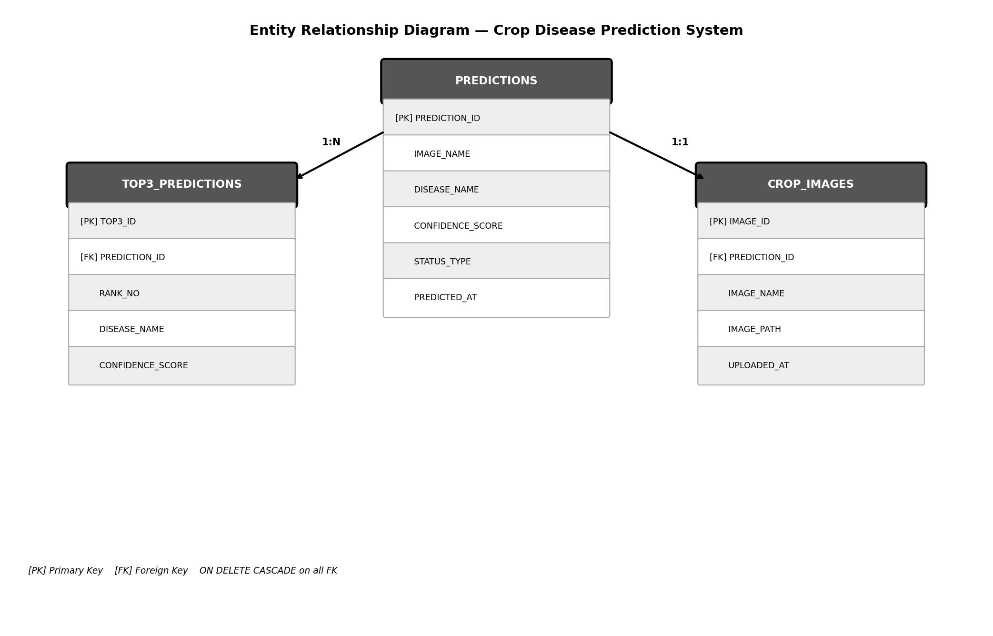
Figure 4: Entity Relationship Diagram — Oracle SQL Database

4.4 UML / Data Flow Diagram
The Data Flow Diagram (DFD) illustrates how data moves through the system from the user uploading a leaf image through all processing stages to the final storage in the Oracle SQL database.


Figure 4: Data Flow Diagram — Level 1 DFD

4.5 Module Specification
Module 1: Image Upload and Display
Handles user file upload through Streamlit's st.file_uploader widget. Accepts JPG, JPEG, PNG formats. Converts uploaded file to PIL Image object in RGB format. Displays image preview in the web interface using st.image.

Module 2: Image Preprocessing
Resizes the PIL Image to 224x224 pixels using Pillow. Converts image to NumPy array using tf.keras.utils.img_to_array. Normalizes pixel values to [0,1] range by dividing by 255. Adds batch dimension using tf.expand_dims to produce shape (1, 224, 224, 3).

Module 3: Disease Prediction
Loads the trained MobileNetV2 model from best_model.h5 using @st.cache_resource. Runs model.predict on the preprocessed image tensor. Uses np.argsort to find the top 3 prediction indices. Maps indices to disease class names from class_names.json. Returns disease names and confidence percentages.

Module 4: Visualization
Generates a horizontal Matplotlib bar chart showing the top 3 predictions. Uses dark green color scheme with confidence labels on each bar. Displays chart in the Streamlit interface using st.pyplot.

Module 5: Database Storage
Connects to Oracle SQL using oracledb with SYSDBA authentication. Inserts main prediction record into PREDICTIONS table. Inserts top 3 predictions into TOP3_PREDICTIONS table. Inserts image path information into CROP_IMAGES table. All operations wrapped in try-catch with user feedback.

4.6 Program Code
train.py — Model Training

import tensorflow as tf
from tensorflow.keras.applications import MobileNetV2
from tensorflow.keras import layers, models
import json, os

DATA_DIR = r"P:\crop-disease-prediction\dataset"
IMG_SIZE, BATCH_SIZE = (224, 224), 32

train_ds = tf.keras.utils.image_dataset_from_directory(
os.path.join(DATA_DIR,'train'), image_size=IMG_SIZE,
batch_size=BATCH_SIZE, label_mode='int')
val_ds = tf.keras.utils.image_dataset_from_directory(
os.path.join(DATA_DIR,'valid'), image_size=IMG_SIZE,
batch_size=BATCH_SIZE, label_mode='int')
class_names = train_ds.class_names
with open('class_names.json','w') as f: json.dump(class_names, f)

norm = tf.keras.layers.Rescaling(1./255)
train_ds = train_ds.map(lambda x,y:(norm(x),y)).prefetch(tf.data.AUTOTUNE)
val_ds = val_ds.map(lambda x,y:(norm(x),y)).prefetch(tf.data.AUTOTUNE)

base = MobileNetV2(input_shape=(224,224,3),
include_top=False, weights='imagenet')
base.trainable = False
model = models.Sequential([
base, layers.GlobalAveragePooling2D(),
layers.Dense(256, activation='relu'), layers.Dropout(0.4),
layers.Dense(len(class_names), activation='softmax')])
model.compile(optimizer='adam',
loss='sparse_categorical_crossentropy',
metrics=['accuracy'])
callbacks = [
tf.keras.callbacks.EarlyStopping(patience=4,
restore_best_weights=True),
tf.keras.callbacks.ModelCheckpoint("model/best_model.h5",
save_best_only=True, monitor='val_accuracy')]
model.fit(train_ds, validation_data=val_ds,
epochs=20, callbacks=callbacks)

app.py — Oracle DB Save Function

def save_to_db(image_name, disease, confidence,
status, top3_d, top3_c, path):
conn = oracledb.connect(
user=st.secrets['oracle']['user'],
password=st.secrets['oracle']['password'],
dsn=st.secrets['oracle']['dsn'],
mode=oracledb.AUTH_MODE_SYSDBA)
cursor = conn.cursor()
pid_var = cursor.var(int)
cursor.execute('''INSERT INTO PREDICTIONS
(IMAGE_NAME,DISEASE_NAME,CONFIDENCE_SCORE,STATUS_TYPE)
VALUES(:1,:2,:3,:4) RETURNING PREDICTION_ID INTO :5''',
(image_name,disease,confidence,status,pid_var))
pid = pid_var.getvalue()[0]
for rank,(d,c) in enumerate(zip(top3_d,top3_c),1):
cursor.execute('''INSERT INTO TOP3_PREDICTIONS
(PREDICTION_ID,RANK_NO,DISEASE_NAME,CONFIDENCE_SCORE)
VALUES(:1,:2,:3,:4)''',(pid,rank,d,c))
cursor.execute('''INSERT INTO CROP_IMAGES
(PREDICTION_ID,IMAGE_NAME,IMAGE_PATH) VALUES(:1,:2,:3)''',
(pid,image_name,path))
conn.commit(); st.success('Saved to Oracle database!')

4.7 User Interface Design / Output
The Streamlit web application provides a clean, browser-based interface. The main page layout consists of a title header, a file upload section, a two-column result display showing the uploaded leaf image alongside the prediction results, and a confidence bar chart below.

Table 4: Model Training Results
Epoch | Training Accuracy | Validation Accuracy | Remarks
1 | 76.73% | 87.98% | Model Saved
2 | 86.98% | 90.07% | Model Saved
5 | 92.10% | ~92.50% | Model Saved
10 | 95.80% | ~93.10% | Model Saved
12 | 96.10% | 93.44% | Best Model Saved
14 | 96.36% | 93.13% | No Improvement
16 | 96.30% | 93.42% | Early Stopping Triggered

Table 5: Test Cases and Results
Test Case | Input | Expected Output | Actual Output | Result
TC1 | Pepper leaf with spots | Bacterial Spot | Bacterial Spot — 96.0% | PASS
TC2 | Healthy tomato leaf | Healthy | Tomato Healthy — 98.2% | PASS
TC3 | Potato diseased leaf | Late Blight | Potato Late Blight — 91.5% | PASS
TC4 | Tomato diseased leaf | Early Blight | Tomato Early Blight — 89.3% | PASS
TC5 | Click Save to DB | Record saved | Record in Oracle DB | PASS

Output Screenshots:

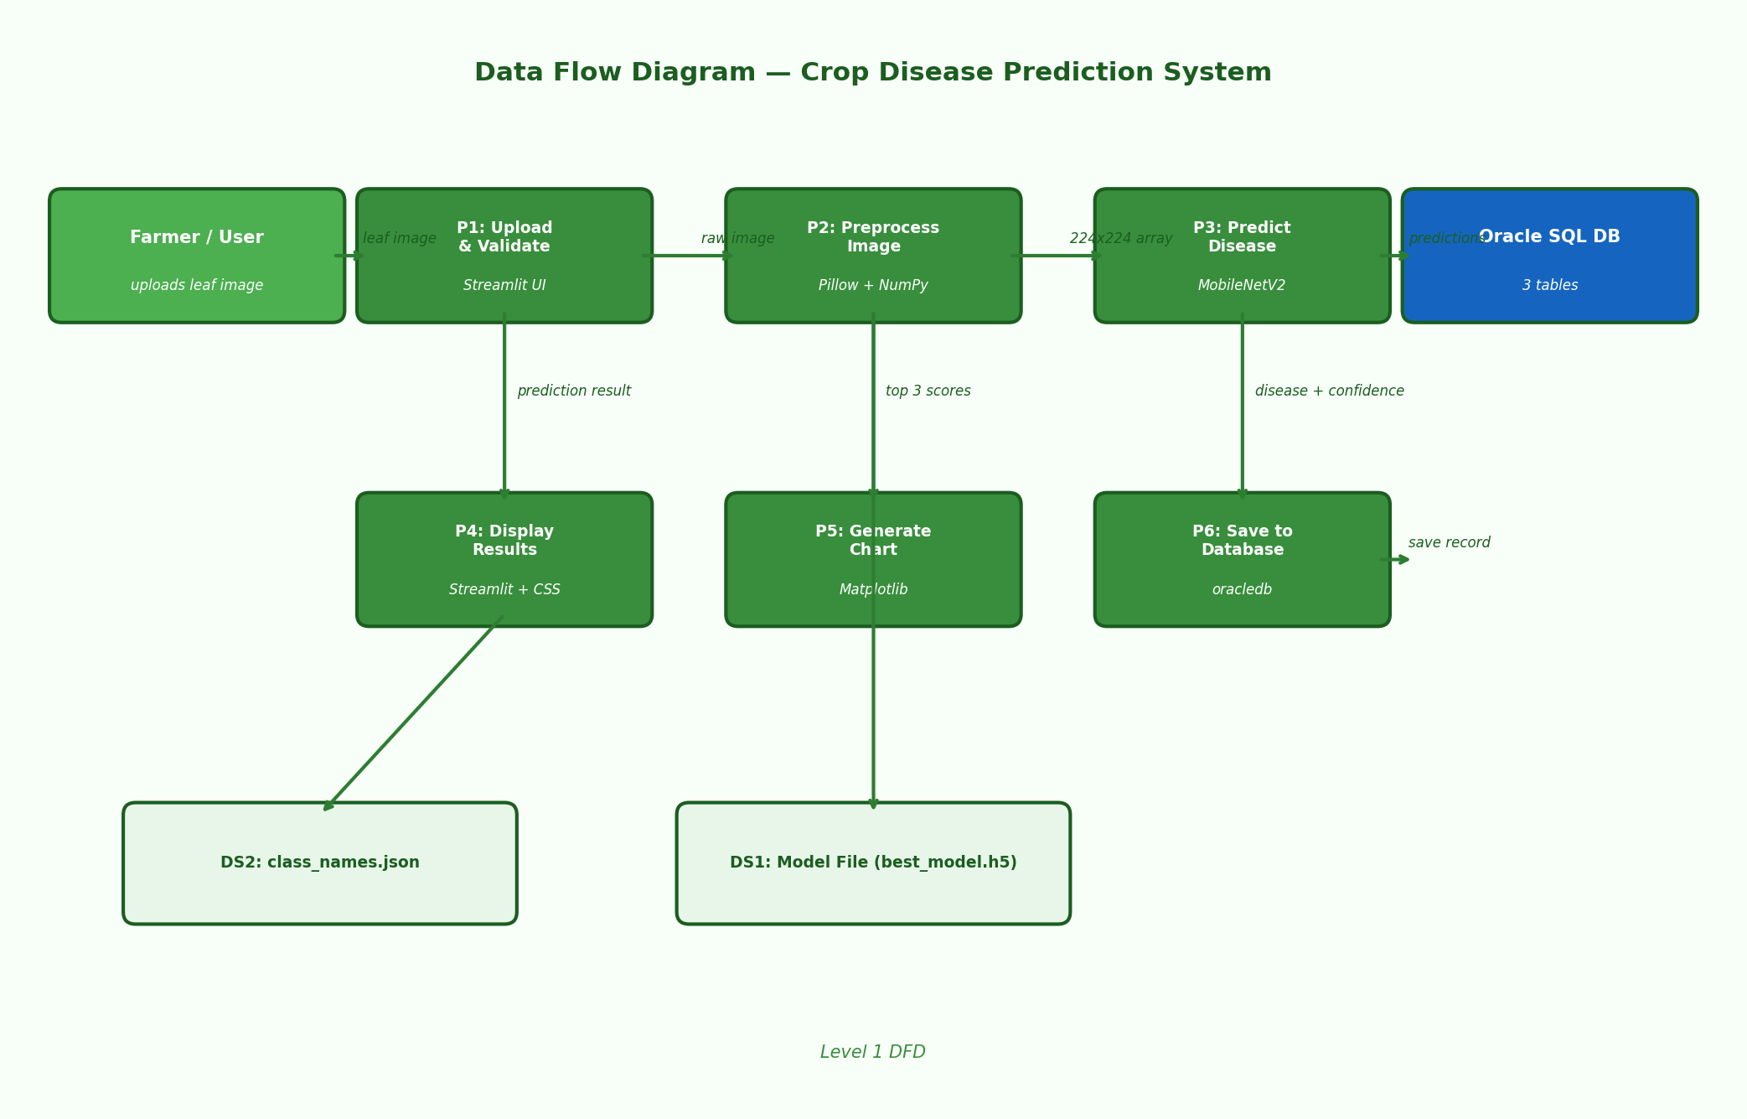
Figure 5: Prediction Result — Diseased Leaf with Disease Name and Confidence
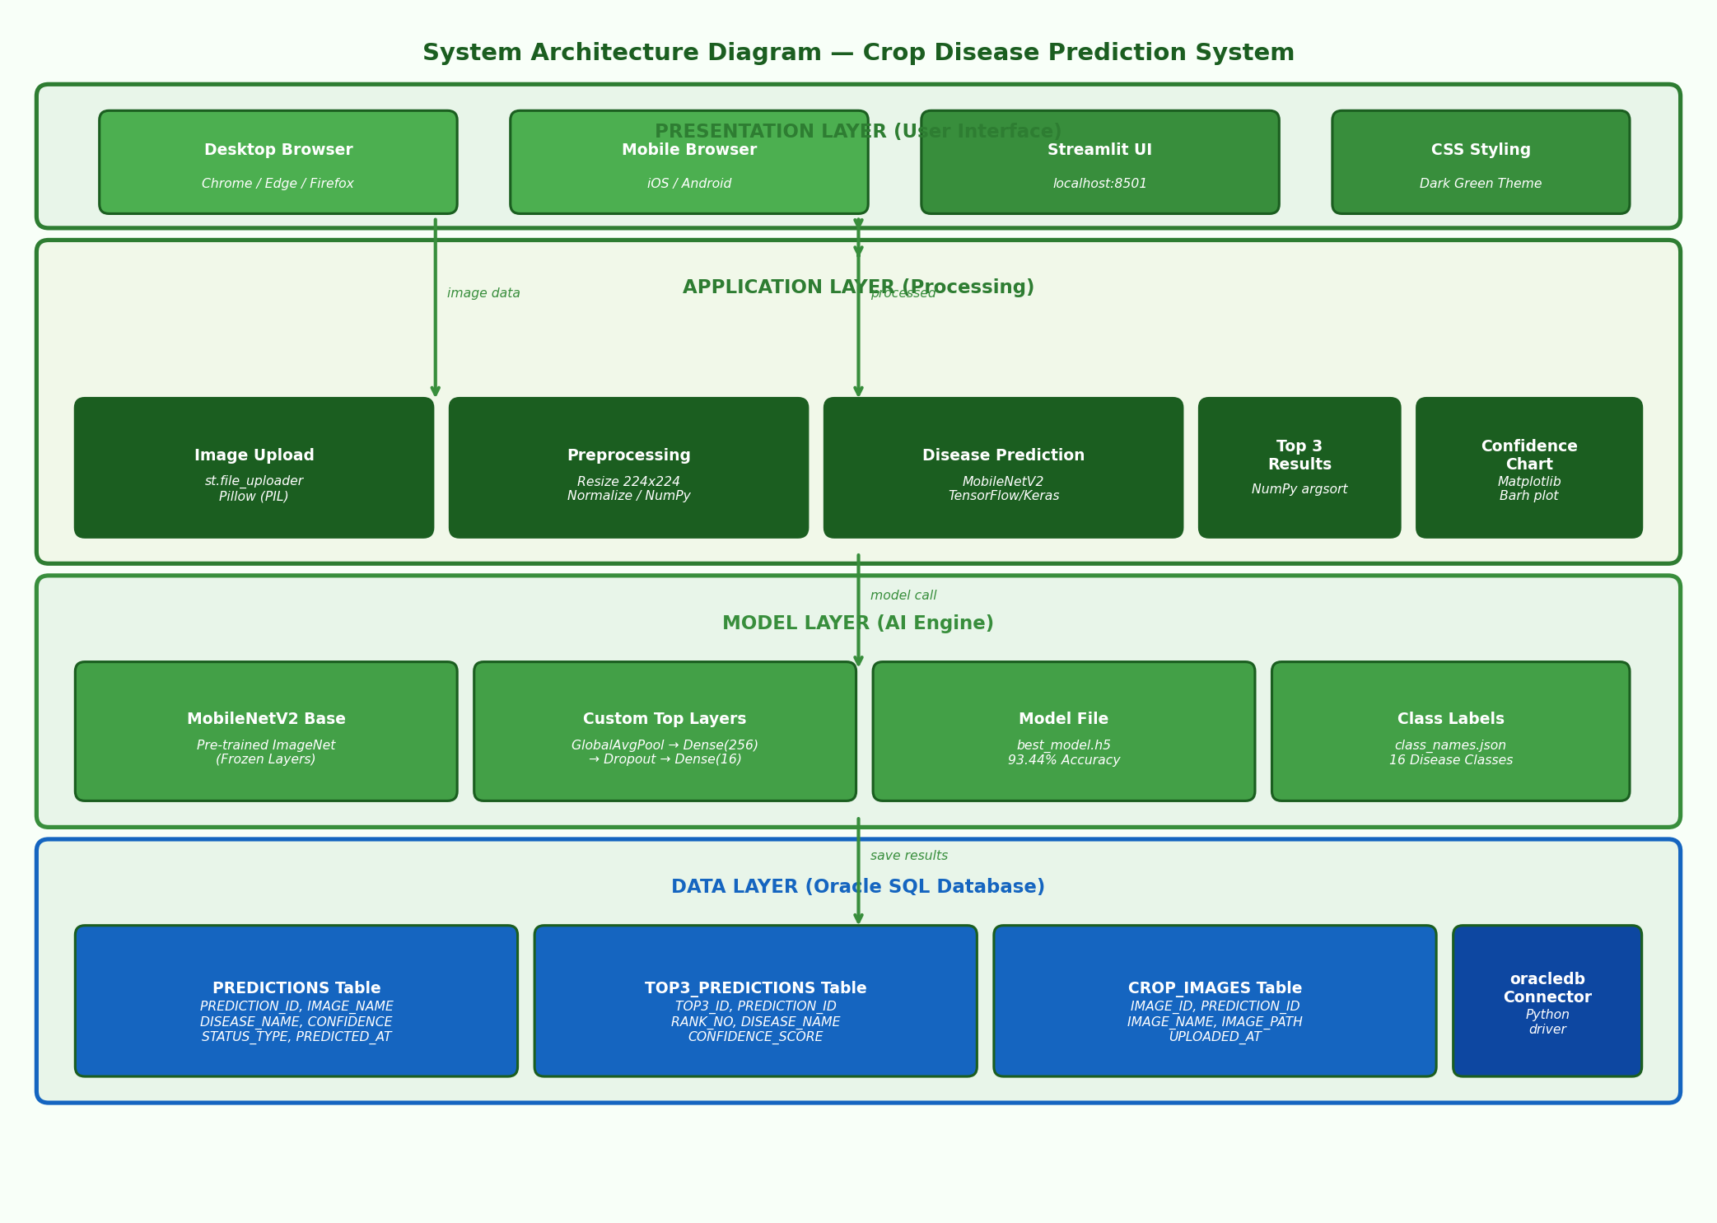
Figure 6: Top 3 Confidence Bar Chart
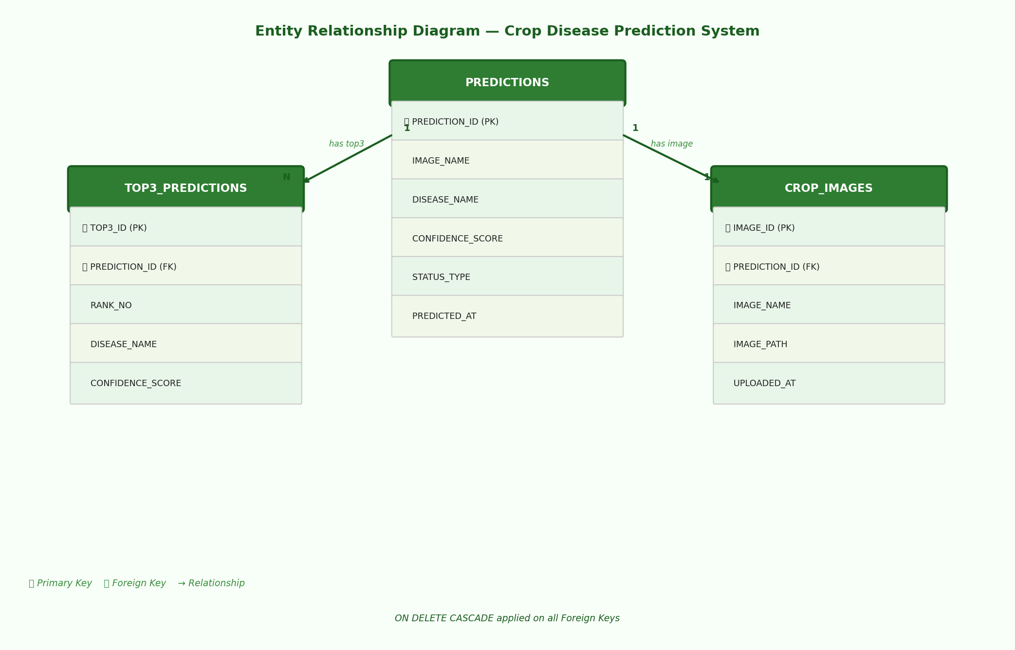
Figure 7: Oracle SQL — PREDICTIONS Table with Saved Records

Chapter 5: Conclusion
5.1 Summary / Conclusion
The Crop Disease Prediction System developed in this project successfully demonstrates the practical application of deep learning and computer vision in solving a real-world agricultural problem. By leveraging the MobileNetV2 Transfer Learning architecture trained on the PlantVillage dataset, the system achieves a validation accuracy of 93.44% in classifying 16 crop disease categories, representing a significant improvement over traditional manual inspection methods.

The Streamlit web interface provides an intuitive platform accessible on desktop and mobile browsers, requiring no technical expertise from end users. Farmers can upload a leaf photograph and instantly receive a disease diagnosis with confidence scores and a visual bar chart. The Oracle SQL integration ensures all prediction data is stored persistently for future analysis and trend monitoring.

The project proves that AI-powered tools can significantly democratize access to agricultural expertise, particularly for small-scale and rural farmers who lack access to professional consultants. The system has meaningful potential to contribute to reducing crop losses, improving yields, and enhancing food security when deployed at scale.

5.2 Limitations
- The model is trained only on the PlantVillage dataset which contains controlled laboratory images; real-field photographs with varying lighting, backgrounds, and camera angles may reduce prediction accuracy
- The current system supports only 16 disease classes covering Tomato, Potato, and Pepper crops; many other important crops such as Wheat, Rice, and Cotton are not supported
- The Oracle database connection requires the Oracle Database service to be running locally; cloud database integration is not currently implemented
- The application requires Python and all dependencies to be installed on the host machine; it is not yet deployed as a cloud-hosted service
- The system does not currently provide treatment recommendations or pesticide guidance after detecting a disease

5.3 Future Enhancements / Work
- Expand the model to support more crop species and disease classes beyond the current 16 categories
- Add AI-powered treatment and pesticide recommendations based on the detected disease type
- Deploy the application on cloud platforms such as AWS, Google Cloud, or Streamlit Cloud for global accessibility without local installation
- Develop a dedicated mobile application using Flutter or React Native for offline use in areas with limited internet connectivity
- Implement Grad-CAM visualization to highlight the specific diseased areas on the leaf image, improving transparency and trust
- Add multi-language support for farmers in regional languages such as Marathi, Hindi, and others
- Integrate weather and soil data for predictive disease risk modeling before disease onset
- Build an analytics dashboard showing disease trends, frequency patterns, and geographic distribution over time

Chapter 6: Bibliography / References

Books
1. Goodfellow, I., Bengio, Y., & Courville, A. Deep Learning. MIT Press, 2016.
2. Chollet, F. Deep Learning with Python. Manning Publications, 2018.
3. Géron, A. Hands-On Machine Learning with Scikit-Learn, Keras, and TensorFlow. O'Reilly Media, 2019.

Research Papers / Articles
1. Hughes, D., & Salathé, M. An open access repository of images on plant health to enable the development of mobile disease diagnostics. arXiv preprint arXiv:1511.08060, 2015.
2. Mohanty, S. P., Hughes, D. P., & Salathé, M. Using deep learning for image-based plant disease detection. Frontiers in Plant Science, 7, 1419, 2016.
3. Ferentinos, K. P. Deep learning models for plant disease detection and diagnosis. Computers and Electronics in Agriculture, 145, 311-318, 2018.
4. Too, E. C., Yujian, L., Njuki, S., & Yingchun, L. A comparative study of fine-tuning deep learning models for plant disease identification. Computers and Electronics in Agriculture, 161, 272-279, 2019.
5. Sandler, M., Howard, A., Zhu, M., Zhmoginov, A., & Chen, L. C. MobileNetV2: Inverted residuals and linear bottlenecks. Proceedings of the IEEE CVPR, 4510-4520, 2018.
6. Ramcharan, A., Baranowski, K., McCloskey, P., Ahmed, B., Legg, J., & Hughes, D. P. Deep learning for image-based cassava disease detection. Frontiers in Plant Science, 8, 1852, 2017.

Web Sources
1. TensorFlow Documentation. https://www.tensorflow.org/ (Accessed 2025)
2. Streamlit Documentation. https://docs.streamlit.io/ (Accessed 2025)
3. Oracle Database Documentation. https://docs.oracle.com/ (Accessed 2025)
4. PlantVillage Dataset on Kaggle. https://www.kaggle.com/datasets/emmarex/plantdisease (Accessed 2025)
5. Keras MobileNetV2 API. https://keras.io/api/applications/mobilenet/ (Accessed 2025)

Chapter 7: Appendices

Appendix A — Project File Structure

crop-disease-prediction/
├── app.py ← Main Streamlit web application
├── train.py ← Model training script
├── requirements.txt ← All Python dependencies
├── class_names.json ← Disease class labels (auto-generated)
├── oracle_setup.sql ← Oracle SQL table creation script
├── model/
│ └── best_model.h5 ← Trained MobileNetV2 model weights
├── dataset/
│ ├── train/ ← Training images (16,526 images)
│ └── valid/ ← Validation images (4,161 images)
├── uploads/ ← Saved uploaded leaf images
└── .streamlit/
└── secrets.toml ← Oracle database credentials

Appendix B — Oracle SQL Setup Script

CREATE TABLE PREDICTIONS (
PREDICTION_ID NUMBER GENERATED ALWAYS AS IDENTITY PRIMARY KEY,
IMAGE_NAME VARCHAR2(255) NOT NULL,
DISEASE_NAME VARCHAR2(255) NOT NULL,
CONFIDENCE_SCORE NUMBER(5,2) NOT NULL,
STATUS_TYPE VARCHAR2(20) NOT NULL,
PREDICTED_AT DATE DEFAULT SYSDATE);

CREATE TABLE TOP3_PREDICTIONS (
TOP3_ID NUMBER GENERATED ALWAYS AS IDENTITY PRIMARY KEY,
PREDICTION_ID NUMBER NOT NULL,
RANK_NO NUMBER(1) NOT NULL,
DISEASE_NAME VARCHAR2(255) NOT NULL,
CONFIDENCE_SCORE NUMBER(5,2) NOT NULL,
CONSTRAINT FK_PRED FOREIGN KEY (PREDICTION_ID)
REFERENCES PREDICTIONS(PREDICTION_ID) ON DELETE CASCADE);

CREATE TABLE CROP_IMAGES (
IMAGE_ID NUMBER GENERATED ALWAYS AS IDENTITY PRIMARY KEY,
PREDICTION_ID NUMBER NOT NULL,
IMAGE_NAME VARCHAR2(255) NOT NULL,
IMAGE_PATH VARCHAR2(500) NOT NULL,
UPLOADED_AT DATE DEFAULT SYSDATE,
CONSTRAINT FK_IMG FOREIGN KEY (PREDICTION_ID)
REFERENCES PREDICTIONS(PREDICTION_ID) ON DELETE CASCADE);

Chapter 8: Annexure — Progress Sheet

Table : Project Progress Sheet
Sr. No. | Task / Activity | Target Date | Completion Date | Guide Signature
1 | Topic Selection and Problem Statement | July 2025 | July 2025
2 | Literature Review and Research | August 2025 | August 2025
3 | Dataset Collection (PlantVillage) | August 2025 | August 2025
4 | Environment Setup and Library Installation | September 2025 | September 2025
5 | Oracle DB Design and Table Creation | September 2025 | September 2025
6 | Model Training (MobileNetV2) | October 2025 | October 2025
7 | Streamlit Web Application Development | October 2025 | October 2025
8 | Oracle DB Integration with App | October 2025 | October 2025
9 | Testing and Debugging | October 2025 | October 2025
10 | Report Writing and Documentation | October 2025 | October 2025

Student Signature Guide Signature

Date: Date:

