**A Project Report**

**On**

***“Online-Movie-Ticket-booking-System”***

**Submitted to**

**Savitribai Phule University**

**For partial fulfilment of**

**Bachelor Of Computer Science**

**Submitted by**

**Mr. Pinjari Pawan.**

**Guided By**

**Dr. B.S. Shinde**

**In The**

**Academic Year**

**2021-22**

 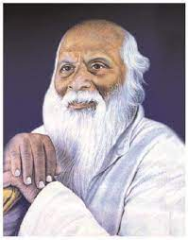

“Education through self help is our motto”-Karmaver

Rayat Shikshan Sanstha`s,

R.B.NARAYANRAO BORAWAKE COLLEGE

Shirampur,413709,Dist – Ahmednagar



CERTIFICATE

DEPARTMENT OF COMPUTER SCIENCE

This is to certify That Mr. Pinjari Pawan Bhausaheb of T.Y.B.Sc.(Comp Sci.) has Satisfactorily carried out required project work according to the syllabus of SAVITRIBAI PHULE PUNE UNIVERSITY during the academic year 2021-22. This journal represents his benefited work.

Project Guide Head of Dept. Examiner

Dr. B.S. Shinde Dr. B.S. Shinde

***INDEX***

|  |  |  |
| --- | --- | --- |
| **SR NO** | **CONTENT** | **PAGE No.** |
| **1** | **Acknowledgement** |  |
| **2** | **Introduction To System** |  |
| **3** | **Need Of Computerization** |  |
| **4** | **Feasibility Study** |  |
| **5** | **Normalization** |  |
| **6** | **ER Diagram** |  |
| **8** | **UML Diagram** |  |
| **9** | **Screens** |  |
| **10** | **Data Dictionary** |  |
| **11** | **Future Enhancement** |  |
| **12** | **Bibliography** |  |

***Acknowledgement***

At the successful completion of the project, looking back at our development Efforts, we found so many people who helped, supported and guided us to complete this project of Application of *“****Online-Movie-Ticket-Booking-System****”* Effectively.

We wish to thank the Principal/Director ***Dr. N. S. Gaikwad*** of our college for permitting us to use all the facilities available in the institution for our project work.

We would also like to thanks the Head of the Bsc. Computer.Science. department and our internal project guide ***Dr. B. S. Shinde Sir*** for his encouragement, guidance and supervision of our project work during the year.

Also, the teaching faculty and all the non-teaching staff of our college for their support in completing the work successfully.

Our classmates have been of great help to us during the project work. Our ideas were shaped and refined progressively through our discussions with them from time to time. We cannot miss to thank them all. There were some persons who were not directly but indirectly involved in our preparatory/practical work. We heartly appreciate their contribution and thank them too.

And last but not least, we would like to thank all our friends for their support and timely help.

You’re sincerely

Mr. Pinjari Pawan Bhausaheb

***Introduction To System***

The main purpose of our ***“Online-Movie-Ticket-Booking-System”*** is to provide an alternate and convenient way for a customer to buy online movie tickets.

The objective of the system is to manage the detail of Movie Show, Ticket, Customer, Show Timings. The Online Movie Ticket Booking System is measurable, cost effective and has very good user interface.

The admin will automate the reservation of tickets and enquiries about availability of the seats. This platform provides details such as what time a movie will be played, what seats are available, movie previews and much more.

Customers can register and login and then book tickets online at any instance of 24 hours a day and buy tickets from anywhere around the world.

In next step he/she select his desire cinema where he/she wish to see movie, then select movie and other details like show, date, time and no of tickets. Based on given parameters a graphical layout of seat status is visible to the customer. Now customer can select his desired seat location and number of seats.

The Theatre Administrator will be able to see all booked and canceled tickets.

***Need Of Computerization***

Generally the process which is used to purchasing online movie ticket by

visiting theatre and then buying the tickets is very basic and manual.

This traditional method may take more efforts. So by computerizing this work

saves the lot of time and also saves the efforts which are complicately

required in the traditional methods.

In a shell, computerizing the existing system will save's work and help

to find the information about newly coming movies in the theatre.

***Software And Hardware Specifications:***

* ***Hardware Specification:-***

Processor : core i5

Ram : 8.00 GB.

SSD : 256 GB.

* ***Software Specification:-***

Frontend : Html, Css, Javascript, Bootstrap.

Web Servers : WampServer.

Backend : Php, Mysql.

Bowser

Program : Google Chrome, MozillaFirefox.

***Feasibility Study:***

A feasibility studies main goal is to access the economic viability of proposed business opportunity, including a look at all possible roadblocks that may stand in the way of the co-operatives success. The outcome of the feasibility study will indicate whether or not to proceed with the proposed system.

If is results of the feasibility study are positives, then we can processed to develop the system software.

If the result show that the project should not should a business idea, and them the project should not carried on further these are the major aspects feasibility study.

* ***Technical Feasibility:-***

This area concern with both the initial purchase and installation costs as well as the operational costs of running the system. Our proposed system will technically feasible because any additional hardware or software requirements will not be needed for it.

* ***Economical Feasibility :-***

The total cost incurred for development and the implementation will be less than that of the previous system.

The system will be economically feasible because if the following reasons. We are going to use browser. After details system will be made available freely and whatever the cost incurred, it will be very less to benefits.

* ***Operational Feasibility :-***

The proposed system after implementation will satisfy the required goals besides providing many other facility. The will be easy to understand. automatic validation of input will enhance to operational feasibility further more.

Our output screen are familiar with their existing data processing environment from the beginning system operations will be made easy for the them. Thus the system will be operationally feasible.

***Normalization***

Normalization is the process in which we can spilt one table into number of the tables and maintain relationships between them in order to reduce the redundancy.

* ***Need for Normalization:-***

Normalization reduces the redundancies of the records. So we can handle the database more efficiently by using relationships between them. By using the normalization we get accurate and consistent results***.***

* ***1NF:-*** It Remove duplicate records from tables.
* ***2NF:-*** It check that every non-key field is strictly depends on key field.
* ***3NF:-*** In this normal form transitive dependencies in the field are removed.

***E-R Diagram:-***

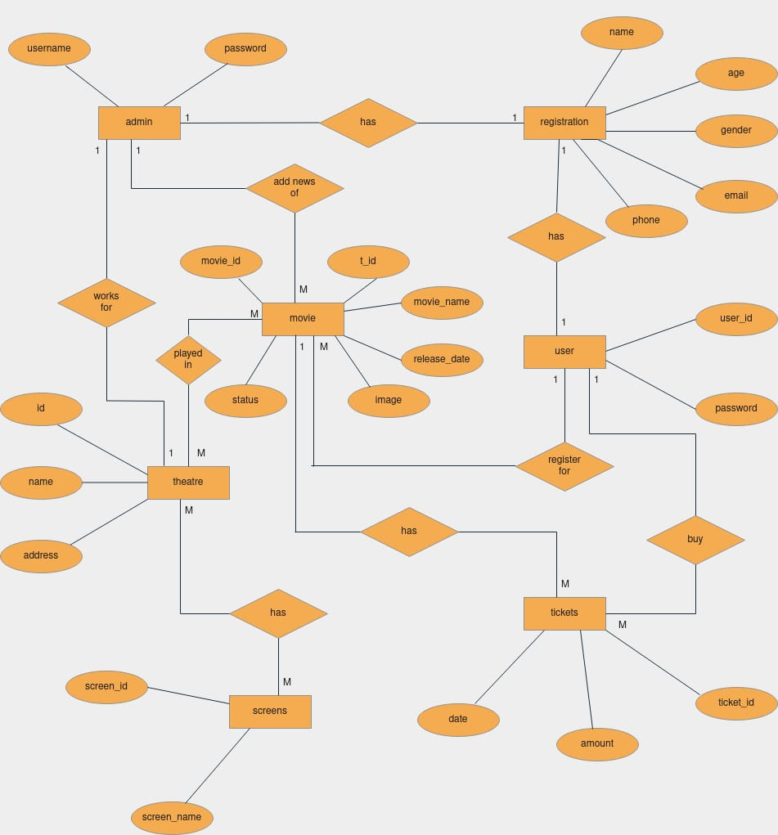

***UML Diagram:-***

* ***Use Case Diagram:-***

**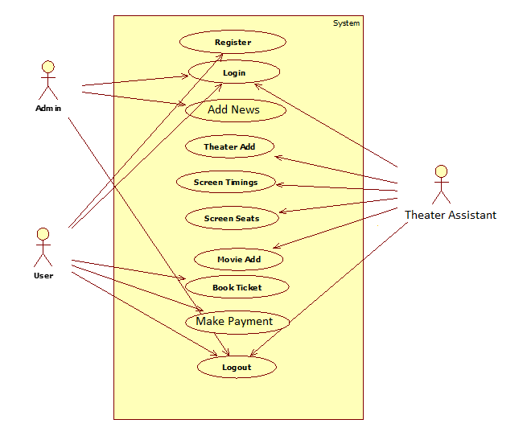*Sequence Diagram:-***

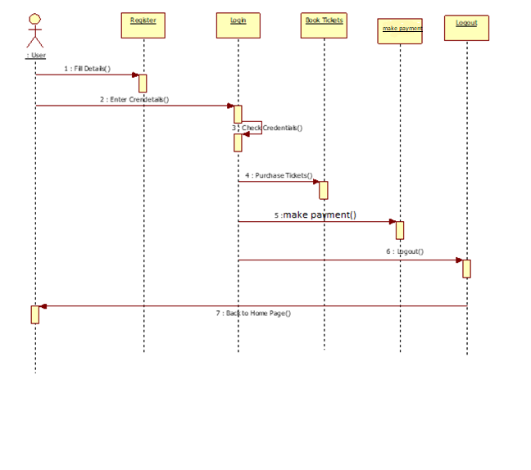

*Sequence Diagram for User*

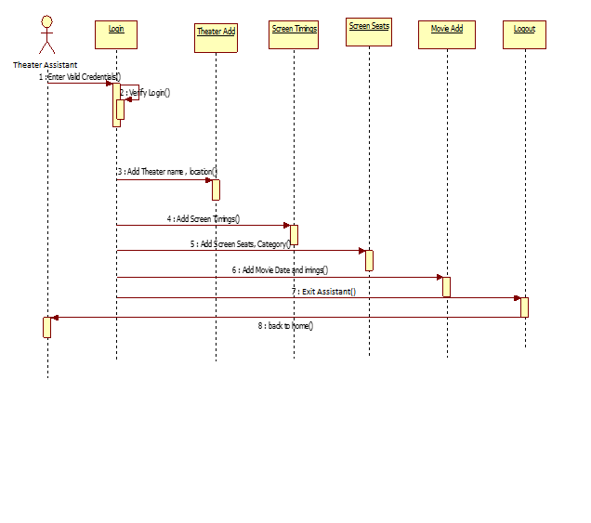

*Sequence Diagram for Theatre Assistant*

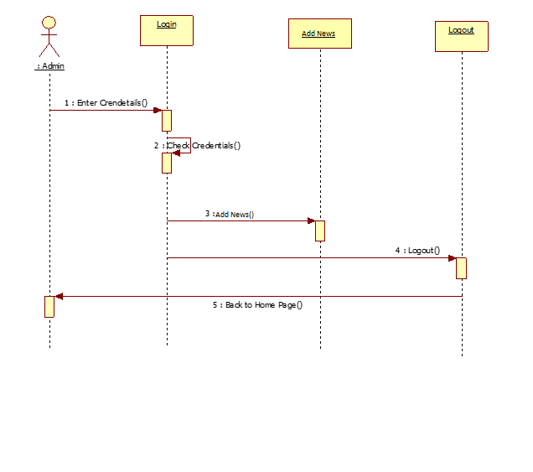

*Sequence Diagram for Admin*

***Activity Diagram:-***

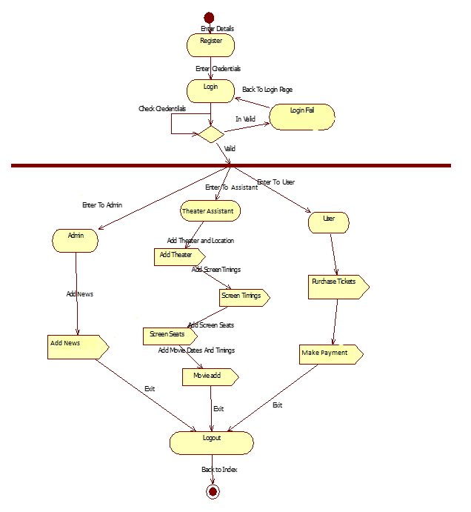

***Component Diagram:-***

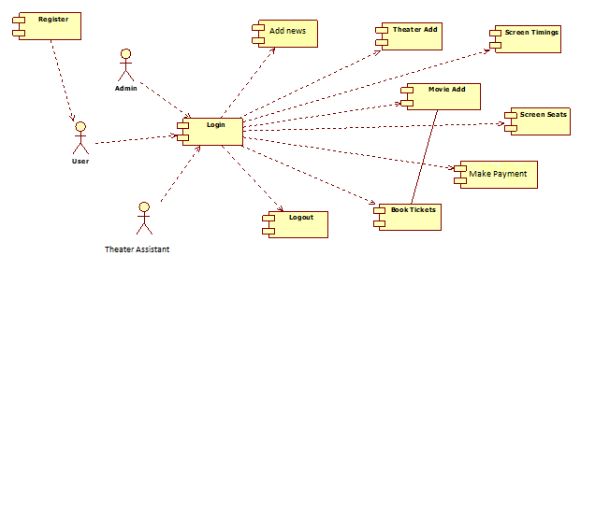

***Screens:-***

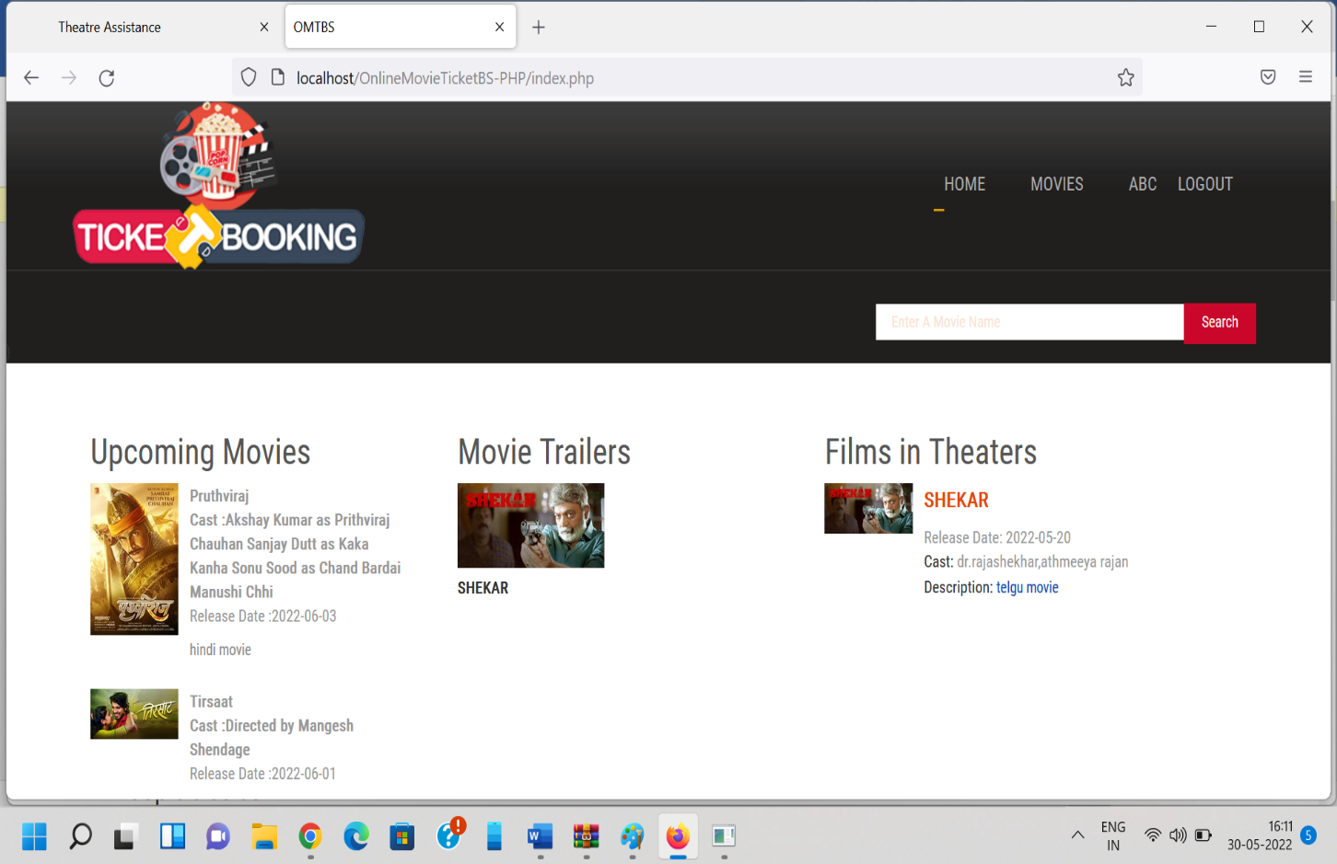

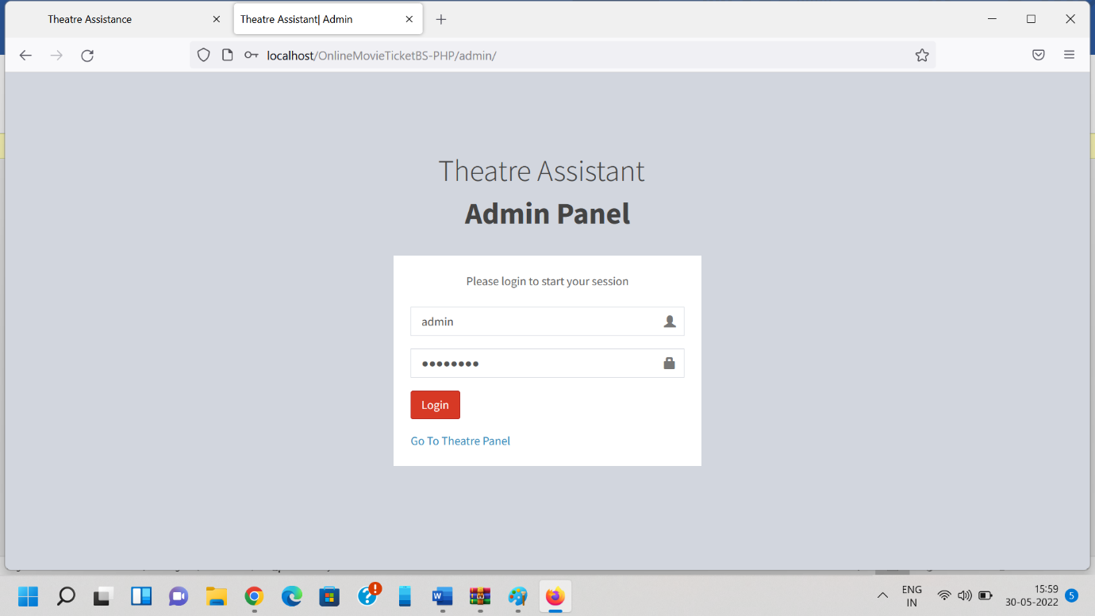

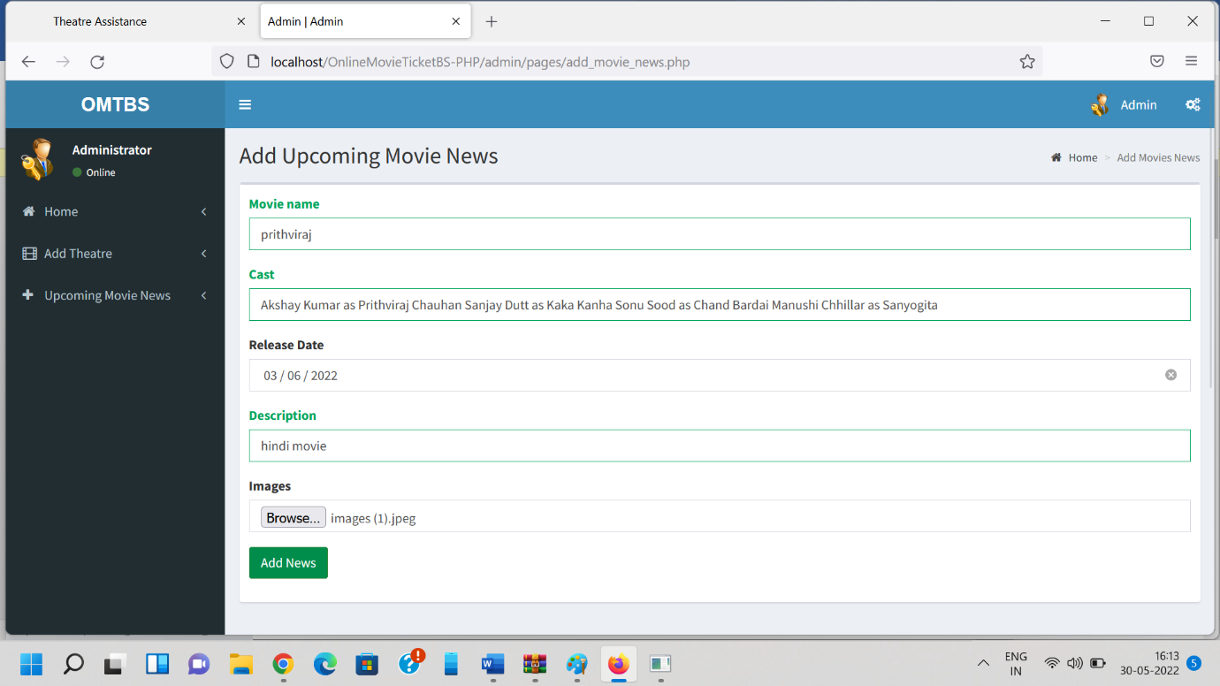

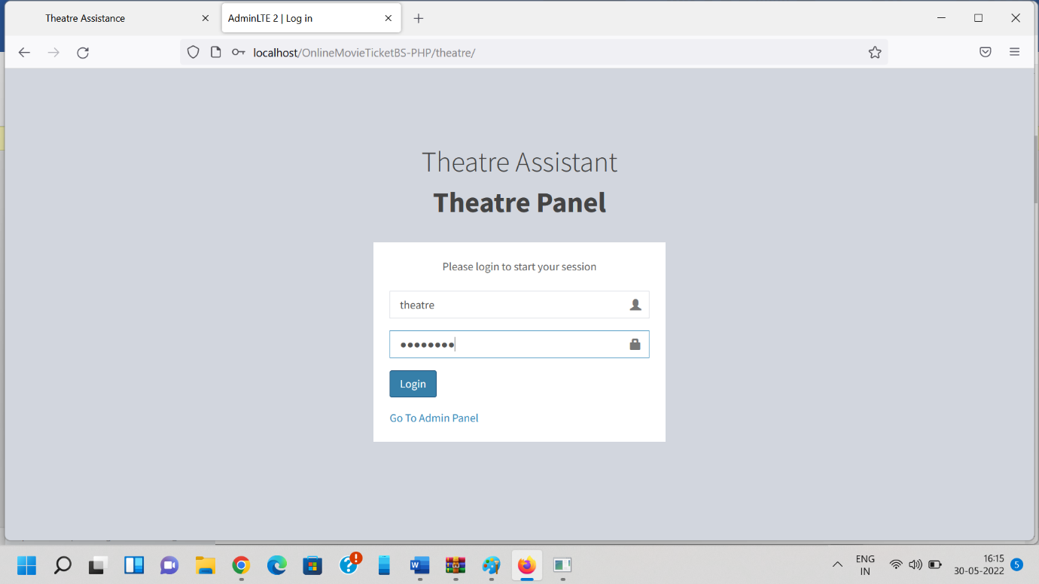

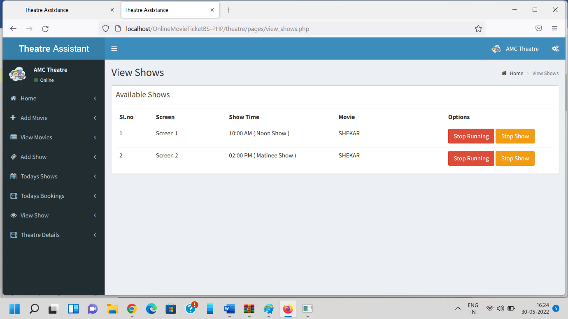

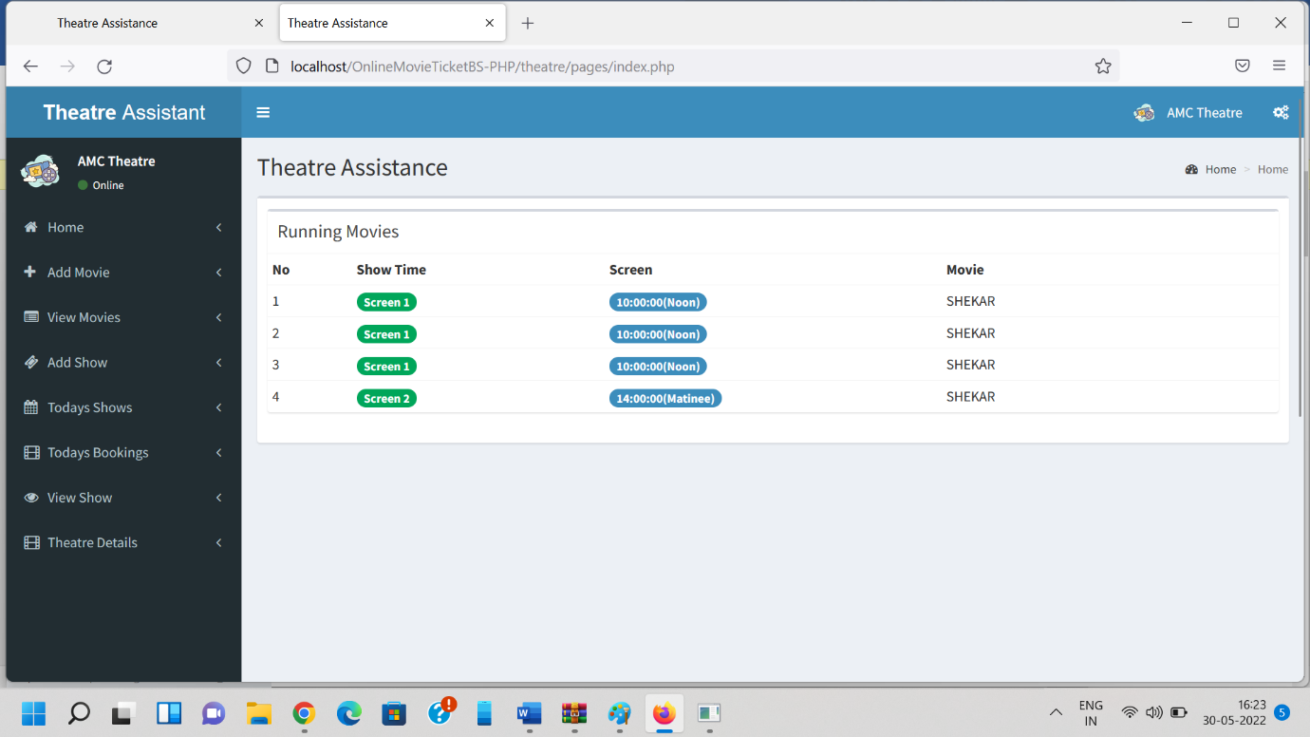

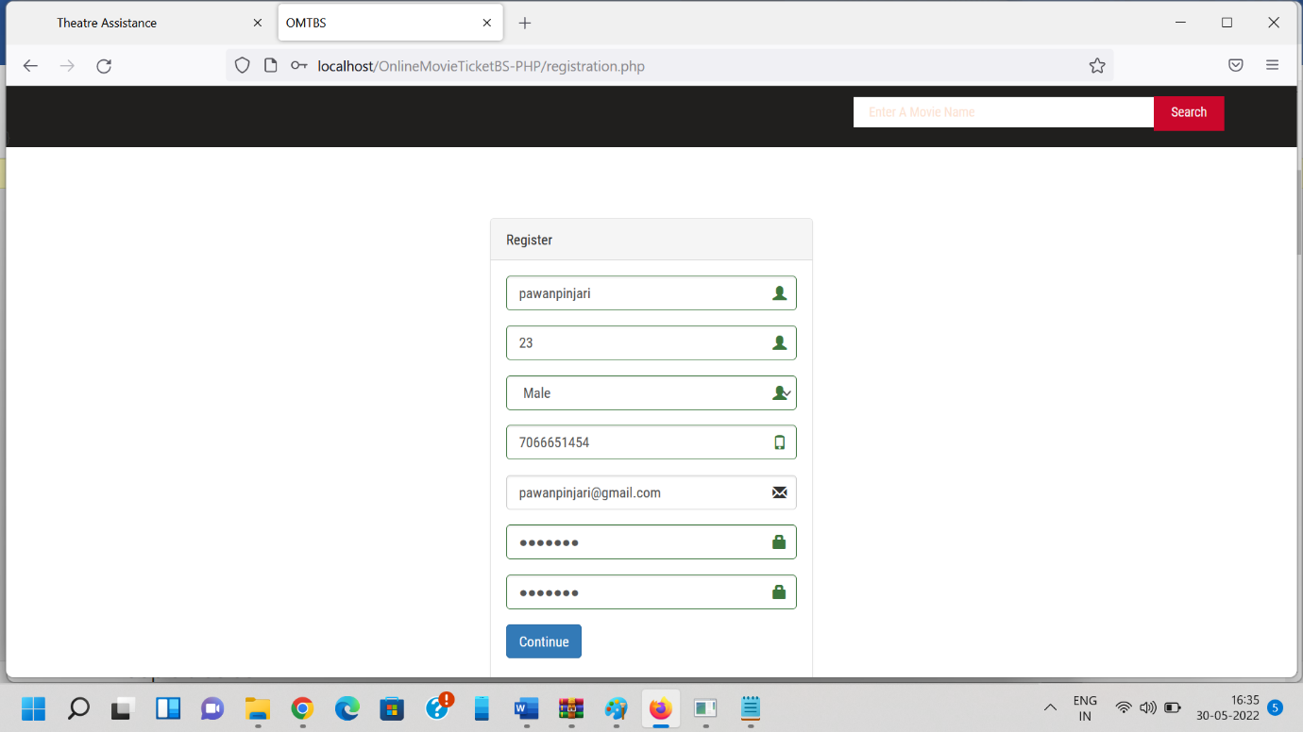

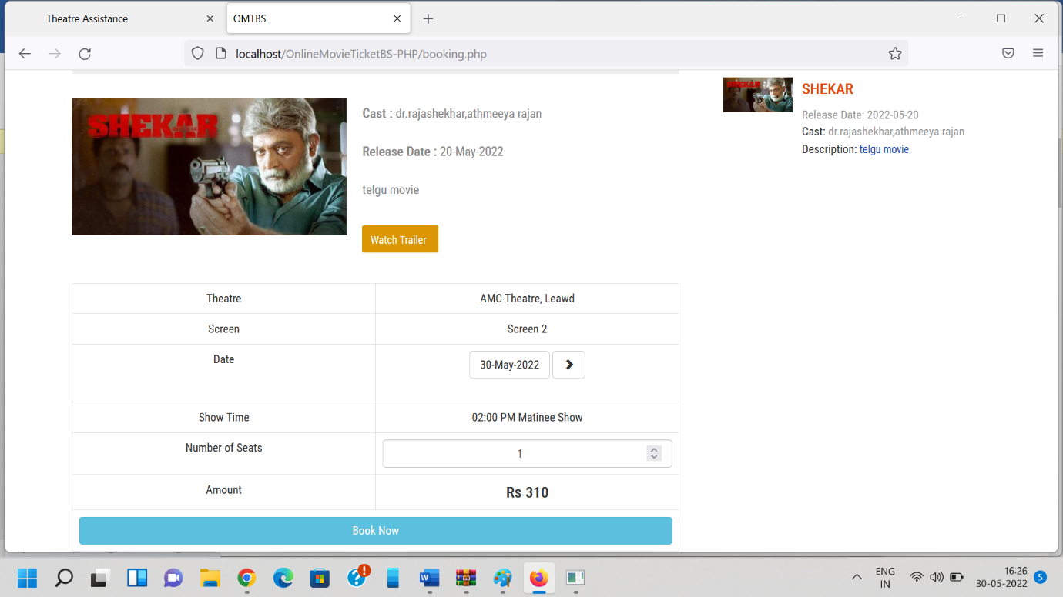

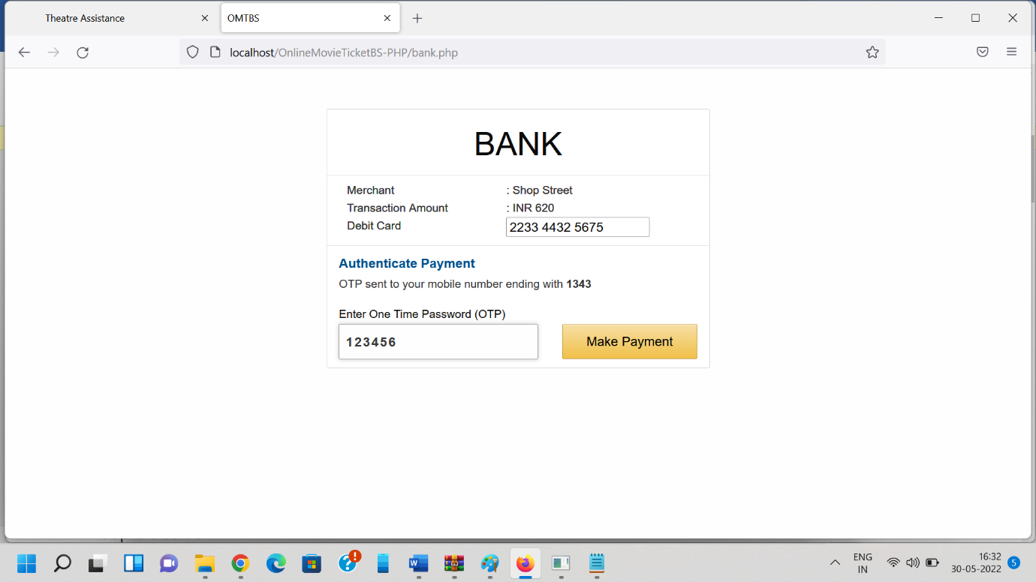

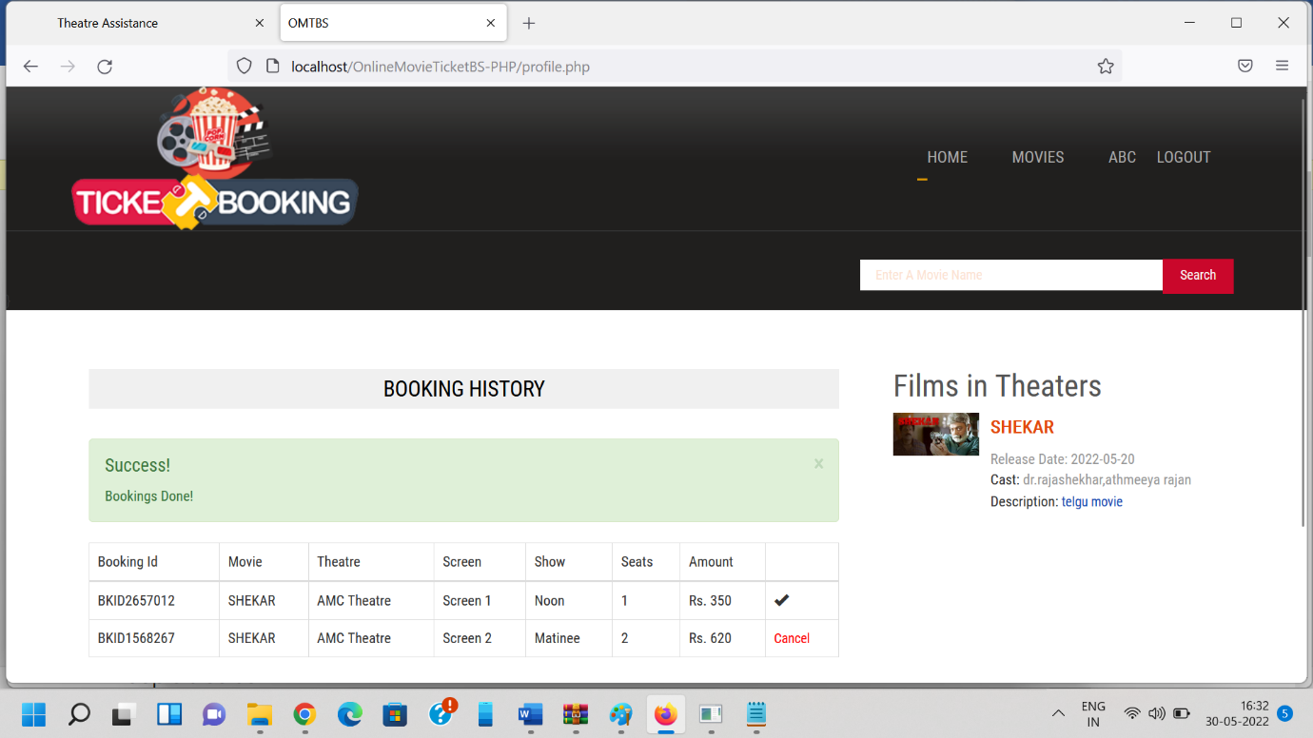

***Data Dictionary***

* ***Login:-*** This is login table to store username and password of user.

|  |  |  |  |
| --- | --- | --- | --- |
| Field | Data Type | Description | Constraints |
| id | int | Contains the id of admin or user or theatre assistant | Primary key |
| user_id | int | Contains user  id | Not null |
| username | varchar | Contains the username | Not null |
| password | varchar | Contains the password | Not null |
| user_type | int | contains user is active or not | Not null |

* ***Registration:-*** This is registration table to store details about registration information .

|  |  |  |  |
| --- | --- | --- | --- |
| Fields | Data Type | Description | Constraints |
| user_id | int | contains the user id | Primary key |
| name | varchar | Contains the  Name of user | Not null |
| email | varchar | Contains the email of user | Not Null |
| phone | varchar | Contains the phone number of user | Not Null |
| age | int | Contains the age of user | Not null |
| gender | varchar | Contains the gender of user | Not null |

* ***Theatre:-***

|  |  |  |  |
| --- | --- | --- | --- |
|  | Data type | Description | Constrains |
| id | int | Contains the  theatre id | Primary Key |
| name | varchar | Contains the name of theatre | Not Null |
| address | varchar | Contains the address of theatre | Not Null |
| place | varchar | Contains the place of theatre | Not Null |
| state | varchar | Contains state of theatre | Not Null |
| pin | int | Contains pin of the theatre area | Not Null |

* ***Movie:-***

|  |  |  |  |
| --- | --- | --- | --- |
| Field | Data Type | Description | Constrains |
| movie_id | int | Contains the id of the movie | Primary key |
| t_id | int | Contains the theatre id | Not Null |
| movie_name | varchar | Contains the movie name | Not Null |
| cast | varchar | Contains the cast of the movie | Not Null |
| desc | varchar | Contains the description of the movie | Not Null |
| release_date | Date | Contains the release date of the movie | Not Null |
| image | varchar | Contains the image/logo of the movie | Not Null |
| video_url | varchar | Contains the trailer of the movie | Not Null |
| status | int | Contains the status of the movie complete or not | Not Null |

* ***Booking;-***

|  |  |  |  |
| --- | --- | --- | --- |
| Fields | Data Type | Description | Constraints |
| book_id | int | contains the booking id | Primary key |
| ticket_id | varchar | Contains the  Id of ticket booking | Not null |
| t_id | int | Contains the id of theatre | Foreign key |
| user_id | int | Contains the user id of the user | Foreign key |
| show_id | int | Contains the id of show | Foreign key |
| screen_id | int | Contains the screen id | Foreign key |
| no_seats | int | Contains the seats | Not Null |
| amount | int | Contains the amount of the movie | Not Null |
| ticket_date | Date | Contains the date of the ticket | Not Null |
| date | date | Contains date | Not Null |
| status | int | Check status | Not Null |

* ***News:-***

|  |  |  |  |
| --- | --- | --- | --- |
| Fields | Data Type | Description | Constraints |
| news_id | int | contains the news id | Primary key |
| name | varchar | Contains the  Name of movie | Not null |
| cast | varchar | Contains the cast of the movie | Not Null |
| news_date | Date | Contains the date of the movie news | Not Null |
| description | varchar | Contains the desc of movie | Not Null |
| attachment | varchar | Contains the image of movie | Not Null |

* ***Screen:-***

|  |  |  |  |
| --- | --- | --- | --- |
| Fields | Data Type | Description | Constraints |
| screen_id | int | contains the screen id | Primary key |
| t_id | int | Contains the  Id of theatre | Foreign key |
| screen_name | varchar | Contains the screen name | Not Null |
| seats | int | Contains the seats in the theatre | Not Null |
| charge | int | Contains the charge | Not Null |

***Future Enhancement***

* Furtherly provide information about new movies.
* Allow Customers to comment on movies.
* Encrypted webpage to ensure customer privacy and transaction security.
* More user friendly interface also in small screen devices .

***Bibliography***

* ***Book Reference:***
* Web Technology Book

-W Jason Gilmore.

* Html Book

-Jakob Nilelsen.

* Javascript -Pocket Reference.
* ***Sites and links:***
* [www.google.com](http://www.google.com)
* www.youtube.com