APEXPLANET • CYBERSECURITY & ETHICAL HACKING INTERNSHIP
TASK 1
Foundations of Cybersecurity
& Environment Setup
Practical Report

Student | Pawan Kumar
Program | B.Tech CSE – Cyber Security
University | Dev Bhoomi Uttarakhand University, Dehradun
Internship | ApexPlanet Cybersecurity & Ethical Hacking Internship

TASK 1 • OVERVIEW

1. Task 1 Overview
Task 1 focuses on building cybersecurity fundamentals and setting up a professional hacking lab. The practical work documented here follows the internship task structure and records the evidence collected during the 12-day foundation phase.
- Understand the CIA triad: Confidentiality, Integrity and Availability.
- Recognize common threats and attack vectors in a controlled learning context.
- Set up and verify Kali Linux, Metasploitable 2 and DVWA.
- Practice essential Linux commands and basic networking.
- Perform introductory cryptography exercises with OpenSSL.
- Capture and filter traffic with Wireshark.
- Use Nmap for host discovery and service/version detection.
- Verify DVWA and demonstrate SQL Injection / Reflected XSS only in the local training lab.

Safety note
All security testing documented in this report is intended for the user's authorized local training environment (DVWA / Metasploitable). The same techniques should not be applied to systems without permission.

TASK 1 • PRACTICAL EVIDENCE

2. Day 1 — Cybersecurity Basics
Objective: understand core cybersecurity concepts and prepare the learning environment.
- CIA triad: Confidentiality, Integrity, Availability.
- Common threats covered: phishing, malware, DDoS, SQL Injection, brute force and ransomware.
- Attack vectors discussed: social engineering, wireless attacks and insider threats.

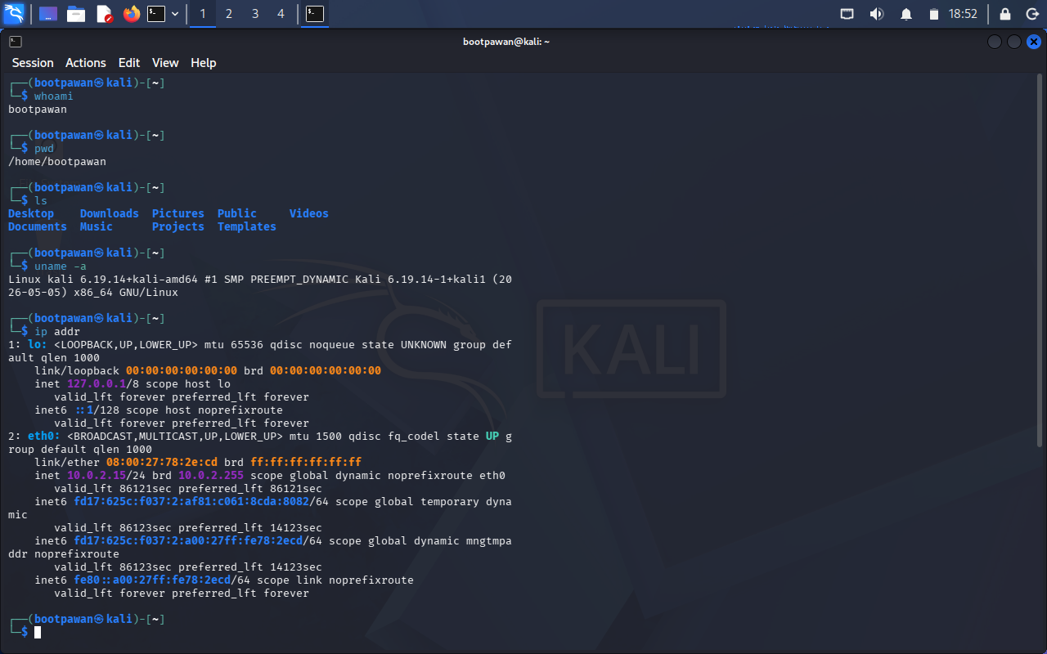
Day 1 — Cybersecurity basics / lab orientation

TASK 1 • PRACTICAL EVIDENCE

3. Day 2 — Lab Environment Setup
Objective: prepare the controlled cybersecurity practice environment.
- Virtualization environment configured for security labs.
- Metasploitable 2 used as an intentionally vulnerable training target.
- DVWA deployed locally for web-application security practice.

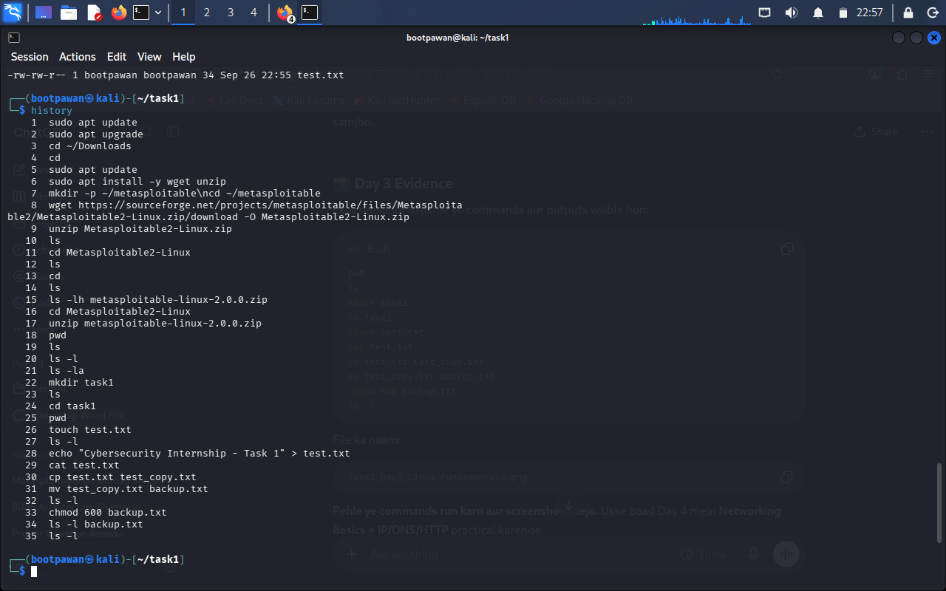
Day 2 — Lab environment setup

TASK 1 • PRACTICAL EVIDENCE

4. Day 3 — Linux Fundamentals
Objective: practice essential Linux filesystem and permission commands.
- Commands practiced included pwd, ls, cd, mkdir, touch, cat, cp, mv, chmod and related shell operations.
- A dedicated task directory was used to organize practical evidence.

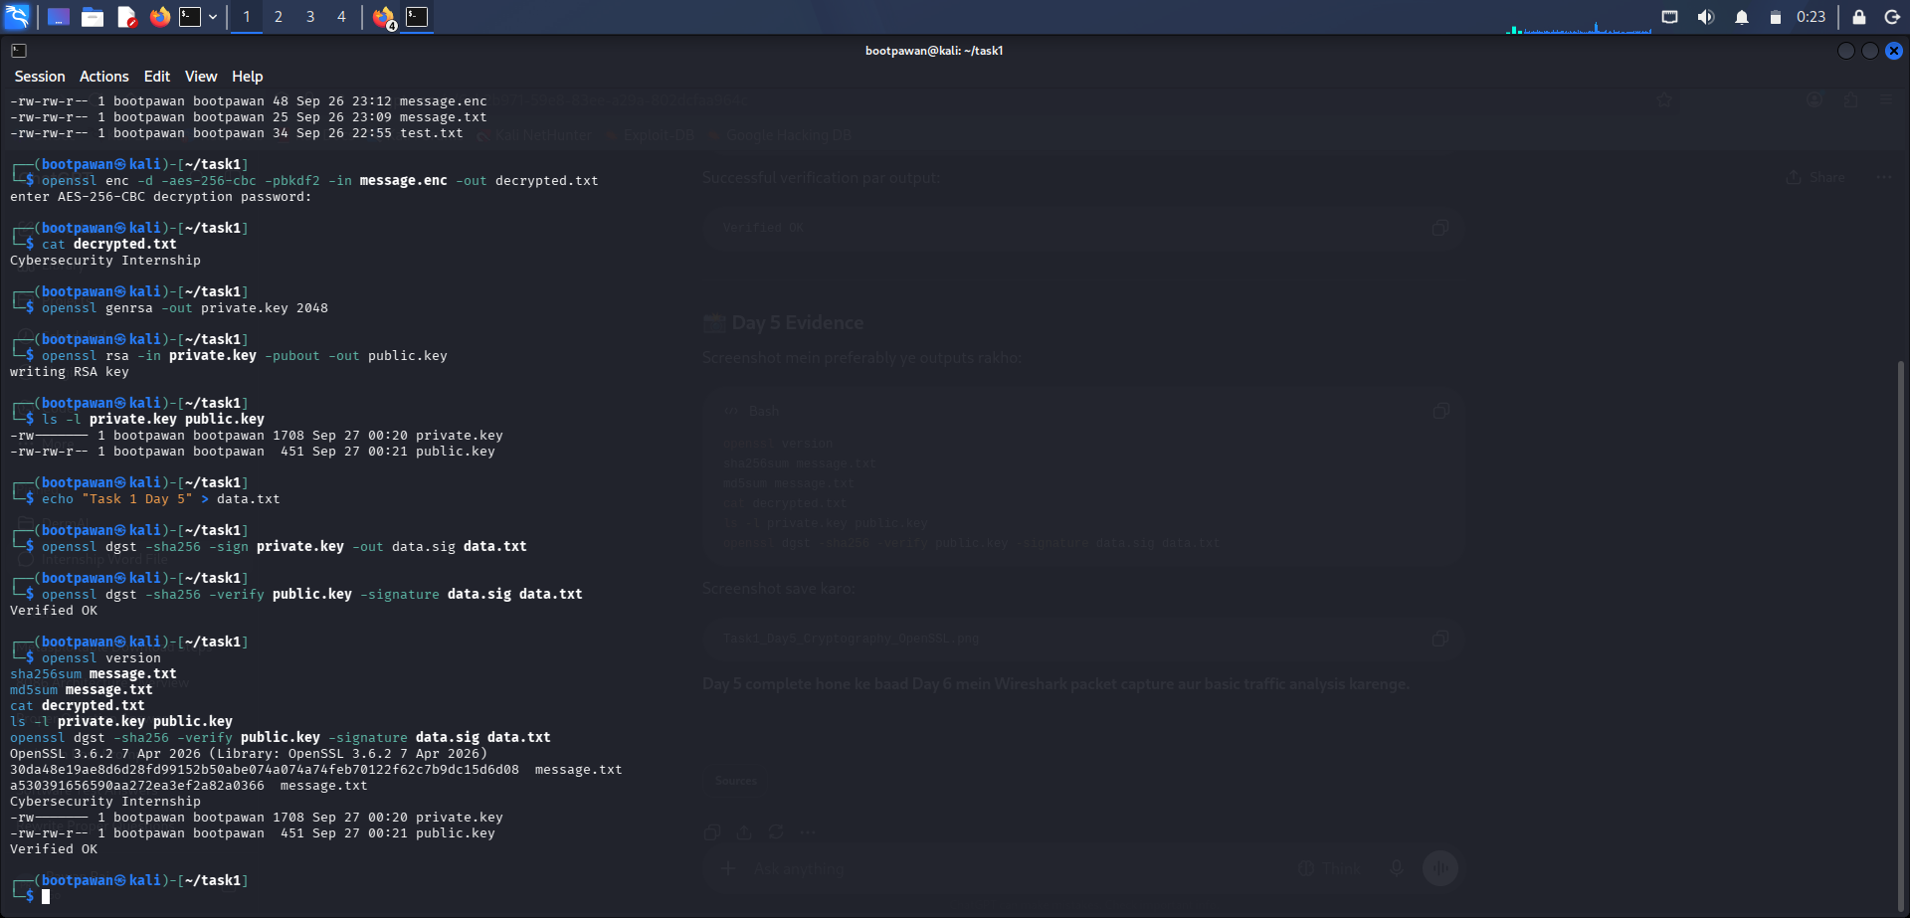
Day 3 — Linux fundamentals

TASK 1 • PRACTICAL EVIDENCE

5. Day 4 — Networking Basics
Objective: understand IP addressing, routes, DNS and basic connectivity.
- Checked interface configuration with ip addr.
- Checked routing information with ip route.
- Verified connectivity with ping and DNS resolution with nslookup.
- Used curl for basic HTTP response inspection.

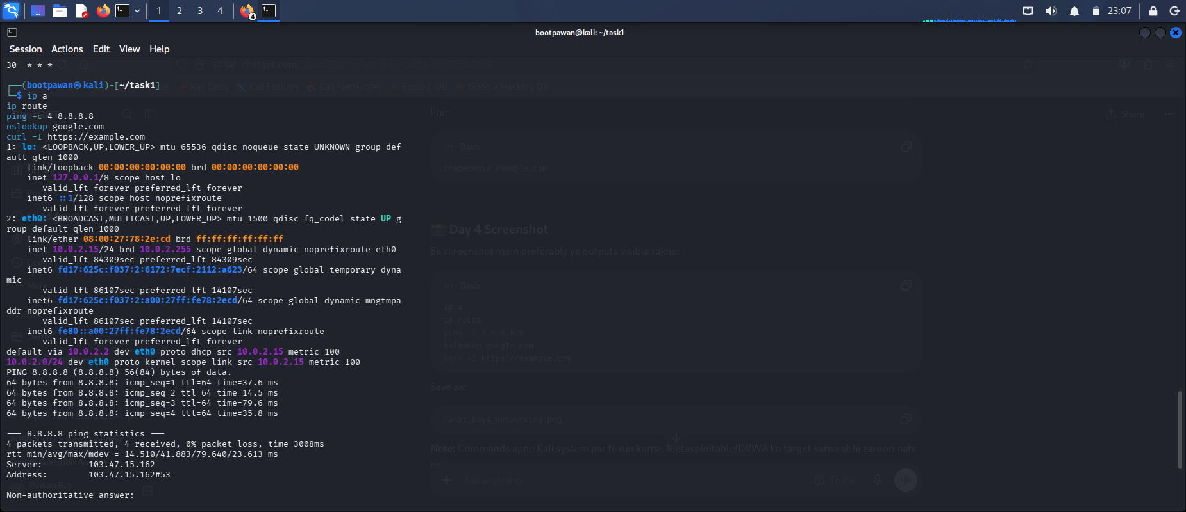
Day 4 — Networking basics

TASK 1 • PRACTICAL EVIDENCE

6. Day 5 — Cryptography & OpenSSL
Objective: practice hashing, encryption/decryption and digital signatures.
- Generated SHA-256 and MD5 hashes for a sample file.
- Encrypted and decrypted a sample message using AES-256-CBC.
- Generated an RSA key pair and created a digital signature.
- Verified the signature successfully with OpenSSL.

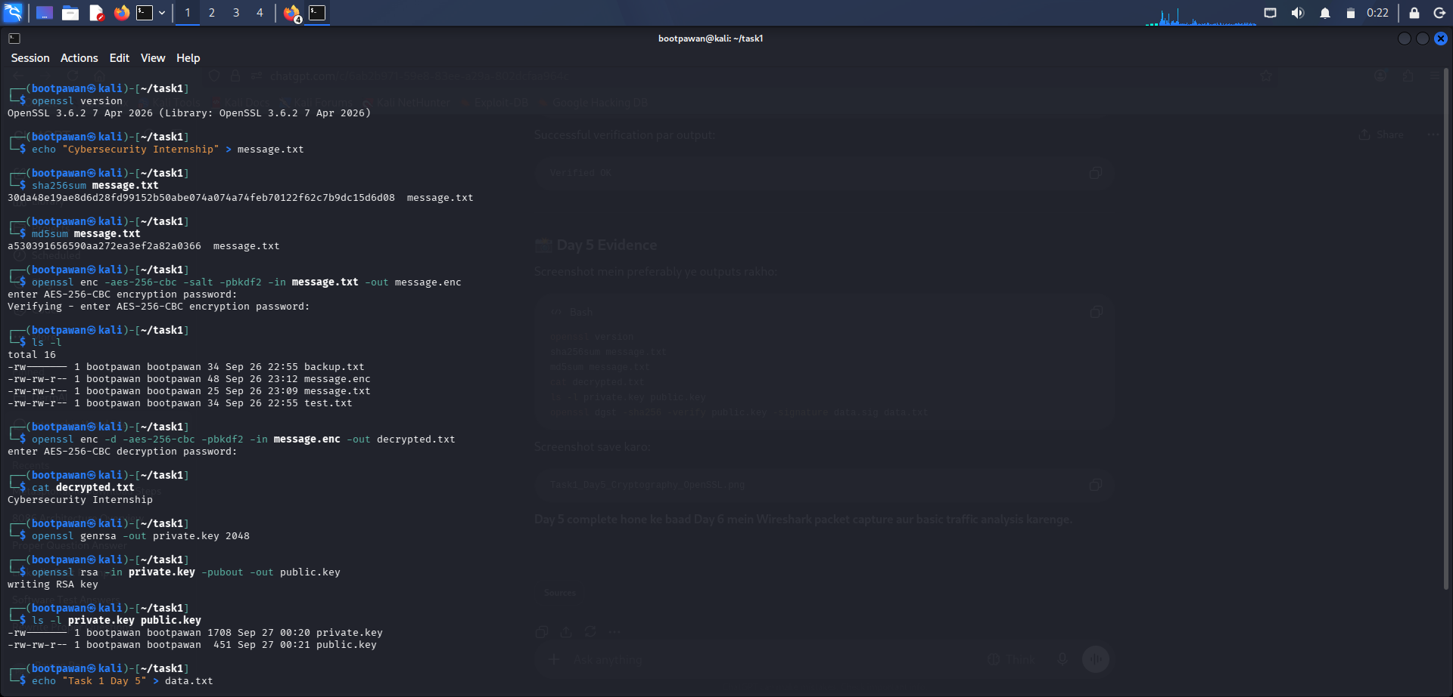
Day 5 — Cryptography and OpenSSL

TASK 1 • PRACTICAL EVIDENCE

7. Day 6 — Wireshark Packet Analysis
Objective: capture and inspect network traffic.
- Captured traffic on the active interface.
- Used display filters such as icmp and dns.
- Inspected packet fields including Ethernet, IP, UDP/TCP and TLS information.
- Observed DNS queries/responses and packet-level details.

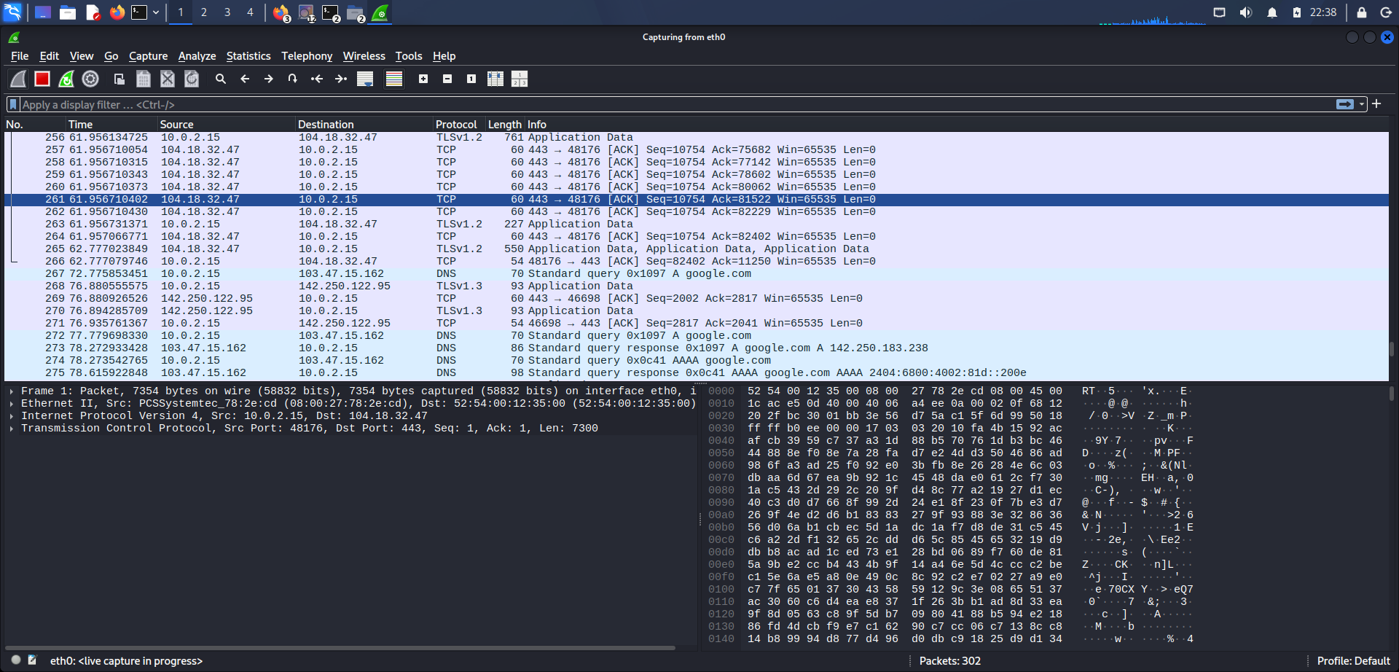
Day 6 — Wireshark capture interface
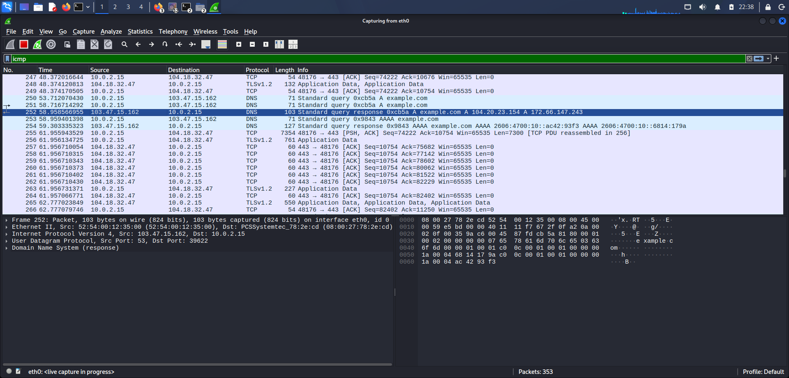
Day 6 — ICMP packet filtering
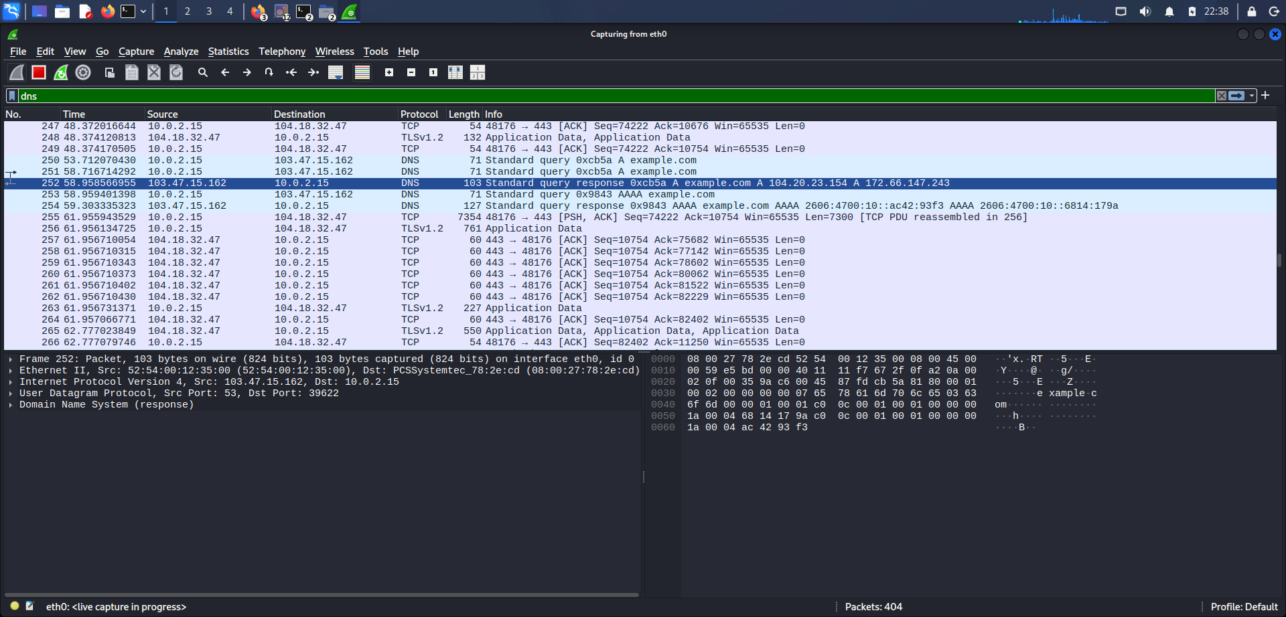
Day 6 — DNS packet filtering
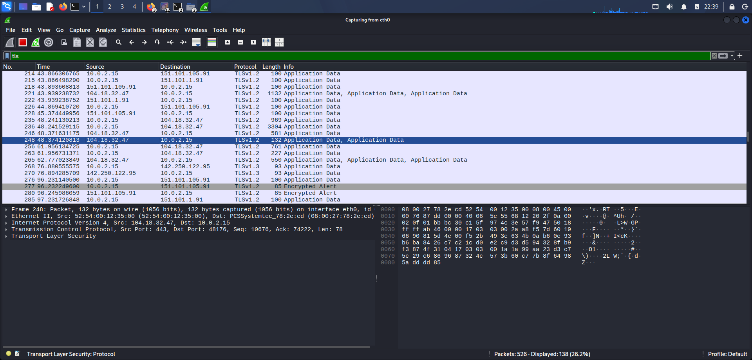
Day 6 — Packet analysis

TASK 1 • PRACTICAL EVIDENCE

8. Day 7 — Nmap Reconnaissance
Objective: identify hosts and inspect services in the authorized lab.
- Verified Nmap installation/version.
- Performed host discovery on the lab subnet.
- Scanned the Metasploitable target for service/version information.
- Saved scan output as evidence.
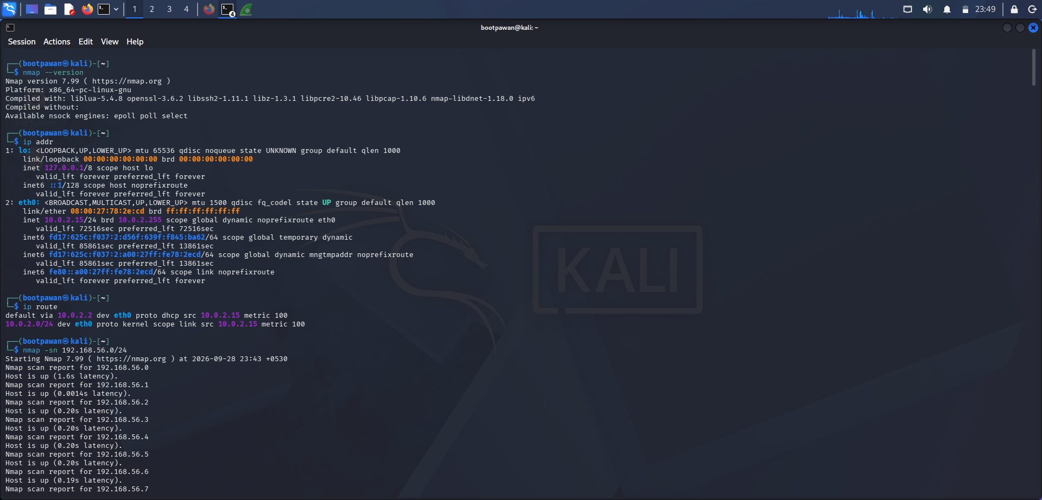
Day 7 — Nmap version verification
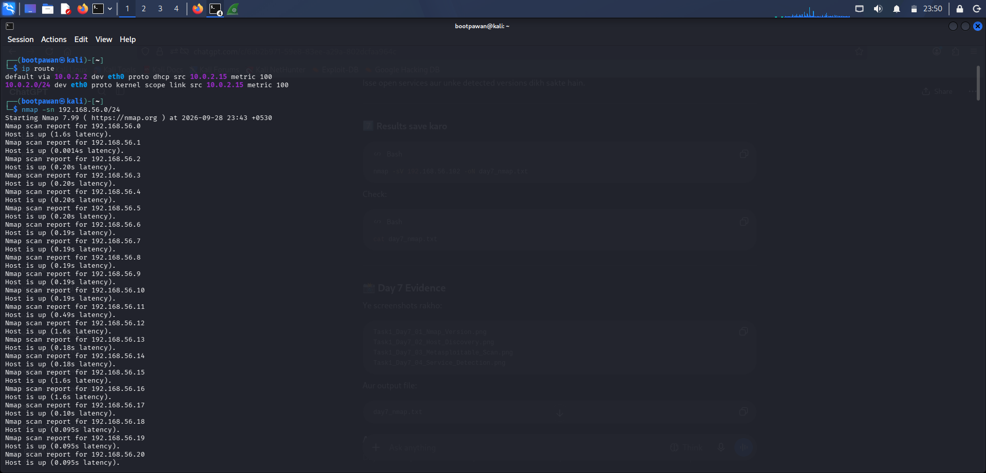
Day 7 — Host discovery

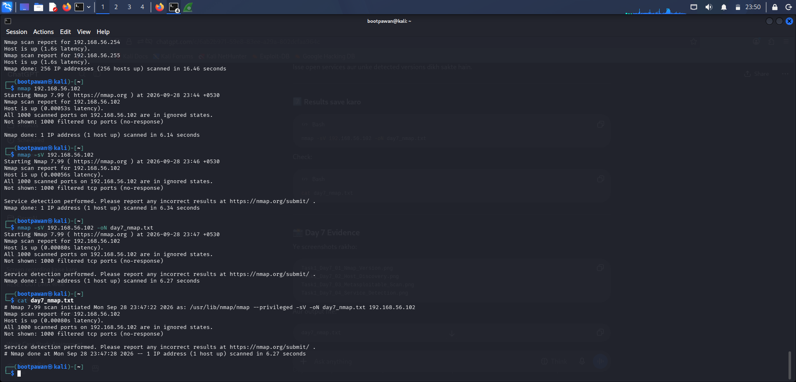
Day 7 — Metasploitable scan

TASK 1 • PRACTICAL EVIDENCE

9. Day 8 — DVWA Login & Verification
Objective: verify the DVWA installation and access the application.
- Logged into the local DVWA application successfully.
- Confirmed the application was reachable at 127.0.0.1.
- Used the application as the controlled environment for later web-security exercises.

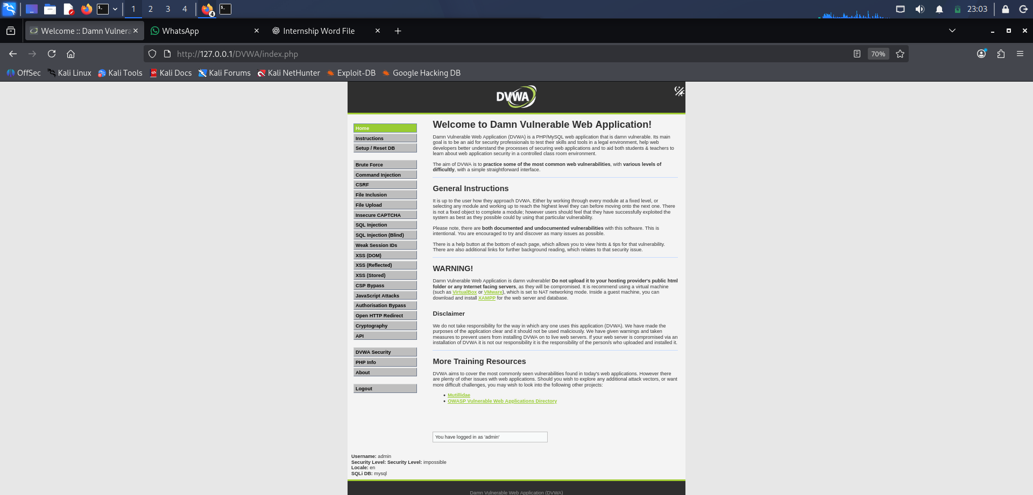
DVWA — successful login

TASK 1 • PRACTICAL EVIDENCE

10. Day 9 — DVWA Database Setup
Objective: initialize the DVWA database and confirm successful setup.
- Created/reset the DVWA database from the Setup / Reset DB page.
- Verified that the setup completed successfully.
- Confirmed the application was ready for security-level configuration.

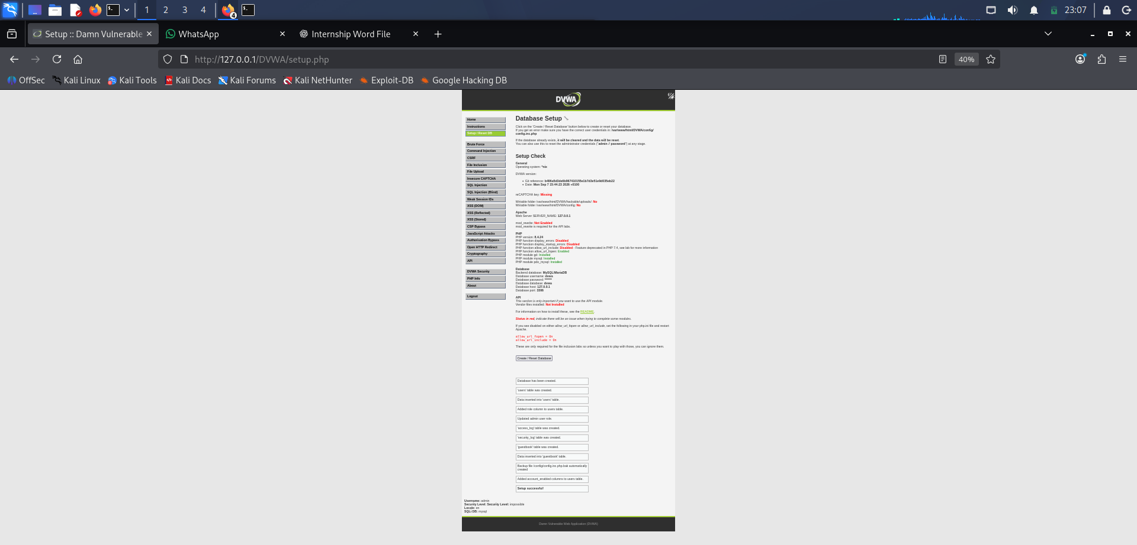
DVWA — database setup

TASK 1 • PRACTICAL EVIDENCE

11. Day 10 — DVWA Security Level & SQL Injection
Objective: use the intentionally vulnerable DVWA module to understand input-handling weaknesses.
- Set DVWA Security Level to Low for the training exercise.
- Opened the SQL Injection module and tested a basic input.
- Observed the application response in the local DVWA environment.
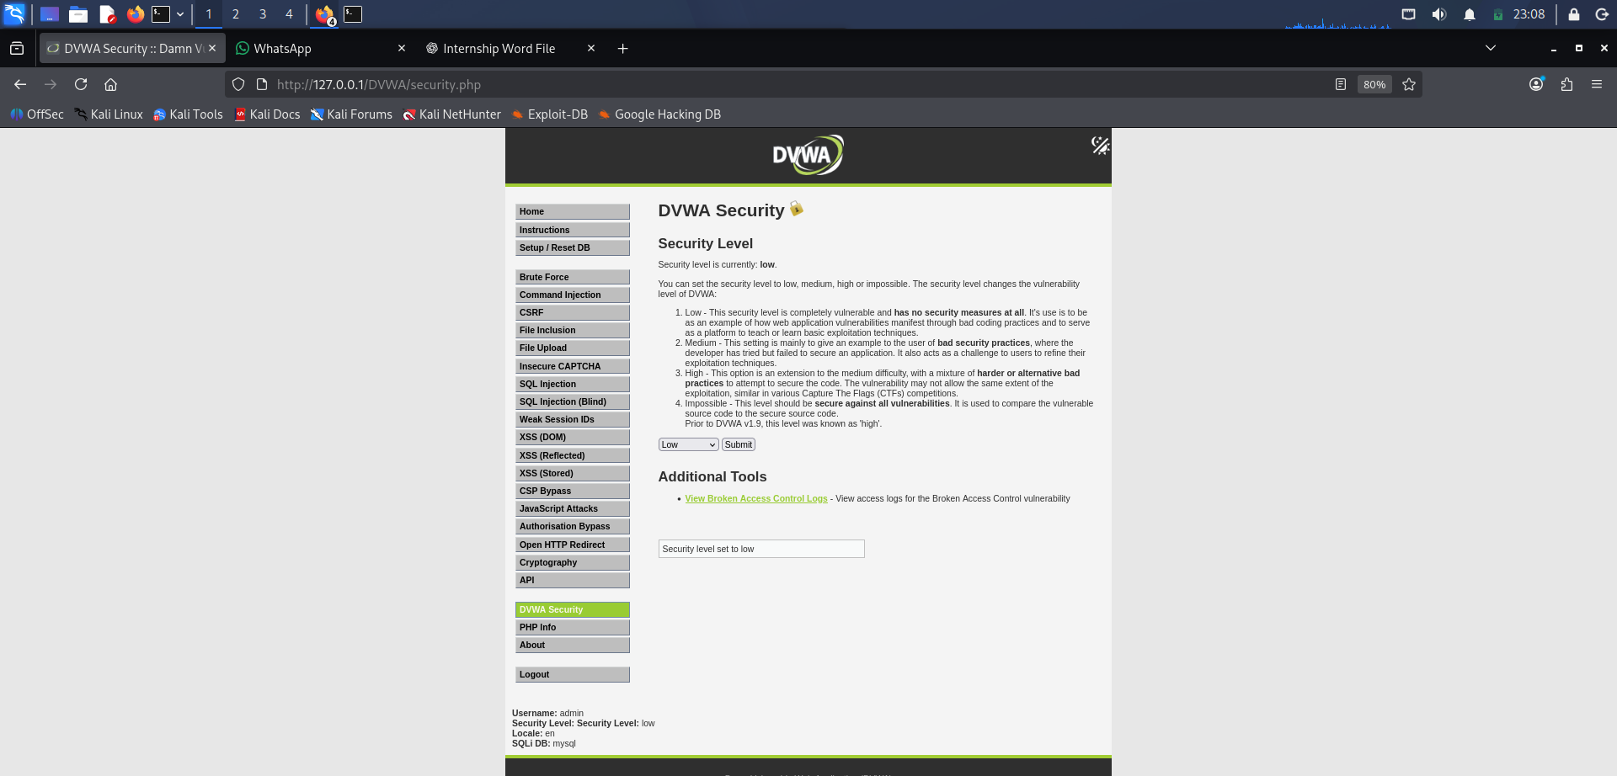
DVWA — security level set to Low
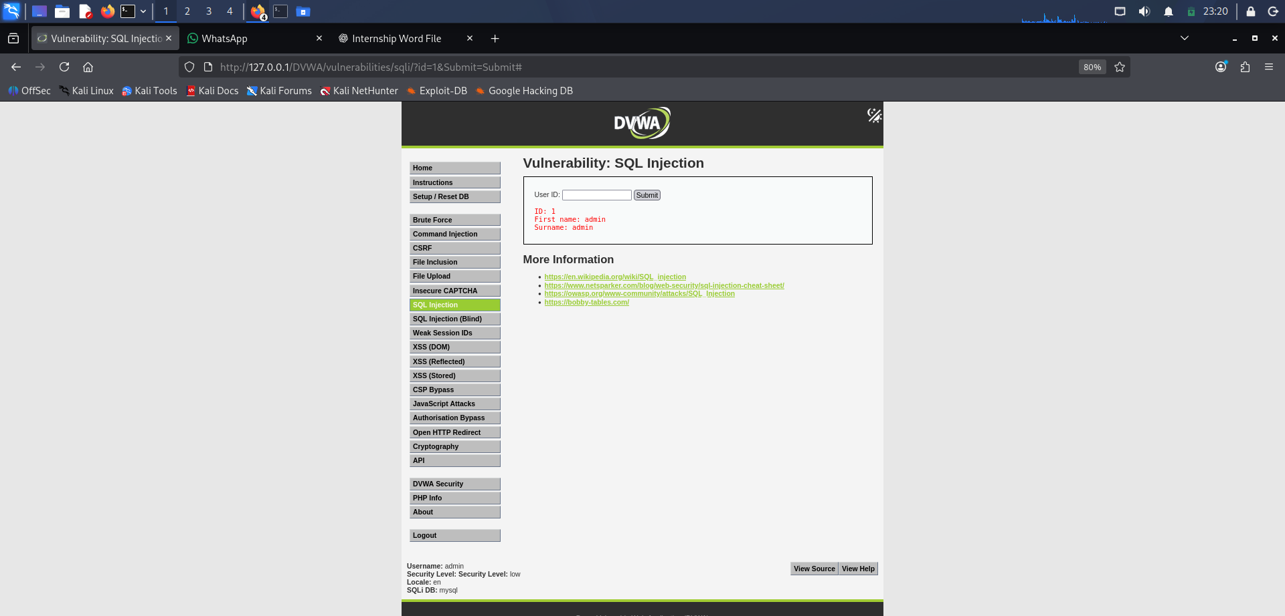
DVWA — SQL Injection demonstration

TASK 1 • PRACTICAL EVIDENCE

12. Day 11 — Reflected XSS
Objective: understand reflected cross-site scripting in the controlled DVWA module.
- Opened XSS (Reflected).
- Tested normal text input and observed it reflected in the response.
- Inspected the page source to understand how the supplied input was reflected.
- Performed the XSS demonstration only against the local DVWA instance.
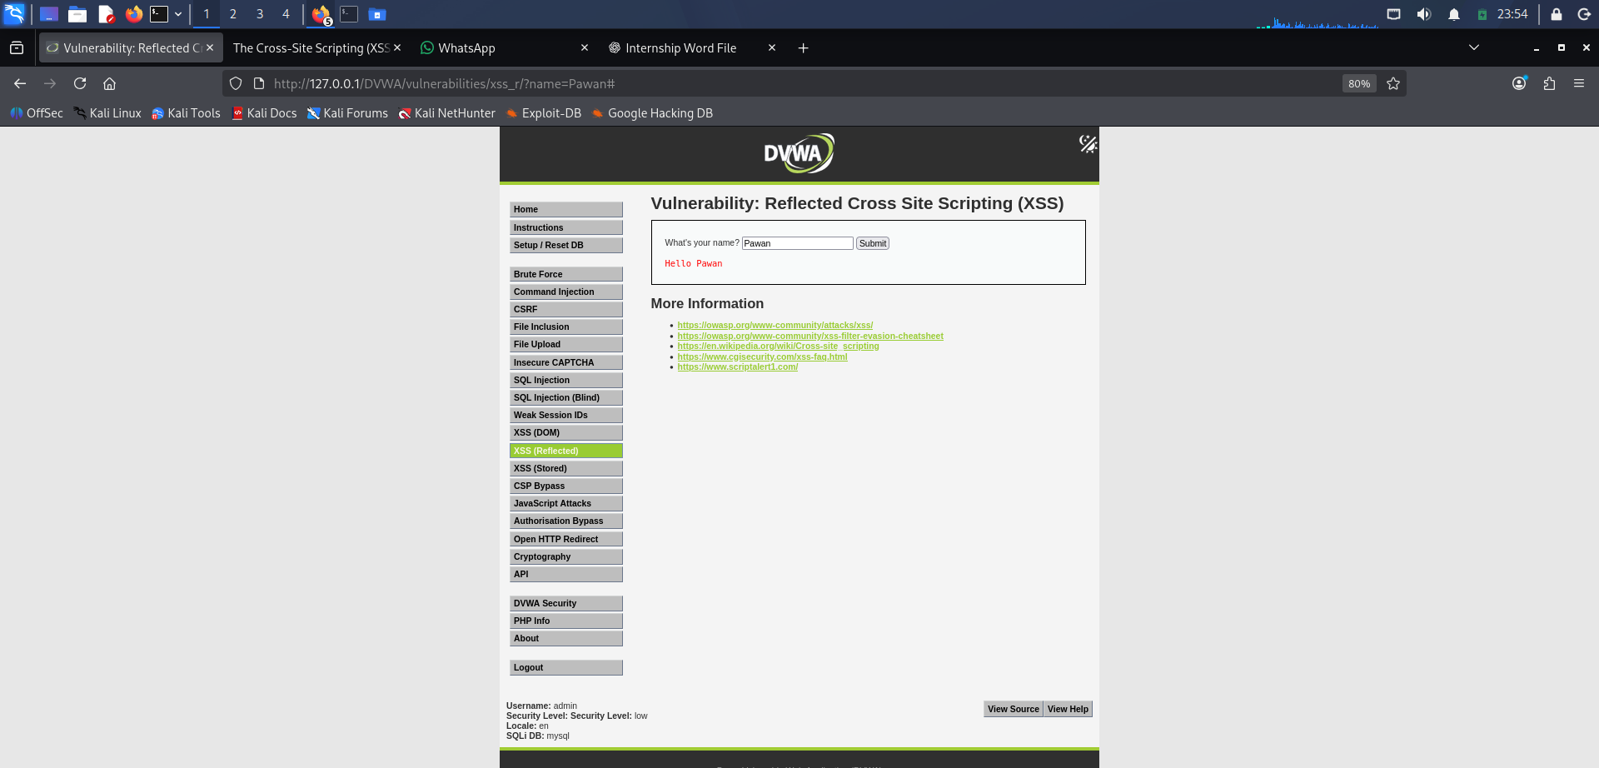
DVWA — Reflected XSS normal input
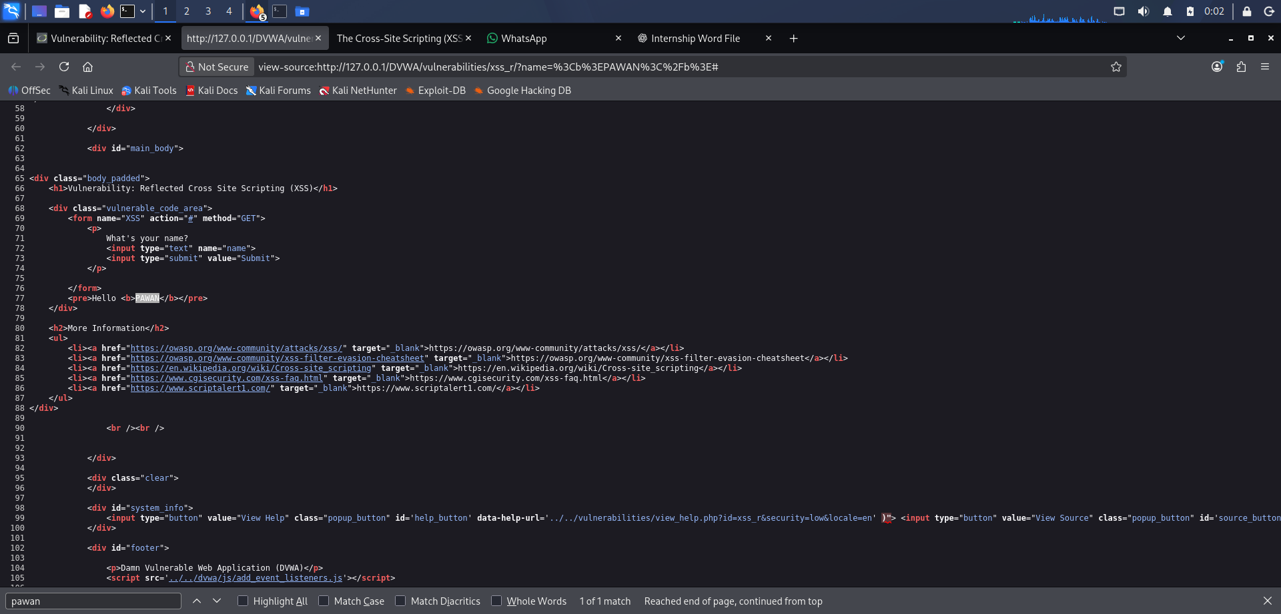
DVWA — Reflected XSS test
TASK 1 • PRACTICAL EVIDENCE

13. Day 12 — Final Verification & Evidence
Objective: consolidate Task 1 evidence and verify the lab components.
- Verified the Kali environment and core commands.
- Verified Wireshark capture/filter evidence.
- Verified Nmap reconnaissance evidence.
- Verified DVWA login, database setup, Low security configuration and web-security modules.
- Prepared screenshots and notes for the internship submission.
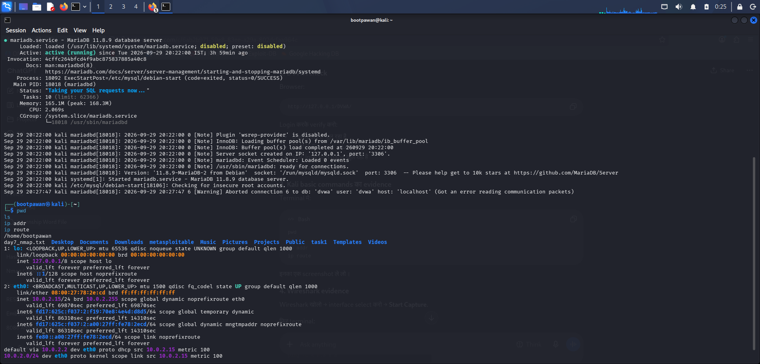
Additional Task 1 terminal evidence
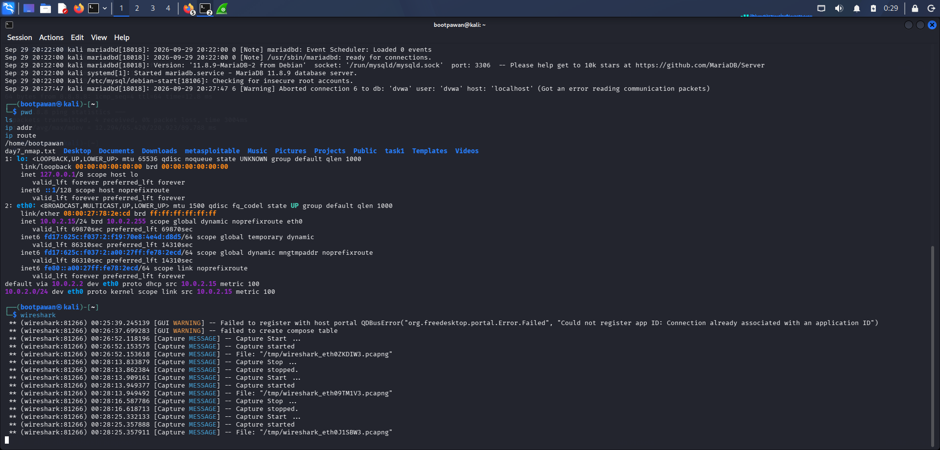

TASK 1 • SUBMISSION CHECKLIST

14. Task 1 Completion Checklist
☑ Cybersecurity fundamentals reviewed (CIA triad, threats and attack vectors).
☑ Controlled lab environment configured and verified.
☑ Linux fundamentals practiced.
☑ Networking and connectivity commands demonstrated.
☑ Cryptography exercises completed with OpenSSL.
☑ Wireshark packet capture and filtering demonstrated.
☑ Nmap host discovery/service detection evidence collected.
☑ DVWA installed, database initialized and login verified.
☑ DVWA Low security level configured for training.
☑ SQL Injection and Reflected XSS modules demonstrated locally.
☑ Screenshots organized for evidence and video walkthrough.

